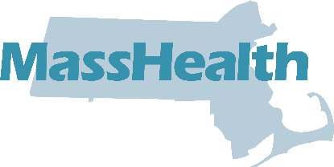
Attention
Changes to the MassHealth Enrollment Guide

New Service Areas
The following new service areas will be offered by MassHealth starting on January 1, 2024:

WellSense Health Plan | Will be in the following service area
WellSense Community Alliance | Oak Bluffs
Boston Children’s ACO | Athol Gloucester Greenfield Pittsfield
East Boston Neighborhood Health WellSense Alliance | Lynn

Removed Service Areas
The following health plan will no longer be offered in the following service area starting on January 1, 2024:

WellSense Health Plan | Will no longer be in the following service area
WellSense Care Alliance | Wareham

How to Find Your Service Area
Look up your town at the end of the Enrollment Guide to find your service area (Pages 38-44).

Hospital Changes
Fallon 365 Care will no longer include Harrington Hospital starting on January 1, 2024. But in an emergency, you can go to any hospital. You do not need to worry about which health plan you have.
All other information in this guide is up to date.
If you want to learn more about health plans and your options, you can:
- Visit www.MassHealthChoices.com; or
- Call MassHealth Customer Service at (800) 841-2900, TDD/TTY: 711. MassHealth Customer Service is open Monday – Friday, 8 am to 5 pm.

EG-I 1123

