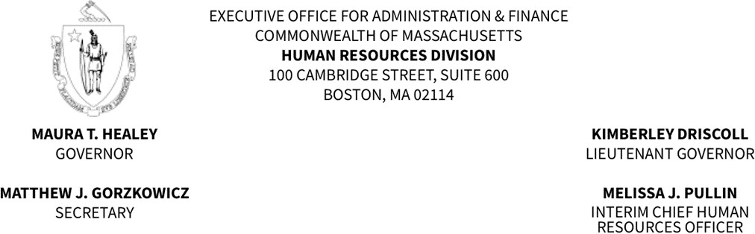

MEMORANDUM

TO: Fire Department Appointing Authorities and Fire Chiefs
FROM: Bruce T. Howard, Jr., Director of Operations, Civil Service Unit
DATE: July 10, 2024
RE: Revocation and Establishment of Fire Promotional Eligible Lists
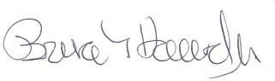

On August 1, 2024, the Human Resources Division (HRD) will establish new eligible lists (Attachment A) resulting from the April 27, 2024, Fire Promotional Series examinations for Lieutenant and Captain.

Promotions made from a current eligible list will be valid only if the selected individuals receive the promotion on or before July 31, 2024. Candidates cannot be promoted after the revocation of an eligible list on which their name appears per Massachusetts General Laws, Chapter 31, § 25.

For those departments where there is not an eligible list scheduled to be established, the department’s existing eligible list will be extended for a period of time until a new eligible list can be established, but not to exceed three years from the first day of the month the examination was held, in accordance with our revocation policy.

Please be advised that all promotions made from an eligible list must be submitted to HRD through the Civil Service online system. If you have any questions or concerns, please do not hesitate to contact your Civil Service liaison. Thank you

Attachment A
DEPARTMENT, TITLE/S
Abington, Captain
Amesbury, Lieutenant
Arlington, Captain
Attleboro, Captain
Bedford, Lieutenant
Beverly, Captain, Lieutenant
Billerica, Captain
Brockton, Captain, Lieutenant
Cambridge, Captain, Lieutenant
Canton, Captain
Chelsea, Captain, Lieutenant
Chicopee, Lieutenant
Cohasset, Lieutenant
Danvers, Captain, Lieutenant
Fall River, Lieutenant
Fitchburg, Captain
Framingham, Captain, Lieutenant
Gardner, Captain
Haverhill, Captain, Lieutenant
Hull, Captain
Ludlow, Captain
Lynn, Captain
Malden, Captain
Marshfield, Captain
Melrose, Captain
Methuen, Lieutenant
Milford, Lieutenant
Nahant, Captain, Lieutenant
New Bedford, Lieutenant
Newburyport, Lieutenant
Newton, Captain
Norwood, Captain, Lieutenant
Peabody, Lieutenant
Plymouth, Captain, Lieutenant
Quincy , Captain, Lieutenant
Randolph, Captain, Lieutenant
Reading, Captain, Lieutenant
Salem, Captain, Lieutenant
Saugus, Lieutenant,
Shrewsbury, Lieutenant
Stoneham, Captain, Lieutenant
Stoughton, Captain
Tewksbury, Captain
Watertown, Captain, Lieutenant
Westfield, Captain
West Springfield, Lieutenant
Weymouth, Captain, Lieutenant
Woburn, Lieutenant
Wrentham, Captain, Lieutenant

