2024 Massachusetts Integrated
HIV, STI, and Viral Hepatitis
Surveillance Report






Massachusetts Department of Public Health
Bureau of Infectious Disease and
Laboratory Sciences
December 2025

Suggested citation:
Massachusetts Department of Public Health, Bureau of Infectious Disease and Laboratory Sciences. 2024 Massachusetts Integrated HIV, STI and Viral Hepatitis Surveillance Report, https://www.mass.gov/doc/2023-integrated-hiv-std-and-viral-hepatitis-report-pdf/download Published December 2025. Accessed [date].
Bureau of Infectious Disease and Laboratory Sciences
Massachusetts Department of Public Health
Dr. Alfred DeMaria, Jr. Campus
305 South Street
Jamaica Plain, MA 02130
Questions about this report
Tel: (617) 983-6560
To reach the Reporting and Partner Services Line
Tel: (617) 983-6999

To speak to the on-call epidemiologist
Tel: (617) 983-6800
Questions about infectious disease reporting
Tel: (617) 983-6801
Requests for additional data
https://www.mass.gov/lists/infectious-disease-data-reports-and-requests
Slide set for 2024 Integrated Report
https://www.mass.gov/lists/std-data-and-reports
For additional contact information see HIV, STI, and Viral Hepatitis Program Staff Contact Information

ACKNOWLEDGMENTS

We are grateful to healthcare providers and laboratories across the Commonwealth who report HIV, STI, and viral hepatitis diagnoses and corresponding clinical information to the Massachusetts Department of Health (DPH), Bureau of Infectious Disease and Laboratory Sciences (BIDLS). These reports are essential to perform timely epidemiologic investigations and to inform an effective public health response. We also wish to acknowledge the contributions of the many program staff within BIDLS who collect, manage, maintain, and analyze this information and who reviewed draft sections relevant to their areas of expertise.

CONTENTS

LIST OF COMMONLY USED ACRONYMS iv
KEY HIGHLIGHTS 1
CHLAMYDIA 4
CHLAMYDIA BY GENDER 4
CHLAMYDIA BY AGE 6
CHLAMYDIA BY AVERAGE AGE AND GENDER 7
CHLAMYDIA BY CITY/TOWN 8
GONORRHEA 9
GONORRHEA BY GENDER 9
GONORRHEA BY AGE 11
GONORRHEA BY CITY/TOWN 12
SYPHILIS 13
SYPHILIS BY GENDER 13
SYPHILIS BY AGE 15
SYPHILIS BY CITY/TOWN 16
HIV 17
HIV PREVALENCE 17
DIAGNOSES AND DEATHS FROM ANY CAUSE AMONG PERSONS REPORTED WITH HIV 18
HIV DIAGNOSES BY CITY/TOWN 19
HIV PREVALENCE BY CITY/TOWN 20
HIV BY EXPOSURE MODE AND SEX ASSIGNED AT BIRTH 21
PERINATAL TRANSMISSION OF HIV 22
AGE AMONG PERSONS LIVING WITH HIV INFECTION 23
SURVIVAL AMONG INDIVIDUALS DIAGNOSED WITH HIV 24
VIRAL HEPATITIS 25
HEPATITIS A 25
HEPATITIS B 26
HEPATITIS B BY AGE 28
ACUTE HEPATITIS B 29
HEPATITIS C (HCV) 30
HEPATITIS C BY AGE 32
SOCIAL VULNERABILITY INDEX 33
CO-INFECTIONS 35
HIV/SYPHILIS 35
HIV/GONORRHEA 36
HIV/HEPATITIS C (HCV) 37
HIV/HCV – PERCENTAGE CO-INFECTED 38
HIV/HEPATITIS B (HBV) 39
HIV/HBV – PERCENTAGE CO-INFECTED 40
SPECIFIC POPULATIONS- ADOLESCENTS AND YOUNG ADULTS 41
STI DIAGNOSES BY AGE 41
STI DIAGNOSES BY AGE AND GENDER 42
HIV DIAGNOSES BY RACE/ETHNICITY AMONG ADOLESCENTS AND YOUNG ADULTS 43
HEPATITIS C BY AGE AND GENDER 44
MASSACHUSETTS YOUTH RISK BEHAVIOR SURVEY 46
SPECIFIC POPULATIONS - MEN WHO HAVE SEX WITH MEN 47
HIV DIAGNOSIS RATE PER 100,000 47
MSM – SYPHILIS RATE PER 100,000 48
MSM – SYPHILIS/HIV CO-INFECTION 49
MSM - SYPHILIS BY COUNTY 50
MSM – RECENT HIV DIAGNOSES 51
MSM – SYPHILIS CASES 52
TRENDS IN HIV EXPOSURE MODE AMONG MALES 53
SPECIFIC POPULATIONS – PERSONS WHO INJECT DRUGS 54
PERSONS WHO INJECT DRUGS – RECENT HIV DIAGNOSES 55
DEATHS FROM ANY CAUSE AMONG INDIVIDUALS REPORTED WITH HIV BY EXPOSURE MODE 56
VIRAL HEPATITIS AND INJECTION DRUG USE 57
SPECIFIC POPULATIONS – RACIAL AND ETHNIC GROUPS 58
SYPHILIS BY RACE/ETHNICITY 59
HIV BY RACE/ETHNICITY 60
SPECIFIC POPULATIONS - WOMEN AND INFANTS 61
WOMEN AND INFANTS – CONGENITAL SYPHILIS 62
WOMEN - RECENT HIV DIAGNOSES 64
SPECIFIC POPULATIONS – OLDER INDIVIDUALS 65
STI DIAGNOSES BY AGE 65
STI DIAGNOSES BY AGE AND GENDER 66
SYPHILIS BY AGE, GENDER, RACE/ETHNICITY, AND RISK 67
OLDER INDIVIDUALS LIVING WITH HIV INFECTION 68
OLDER INDIVIDUALS RECENTLY DIAGNOSED WITH HIV INFECTION 72
STRENGTHS AND LIMITATIONS OF DATA 74
INTERPRETING HIV, STI, AND VIRAL HEPATITIS DATA 76
HIV, STI, AND VIRAL HEPATITIS CASE CLASSIFICATIONS 80
HIV infection 80
Sexually transmitted infections (STI) 80
Viral Hepatitis 90
HIV, STI, AND VIRAL HEPATITIS PROGRAM STAFF CONTACT INFORMATION 98
ADDITIONAL HIV, STI, AND VIRAL HEPATITIS RESOURCES 99

LIST OF COMMONLY USED ACRONYMS

AFAB Assigned Female at Birth
AI/AN American Indian/Alaska Native
AIDS Acquired Immunodeficiency Syndrome
AMAB Assigned Male at Birth
API Asian/Pacific Islander
BIDLS Bureau of Infectious Disease and Laboratory Sciences
BRFSS Behavioral Risk Factor Surveillance System
CDC Centers for Disease Control and Prevention
CI Confidence Interval
COVID-19 Coronavirus Disease 2019
DOE Department of Education
DPH (Massachusetts) Department of Public Health
HAV Hepatitis A Virus
HBV Hepatitis B Virus
HCV Hepatitis C Virus
HIV Human Immunodeficiency Virus
HSR Health Service Region
HTSX Heterosexual Sex
IDU Injection Drug Use
MSM Male-to-Male Sex or Men Who Have Sex with Men
N Number
NH Non-Hispanic
NIR No Identified Risk
PLWH Persons Living with HIV Infection
Pres. HTSX Presumed Heterosexual Sex
PR/USD Puerto Rico/United States Dependency
PWID Persons Who Inject Drugs
STD Sexually Transmitted Disease
STI Sexually Transmitted Infection

KEY HIGHLIGHTS

The 2024 Integrated HIV, STI, and Viral Hepatitis Surveillance Report provides data on infections reported to the Massachusetts Department of Public Health (DPH), Bureau of Infectious Disease and Laboratory Sciences (BIDLS) by healthcare providers and laboratories per regulation (105 CMR 300.000). This report focuses on a subset of these diseases:
- Chlamydia
- Gonorrhea
- Syphilis
- HIV
- Hepatitis A, B, and C
The intended audience for this annual surveillance report includes the clinicians and laboratory professionals who report cases, community organizations, local public health departments, advocates, policymakers, and researchers who are interested in the health of Massachusetts residents.
Key Highlights in 2024
Chlamydia, Gonorrhea, and Syphilis:
- Substantial declines in cases of all three reportable bacterial sexually transmitted infections (chlamydia, gonorrhea, and syphilis) occurred between 2023 and 2024. Previously during this decade, decreased case reporting was seen in 2020, presumably due to the impact of the COVID-19 pandemic on behaviors and health care access, but STI (sexually transmitted infection) reporting has since recovered. Since the reductions seen in 2024 are greater in males than females, and greatest for syphilis, we believe that the diffusion of doxycycline post-exposure prophylaxis (Doxy PEP) for the prevention of bacterial STIs, currently recommended in Massachusetts for gay and bisexual men and transgender women with history of STI in the previous year, is at least one reason for declines in STIs reported in 2024.
- Similar declines are being reported in provisional national 2024 STI data released by the CDC. Additionally, in 2023 (the last time state-specific data were released in rank order from highest to lowest incidence rates), rates of STIs in Massachusetts were well below the national rates and among the lowest of the 50 states. Massachusetts ranked 36th lowest in chlamydia incidence rate (at 412.7 per 100,000), 31st in gonorrhea incidence rate (at 139.8 per 100,000), 34th in primary and secondary syphilis incidence rate (at 10.6 per 100,000), and 44th in congenital syphilis rate (at 20.4 per 1,000 live births).
KEY HIGHLIGHTS

HIV:
- With advances in treatment, survival of individuals diagnosed with HIV infection has increased over time. While the estimated survival rate at ten years after HIV infection diagnosis for the cohort of individuals diagnosed with HIV infection from 2000 to 2004 is 86%, it is approaching 100% for individuals diagnosed from 2020 to 2024 (96%). Additionally, after reaching a ten-year peak in 2022, all-cause deaths among people reported with HIV declined substantially in 2023 and then increased only slightly in 2024. The proportion of deaths among individuals reported with HIV infection attributed to HIV-related causes has decreased over time, with the leading causes of death now being external causes of injuries and poisonings (which includes opioid overdoses) and cancer.
- Although there have been reductions in deaths and some reductions in cases over the past ten years, vulnerable and historically marginalized populations remain disproportionately impacted:
  - Black (non-Hispanic) and Hispanic/Latinx individuals were diagnosed with HIV infection during 2022 – 2024 at rates 13 and six times that of White (non-Hispanic) individuals, respectively.
  - Men who have sex with men (MSM) continued to represent the largest proportion of new HIV infection diagnoses (41% overall and 56% among individuals assigned male at birth [AMAB] in 2022–2024).
  - Outbreaks have occurred among persons who inject drugs in the Commonwealth. Although focused public health responses were highly successful in stopping transmission of HIV infection associated with the outbreaks among PWID in the northeastern part of the state (from 2016 to 2018) and in Boston (starting in early 2019), the Boston cluster is still an active cluster of concern. Continued vigilance and monitoring of population based trends will be needed to prevent future outbreaks.
Hepatitis A, B, and C:
- Between 2018 and 2020, DPH and local health departments investigated an outbreak of hepatitis A that affected more than 500 residents. The populations most affected by the outbreak were those with recent homelessness or unstable housing, and/or substance use disorder. The outbreak was declared over in the spring of 2020 and case counts among the affected populations remained low through 2022. However, a smaller outbreak affecting these same populations was detected in the fall of 2023, prompting additional vaccination efforts. This outbreak ended in May of 2024 with a total of 24 cases.

KEY HIGHLIGHTS

- From 2015 to 2024, an average of 1,740 cases of confirmed and probable chronic hepatitis B virus (HBV) infection were reported each year (with a low of 1,160 in 2020 and a high of 2,155 in 2024). Changes in testing behaviors and travel due to the COVID-19 pandemic likely influenced the number of reported cases and may have contributed to the decrease in 2020, followed by the rebound from 2021 to 2024. The recent increase in newly reported cases is likely related to both broadened screening recommendations as well as an updated case definition. HBV case definitions were revised in 2024. The updated definitions added a probable case classification for acute HBV and broadened the criteria for both chronic and acute HBV.
- The total number of confirmed acute HBV cases reported decreased from 53 cases in 2017 to 14 cases in 2021 and subsequently increased to 44 cases in 2024.
- In 2024, 2,116 confirmed and probable cases of hepatitis C (HCV) were reported. This represents a 76% decrease in newly reported cases from the 8,696 reported in 2015, likely driven in part by the effect of increases in Massachusetts of prevention strategies such as harm reduction, with many cities and towns in the Commonwealth now providing such services. Most reported cases are chronically infected and DPH currently estimates that there are over 250,000 persons living with HCV infection in Massachusetts.
- Forty percent (N=847/2,116) of HCV cases reported in 2024 were among young adults (age 20–39 years), reflecting ongoing transmission among young people who inject drugs.

CHLAMYDIA

CHLAMYDIA BY GENDER
Chlamydia is the most frequently reported sexually transmitted infection (STI) in Massachusetts and nationally. Chlamydia is a sexually transmitted bacterial infection that can be spread through vaginal, anal, or oral sexual contact with an infected partner, and from a pregnant person to child during birth. While most people with chlamydia usually have no signs or symptoms, some may experience dysuria; vaginal, penile, or anal discharge; or irregular bleeding. Chlamydia is easily treated, but repeated infections are common. Women are at great risk of complications of repeated infections. For more information, see https://www.cdc.gov/std/chlamydia/stdfact-chlamydia-detailed.htm.

Figure 1. Number of confirmed chlamydia cases reported by gender, Massachusetts 2015–2024

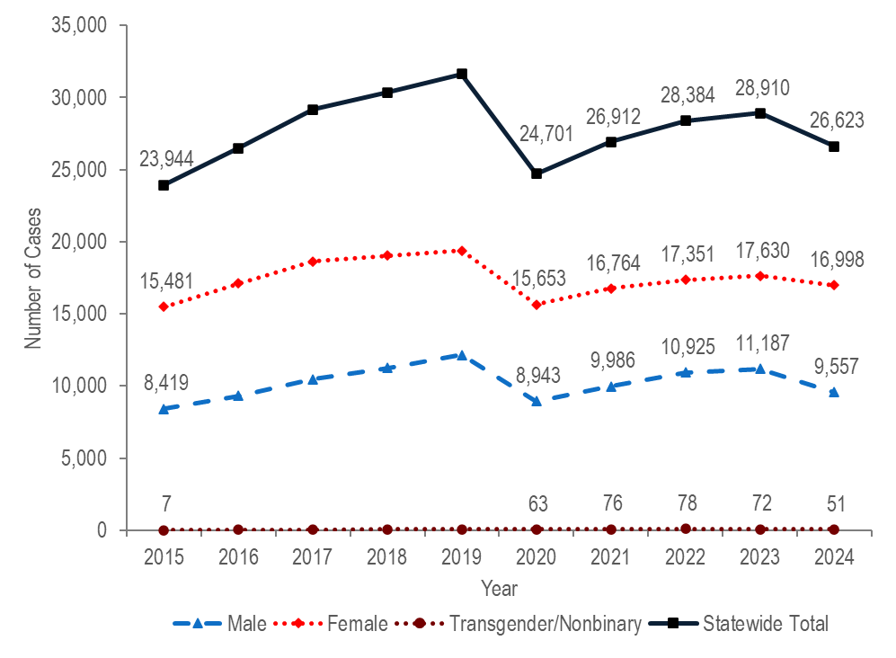
Note: Cases with no gender reported (2015–2024: N=337) are included in the statewide total but are not depicted in the figure above separately due to small numbers.
Data Source: Bureau of Infectious Disease and Laboratory Sciences, data are current as of 6/02/2025 and subject to change.

CHLAMYDIA BY GENDER

- The total number of confirmed chlamydia cases increased by 32% from 23,944 in 2015 to 31,633 in 2019, decreased to 24,701 in 2020, and then increased to 26,623 in 2024. A decrease in chlamydia cases in 2020, followed by an increase in 2021 was also observed nationally.
- Each year from 2015 to 2024, nearly twice as many confirmed chlamydia cases were reported among females as among males. In 2024, the ratio of female-to-male chlamydia cases was 1.8 (1.8 = 16,998/9,557).
- In 2024, 51 confirmed chlamydia cases were reported among individuals of transgender experience and/or individuals who are nonbinary.

CHLAMYDIA BY AGE

Figure 2. Number of confirmed chlamydia cases reported by age group (years), Massachusetts 2015–2024
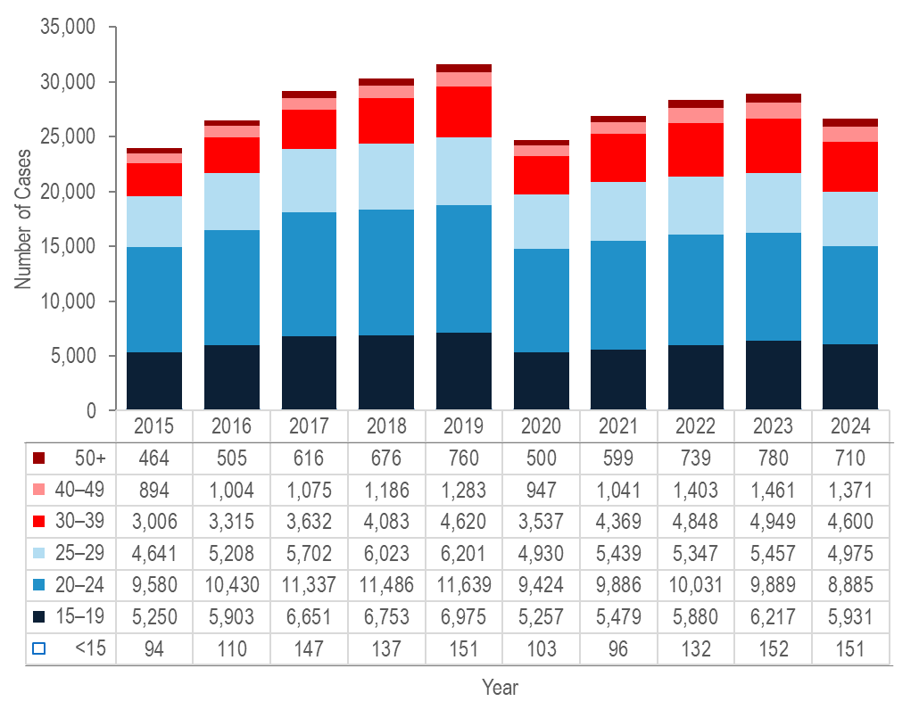
Note: Cases with no age reported (2015–2024: N=70) are not included in this figure
Data Source: Bureau of Infectious Disease and Laboratory Sciences, data are current as of 6/02/2025 and subject to change.

- Each year from 2015 to 2024, the greatest number of confirmed chlamydia cases was reported among 20–24 year-olds, followed by 15–19 year-olds. In each of these years over half (56% to 62%) of confirmed chlamydia cases were reported among individuals in these age groups.
- From 2015 to 2024, the number of confirmed chlamydia cases increased among individuals aged under 15 years (by 61%), 30–39 years, 40–49 years, 50+ years, (each by 53%), 15–19 years (by 13%), and 25–29 years (by 7%), while it decreased among individuals aged 20–24 years (by 7%).

CHLAMYDIA BY AVERAGE AGE AND GENDER

In 2021, the United States Preventive Services Task Force and the CDC recommended screening for chlamydia in sexually active women under 25 years of age, and in older women at increased risk for infection. Screening of sexually active men should be considered in higher prevalence clinical settings such as adolescent clinics, correctional facilities, and sexual and reproductive health clinics, and among men who have sex with men.
Figure 3. Average age of confirmed chlamydia cases reported by gender, Massachusetts 2015–2024

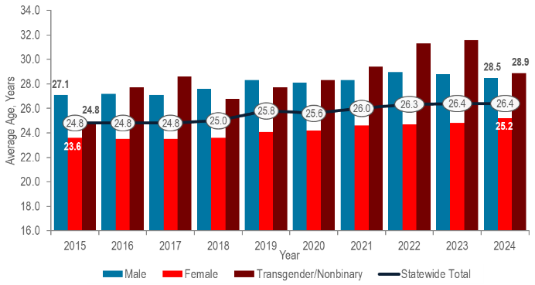
Note: Cases with no age reported (2015–2024: N=70) are not included in this analysis.
Data Source: Bureau of Infectious Disease and Laboratory Sciences, data are current as of 6/02/2025 and subject to change.

- The overall average age of confirmed chlamydia cases in Massachusetts increased from 24.8 years in 2015 to 26.4 years in 2024. This marks the sixth year that the average age has exceeded the CDC recommended screening age range of under 25 years for sexually active women.
- From 2015 to 2024, the average age of confirmed chlamydia cases reported among males increased by 1.4 years compared to an increase of 1.6 years among females.

CHLAMYDIA BY CITY/TOWN

Figure 4. Incidence rate of confirmed chlamydia cases per 100,000 population reported by city/town, Massachusetts 2024
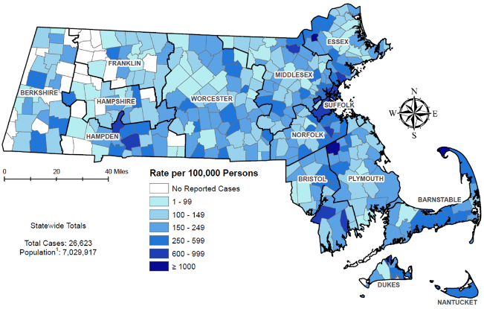
¹ Population based on University of Massachusetts Donahue Institute Estimates.
Note: regional data include individuals tested in a correctional facility.
There are no city/towns with <10 cases of chlamydia that fall within the top two rate categories (≥600 cases per 100,00).
Data Source: Bureau of Infectious Disease and Laboratory Sciences, data are current as of 6/02/2025 and subject to change.

- Confirmed chlamydia cases continue to be reported throughout Massachusetts, with concentrations in the most populated cities.
- The five cities with the highest confirmed chlamydia incidence rates in 2024 were Provincetown (1,337.3 per 100,000), Brockton (1,275.0 per 100,000), Lawrence (1,133.0 per 100,000), Chelsea (899.8 per 100,000), and Springfield (883.7 per 100,000).
- In 2024, the statewide confirmed chlamydia incidence rate of 378.7 per 100,000 population was lower than the 2023 national rate of 492.2 per 100,000.
- While Louisiana ranked first (highest rate) and New Hampshire ranked 50th (lowest rate), Massachusetts ranked 36th in chlamydia incidence rate among the 50 states in 2023, the last year for which these national data are publicly available.

GONORRHEA

GONORRHEA BY GENDER
Gonorrhea is a common bacterial STI. It can be spread through vaginal, anal, or oral sexual contact with an infected partner, or to an infant during birth. Symptoms of gonococcal infection can vary depending on the site of infection and may include dysuria; vaginal, penile, or anal discharge; irregular bleeding; abdominal or anal pain; and sore throat. Still, many infected individuals do not present with any symptoms of infection. Although gonorrhea infection is treatable, treatment has become more complex with increased antimicrobial non-susceptibility, including two cases of a novel strain of multidrug-non-susceptible gonorrhea that were detected in Massachusetts in 2022. For more information, see https://www.mass.gov/doc/clinical-alert-on-non-susceptible-gonorrhea-january-19-2023/download. For more general information, see https://www.cdc.gov/std/gonorrhea/stdfact-gonorrhea-detailed.htm

Figure 5. Number of confirmed gonorrhea cases reported by gender, Massachusetts 2015–2024
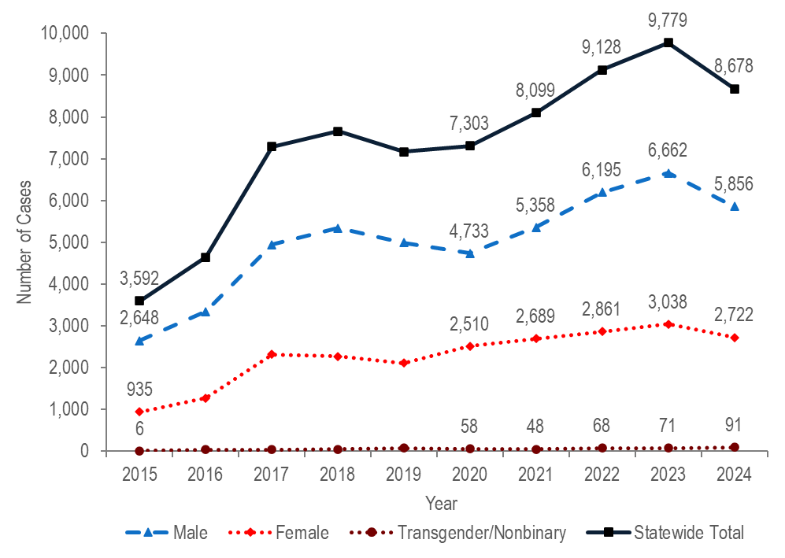

Note: Cases with no gender reported (2015–2024: N=37) are included in the statewide total but are not depicted in Figure 6 separately due to small numbers.
Data Source: Bureau of Infectious Disease and Laboratory Sciences, data are current as of 6/02/2025 and subject to change.

GONORRHEA BY GENDER

- After a sharp 57% increase from 2016 (N=4,638) to 2017 (N=7,293), the number of confirmed gonorrhea cases remained relatively stable through 2020 (N=7,303), increased by 34% to 9,779 in 2023, and then decreased by 11% to 8,678 in 2024.
- Between 2015 and 2024, the number of confirmed gonorrhea cases reported among males increased by 2.2 times (from 2,648 to 5,856, respectively). The number of confirmed gonorrhea cases among males in 2024 was more than double the number among females (2,722), resulting in a male-to-female ratio of 2.2 (2.2 = 5,856/2,722).
- The number of confirmed gonorrhea cases reported among females increased by 2.9 times from 935 in 2015 to 2,722 in 2024.
- In 2024, 91 confirmed gonorrhea cases were reported among individuals of transgender experience and/or nonbinary individuals.

GONORRHEA BY AGE

Figure 6. Number of confirmed gonorrhea cases reported by age group (years), Massachusetts 2015–2024
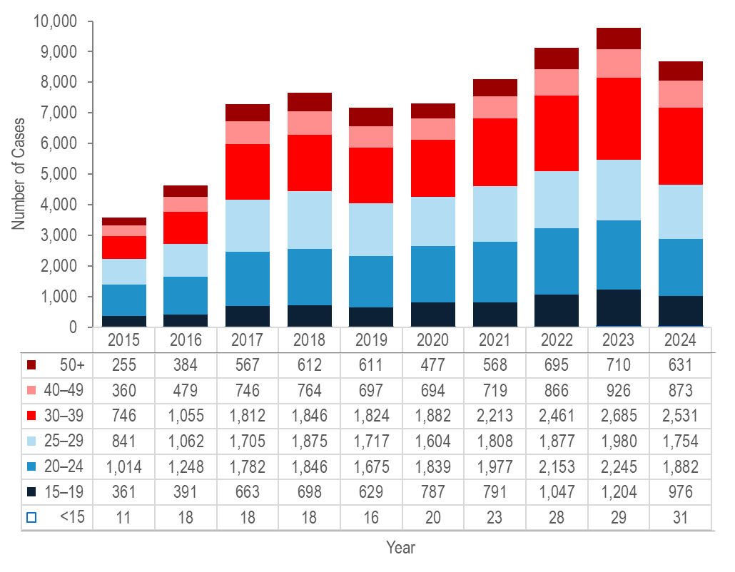
Note: Cases missing age (2015–2024: N=10) are not included in this figure
Data Source: Bureau of Infectious Disease and Laboratory Sciences, data are current as of 6/02/2025 and subject to change.
- Each year from 2015 to 2024, about half (42% to 52%) of confirmed gonorrhea cases were reported among individuals aged 20–24 or 25–29 years.
- From 2015 to 2024, the largest increase in the number of confirmed gonorrhea cases was among individuals aged 30–39 years (by 3.4 times from 746 to 2,531).

GONORRHEA BY CITY/TOWN

Figure 7. Incidence rate of confirmed gonorrhea cases per 100,000 population reported by city/town, Massachusetts 2024
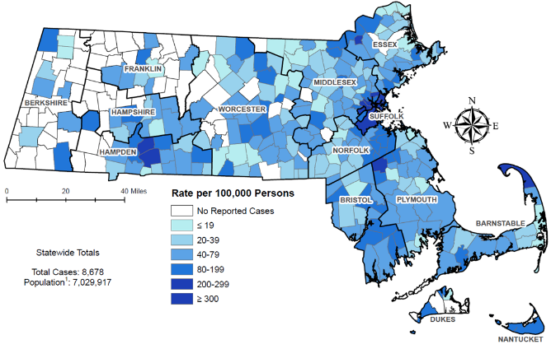
¹ Population based on University of Massachusetts Donahue Institute Estimates
There is one city/town with <10 cases of gonorrhea that falls within the top two rate categories (≥200 cases per 100,000): Truro.
Note: regional data include individuals tested in a correctional facility.
Data Source: Bureau of Infectious Disease and Laboratory Sciences, data are current as of 6/02/2025 and subject to change.
- Confirmed gonorrhea cases continued to be clustered in the most populated cities in Massachusetts in 2024.
- The five cities with the highest incidence rates of confirmed gonorrhea in 2024 were Provincetown (2,538.2 per 100,000), Boston (344.6 per 100,000), Brockton (319.0 per 100,000), Springfield (313.0 per 100,000), and Chelsea (286.9 per 100,000).
- In 2024, the statewide incidence rate of confirmed gonorrhea of 123.4 per 100,000 population was lower than the 2023 national rate of 179.5 per 100,000.
- While Alaska ranked first (highest rate) and Vermont ranked 50th (lowest rate), Massachusetts ranked 31st in gonorrhea incidence rate among the 50 states in 2023, the last year for which these national data are publicly available.

SYPHILIS

SYPHILIS BY GENDER
Syphilis is a sexually transmitted infection that can be spread through sexual contact with an infected person. The first symptom of syphilis infection is a sore or chancre at the site of inoculation that is usually firm, round, and painless. The most recognized symptom of the second stage of infection is a body rash which can be present on the palms of hands and soles of feet. As with primary syphilis symptoms, secondary symptoms also resolve with or without treatment. After the secondary stage of syphilis, untreated infected individuals enter a time of latent syphilis that can last for years. Individuals with syphilis are thought to be most infectious for the first year after acquisition. Syphilis infection can also be transmitted to an infant during pregnancy and birth. Syphilis transmission to an unborn baby is a serious complication of syphilis infection among pregnant individuals. From 2019 to 2024, the annual number of probable cases of congenital syphilis diagnosed in Massachusetts ranged from nine to nineteen after remaining between zero and four from 2011 to 2018. Syphilis is treatable and it is possible to be re-infected with repeated exposure. For more information, see https://www.cdc.gov/std/syphilis/stdfact-syphilis-detailed.htm

Figure 8. Number of confirmed and probable infectious syphilis cases reported by gender, Massachusetts 2015–2024
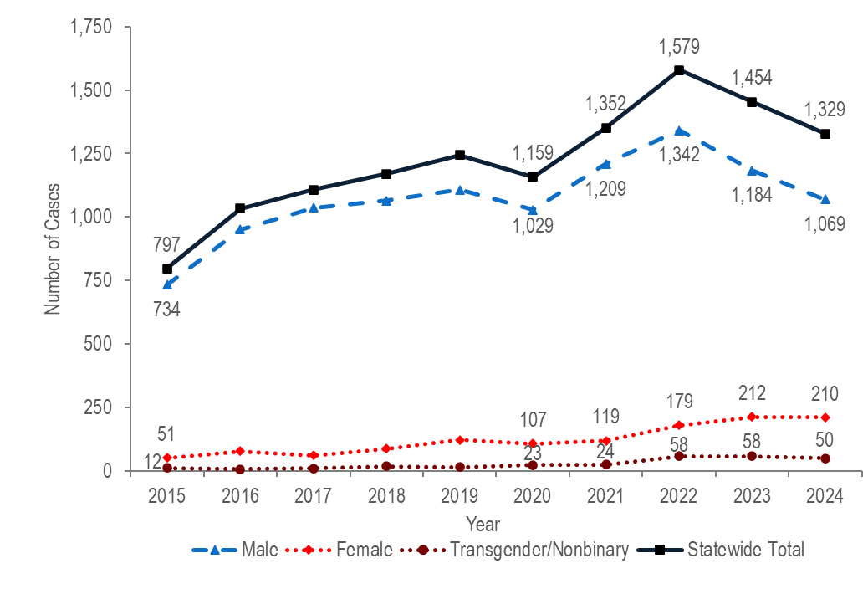
Note: Cases with no gender reported (2015–2024: N=1) are included in the statewide total but are not depicted in the figure above separately due to small numbers. Data Source: Bureau of Infectious Disease and Laboratory Sciences, data are current as of 6/02/2025 and subject to change.

SYPHILIS BY GENDER

- The total number of reported confirmed and probable infectious syphilis cases increased to a ten-year high of 1,579 in 2022 and subsequently decreased to 1,329 in 2024. A ten-year high was observed in 2022 among males (N=1,342) and in 2023 among females (N=212).
- The total number of confirmed and probable infectious syphilis cases increased by 1.7 times from 2015 (N=797) to 2024 (N=1,329). In the most recent five years from 2020 to 2024 the number of cases increased by 15% (from 1,159 to 1,329).
- Between 2015 and 2024, the proportion of confirmed and probable infectious syphilis cases among males remained between 80% and 94% each year. In 2024, there were 5.1 times as many syphilis cases reported among males (N=1,069) as among females (N=210).
- In 2024, 50 confirmed and probable infectious syphilis cases were reported among individuals of transgender experience and/or nonbinary individuals.

SYPHILIS BY AGE

Figure 9. Number of confirmed and probable infectious syphilis cases reported by age group (years), Massachusetts 2015–2024
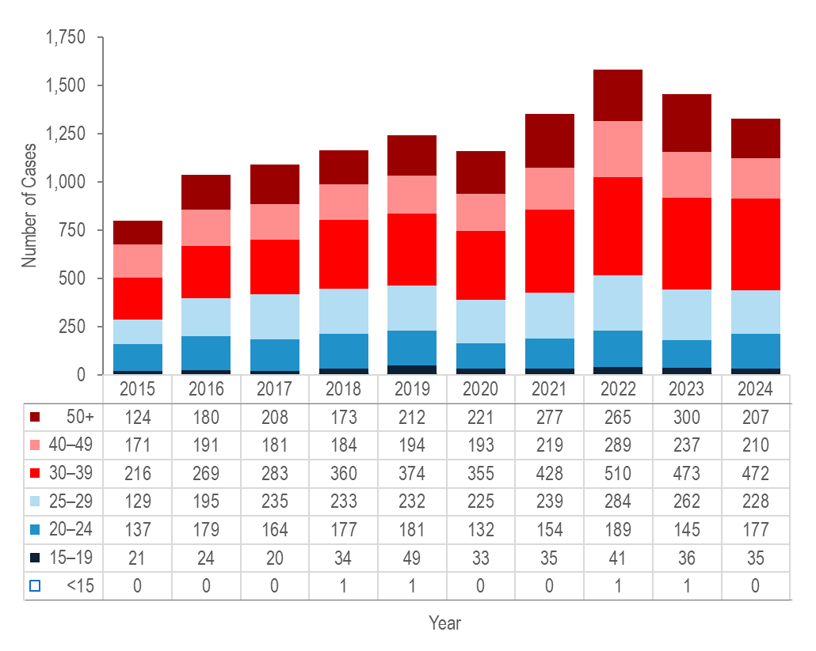
Note: All syphilis cases from 2015 to 2024 were reported with age, none were excluded from this figure
Data Source: Bureau of Infectious Disease and Laboratory Sciences, data are current as of 6/02/2025 and subject to change.

- From 2015 to 2024, the largest increases in the number of reported confirmed and probable infectious syphilis cases were among individuals aged 30–39 years (by 2.2 times from 216 to 472) and 25–29 years (by 77% from 137 to 177).
- The largest number of reported confirmed and probable infectious syphilis cases was among 30–39 year-olds for the past decade.

SYPHILIS BY CITY/TOWN

Figure 10. Incidence rate of confirmed and probable infectious syphilis cases per 100,000 population reported by city/town, Massachusetts 2024
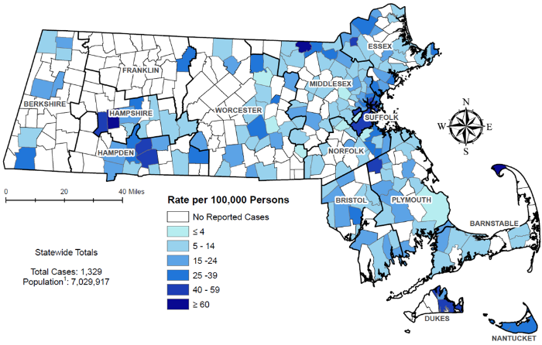
¹ Population based on University of Massachusetts Donahue Institute Estimates.
There are seven city/towns with <10 cases of syphilis that fall within the top two rate categories (≥40 cases per 100,00): Huntington, Westhampton, Dunstable, Nahant, Tisbury, Edgartown and Provincetown.
Note: regional data include individuals tested in a correctional facility.
Data Source: Bureau of Infectious Disease and Laboratory Sciences, data are current as of 7/10/2023 and subject to change.
- The statewide confirmed and probable infectious syphilis incidence rate decreased from a ten-year high of 22.7 in 2022 to 18.9 in 2024.
- The five cities with the highest confirmed and probable infectious syphilis incidence rates were Lawrence (58.3 per 100,000), Springfield (56.4 per 100,000), Chelsea (56.4 per 100,000), Everett (48.9 per 100,000), and Chicopee (46.8 per 100,000).
- While South Dakota ranked first (highest rate) and Vermont ranked 50th (lowest rate), Massachusetts ranked 34th in primary and secondary syphilis incidence rate among the 50 states in 2023, the last year for which these national data are publicly available.

HIV

HIV PREVALENCE
Human immunodeficiency virus (HIV) is transmitted through exposure to blood, semen, vaginal secretions, or breast milk, most commonly through unprotected sex or through sharing drug injection equipment. HIV attacks the body’s immune system, specifically the CD4 cells. Without treatment, HIV can destroy so many of these cells that the body can’t fight off infections and can lead to acquired immunodeficiency syndrome (AIDS). But with proper medical care, HIV can be controlled. People with HIV who get effective HIV treatment can live long, healthy lives and protect their partners by reducing the risk for HIV transmission.
Figure 11. Number of persons living with HIV infection, Massachusetts 2015–2024
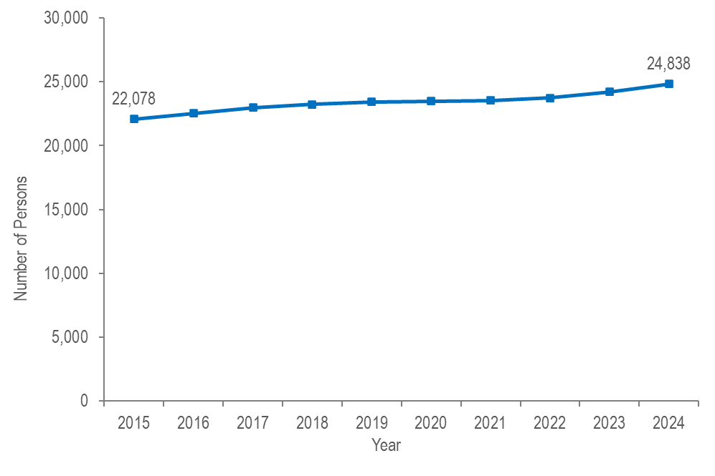
Data Source: Bureau of Infectious Disease and Laboratory Sciences, data are current as of 7/1/2025 and subject to change.

- The number of persons living with HIV infection (PLWH) in Massachusetts increased by 13% from 22,078 in 2015 to 24,838 in 2024.,

DIAGNOSES AND DEATHS FROM ANY CAUSE AMONG PERSONS REPORTED WITH HIV

Figure 12. Number of HIV infection diagnoses and deaths from any cause among persons with HIV, Massachusetts 2015–2024

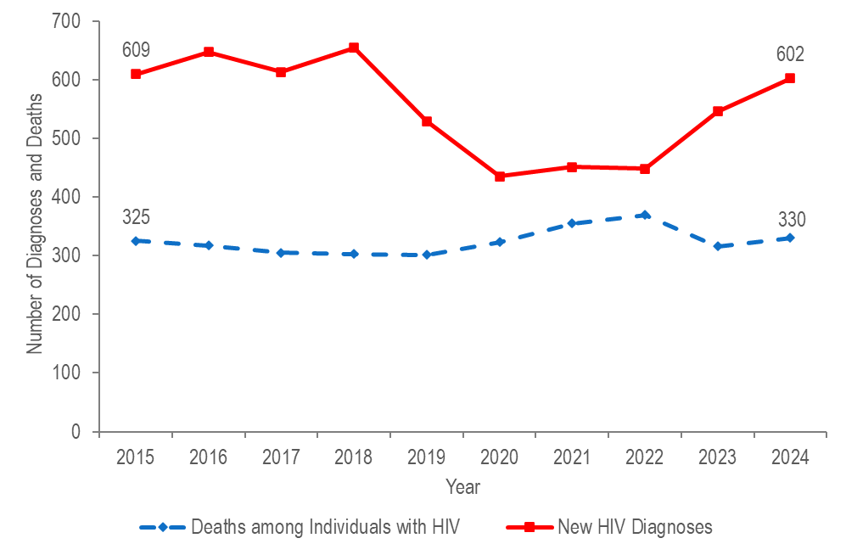
Data Source: Bureau of Infectious Disease and Laboratory Sciences, data are current as of 7/1/2025 and subject to change.
- After ranging from 609 to 654 from 2015 to 2018, the number of new HIV infection diagnoses declined to 529 in 2019. In 2020, the number of new HIV infection diagnoses further declined to 435 and then remained at this lower level in 2021 and 2022, when there were 451 and 448 diagnoses, respectively. However, caution should be used in the interpretation of this decline and subsequent stabilization due to the impact of COVID-19 on access to HIV testing and care services, and case surveillance activities. The number of new HIV infection diagnoses returned to pre-pandemic levels in 2023 (N=546), increasing by 22% compared to the prior year, and then by an additional 10% in 2024 (N=602).
- The number of deaths due to any cause among individuals reported with HIV infection increased by 14% from 325 in 2015 to a peak of 369 in 2022 and then decreased by 11% to 330 in 2024.

HIV DIAGNOSES BY CITY/TOWN

Figure 13. Average annual rate of HIV diagnosis per 100,000 population by city/town, Massachusetts 2022–2024
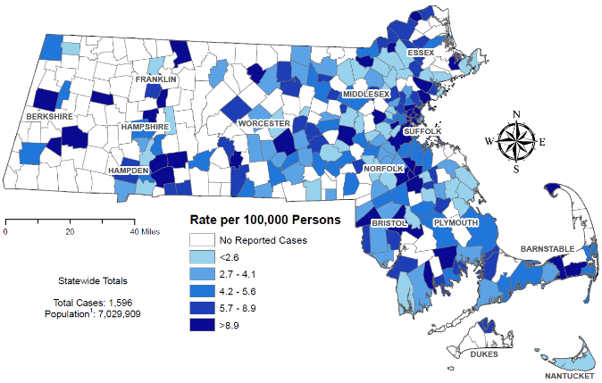

¹ Population based on University of Massachusetts Donahue Institute Estimates.
Note: regional HIV data exclude individuals diagnosed in a correctional facility.
Data Source: Bureau of Infectious Disease and Laboratory Sciences, data are current as of 7/1/2025 and subject to change.
- The cities and towns with the highest average annual rate of HIV infection diagnosis during 2022 to 2024 included Brockton (30.3 per 100,000), Everett (21.1), Chelsea (19.6), Randolph (18.1), and Boston (17.4).
- Boston had the highest number of new HIV infection diagnoses from 2022–2024 (N=352), followed by Brockton (N=96).

HIV PREVALENCE BY CITY/TOWN

Figure 14. Prevalence rate of persons living with HIV infection (PLWH) per 100,000 population by city/town, Massachusetts 2024

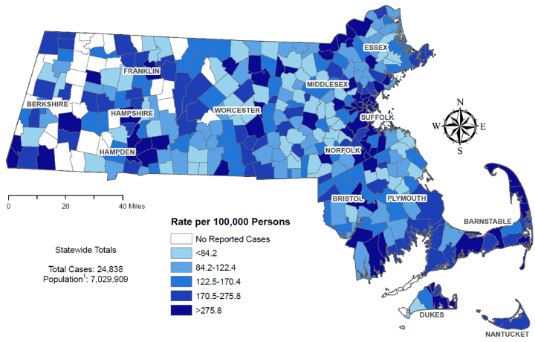

¹ Population based on University of Massachusetts Donahue Institute Estimates.
Note: regional HIV data may include PLWH who may have been incarcerated in 2024.
Data Source: Bureau of Infectious Disease and Laboratory Sciences, data are current as of 7/1/2025 and subject to change.
- The cities and towns with the highest prevalence rate of PLWH in 2024 included Provincetown (12,313.6 per 100,000), Ayer (861.0), Boston (853.0), Springfield (846.5), and Chelsea (789.5).
- Boston and Springfield had the highest numbers of PLWH in 2024, at 5,763 and 1,320, respectively.

HIV BY EXPOSURE MODE AND SEX ASSIGNED AT BIRTH

Figure 15. Percentage of HIV infection diagnoses by sex assigned at birth and exposure mode, Massachusetts 2022–2024
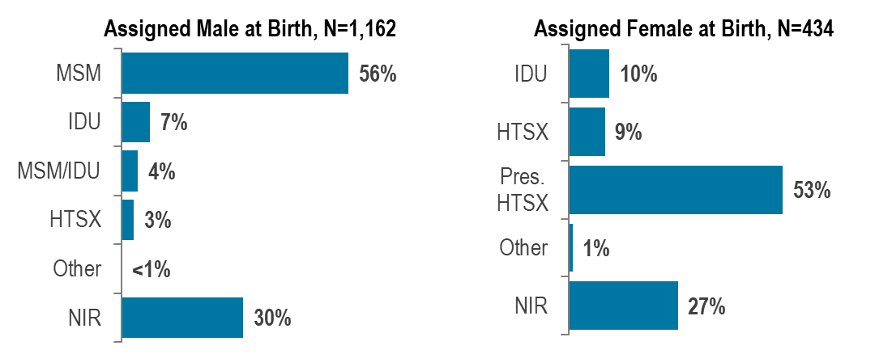
Data Source: Bureau of Infectious Disease and Laboratory Sciences, data are current as of 7/1/2025 and subject to change.
MSM=male-to-male sex; IDU=injection drug use; HTSX=heterosexual sex; Pres. HTSX=presumed heterosexual exposure, includes individuals assigned female at birth with a negative history of injection drug use who report having sex with an individual that identifies as male of unknown HIV status and risk; NIR=no identified risk. For detailed definitions of primary exposure mode categories see Interpreting HIV, STI, and Viral Hepatitis Data

- From 2022 to 2024, of the 1,596 HIV infections newly diagnosed in Massachusetts, 1,162 (73%) were among individuals assigned male at birth (AMAB) and 434 (27%) were among individuals assigned female at birth (AFAB). Among the 1,596 HIV infections, 33 (2%) were among individuals of transgender experience, and 1,563 (98%) were among cisgender individuals.
- From 2022 to 2024, the most frequently reported known exposure mode among individuals AMAB was male-to-male sex (56%) and among individuals AFAB was presumed heterosexual sex (53%). A substantial proportion of diagnoses among both individuals AMAB and AFAB were reported with no identified risk (30% and 27%, respectively).
- Among individuals AMAB, the proportion of HIV infection diagnoses with injection drug use (IDU) exposure mode increased from 7% (N=33/447) in 2015 to 16% (N=75/456) in 2017, decreased to 9% (N=35/389) in 2019, increased to 17% in 2021 (N=55/316), and then decreased again to 6% (N=24/432) in 2024.
- Among individuals AFAB, the proportion of HIV infection diagnoses with IDU exposure mode increased from 10% (N=17/162) in 2015 to 25% (N=40/157) in 2017, decreased to 18% (N=25/140) in 2019, increased to 22% in 2020 (N=27/122), and then decreased again to 11% (N=19/170) in 2024.

PERINATAL TRANSMISSION OF HIV

Figure 16. Number of reported cases of perinatal transmission of HIV infection, by year of birth, Massachusetts 1985–2024

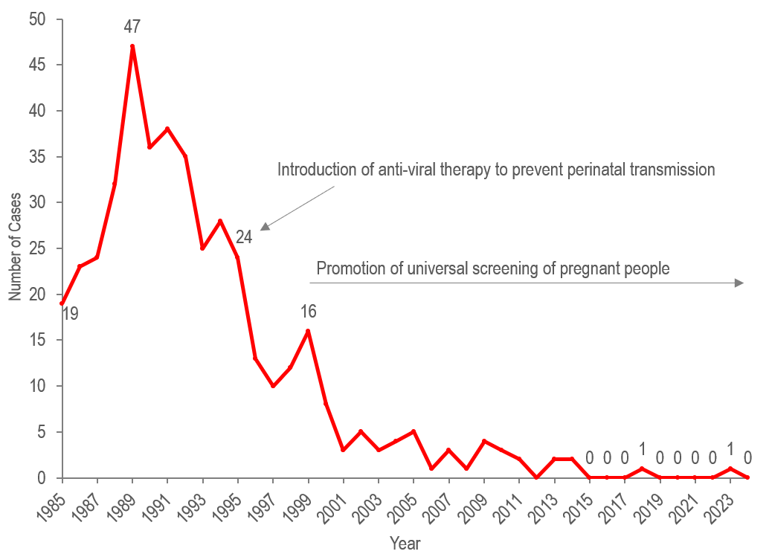
Data Source: Bureau of Infectious Disease and Laboratory Sciences, data are current as of 7/1/2025 and subject to change.

- Since the mid-1990s, there has been a dramatic reduction in perinatal transmission of HIV infection related to high rates of antiretroviral treatment of HIV positive people and promotion of HIV screening during pregnancy.
- There were only two cases identified in the past ten years (one in 2018 and one in 2023).

AGE AMONG PERSONS LIVING WITH HIV INFECTION

Figure 17. Percentage distribution of individuals living with HIV infection by age on December 31, Massachusetts 2015–2024
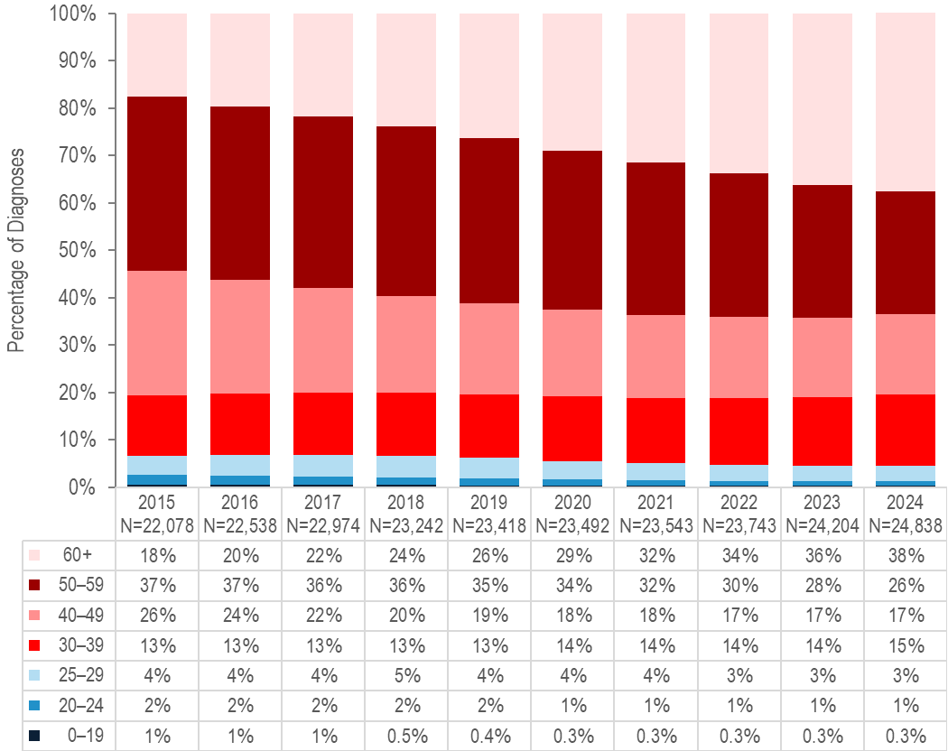
Data Source: Bureau of Infectious Disease and Laboratory Sciences, data are current as of 7/1/2025 and subject to change.

- Because of effective HIV treatment, people diagnosed with HIV infection are living longer, healthier lives. The proportion of people living with HIV infection who were aged 60 years or older increased from 18% on December 31, 2015 to 38% on December 31, 2024.,

SURVIVAL AMONG INDIVIDUALS DIAGNOSED WITH HIV

Figure 18. Ten-year survival among individuals with HIV infection by year of diagnosis, Massachusetts 2000–2024 (Total number of HIV diagnoses from 2000–2024, N=17,912)

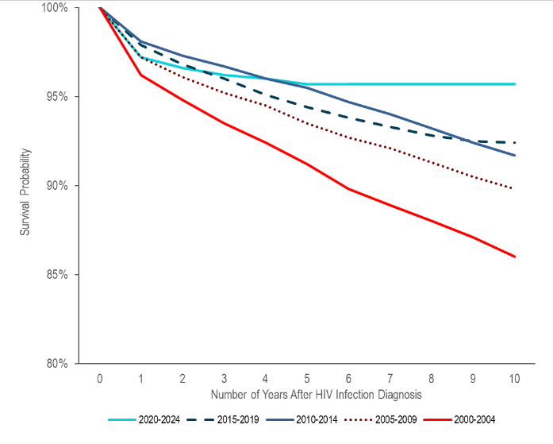
Data Source: Bureau of Infectious Disease and Laboratory Sciences, data are current as of 7/1/2025 and subject to change.

- Survival of individuals diagnosed with HIV infection has increased over time. In the earliest cohort of HIV infection diagnoses (2000–2004), estimated survival at ten years after HIV infection diagnosis was 86%, compared to 90% among individuals diagnosed from 2005–2009, 92% among individuals diagnosed from 2010–2014 and from 2014–2018, and 96% among individuals diagnosed from 2020–2024.,

VIRAL HEPATITIS

HEPATITIS A
Hepatitis A is a vaccine-preventable, viral liver disease that can cause mild to severe illness. It is usually transmitted person-to-person through the fecal-oral route or through consumption of contaminated food or water. Hepatitis A is a self-limited disease that does not result in chronic infection.

Figure 19. Number of hepatitis A cases reported by year, housing status, and presence of substance use disorder, Massachusetts 2015–2024
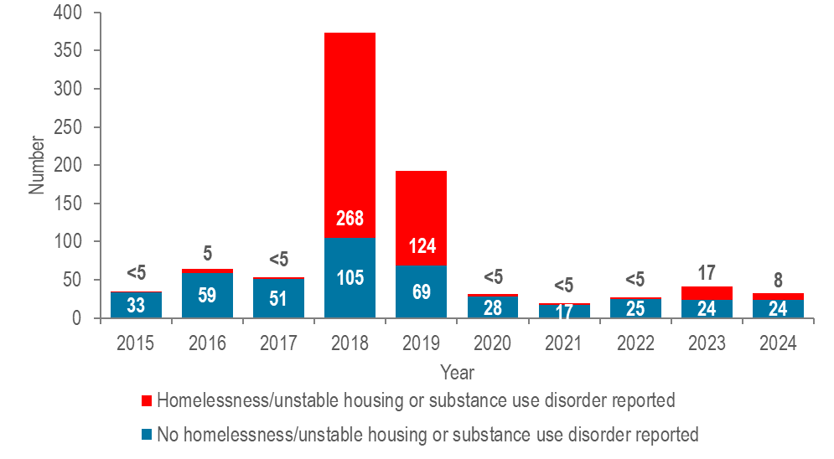
Data Source: Bureau of Infectious Disease and Laboratory Sciences, data are current as of 9/03/2025 and subject to change.

- Between 2018 and 2020, the Massachusetts Department of Public Health (DPH) and local health departments investigated an outbreak of hepatitis A that affected more than 500 residents. The populations most affected by the outbreak were those reported with recent homelessness or unstable housing, and/or substance use disorder, accounting for 72% (N=268/373) and 64% (N=124/193) of cases in 2018 and 2019, respectively. DPH partnered with clinical and community-based providers to implement a hepatitis A (HAV) vaccination response by deploying mobile vaccination providers to shelters, correctional facilities, harm reduction programs, and outreach venues. The outbreak was declared over in spring of 2020, and case counts among individuals with homelessness/unstable housing or substance use disorder remained low through 2022. A second, smaller outbreak affecting the same populations was detected in fall 2023, prompting additional vaccination efforts. This outbreak ended in May of 2024 with a total of 24 cases. DPH encourages continued vaccination of populations at high risk of acquiring hepatitis A in accordance with recommendations from the Advisory Committee on Immunization Practices.

HEPATITIS B

Hepatitis B is a liver infection caused by the hepatitis B virus. Transmission occurs via contact with blood or other body fluids, including from pregnant person to infant at birth, via sexual contact, and through sharing of drug injection equipment. Most people who get the disease recover from it and cannot be re-infected. However, about 10% of adults who get hepatitis B will go on to have chronic (long-term) infection and can pass it on to others. When it is chronic, it can be a serious disease that can lead to cirrhosis (scarring of the liver) and/or liver cancer. The younger a person is when infected, the more likely they are to go on to have chronic infection and to develop serious liver disease. There is a vaccine to prevent hepatitis B infection.
The impact of chronic hepatitis B in the US is greater among people born in regions of the world with high or moderate prevalence of chronic hepatitis B, including much of Asia and the Pacific Islands.

Figure 20. Number of confirmed and probable chronic hepatitis B cases reported by female and male gender, Massachusetts 2015–2024
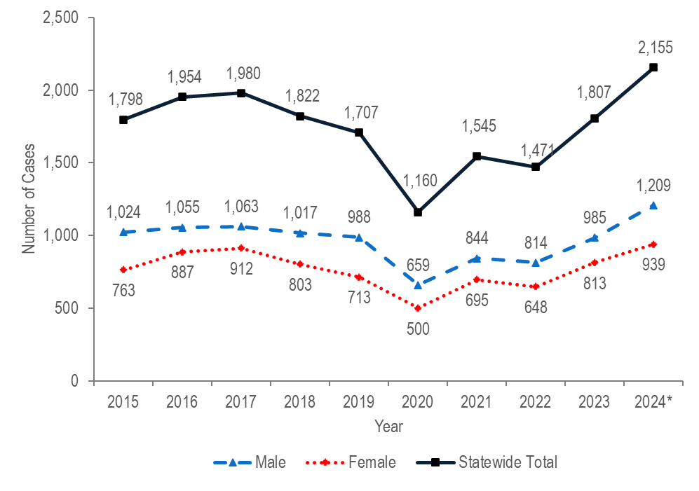

* Note hepatitis B case definitions were revised in 2024. For more information, see HIV, STI, and Viral Hepatitis Case Classifications.
Note: Cases reported as transgender or missing gender (2015–2024: N=68) are included in the statewide total but are not depicted in the figure above separately due to small numbers.
Data Source: Bureau of Infectious Disease and Laboratory Sciences, data are current as of 9/03/2025 and subject to change.

HEPATITIS B BY GENDER

- From 2015 to 2024, an average of 1,740 cases of confirmed and probable chronic hepatitis B virus (HBV) infection were reported each year (with a low of 1,160 in 2020 and a high of 2,155 in 2024). Changes in testing behaviors and travel due to the COVID-19 pandemic likely influenced the number of reported cases and may contribute to the decrease in 2020, followed by the rebound from 2021 to 2024. Please note that HBV case definitions were revised in 2024. The updated definitions added a probable case classification for acute HBV and broadened the criteria for both chronic and acute HBV. The recent increase in reported chronic cases may also be partially due to updated screening recommendations introduced in 2023.
- In 2024, 1,209 (56%) of cases of confirmed and probable chronic HBV infection were newly reported among males and 939 (44%) were reported among females.
- Hepatitis B in people of childbearing age is of particular concern due to the risk of transmission from pregnant person to infant at birth. Perinatal HBV transmission can be prevented by identifying HBV-positive pregnant people and providing post-exposure prophylaxis (PEP) to their infants within 12 hours of birth. The DPH Perinatal Hepatitis B Prevention Program provides case management to pregnant people who are HBV-positive and their infants to ensure appropriate PEP, vaccination, and post-vaccination serologic testing.

HEPATITIS B BY AGE

Figure 21. Number of confirmed and probable chronic hepatitis B cases reported by age group (years), Massachusetts 2015–2024
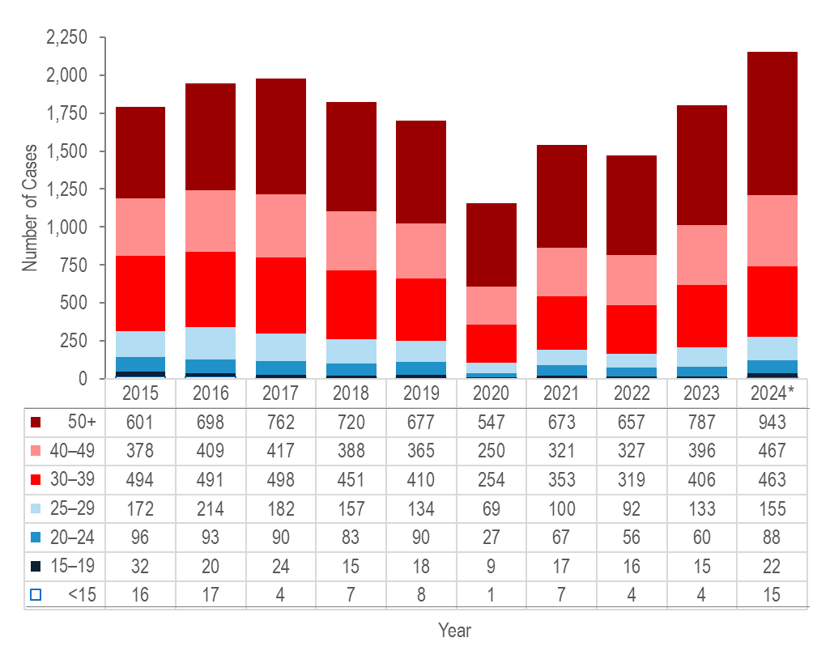
* Note Hepatitis B case definitions were revised in 2024. For more information, see HIV, STI, and Viral Hepatitis Case Classifications.
Note: Cases with no age reported (2015–2024: N=48) are not included in this figure
Data Source: Bureau of Infectious Disease and Laboratory Sciences, data are current as of 9/03/2025 and subject to change

- From 2015 to 2024, the largest increase in the number of reported confirmed and probable hepatitis B cases was among individuals aged 50 years and older (by 57% from 601 to 943), followed by individuals aged 40–49 years (by 24% from 378 to 467).
- During the same time period, the largest decrease in the number of confirmed and probable hepatitis B cases was among individuals aged 15–19 years (by 31% from 32 to 22), followed by individuals aged 25–29 years (by 10% from 172 to 155).

ACUTE HEPATITIS B

Figure 22. Number of confirmed, probable, and suspect acute hepatitis B cases reported by year, Massachusetts 2015–2024
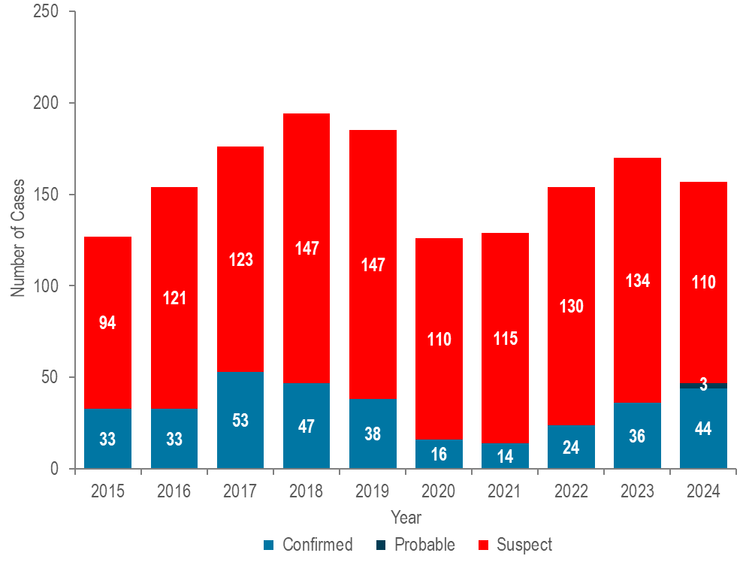
Data Source: Bureau of Infectious Disease and Laboratory Sciences, data are current as of 9/03/2025 and subject to change.
- In 2024, there were 44 confirmed acute, 110 suspect acute, and three probable acute HBV cases for a total of 157 acute cases. Please note that HBV case definitions were revised in 2024. The updated definitions added a probable case classification for acute HBV and broadened the criteria for both chronic and acute HBV. The updated definition for acute HBV, in particular, means that certain cases that would have been classified as suspect acute in 2023 and earlier are now classified as confirmed acute.
- The total number of confirmed acute HBV cases reported decreased from 53 cases in 2017 to 14 cases in 2021 and subsequently increased to 44 cases in 2024. Caution should be used in the interpretation of this decline and subsequent increase due to the impact of COVID-19 on testing behaviors.
- Injection drug use (IDU) is a significant, and increasingly important, risk factor for acquisition of acute HBV infection. As shown in Figure 44, 31% (N=41/134) of people reported with acute HBV from 2020 to 2024 reported injection drug use in their incubation period.

HEPATITIS C (HCV)

Hepatitis C (HCV) is a liver infection caused by the hepatitis C virus. The majority of infected individuals are asymptomatic, but symptoms, when present, can include fatigue, loss of appetite, nausea, vomiting, abdominal pain, and jaundice. Over time, liver damage can result, and complications can include cirrhosis and liver cancer. HCV infection is spread by direct contact with the blood of someone with HCV infection. Transmission mechanisms can include: sharing equipment used to inject drugs, blood transfusions and organ transplants (primarily prior to 1992 when widespread screening of the blood supply began), from pregnant person to infant at birth, sharing personal items such as toothbrushes or razors, tattoos and piercings in non-sterile environments, infection control breaches in healthcare settings, and, rarely, through sexual contact (more likely with HIV co-infection). Most people who get the infection will go on to have chronic infection. With the advent of direct-acting antivirals, HCV infection is curable with an 8-12 week course of treatment.

Figure 23. Number of confirmed and probable HCV cases reported by female and male gender, Massachusetts 2015–2024
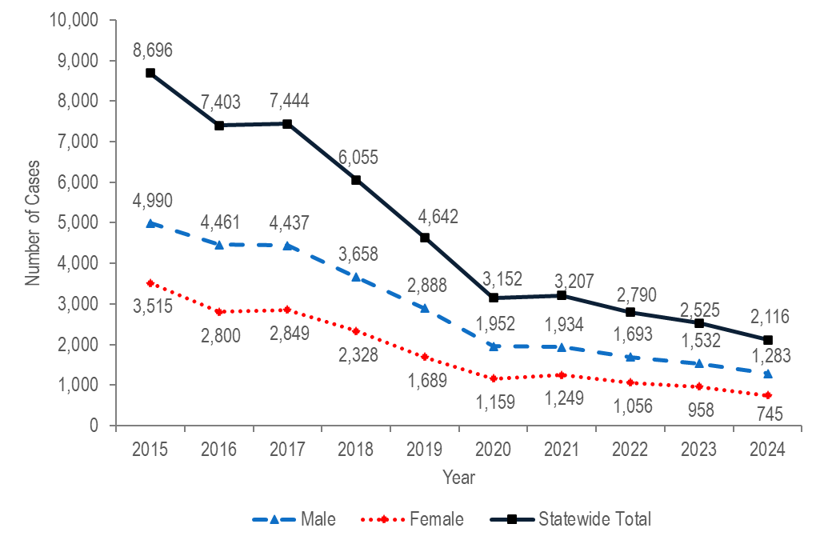

Note: Cases reported as transgender or missing gender (2015–2024: N=854) are included in the statewide total but are not depicted in the figure aboe separately due to small numbers.
Data Source: Bureau of Infectious Disease and Laboratory Sciences, data are current as of 6/18/2025 and subject to change.

HEPATITIS C (HCV) BY GENDER

- The total number of reported confirmed and probable HCV cases decreased by 76% from 8,696 in 2015 to 2,116 in 2024.
- Most reported cases are chronically infected and DPH currently estimates that there are over 250,000 people living with HCV infection in Massachusetts.
- In 2024, 1,283 (61%) cases of confirmed and probable HCV infection were newly reported among males, 745 (35%) were reported among females, and 88 (4%) were reported among individuals with transgender experience or unknown gender.

HEPATITIS C BY AGE

Figure 24. Number of confirmed and probable chronic hepatitis C cases reported by age group (years), Massachusetts 2015–2024

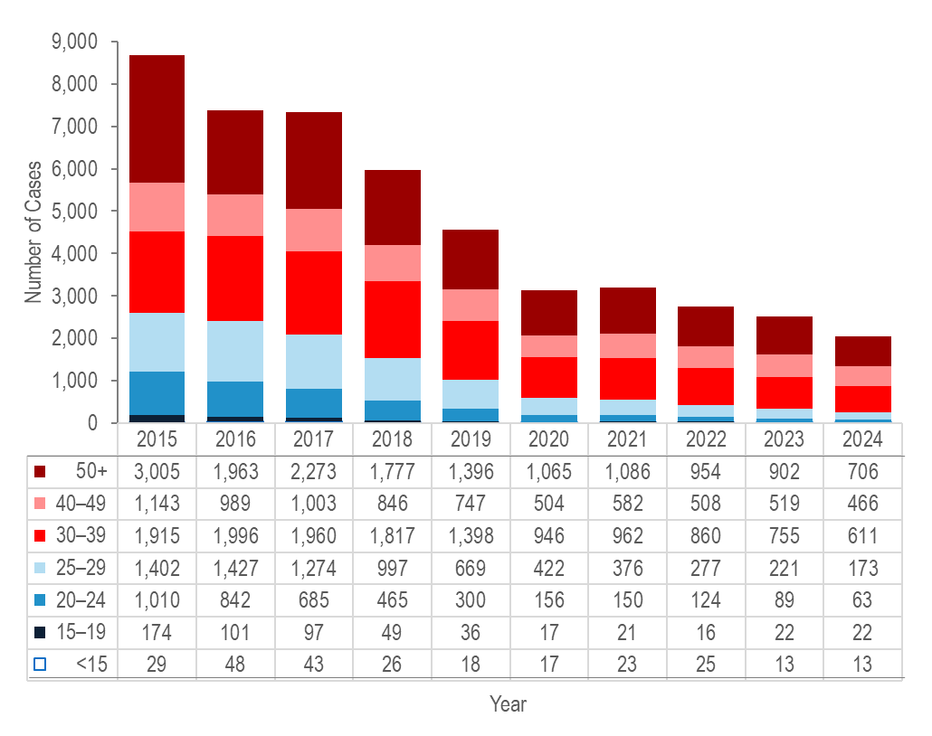
Note: Cases with no age reported (2015–2024: N=444) are not included in this figure
Data Source: Bureau of Infectious Disease and Laboratory Sciences, data are current as of 6/18/2025 and subject to change

- Forty percent (N=847/2,116) of HCV cases reported in 2024 were among young adults (age 20–39 years), reflecting ongoing transmission among young people who inject drugs.
- From 2015 to 2024, the largest percentage decrease in the number of reported confirmed and probable hepatitis C cases was among individuals aged 20–24 years (by 94% from 1,010 to 63), followed by individuals aged 25–29 years (by 88% from 1,402 to 173), and individuals aged 15–19 years (by 87% from 174 to 22).

SOCIAL VULNERABILITY INDEX

The social vulnerability index (SVI) is a tool to identify socially vulnerable communities that was created by CDC and the Agency for Toxic Substances and Disease Registry (ATSDR). The CDC/ATSDR SVI uses U.S. Census data to determine the social vulnerability of every census tract. The SVI ranks each tract on 16 social factors, including poverty, lack of vehicle access, and crowded housing, and groups them into four related themes: socioeconomic status, household characteristics, racial and ethnic minority status, and housing type/transportation. Each census tract receives a separate ranking for each of the four themes, as well as an overall ranking. Originally developed to incorporate social determinants of health into emergency response and recovery efforts for environmental and natural disasters, more recently, higher SVI has been linked to higher HIV and STI diagnosis rates, COVID-19 mortality, and lower COVID-19 vaccination coverage. As such, the following maps of SVI by city/town in Massachusetts are provided as a comparison to the maps of HIV and STI diagnosis rates by city/town.
Figure 25. Social Vulnerability Index (SVI) by census tract, Massachusetts
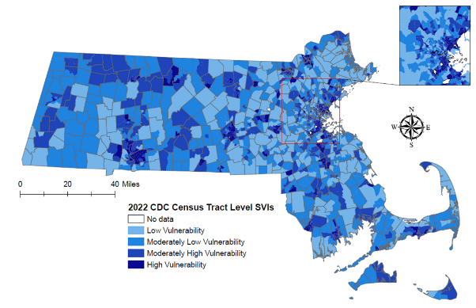
SVI quartiles: (low: <0.25, moderately low: 0.25 – 0.49, moderately high: 0.50 – 0.74, high: ≥0.75)
Note: Census tract level overall SVI values for 2022 were obtained from the CDC/Agency for Toxic Substance and Disease Registry. Values range from 0 to 1, with higher values implying greater social vulnerability. Data Sources: CDC/Agency for Toxic Substance and Disease, Bureau of Infectious Disease and Laboratory Sciences, data are current as of 6/02/2025 and subject to change.
- Large cities such as Boston, Springfield, Worcester, Lawrence, Brockton, and Lowell contain the greatest number of census tracts with high social vulnerability (≥ 0.75).
- Census tracts with high social vulnerability also appear in many smaller cities and suburbs across the state but are limited to one or a few tracts.
- Overall, there are dense urban clusters with widespread high vulnerability and scattered pockets of extreme vulnerability in smaller municipalities.

Table 1. Incidence rate of confirmed chlamydia cases, confirmed gonorrhea cases, confirmed and probable infectious syphilis cases, and HIV diagnosis per 100,000 population by Social Vulnerability Index, Massachusetts 2024
 | Chlamydia Rate  2024 | Gonorrhea Rate  2024 | Infectious Syphilis Rate  2024 | HIV Diagnosis Rate  2024
High (≥0.75) | 773.04 | 239.63 | 35.79 | 15.56
Moderately High (0.5 – 0.74) | 335.38 | 117.08 | 20.92 | 9.92
Moderately Low (0.25 – 0.49) | 196.87 | 64.93 | 9.63 | 6.12
Low (<0.25) | 157.82 | 51.85 | 6.91 | 6.78
Overall State Total | 378.20 | 123.28 | 18.80 | 8.56
Confirmed Chlamydia 2024, N=26,623; Confirmed Gonorrhea 2024, N=8,678; Confirmed and Probable Infectious Syphilis 2024, N=1,329; HIV Diagnoses 2024, N=602; Data Source: Bureau of Infectious Disease and Laboratory Sciences, HIV data are current as of 7/1/2025, STI data are current as of 6/02/2025
Data Source: Bureau of Infectious Disease and Laboratory Sciences, data are current as of 6/02/2025 and subject to change.
- As observed nationally, higher SVI in Massachusetts census tracts is linked to higher rates of STIs and HIV:
  - In 2024, the average rate of confirmed chlamydia was 773.04 per 100,000 in census tracts with high SVI scores, compared to 335.38 in census tracts with moderately high scores, 196.87 in census tracts with moderately low scores, and 157.82 in census tracts with low scores.
  - In 2024, the average rate of confirmed gonorrhea was 239.63 per 100,000 in census tracts with high SVI scores, compared to 117.08 in census tracts with moderately high scores, 64.93 in census tracts with moderately low scores, and 51.85 in census tracts with low scores.
  - In 2024, the average rate of infectious syphilis was 35.79 per 100,000 in census tracts with high SVI scores, compared to 20.92 in census tracts with moderately high scores, 9.63 in census tracts with moderately low scores, and 6.91 in census tracts with low scores.
  - In 2024, the HIV diagnosis rate was 15.56 per 100,000 in census tracts with high SVI scores, compared to 9.92 in census tracts with moderately high scores, 6.12 in census tracts with moderately low scores, and 6.78 in census tracts with low scores.

CO-INFECTIONS

HIV/SYPHILIS
Table 2. Percentage of 2024 confirmed and probable infectious syphilis cases ever co-infected with HIV by gender, race/ethnicity, and age
 | HIV/Syphilis Co-infections | Syphilis  Cases | % of Syphilis Cases Co-infected with HIV
Total: | 339 | 1,329 | 26%
Gender:
Male | 309 | 1,069 | 29%
Female | 10 | 210 | 5%
Transgender/Nonbinary | 20 | 50 | 40%
Race/Ethnicity:
White NH | 129 | 440 | 29%
Black NH | 73 | 245 | 30%
Hispanic/Latino | 110 | 510 | 22%
Other NH | 16 | 118 | 14%
Unreported | 0 | 16 | 0%
Age:
<15 years | 0 | 0 | 0%
15–19 years | 2 | 35 | 6%
20–24 years | 22 | 177 | 12%
25–29 years | 42 | 228 | 18%
30–39 years | 132 | 472 | 28%
40–49 years | 59 | 210 | 28%
50+ years | 82 | 207 | 40%
Data Source: Bureau of Infectious Disease and Laboratory Sciences, data are current as of 6/02/2025 and subject to change.

- In 2024, among 1,329 reported cases of confirmed and probable infectious syphilis, 26% (N=339/1,329) were co-infected with HIV.
- Among confirmed and probable infectious syphilis cases reported in 2024, proportions of HIV co-infection higher than the total proportion (26%) were observed in transgender individuals, Black (non-Hispanic) and White (non-Hispanic) individuals, and individuals aged 50 years and above.
- Seventy percent (N=743/1,069) of confirmed and probable infectious syphilis cases among males reported same sex contact. Of those who reported male-to-male sex, 36% (N=271/743) were co-infected with HIV, compared to 12% (N=38/328) of males with unknown risk.

HIV/GONORRHEA

Table 3. Percentage of 2024 confirmed gonorrhea cases ever co-infected with HIV by gender, race/ethnicity, and age
 | HIV/Gonorrhea  Co-infections | Gonorrhea Cases | % of Gonorrhea Cases Co-infected with HIV
Total: | 691 | 8,678 | 8%
Gender:
Male | 635 | 5,856 | 11%
Female | 27 | 2,722 | 1%
Transgender/Nonbinary | 29 | 91 | 32%
Unreported | 0 | 9 | 0%
Race/Ethnicity:
White NH | 183 | 2,220 | 8%
Black NH | 89 | 1,569 | 6%
Hispanic/Latino | 168 | 1,612 | 10%
Other NH | 85 | 879 | 10%
Unreported | 166 | 2,398 | 7%
Age:
<15 years | 0 | 31 | 0%
15–19 years | 5 | 976 | 1%
20–24 years | 62 | 1,882 | 3%
25–29 years | 105 | 1,754 | 6%
30–39 years | 269 | 2,531 | 11%
40–49 years | 126 | 873 | 14%
50+ years | 124 | 631 | 20%
Data Source: Bureau of Infectious Disease and Laboratory Sciences, data are current as of 6/02/2025 and subject to change.

- In 2024, among 8,678 confirmed cases of gonorrhea, 8% (N=691/8,678) were ever co-infected with HIV.
- Among confirmed gonorrhea cases reported in 2024, proportions of HIV co-infection higher than the total proportion (8%) were observed in transgender individuals, and individuals aged 40 years and above.

HIV/HEPATITIS C (HCV)

Figure 26. Number of individuals diagnosed with HIV infection only, and ever co-infected with hepatitis C (HCV) by year of HIV infection diagnosis, Massachusetts 2008–2024
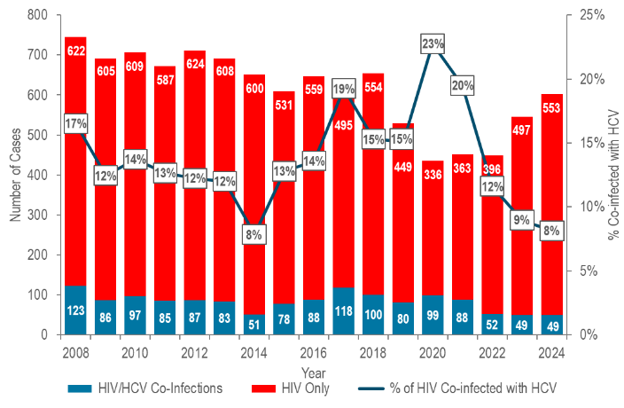
Data Source: Bureau of Infectious Disease and Laboratory Sciences, data are current as of 7/1/2025 and subject to change.
- The percentage of individuals diagnosed with HIV infection who were co-infected with HCV decreased from 17% (N=123/745) in 2008 to 8% (N=51/651) in 2014, increased to 19% (N=118/613) in 2017, decreased to 15% in 2018 (N=100/654), increased again to a 25-year high of 23% (N=99/435) in 2020, and then decreased to 8% (N=49/602) in 2024. , This trend mirrors that among HIV infection diagnoses with a primary exposure mode of injection drug use and is likely related to two outbreaks of HIV infection among persons who inject drugs. The first outbreak occurred from 2016 to 2018 in the northeastern part of the state and the second was identified in 2019 in the Boston area and is still ongoing (see Specific Populations – Persons Who Inject Drugs for more information).

HIV/HCV – PERCENTAGE CO-INFECTED

Table 4. Percentage of 2024 HIV infection diagnoses ever co-infected with HCV by gender, race/ethnicity, age, and HIV exposure mode
 | HIV/HCV Co-infections | HIV Diagnoses | % of HIV Diagnoses  Co-infected with HCV
Total | 49 | 100% | 602
Assigned Sex at Birth:
Male | 31 | 63% | 432
Female | 18 | 37% | 170
Race/Ethnicity:
White NH | 33 | 67% | 154
Black NH | 9 | 18% | 246
Hispanic/Latino | 7 | 14% | 183
Asian/Pacific Islander NH | 0 | 0% | 14
Other NH/Unknown | 0 | 0% | 5
Age:
0–19 years | 0 | 0% | 13
20–29 years | 5 | 10% | 171
30–39 years | 22 | 45% | 206
40–49 years | 15 | 31% | 103
50+ years | 7 | 14% | 109
HIV Exposure Mode:
MSM | 7 | 14% | 251
IDU | 33 | 67% | 43
MSM/IDU | 5 | 10% | 11
HTSX | 0 | 0% | 26
Other | 0 | 0% | 1
Pres. HTSX | <5 | N/A* | 91
NIR | <5 | N/A | 179
MSM=Male-to-Male Sex and Men Who Have Sex with Men, IDU=Injection Drug Use, HTSX=Heterosexual Sex, Pres.=Presumed, NIR=No Identified Risk. *Values one through four are suppressed for denominator populations less than 50,000 or for unknown population sizes. Additional values of zero and greater than or equal to five may be suppressed to prevent back calculation.
Data Source: Bureau of Infectious Disease and Laboratory Sciences, data are current as of 7/1/2025 and subject to change.
- In 2024, among 602 individuals diagnosed with HIV infection, 8% (N=49/602) were ever co-infected with HCV.
- Among individuals diagnosed with HIV infection in 2024, higher rates of HCV co-infection than the total proportion (8%) were observed in White (non-Hispanic) individuals (21%), individuals aged 40–49 years old (15%), and individuals with IDU (77%) and MSM/IDU (45%) exposure modes. Co-infection rates were slightly higher for individuals assigned female at birth (11%) than individuals assigned male at birth (7%).
- In 2024, individuals co-infected with HIV/HCV were predominantly assigned male at birth (63%), White (non-Hispanic) (67%), aged 30–39 years old (45%), and had injection drug use exposure mode (67%).

HIV/HEPATITIS B (HBV)

Figure 27. Number of individuals diagnosed with HIV infection only, and ever co-infected with HBV by year of HIV infection diagnosis, Massachusetts 2008–2024
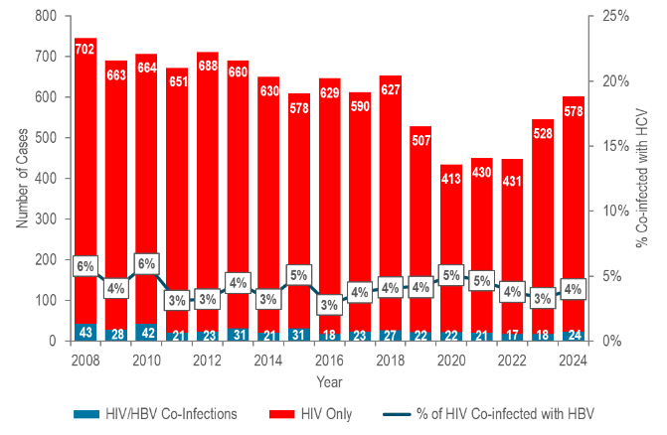

- The percentage of individuals diagnosed with HIV infection who were co-infected with HBV ranged from 3% to 6% from 2008 to 2024. ,

HIV/HBV – PERCENTAGE CO-INFECTED

Table 5. Percentage of 2024 HIV infection diagnoses ever co-infected with HBV by gender, race/ethnicity, age, and HIV exposure mode
 | HIV/HBV Co-infections | HIV Diagnoses | % of HIV Diagnoses  Co-infected with HBV
Total | 24 | 100% | 602
Assigned Sex at Birth:
Male | 14 | 58% | 432
Female | 10 | 42% | 170
Race/Ethnicity:
White NH | 4 | 17% | 154
Black NH | 16 | 67% | 246
Hispanic/Latino | 4 | 17% | 183
Asian/Pacific Islander NH | 0 | 0% | 14
Other NH/Unknown | 0 | 0% | 5
Age:
0–19 years | 0 | 0% | 13
20–29 years | 5 | 21% | 171
30–39 years | 7 | 29% | 206
40–49 years | 4 | 17% | 103
50+ years | 8 | 33% | 109
HIV Exposure Mode:
MSM | <5 | N/A* | 251
IDU | <5 | N/A | 43
MSM/IDU | 0 | 0% | 11
HTSX | 0 | 0% | 26
Other | 0 | 0% | 1
Pres. HTSX | <5 | N/A | 91
NIR | 15 | N/A | 179
NH=Non-Hispanic, API=Asian/Pacific Islander, MSM=Male-to-Male Sex and Men Who Have Sex with Men, IDU=Injection Drug Use, HTSX=Heterosexual Sex, Pres.=Presumed, NIR=No Identified Risk
* Values one through four are suppressed for denominator populations less than 50,000 or for unknown population sizes. Additional values of zero and greater than or equal to five may be suppressed to prevent back calculation.
Data Source: Bureau of Infectious Disease and Laboratory Sciences, data are current as of 7/1/2025 and subject to change

- In 2024, among 602 individuals diagnosed with HIV infection, 4% (N=24/602) were ever co-infected with HBV.
- Among individuals diagnosed with HIV infection in 2024, slightly higher rates of HBV co-infection were observed in Black (non-Hispanic) individuals (7%), individuals aged 50 years and older (7%), and individuals with no identified risk for HIV exposure mode (8%).
- In 2024, individuals co-infected with HIV/HBV were predominantly assigned male at birth (58%), Black (non-Hispanic) (67%), and had no identified risk for HIV exposure mode (63%).

SPECIFIC POPULATIONS- ADOLESCENTS AND YOUNG ADULTS

STI DIAGNOSES BY AGE
Figure 28. Distribution of confirmed chlamydia and gonorrhea cases reported by age group (years), Massachusetts 2024
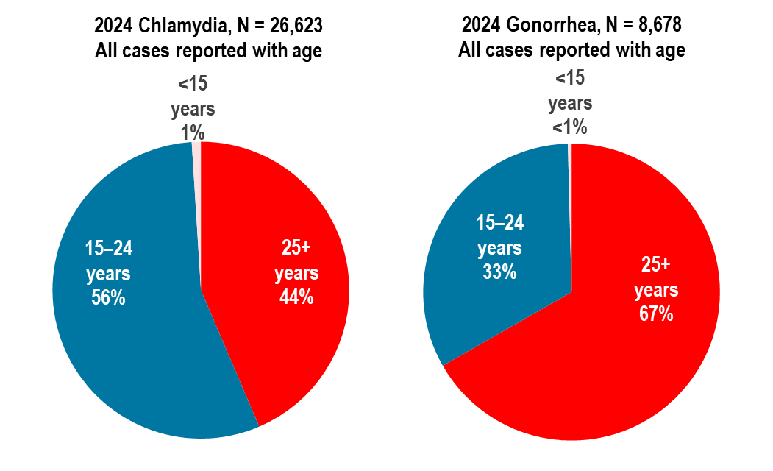
Data Source: Bureau of Infectious Disease and Laboratory Sciences, data are current as of 6/02/2025 and subject to change.

- In 2024, in Massachusetts, 56% of confirmed chlamydia cases and 33% of confirmed gonorrhea cases were reported among adolescents and young adults aged 15–24 years.
  - Nationally, 57% of chlamydia cases and 39% of gonorrhea cases were reported among adolescents and young adults aged 15–24 years in 2023.

STI DIAGNOSES BY AGE AND GENDER

Figure 29. Distribution of confirmed chlamydia and gonorrhea cases reported by age group (years) and gender, Massachusetts 2024
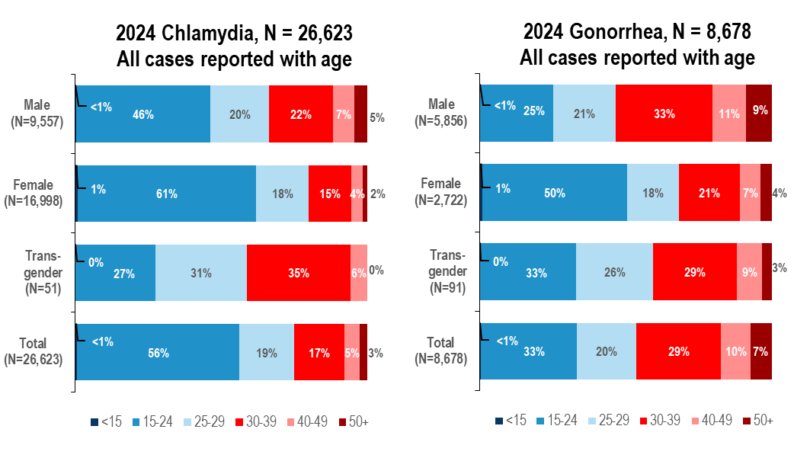
Data Source: Bureau of Infectious Disease and Laboratory Sciences, data are current as of 6/02/2025 and subject to change.
- In 2024, in Massachusetts, 46% of confirmed chlamydia cases reported among males, 61% among females, 27% among individuals of transgender experience, and 56% of total cases were reported among adolescents and young adults aged 15–24 years.
  - Nationally in 2023, 46% of chlamydia cases reported among males, 64% among females, and 57% of total cases were reported among adolescents and young adults aged 15–24 years.
- In 2024, in Massachusetts, 25% of confirmed gonorrhea cases reported among males, 50% among females, 33% among individuals of transgender experience, and 33% of total cases were reported among adolescents and young adults aged 15–24 years.
- Nationally in 2023, 31% of gonorrhea cases reported among males, 53% among females, and 39% of total cases were reported among adolescents and young adults aged 15–24 years.

HIV DIAGNOSES BY RACE/ETHNICITY AMONG ADOLESCENTS AND YOUNG ADULTS

Figure 30. Distribution of HIV infection diagnoses in adolescents and young adults (aged 15–24 years) by race/ethnicity, exposure mode, place of birth, and sex assigned at birth, Massachusetts 2022–2024, N=194
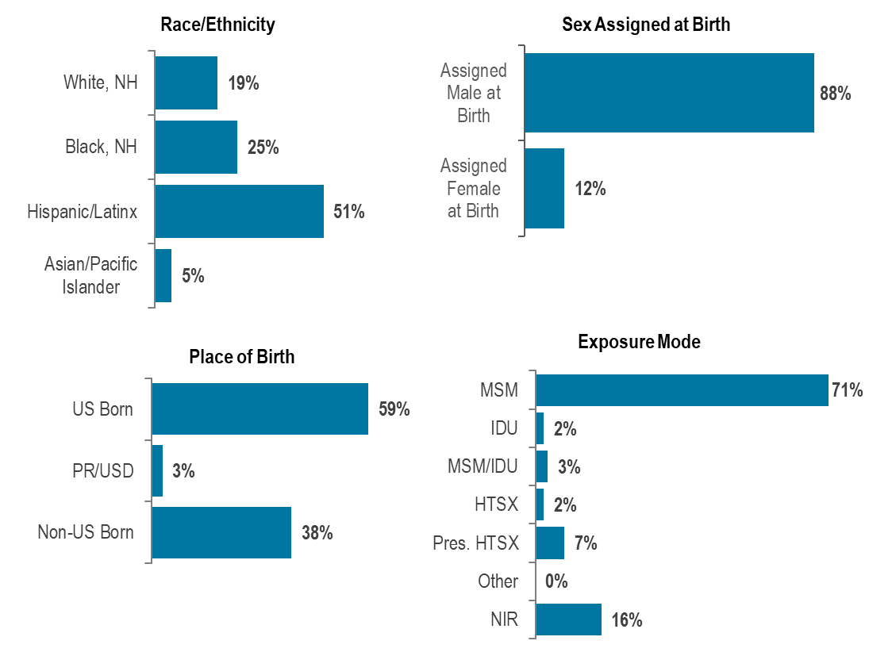
Data Source: Bureau of Infectious Disease and Laboratory Sciences, data are current as of 7/1/2025 and subject to change.
- During 2022 to 2024, 12% (N=194/1,596) of HIV infection diagnoses were reported among adolescents and young adults aged 15–24 years.
- Adolescent and young adults aged 15–24 years newly diagnosed with HIV infection in Massachusetts during 2022 to 2024 were predominantly Hispanic/Latinx (51%), assigned male at birth (88%), and US born (59%), with an exposure mode of male-to-male sex (71%).

HEPATITIS C BY AGE AND GENDER

Figure 31. Number of confirmed and probable HCV cases reported by age and female and male gender, Massachusetts 2002, 2008, 2024
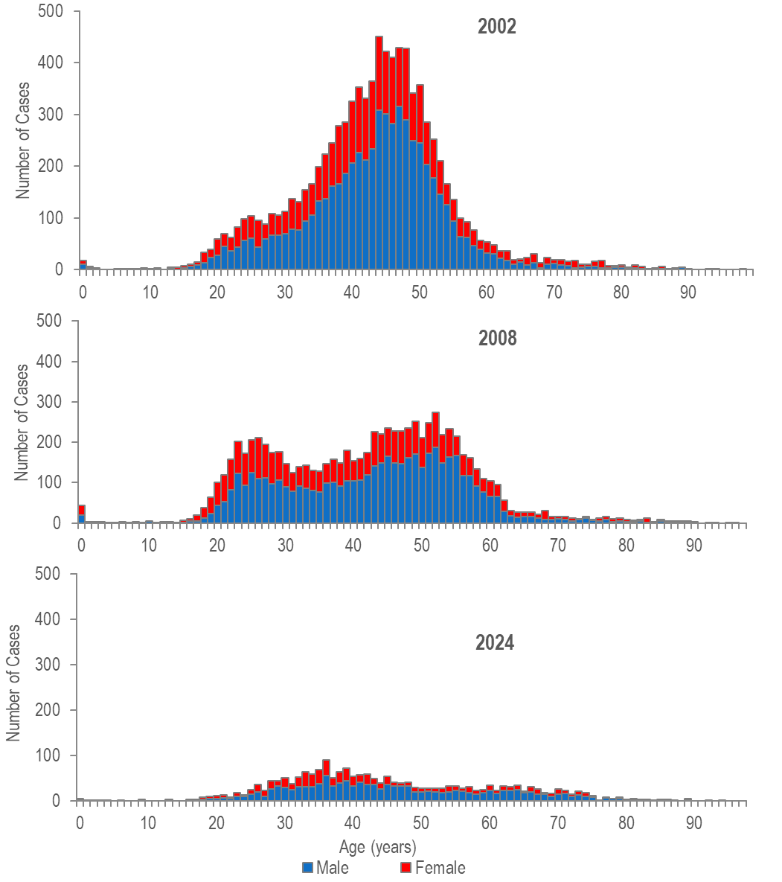

HEPATITIS C BY AGE AND GENDER

- The age distribution of hepatitis C virus (HCV) cases reported in Massachusetts changed between 2002 and 2024 with a significant increase in the proportion of cases represented by young persons who inject drugs.
- In 2002, reported HCV cases were distributed in a curve with one age peak at 44 years.
- In 2008, reported cases of HCV were distributed in a curve with two age peaks, with the lower peak at age 26 years and the higher peak at age 52 years.
- In 2024, HCV cases among young adults who inject drugs outnumbered newly reported cases among the older (“baby boomer”) age cohort.
- The proportion of cases among young adults (aged 20-39 years) was higher in 2008 (39%, N=3,158/8,091) and 2024 (41%, N=837/2,028) compared to 2002 (31%, N=2,803/9,053).
- The primary risk for HCV infection in younger adults is injection drug use. While the primary exposure mode for HIV infection in younger adults is male-to-male sex, recent increases in the number of HIV infections attributed to injection drug use have been observed, particularly among young adults (aged 13-39 years).

MASSACHUSETTS YOUTH RISK BEHAVIOR SURVEY

Table 6. Reported sexual behaviors among Massachusetts high school students, 2015–2023
 | 2015 | 2017 | 2019 | 2021 | 2023
Percentage who reported: | %  (95% CI)  n | %  (95% CI)  n | %  (95% CI)  n | %  (95% CI)  n | %  (95% CI)  n
Ever having sexual intercourse | 36.4%  (32.4–40.6)  2,779 | 35.3%  (31.8–39.1)  2,889 | 36.9%  (32.8–41.3)  1,946 | NA | NA
Having sexual intercourse before age 13 | 2.9%  (2.2–3.8)  2,793 | 2.4%  (1.6–3.4)  2,886 | 2.5%  (1.7–3.4)  1,951 | 2.7%  (2.1–3.3)  2,897 | 3.0%  (2.2–3.8)  2,740
Having had sexual intercourse with 4+ partners during their life | 7.9%  (6.2–10.0)  2,781 | 6.7%  (5.4–8.2)  2,886 | 7.8%  (6.3–9.5)  1,938 | 4.3%  (3.4–5.3)  2,883 | 5.3%  (3.9–6.7)  2,732
Using a condom at last sexual intercourse | 62.5%  (58.9–65.9)  766 | 57.8%  (53.1–62.3)  719 | 51.4%  (45.3–57.4)  427 | 58.0%  (52.8–63.3)  468 | 51.6%  (45.7–57.5)  568
Drinking alcohol or using drugs before last sexual intercourse | 21.8%  (18.1–26.0)  782 | 18.2%  (15.8–21.0)  631 | 23.4%  (19.5–27.9)  434 | 20.7%  (17.6–23.7)  432 | 19.1%  (14.2–23.9)  572
Ever tested for HIV | 9.9%  (8.0–12.2)  3,010 | 10.5%  (9.0–12.1)  3,125 | 12.6%  (10.4–15.3)  2,085 | NA | NA
Data Source: Massachusetts Department of Elementary and Secondary Education and Massachusetts Department of Public Health, Office of Data Management and Outcomes Assessment

- The Massachusetts Youth Risk Behavior Survey (MYRBS) is performed biennially among a sample of ninth to twelfth grade students.
- The proportion of students reporting condom use at last sexual intercourse was lower in 2023 (51.6%, 95% CI: 45.7%–57.5%, n=568) compared to 2015 (62.5%, 95% CI: 58.9%–65.9%, n=766).

SPECIFIC POPULATIONS - MEN WHO HAVE SEX WITH MEN

HIV DIAGNOSIS RATE PER 100,000
Figure 32. Estimated average annual HIV diagnosis rate per 100,000 population: MSM (men who have sex with men) compared to non-MSM (males) ages 18–64 years: Massachusetts 2022–2024
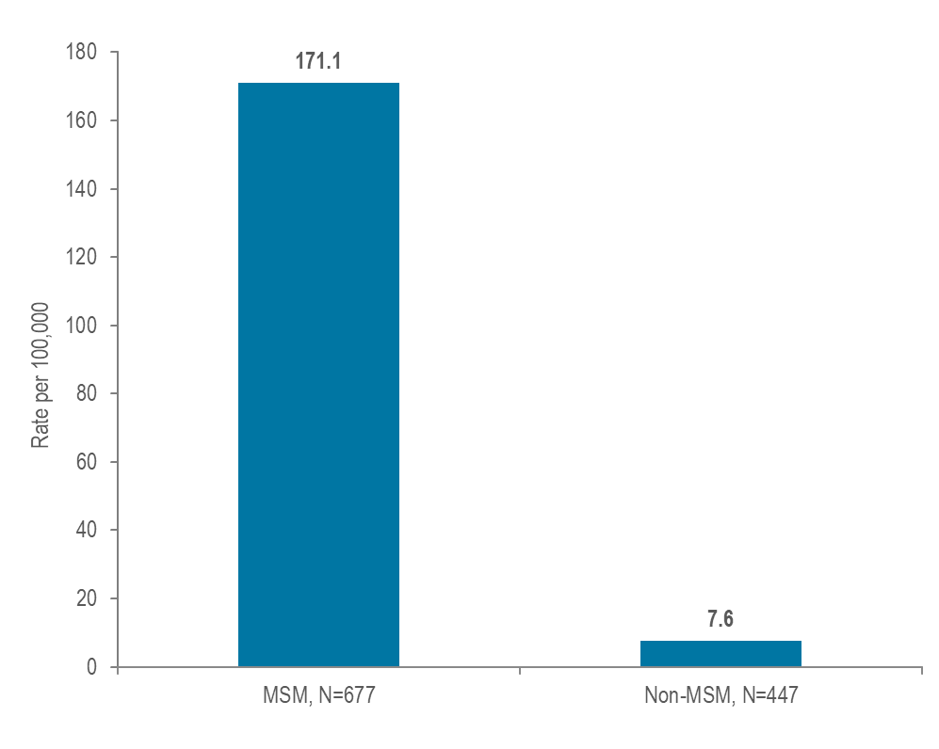

- At 171.1 per 100,000 population (95% confidence interval [CI]: 141.8–220.0 per 100,000), the estimated average rate of HIV diagnosis from 2022 to 2024 among MSM (ages 18–64 years) was 23 times the rate of infection in men who did not report sex with men (7.6 per 100,000 [95% CI: 7.5–7.7 per 100,000]).

MSM – SYPHILIS RATE PER 100,000

Figure 33. Estimated confirmed and probable infectious syphilis rate per 100,000 population: MSM compared to non-MSM (males) ages 18–64 years: Massachusetts 2024

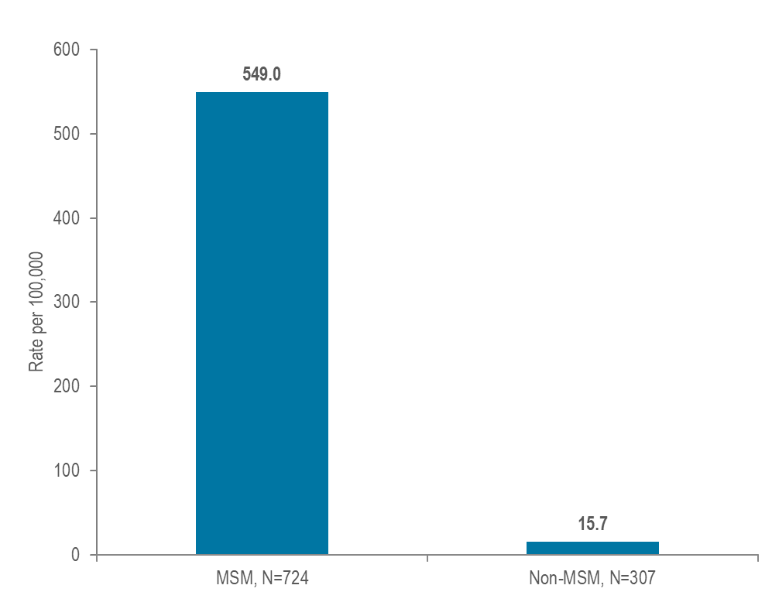

- At 549.0 per 100,000 population (95% confidence interval [CI]: 455.1–705.8 per 100,000), the estimated confirmed and probable infectious syphilis rate in 2024 among MSM (ages 18–64) was 35 times the rate of infection in men who did not report sex with men (15.7 per 100,000 [95% CI: 15.4–15.9 per 100,000]).

MSM – SYPHILIS/HIV CO-INFECTION

Figure 34. Number of confirmed and probable infectious syphilis cases among MSM and the percent of cases among MSM known to ever be co-infected with HIV, Massachusetts 2020–2024
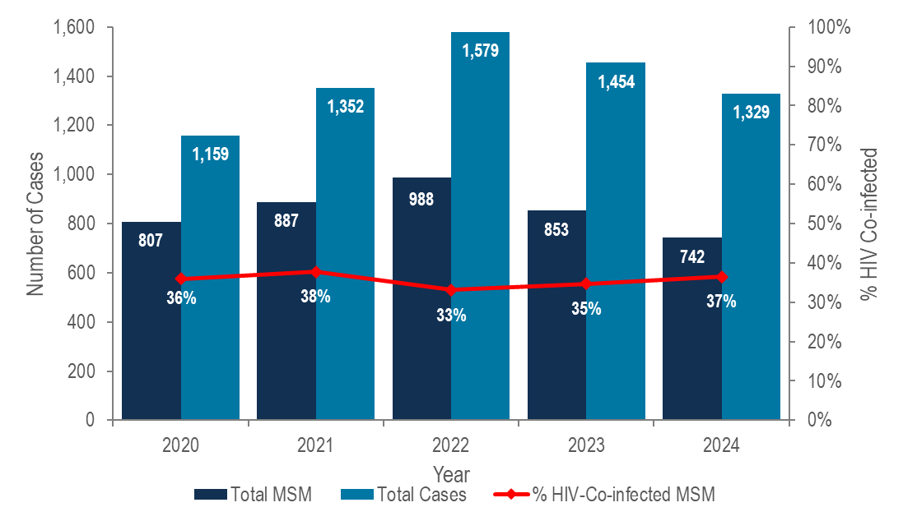

Data Source: Bureau of Infectious Disease and Laboratory Sciences, data are current as of 6/02/2025 and subject to change.

- The incidence of confirmed and probable infectious syphilis in Massachusetts increased by 36% from 2020 to 2022 and subsequently decreased by 16% in 2024; MSM represented the majority of cases (56% in 2024).
- In 2024, 37% (N=271/742) of confirmed and probable infectious syphilis cases among men reporting sex with men also self-reported co-infection with HIV.

MSM - SYPHILIS BY COUNTY

Figure 35. Total number of confirmed and probable infectious syphilis cases and number among MSM by county, Massachusetts 2024
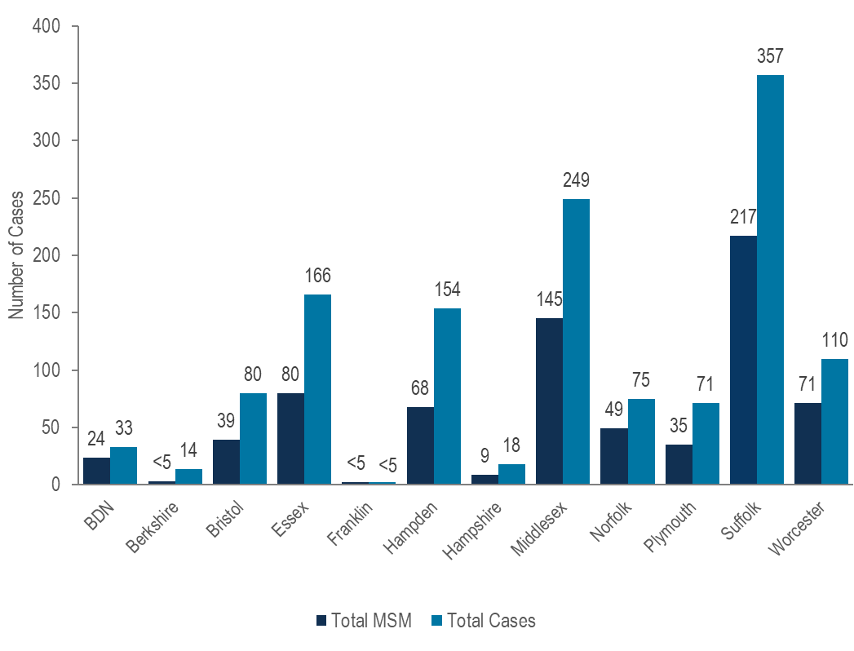

Note: MSM N=742, missing risk information N=93, other risk N =13, total cases N=1,329
Data Source: Bureau of Infectious Disease and Laboratory Sciences, data are current as of 6/02/2025 and subject to change.
BDN=Barnstable, Dukes and Nantucket; Counties are combined because of small numbers.

- In 2024, the largest proportions of MSM among confirmed and probable infectious syphilis cases were reported in Barnstable, Dukes, and Nantucket (73%, N=24/33), Norfolk (65%, N=49/75), and Worcester (65%, N=71/110) counties.

MSM – RECENT HIV DIAGNOSES

Figure 36. HIV infection diagnoses among men reporting sex with men by race/ethnicity, age at diagnosis, and place of birth, Massachusetts 2022–2024 (N=652)
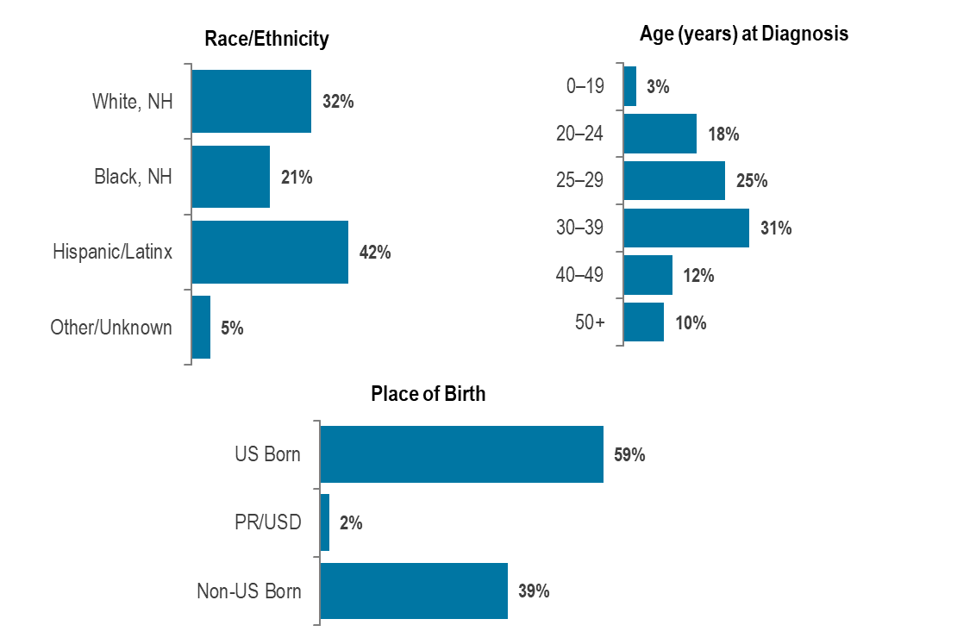
Data Source: Bureau of Infectious Disease and Laboratory Sciences, data are current as of 7/1/2025 and subject to change.
- Black (non-Hispanic) and Hispanic/Latinx individuals represented 7% and 13% of men in Massachusetts, compared to 21% and 42%, respectively, of men recently diagnosed with HIV infection with MSM exposure mode.
- Individuals with MSM exposure mode newly diagnosed with HIV infection in Massachusetts during 2022 to 2024 were predominantly in their twenties or thirties (42% 20–29 year-olds, 31% 30–39 year-olds), Hispanic/Latinx (42%) or White (non-Hispanic) (32%), and US born (59%).

MSM – SYPHILIS CASES

Figure 37. Confirmed and probable infectious syphilis cases among men reporting sex with men, by race/ethnicity and age, Massachusetts 2024 (N=742)
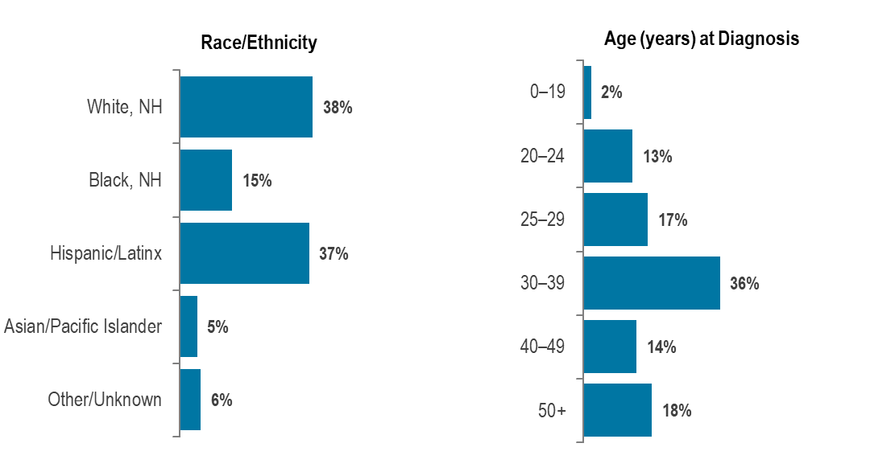

Data Source: Bureau of Infectious Disease and Laboratory Sciences, data are current as of 6/02/2025 and subject to change.
- Black (non-Hispanic) and Hispanic/Latinx individuals represented 7% and 13% of men in Massachusetts, compared to 15% and 38%, respectively, of confirmed and probable infectious syphilis cases among men reporting sex with men in 2024.
- In 2024, confirmed and probable infectious syphilis cases among men reporting sex with men were predominantly White (non-Hispanic) (38%) or Hispanic/Latinx (37%), and age 30 years and above (69% 30+ year-olds).

TRENDS IN HIV EXPOSURE MODE AMONG MALES

Figure 38. Percentage distribution of individuals assigned male at birth (AMAB) diagnosed with HIV infection by exposure mode, Massachusetts 2015–2024
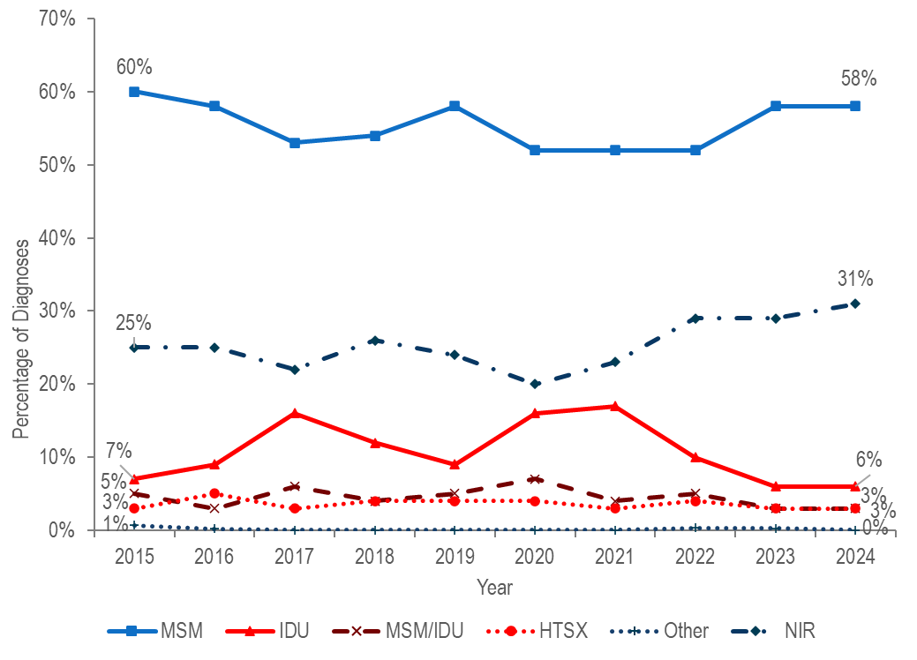
Data Source: Bureau of Infectious Disease and Laboratory Sciences, data are current as of 7/1/2025 and subject to change.
- Among individuals AMAB, the proportion of HIV infection diagnoses with male-to-male sex as the reported mode of exposure decreased from 60% in 2015 to 52% in 2020 and subsequently increased to 58% in 2023 and 2024. During the same time period, the proportion reported with no identified risk remained between 20% and 31%.
- The proportion of cases among individuals AMAB attributed to injection drug use increased from 7% in 2014 to 16% in 2017 and then decreased to 9% in 2019. The increase in 2017 was primarily due to an outbreak among persons who inject drugs in the northeast part of the state between 2016 and 2018.² Following a focused public health response, the number of HIV infection diagnoses attributed to IDU in the northeast decreased. However, in early 2019, a new cluster of HIV infection was identified in Boston among PWID who were experiencing or had experienced recent homelessness, and the proportion of HIV infection diagnoses among individuals AMAB with IDU as the primary exposure increased to 17% in 2021. Following another focused public health response, the proportion decreased to 6% in 2024.

SPECIFIC POPULATIONS – PERSONS WHO INJECT DRUGS

Figure 39. Individuals diagnosed with HIV infection by exposure mode, Massachusetts 2015–2024
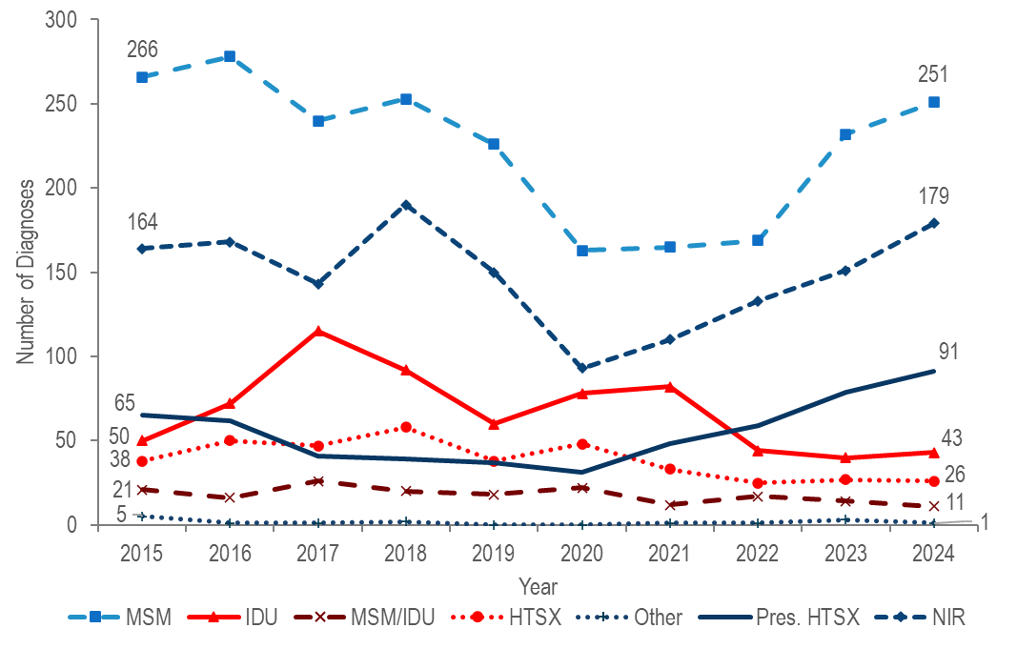
Data Source: Bureau of Infectious Disease and Laboratory Sciences, data are current as of 7/1/2025 and subject to change.
- The number of reported cases with injection drug use (IDU) as the primary exposure mode increased from 50 in 2015 to a peak of 115 in 2017 and then decreased to 60 in 2019. The increase in 2017 was primarily due to an outbreak among persons who inject drugs (PWID) in the northeast part of the state between 2016 and 2018. Following a focused public health response, the number of HIV infection diagnoses attributed to IDU in the northeast decreased.
- However, in early 2019, a new cluster of HIV infection was identified in Boston among PWID who were experiencing or had experienced recent homelessness, and the total statewide number of reported cases with IDU as the primary exposure increased to 82 in 2021. Following another focused public health response, the number of HIV infection diagnoses attributed to IDU decreased by 48% to 43 cases in 2024. As of July 1, 2025, a total of 239 cases diagnosed since November 2018 have been investigated and identified as part of the Boston cluster. As it is an active cluster of concern, additional cases will continue to be investigated and added. Continuing trends among those newly diagnosed in the Boston cluster (N=16 cases diagnosed in 2024) include an increase in polysubstance and methamphetamine use.

PERSONS WHO INJECT DRUGS – RECENT HIV DIAGNOSES

Figure 40. Percentage of individuals with IDU exposure mode diagnosed with HIV infection by race/ethnicity, age, place of birth and current gender, Massachusetts 2022–2024 (N=127)
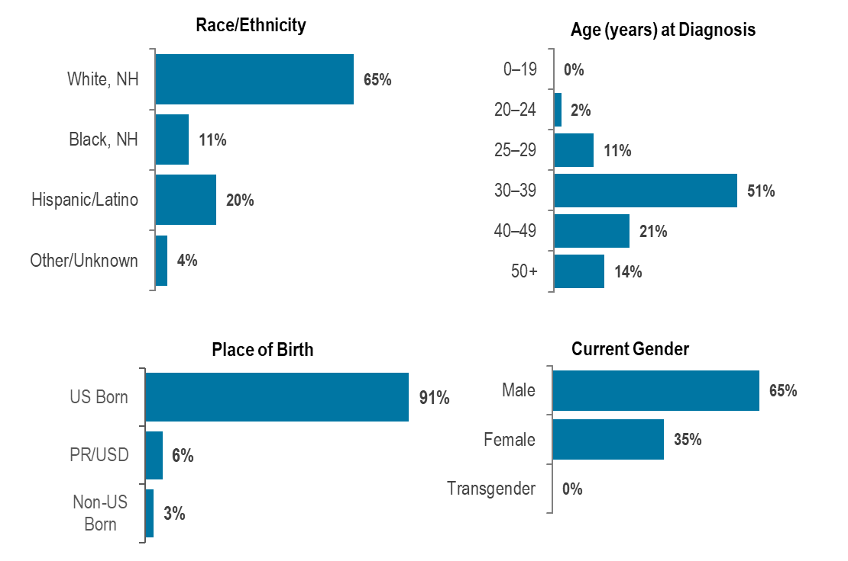
Data Source: Bureau of Infectious Disease and Laboratory Sciences, data are current as of 7/1/2025 and subject to change.

- Individuals with IDU exposure mode newly diagnosed with HIV infection in Massachusetts during 2022 to 2024 were predominantly White (non-Hispanic) (65%), between 30 and 39 years of age (51%), US born (91%), and male (65%).

DEATHS FROM ANY CAUSE AMONG INDIVIDUALS REPORTED WITH HIV BY EXPOSURE MODE

Figure 41. Deaths from any cause among individuals reported with HIV by exposure mode, Massachusetts 2024 (N=330)

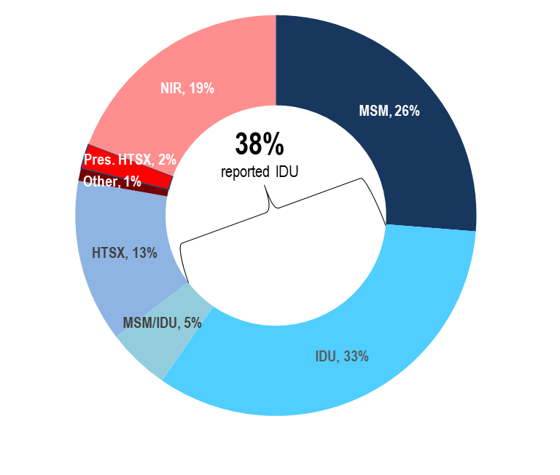
Data Source: Bureau of Infectious Disease and Laboratory Sciences, data are current as of 7/1/2025 and subject to change.

- The proportion of deaths from any cause among individuals with HIV with IDU exposure mode decreased from 42% in 2015 to 33% in 2024. At 33%, the proportion among IDU remained the largest among exposure modes in 2024, followed by MSM at 26%, with an additional 5% reported with an exposure mode of MSM/IDU. Comparatively, IDU and MSM/IDU accounted for 7% and 2%, respectively, of new HIV diagnoses in that year.

VIRAL HEPATITIS AND INJECTION DRUG USE

Figure 42. Confirmed acute hepatitis A, confirmed acute hepatitis B, and confirmed acute hepatitis C by reported risk of injection drug use (identified in incubation period), Massachusetts 2020–2024

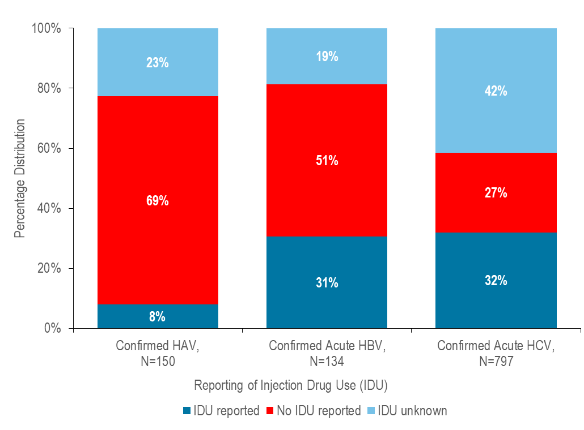
Data Source: Bureau of Infectious Disease and Laboratory Sciences, HAV and HBV data are current as of 9/3/2025, HCV data are current as of 6/18/2025 and subject to change

- A large number of acute viral hepatitis cases from 2020 to 2024 reported recent injection drug use: 8% (N=12/150) of hepatitis A cases, 31% (N=41/134) of hepatitis B cases, and 32% (N=254/797) of hepatitis C cases reported injection drug use in their incubation period.

SPECIFIC POPULATIONS – RACIAL AND ETHNIC GROUPS

Figure 43. Distribution of the general population and of individuals diagnosed with confirmed and probable infectious syphilis, confirmed and probable hepatitis B, confirmed and probable hepatitis C in 2024, and HIV infection during 2022–2024 by race/ethnicity, Massachusetts
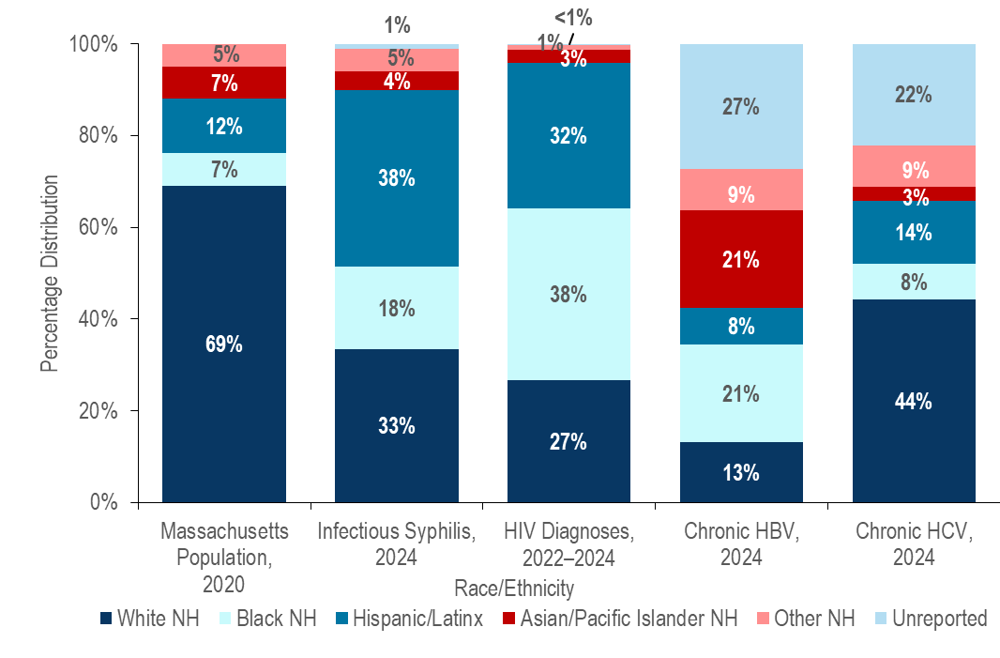
Confirmed and Probable Infectious Syphilis 2024, N=1,329; HIV Diagnoses 2022-2024, N=1,596; Confirmed and Probable Hepatitis B 2024, N=2,155, Confirmed and Probable Hepatitis C 2024, N=2,116
Data Source: Bureau of Infectious Disease and Laboratory Sciences, HIV data are current as of 7/1/2025, STI data are current as of 6/02/2025, HBV data are current as of 9/03/2025, HCV data are current as of 6/18/2025 and subject to change
- In 2024, Black (non-Hispanic), Hispanic/Latinx, and Asian/Pacific Islander (non-Hispanic) individuals represented 7%, 12%, and 7% of the total Massachusetts population and:
  - 18%, 38%, and 4% of confirmed and probable infectious syphilis cases,
  - 21%, 8%, and 21% of confirmed and probable chronic hepatitis B cases, and
  - 8%, 14%, and 3% of confirmed and probable hepatitis C cases respectively.
  - During 2022 to 2024, Black (non-Hispanic), Hispanic/Latinx, and Asian/Pacific Islander (non-Hispanic) individuals represented 38%, 32%, and 3% of individuals diagnosed with HIV infection in Massachusetts, respectively.

SYPHILIS BY RACE/ETHNICITY

Figure 44. Number of confirmed and probable infectious syphilis cases reported by race/ethnicity, Massachusetts 2015–2024
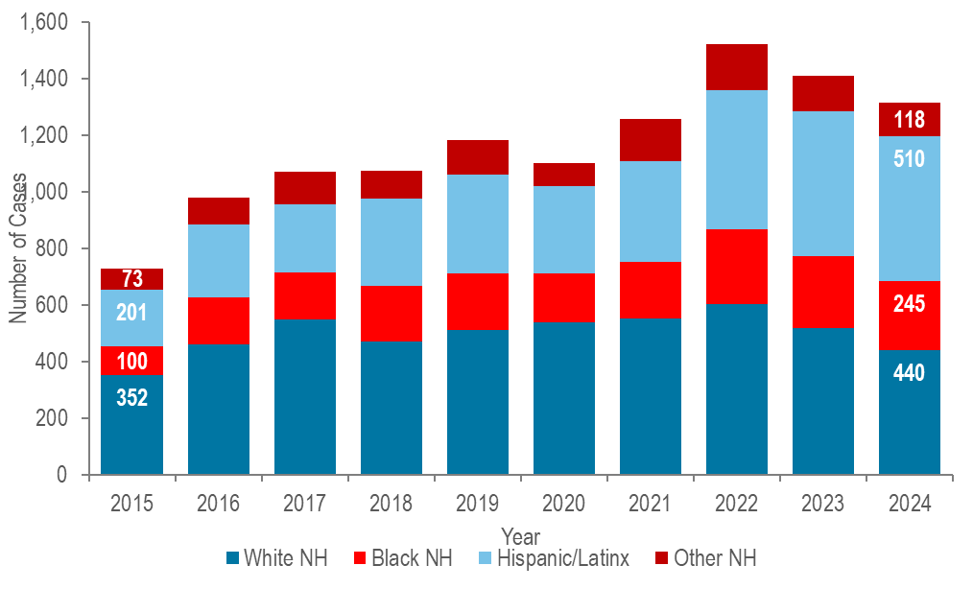
Confirmed and Probable Syphilis 2015-2024 Total N=12,205; 574 (5%) cases missing race/ethnicity are not included in this figure; Data Source: Bureau of Infectious Disease and Laboratory Sciences, data are current as of 6/02/2025 and subject to change.

- The greatest number of confirmed and probable infectious syphilis cases was among White (non-Hispanic) individuals each year from 2015 to 2023. In 2024, the greatest number of cases was among Hispanic/Latinx individuals.
- From 2015 to 2024, the greatest proportionate increase in the number of confirmed and probable infectious syphilis cases was reported among Hispanic/Latinx individuals (increased by 2.5 times from 201 to 510) and Black (non-Hispanic) individuals (increased by 2.5 times from 100 to 245), followed by White (non-Hispanic) (increased by 25% from 352 to 440).
- From 2015 to 2024, the proportion of confirmed and probable infectious syphilis cases among White (non-Hispanic) individuals decreased from 48% to 34% while it increased from 28% to 39% among Hispanic/Latinx individuals, and from 14% to 19% among Black (non-Hispanic) individuals.
- In 2024, the age-adjusted confirmed and probable infectious syphilis incidence rates among Black (non-Hispanic) individuals (49.1 per 100,000) and Hispanic/Latinx individuals (53.2 per 100.000) were five and six times that of White (non-Hispanic) individuals (9.3 per 100,000), respectively.

HIV BY RACE/ETHNICITY

Figure 45. Average annual age-adjusted HIV diagnosis rate per 100,000 population by sex assigned at birth and race/ethnicity, Massachusetts 2022–2024 (N=1,596)
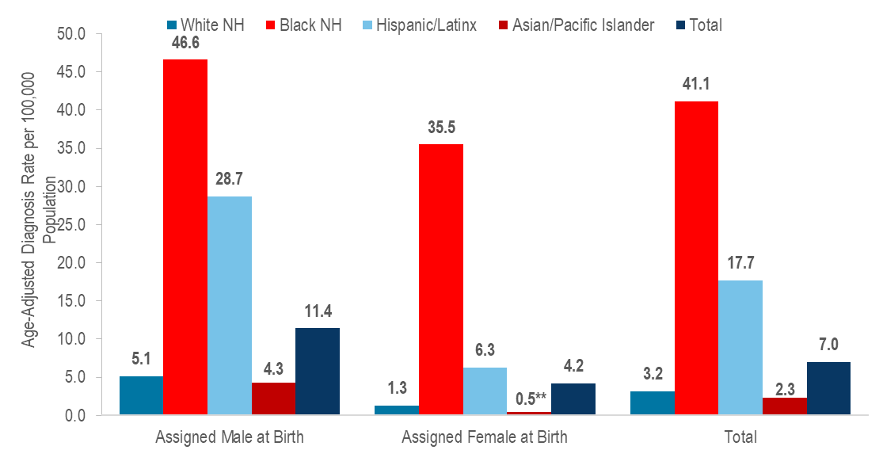
**Rates based on numerators <12 are marked with an asterisk (*) and should be interpreted with caution.
Data Source: Bureau of Infectious Disease and Laboratory Sciences, data are current as of 7/1/2025 and subject to change.
In 2022–2024, the average annual age-adjusted HIV diagnosis rate per 100,000 population of individuals assigned male at birth (AMAB) was nearly three times that of individuals assigned female at birth (AFAB). There were large disparities in average annual age-adjusted HIV diagnosis rates for 2022 to 2024 by race/ethnicity. Compared to the rate among White (non-Hispanic) individuals, the rate among:
- Black (non-Hispanic) individuals was 13 times greater, and
- Hispanic/Latinx individuals was six times greater.
With respect to differences based on race/ethnicity and sex assigned at birth, the average annual age-adjusted HIV diagnosis rate for 2022 to 2024 among:
- Black (non-Hispanic) individuals assigned male at birth (AMAB), was nine times that of White (non-Hispanic) individuals AMAB,
- Hispanic/Latinx individuals AMAB was six times that of White (non-Hispanic) individuals AMAB,
- Black (non-Hispanic) individuals assigned female at birth (AFAB) was 28 times that of White (non-Hispanic) individuals AFAB, and
- Hispanic/Latinx individuals AFAB was five times that of White (non-Hispanic) individuals AFAB.

SPECIFIC POPULATIONS - WOMEN AND INFANTS

Figure 46. Distribution of confirmed chlamydia and gonorrhea cases reported by gender, Massachusetts 2024
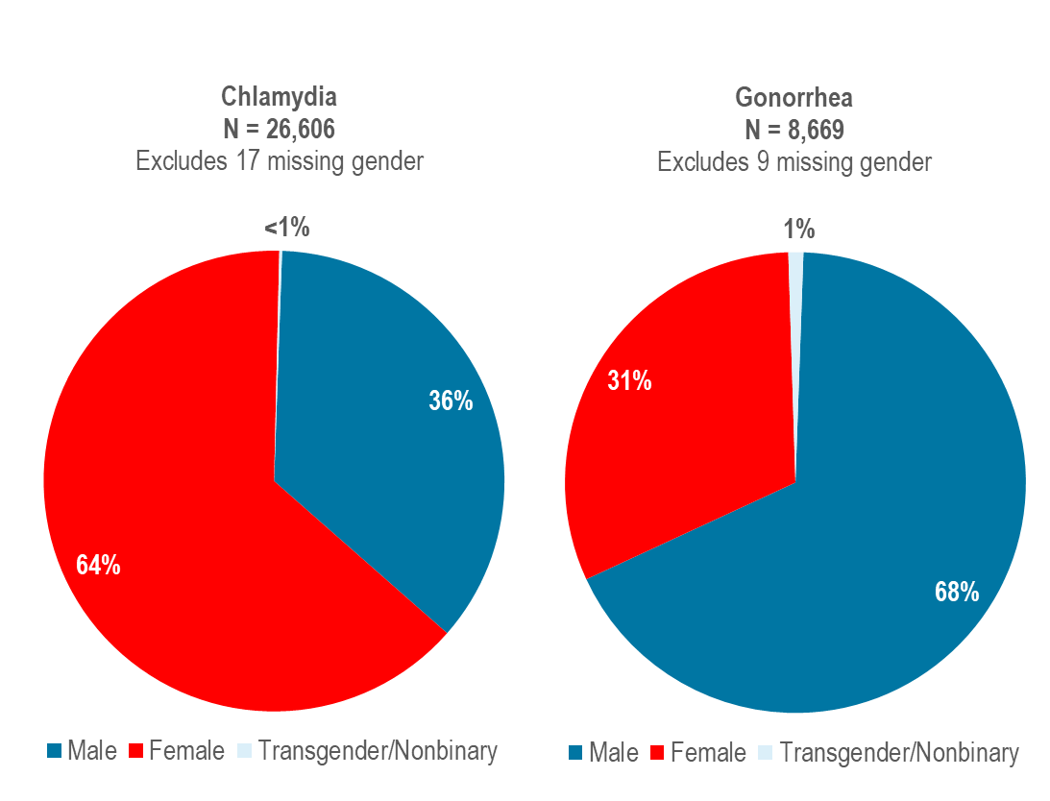
Data Source: Bureau of Infectious Disease and Laboratory Sciences, data are current as of 6/02/2025 and subject to change.

- In 2024, 64% of confirmed chlamydia cases were among females (N=16,998), 36% were among males (N=9,557), and less than one percent (N=51) was among individuals of transgender experience or individuals who are nonbinary.
- In 2024, 31% of confirmed gonorrhea cases were among females (N=2,722), 68% were among males (N=5,856), and one percent (N=91) was among individuals of transgender experience or individuals who are nonbinary.

WOMEN AND INFANTS – CONGENITAL SYPHILIS

Despite close follow-up of cases of syphilis in pregnant patients and their partners, breakthrough cases of congenital syphilis have increased in Massachusetts. Two syphilitic stillbirths and 17 presumptive reportable cases were reported to DPH in 2024. In 2020, DPH released a recommendation for universal syphilis screening early in the 3rd trimester (27–28 weeks gestation), in addition to routine syphilis screening performed at the first prenatal visit. For more information see, Congenital Syphilis Clinical Alert, June 30, 2020, available at https://www.mass.gov/doc/congenital-syphilis-clinical-alert-6-30-2020/download
Figure 47. Number of confirmed and probable congenital syphilis cases reported by year of birth and rate of confirmed and probable infectious syphilis per 100,000 among individuals assigned female at birth (AFAB) of child-bearing age (15–44 years), Massachusetts 2015–2024
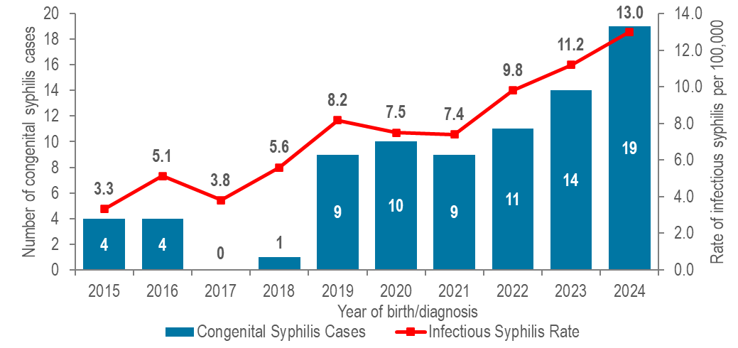
Data Source: Bureau of Infectious Disease and Laboratory Sciences, data are current as of 6/02/2025 and subject to change.
- After remaining between zero and four from 2011 to 2018, the annual number of reportable cases of congenital syphilis diagnosed in Massachusetts increased significantly, ranging from nine to 19 from 2019 to 2024. The proportion of congenital syphilis cases averted also increased during this time period from 80% in 2019 (N=35 all stage syphilis cases among pregnant persons who did not have a confirmed or probable congenital syphilis case/44 total all stage syphilis cases among all pregnant persons) to 88% in 2024 (N=135/154).

WOMEN AND INFANTS – CONGENITAL SYPHILIS

- Trends in congenital syphilis typically mirror trends in infectious syphilis among individuals AFAB of child-bearing age. In Massachusetts, as the rate of confirmed and probable infectious syphilis among individuals AFAB of child-bearing age increased to 13.0 per 100,000 in 2024, so too did the number of confirmed and probable cases of congenital syphilis (N=19).
- Nationally, the number of congenital syphilis cases reached 3,882 in 2023, with a rate of 105.8 cases per 100,000 live births, the highest rate reported since 1994. Massachusetts ranked 44th in congenital syphilis incidence rate among the 50 states in 2023.

WOMEN - RECENT HIV DIAGNOSES

Figure 48. Percentage of individuals assigned female at birth and diagnosed with HIV infection by race/ethnicity, age, place of birth, and exposure mode, Massachusetts 2022–2024 (N=434)
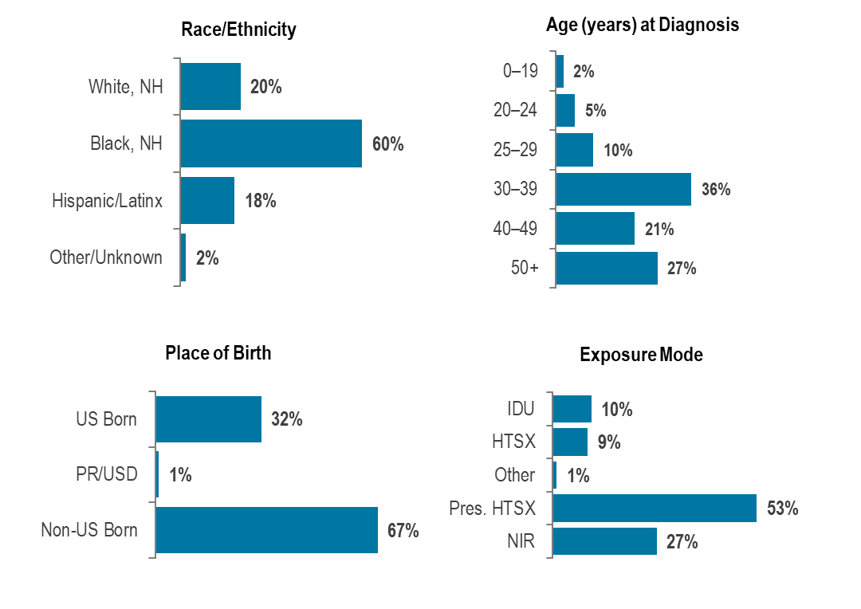
Data Source: Bureau of Infectious Disease and Laboratory Sciences, data are current as of 7/1/2025 and subject to change.
- Individuals assigned female at birth (AFAB) and newly diagnosed with HIV infection in Massachusetts during 2022–2024 were predominantly Black (non-Hispanic) (60%), 30 years of age or older (36% 30–39 year-olds, 21% 40–49 year-olds, 28% 50+ year-olds), with an exposure mode of presumed heterosexual sex (53%). While presumed heterosexual sex was the leading reported exposure mode, a large percentage of new HIV diagnoses were reported with no identified risk (NIR) (27%).
- Among individuals AFAB, the proportion of HIV infection diagnoses with IDU exposure mode increased from 10% (N=17/162) in 2015 to 25% (N=40/157) in 2017, remained between 18% (2019, N=25/140) and 22% (2020, N=27/122) from 2018 through 2021, and then decreased to 11% (N=19/170) in 2024.

SPECIFIC POPULATIONS – OLDER INDIVIDUALS

STI DIAGNOSES BY AGE
Figure 49. Distribution of confirmed chlamydia, confirmed gonorrhea, and confirmed and probable infectious syphilis cases reported by age group (years), Massachusetts 2024
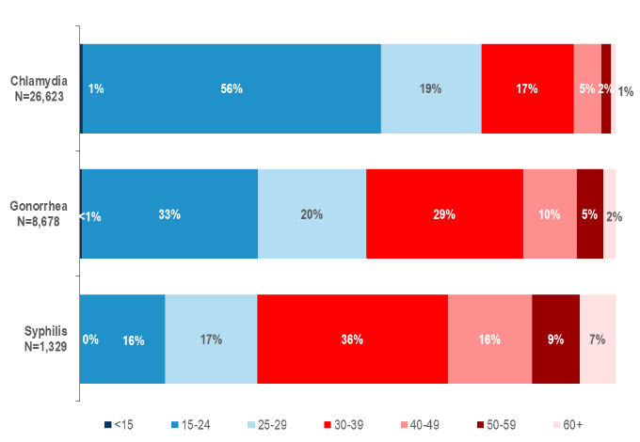
Data Source: Bureau of Infectious Disease and Laboratory Sciences, data are current as of 6/02/2025 and subject to change.

- In 2024, in Massachusetts, 1% of confirmed chlamydia cases, 2% of confirmed gonorrhea cases, and 7% of confirmed and probable infectious syphilis cases were reported among individuals aged 60+ years. An additional 2% of confirmed chlamydia cases, 5% of confirmed gonorrhea cases, and 9% of confirmed and probable infectious syphilis cases were reported among individuals aged 50–59 years.

STI DIAGNOSES BY AGE AND GENDER

Figure 50. Percentage of confirmed chlamydia and gonorrhea cases by age at diagnosis (<60 years vs. 60+ years) and gender, Massachusetts 2024

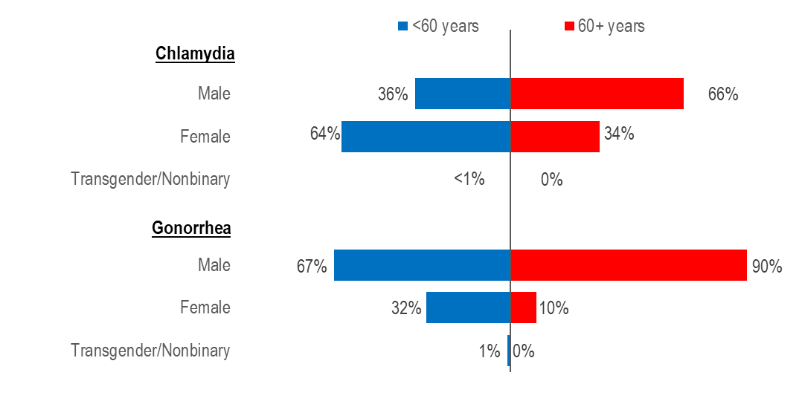

Note: 2024 chlamydia N=26,606 (<60 N=26,383; 60+ N=223) and excludes cases missing gender and/or age (N=17). 2024 gonorrhea N=8,669 (<60 N=8,467; 60+ N=202) and excludes cases missing gender and/or age (N=9).
Data Source: Bureau of Infectious Disease and Laboratory Sciences, data are current as of 6/02/2025 and subject to change.

- In 2024, a much larger proportion of confirmed chlamydia cases among individuals aged 60 years or older (66%) than aged less than 60 years (36%) was male.
- Similarly in 2024, a much larger proportion of confirmed gonorrhea cases among individuals aged 60 years or older (90%) than aged less than 60 years (67%) was male.

SYPHILIS BY AGE, GENDER, RACE/ETHNICITY, AND RISK

Figure 51. Percentage of confirmed and probable infectious syphilis cases by age at diagnosis (<60 years vs. 60+ years), gender, race/ethnicity, and risk, Massachusetts 2024
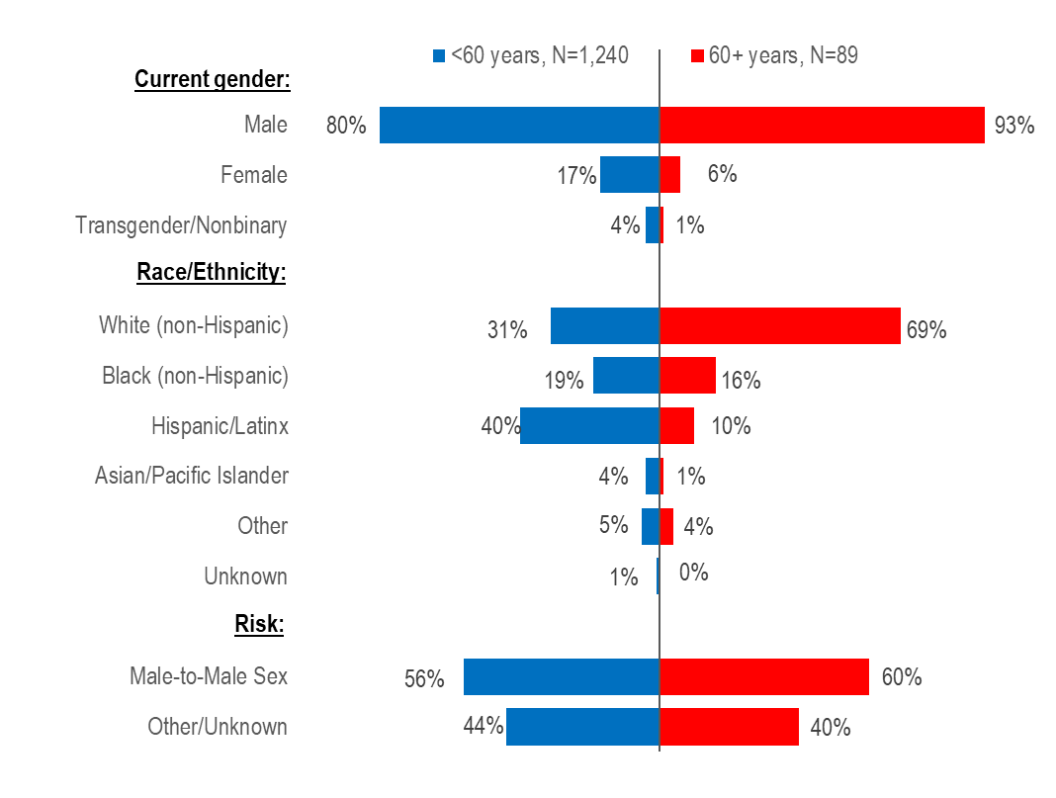

Note: 2024 syphilis N=1,329 (<60 N=1,240; 60+ N=89), all cases were reported with gender and age
Data Source: Bureau of Infectious Disease and Laboratory Sciences, data are current as of 6/02/2025 and subject to change.
- In 2024, a larger proportion of confirmed and probable infectious syphilis cases among individuals aged 60 years or older (93%) than aged less than 60 years (80%) was male.
- A much larger proportion of confirmed and probable infectious syphilis cases among individuals aged 60 years or older (69%) than aged less than 60 years (31%) was White non-Hispanic.
- A similar proportion of confirmed and probable infectious syphilis cases among individuals aged 60 years or older (60%) and aged less than 60 years (56%) reported male-to-male sex.

OLDER INDIVIDUALS LIVING WITH HIV INFECTION

Figure 52. Persons living with HIV infection by expanded age category, Massachusetts 2024 (N=24,838)
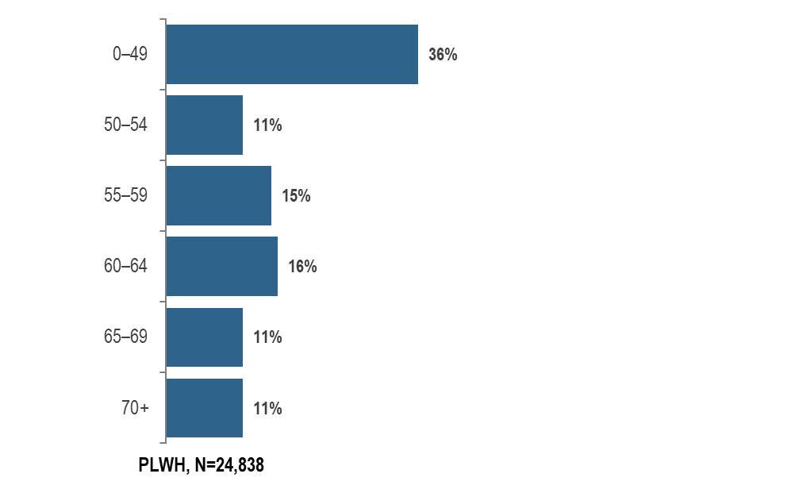

Data Source: Bureau of Infectious Disease and Laboratory Sciences, data are current as of 7/1/2025 and subject to change.

- In 2024, 22% (N=5,441) of PLWH were aged 65 years or older, the age of eligibility for Medicare for individuals without a disability.

OLDER INDIVIDUALS LIVING WITH HIV INFECTION

Figure 53. Number of years since HIV infection diagnosis among individuals aged 60 years and older living with HIV infection, Massachusetts 2024 (N=9,471)
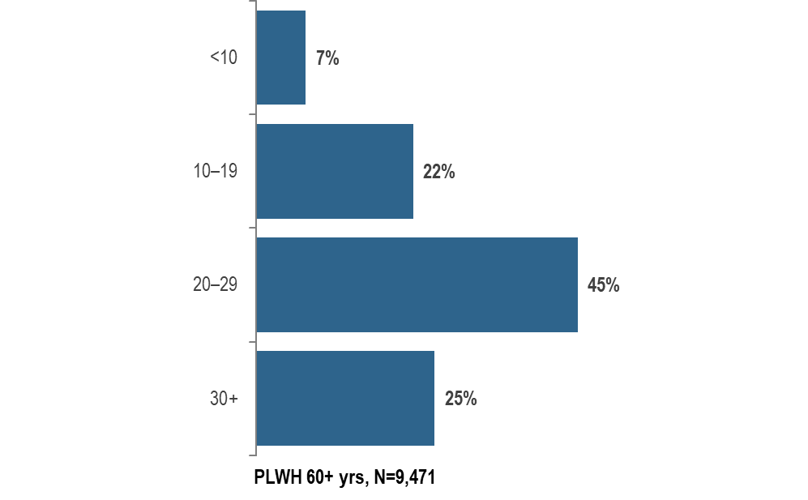

Data Source: Bureau of Infectious Disease and Laboratory Sciences, data are current as of 7/1/2025 and subject to change.

- In 2024, the majority (70%, N=6,663) of PLWH aged 60 years and older were diagnosed with HIV infection at least 20 years ago. The average number of years since HIV infection diagnosis among PLWH aged 60 years and older was 23.5 years.

OLDER INDIVIDUALS LIVING WITH HIV INFECTION

Figure 54. People aged 60 years and older living with HIV infection compared to people aged under 60 years by selected characteristics, Massachusetts 2024
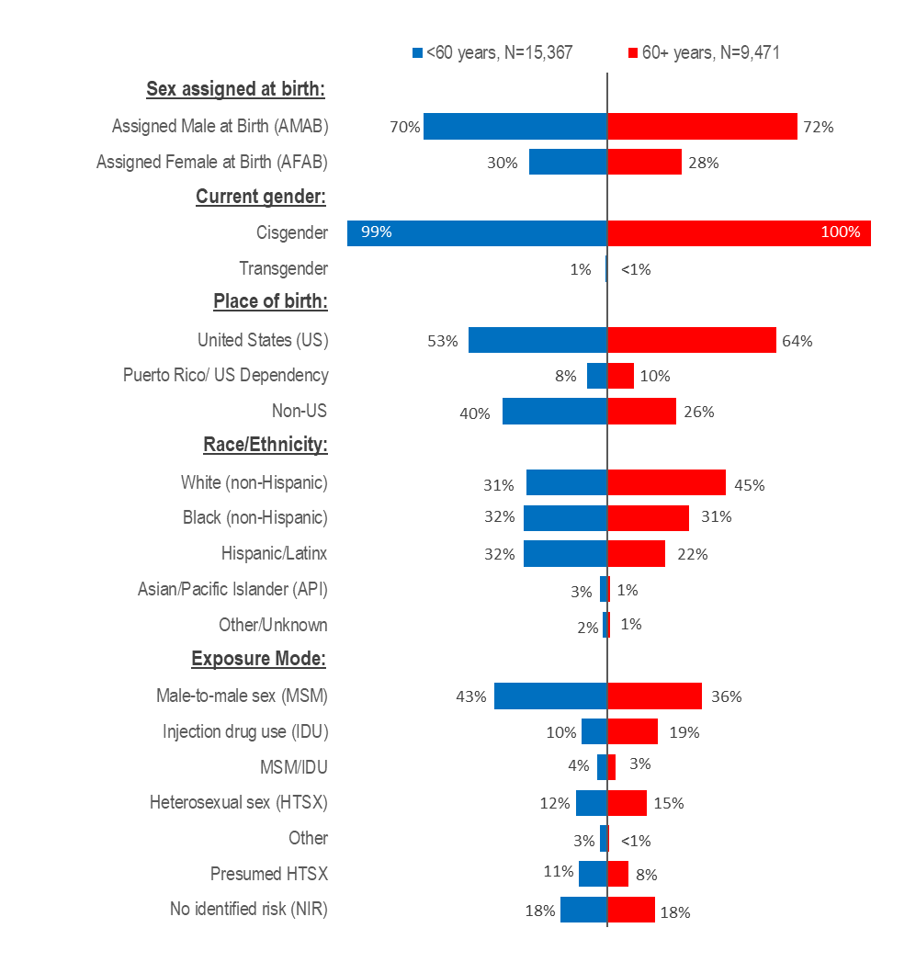

Note: 2024 People living with HIV infection: N=24,838 (<60 N=15,367; 60+ N=9,471), no cases were excluded from this analysis
Data Source: Bureau of Infectious Disease and Laboratory Sciences, data are current as of 7/1/2025 and subject to change.

OLDER INDIVIDUALS LIVING WITH HIV INFECTION

- In 2024, the distributions of people living with HIV infection by place of birth, race/ethnicity, and exposure mode varied by age:
  - A larger proportion of individuals aged 60+ years (64%) than <60 years (53%) was born in the US.
  - A larger proportion of individuals aged 60+ years (45%) than <60 years (31%) was White (non-Hispanic), and a smaller proportion was Hispanic/Latinx (22% vs. 32%).
  - A larger proportion of individuals aged 60+ years (19%) than <60 years (10%) had injection drug use exposure mode and a smaller proportion had MSM exposure mode (36% vs. 43%). However, MSM was still the most frequently reported exposure mode for both age groups.
  - The distributions of people living with HIV infection by sex assigned at birth and current gender identity were similar for both age groups in 2024.

OLDER INDIVIDUALS RECENTLY DIAGNOSED WITH HIV INFECTION

Figure 55. People aged 60 years and older diagnosed with HIV infection compared to people aged under 60 years by selected characteristics, Massachusetts 2022–2024
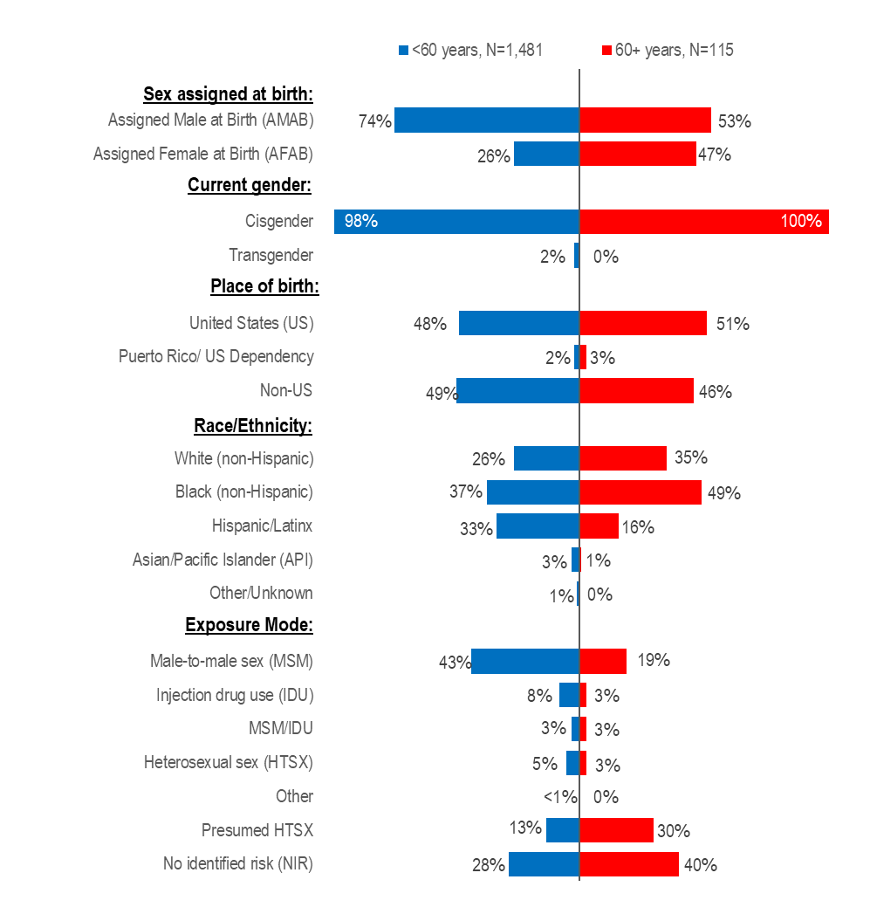

Note: 2022–2024 HIV diagnoses: N=1,596 (<60 N=1,481; 60+ N=115), no cases were excluded from this analysis
Data Source: Bureau of Infectious Disease and Laboratory Sciences, data are current as of 7/1/2025 and subject to change.

OLDER INDIVIDUALS RECENTLY DIAGNOSED WITH HIV INFECTION

When reviewing the data presentations on people diagnosed with HIV infection at age 60+ years, please note that the ascertainment of accurate initial diagnosis date/age is often more difficult for individuals born outside the United States than those born in the United States or Puerto Rico. This is due to limited access to clinical documentation and/or less access to testing in the patient’s country of origin. Differences between younger (<60) and older (60+) individuals diagnosed with HIV infection displayed in this report may be an artefact of this data quality discrepancy rather than actual age at diagnosis.
- During 2022 to 2024, the distributions of individuals diagnosed with HIV infection by sex assigned at birth, race/ethnicity, and exposure mode varied by age:
  - A larger proportion of individuals aged 60+ years (47%) than <60 years (26%) was assigned female at birth.
  - A larger proportion of individuals aged 60+ years (49%) than <60 years (37%) was Black (non-Hispanic).
  - A larger proportion of individuals aged 60+ years (30%) than <60 years (13%) had presumed heterosexual exposure mode and no identified risk (40% vs. 28%) and a smaller proportion had MSM exposure mode (19% vs. 43%).

STRENGTHS AND LIMITATIONS OF DATA

 | HIV/AIDS | STI | Viral Hepatitis
Description | - Collected by DPH Bureau of Infectious Disease and Laboratory Sciences  - Reported statewide  - All laboratories and healthcare providers are required by state law to report. New HIV diagnoses include only individuals who were first diagnosed in Massachusetts.  - HIV prevalence data include all individuals who were reported as residing in Massachusetts regardless of where they were first diagnosed. | - Collected by DPH Bureau of Infectious Disease and Laboratory Sciences  - Reported statewide  - All laboratories and healthcare providers are required by state law to report.  - Includes individuals first reported as living in MA. | - Collected by DPH Bureau of Infectious Disease and Laboratory Sciences  - Reported statewide  - All laboratories and healthcare providers are required by state law to report.  - Includes individuals first reported as living in MA.
Strengths | - Completeness of race/ethnicity data is high.  - All clinical laboratories in MA report electronically resulting in more complete and timely reporting of disease.  - Data are estimated to be 99% complete. | - All clinical laboratories in MA report electronically resulting in more complete and timely reporting of disease.  - Most infectious syphilis cases agree to interview, resulting in reasonably complete race/ethnicity and sex of sex partner data. | - All clinical laboratories in MA report electronically resulting in more complete and timely reporting of disease.
Limitations | - 2024 HIV prevalence data as of 7/1/2025 are preliminary. | - Race/ethnicity data are incomplete for gonorrhea and chlamydia.  - Sex of sex partner is not routinely collected for gonorrhea and chlamydia cases.  - Bias is introduced for some STIs, such as chlamydia infection, where screening of asymptomatic persons occurs more frequently among women than among men. | - Race/ethnicity data are incomplete.  - Risk history data are not collected on chronic HBV cases.

Massachusetts Youth Risk Behavior Survey

Description | The Massachusetts Youth Risk Behavior Survey (MYRBS) is conducted every two years through a collaborative effort between the Massachusetts Department of Elementary and Secondary Education (ESE) and Department of Public Health (DPH) to monitor health indicators, behaviors, and risk factors contributing to the leading causes of morbidity, mortality, and social and academic problems among adolescents. For more information see https://www.mass.gov/lists/massachusetts-youth-health-survey-myhs
Strengths | A two-stage sampling method is used to produce representative samples of students in grades 9 – 12. Response rates are high.
Limitations | All data collected for the MYRBS and the MYHS are based on self-report from students. Self-reported data may be subject to error for several reasons, including inaccurate recall of events.

INTERPRETING HIV, STI, AND VIRAL HEPATITIS DATA

Hepatitis A and hepatitis B surveillance data are current as of September 3, 2025, hepatitis C (HCV) data are as of June 18, 2025, HIV data are as of July 1, 2025, and STI data are as of June 2, 2025. All data are subject to change.
I. Impact of COVID-19
The coronavirus disease 2019 (COVID-19) pandemic has had a large impact on the screening, treatment, and surveillance of other infectious diseases in 2020 and 2021. Nationally, the Centers for Disease Control and Prevention (CDC) observed a sharp decline in reported STI cases from March-April 2020, compared to March-April 2019. Three factors were cited as likely contributing to the initial decrease in reported cases:
- Reduced screening – many health care clinics limited in-person visits to symptomatic cases or closed down.
- Limited resources – many state and local health department STI staff were redirected from routine STI responsibilities to COVID-19 activities, which affected STI tracking capacity and reporting.
- Social distancing measures – intended to reduce COVID-19 spread, they may have influenced sexual behaviors and reduced STI transmission.
After the initial decrease in 2020, an increase across STIs was observed nationally and in the Commonwealth in 2021 and 2022. Possible factors contributing to an increase in reported cases include:
- Increased service utilization after health care clinics re-opened.
- Continued direction of services to patients most likely to be infected, increasing the number of cases identified.
- Higher disease transmission - due to reduced access to care, those with an STI may have had their infections longer, providing more opportunities to transmit infection to their sexual partners. Additionally, following the initial shelter-in-place orders, sexual behaviors may have changed, including frequency of new sexual partners, leading to spread in sexual networks.
The full effects of the COVID-19 pandemic on case detection and reporting and efforts to control the spread of infectious disease in the Commonwealth have yet to be determined. As such, please interpret infectious disease data from 2020 to 2022 with caution.
II. Gender
Gender is a multi-dimensional construct that includes identity (e.g., man, woman, genderqueer, nonbinary) and expression (e.g., masculine, feminine, neither masculine nor feminine, or both masculine and feminine, or something else through appearance and behavior).
III. Individuals of Transgender Experience and Nonbinary Individuals
Please note reported numbers among individuals of transgender experience and individuals who are nonbinary are likely to be underestimates. Gender may be under or misreported due to the effects of stigma and discrimination, lack of experience and/or training among medical professionals in treating the unique needs of transgender and nonbinary patients, as well as the absence of appropriate collection of gender options in medical records (e.g., individuals who are genderqueer, pangender, gender fluid, androgynous, etc.).
IV. HIV Primary Exposure Mode Definitions
The HIV primary exposure mode indicates the most probable exposure associated with HIV infection. Assignment of primary exposure mode is done in accordance with Centers for Disease Control and Prevention (CDC) guidelines when multiple exposure modes are reported. Although the reported primary exposure mode is the most likely mode of transmission, there is always the possibility that it is not the actual mode of transmission. Following is a description of the exposure mode categories:
- MSM (Male-to-Male Sex): Includes all individuals assigned male at birth who report any sexual contact with other individuals that identify as male. Please note that in accordance with CDC guidelines, this category is defined by an individual’s assigned sex at birth and not an individual’s current gender identity.
  - Sex with Men: This exposure mode category is used by the Bureau of Infectious Disease and Laboratory Sciences (BIDLS) to categorize sexual risk in transgender women reporting sex with men only. For the purposes of official reporting in the MA HIV Surveillance System and to CDC, exposure mode for transgender women is based on sex assigned at birth, and therefore would be reported as male-to-male sex.
- IDU (Injection Drug Use): Cases among persons who report injection drug use.
- MSM/IDU: Includes all individuals assigned male at birth who report both injection drug use and any sexual contact with other individuals that identify as male.
  - Sex with Men/IDU: This exposure mode category is used by BIDLS to categorize sexual risk in transgender women reporting both sex with men and injection drug use. For the purposes of official reporting in the MA HIV Surveillance System and to CDC, exposure mode for transgender women is based on sex assigned at birth, and therefore would be reported as MSM/IDU.
- Heterosexual Sex: Cases among persons who report heterosexual sex with a person diagnosed with, or at increased risk for, HIV infection (e.g., a PWID). The sub-categories for this mode of transmission are listed below.
  - Heterosexual Sex w/ a person who injects drugs
  - Heterosexual Sex w/ a person diagnosed w/ HIV infection or AIDS
  - Heterosexual Sex w/ a bisexual male
  - Other Heterosexual Sex: Includes all other sub-categories of heterosexual risk, such as heterosexual contact with a person infected through a blood transfusion.
- Other: Cases among persons with other known exposure modes, including receipt of clotting factor, receipt of transfusion or transplant, and person-to-child transmission through pregnancy, childbirth, or breastfeeding (perinatal transmission).
- Presumed Heterosexual: The presumed heterosexual risk category is used by BIDLS exclusively for individuals assigned female at birth to identify HIV exposure mode when sex with individuals that identify as male was the only reported risk factor, there was no evidence of current or past injection drug use (IDU), and behavioral risk and HIV status information about sexual partners that identify as male was unknown. The rationale for the application of the presumed heterosexual risk category to individuals assigned female at birth only has been addressed in the DPH Office of HIV report “Intersecting Risks: HIV Infection among Heterosexual Women and Men in Massachusetts” (2010).
- NIR (No Identified Risk): Cases among persons with no reported history of exposure to HIV through any of the listed exposure categories. Follow-up is conducted to determine exposure for those cases that are initially reported without an exposure mode identified. Includes cases among individuals assigned male at birth who were previously categorized in Massachusetts as Presumed Heterosexual.
V. References to Newly Diagnosed HIV Infections
Due to the extensive follow-up required to verify accurate date of diagnosis, all HIV data reflect HIV infections diagnosed through 2024. Newly diagnosed HIV infections/cases include all persons diagnosed with HIV from 2022-2024, including those who were concurrently or subsequently diagnosed with AIDS. All HIV data are presented by the year of diagnosis, not the year of report.
VI. Deaths among People Reported with HIV
The all-cause death data presented in this report include all deaths among people diagnosed and reported with HIV in Massachusetts to present a full description of trends in mortality among this population. This includes deaths from non-HIV related causes such as drug overdoses, suicides, motor vehicle accidents, and other causes. Therefore, the total number of annual deaths reported here will vary from the number of HIV-related deaths reported in Massachusetts Deaths by the Massachusetts Department of Public Health, Office of Population Health (available at https://www.mass.gov/lists/death-data ). Data on deaths occurring in Massachusetts are from matches with the Massachusetts Registry of Vital Records and Statistics and from provider reports and are considered complete through 2024. Data on deaths occurring outside of Massachusetts are from matches with the Social Security Death Master File and were completed only partially for 2024 based on availability of data.
VII. Race/Ethnicity of STI and HIV Cases
Race/ethnicity references to White residents and Black residents represent persons who are White (non-Hispanic) and Black (non-Hispanic), respectively. All references to Hispanic/Latinx for race/ethnicity represent persons of Hispanic/Latinx heritage regardless of race.
VIII. STI Case Reports and Analyses
All information on STI cases reflects year of report. As of 1/1/2020, BIDLS calculates rates per 100,000 population using denominators estimated by the University of Massachusetts Donahue Institute using a modified Hamilton-Perry model. 2020 population estimates were used for single-year rates; for pooled year rates (i.e., 2022-2024), the 2020 population estimates were multiplied by three. For more information, see: Strate S, et al. Small Area Population Estimates for 2011 through 2020, report published Oct 2016, and http://www.donahue.umassp.edu/business-groups/economic-public-policy-research/massachusetts-population-estimates-program. When the proportion of STI cases with unknown values is greater than or equal to 30%, incidence trends are not presented by that variable. For instance, race/ethnicity is unknown for 58% of confirmed chlamydia cases and 41% of confirmed gonorrhea cases reported from 2015 to 2024. Therefore, the number of confirmed chlamydia and gonorrhea cases by race/ethnicity are not presented in this report.

IX. Cell Suppression Methodology:
Values one through four are suppressed for denominator populations less than 50,000 or for unknown population sizes. Additional values of zero and greater than or equal to five may be suppressed to prevent back calculation. Values less than five are not suppressed for compound categories (categories containing two or more subcategories, such as other/undetermined) because the exact population value of each subcategory cannot be determined.

HIV, STI, AND VIRAL HEPATITIS CASE CLASSIFICATIONS

In the time period of the data in this report

HIV infection
Clinical description: HIV (human immunodeficiency virus) is a retrovirus with two serologically and geographically distinct species: HIV-1 and HIV-2. It is spread via person-to-person transmission through: sexual contact, the use of HIV-contaminated needles and syringes, vertical transmission from mother to infant, or the transfusion of contaminated blood or its components. HIV attacks the body’s immune system, making the individual more likely to acquire infections or develop infection-related cancers. These opportunistic infections or cancers take advantage of the “opportunity” of a weakened immune system and may be one signal that the person has an AIDS diagnosis (acquired immunodeficiency syndrome), the advanced stage of HIV infection.
Case Classification
Confirmed: Positive HIV-1, Positive HIV-2, or Positive (Undifferentiated) HIV result from a differentiating immunoassay, Western Blot, IFA, or culture; Positive/Detected Qualitative HIV NAT (DNA or RNA); Quantitative HIV NAT (detectable viral load assay) or physician verified diagnosis.

Sexually transmitted infections (STI)
Chlamydia trachomatis Infection (2010)
Clinical description
Infection with Chlamydia trachomatis may result in urethritis, epididymitis, cervicitis, acute salpingitis, or other syndromes when sexually transmitted; however, the infection is often asymptomatic in women. Perinatal infections may result in inclusion conjunctivitis and pneumonia in newborns. Other syndromes caused by C. trachomatis include lymphogranuloma venereum (see Lymphogranuloma Venereum) and trachoma.
Laboratory criteria for diagnosis
- Isolation of C. trachomatis by culture or
- Demonstration of C. trachomatis in a clinical specimen by detection of antigen or nucleic acid
Case classification
Confirmed: a case that is laboratory confirmed.
Chlamydia trachomatis Infection (2022)
Clinical Description
Chlamydia is a sexually transmitted infection that has a variable clinical course based on the serotype causing infection. Serovars D-K of C. trachomatis are the typical cause of chlamydial infections in the United States, and infection with C. trachomatis can result in urethritis, epididymitis, cervicitis, acute salpingitis, or other syndromes when sexually transmitted; however, the infection is often asymptomatic. Perinatal infections may result in inclusion conjunctivitis and pneumonia in newborns. Other syndromes caused by C. trachomatis include LGV and trachoma.

LGV is a specific type of chlamydial infection, caused by the serovars L1, L2, and L3 of C. trachomatis. Symptomatic LGV can be divided into three stages. The primary stage can include a small ulcer or lesion at the site of inoculation (genital, rectal, or oral/oropharyngeal sites). The secondary stage can include a syndrome featuring cervical, inguinal, and/or femoral lymphadenopathy that may rupture or an anorectal syndrome featuring proctocolitis (including mucoid or hemorrhagic rectal discharge, anal pain, constipation, fever, and/or tenesmus). Late stage LGV typically involves sequelae, such as genital elephantiasis, lymph node scarring, chronic colorectal fistulas and strictures, perirectal abscesses, and/or anal fissures. LGV may also be asymptomatic.
Laboratory Criteria
- Demonstration of C. trachomatis in a clinical specimen by detection of antigen or nucleic acid, OR
- Detection of LGV-specific antigen or nucleic acid in a clinical specimen, OR
- Isolation of C. trachomatis by culture
Criteria to Distinguish a New Case from an Existing Case
For surveillance purposes, a new case of C. trachomatis infection (caused by either non-LGV or LGV serotypes) meets the following criteria:
- There is no evidence of a prior C. trachomatis infection that has been reported as a case;
OR
- There is evidence of a prior C. trachomatis infection that has been reported as a case, but the prior infection’s specimen collection date or treatment date was >30 days before the current infection’s specimen collection date;
OR
- There is evidence of a prior C. trachomatis infection that has been reported as a case with a specimen collection date or treatment date ≤30 days from the current infection’s specimen collection date, but there is evidence of re-infection.
Case Classification
Confirmed
A case that meets laboratory evidence.
Case Classification Comments
The following provides guidance for health departments to use for the classification and notification of cases of C. trachomatis infection caused by serovars L1, L2, and L3 (also known as lymphogranuloma venereum, or LGV). Cases should be reported to the Centers for Disease Control and Prevention (CDC) through voluntary notification as C. trachomatis infection and should be marked as LGV in the CDC case report data, as defined below.
Classification of C. trachomatis infection cases to identify LGV.
Verified: a person with detection of LGV-specific antigen or nucleic acid in a clinical specimen. This includes asymptomatic cases.
Likely: a person with demonstration of C. trachomatis in a clinical specimen by detection of antigen or nucleic acid OR isolation of C. trachomatis by culture; AND who demonstrates clinical symptoms or signs consistent with LGV; AND has no negative test for LGV-specific antigen or nucleic acid in a clinical specimen.

Gonorrhea (2014)
Clinical description
A sexually transmitted infection commonly manifested by urethritis, cervicitis, proctitis, salpingitis, or pharyngitis. Infection may be asymptomatic.
Laboratory criteria for diagnosis
- Observation of gram-negative intracellular diplococci in a urethral smear obtained from a male or an endocervical smear obtained from a female, or
- Isolation of typical gram-negative, oxidase-positive diplococci by culture (presumptive Neisseria gonorrhoeae) from a clinical specimen, or
- Demonstration of N. gonorrhoeae in a clinical specimen by detection of antigen or nucleic acid
Case classification
Probable: demonstration of gram-negative intracellular diplococci in a urethral smear obtained from a male or an endocervical smear obtained from a female.
Confirmed: a person with laboratory isolation of typical gram-negative, oxidase-positive diplococci by culture (presumptive N. gonorrhoeae) from a clinical specimen, or demonstration of N. gonorrhoeae in a clinical specimen by detection of antigen or detection of nucleic acid via nucleic acid amplification (e.g., polymerase chain reaction [PCR]) or hybridization with a nucleic acid probe.
Gonorrhea (2023)
Clinical Description
Gonorrhea is a sexually transmitted infection caused by the bacterium Neisseria gonorrhoeae. Gonococcal infection can result in urethritis, epididymitis, cervicitis, acute salpingitis, proctitis, pharyngitis, or other syndromes when sexually transmitted; however, infections at the endocervix, pharynx, and rectum are often asymptomatic. Perinatal exposure to endocervical infection may result in gonococcal conjunctivitis in newborns. Disseminated gonococcal infection (DGI) is an additional syndrome caused by Neisseria gonorrhoeae.
DGI occurs when Neisseria gonorrhoeae from a mucosal site infection (urogenital, pharyngeal, rectal) invades the bloodstream and spreads to distant sites in the body. Clinical manifestations of DGI include petechial or pustular acral skin lesions, tenosynovitis, asymmetric polyarthralgia, bacteremia, oligoarticular septic arthritis, or, on rare occasions, endocarditis, osteomyelitis, or meningitis.
Laboratory Criteria
Confirmatory laboratory evidence:
- Isolation of Neisseria gonorrhoeae by culture of a clinical specimen, minimally with isolation of typical gram-negative, oxidase-positive diplococci,
OR
- Detection of Neisseria gonorrhoeae by nucleic acid amplification (e.g., Polymerase Chain Reaction [PCR]) or hybridization with a nucleic acid probe in a clinical specimen
Presumptive laboratory evidence:
- Observation of gram-negative intracellular diplococci in a urethral or an endocervical smear
Note: The categorical labels used here to stratify laboratory evidence are intended to support the standardization of case classifications for public health surveillance. The categorical labels should not be used to interpret the utility or validity of any laboratory test methodology.
Criteria to Distinguish a New Case from an Existing Case
For surveillance purposes, a new case of Neisseria gonorrhoeae infection meets the following criteria:
- There is no evidence of a prior Neisseria gonorrhoeae infection that has been reported as a case;
OR
- There is evidence of a prior Neisseria gonorrhoeae infection that has been reported as a case, but the prior infection’s specimen collection date or treatment date was >30 days prior to the current infection’s specimen collection date;
OR
- There is evidence of a prior Neisseria gonorrhoeae infection that has been reported as a case with a treatment date ≤30 days from the current infection’s specimen collection date, AND there is evidence of re-infection.*
* Reinfection can occur from condomless sexual intercourse with a new partner, with an untreated partner, or with a treated partner prior to eradication of partner’s infection (seven days post-treatment and after resolution of symptoms, if present).
Case Classification
Probable
Meets presumptive laboratory evidence in the absence of confirmatory laboratory evidence.
Confirmed
Meets confirmatory laboratory evidence.
Case Classification Comments
The following provides guidance for health departments to use for the classification and notification of cases of Neisseria gonorrhoeae infection that result in DGI. Cases should be reported to the Centers for Disease Control and Prevention (CDC) through voluntary notification as Neisseria gonorrhoeae infection and should be marked as DGI in the CDC case notification data, as defined below.
Classification of Neisseria gonorrhoeae infection cases to identify DGI:
- Verified: Isolation or detection of Neisseria gonorrhoeae from a disseminated site of infection (e.g., skin, synovial fluid, blood, or cerebrospinal fluid [CSF]) by culture or nucleic acid amplification test (NAAT).
- Likely: Clinical manifestations of DGI without other known causes AND isolation or detection of Neisseria gonorrhoeae from a mucosal site of infection by culture or nucleic acid amplification test (NAAT).

Syphilis
Syphilis is a complex sexually transmitted disease that has a highly variable clinical course. Adherence to the following surveillance case definitions will facilitate understanding the epidemiology of this disease across the US.
Syphilis, primary (2014)
Clinical description
A stage of infection with Treponema pallidum characterized by one or more ulcerative lesions (e.g. chancre), which might differ considerably in clinical appearance.
Laboratory criteria for diagnosis
Demonstration of T. pallidum in clinical specimens by darkfield microscopy, or by PCR or equivalent direct molecular methods.
Case classification
Probable: a case that meets the clinical description of primary syphilis with a reactive serologic test (nontreponemal: Venereal Disease Research Laboratory [VDRL], rapid plasma reagin [RPR], or equivalent serologic methods; treponemal: fluorescent treponemal antibody absorbed [FTA-ABS], T. pallidum particle agglutination [TP-PA], enzyme immunoassay [EIA], chemiluminescence immunoassay [CIA], or equivalent serologic methods). These treponemal tests supersede older testing technologies, including microhemagglutination assay for antibody to T. pallidum [MHA-TP].
Confirmed: a case that meets the clinical description of primary syphilis that is laboratory confirmed.
Syphilis, primary (2018)
Clinical description
A stage of infection with Treponema pallidum characterized by one or more ulcerative lesions (e.g. chancre), which might differ considerably in clinical appearance.
Laboratory criteria for diagnosis
Confirmatory:
- Demonstration of T. pallidum by darkfield microscopy in a clinical specimen that was not obtained from the oropharynx and is not potentially contaminated by stool, OR
- Demonstration of T. pallidum by polymerase chain reaction (PCR) or equivalent direct molecular methods in any clinical specimen.
Supportive:
- A reactive nontreponemal serologic test VDRL, RPR, or equivalent serologic methods), OR
- A reactive treponemal serologic test (TP-PA, EIA, CIA], or equivalent serologic methods).*
* These treponemal tests supersede older testing technologies, including MHA-TP.
Case classification
Probable: A case that meets the clinical description of primary syphilis and the supportive laboratory criteria.
Confirmed: A case that meets the clinical description of primary syphilis and the confirmatory laboratory criteria.

Syphilis, secondary (2014)
Clinical description
A stage of infection caused by T. pallidum characterized by localized or diffuse mucocutaneous lesions (e.g., rash – such as non-pruritic macular, maculopapular, popular, or pustular lesions), often with generalized lymphadenopathy. Other symptoms can include mucous patches, condyloma lata, and alopecia. The primary ulcerative lesion may still be present. Because of the wide array of symptoms possibly indicating secondary syphilis, serologic tests for syphilis and a thorough sexual history and physical examination are crucial to determining if a case should be classified as secondary syphilis.
Laboratory criteria for diagnosis
Demonstration of T. pallidum in clinical specimens by darkfield microscopy, or by PCR or equivalent direct molecular methods.
Case classification
Probable: a case that meets the clinical description of secondary syphilis with a nontreponemal (VDRL, RPR, or equivalent serologic methods) titer ≥4 and a reactive treponemal test (FTA-ABS, TP-PA, EIA, CIA, or equivalent serologic methods).
Confirmed: a case that meets the clinical description of secondary syphilis (with at least one sign or symptom) that is laboratory confirmed.
Syphilis, secondary (2018)
Clinical description
A stage of infection caused by T. pallidum characterized by localized or diffuse mucocutaneous lesions (e.g., rash – such as non-pruritic macular, maculopapular, papular, or pustular lesions), often with generalized lymphadenopathy. Other signs can include mucous patches, condyloma lata, and alopecia. The primary ulcerative lesion may still be present.*
*Because of the wide array of symptoms and signs possibly indicating secondary syphilis, serologic tests for syphilis and a physical examination are crucial to determining if a case should be classified as secondary syphilis.
Laboratory criteria for diagnosis
Confirmatory:
- Demonstration of T. pallidum by darkfield microscopy in a clinical specimen that was not obtained from the oropharynx and is not potentially contaminated by stool, OR
- Demonstration of T. pallidum by polymerase chain reaction (PCR) or equivalent direct molecular methods in any clinical specimen.
Supportive:
- A reactive nontreponemal serologic test VDRL, RPR, or equivalent serologic methods), AND
- A reactive treponemal serologic test (TP-PA, EIA], CIA, or equivalent serologic methods).
Case classification
Probable: A case that meets the clinical description of secondary syphilis and the supportive laboratory criteria.
Confirmed: A case that meets the clinical description of secondary syphilis and the confirmatory laboratory criteria.
Syphilis, early latent (2014)
Clinical description
A subcategory of latent syphilis (a stage of infection caused by T. pallidum in which organisms persist in the body of the infected person without causing symptoms or signs) when initial infection has occurred within the previous 12 months.
Case classification
Probable: A person with no clinical signs or symptoms of syphilis who has one of the following:
- No past diagnosis of syphilis, and a reactive nontreponemal test (e.g., VDRL, RPR, or equivalent serologic methods), and a reactive treponemal test (e.g., FTA-ABS, TP-PA, EIA, CIA, or equivalent serologic methods),
OR
- A current nontreponemal test titer demonstrating fourfold or greater increase from the last nontreponemal test titer
AND evidence of having acquired the infection within the previous 12 months based on one or more of the following criteria:
- Documented seroconversion or fourfold or greater increase in titer of a nontreponemal test during the previous 12 months
- Documented seroconversion of a treponemal test during the previous 12 months
- A history of symptoms consistent with primary or secondary syphilis during the previous 12 months
- A history of sexual exposure to a partner within the previous 12 months who had primary, secondary, or early latent syphilis (documented independently as duration <12 months)
- Only sexual contact was within the last 12 months (sexual debut).
There is no confirmed case classification for early latent syphilis.
Syphilis, early non-primary non-secondary (2018)
Clinical description
A stage of infection caused by T. pallidum in which initial infection has occurred within the previous 12 months, but there are no signs or symptoms of primary or secondary syphilis.
Laboratory criteria for diagnosis
Supportive:
- A current nontreponemal test titer demonstrating fourfold or greater increase from the last nontreponemal test titer, unless there is evidence that this increase was not sustained for >2 weeks.
Case classification
Probable
- A person with no clinical signs or symptoms of primary or secondary syphilis who has one of the following:
- No prior history of syphilis, AND a current reactive nontreponemal test (e.g., VDRL, RPR, or equivalent serologic methods), AND a current reactive treponemal test (e.g., TP-PA, EIA, CIA, or equivalent serologic methods), OR
- A prior history of syphilis and meets the supportive laboratory criteria.
AND evidence of having acquired the infection within the previous 12 months based on one or more of the following criteria:
- Documented seroconversion or fourfold or greater increase in titer of a nontreponemal test during the previous 12 months, unless there is evidence that this increase was not sustained for >2 weeks
- Documented seroconversion of a treponemal test during the previous 12 months
- A history of symptoms consistent with primary or secondary syphilis during the previous 12 months
- Meets epidemiologic criteria
Epidemiological Criteria:
- A history of sexual exposure to a partner within the previous 12 months who had primary, secondary, or early non-primary non-secondary syphilis (documented independently as duration <12 months).
- Only sexual contact (sexual debut) was within the previous 12 months.
Syphilis, late latent (2014)
Clinical description
A subcategory of latent syphilis (a stage of infection caused by T. pallidum in which organisms persist in the body of the infected person without causing symptoms or signs) when initial infection has occurred >12 months previously.
Case classification
Probable: a person with no clinical signs or symptoms of syphilis who has one of the following:
- No past diagnosis of syphilis, and a reactive nontreponemal test (e.g., VDRL, RPR, or equivalent serologic methods), and a reactive treponemal test (e.g., FTA-ABS, TP-PA, EIA, CIA, or equivalent serologic methods),
OR
- A past history of syphilis therapy and a current nontreponemal test titer demonstrating fourfold or greater increase from the last nontreponemal test titer.
AND who has no evidence of having acquired the disease within the preceding 12 months (see Syphilis, early latent).
There is no confirmed case classification for late latent syphilis.
Syphilis, unknown duration or late (2018)
Clinical description
A stage of infection caused by T. pallidum in which initial infection has occurred >12 months previously or in which there is insufficient evidence to conclude that infection was acquired during the previous 12 months.

Case classification
Probable
A person with no clinical signs or symptoms of primary or secondary syphilis who meets one of the following sets of criteria:
- No prior history of syphilis, and a current reactive nontreponemal test (e.g., VDRL, RPR, or equivalent serologic methods), and a current reactive treponemal test (e.g., TP-PA, EIA, CIA, or equivalent serologic methods), OR
- A prior history of syphilis, and a current nontreponemal test titer demonstrating fourfold or greater increase from the last nontreponemal test titer, unless there is evidence that this increase was not sustained for >2 weeks, OR
- Clinical signs or symptoms and laboratory results that meet the likely or verified criteria for neurologic, ocular, otic, or late clinical manifestations syphilis (see below)
AND who has no evidence of having acquired the disease within the preceding 12 months (see Syphilis, early non-primary non-secondary)
Comments
Although cases of syphilis of unknown duration are grouped together with late syphilis for the purposes of surveillance, the conservative clinical and public health responses to these cases will differ when there is uncertainty about the duration of infection. When faced with uncertainty, clinicians should act conservatively and treat unknown duration syphilis as if it were late infection, with three doses of benzathine penicillin. In contrast, the most conservative approach for STI control programs would be to manage cases of syphilis of unknown duration as early non-primary non-secondary infections and search for partners who may have been recently infected. Because this would not be feasible for most STI control programs, programs should consider prioritizing cases of syphilis of unknown duration with higher nontreponemal titers (e.g., 1:32 or higher) for investigation and partner services. Although nontreponemal titers cannot reliably distinguish between early infection (<12 months duration) and late infection (>12 months duration), nontreponemal titers usually are higher early in the course of syphilis infection.
Syphilis, Congenital (2015)
Clinical description
A condition caused by infection in utero with T. pallidum. A wide spectrum of severity exists, from inapparent infection to severe cases that are clinically apparent at birth. An infant or child (aged less than 2 years) may have signs such as hepatosplenomegaly, rash, condyloma lata, snuffles, jaundice (nonviral hepatitis), pseudoparalysis, anemia, or edema (nephrotic syndrome and/or malnutrition). An older child may have stigmata (e.g., interstitial keratitis, nerve deafness, anterior bowing of shins, frontal bossing, mulberry molars, Hutchinson teeth, saddle nose, rhagades, or Clutton joints).
Laboratory criteria for diagnosis
- Demonstration of T. pallidum by darkfield microscopy of lesions, body fluids, or neonatal nasal discharge, or
- PCR or other equivalent direct molecular methods of lesions, placenta, umbilical cord, or autopsy material, or
- Immunohistochemistry (IHC), or special stains (e.g., silver staining) of specimens from lesions, neonatal nasal discharge, placenta, umbilical cord, or autopsy material.
Case classification
Probable: a condition affecting an infant whose mother had untreated or inadequately treated* syphilis at delivery, regardless of signs in the infant, or an infant or child who has a reactive non-treponemal test for syphilis (VDRL, RPR, or equivalent serologic methods) AND any one of the following:
- Any evidence of congenital syphilis on physical examination (see Clinical description)
- Any evidence of congenital syphilis on radiographs of long bones
- A reactive cerebrospinal fluid (CSF) VDRL test
- In a nontraumatic lumbar puncture, an elevated CSF leukocyte (white blood cell [WBC]) count or protein (without other cause):
* Adequate treatment is defined as completion of a penicillin-based regimen, in accordance with CDC treatment guidelines, appropriate for stage of infection, initiated 30 or more days before delivery.
Suggested parameters for abnormal CSF WBC and protein values:
- During the first 30 days of life, a CSF WBC count of >15 WBC/mm3 or a CSF protein >120 mg/dL.
- After the first 30 days of life, a CSF WBC count of >5 WBC mm3 or a CSF protein >40 mg/dL, regardless of CSF serology.
- The treating clinician should be consulted to interpret the CSF values for the specific patient.
Confirmed: a case that is laboratory confirmed.
Syphilis, Congenital (2018)
Clinical Description
A condition caused by infection in utero with Treponema pallidum. A wide spectrum of severity exists, from inapparent infection to severe cases that are clinically apparent at birth. An infant or child (aged less than 2 years) may have signs such as hepatosplenomegaly, rash, condyloma lata, snuffles, jaundice (nonviral hepatitis), pseudoparalysis, anemia, or edema (nephrotic syndrome and/or malnutrition). An older child may have stigmata (e.g., interstitial keratitis, nerve deafness, anterior bowing of shins, frontal bossing, mulberry molars, Hutchinson teeth, saddle nose, rhagades, or Clutton joints).
Laboratory Criteria for Diagnosis
Demonstration of Treponema pallidum by:
- Darkfield microscopy of lesions, body fluids, or neonatal nasal discharge, OR
- Polymerase chain reaction (PCR) or other equivalent direct molecular methods of lesions, neonatal nasal discharge, placenta, umbilical cord, or autopsy material, OR
- Immunohistochemistry (IHC), or special stains (e.g., silver staining) of specimens from lesions, placenta, umbilical cord, or autopsy material.
Case Classification
Probable
- A condition affecting an infant whose mother had untreated or inadequately treated* syphilis at delivery, regardless of signs in the infant, OR
- An infant or child who has a reactive non-treponemal test for syphilis (VDRL, RPR, or equivalent serologic methods) AND any one of the following:
- Any evidence of congenital syphilis on physical examination (see Clinical description)
- Any evidence of congenital syphilis on radiographs of long bones
- A reactive CSF venereal disease research laboratory test (VDRL) test
- In a non-traumatic lumbar puncture, an elevated CSF leukocyte (white blood cell, WBC) count or protein (without other cause):
- Suggested parameters for abnormal CSF WBC and protein values:
- During the first 30 days of life, a CSF WBC count of >15 WBC/mm3 or a CSF protein >120 mg/dl is abnormal.
- After the first 30 days of life, a CSF WBC count of >5 WBC/mm3 or a CSF protein >40 mg/dl, regardless of CSF serology. The treating clinician should be consulted to interpret the CSF values for the specific patient.
* Adequate treatment is defined as completion of a penicillin-based regimen, in accordance with CDC treatment guidelines, appropriate for stage of infection, initiated 30 or more days before delivery.
Confirmed
A case that is laboratory confirmed.
Comments
Congenital and acquired syphilis may be difficult to distinguish when a child is seropositive after infancy. Signs of congenital syphilis may not be obvious, and stigmata may not yet have developed. Abnormal values for CSF VDRL, WBC count, and protein may be found in either congenital or acquired syphilis. Findings on radiographs of long bones may help because radiographic changes in the metaphysis and epiphysis are considered classic signs of congenitally acquired syphilis. While maternal antibodies can complicate interpretation of serologic tests in an infant, reactive tests past 18 months of age are considered to reflect the status of the child. The decision may ultimately be based on maternal history and clinical judgment. In a young child, the possibility of sexual abuse should be considered as a cause of acquired rather than congenital syphilis, depending on the clinical picture. For reporting purposes, congenital syphilis includes cases of congenitally acquired syphilis among infants and children as well as syphilitic stillbirths.

Viral Hepatitis
Hepatitis is inflammation of the liver. It can impair vital liver functions such as processing nutrients, filtering the blood and fighting infection. Viral hepatitis is inflammation of the liver caused by infection with a virus. In Massachusetts, the most common types of viral hepatitis are hepatitis A, hepatitis B and hepatitis C (HCV). Non-viral hepatitis can also result from heavy alcohol use, toxins, some medications, and certain medical conditions.
Hepatitis A, Acute (2019)
Clinical Criteria - An acute illness with a discrete onset of any sign or symptom consistent with acute viral hepatitis (e.g., fever, headache, malaise, anorexia, nausea, vomiting, diarrhea, abdominal pain, or dark urine)
AND
a) jaundice or elevated total bilirubin levels ≥ 3.0 mg/dL, OR
b) elevated serum alanine aminotransferase (ALT) levels >200 IU/L,

AND
c) the absence of a more likely diagnosis
Laboratory Criteria for Diagnosis
Confirmatory laboratory evidence:
- Immunoglobulin M (IgM) antibody to hepatitis A virus (anti-HAV) positive,
OR
- Nucleic acid amplification test (NAAT; such as Polymerase Chain Reaction [PCR] or genotyping) for hepatitis A virus RNA positive
Epidemiologic Linkage
Contact (e.g., household or sexual) with a laboratory-confirmed hepatitis A case 15-50 days prior to onset of symptoms.
Criteria to Distinguish a New Case from an Existing Case
Hepatitis A is usually self-limiting and does not result in chronic infection. However, up to 10% of persons with hepatitis A may experience a relapse during the 6 months after acute illnesses. Cases of relapsing hepatitis A should not be enumerated as new cases. In addition, a case should not be counted as a hepatitis A case if there is an alternate, more likely diagnosis.
Case Classification
Confirmed:
- A case that meets the clinical criteria and is IgM anti-HAV positive §, OR
- A case that has hepatitis A virus RNA detected by NAAT (such as PCR or genotyping), OR
- A case that meets the clinical criteria and occurs in a person who had contact (e.g., household or sexual) with a laboratory-confirmed hepatitis A case 15-50 days prior to onset of symptoms.
§ And not otherwise ruled out by IgM anti-HAV or NAAT for hepatitis A virus testing performed in a public health laboratory.
Hepatitis B, Acute (2012)
Clinical Presentation: An acute illness with a discrete onset of symptoms consistent with acute viral hepatitis (e.g., fever, headache, malaise, anorexia, nausea, vomiting, diarrhea, and abdominal pain) and either a) jaundice or b) elevated serum alanine aminotransferase levels > 100 IU/L
Confirmed:
Clinically compatible case* not known to have chronic hepatitis B and
HBsAg positive
AND
IgM antibody to hepatitis B core antigen (IgM anti– HBc) positive, if done *
A documented negative hepatitis B surface antigen (HBsAg) laboratory test result within 6 months prior to a positive test (either HBsAg, Hepatitis B “e” antigen (HBeAg), or hepatitis B virus nucleic acid testing (HBV NAT) including genotype) result does NOT require an acute clinical presentation to meet the surveillance case definition.
Suspect:
Positive IgM antibody to hepatitis B core antigen (IgM anti-HBc) that does not meet the clinical definition
Note that the year into which a case is categorized is based upon the case’s “Event Date”, which is assigned by the following case characteristics, in decreasing order of specificity, dependent on availability of information: symptom onset date, specimen collection date, diagnosis date, or case report date
Hepatitis B, Chronic (2012)
Confirmed:
IgM antibodies to hepatitis B core antigen (IgM anti-HBc) negative
AND
A positive result on one of the following tests: hepatitis B surface antigen (HBsAg), hepatitis B e antigen (HBeAg), or nucleic acid test for hepatitis B virus DNA (including qualitative, quantitative and genotype testing),
OR
HBsAg positive or nucleic acid test for hepatitis B virus DNA (including qualitative, quantitative and genotype testing), or HBeAg positive two times at least 6 months apart (Any combination of these tests performed 6 months apart is acceptable.)
Probable:
A case with a single HBsAg positive or HBV DNA positive (including qualitative, quantitative and genotype testing), or HBeAg positive lab result when no IgM anti-HBc results are available
Hepatitis B, Acute and Chronic (2024)
Clinical Criteria
In the absence of a more likely, alternative diagnosis*, acute onset or new detection of at least one of the following:
- Jaundice,
- Total bilirubin ≥ 3.0mg/dL, or
- Elevated serum alanine aminotransferase (ALT) levels > 200 IU/L.
* Alternative diagnoses may include evidence of acute liver disease due to other causes or advanced liver disease due to hepatitis B reactivation (see section VIB), pre-existing chronic HBV infection, other causes including alcohol exposure, other viral hepatitis, hemochromatosis, or conditions known to produce false positives of hepatitis B surface antigen, etc.
Criteria to Distinguish a New Case from an Existing Case
- A case of HBV infection classified under the Perinatal HBV position statement (16-ID-06) can be additionally enumerated as a confirmed case of chronic HBV infection if a positive HBV viral detection test (HBsAg, HBeAg, or HBV DNA) is obtained after 24 months of age.
- A confirmed acute case of HBV infection may be additionally enumerated as a new confirmed chronic case of HBV infection if a positive HBV viral detection test is reported 6 months or longer after acute case onset or, if asymptomatic, after the initial positive test result.
- An acute case of HBV infection should not have been previously enumerated as a case of either acute or chronic HBV infection.
- A chronic case of HBV infection should not have been previously enumerated as a case of chronic HBV infection.
Hepatitis B, Acute (2024)
Laboratory Criteria
Confirmatory Laboratory Evidence:
Tier 1
- Detection of HBsAg† AND detection of IgM anti-HBc, OR
- Detection of HBeAg AND detection of IgM anti-HBc, OR
- Detection of HBV DNA†† AND detection of IgM anti-HBc, OR
- Detection of HBsAg,† HBeAg, or HBV DNA within 12 months (365 days) of a negative HBsAg test result (i.e., HBsAg seroconversion).
Tier 2
- Detection of HBV surface antigen (HBsAg)† AND IgM antibody to HBV core antigen (IgM anti-HBc) test not done or result not available, OR
- Detection of HBV DNA†† AND IgM anti-HBc test not done or result not available.
Presumptive Laboratory Evidence:
- Detection of IgM anti-HBc, AND
- Negative or test not done for HBsAg, HBV DNA, or HBeAg.
Note: The categorical labels used here to stratify laboratory evidence are intended to support the standardization of case classifications for public health surveillance. The categorical labels should not be used to interpret the utility or validity of any laboratory test methodology.
† If information on HBsAg test method is available and HBsAg confirmatory neutralization was performed as recommended, HBsAg positive by confirmatory neutralization.
†† DNA detection by nucleic acid test, including qualitative, quantitative, or genotype testing.
Case Classification
Probable
- Meets clinical criteria AND presumptive laboratory evidence of acute HBV infection.
Confirmed
- Meets Tier 1 confirmatory laboratory evidence of acute HBV infection, OR
- Meets clinical criteria AND Tier 2 confirmatory laboratory evidence of acute HBV infection.
Hepatitis B, Chronic (2024)
Laboratory Criteria
Confirmatory Laboratory Evidence:
- Detection of HBsAg† in two clinical specimens taken ≥ 6 months apart, OR
- Detection of HBeAg in two clinical specimens taken ≥ 6 months apart, OR
- Detection of [HBsAg† OR HBeAg] AND total anti-HBc, OR
- Detection of HBsAg† AND HBeAg, OR
- Detection of HBV DNA.††
Presumptive Laboratory Evidence:
- Detection of [HBsAg† OR HBeAg] AND IgM anti-HBc test negative, not done, or result not available.
Note: The categorical labels used here to stratify laboratory evidence are intended to support the standardization of case classifications for public health surveillance. The categorical labels should not be used to interpret the utility or validity of any laboratory test methodology.
† If information on HBsAg test method is available and HBsAg confirmatory neutralization was performed as recommended, HBsAg positive by confirmatory neutralization.
†† DNA detection by nucleic acid test, including qualitative, quantitative, or genotype testing.
Case Classification
Probable
- Meets presumptive laboratory evidence of chronic HBV infection.
Confirmed
- Meets confirmatory laboratory evidence of chronic HBV infection.
Case Classification Comments
Individuals born in the US, under or equal to the age of 24 months, and born to a mother with documented evidence of Hepatitis B should be reported using the Perinatal Hepatitis B Position Statement (16-ID-06), unless there is evidence that exposure occurred via a non-perinatal mechanism (e.g., healthcare acquired).
Hepatitis C, Acute (2012)
Clinical description – An acute illness with a discrete onset of any sign or symptom* consistent with acute viral hepatitis (e.g. fever, headache, malaise, anorexia, nausea, vomiting, diarrhea, and abdominal pain), and either a) jaundice, or b) elevated ALT levels >400 IU/L.
* A documented negative HCV antibody laboratory test result followed within 6 months by a positive test result does not require an acute clinical presentation to meet the surveillance case definition.
Laboratory criteria for diagnosis – One or more of the following three criteria (except in persons less than 18 months of age, for whom only the third criterion would meet the case classification criteria):
- Antibodies to hepatitis C virus (anti-HCV) screening-test-positive with a signal to cut-off ratio predictive of a true positive as determined for the particular assay as defined by CDC. (URL for the signal to cut-off ratios: https://www.cdc.gov/hepatitis/HCV/LabTesting.htm), OR
- Hepatitis C Virus Recombinant Immunoblot Assay (HCV RIBA) positive, OR
- Nucleic Acid Test (NAT) for HCV RNA positive (including qualitative, quantitative or genotype testing)
AND, if done meets the following two criteria:
- Absence of IgM antibody to hepatitis A virus (if done) (IgM anti-HAV), AND
- Absence of IgM antibody to hepatitis B core antigen (if done) (IgM anti-HBc)
Confirmed – A case that meets the clinical case definition, is laboratory confirmed, and is not known to have chronic HCV.

Hepatitis C, Past or Present (2012)
Laboratory criteria for diagnosis – One or more of the following three criteria (except in persons less than 18 months of age, for whom only the third criterion would meet the case classification criteria):
- Antibodies to hepatitis C virus (anti-HCV) screening-test-positive with a signal to cut-off ratio predictive of a true positive as determined for the particular assay as defined by CDC. (URL for the signal to cut-off ratios: https://www.cdc.gov/hepatitis/HCV/LabTesting.htm), OR
- Hepatitis C virus recombinant immunoblot assay (HCV RIBA) positive, OR
- Nucleic acid test (NAT) for HCV RNA positive (including qualitative, quantitative or genotype testing).
Probable – A case that does not meet the case definition for acute HCV, is anti-HCV positive (repeat reactive) by EIA, and has ALT values above the upper limit of normal, but the anti-HCV EIA result has not been verified by an additional more specific assay or the signal to cut-off ratio is unknown.
Confirmed – A case that is laboratory confirmed and does not meet the case definition for acute HCV.
Hepatitis C, Acute (2016)
Clinical criteria – An illness with discrete onset of any sign or symptom consistent with viral hepatitis (e.g. fever, headache, malaise, anorexia, nausea, vomiting, diarrhea, and abdominal pain) AND
a) jaundice OR
b) a peak elevated serum ALT level >200 IU/L during the period of acute illness.
Laboratory criteria for diagnosis
- A positive test for antibodies to hepatitis C virus (anti-HCV)
- Hepatitis C virus detection test:
  - Nucleic acid test (NAT) for HCV RNA positive (including qualitative, quantitative or genotype testing)
  - A positive test indicating presence of hepatitis C viral antigen(s) (HCV antigen)*
* When and if a test for HCV antigen(s) is approved by FDA and available.
Probable
- A case that meets clinical criteria and has a positive anti-HCV antibody test, but has no reports of a positive HCV NAT or positive HCV antigen tests,
AND
- Does not have test conversion within 12 months or has no report of test conversion.
Confirmed
- A case that meets clinical criteria and has a positive hepatitis C virus detection test (HCV NAT or HCV antigen),
OR
- A documented negative HCV antibody, HCV antigen or NAT laboratory test result followed within 12 months by a positive result of any of these tests (test conversion).
Hepatitis C, Chronic (2016)
Laboratory criteria for diagnosis
- A positive test for antibodies to hepatitis C virus (anti-HCV)
- Hepatitis C virus detection test:
  - Nucleic acid test (NAT) for HCV RNA positive (including qualitative, quantitative or genotype testing)
  - A positive test indicating presence of hepatitis C viral antigen(s) (HCV antigen) *
* When and if a test for HCV antigen(s) is approved by FDA and available.
Probable
- A case that does not meet clinical criteria or has no report of clinical criteria, AND
- Does not have test conversion within 12 months or has no report of test conversion, AND
- Has a positive anti-HCV antibody test, but no report of a positive HCV NAT or positive HCV antigen test.
Confirmed
- A case that does not meet clinical criteria or has no report of clinical criteria, AND
- Does not have test conversion within 12 months or has no report of test conversion, AND
- Has a positive HCV NAT or HCV antigen test.

Hepatitis C, Acute (2020)
Clinical Criteria
All HCV virus cases in each classification category should be > 36 months of age, unless known to have been exposed non-perinatally.
One or more of the following:
- Jaundice, OR
- Peak elevated total bilirubin levels ≥ 3.0 mg/dL, OR
- Peak elevated serum ALT levels >200 IU/L,
AND
The absence of a more likely diagnosis (which may include evidence of acute liver disease due to other causes or advanced liver disease due to pre-existing chronic HCV virus (HCV) infection or other causes, such as alcohol exposure, other viral hepatitis, hemochromatosis, etc.)
Laboratory Criteria
Confirmatory laboratory evidence:
- Positive HCV virus detection test: NAT for HCV RNA positive (including qualitative, quantitative, or genotype testing), OR
- A positive test indicating presence of HCV viral antigen(s) (HCV antigen)
Presumptive laboratory evidence:
- A positive test for antibodies to HCV virus (anti-HCV)
Case Classification
Probable
- A case that meets clinical criteria and has presumptive laboratory evidence, AND
- Does not have a HCV virus detection test reported, AND
- Has no documentation of anti-HCV or HCV RNA test conversion within 12 months,
Confirmed
- A case that meets clinical criteria and has confirmatory laboratory evidence, OR
- A documented negative HCV antibody followed within 12 months by a positive HCV antibody test (anti-HCV test conversion) in the absence of a more likely diagnosis, OR
- A documented negative HCV antibody OR negative HCV virus detection test (in someone without a prior diagnosis of HCV infection) followed within 12 months by a positive HCV virus detection test (HCV RNA test conversion) in the absence of a more likely diagnosis.
Hepatitis C, Chronic (2020)
Clinical Criteria - All HCV virus cases in each classification category should be > 36 months of age, unless known to have been exposed non-perinatally.
One or more of the following:
- Jaundice, OR
- Peak elevated total bilirubin levels ≥ 3.0 mg/dL, OR
- Peak elevated serum ALT levels >200 IU/L,
AND
The absence of a more likely diagnosis (which may include evidence of acute liver disease due to other causes or advanced liver disease due to pre-existing chronic HCV virus (HCV) infection or other causes, such as alcohol exposure, other viral hepatitis, hemochromatosis, etc.)
Laboratory Criteria
Confirmatory laboratory evidence:
- Positive HCV virus detection test: NAT for HCV RNA positive (including qualitative, quantitative, or genotype testing), OR
- A positive test indicating presence of HCV viral antigen(s) (HCV antigen)
Presumptive laboratory evidence:
- A positive test for antibodies to HCV virus (anti-HCV)

Case Classification
Suspect
NUL
Probable
- A case that does not meet OR has no report of clinical criteria,
AND
- Has presumptive laboratory evidence,
AND
- Has no documentation of anti-HCV or RNA test conversion within 12 months,
AND
- Does not have an HCV RNA detection test reported.
Confirmed
- A case that does not meet OR has no report of clinical criteria,
AND
- Has confirmatory laboratory evidence,
AND
- Has no documentation of anti-HCV or HCV RNA test conversion within 12 months.

HIV, STI, AND VIRAL HEPATITIS PROGRAM STAFF CONTACT INFORMATION

Table 1. Division of STD Prevention, HIV Surveillance, and Ratelle STD/HIV Prevention Training Center
Topic | Contact | Email
Policy Development and Administration | Betsey John (Director, Division of Sexually Transmitted Disease Prevention (DSTDP))  Brenda Hernandez (Deputy Director, Division of STD Prevention and HIV Surveillance) | Betsey.John@mass.gov  Brenda.Hernandez@mass.gov
Sylvie Ratelle STD/HIV Prevention Training Center | Katherine Hsu (Medical Director)  Janine Dyer (Deputy Director) | Katherine.Hsu@mass.gov  Janine.Dyer@mass.gov
STD/HIV Surveillance and Epidemiology | Kavita Gadani (Director, HIV & STI Surveillance, DSTDP)  Betsey John (Director, DSTDP) | Kavita.M.Gadani@mass.gov  Betsey.John@mass.gov
STD Clinical Services | Katherine Hsu (Medical Director)  Kaitlin Nichols (Senior Public Health Nurse for STI Prevention Projects) | Katherine.Hsu@mass.gov  Kaitlin.Nichols@mass.gov

Table 2. Office of HIV/AIDS
Topic | Contact | Email
HIV/AIDS Resource Allocation, Policy, and Programs | Linda Goldman (Director, Office of HIV/AIDS (OHA)) | Linda.Goldman@mass.gov
Health Promotion and Disease Prevention Services | Emily Levine (Director, Health Promotion and Disease Prevention Services, OHA) | Emily.Levine@mass.gov
Behavioral Health and Community Engagement | Barry Callis  (Director of Behavioral Health and Infectious Disease Prevention) | Barry.Callis@mass.gov

Table 3. Viral Hepatitis Program
Topic | Contact | Email
Viral Hepatitis Surveillance and Epidemiology | Lindsay Bouton (Hepatitis A and B Surveillance Coordinator)  Anthony Osinski (Hepatitis C Surveillance Coordinator)  Caroline Krawczyk (Surveillance epidemiologist – Viral Hepatitis, Arbovirus, and Zoonotic) | Lindsay.Bouton@mass.gov  Anthony.Osinski@mass.gov  Caroline.P.Krawczyk@mass.gov

ADDITIONAL HIV, STI, AND VIRAL HEPATITIS RESOURCES

Topic | Contact Information and Website
STI Education, STI Partner Notification, and  STI Reporting | 617-983-6940  www.mass.gov/dph/cdc/std
HIV Reporting and Surveillance Projects | 617-983-6560  www.mass.gov/dph/cdc/aids
HIV Provider Trainings | 617-624-5338  www.mass.gov/dph/aids
Viral Hepatitis Education | 617-983-6800  www.mass.gov/HepA  www.mass.gov/HepB  www.mass.gov/HepC
STI Diagnosis, Treatment, and Management | 617-983-6945  www.RatellePTC.org
Massachusetts HIV Epidemiologic Profile | 617-983-6560  https://www.mass.gov/lists/hivaids-epidemiologic-profiles
HIV Reporting for Health Care Providers | 617-983-6560  https://www.mass.gov/infectious-disease-surveillance-reporting-and-control
STI, and HIV Posters and Brochures | 617-983-6800  https://massclearinghouse.ehs.state.ma.us/
STI Diagnosis, Treatment, and  Management Toolkits | 617-983-9645  www.RatellePTC.org
Partner Services Program Information | 617-983-6999  https://www.mass.gov/partner-services-program-psp

DPH and DPH Funded Websites
Bureau of Infectious Disease and Laboratory Sciences www.mass.gov/orgs/bureau-of-infectious-disease-
and-laboratory-sciences
Office of HIV/AIDS www.mass.gov/dph/aids
Viral Hepatitis Programs www.mass.gov/HepA
www.mass.gov/HepB
www.mass.gov/HepC

Sylvie Ratelle STD/HIV Prevention Training Center www.RatellePTC.org
Division of STD Prevention www.mass.gov/dph/cdc/std
National Websites
Centers for Disease Control and Prevention www.cdc.gov
Division of STD Prevention www.cdc.gov/std
Division of HIV Prevention www.cdc.gov/hiv
Division of Viral Hepatitis www.cdc.gov/hepatitis
National Network of STD/HIV Prevention www.nnptc.org
Training Centers

Providers may use this number to report individuals newly diagnosed with a notifiable sexually transmitted infection, including HIV, or request partner services. Partner services is a free and confidential service for individuals recently diagnosed with a priority infection. The client-centered program offers counseling, linkage to other health and social services, anonymous notification of partners who were exposed and assistance with getting testing and treatment. For more information, see: https://www.mass.gov/service-details/partner-services-program-information-for-healthcare-providers
Please consider the impact of the COVID-19 pandemic on infectious disease screening, treatment, and surveillance in the interpretation of data from 2020 to 2022.
For more information, see: CLINICAL ADVISORY: Doxycycline Post-Exposure Prophylaxis (PEP) for Prevention of Bacterial Sexually Transmitted Infections (STIs) June 5, 2024 https://www.mass.gov/doc/doxycycline-post-exposure-prophylaxis-pep-for-prevention-of-bacterial-sexually-transmitted-infections-stis-june-5-2024/download
Sexually Transmitted Infections Surveillance, 2024 (Provisional) https://www.cdc.gov/sti-statistics/annual/index.html
Centers for Disease Control and Prevention. Sexually Transmitted Infections Surveillance 2023 Atlanta: U.S. Department of Health and Human Services; 2025. Please note, 2023 state rankings and rates are presented because 2024 rankings were not yet available at the time of this publication. 2023 rates presented here are from CDC and may differ from 2023 rates reported in the Massachusetts Integrated HIV, STI, and Viral Hepatitis Reports.
For more information, see HIV, STI, and Viral Hepatitis Case Classifications.
Expedited Partner Therapy (EPT) provides for the treatment of sex partners of people with chlamydia infections. Treatment can be offered without sex partners having to be tested or seen by health care providers. For more information, see Expedited Partner Therapy (EPT) | Mass.gov
Please consider the impact of the COVID-19 pandemic on infectious disease screening, treatment, and surveillance in the interpretation of data from 2020 to 2022.
CDC, Trends in Reported Cases and Rates of Reported Cases for Nationally Notifiable STDs, United States, 2017-2021*, available at https://www.cdc.gov/std/statistics/2021/default.htm Pagaoa, Melissa MPH; Grey, Jeremy PhD; Torrone, Elizabeth PhD; Kreisel, Kristen PhD; Stenger, Mark MA; Weinstock, Hillard MD Trends in Nationally Notifiable Sexually Transmitted Disease Case Reports During the US COVID-19 Pandemic, January to December 2020, Sexually Transmitted Diseases: October 2021 - Volume 48 - Issue 10 - p 798-804
Please note reported numbers among individuals of transgender experience and individuals who are nonbinary are likely to be underestimates. For more information, see Interpreting HIV, STD, and Viral Hepatitis Data.
Please consider the impact of the COVID-19 pandemic on infectious disease screening, treatment, and surveillance in the interpretation of data from 2020 to 2022.
Source: Final Recommendation Statement: Chlamydia and Gonorrhea: Screening. U.S. Preventive Services Task Force. September 2021. https://www.uspreventiveservicestaskforce.org/uspstf/recommendation/chlamydia-and-gonorrhea-screening#fullrecommendationstart
Source: Final Recommendation Statement: Chlamydia and Gonorrhea: Screening. U.S. Preventive Services Task Force. September 2021. https://www.uspreventiveservicestaskforce.org/uspstf/recommendation/chlamydia-and-gonorrhea-screening#fullrecommendationstart
Please consider the impact of the COVID-19 pandemic on infectious disease screening, treatment, and surveillance in the interpretation of data from 2020 to 2022.
Among cities that reported at least 12 confirmed chlamydia cases in 2024.
The chlamydia incidence rate for Provincetown is high because of small population size (2,583), as opposed to the number of cases (79).
Centers for Disease Control and Prevention, Sexually Transmitted Infections Surveillance 2023, available at https://www.cdc.gov/sti-statistics/annual/index.html
Centers for Disease Control and Prevention. Sexually Transmitted Infections Surveillance 2023 Atlanta: U.S. Department of Health and Human Services; 2025. Please note, 2023 state rankings are presented because 2024 rankings were not yet available at the time of this publication.
Please consider the impact of the COVID-19 pandemic on infectious disease screening, treatment, and surveillance in the interpretation of data from 2020 to 2022.
Please note reported numbers among individuals of transgender experience and individuals who are nonbinary are likely to be underestimates, for more information see Interpreting HIV, STI, and Viral Hepatitis Data.
Please consider the impact of the COVID-19 pandemic on infectious disease screening, treatment, and surveillance in the interpretation of data from 2020 to 2022.
Among cities that reported at least 12 confirmed gonorrhea cases in 2024.
The gonorrhea incidence rate for Provincetown is high because of small population size (2,583), as opposed to the number of cases (93).
Please consider the impact of the COVID-19 pandemic on infectious disease screening, treatment, and surveillance in the interpretation of data from 2020 to 2022.
Centers for Disease Control and Prevention, Sexually Transmitted Infections Surveillance 2023, available at https://www.cdc.gov/sti-statistics/annual/index.html
Centers for Disease Control and Prevention. Sexually Transmitted Infections Surveillance 2023 Atlanta: U.S. Department of Health and Human Services; 2025. Please note, 2023 state rankings are presented because 2024 rankings were not yet available at the time of this publication.
Infectious syphilis includes diagnoses made in the primary, secondary, and early non-primary non-secondary stages of infection (latent asymptomatic syphilis where infection occurred in the past 12 months).
Please consider the impact of the COVID-19 pandemic on infectious disease screening, treatment, and surveillance in the interpretation of data from 2020 to 2022.
Please note reported numbers among individuals of transgender experience and individuals who are nonbinary are likely to be underestimates, for more information see Interpreting HIV, STI, and Viral Hepatitis Data.
Infectious syphilis includes diagnoses made in the primary, secondary, and early non-primary non-secondary stages of infection (latent asymptomatic syphilis where infection occurred in the past 12 months).
Please consider the impact of the COVID-19 pandemic on infectious disease screening, treatment, and surveillance in the interpretation of data from 2020 to 2022.
Infectious syphilis includes diagnoses made in the primary, secondary, and early non-primary non-secondary stages of infection (latent asymptomatic syphilis where infection occurred in the past 12 months).
Please consider the impact of the COVID-19 pandemic on infectious disease screening, treatment, and surveillance in the interpretation of data from 2020 to 2022.
Among cities that reported at least 12 confirmed syphilis cases in 2024.
Centers for Disease Control and Prevention. Sexually Transmitted Infections Surveillance 2023 Atlanta: U.S. Department of Health and Human Services; 2025. Please note, 2023 state rankings are presented because 2024 rankings were not yet available at the time of this publication.
For more information, see Centers for Disease Control and Prevention. Diagnose and Treat to Save Lives: Decreasing Deaths Among People with HIV. Atlanta: U.S. Department of Health and Human Services; 2020, available at: https://www.cdc.gov/hiv/statistics/deaths/index.html
Please consider the impact of the COVID-19 pandemic on infectious disease screening, treatment, and surveillance in the interpretation of data from 2020 to 2022.
2024 HIV prevalence data are preliminary and subject to change.
Please consider the impact of the COVID-19 pandemic on infectious disease screening, treatment, and surveillance in the interpretation of data from 2020 to 2022.
Among cities that reported at least 12 HIV infections during 2021-2023. City/town is based on residence at HIV infection diagnosis and excludes individuals diagnosed in a correctional facility.
Please consider the impact of the COVID-19 pandemic on infectious disease screening, treatment, and surveillance in the interpretation of data from 2020 to 2022.
Among cities that reported at least 50 PLWH in 2024. City/town is based on residence at HIV infection diagnosis and may include PLWH who may have been incarcerated in 2024.
The rates of HIV prevalence for Provincetown, and Ayer are high because of small population sizes (3,663 and 8,479, respectively), as opposed to the number of cases (451 and 73, respectively). The rate of HIV prevalence in Ayer is also high due to the inclusion of incarcerated individuals housed at Federal Medical Center (FMC) Devens.
Data reflect sex assigned at birth and therefore not gender identity or gender expression of transgender individuals.
Please consider the impact of the COVID-19 pandemic on infectious disease screening, treatment, and surveillance in the interpretation of data from 2020 to 2022.
Please note reported numbers among individuals of transgender experience and individuals who are nonbinary are likely to be underestimates, for more information see Interpreting HIV, STI, and Viral Hepatitis Data.
Persons whose current gender identity corresponds with their sex assigned at birth.
Presumed heterosexual exposure includes individuals assigned female at birth with a negative history of injection drug use who report having sex with an individual that identifies as male of unknown HIV status and risk
Please consider the impact of the COVID-19 pandemic on infectious disease screening, treatment, and surveillance in the interpretation of data from 2020 to 2022.
Please consider the impact of the COVID-19 pandemic on infectious disease screening, treatment, and surveillance in the interpretation of data from 2020 to 2022.
2024 HIV prevalence data are preliminary and subject to change.
Please consider the impact of the COVID-19 pandemic on infectious disease screening, treatment, and surveillance in the interpretation of data from 2020 to 2022.
Please note that actual ten-year survival is only available for individuals diagnosed in 2015 in the 2015–2019 cohort and not available for any individuals diagnosed in the most recent cohort (2020–2024).
Please consider the impact of the COVID-19 pandemic on infectious disease screening, treatment, and surveillance in the interpretation of data from 2020 to 2022.
Nelson NP, Weng MK, Hofmeister MG, et al. Prevention of Hepatitis A Virus Infection in the United States: Recommendations of the Advisory Committee on Immunization Practices, 2020. MMWR Recomm Rep 2020;69(No. RR-5):1–38. DOI: http://dx.doi.org/10.15585/mmwr.rr6905a1
Please consider the impact of the COVID-19 pandemic on infectious disease screening, treatment, and surveillance in the interpretation of data from 2020 to 2022.
For more information, see HIV, STI, and Viral Hepatitis Case Classifications.
For more information, see https://www.cdc.gov/hepatitis-b/hcp/diagnosis-testing/index.html
Please consider the impact of the COVID-19 pandemic on infectious disease screening, treatment, and surveillance in the interpretation of data from 2020 to 2022.
For case definitions and classifications, see HIV, STI, and Viral Hepatitis Case Classifications.
Please consider the impact of the COVID-19 pandemic on infectious disease screening, treatment, and surveillance in the interpretation of data from 2020 to 2022.
Please consider the impact of the COVID-19 pandemic on infectious disease screening, treatment, and surveillance in the interpretation of data from 2020 to 2022. Please note, in 2016, revised case definitions for acute and chronic HCV infection were implemented that contain significant changes from the case definitions for 2012 to 2015. For further information see https://wwwn.cdc.gov/nndss/conditions/
Please note reported numbers among individuals of transgender experience and individuals who are nonbinary are likely to be underestimates, for more information see Interpreting HIV, STI, and Viral Hepatitis Data
For more information, see: https://www.atsdr.cdc.gov/placeandhealth/svi/index.html
Gant, Z., Dailey, A., Hu, X. et al. A Census Tract–Level Examination of Diagnosed HIV Infection and Social Vulnerability among Black/African American, Hispanic/Latinx, and White Adults, 2018: United States. J. Racial and Ethnic Health Disparities (2022). https://doi.org/10.1007/s40615-022-01456-7
Copen CE, Haderxhanaj LT, Renfro KJ, Loosier PS. County-Level Chlamydia and Gonorrhea Rates by Social Vulnerability, United States, 2014-2018. Sex Transm Dis. 2022 Dec 1;49(12):822-825.
Dasgupta S, Bowen VB, Leidner A, et al. Association Between Social Vulnerability and a County’s Risk for Becoming a COVID-19 Hotspot — United States, June 1–July 25, 2020. MMWR Morb Mortal Wkly Rep 2020;69:1535–1541. DOI: http://dx.doi.org/10.15585/mmwr.mm6942a3
Infectious syphilis includes diagnoses made in the primary, secondary, and early non-primary non-secondary stages of infection (latent asymptomatic syphilis where infection occurred in the past 12 months).
Population based on University of Massachusetts Donahue Institute Estimates.
Total includes census tracts and cases with unknown SVI scores.
Infectious syphilis includes diagnoses made in the primary, secondary, and early non-primary non-secondary stages of infection (latent asymptomatic syphilis where infection occurred in the past 12 months).
HIV/syphilis co-infections include all infectious syphilis cases reported in 2024 that were ever diagnosed with HIV infection.
Please consider the impact of the COVID-19 pandemic on infectious disease screening, treatment, and surveillance in the interpretation of data from 2020 to 2022.
Please note reported numbers among individuals of transgender experience and individuals who are nonbinary are likely to be underestimates, for more information see Interpreting HIV, STI, and Viral Hepatitis Data.
Case counts are based on current gender and include individuals of transgender experience who currently identify as male.
HIV/gonorrhea co-infections include all confirmed gonorrhea cases reported in 2023 that were ever diagnosed with HIV infection.
Please consider the impact of the COVID-19 pandemic on infectious disease screening, treatment, and surveillance in the interpretation of data from 2020 to 2022.
Please note reported numbers among individuals of transgender experience and individuals who are nonbinary are likely to be underestimates, for more information see Interpreting HIV, STI, and Viral Hepatitis Data.
Please consider the impact of the COVID-19 pandemic on infectious disease screening, treatment, and surveillance in the interpretation of data from 2020 to 2022.
Total number of annual HIV diagnoses now excludes those first diagnosed in another state. Previously, all HIV diagnoses, including those first made in another state, were included in the co-infection analysis.
HIV/HCV co-infections include all HIV infection diagnoses reported in 2024 that were ever diagnosed with HCV infection. Total number of annual HIV diagnoses now excludes those first diagnosed in another state. Previously, all HIV diagnoses, including those first made in another state, were included in the co-infection analysis.
Please consider the impact of the COVID-19 pandemic on infectious disease screening, treatment, and surveillance in the interpretation of data from 2020 to 2022.
Total number of annual HIV diagnoses excludes those first diagnosed in another state.
HIV/HBV co-infections include all HIV infection diagnoses reported in 2024 that were ever diagnosed with HBV infection. Total number of annual HIV diagnoses excludes those first diagnosed in another state.
Centers for Disease Control and Prevention. Sexually Transmitted Infections Surveillance 2023. Atlanta: U.S. Department of Health and Human Services; 2025. National percentages among 15-24 year-olds also exclude cases of unknown age for comparability with Massachusetts percentages. Please note, 2023 national data are presented because 2024 data by age were not yet available at the time of this publication.
Please note reported numbers among individuals of transgender experience and individuals who are nonbinary are likely to be underestimates, for more information see Interpreting HIV, STI, and Viral Hepatitis Data.
Centers for Disease Control and Prevention. Sexually Transmitted Infections Surveillance 2022. Atlanta: U.S. Department of Health and Human Services; 2024. National percentages among 15-24 year-olds also exclude cases of unknown age for comparability with Massachusetts percentages. Please note, 2023 national data are presented because 2024 data by age and gender were not yet available at the time of this publication.
Please consider the impact of the COVID-19 pandemic on infectious disease screening, treatment, and surveillance in the interpretation of data from 2020 to 2022.
Probable and Confirmed HCV 2002, N=9,053 (excludes 159 with missing age and/or gender), 2008 N=8,091 (excludes 595 with missing age and/or gender), 2024 N=2,028 (excludes 88 with missing age and/or gender). Cases reported as transgender are not depicted in this Figure separately due to small numbers. Data Source: Bureau of Infectious Disease and Laboratory Sciences, data are current as of 6/18/2025 and subject to change.
Please consider the impact of the COVID-19 pandemic on infectious disease screening, treatment, and surveillance in the interpretation of data from 2020 to 2022.
Caution should be used in the interpretation of 2021 YRBS data due to the effect of the COVID-19 pandemic. COVID-19 precautions might have reduced school and student participation, although more schools were sampled in 2021 than in previous cycles. Additionally, COVID-19 may have also affected student behavior. For more information, see: Mpofu JJ, Underwood JM, Thornton JE, Brener ND, Rico A, Kilmer G, Harris WA, Leon-Nguyen M, Chyen D, Lim C, Mbaka CK, Smith-Grant J, Whittle L, Jones SE, Krause KH, Li J, Shanklin SL, McKinnon I, Arrey L, Queen BE, Roberts AM. Overview and Methods for the Youth Risk Behavior Surveillance System - United States, 2021. MMWR Suppl. 2023 Apr 28;72(1):1-12. doi: 10.15585/mmwr.su7201a1. PMID: 37104281; PMCID: PMC10156160.
The number of respondents (unweighted) varied for each question because participants may not answer all questions.
Not asked. Some questions were removed from the YRBS in 2021 to allow for the addition questions related to COVID-19 and adverse childhood experiences.
Among youth reporting sexual intercourse in the past three months
Among youth reporting sexual intercourse in the past three months
Multiple source estimation method for MSM rate (2021–2023 BRFSS, UMDI Interim 2020 Population Estimates by Age, Sex, Race, and Municipality, UMass Donahue Institute Population Estimates Program, March 1, 2022; and MDPH Bureau of Infectious Disease and Laboratory Sciences, data as of 7/1/2025)
Please consider the impact of the COVID-19 pandemic on infectious disease screening, treatment, and surveillance in the interpretation of data from 2020 to 2022.
Multiple source estimation method for MSM rate (2021–2023 BRFSS, UMDI Interim 2020 Population Estimates by Age, Sex, Race, and Municipality, UMass Donahue Institute Population Estimates Program, March 1, 2022, and MDPH Bureau of Infectious Disease and Laboratory Sciences, data as of 6/02/2025)
Infectious syphilis includes diagnoses made in the primary, secondary, and early non-primary non-secondary stages of infection (latent asymptomatic syphilis where infection occurred in the past 12 months).
Infectious syphilis includes diagnoses made in the primary, secondary, and early non-primary non-secondary stages of infection (latent asymptomatic syphilis where infection occurred in the past 12 months).
Please consider the impact of the COVID-19 pandemic on infectious disease screening, treatment, and surveillance in the interpretation of data from 2020 to 2022.
Please note that the syphilis/HIV co-infection rate among MSM is based on self-report; not database matching analyses, which were used to calculate HIV/syphilis co-infection rates elsewhere in this report.
Infectious syphilis includes diagnoses made in the primary, secondary, and early non-primary non-secondary stages of infection (latent asymptomatic syphilis where infection occurred in the past 12 months).
Please consider the impact of the COVID-19 pandemic on infectious disease screening, treatment, and surveillance in the interpretation of data from 2020 to 2022.
Infectious syphilis includes diagnoses made in the primary, secondary, and early non-primary non-secondary stages of infection (latent asymptomatic syphilis where infection occurred in the past 12 months).
Please consider the impact of the COVID-19 pandemic on infectious disease screening, treatment, and surveillance in the interpretation of data from 2020 to 2022.
For more information, see: Joint MDPH and BPHC Clinical Advisory: Increase in newly diagnosed HIV infections among persons who inject drugs in Boston, March 15, 2021, available at: https://www.mass.gov/doc/joint-mdph-and-bphc-clinical-advisory-hiv-transmission-through-injection-drug-use-in-boston-march-15-2021/download
For more information, see: Charles Alpren et al. “Opioid Use Fueling HIV Transmission in an Urban Setting: An Outbreak of HIV Infection Among People Who Inject Drugs—Massachusetts, 2015–2018”, American Journal of Public Health 110, no. 1 (January 1, 2020): pp. 37-44. https://doi.org/10.2105/AJPH.2019.305366
Please consider the impact of the COVID-19 pandemic on infectious disease screening, treatment, and surveillance in the interpretation of data from 2020 to 2022.
For more information, see: Joint MDPH and BPHC Clinical Advisory: Increase in newly diagnosed HIV infections among persons who inject drugs in Boston, March 15, 2021, available at: https://www.mass.gov/doc/joint-mdph-and-bphc-clinical-advisory-hiv-transmission-through-injection-drug-use-in-boston-march-15-2021/download
Please consider the impact of the COVID-19 pandemic on infectious disease screening, treatment, and surveillance in the interpretation of data from 2020 to 2022.
Please consider the impact of the COVID-19 pandemic on infectious disease screening, treatment, and surveillance in the interpretation of data from 2020 to 2022.
Population Data Source: UMDI Interim 2020 Population Estimates by Age, Sex, Race, and Municipality, UMass Donahue Institute Population Estimates Program, March 1, 2022
Infectious syphilis includes diagnoses made in the primary, secondary, and early non-primary non-secondary stages of infection (latent asymptomatic syphilis where infection occurred in the past 12 months).
Please consider the impact of the COVID-19 pandemic on infectious disease screening, treatment, and surveillance in the interpretation of data from 2020 to 2022.
Infectious syphilis includes diagnoses made in the primary, secondary, and early non-primary non-secondary stages of infection (latent asymptomatic syphilis where infection occurred in the past 12 months).
Please consider the impact of the COVID-19 pandemic on infectious disease screening, treatment, and surveillance in the interpretation of data from 2020 to 2022.
As of 01/01/2020, BIDLS calculates rates per 100,000 population using denominators estimated by the University of Massachusetts Donahue Institute: UMDI Interim 2020 Population Estimates by Age, Sex, Race, and Municipality, UMass Donahue Institute Population Estimates Program, March 1, 2022; Note that rates and trends calculated using previous methods cannot be compared to these. All rates are age-adjusted using the 2000 US standard population.
Please consider the impact of the COVID-19 pandemic on infectious disease screening, treatment, and surveillance in the interpretation of data from 2020 to 2022.
Please note reported numbers among individuals of transgender experience and individuals who are nonbinary are likely to be underestimates, for more information see Interpreting HIV, STI, and Viral Hepatitis Data.
A condition caused by infection in utero with Treponema pallidum. A wide spectrum of severity exists, from inapparent infection to severe cases that are clinically apparent at birth. For more information see http://www.cdc.gov/std/stats/congenitalsyphilisdef-rev-jan-2015.pdf
Please consider the impact of the COVID-19 pandemic on infectious disease screening, treatment, and surveillance in the interpretation of data from 2020 to 2022.
On January 1, 2015, the congenital case definition was updated to better define treatment and laboratory parameters for classifying cases. From 2015 through 2024, one confirmed case of congenital syphilis, two infant deaths associated with congenital syphilis, and 14 syphilitic stillbirths were reported. All other reportable cases from 2015 to 2024 met the case definition of probable congenital syphilis which uses the birthing person’s treatment adequacy and timing as the primary criteria for this classification status.
Please consider the impact of the COVID-19 pandemic on infectious disease screening, treatment, and surveillance in the interpretation of data from 2020 to 2022.
Centers for Disease Control and Prevention. Sexually Transmitted Infections Surveillance 2023 Atlanta: U.S. Department of Health and Human Services; 2025. Please note, 2023 state rankings are presented because 2024 rankings were not yet available at the time of this publication.
Recent HIV diagnoses among women include 434 individuals assigned female sex at birth. Data included reflect sex assigned at birth and therefore not gender identity or gender expression of individuals of transgender experience (N=33 individuals of transgender experience diagnosed with HIV infection from 2022 – 2024).
Please consider the impact of the COVID-19 pandemic on infectious disease screening, treatment, and surveillance in the interpretation of data from 2020 to 2022.
Infectious syphilis includes diagnoses made in the primary, secondary, and early non-primary non-secondary stages of infection (latent asymptomatic syphilis where infection occurred in the past 12 months).
Infectious syphilis includes diagnoses made in the primary, secondary, and early non-primary non-secondary stages of infection (latent asymptomatic syphilis where infection occurred in the past 12 months).
Please consider the impact of the COVID-19 pandemic on infectious disease screening, treatment, and surveillance in the interpretation of data from 2020 to 2022.
Source: CDC Press Release, July 16, 2021: Trends in STD case reports during the U.S. COVID-19 pandemic, January-December 2020 available at: https://www.cdc.gov/nchhstp/newsroom/2021/2020-std-trend-report.html
CDC. Media Statement. U.S. STI Epidemic Showed No Signs of Slowing in 2021 – Cases Continued to Escalate.\
CDC. Impact of COVID-19 on STDs. https://www.cdc.gov/std/statistics/2020/impact.htm
Centers for Disease Control and Prevention. De-Duplication Guidance for Gonorrhea and Chlamydia Laboratory Reports

