COMMONWEALTH OF MASSACHUSETTS

2024 Olmstead

Update Report

Celebrating the 25th Anniversary of Olmstead and Charting Pathways for Continued Progress

# Contents

Executive Summary 1

Olmstead Overview 3

What is an Olmstead Plan? 3

Massachusetts’ Olmstead Goals — The Four Pillars 3

What Have We Accomplished? Progress Since 2018 5

Expansion of Access to Affordable, Accessible Housing 5

Enhancements to Community-Based Services and Supports 15

Promotion of Community-Integrated Employment of People with Disabilities 29

Investments in Accessible Transportation for Individuals with Disabilities 32

Where Are We Now?State Snapshot 36

Overall Progress 36

Community Feedback 40

Where Are We Going? Current Initiatives to Achieve Continued Progress 42

Massachusetts’ Community Living Initiative 42

Expanding Access to Affordable, Accessible Housing 43

Enhancing Community-Based Services and Supports 46

Promoting Community-Integrated Employment of People with Disabilities 49

Investing in Accessible Transportation for Individuals with Disabilities 50

Conclusion 50

Olmstead Voices 52

# Executive Summary

This year marks the 25th anniversary of the Supreme Court’s landmark *Olmstead* decision, which elevated the rights of people with disabilities to live fully integrated in their communities of choice. This year also marks 16 years since Massachusetts released its initial Olmstead Plan charting a path towards improved community integration. Over that time, Massachusetts’ long-term care system has evolved considerably. In this 25th anniversary year, the Executive Office of Health and Human Services[1] (EOHHS), in collaboration with the Executive Office of Housing and Livable Communities[2] (EOHLC), is issuing this report to track Massachusetts’ Olmstead progress, provide a snapshot of the current state, and identify new initiatives and opportunities for continued development.

Looking back over the years, the prioritization of community integration has long been a focus of Massachusetts government, as evidenced by the lengthy arc of its successful initiatives in this area. This includes participation in the federal Balancing Incentive Program (BIP) in the years 2012‒2015 to increase the use of community-based services over facility-based services; the successful implementation of a Money Follows the Person (MFP) Rebalancing Demonstration in the years 2012‒2018 to move individuals from facility settings to the community; and the development and implementation of multiple Medicaid Home and Community-Based Services (HCBS) waivers that enable persons with complex needs to live in the community as an alternative to facility-based care.

In 2018, Massachusetts issued an update to its original 2008 Olmstead Plan. The update introduced a framework for measuring progress with actions. The focus of this report is measuring Massachusetts’ progress as a result of its actions. In doing so, this report provides an overview of Massachusetts’ evolving system of services and supports. Recognizing that Olmstead is about real lives and real people — our neighbors, our friends, our families — this report also includes personal stories that provide a close-up view into the real-world importance of Olmstead. In doing so, this report provides both a macro-level overview, as well as a person-centered focus, on the state’s Olmstead efforts.

Highlighted in this report are projects and initiatives that expand access to affordable housing, historic investments in community-based services, and unique initiatives that solidify and exemplify Massachusetts as a health care and housing innovator and national leader. This report also identifies new developments and initiatives currently underway that chart a path towards continued evolution of the state’s community integration efforts. Among these is the Massachusetts Community Living Initiative (detailed on page 34), through which the state seeks to assist a minimum of 2,400 MassHealth-eligible individuals interested in community living to transition from nursing facilities to the community over eight years.

In this 25th anniversary year, Massachusetts remains committed to implementing Olmstead principles to promote inclusive and supportive community living, ensuring that individuals with disabilities have greater opportunities to thrive in their community of choice. We aim to leverage technological innovations to enhance independence, improve safety, and create solutions tailored to an individual’s unique needs. Additionally, we recognize the importance of flexibility and remain focused on adapting to meet the evolving needs of Massachusetts residents who could benefit from our support. By taking these steps, we strive to empower individuals with disabilities to lead fulfilling and self-directed lives.

Finally, in reporting on the state’s progress, this Report serves to elevate and acknowledge Massachusetts’ Olmstead vision. In this manner — as our society continues its work towards becoming a fully accessible and inclusive community — measuring progress as a way to deepen focus, raise awareness, and re-affirm the state’s commitment to the principles of Olmstead.

# 

# Olmstead Overview

## What is an Olmstead Plan?

The term “Olmstead Plan” derives from the Supreme Court’s opinion in Olmstead v. L.C., 527 U.S. 581 (1999), in which the Court held that the Americans with Disabilities Act, as well as the regulations promulgated under that statute, prohibit the unjustified institutional isolation of individuals with disabilities. Specifically, the Court concluded that public entities must make community-based services — as opposed to facility-based services — available to persons with disabilities when:

* + 1. Such services are appropriate;
    2. The affected persons do not oppose the community-based services; and
    3. The community-based services can be reasonably accommodated, taking into account the resources available to the public entity and the needs of others with disabilities.

The court also signaled that states should develop “a comprehensive, effective working plan” for expanding access to community-based services for qualified persons with disabilities in long-term care facilities or at risk of entering a long-term care facility. In the years since the Supreme Court’s Olmstead decision, 24 states have issued Olmstead Plans setting a national path towards community integration. Massachusetts is one of these 24 states.

Massachusetts issued its initial Olmstead Plan in 2008. This initial plan served as a guide for advancing community integration for individuals with disabilities across all age groups—children, youth, adults, and seniors. In 2018, Massachusetts issued an update to its Olmstead Plan that established a strategic framework built around four goals, or pillars, necessary for persons with disabilities to live fully integrated in the community and identified actions to help achieve progress towards those goals.

## Massachusetts’ Olmstead Goals — The Four Pillars

Recognizing that a state’s Olmstead Plan should reflect the whole person, Massachusetts structured its 2018 Olmstead Plan around four Olmstead-related goals, each representing a core facet necessary for building a successful foundation for community integration. These are:

Expanding Access to Affordable Accessible Housing with Supports

Massachusetts recognizes that a robust system of affordable, accessible housing is essential to helping individuals with disabilities transition to, and remain in, the community. Many people with disabilities need affordable housing that is accessible. They may also need services to help them find community-based housing to move out of a facility, like a shelter or nursing home, or avoid having to move into one.

Enhancing Community-Based Long-Term Services and Supports

Massachusetts recognizes that it is important for persons with disabilities to have access to a broad range of community-based services. Community-based services help people move into, and stay in, community-based settings. Persons should be able to choose the services they need and have ready access to those services. People need access to services like medical, mental health, substance use disorder treatment, personal care, and other services to thrive in their homes and communities.

Promoting Community-Integrated Employment of People with Disabilities

Massachusetts recognizes that to be fully integrated in community living, persons with disabilities need to have access to competitive job opportunities that are not segregated. This means they should be able to get the same opportunities and benefits, in the same work setting, as people without disabilities.

Investing in Accessible Transportation for Individuals with Disabilities

Massachusetts recognizes that many people with disabilities rely on local or regional transportation systems and need access to a robust and accessible transportation system. Transportation allows individuals with disabilities to live independently within their communities.   
It connects individuals to employment, education, healthcare, and community life.

1. The Four Olmstead Pillars

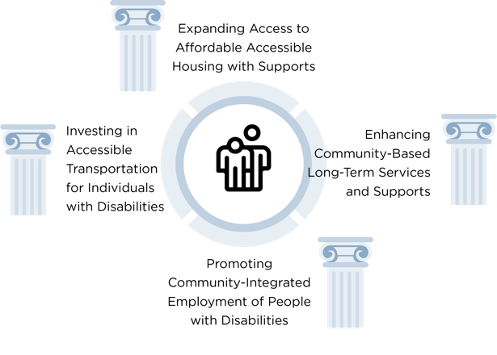

# What Have We Accomplished?

Progress Since 2018

In its 2018 Olmstead Plan, Massachusetts set an ambitious agenda with specific goals that would improve community living efforts across the four pillars of Housing, Services, Employment, and Transportation. While substantial progress has been made towards community integration, implementation of a state’s Olmstead Plan does not occur in a vacuum, but often in the context of a system or systems already faced with competing priorities, finite resources, and a myriad of challenging circumstances.

Since 2018, Massachusetts has experienced growing demands and complexities within its system, largely driven by the global COVID-19 pandemic and its ongoing effects. While the pandemic brought unique challenges, it also highlighted the need for strategies to address workforce shortages in the community-based system and the importance of flexible service delivery. In needing to adapt to changing circumstances, Massachusetts has been guided at every step by individuals with lived experience, their families, and a diverse group of stakeholders.

Below are specific initiatives focused around the four pillars of Housing, Services, Employment, and Transportation that Massachusetts has undertaken since 2018 that have advanced the cause of community living and the principles of Olmstead.

## Expansion of Access to Affordable, Accessible Housing

Massachusetts has a high-cost housing market. In response to this challenge, Massachusetts has established multiple state-funded housing production and rental assistance programs specifically targeted to support people with disabilities to live in their community of choice. Today, Massachusetts is a leader in providing integrated, affordable, accessible housing. While no state has an adequate supply of affordable rental housing, the National Low Income Housing Coalition data shows that Massachusetts ranks in the top tier.

Nationally, Massachusetts ranks 11th in adequacy of housing supply among states and has the 10th highest number of units, with 46 affordable rental units per 100 extremely low-Income renter households.

Since the release of its 2018 Olmstead Plan, Massachusetts has continued to invest substantial resources in making housing more affordable and accessible for people with disabilities. These investments include: new production, increased supply of integrated housing, increasing investments in rental assistance programs, supporting the modification of existing homes, and housing search and transitional assistance.

1. No State has an Adequate Supply of Affordable Rental Housing for the Lowest-Income Renters[3]

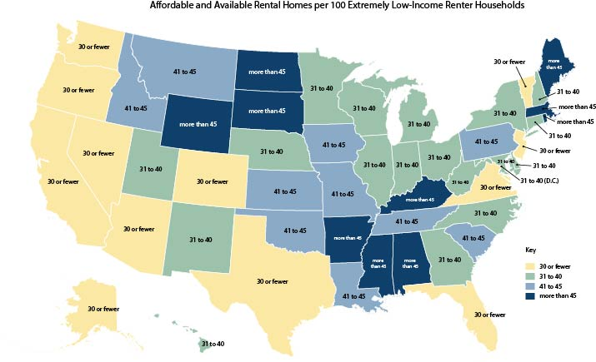

Source: Map based on [The Gap: A Shortage of Affordable Homes](https://nlihc.org/gap), National Low Income Housing Coalition

### **New Production**

Massachusetts continually invests in new housing to increase the supply of affordable and accessible housing. Specific housing capital programs that fund housing for people with disabilities include the Facilities Consolidation Fund (FCF) and the Community Based Housing (CBH) program fund, as well as the Housing Innovation Fund (HIF). FCF was created in response to an advocate-driven effort to close institutions serving Department of Mental Health (DMH) or Department of Developmental Services (DDS) consumers. The fund provides capital for the development of community-based housing for clients of DMH and DDS. The CBH program funds the development of integrated housing for people with disabilities, including older adults, with priority for individuals who are in institutions, nursing facilities, or at risk of entering an institution or nursing facility. HIF funds affordable rental housing for special needs populations; EOHLC currently gives preference to projects that provide transitional and permanent housing for individuals and families experiencing homelessness. Since the release of the 2018 Olmstead Plan, Massachusetts has invested over $220 million through these programs in building housing for people with disabilities and those experiencing homelessness.

1. Investments in building housing for people with disabilities since 2018

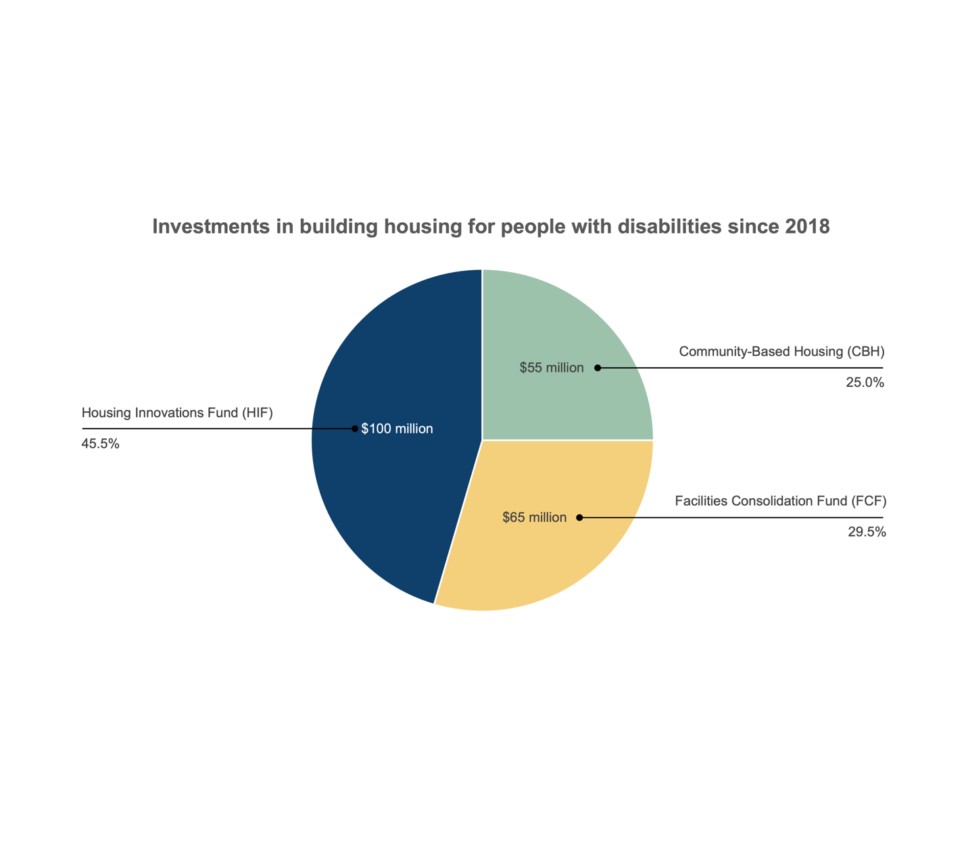

Between fiscal year (FY) 2018 and FY2023, over 10,000 affordable units were funded. As these and other EOHLC investments are generally in new construction or substantial rehabilitation, most of these properties include accessible units as required under state and federal fair housing laws. Among the 10,000 affordable units, Massachusetts funded the development of 3,897 units of permanent supportive housing (PSH) across multiple funding sources. PSH refers to affordable housing combined with voluntary supportive services, prioritized for people with disabilities and/or who have experienced homelessness or housing instability.

### **Increased Supply of Integrated Housing**

Towards that same end, Massachusetts has shifted policy to increase the supply of integrated housing for people with disabilities. The Massachusetts 3% Priority Program, for example, supports the state’s efforts to help people with disabilities and older adults live in the least restrictive and most integrated setting possible of their choosing. Through this program, the state provides priority access for people with disabilities and older adults to community-based housing coupled with the services they need to be successful members of the community. Since 2018, Massachusetts has refined the program to better target low-income individuals with disabilities referred by DMH, DDS, MassAbility[4], and the Executive Office of Elder Affairs (EOEA). As of September 2020, owners of publicly supported rental developments[5] with at least 17 affordable units are required to prioritize referrals from these state agencies for 3% of the subsidized units.

### **Increasing Investments in Rental Assistance Programs**

In addition to increasing the supply of affordable units, Massachusetts has committed to funding programs that provide housing assistance to persons with disabilities. EOHLC administers numerous rental assistance programs consisting of flexible subsidies that assist individuals and households in affording the housing costs of market-rate units. Rental assistance program participants typically pay 30% of their income for rent and EOHLC pays the landlord the remaining cost, up to the applicable rental standard. Tenants are generally able to choose the type and location of their unit. Some vouchers are mobile and allow the participants to take the vouchers with them if they move to another property or community. Other vouchers are attached to specific units and are not mobile.

EOHLC administers over 23,000 federally funded Section 8 Housing Choice Voucher Program (HCVP) vouchers and over 10,000 state-funded Massachusetts Rental Voucher Program (MRVP) vouchers. People with disabilities have access to both of these programs. EOHLC reports that an estimated 40% of MRVP vouchers are used by households with a head of household who has a disability and that 49% of HCVP vouchers are used by households with a head of household who has a disability and/or is an older adult. EOHLC often project-bases HCVP and MRVP vouchers in projects funded with FCF, CBH, and HIF in order to make them affordable to extremely low-income people with disabilities.

Importantly, the state also administers vouchers that are specifically targeted and available only to people with disabilities. Federally funded targeted programs include Mainstream vouchers, a component of the HCVP program for which the only eligible households are those that include at least one person between the ages of 18 and 62 who has a disability. Since 2018, the state has been awarded 127 additional Mainstream vouchers for a total of 291. EOHLC also administers the Section 811 Project Rental Assistance (PRA) program, a federally funded partnership between EOHLC and EOHHS that provides integrated housing for extremely low-income adults with disabilities under the age of 62 including individuals transitioning from long-term care facilities into the community and those who are at risk of entering such facilities. The program is designed to support persons with disabilities who need affordable housing and access to community-based supports and services, such as case management, housekeeping, and daily living assistance, to successfully live independently in the community. The state has applied to and been successful in every 811 PRA competitive funding round beginning in 2012. Since 2018, the state has applied for and been awarded funding for 72 units in 2020 and funding for 62 units in 2023, bringing the current total to 272 units.

State-funded rental assistance programs targeted to people with disabilities include DMH’s Rental Subsidy Program and the Alternative Housing Voucher Program (AHVP). Only DMH clients are eligible for the DMH Rental Subsidy Program, which provides sponsor-based and tenant-based vouchers; this rental assistance is paired with services funded by DMH. AHVP provides rental assistance to non-elderly persons with disabilities, and is administered by local housing authorities and regional administering agencies. Since 2018, the DMH Rental Subsidy Program has increased by more than 50%, from serving 1,430 clients in FY2019 to 2,451 in FY2024. The AHVP program has increased by over 85% from 425 leased vouchers in FY2019 to 798 in FY2024.

The chart below shows the overall growth in housing vouchers for persons with disabilities from 2019 to 2023, and indicates a 11.1% increase from 17,502 vouchers in 2019 to 19,444 vouchers in 2023.

1. Housing Vouchers for People with Disabilities in Massachusetts

A stacked bar chart showing how many vouchers of each type were available from 2019 to 2023. 
The biggest category is Housing Choice Vouchers: the number of HCV vouchers varied slightly over the 5-year period, starting with 10,351 in 2019 and ending up with 10,518 in 2023. 
The second-largest category, MRVP vouchers, increased from 3,850 in 2019 to 4,478 in 2023. DMH Rental Subsidy Program Vouchers increased from 1,430 to 2,254. AHVP vouchers increased from 570 to 893. 
The numbers of HUD Mainstream Vouchers, NED vouchers, and PRA 811 vouchers all stayed steady: Mainstream vouchers at 291; NED vouchers at 800; and PRA 811 vouchers at 210.

1. Housing Vouchers for People with Disabilities in Massachusetts

|  |  |  |  |  |  |
| --- | --- | --- | --- | --- | --- |
| Housing Vouchers for Persons with Disabilities in MA | 2019 | 2020 | 2021 | 2022 | 2023 |
| **811 Vouchers** | 210 | 210 | 210 | 210 | 210 |
| **Alternative Housing Voucher Program Vouchers** | 570 | 702 | 753 | 819 | 893 |
| **Dept. of Mental Health Rental Subsidy Program Vouchers** | 1,430 | 1,573 | 1,799 | 2,007 | 2,254 |
| **Housing Choice Vouchers (HCV)\*\*** | 10,351 | 10,424 | 10,613 | 10,571 | 10,518 |
| **HUD Mainstream Vouchers** | 291 | 291 | 291 | 291 | 291 |
| **MA Rental Voucher Program Vouchers* (MRVP)** | 3,850 | 3,930 | 4,180 | 4,437 | 4,478 |

*This data series represents the 40% of the MRVP vouchers held by households with a disabled head of household.  
**This data series represents the 49% of HCV held by households with a disabled and/or elder head of household.

### **Supporting the Modification of Existing Homes**

Another strategy Massachusetts has used to increase accessible, affordable housing is to fund the modification of existing homes or properties to accommodate residents or their family members with disabilities.

The Home Modification Loan Program (HMLP), administered by the Community Economic Development Assistance Corporation (CEDAC), helps individuals to remain in their own homes by making changes such as installing wheelchair ramps, bathroom adaptations, and other accessibility modifications. HMLP provides low- and no-interest loans for home modifications to older adults, individuals with disabilities, the families of children with disabilities, and qualified landlords who rent homes to individuals with disabilities. Since FY2019, Massachusetts has issued 1,140 home modification loans, totaling an investment of over $34 million, through this program.

1. Home Modification Loans (FY19 – FY23)

A graph showing the number of home modification loans issued annually from fiscal year 2019 to fiscal year 2023. 
There were 238 in FY2019; 190 in FY2020; 173 in FY2021; 144 in FY2022; and 162 in FY2023, for a cumulative total of 907 loans.

1. Statewide Fiscal Year Summary for Home Modification Loans (FY2019 – FY2024)

|  |  |  |  |  |
| --- | --- | --- | --- | --- |
| State Fiscal Year | No. of Households | No. of Loans | Total Amount Deployed | Average  Loan amount |
| **2024** | 212 | 233 | $7,209,635 | $34,000 |
| **2023** | 149 | 162 | $5,074,189 | $34,055 |
| **2022** | 131 | 144 | $4,436,280 | $33,864 |
| **2021** | 157 | 173 | $5,319,427 | $33,881 |
| **2020** | 172 | 190 | $5,411,610 | $31,462 |
| **2019** | 205 | 238 | $6,552,144 | $31,961 |

MassAbility also provides home modifications through its community living division. MassAbility covers the cost of home modifications up to $50,000 when needed to help a person transition from a nursing facility to the community under the Moving Forward Plan-Community Living waiver or the MFP Demonstration. Examples of home modifications funded through MassAbility under these two programs include the installation of wheelchair ramps, the widening of doorways to enable wheelchair ingress/egress, and the remodeling of homes to create accessible bathrooms. Homeownership is not required, and modifications are available for individuals transitioning to both rental apartments and privately owned homes.

Since 2018, MassAbility has completed 995 home modifications that were necessary to enable an individual to move from a facility to the community, with an average cost of approximately $19,700 per home modification. Table 3, below, provides the total number of home modifications provided by MassAbility from FY2018 through FY2024.

1. Home Modifications by MassAbility from FY2018–FY2024

|  |  |  |  |  |
| --- | --- | --- | --- | --- |
| STATE FISCAL YEAR | Major Home Mods (>$5,000) | Minor Home Mods (<$5,000) | TOTAL | Average Home mods cost |
| **2024** | 116 | 32 | 148 | $ 21,634.65 |
| **2023** | 121 | 37 | 158 | $ 16,952.94 |
| **2022** | 96 | 47 | 149 | $ 17,115.19 |
| **2021** | 103 | 25 | 128 | $ 20,325.22 |
| **2020** | 120 | 8 | 128 | $ 24,752.56 |
| **2019** | 137 | 12 | 149 | $ 17,419.22 |
| **2018** | 115 | 20 | 135 | $ 19,715.54 |

### Housing Search and Transitional Assistance

In addition to increasing the supply of affordable and accessible housing and supporting residents’ ability to afford existing housing, Massachusetts has made significant advances in supporting individuals throughout the housing-seeking process. These improvements focus on enhancing access to housing by refining housing search and application procedures and tools. In April 2019, Massachusetts introduced the [Common Housing Application for Massachusetts Programs](https://publichousingapplication.ocd.state.ma.us/) (“CHAMP”) portal, allowing applicants to access state-funded subsidized housing resources online, including state-aided public housing, MRVP, and AHVP.

Furthermore, the state facilitated the development of the [Housing Navigator](https://search.housingnavigatorma.org/) in 2021, an online search tool encompassing all affordable housing options. Housing Navigator is the official online listing and search tool for accessible and affordable rental homes in Massachusetts, and includes filters for various accessibility features of listed units. As of mid-2024, 40,000 people use the Housing Navigator search tool every month — more than 400,000 unique users a year.[6]

Beyond having sufficient affordable and accessible housing, and assistance with locating such housing, persons seeking to transition to the community from an institution may have other unique housing related barriers to transition. These barriers may manifest as lack of funds to cover a security deposit, a lack of resources to cover costs associated with furnishing a home in the community, or need for assistance with setting up utilities and coordinating a move to the community. Massachusetts has sought to address these unique barriers to transition through the following initiatives.

#### Mitigating the Costs of Housing (MATCH) Program

With federal funds available through the American Rescue Plan Act (ARPA), EOHHS developed the MATCH program in 2023 to help MassHealth members pay for move-in costs and buy the items they need to make a new home livable. MATCH funds were available to pay for one-time costs for those moving out of institutions — including nursing homes and correctional facilities — or moving from homelessness into housing. Flexible funds were used for a variety of services including the following one-time transition costs: move-in assistance (e.g., moving costs, security deposits, costs related to starting utilities, first month’s rent); furniture; basic furnishings and supplies to set up a bathroom and bedroom (e.g., bedding, towels, toiletries); basic kitchen supplies (e.g., dishware, silverware, cooking supplies, appliances not supplied by the property owner); environmental modifications necessary to install necessary accommodations but not covered by insurance; pest eradication or one-time cleaning; and other one-time expenses required for the transition from an institution to community housing. Through the MATCH program, Massachusetts helped almost 2,600 individuals to find, secure, and transition to community housing.

While MATCH was a standalone program funded with one-time funds available through ARPA, Massachusetts currently operates multiple programs that cover similar transition costs to assist individuals in overcoming housing-related barriers and moving from facilities to the community. These programs include multiple MassHealth HCBS waivers that provide transitional assistance services; the state’s current MFP Demonstration, launched in 2023; and the Executive Office of Elder Affairs’ Community Transition Liaison Program (CTLP). Details on these programs are provided in the next section of this report, covering enhancements to community-based services and supports since 2018.

#### Homeless Initiatives Serving People with Disabilities

Despite efforts to increase housing supply and affordability and decrease barriers to finding housing, homelessness persists among the disability population. The U.S. Department of Housing and Urban Development’s (HUD) 2023 HUD Homeless Populations and Subpopulations report for Massachusetts indicates that many homeless individuals self-report as having a mental illness and/or a substance use disorder.[7] As many of these individuals with disabilities are not only experiencing homelessness but are also at risk of entering an institution or nursing facility, Massachusetts’ Olmstead-related housing initiatives have also sought to address homelessness.

One way Massachusetts has worked to address homelessness among individuals with disabilities is by participating in the federally funded Continuum of Care (CoC) program. Through this program, regional organizations coordinate housing programs and services to assist individuals and families experiencing homelessness. There are 11 CoCs in Massachusetts that collectively fund 8,881 units of PSH. PSH provides long-term housing subsidies and support services to eligible individuals who are homeless and have a disability. Additionally, the Balance of State CoC, managed by EOHLC, anticipates increasing the number of households in PSH during 2024 by 35 households with children. In EOHLC’s October 2024 submission to HUD for additional funding, EOHLC is seeking to add 37 units for medically fragile homeless individuals and 30 units for homeless individuals with a substance use disorder.

The Safe Haven program is another Massachusetts initiative that seeks to address homelessness among individuals with disabilities. This program provides supportive housing for hard-to-reach individuals with serious mental illness (SMI), primarily those who have been living on the streets and are unable or unwilling to engage in traditional housing or support services. Safe Havens use a [Housing First](https://mhsa.net/how-we-help/housing-first/) supportive housing model, offering an alternative to shelter placement. While many Safe Haven clients choose to participate in behavioral health treatment, it is not required to access Safe Haven housing. Since 2018, DMH has added 39 Safe Haven beds, with 35 more in development, which will bring the total to 140 beds.

Additionally, in 2022, EOHLC developed the Sponsor Based Permanent Supportive Housing Program, creating 200 units of service-rich housing for very vulnerable homeless persons. The project was expanded in 2023 to sustain low-threshold sponsor-based leasing. The program was designed to mitigate overcrowding in homeless shelters and leverage existing Medicaid supportive services to ensure individuals have the necessary supports to remain housed. In 2024, the program received $8.9 million in legislative appropriations to support 329 adults in PSH.

Another innovative program to help prevent homelessness and promote long-term housing stabilization for individuals with high health care needs is Massachusetts’ Medical Respite pilot program. In 2023, Massachusetts awarded $5.2 million in grants for partnerships between health care agencies and community-based organizations under a new medical respite pilot program that provides individuals experiencing homelessness a safe space to recover after a hospital visit. Medical Respite locations currently offer 40 beds of temporary housing with clinical supports while program participants receive assistance in finding suitable long-term housing. The Medical Respite Program aims to improve hospital discharge rates, reduce hospital lengths of stay, and decrease the total cost of care for patients experiencing homelessness. It also seeks to strengthen the relationship between providers of homelessness services and health care agencies. Medical respite locations serve individuals experiencing homelessness who meet specific criteria, such as being discharged from a hospital with no housing option, requiring a safe place to prepare for a medical procedure, and not needing hospital-level care or 24/7 support. Studies have shown that medical respite programs significantly reduce health care costs and improve health outcomes by reducing hospital inpatient lengths of stay and readmissions. They have also proven instrumental in helping individuals achieve long-term housing stabilization.

## Enhancements to Community-Based Services and Supports

Since 2018, Massachusetts has made substantial investments to improve access to and quality of community-based care, expand community-based service options, and support choice in services and providers. Most notably, via one-time ARPA funds, Massachusetts invested more than $650 million in a range of initiatives designed to support the strengthening of Medicaid-related home and community-based services.[8]

The following section captures progress across two main Olmstead-related themes: 1) new and existing programs and initiatives designed to support diversion and discharge from facility-based settings to the community and 2) new and existing programs and initiatives to enhance and expand Massachusetts’ infrastructure of community-based services and supports.

### Programs and Initiatives that Support Diversion

In the 25 years since the Supreme Court’s Olmstead decision, Massachusetts has developed and implemented numerous programs that are designed to help reduce reliance on facility-based settings for the delivery of long-term services and supports. This includes programs that provide options counseling for individuals living in the community to help them understand their care options. This also includes programs that screen individuals prior to an admission to a nursing facility to determine whether they have an intellectual disability or serious mental illness and to assess whether community-based services are more appropriate. Additionally, this includes innovative diversion programs for persons with mental illness that seek to help maintain community tenure, as well as programs that evaluate hospital patients at the point of discharge to a nursing facility for post-acute care to determine whether discharge home is a possible alternative.

For individuals who have been residing long-term in facility-based settings, there are programs and initiatives to help them understand their options for discharge and return to the community. Additionally, because individuals who have resided long-term in a facility-based setting frequently do not have access to community housing, these programs include support in locating and accessing community-based housing. This support may include assistance with the housing search process, completion of housing related paperwork, and funding for one-time setup costs for the individual’s new home in the community (e.g., the purchase of kitchen supplies and bedroom furnishings).

#### Options Counseling to Promote Informed Choice for Long-Term Care

Often times individuals and their caregivers are unaware of their options for long-term care and presume that admission to a nursing facility is the only path. Massachusetts recognizes the importance of informed choice and operates multiple programs to help ensure that individuals and their families are informed of the options to receive long-term care services in the community and as an alternative to receiving services in a facility-based setting. One manner in which outreach is performed is through EOEA’s Options Counseling program. The Options Counseling program serves both individuals in community settings who are at risk of admission to a nursing facility, as well as individuals residing in facilities who express a wish to return to the community, and is available to all individuals regardless of insurance type.

In state fiscal year (SFY) 2023, EOEA provided options counseling to 4,785 individuals. [9] Review of available data indicates that 96% of individuals who received options counseling in the community with an initial goal of staying in the community were able to achieve that goal.[10] More importantly, 65% of individuals who received options counseling in the community with an initial goal of entering a nursing facility opted for community-based services instead.[11]

#### Pre-Admission Screening and Resident Review (PASRR) Enhancements

For persons with an intellectual disability (ID) or Serious Mental Illness (SMI)[12], or suspected of having an ID or SMI, EOHHS operates a PASRR program pursuant to federal requirements. Through PASRR, EOHHS is able to ensure that persons seeking admission to a nursing facility are screened for ID/SMI and that persons suspected of having ID/SMI receive a comprehensive evaluation prior to admission and upon any significant change in condition. The comprehensive evaluation includes an assessment, recommendation, and determination as to whether the person’s total care needs can be met in a nursing facility or whether community-based services would be more appropriate.

In 2023, EOHHS, in collaboration with DMH and DDS, launched an online PASRR portal to digitize and streamline the PASRR process. Introduced in late August 2023, this portal enables the state to track PASRR screenings and PASRR evaluations more effectively. The portal also enhances DDS’s and DMH’s ability to analyze PASRR outcomes on a broader scale, helping to identify patterns and detect potential biases. Additionally, the portal assists nursing facilities in monitoring PASRR status for their residents and supports EOHHS enforcement of nursing facility compliance with PASRR regulations. In FY2023, 84,585 PASRR Level I screenings were completed, and 5,802 PASRR Level II evaluations were conducted.

1. PASRR Screening Data

|  |  |
| --- | --- |
| PASRR Screening Completed | Metrics |
| Number of PASRR Level I screens completed 8/28/23-6/30/24*  *The PASRR Level I screen assesses whether a person may have SMI and/or ID. If the screening indicates the assessed person may have SMI and/or ID, a PASRR Level II evaluation is performed.* | Total Screenings: 84,585  May have SMI: 10,611 May have ID: 817 May have SMI and ID: 243 No SMI: 73,974 No ID: 73,157 |
| Number of PASRR Level II evaluations completed 7/1/23-6/30/24*  *The PASRR Level II evaluation determines whether a person has SMI and/or ID.* | Total Evaluations: 5,802  SMI Positive: 670 SMI Negative: 5,132 ID Positive: 523 ID Negative: 147 |

*Data is by total number of screenings/evaluations, not total number of individuals screened/evaluated

#### Hospital to Home Partnership Program (HHPP)

To further promote diversion from nursing facility admission and towards community-based services, EOHHS launched a grant program in 2024 to embed a Hospital to Home Liaison in hospitals to provide enhanced discharge planning. The grant funds support HCBS Hospital Liaisons, employed by local area Aging Services Access Points (ASAPs), who partner with hospital case managers to connect patients with home and community-based services before discharge. This initiative aims to reduce hospital-to-nursing-facility discharges by fostering partnerships between hospitals and local ASAPs, improving communication and coordination with community-based services providers and with the goal of promoting discharges directly to home settings. Massachusetts awarded an initial 10 grants of $300,000 each followed by an additional 5 grants totaling approximately $850,000. While this is a new program, some hospitals have already reported that this program has been an invaluable resource for improving discharges to home and other hospitals have expressed interest in participating.

#### DMH Jail Diversion Program

The DMH Jail Diversion Program has aimed to keep individuals with mental illness or other behavioral health conditions who are experiencing a crisis out of prisons, jails, and emergency departments. Studies note that nationally, jails have become the nation’s largest psychiatric institutions, and emergency departments can be the gateway to long-term institutional care. The DMH Jail Diversion Program has provided grant funding directly to municipalities and behavioral health providers to help support diversion projects, while also supporting technical assistance for law enforcement and their behavioral health partners statewide. Data gathered by DMH to evaluate the success of these grants has demonstrated positive outcomes.

1. Diversion Outcomes by Grantees (FY19–FY23)

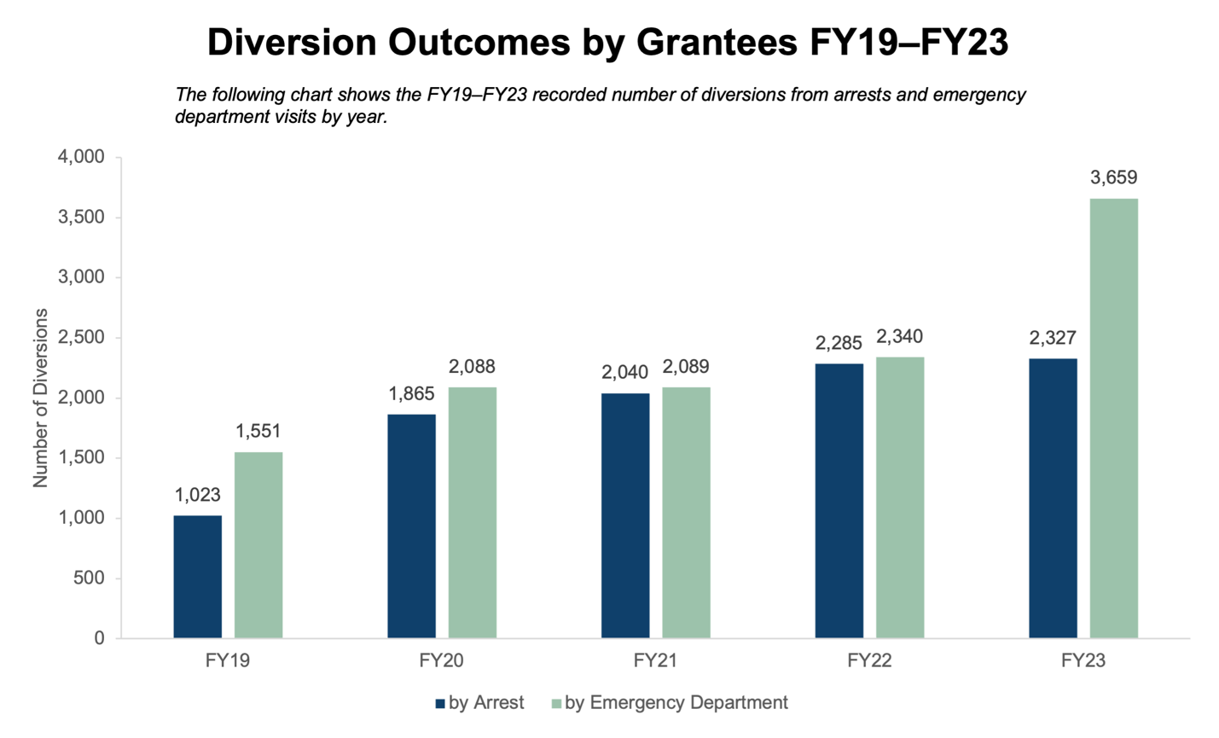

Further evidence to support the success of DMH’s efforts to reduce unnecessary hospitalizations can be found in an NRI State Profiles report which identifies Massachusetts among states with the lowest percentage of population in state psychiatric hospitals.

1. State Psychiatric Hospital Patients on First Day of Fiscal Year 2022, per 100,000 State Population

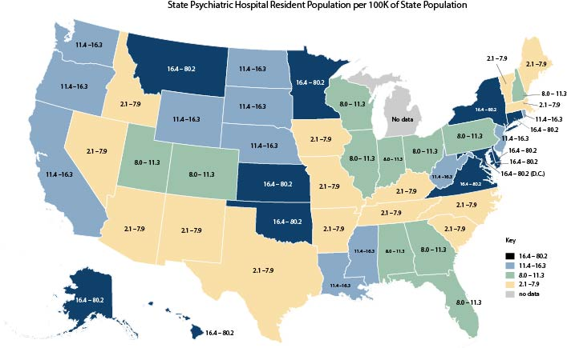

### Programs and Initiatives that Support Discharge from Long-term Care Facilities

Since implementation of the 2018 Olmstead Plan, Massachusetts has made substantial investments in a number of innovative programs to identify and assist individuals residing in long-term care facilities to transition to the community with supports. This includes:

#### ***The Community Transition Liaison Program (CTLP)***

CTLP was created by EOEA to assist nursing facility residents in exploring community service options and transitioning back to community living. The program began operation in July 2023 and is available to all nursing facility residents aged 22 and older, regardless of diagnosis or insurance type. The program operates through EOEA contracts with local area ASAPs. CTLP teams are assigned to specific nursing facilities and visit each nursing facility at least once a week. CTLP teams offer education about community living options, support informed choice, and for residents interested in transitioning to the community, CTLP teams provide transition support and help arranging community-based services and supports. Each team includes a full-time Community Transition Liaison and a Case Assistant supported by a part-time supervisor. In 2024, there are 45 CTLP teams providing statewide coverage. Since implementation of this new program, CTLP teams have helped over 1,200 individuals transition from nursing facility to community settings. The chart below provides the total number of individuals that enrolled in CTLP and who completed a transition to the community with CTLP supports in SFY 2024.

1. Community Transition Liaison Program Enrollments and Assisted Transitions for State FY23

|  |  |  |
| --- | --- | --- |
| State Fiscal Year | CTLP Enrollment | CTLP Assisted Transitions |
| 2024 | 3,763 | 1,201 |

#### Implementation of a Renewed Money Follows the Person Demonstration (MFP Demo)

In April 2023, EOHHS successfully negotiated funding for a renewed MFP Demo with the federal government. This initiative supports EOHHS’s goal of promoting community-based care as an alternative to receiving care in an institutional setting. The MFP Demo seeks to identify Medicaid-eligible individuals residing in a nursing facility for at least 60 days who wish to transition to community living, with a focus on identifying older adults, individuals with ID/DD, individuals with mental illness, and individuals with physical disabilities. Participants in the program receive specialized services beyond those covered by MassHealth, including housing search assistance, transitional assistance services to help cover initial home set up costs such as the purchase of kitchen supplies and bedroom furnishings, as well as medically necessary home modifications such as the installation of ramps for ingress and egress.

Massachusetts’ MFP Demo began enrolling individuals in July, 2023 and currently there are 710 individuals enrolled in the program, while 173 individuals have successfully transitioned from a facility to the community under the program.

1. Money Follows the Person (MFP) Demonstration Chart: Number enrolled to date and number of transitions to date

|  |  |  |
| --- | --- | --- |
| Calendar Year | MFP Demo Enrollment | MFP Demo Participants (transitioned to the community) |
| **2023** | 381 | 71 |
| **2024** | 710 | 173 |

#### Behavioral Health Community Partners in Nursing Facilities (BH CPs in NFs)

In July 2023, EOHHS and DMH launched the Behavioral Health Community Partners (BH CP) program in nursing facilities to provide enhanced coordination of behavioral health and specialized services for nursing facility residents identified as having SMI pursuant to a PASRR evaluation. The overall goal of the BH CP program is to improve care coordination and delivery of behavioral health and specialized services for nursing facility residents with SMI, with an emphasis on facilitating transitions to community-based living.

Through this program, EOHHS partners with BH CPs — organizations specializing in behavioral health care — to coordinate recommended behavioral health and specialized services. This care coordination helps ensure that nursing facility residents with SMI receive the essential behavioral health services and supports they need. Since implementation of this program more than 840 individuals residing in nursing facilities have received BH CP care coordination.

In combination with this program, in December 2022, DMH updated its regulations to extend DMH eligibility to all nursing facility residents identified as having SMI through a PASRR evaluation. As part of this expansion, DMH now offers transition case management services to nursing facility residents identified as having SMI who are expected to be discharged within 90 days. The DMH transition case managers facilitate the transition process and coordination for supports and services in the community. Since implementation of this program, DMH has provided nursing facility transition case management to over 92 individuals to assist with transition to a community-setting with supports.

1. Department of Mental Health (DMH) and Behavioral Health Community Partners (CP) Outcomes

|  |  |
| --- | --- |
| DMH Nursing Facility Transition Team and BH CP |  |
| Number of persons enrolled with DMH transition case management | 164 |
| Number of persons with DMH transition case management who transitioned to community | 92 |
| Number of persons enrolled with BH CP | 804 |

For individuals who transition to the community with DMH supports, DMH offers community-based supports through its Adult Clinical Community Services (ACCS) program, which is a comprehensive, clinically focused service model anchored by a multidisciplinary team that provides clinical coverage 24 hours a day, 7 days a week, 365 days a year. Specifically, ACCS provides clinical assessment of symptoms and risk factors and develops treatment plans to treat symptoms and mitigate risk in order to promote community tenure, improve symptom stabilization, promote self-sufficiency, and maximize functioning, safety, and health for persons with complex behavioral health issues living in the community.

ACCS encompasses two primary components: ACCS Group Living Environments (GLEs) and ACCS Integrated Teams (ITs). ACCS GLEs provide a range of housing with services options, which serve as treatment settings to assist individuals in developing skills and establishing natural supports and resources to live successfully in the community. ACCS ITs provide clinical interventions and peer and family support to individuals residing in the community, and support individuals as they develop the skills to move toward independence. Specific supports include providing assistance with securing affordable housing, including ongoing engagement with clinical teams, and continued treatment interventions to promote successful community living.

To further support individuals who are transitioning or diverting from skilled nursing facilities to the community, DMH has established a new intensive ACCS model — Enhanced Medical Group Living Environment (EMGLE) — that provides 24/7 nursing and related supports in a community-based setting for individuals who require a higher level of nursing care than available under a GLE.

### Growth in Massachusetts’ Community-Based Services Infrastructure

Since 2018, Massachusetts has continued to invest, innovate and expand its community-based services infrastructure. This includes the continued expansion and growth in the state’s Medicaid Home and Community-based services waivers, as well as the continued investment and expansion in options to self-direct services. The overall result of these efforts has been a continual decline in the number of Massachusetts residents residing in nursing facilities. While there have been numerous initiatives across EOHHS agencies, the following seeks to provide a brief overview of growth in this area.

### **Enhancements to MassHealth Home and Community-Based Services Waivers**

EOHHS, through its MassHealth program, operates ten Medicaid 1915(c) HCBS waivers, offering eligible individuals community-based services as an alternative to facility-based care. Together, these waivers support approximately 32,000 individuals—who would otherwise require services in a facility-based setting—to live integrated within their communities of choice.

MassHealth’s HCBS waivers are administered by different EOHHS agencies to leverage each agency’s specialized expertise in serving older adults and individuals with specific disabilities. Below is an overview of MassHealth’s ten HCBS waivers and the populations they serve.

#### Frail Elder Waiver

This waiver is operated by EOEA and is designed to help eligible older adults (60+) remain in their communities instead of moving to facility-based care as well as assist those seeking to transition from a facility to a community residence. Available services in the Frail Elder Waiver include services designed to assist frail older adults to maintain community residency and include services such as homemaking, assistance with personal care, grocery shopping and delivery, certified older adult peer supports, homemade meals, Alzheimer’s/dementia coaching, supportive day program services, transitional assistance, environmental accessibility adaptations, as well as a range of other services. Approximately 15,000 individuals are enrolled in the waiver at this time. In 2019, EOHHS renewed the waiver for an additional five years. In renewing the waiver, EOHHS increased capacity in the waiver by 800 slots and added self-direction as a mode of service delivery.

#### Intellectual Disability (ID) Waivers

These are three waivers operated by DDS — the Adult Supports waiver, the Community Living waiver, and the Intensive Supports waiver— that are designed to assist adults with intellectual disabilities to reside in the community as an alternative to residing in an Intermediate Care Facility for Intellectual Disability (ICF-ID). The three ID waivers each contain a unique set of services targeted to different acuity levels. All three waivers offer the ability for self-direction of certain services. Currently, there are approximately 16,500 individuals with ID enrolled in these waivers.

#### ****Moving Forward Plan (MFP) Waivers****

These are two waivers designed to assist adults with disabilities transition from a nursing facility or a psychiatric, chronic disease, or rehabilitation hospital back to the community. The MFP Community Living waiver is operated by MassAbility and supports those seeking to live independently in their own home or apartment, while the MFP Residential Supports waiver is operated by DDS and serves those needing 24/7 supervision and support in a provider-operated residence. Together, these two waivers serve approximately 1,527 individuals. The Massachusetts Community Living Initiative, described further in this report at page 42 includes an expansion of capacity in these two waivers.

#### ****Children’s Autism Waiver****

This waiver supports children with autism, from birth to age 10, to live in the community. The waiver is operated by DDS and includes a range of services including expanded habilitation, education, and in-home services and supports. In 2022, the waiver was amended to add capacity to serve an additional 225 individuals, bringing the total capacity to 665.

#### ****Acquired Brain Injury (ABI) Waivers****

These are two waivers designed to assist individuals aged 22+ with brain injuries transition from a nursing facility or a psychiatric, chronic disease, or rehabilitation hospital back to the community. The ABI Non-Residential waiver is operated by MassAbility and is designed for those seeking to live independently in their own home or apartment, while the ABI Residential waiver is operated by DDS and serves those needing 24/7 supervision and support in a provider-operated residence. Combined, these two waivers serve over 700 individuals. In 2019 EOHHS renewed the waivers for an additional 5-year term and as part of the renewal process, added services to the waivers to align with services available in the MFP waivers including Community-Behavioral Support and Navigation Services, Community-Based Day Supports, assistive technology, home delivered meals, and laundry services.

#### Traumatic Brain Injury (TBI) Waiver

Operated by MassAbility, this waiver supports adults aged 18+ with TBI who wish to live in the community instead of a facility. The waiver includes residential support services, habilitation services, and other services designed to enable participates to reside safely in the community. This waiver currently serves 78 waiver participants. In 2023, EOHHS amended the waiver to include assistive technology as an additional available waiver service.

### **Expansion of MassHealth’s Integrated Care Programs**

MassHealth, in conjunction with Medicare, administers three different integrated care programs to provide comprehensive, person-centered, coordinated care for MassHealth members with disabilities. These programs are the Senior Care Options (SCO) Program, the One Care Program, and the Program of All-Inclusive Care for the Elderly (PACE).

Since 2004, Massachusetts has offered the Senior Care Options (SCO) Program, which provides a comprehensive suite of services for MassHealth members aged 65 and older. The program combines all Medicare and Medicaid benefits into one, with access to additional services aimed at helping SCO enrollees remain in their communities of choice and to age in place. Each SCO enrollee receives case management support, including a geriatric support services coordinator. Innovative services available through SCO that support community tenure include home safety evaluations, environmental accessibility adaptations, and Alzheimer’s/dementia coaching, among other services. As of 2024, there are six SCO plans that collectively serve approximately 79,000 MassHealth members.

Similar to SCO, the One Care program (One Care) provides a comprehensive suite of services for disabled MassHealth members aged 21 to 64, aimed at helping One Care enrollees to live independently in their communities of choice. The program combines all Medicare and Medicaid benefits into one, with access to additional services. Each One Care enrollee receives care coordination of their services, which includes the option to receive additional care coordination for long-term services through a long-term services and supports coordinator. One Care also includes innovative services that promote community integration, such as coverage for social transportation, among other services. Massachusetts has offered the One Care program since 2013. As of 2024, there are three One Care plans that collectively serve approximately 42,000 MassHealth Members.

The PACE program is for eligible individuals age 55 + who require a nursing facility level of care. The program combines all Medicare and Medicaid benefits into one, and service delivery is centered around a PACE day program that provides access to community services and socialization in addition to medical services and care coordination. The primary goal of the PACE program is to provide PACE enrollees with the services they need to remain in their communities of choice and to age in place. Massachusetts has offered the PACE program through MassHealth for over 30 years. In the last several years, there has been a focus on expanding the service areas of existing PACE organizations to allow PACE to be offered to all eligible Massachusetts residents. As of 2024, Massachusetts has eight PACE organizations with over 5,000 enrollees. Nationally, Massachusetts ranks 2nd for PACE enrollment.[13]

1. Enrollment Growth for SCO (July 2018 – July 2024)

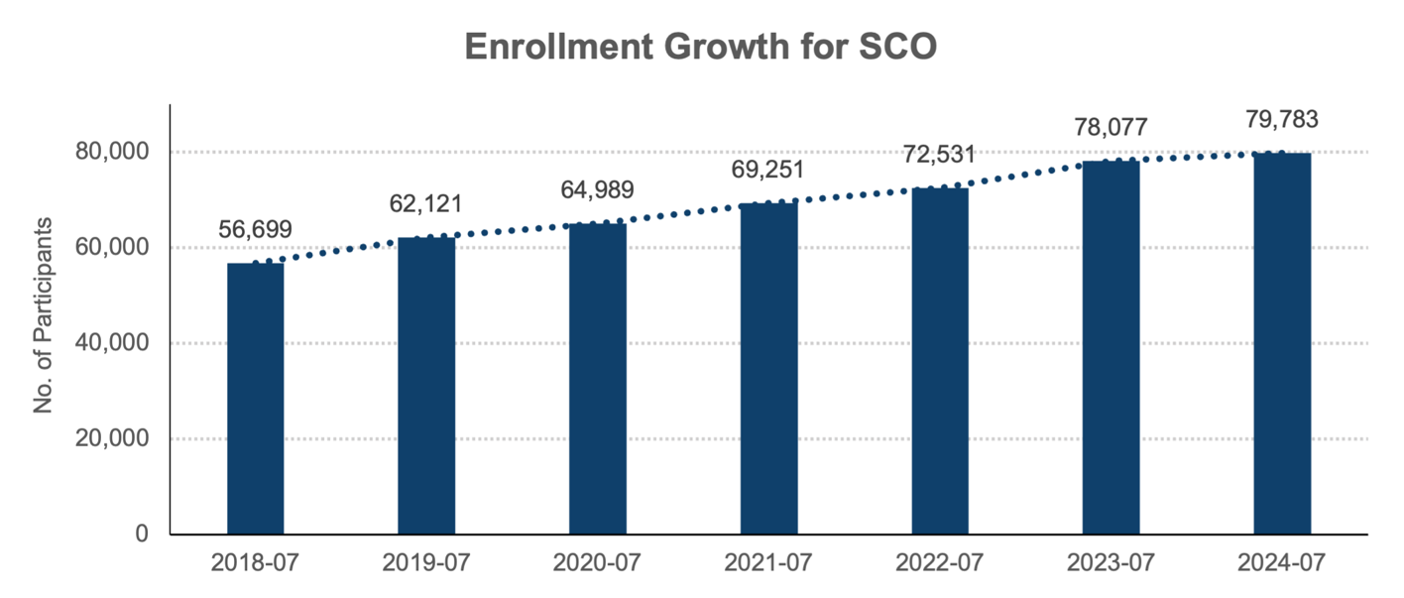

1. Enrollment Growth for One Care (July 2018 – July 2024)

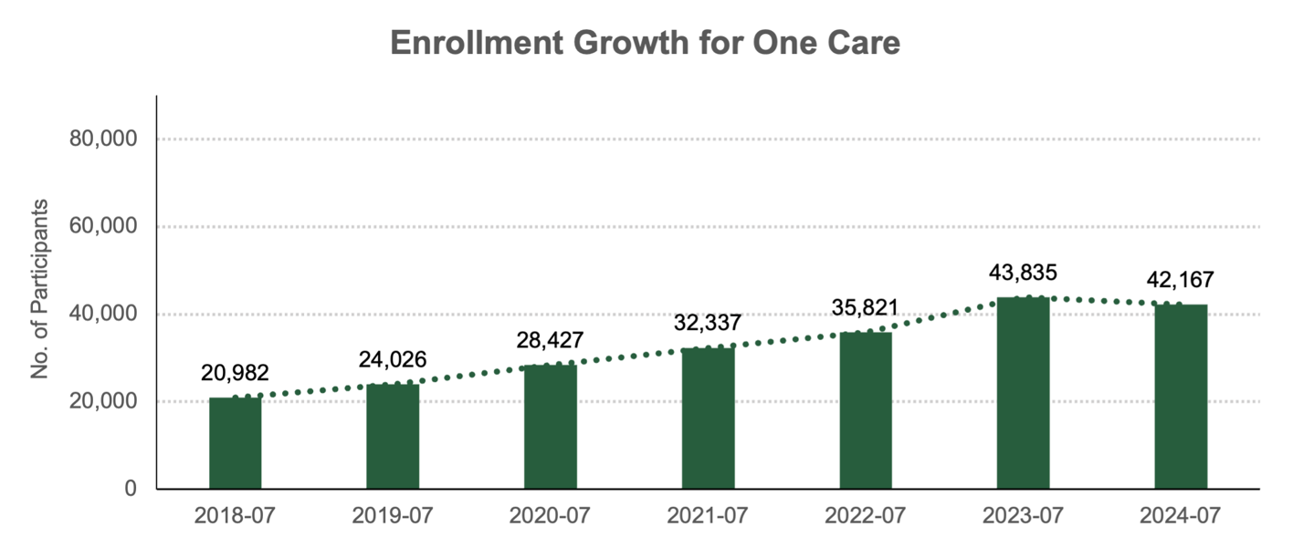

1. Enrollment Growth for PACE (July 2018 – July 2024)

Bar graph of enrollment growth for PACE by year from July 2018 to July 2024: 
2018: 4,662
2019: 4,927
2020: 4,717
2021: 4,824
2022: 5,066
2023: 5,364
2024: 5,445


### **Expansion of Opportunities for Self-Direction**

Massachusetts has a significant dedication to, and long history of promoting, self-direction of publicly funded services. The state’s dedication to self-direction is grounded in the Independent Living philosophy, which emphasizes consumer control, recognizing that individuals with disabilities are the best experts on their own needs. The philosophy recognizes that individuals with disabilities have agency, that their perspectives are crucial and valuable, and that they deserve equal opportunities to decide how they live, work, and participate in their communities — especially when it comes to services that significantly impact their daily lives and independence.

Self-direction service delivery models provide individuals and their families direct control over services, enabling them to tailor services to their specific needs and preferences. These models may include authority over decisions on hiring or firing providers, setting service schedules, defining tasks, choosing service locations, and may include authority over managing a budget. Through the inclusion of autonomy in the decision-making process, self-directed services help individuals maintain independence and dignity in the community.

Massachusetts ranks 4th in the nation for the number of individuals who choose to self-direct services.[14] Since 2018 Massachusetts has expanded self-direction opportunities in multiple programs and continues to invest and expand self-directed services through MassHealth, DDS, EOEA and other state agency programs.

Under Massachusetts Real Lives law, DDS provides the option for individuals with developmental or intellectual disabilities and their families to self-direct their services. In 2024, DDS introduced regulations establishing two options for self-directing services: 1) the Participant-Directed Program, and 2) Agency with Choice. The Participant-Directed Program allows individuals to manage their budgets and customize services and tasks based on their activities, interests, and needs. The Agency with Choice option provides agency support for employment functions and other activities, while still allowing individuals a degree of personal control. DDS’s recently promulgated self-direction regulations aim to further promote and enable DDS clients and their families to self-direct DDS-covered services and supports.

As shown in the table below, utilization of self-direction in DDS programs has grown significantly since 2018.

1. Growth in DDS self-direction numbers

|  |  |  |
| --- | --- | --- |
| State Fiscal Year | Number Enrolled in DDS Self-Direction Programs | State Spend |
| **2019** | 1,279 | $11,628,852 |
| **2024** | 2,475 | $25,734,937 |

Massachusetts demonstrates its commitment to self-direction not only through DDS and the Real Lives law, but also through the MassHealth Personal Care Attendant (PCA) Program, which enables eligible MassHealth members to self-direct their personal care services. Established in the 1970s, the program has empowered thousands of disabled individuals to live independently in their communities. The table below shows unduplicated member counts, the number of active PCAs, and program funding by state fiscal year. The data reflects the state’s substantial investment in self-direction, with PCA service utilization increasing by approximately 71% and state spending on PCA services more than doubling since 2018.

1. Growth in PCA program (SFY 2018 – SFY 2024)

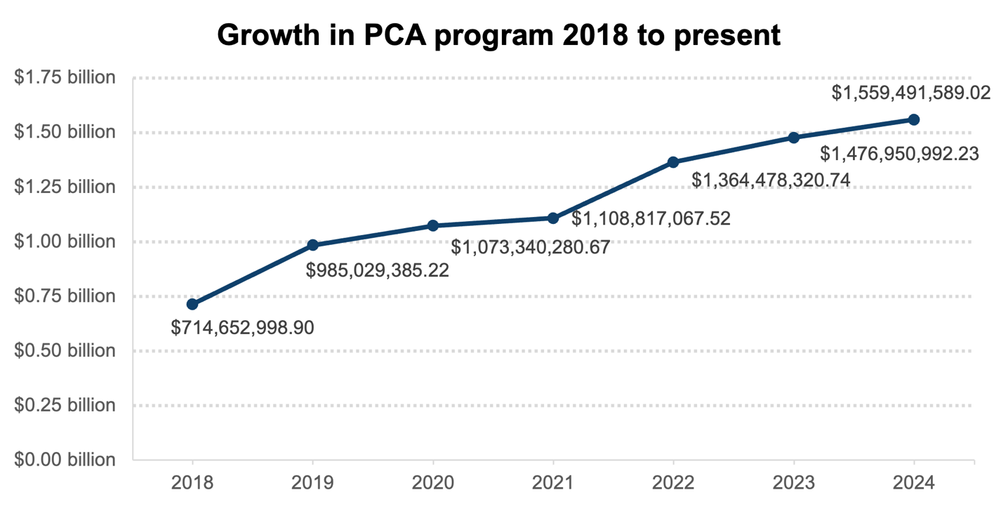

1. Growth in PCA program (SFY 2018–SFY 2024)

|  |  |  |  |
| --- | --- | --- | --- |
| State Fiscal Year | MassHealth Members Receiving PCA services | Number of PCAs | State Spend |
| **2018** | 31,863 | 47,664 | $714,652,998.90 |
| **2019** | 47,609 | 49,762 | $985,029,385.22 |
| **2020** | 48,585 | 47,871 | $1,073,340,280.67 |
| **2021** | 49,285 | 49,395 | $1,108,817,067.52 |
| **2022** | 51,168 | 51,010 | $1,364,478,320.74 |
| **2023** | 50,233 | 53,502 | $1,476,950,992.23 |
| **2024** | 51,649 | 53,570 | $1,559,491,589.02 |

Other MassHealth programs that offer the opportunity to self-direct services include the three Adult ID HCBS waivers, the Children’s Autism HCBS waiver, and the two Moving Forward Plan HCBS waivers. These six MassHealth HCBS waivers offer the opportunity to self-direct numerous services, including personal care, homemaking, adult companion, peer support, chore, and individual supports and community habilitation. Recognizing the importance of self-direction, EOHHS is currently working to operationalize self-direction in three other MassHealth HCBS Waivers, specifically the two Acquired Brain Injury Waivers and the Frail Elder Waiver.

The Massachusetts commitment to self-direction exists in other state programs as well. The state’s Home Care program, administered by EOEA, allows participants to self-direct personal care, homemaking, and companion services through the Consumer-Directed Care (CDC) model. Since 2018, the use of self-direction in the Home Care program has increased by approximately 45% and state spending on these services has doubled, as shown in the table below.

1. Growth in Home Care Program self-direction numbers

|  |  |  |
| --- | --- | --- |
| State Fiscal Year | Home Care Program Participants Utilizing CDC Self Directed Services | State Spend |
| **2018** | 2,471 | $10,000,494.56 |
| **2024** | 3,854 | $20,545,326.91 |

Massachusetts continues to receive broad stakeholder support for its self-directed programs. The opportunities to self-direct in Massachusetts programs are likely to continue to grow in importance as a means of ensuring services meet individuals’ needs while promoting individuals’ dignity and ability to live integrated in their communities of choice.

### **Declining Nursing Facility Occupancy**

Parallel to Massachusetts’ successful operation and expansion of community-based services and diversion and transition efforts, nursing facility occupancy in Massachusetts had been declining in recent years. The right-sizing of the nursing facility industry and the prioritization of community-based care wherever possible was a central theme of Massachusetts’ 2019 Nursing Facility Task Force established by the legislature. Since 2018, Massachusetts has seen 36 nursing homes close, and nursing facility occupancy in the state has declined from approximately 37,000 in April 2018 to approximately 33,000 in April 2024.[15] Further, EOHHS and the Department of Public Health have both implemented higher staffing level requirements and set maximum room occupancy standards to promote higher standards of care and living for those residing in nursing facilities. In sum, since 2018, EOHHS and its agencies have taken a multifaceted approach to ensure high-quality long-term care, continue to support and increase access to and utilization of community-based services and supports, and promote, improve, and sustain successful community transitions.

## Promotion of Community-Integrated Employment of People with Disabilities

A commitment to support individuals living with disabilities in the community of their choice includes more than just supporting accessible housing and the delivery of community-based services. Fully inclusive lives demand equal opportunity to engage in community alongside nondisabled peers. In Massachusetts, ensuring that individuals living with disabilities have integrated and competitive employment opportunities requires a coordinated approach across multiple state agencies, with primary responsibilities belonging to MassAbility, DDS, and the Executive Office of Labor and Workforce Development (EOLWD).

### **Vocational Rehabilitation Career Services**

MassAbility provides Career Services (also known as vocational rehabilitation) for individuals with disabilities. This includes a range of highly individualized supports for individuals seeking competitive integrated employment. This may include connecting individuals with services to obtain a GED or post-secondary education, and can include coverage of tuition and fees, uniforms, and tools necessary for job-seeking, job placement, and training. Career Service counselors meet with individuals in the community, develop an individualized plan, and make robust connections to help the individual forge a path to their vocational goals. Additionally, Career Services can provide home and vehicle modifications to support an individual’s vocational goals.

MassAbility’s Career Services staff works with public colleges and universities, professional training programs, and employers to break down barriers for individuals living with disabilities and expand possibilities in modern career and work life. Program participants can explore many industries and sectors to find what is best for them and their situation. MassAbility also provides guidance and support to employers to create the accessible and inclusive environment service recipients deserve. Success of these efforts for FY 2023 are highlighted in the box below:

**MassAbility FY2023 Vocational Rehabilitation Career Services Accomplishments**

2,823 job seekers with disabilities have been successfully placed into competitive employment based on their choices, interests, needs, and skills.

The earnings of successfully placed employees in MA in the first year were $75.6 million

* Average Hourly Wage: $18.73
* Average Work Hours Weekly: 27.5
* New referrals: 10,213
* Applicants: 7,783
* Job seekers actively receiving services: 21,704
* Participants enrolled in training/education programs: 16,026
* Placements leading to successful employment outcomes: 86.5%
* Participants employed with medical insurance: 99.4%

### **NextGen Careers**

In 2022, MassAbility received a competitive $17 million Innovation Grant from the federal Rehabilitation Services Administration (RSA), which it used to launch NextGen Careers — a program that helps young adults ages 18-30 with disabilities who want to make a change in their life. Dedicated experts in counseling, benefits, and peer support help “NextGen-ers” learn to advocate for themselves, gain self-confidence, and become self-sufficient on their career path. Program participants are encouraged to pursue careers on their terms, understanding that it is their choice, their career, and their life. With offices in Lawrence, Lowell, Downtown Boston, Roxbury, Braintree, Springfield, and Worcester, 328 young adults were served in the first year.

### **Cross-Agency Coordination Efforts**

MassAbility recognizes that meeting the needs of individuals with disabilities requires a coordinated approach that combines the strengths of various agencies. MassAbility has established a memorandum of understanding with DDS for blending and braiding funding, recognizing that many people in Pre-employment Transition Services come from DDS. In addition, MassAbility coordinates funding with DMH to provide specialty Mental Health Vocational Rehabilitation counselors. A team of 26 counselors provide support to individuals receiving community-based services through DMH. This integrated resource team has reduced the Individualized Plan for Employment time by almost half.

These partnerships allow MassAbility’s Career Services program to offer services above and beyond what traditional vocational rehabilitation programs provide. By collaborating with other state agencies, MassAbility is able to leverage the other agency’s expertise to provide career resources tailored to the specific needs of different populations, improving service effectiveness. In line with the principles of Olmstead, this cross-agency coordination not only enhances that quality of MassAbility’s career services but also promotes community integration by supporting individuals with disabilities to live and work in the settings of their choice.

#### Without Walls Initiative

Consistent with the theme of a coordinated approach, MassAbility and DDS have partnered to support the Without Walls Initiative, a DDS service delivery approach for Community Based Day Supports (CBDS) that provides services exclusively in the community for small groups of individuals and does not use a day program center as a base, but instead uses small satellites or program hubs/storefronts located in community centers accessible to transportation and a variety of community resources, businesses, and activities. This innovative CBDS initiative leverages MassAbility’s Career Services expertise for participating individuals who are on a path to employment through engaging in community activities.

#### DDS Blueprint for Success 2.0, Moving Forward Together

DDS has utilized an employment first model for many years and supports individuals with disabilities in competitive integrated employment through strong partnerships. Since the end of the federal COVID-19 public health emergency, DDS has convened various community partners with the goal of increasing and enhancing employment and/or meaningful engagement opportunities for individuals served by DDS to be productive and contributing members of their communities. These community engagements culminated in the development of a roadmap that provides a path forward to “reset” following the end of the federal COVID-19 public health emergency and build on the momentum of the Employment First initiatives and the changes and outcomes that occurred as a result of the 2013–2018 Blueprint for Success: Employing Individuals with Intellectual Disabilities in Massachusetts. In commitment to competitive, integrated employment, DDS recently adopted the position that it will no longer support subminimum wages. As of October 1, 2024, all DDS-funded programs in Massachusetts pay persons with disabilities at least the state minimum wage.

#### MassHire

EOWLD operates a number of programs and initiatives dedicated to employment opportunities for individuals with disabilities offered in coordination with other agencies such as MassAbility, the Massachusetts Commission for the Blind, and the Massachusetts Commission for the Deaf and Hard of Hearing. The MassHire Department of Career Services under EOLWD provides assistance to job seekers and employers. Statewide Career Centers offer a range of services including job search assistance and short-term training. In 2021, 5,859 people with disabilities were served through MassHire.

#### People With Disabilities Workforce Data Dashboard

EOLWD also created the [People with Disabilities Workforce Data Dashboard](https://www.mass.gov/info-details/people-with-disabilities-in-the-massachusetts-labor-force), which provides a comprehensive view of employment-related insights across a number of variables. This public-facing dashboard, developed with the input of state and community partners, enables Massachusetts to use data on barriers and opportunities to inform strategy. In addition, this dashboard can highlight areas of success such as overall improvement in employment rates for individuals with disabilities and the increase in the number of individuals with disabilities who work remotely.

1. People with Disabilities Workforce Dashboard, U.S. Census Bureau

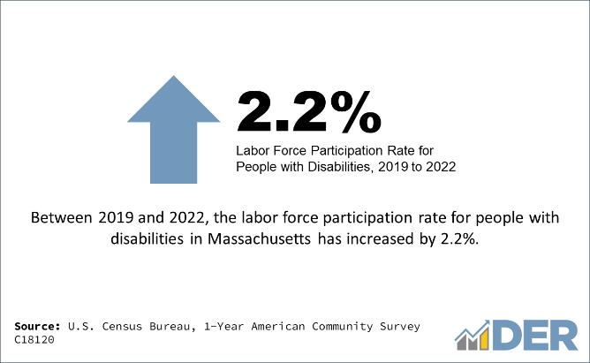 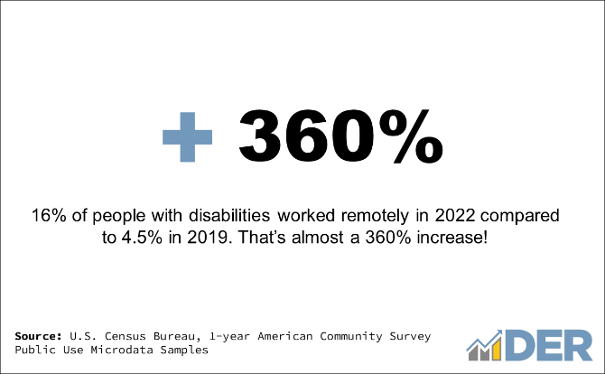

Source: U.S. Census Bureau, 1-Year American Community Survey

#### Disability Employment Tax Credit

In addition to these efforts, Massachusetts established a tax incentive program — the Disability Employment Tax Credit (DETC) — for employers, aimed at increasing employment opportunities for individuals with a disability in Massachusetts. After a minimum of 12 months of continuous employment, employers are eligible for a state tax credit equal to $5,000 or 30% of the wages paid to each qualified employee with a disability in the first taxable year of employment, whichever is less. In each subsequent tax year, employers are allowed a credit equal to $2,000 or 30% of the wages paid to each qualified employee with a disability, whichever is less. To promote utilization of the employer tax credit, MassAbility has created an online form that may be used by individuals seeking employment to explain that they qualify for employment with a disability under this employer tax credit.

## Investments in Accessible Transportation for Individuals with Disabilities

Recognizing that many individuals with disabilities rely on public transportation, the Massachusetts Department of Transportation (MassDOT), the Massachusetts Bay Transportation Authority (MBTA), and Regional Transit Authorities (RTAs) have prioritized improving accessibility in line with Olmstead objectives. This effort includes: investments and innovations, MBTA improvements, and growth in on-demand microtransit.

### Investments and Innovations

Every new capital project in MassDOT’s Capital Investment Plan (CIP) has accessibility components, ensuring that new infrastructure is accessible. More specifically, MassDOT has made increasing investments through the Accessibility Improvement Program under the agency’s modernization efforts to implement projects in areas with the greatest programmatic need. The program evolved from a focus on ADA retrofits to a much broader one that includes all elements of the pedestrian infrastructure network at various phases of their life cycle to achieve an accessible and connected network. Investments under this program have more than doubled in the past seven years, from just under $20 million in the 2018-2022 CIP, to $41.7 million in the current 2025-2029 CIP.

Additional MassDOT initiatives include the Community Transit Grant Program (CTGP), which awards funds to help meet the transportation and mobility needs of older adults and people with disabilities. The program is an important means of support for transportation partners who work to ensure access to destinations for those with limited mobility options, including RTAs, municipalities, Councils on Aging, non-profit organizations, and private operators of public transit (ride-share) services. The FY2024 and FY2025 state budgets both included $4 million to expand the CTGP.

### MBTA Improvements

Over the last 15 years, the MBTA has invested heavily in improving its policies and services in order to achieve the vision of a 100% accessible MBTA. Highlights of those efforts include:

* Full-scale renovations of dozens of MBTA stations in order to enhance accessibility, with over 35 stations that are either in the design or construction phase for major accessibility upgrades.
* Comprehensive updated training for all frontline employees on delivering accessible services.
* Development and implementation of policies and procedures to ensure transit information is provided in accessible formats — both audibly and visually — throughout the transit system.
* Increased staffing levels of RIDE drivers to improve on-time performance.
* The creation of RIDE Flex, a first-of-its-kind partnership between the RIDE and ride sharing companies, offering expanded mobility options to RIDE customers including same-day on-demand trip booking.
* The MBTA provision of a $3 million annual subsidy to ensure an adequate number of wheelchair accessible vehicles are available for RIDE Flex users.
* The creation of the Mobility Center, launched in 2020, which serves as a one-stop resource for customers seeking accessible transportation options. Available both in-person and virtually, the center offers services such as travel training, trip planning, and support with technology tools. Staff also assist customers in connecting with additional community transportation resources.
* The September 2023 launch of a marketing campaign, Access in Motion, aimed at promoting awareness of accessibility and its benefits for all MBTA riders.

1. Sample Access in Motion Advertisement



Additionally, most major MBTA projects now include input from the [Riders Transportation Access Group (RTAG)](https://www.mbta.com/accessibility/get-involved/rtag?utm_campaign=rtag-launch&utm_source=swa), a community-based group that advises the MBTA on transportation matters impacting people with disabilities and older adults. The group’s goal is to ensure that all people with disabilities and older adults have every opportunity to be fully participating members of their community. Additionally, an RTAG paratransit subcommittee was established to focus specifically on paratransit services. This subcommittee meets monthly with The RIDE to provide advice and recommendations on service delivery and emerging technologies.

### Growth in On-Demand Microtransit

Over the past five years, on-demand microtransit has redefined public transportation outside dense urban areas by offering flexible, affordable, and accessible services. Operating within specific areas and hours, these shared rides have become increasingly popular, especially in regions where traditional bus routes struggle with low ridership or are non-existent. On-demand microtransit is designed to deliver the kind of service that people love about ride-hailing apps like Uber and Lyft, but with key advantages: it is much more affordable and accessible, and drivers are trained in wheelchair securement. This makes it an appealing choice for those seeking the convenience of ride-hailing without the associated costs or accessibility barriers.

A prime example of this success is the Franklin Regional Transit Authority’s (FRTA) pilot of on-demand service in rural areas, including weekend coverage. This pilot, which began in 2019, has since become a permanent feature, with plans for expansion. The FRTA’s success highlights the growing demand for on-demand microtransit options across the region. Similarly, the Quaboag Connector, which serves ten towns between Worcester and Springfield, is an example of the utility of microtransit. Launched in 2017 through a collaboration of various human service agencies and the town of Ware, it has become a model for how organizations can work together to meet the transportation needs of rural communities. Though not on-demand, the Quaboag Connector uses a demand-response model with passengers reserving services in advance.

### Transportation is a Health Issue

MassHealth recognizes that transportation is more than just a logistical concern — it is a critical health issue, especially for individuals with disabilities. Social isolation can have serious medical consequences, and to address this MassHealth’s integrated care plans now include social transportation services to help maintain essential community connections that promote overall well-being.

In 2023, EOHHS launched two grant programs to improve access to MassHealth day programs by expanding transportation services. The first, the Adult Day Health and Day Habilitation Community Inclusion Transportation Grant Program, is a $2 million initiative aimed at increasing transportation to MassHealth-funded day programs. The second, the Day Habilitation Transportation Grant Program, allocates $3 million to enhance transportation for day habilitation services. Since these grant programs were implemented, EOHHS has awarded grants of up to $150,000 each to 55 day program providers. These funds are being used to purchase, maintain, or modify vehicles, or to explore alternative transportation solutions. The goal of both grant programs is to help eliminate transportation barriers and ensure that individuals with disabilities are able to fully access day program services.

# Where Are We Now?

State Snapshot

## Overall Progress

With a strong commitment to the principles of Olmstead, Massachusetts has significantly transformed its long-term care system to promote greater community integration. Data that supports the results of these significant investments and efforts include the following.

In AARP’s 2023 Long Term Services and Supports (LTSS) Scorecard, Massachusetts was ranked in the top tier for all states for overall LTSS performance.[16] The AARP LTSS Scorecard measures a state's LTSS services across five dimensions: affordability and access, choice of setting and provider, safety and quality, support for family caregivers, and community integration. States are ranked from 1 to 50, with Tier 1 being the top performing states.

1. Overall Performance Across Five Dimensions of LTSS

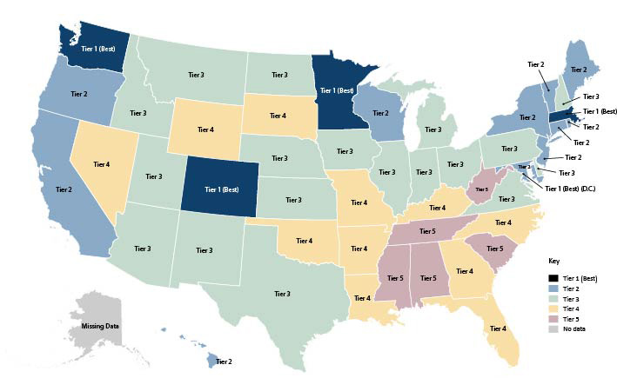 Source: [AARP Long-Term Services and Supports State Scorecard 2023 Edition](https://ltsschoices.aarp.org/sites/default/files/documents/doi/ltss-scorecard-2023-innovation-and-opportunity.doi.10.26419-2Fppi.00203.001.pdf#page=9), p. 9.

Massachusetts was also ranked 4th in the nation overall for LTSS performance.

1. LTSS Performance by Dimension – Massachusetts

|  |  |  |
| --- | --- | --- |
| Performance Dimension | 2023 Rank | Performance Tier |
| **Overall** | 4 | Tier 1 |
| **Affordability and Access** | 4 | Tier 2 |
| **Choice of Setting and Provider** | 2 | Tier 1 |
| **Safety and Quality** | 14 | Tier 2 |
| **Support for Family Caregivers** | 13 | Tier 2 |
| **Community Integration** | 9 | Tier 2 |

Key:  1st Tier (Best)  2nd Tier  3rd Tier 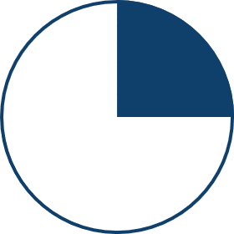 4th Tier  5th Tier (Worst)

Additional data in the Scorecard indicates that Massachusetts was ranked 11th in the nation for the balance of Medicaid spending on community-based LTSS compared to facility-based LTSS.

1. Percentage of Medicaid LTSS spending going to HCBS for older people and adults with physical disabilities for FY 2020

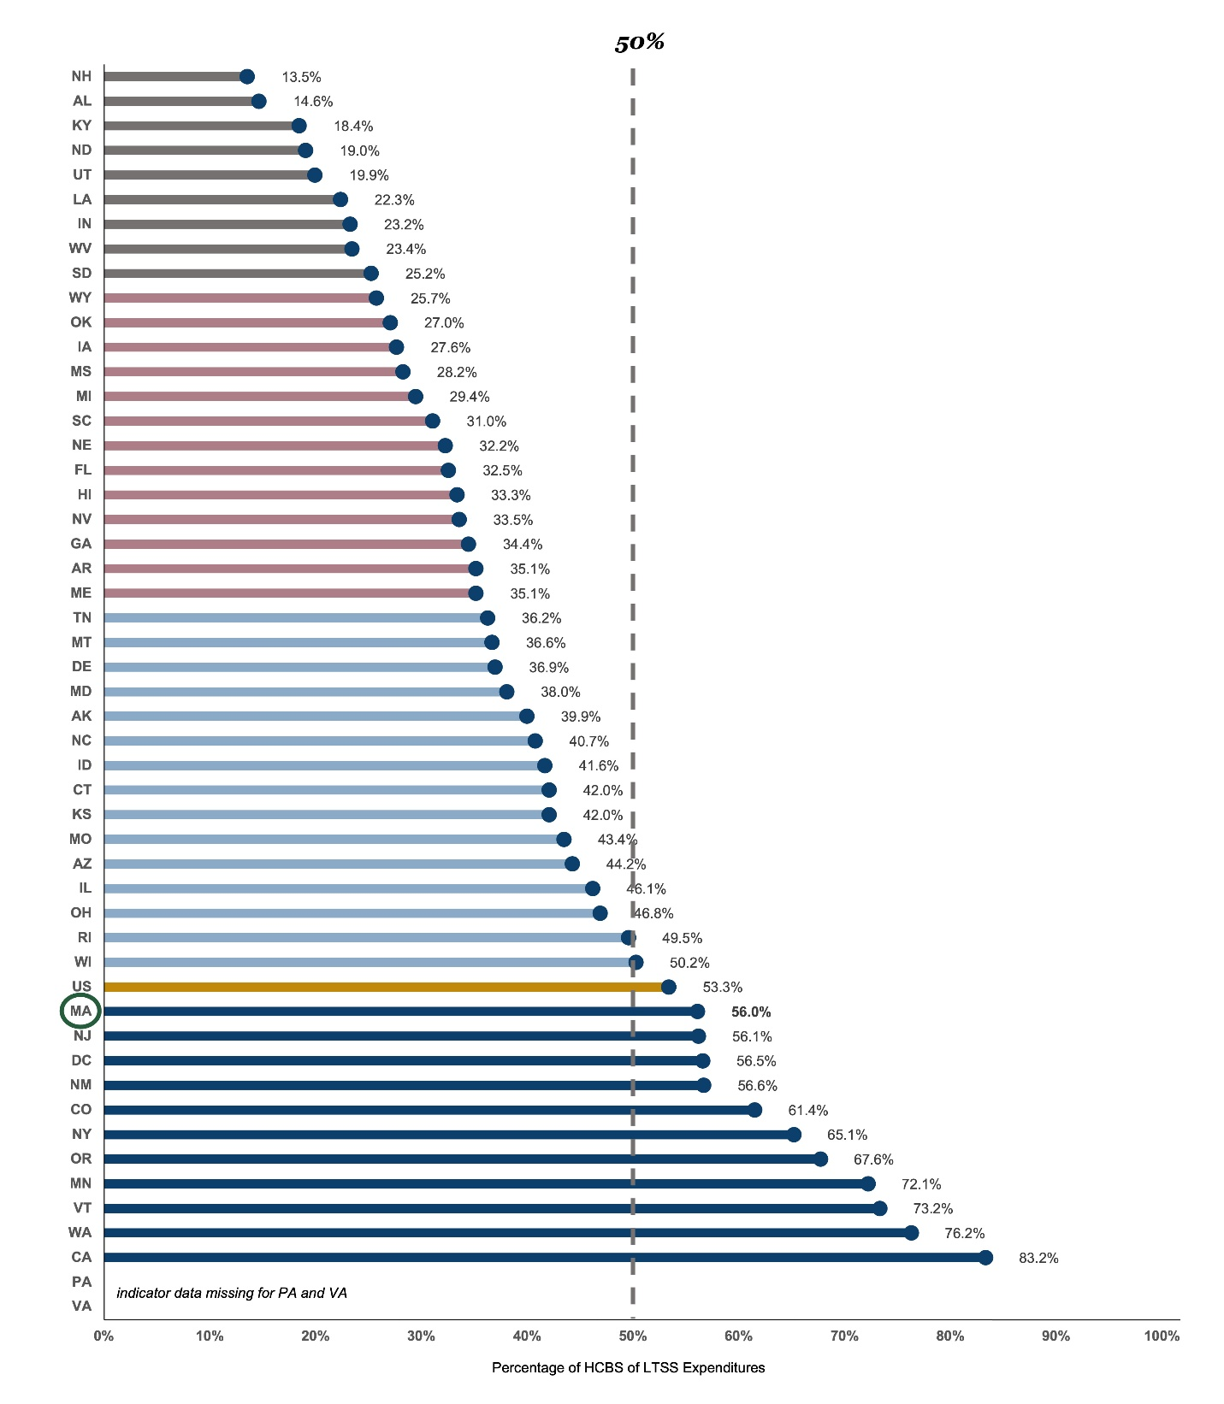

Source: Based on AARP, Appendix K: Indicator Data: Choice of Setting and Provider, [Long-Term Services and Supports State Scorecard 2023 Edition](https://ltsschoices.aarp.org/sites/default/files/documents/doi/ltss-scorecard-2023-innovation-and-opportunity.doi.10.26419-2Fppi.00203.001.pdf#page=167), p. 167

At the individual level, for Massachusetts residents, this ranking correlates with MassHealth data that indicates a longstanding trend of increasing MassHealth member reliance on community-based LTSS while the use of facility-based LTSS has declined as a percentage of overall LTSS utilization.

1. Percentage of MassHealth members receiving LTSS in the community (2005–2022). In Massachusetts, approximately 90% of members receiving LTSS in the community today, vs. approximately 65% in 2005. The percentage of members receiving LTSS in the community has steadily increased over the past decade….

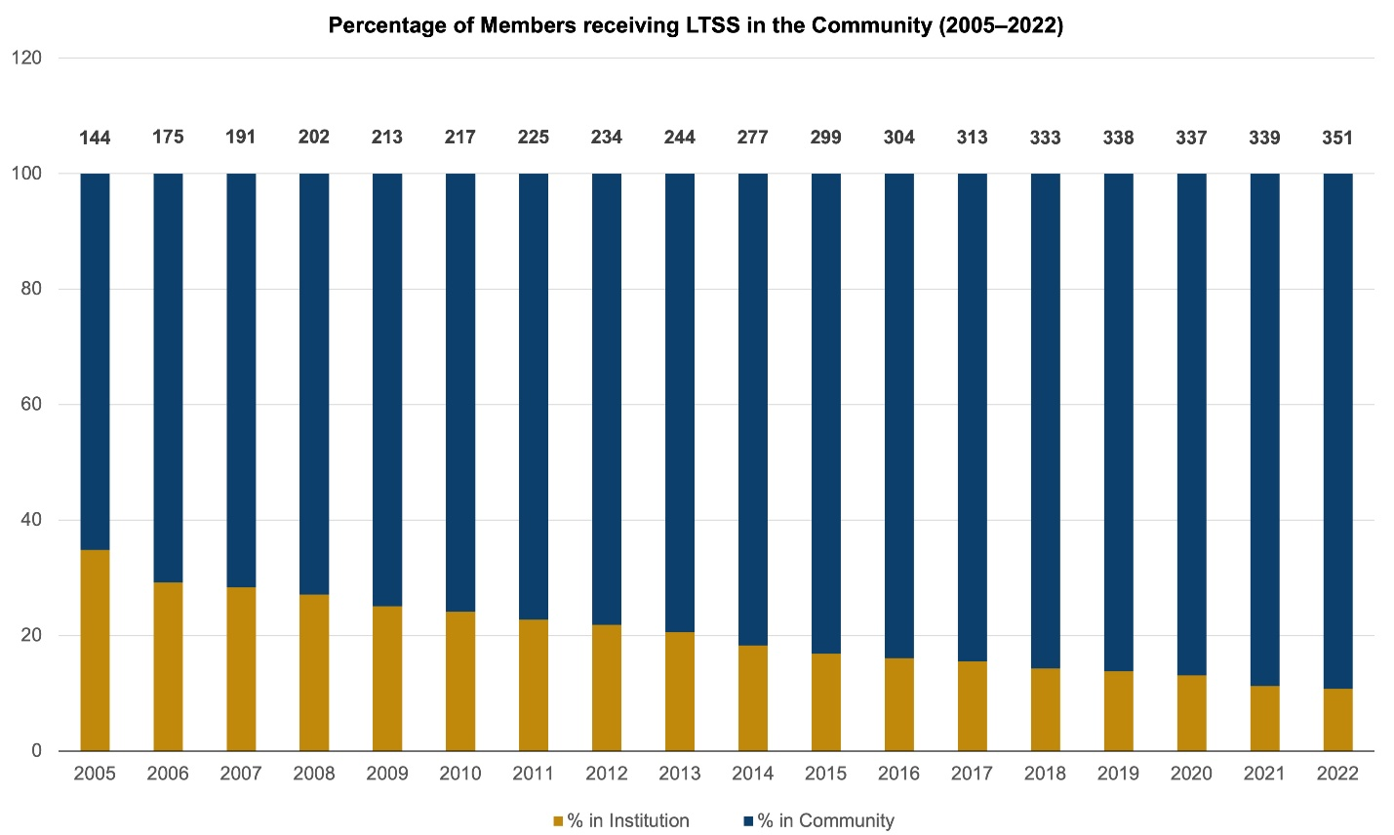

. . . Representing approximately 10,000 members diverted over time.

* Diversion estimate calculated as (% of people who would have been institutionalized in FY22 given split community vs. institutional) vs. (%) that are today given current split community vs. institutional)
* Potential reasons for diversion include:
  + creation of new community-based programs that fit in the needs of these individuals
  + Re-evaluation or change of needs leads to transitioning into the community.

Source: MassHealth program data. Members in community includes FFS HCBS utilization and Community Rating Categories for Integrated Care Members in institutional include SNF utilization and nursing facility Rating Categories for Integrated Care

Although Massachusetts ranks among the top states in the nation for LTSS performance, there is still room for improvement. In the national measures related to nursing facility transitions in AARP’s 2023 Scorecard, Massachusetts did not place in the top 10. Specifically, the state ranked 11th in successful community discharges and 31st for nursing facility residents with low care needs. This suggests that more can be done to help ensure individuals in nursing facilities are informed of their options to receive community-based services as an alternative to nursing facility care and that individuals interested in transitioning to the community have access to transition supports to promote their successful discharge to the community. The Massachusetts Community Living Initiative, discussed further on page 34, is an effort to improve the state’s performance in these areas.

## Community Feedback

In developing this report, EOHHS and EOHLC issued a Request for Information (RFI) to solicit feedback on areas for improvement across the four pillars of Housing, Services, Employment, and Transportation.

EOHHS and EOHLC received responses from individuals, family and other caregivers, advocates, and organizations/providers. The following provides a high-level summary of their comments.

Knowledge Gap

Respondents identified a significant "knowledge gap" in awareness of and access to services, highlighting that existing systems are often complicated, fragmented, and opaque. Many felt that assistance is needed not only to access information and education but also to help navigate application processes to gain access to services. Additionally, respondents emphasized the importance of increasing and enhancing community engagement, suggesting that more efforts be made to connect with the public about available services.

Grow Accessible Affordable Housing

Many respondents identified the lack of affordable housing as a significant challenge, citing limited access to housing vouchers and the need for more vouchers specifically targeted to people with disabilities. They also highlighted a shortage of accessible housing units and emphasized the importance of developing units that exceed minimum accessibility requirements. Additionally, respondents expressed a desire for a wider variety of housing options, including support for accessory dwelling units (ADUs) as a viable alternative and an increase in different types of community-based provider settings, such as shared living arrangements.

Strengthen Community-Based Services and Supports

Respondents overwhelmingly pointed to challenges within the workforce and provider networks for community-based services, particularly high turnover and vacancy rates. Suggestions for improvement included expanding person-centered programming and self-directed services, providing more support for family caregivers (including respite and daytime assistance), and increasing opportunities for individuals with disabilities to engage with peers and natural supports in areas such as living, working, and socializing. There was also a call for greater use of assistive technology.

Increase Community-Integrated Employment for People with Disabilities

Employment challenges were a common theme, with respondents frequently citing the need for more accessible job opportunities that offer competitive wages. Many respondents advocated for increased technical job skills training, better support for work in competitive environments, and enhanced incentives for employers to hire individuals with disabilities. Additionally, there were concerns about how employment might impact public benefits, such as MassHealth and federal Supplemental Security Income, and a desire for improved technology use in the workplace for people with disabilities.

Improve Accessible Transportation

Transportation was another area of concern, with respondents noting the need for reliable, well-funded, and accessible transportation services. Public transportation was described as unreliable, though The RIDE and ride-sharing options were viewed as potential solutions. Respondents also highlighted a lack of coordination across geographic regions, the need for door-to-door and through-the-door services, and a lack of public transportation options in rural areas.

Increase Community Collaboration

Many respondents identified EOHHS’ recent proposal to procure an independent assessment entity for MassHealth community-based LTSS that would replace the current structure in which assessments are performed by providers and community-based entities. In raising this procurement, respondents advocated for a different approach.

The feedback received from the RFI provided Massachusetts with valuable insights into its progress on community integration. Responses helped assess whether current efforts align with public interest and highlighted areas for improvement. One immediate change resulting from this input has been to reconsider MassHealth’s approach to establishing an independent assessor entity. Overall, while highlighting some new areas for attention, the feedback revealed a strong alignment between the priorities identified by respondents and Massachusetts’ current initiatives aimed at driving progress, as detailed in the following section on Massachusetts’ ongoing efforts.

# 

# Where Are We Going?

Current Initiatives to Achieve Continued Progress

With unprecedented investments in funding and innovation in recent years, Massachusetts has launched several key initiatives to further advance progress around the four pillars of its Olmstead goals. These efforts include new investments in accessible housing and strategies to build and strengthen the future direct care workforce. Massachusetts is also funding studies on innovative approaches to delivering post-acute care in home-based settings, new ways for promoting community-integrated employment, and making additional investments in accessible transportation.

While many of the initiatives described in this section are still in development, the Healey-Driscoll administration is excited about the opportunities ahead and remains committed to their continued progress and implementation.

## Massachusetts’ Community Living Initiative

Massachusetts’ Community Living Initiative grew out of a class action settlement, *Marsters v. Healey,* and is an ambitious commitment to further grow the state’s ability to serve people with disabilities in the community and as an alternative to receiving services in a nursing facility setting. Through this initiative Massachusetts will assist a minimum of 2,400 MassHealth eligible individuals interested in community living to transition from nursing facilities to the community over eight years, while also expanding the state’s capacity to provide residential services and supports.

The initiative is built on the foundation of in-reach, informed choice, and transition support provided through EOEA’s CLTP and MassHealth’s MFP Demonstration, described previously, and that are designed to inform nursing facility residents about the option to receive community-based services and assist them in transitioning to the community.

For nursing facility residents with PASRR SMI, the initiative leverages the expertise of DMH and the support of MassHealth’s Behavioral Health Community Partner program to provide enhanced behavioral health care coordination and case management during the transition to community-based living.

Growth targets for this initiative include expanding MassHealth’s Moving Forward Plan – Residential Supports (MFP-RS) waiver to accommodate 400 more individuals over the next eight years and increasing capacity in the Moving Forward Plan – Community Living (MFP-CL) waiver to serve an additional 595 individuals over the same time period. Under the initiative, DMH will also expand its capacity to serve individuals in DMH provider-operated group living environments by 200 individuals, with a goal of further increasing capacity by another 200 individuals over the initiative’s eight-year period.

The initiative also includes a commitment by EOHHS in coordination with EOHLC to expand subsidized housing capacity targeted to elder and disabled MassHealth members with disabilities transitioning from nursing facilities to the community by adding 800 new subsidized housing opportunities over eight years. This will be achieved through a combination of mobile and project-based vouchers, as well as increased funding for the development of new housing units. Finally, through this initiative DMH will expand its rental subsidy program to support 320 more individuals over the course of the initiative and MassAbility will complete a minimum of 120 home modifications that enable a person to transition from a nursing facility to the community.

## Expanding Access to Affordable, Accessible Housing

Looking toward the horizon, the expansion of affordable, accessible housing continues to be a priority for Massachusetts as described below.

### Housing Investments

Passed by the legislature and signed into law by Governor Healey in July 2024, the Affordable Homes Act and related initiatives will support the production, preservation, and rehabilitation of more than 65,000 homes statewide over the next five years. This is the largest housing bond bill ever filed and signed in Massachusetts, at more than triple the spending authorizations of the last housing bill passed in 2018. The historic legislation authorizes $5.16 billion in spending over the next five years along with 49 policy initiatives to counter rising housing costs caused by high demand and limited supply. Key spending authorizations and policy changes include ADUs; an unprecedented investment in modernizing the state’s public housing system, including $15 million dedicated to accessibility improvements; and incentives to build more housing for low- to moderate-income residents.

1. Affordable Homes Act Investments

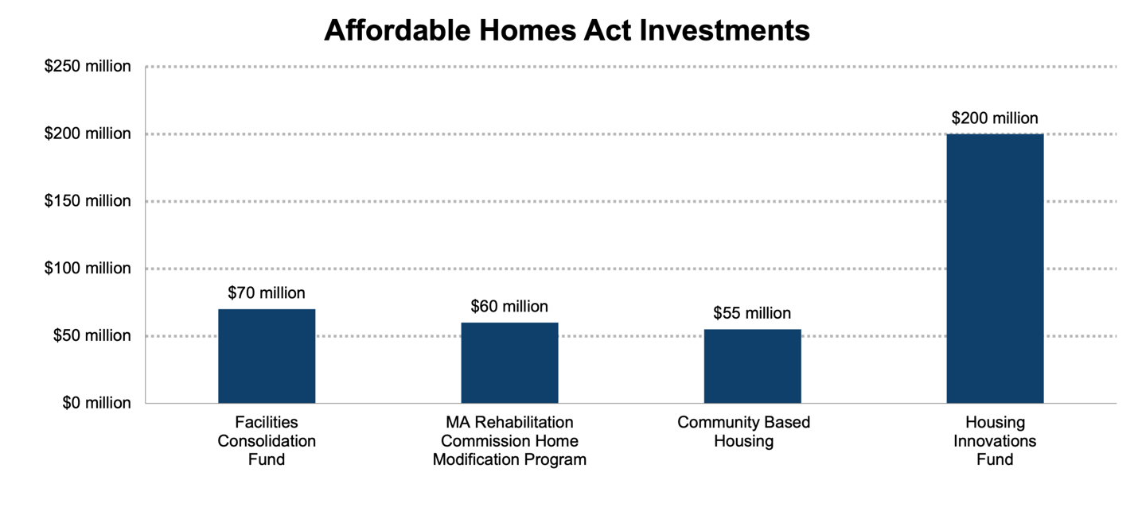

The increased investment in FCF and CBH supports the development of community-based housing specifically for people with disabilities, including clients of DMH, DDS, and MassAbility. The Affordable Homes Act doubled the investment for HIF supports to $200 million. The fund supports innovative and alternative forms of rental housing including single person occupancy (SPO) units, transitional and permanent housing for people experiencing homelessness, housing for seniors and veterans, and transitional units for persons recovering from substance use disorders. A $60 million investment was made in the MassAbility Home Modification Program, which provides funding to modify homes for individuals and families with disabilities. These modifications enable residents to stay in their homes or return home from institutional settings.

In addition to the unprecedented level of spending authorizations, the Affordable Homes Act creates key policy initiatives, including allowing ADUs under 900 square feet by right on single-family lots. Often referred to as in-law apartments, ADUs can be attached to or detached from a single-family home and often take shape as a basement or attic conversion, a cottage in a backyard, or a bump-out addition to a home. Though ADUs are important to address the state’s housing shortage, they also offer affordable living arrangements for older adults and people with disabilities to live independently while being near family, caregivers, or other supports.

1. An Accessory Dwelling Unit as Home Modification



Source: [Home Modification Loan Program Cape Accessory Dwelling Unit Testimonial](https://youtu.be/9oc1RmMn-Ek), YouTube

As an example, above is a picture of an ADU built as a Home Modification for an individual with a mental health disability. He now lives next door to his parents in his own home (unit on the left).[17] The autonomy and proximity to family supports has improved the health outcomes and housing stability for this individual.

The new statutory specifications for ADUs replace a patchwork of zoning regulations across the state with a uniform law that allows homeowners on single-family lots to add these small units without needing a special permit or variance unless they want to add more than one. The Healey-Driscoll administration estimates that between 8,000 and 10,000 ADUs will be built across the state over the next five years due to passage of the law, significantly increasing much needed housing supply.

The Affordable Homes Act also established three new commissions to study and recommend new policy to address housing disparities for older adults, households needing accessible housing, and extremely low-income households. The recommendations set forth by these commissions will further inform the Commonwealth’s efforts to meet the housing needs of Massachusetts residents, including older adults and persons with disabilities.

Another critical policy initiative for people with disabilities exiting homelessness is the Supportive Housing Pool Fund. This fund creates a flexible supportive housing pool program to provide critical assistance for supportive housing by funding staffing, case management, service coordination, and other tenancy-related services not funded through other sources. By investing in PSH resources, the state will be able to increase the pipeline of service-enhanced subsidized housing for people with disabilities who have experienced long-term homelessness.

Beyond capital investments through the historic Affordable Homes Act housing bond bill, Massachusetts is making a significant commitment to additional housing investments. Specifically, through the Community Living Initiative discussed previously, Massachusetts is committed to further increasing subsidized housing solutions, including residential services, non-residential services with housing supports, and home modifications, ensuring that individuals with disabilities can live independently within their communities.

## Enhancing Community-Based Services and Supports

Massachusetts continues to be a health care innovator. Beyond the community-based services and supports previously discussed, the state is actively working to enhance, expand, and improve access to community-based services and further promote community tenure for older adults and people with disabilities. Among these efforts includes an innovative expansion of behavioral health and community-based services under the MassHealth program; a first-of-its-kind clinical research trial to explore the efficacy of intensive in-home post-acute care as an alternative to post-acute care in a nursing facility, as well as historic investments in the state’s PCA workforce. This also includes substantial investments in efforts and initiatives to grow the direct care workforce in order to expand access to services and to enable providers to innovate and further increase service offerings.

### MassHealth 1115 Waiver Initiatives

Approved by the Centers for Medicare and Medicaid Services (CMS) in June 2024, MassHealth’s new 1115 Waiver includes several key provisions to help prevent long-term institutionalization and support transitions to community-based living. Starting in January 2025, the waiver will cover Homeless Medical Respite Services, building upon the existing pilot program that provides pre-procedure or post-hospitalization short-term housing for individuals experiencing homelessness for up to 183 days, in collaboration with medical and homeless service providers. It also expands Behavioral Health Diversionary Services, offering community-based options to help individuals return to their communities after acute placements, with the goal of stabilizing individuals in the community. Additionally, the new 1115 waiver provides authorization for MassHealth to cover nonclinical services that impact health outcomes and community tenure through Health-Related Social Needs (HRSN) initiatives. By leveraging federal flexibility available under the 1115 waiver, Massachusetts will be able to fund innovative supports through Accountable Care Organizations (ACOs), seeking to address food insecurity and housing-related needs.

### Home First Clinical Research Trial

Massachusetts has launched a first of its kind clinical research trial to test the efficacy of a new post-acute care model, where a patient gets post-acute care delivered in their home instead of in a skilled nursing facility. Post-acute care involves a combination of medical direction by an attending physician, and often includes skilled nursing, physical and occupational therapy, administration of medications and functional support for personal care and assistance with basic and instrumental activities of daily living. Approximately 40% of older adults require post-acute care and rehabilitation when discharged from a hospital. Currently, most hospitalized individuals who require facility-based post-acute care are discharged to a skilled nursing facility. While currently post-acute care is typically delivered in nursing facilities, the study seeks to evaluate whether discharge to the home with intensive, time-limited post-acute care supports trends toward lower cost, greater functional status improvement, and better patient experience.

Through the Home First clinical research trial, two hospitals will enroll 900+ participants over the next 18 months. to ascertain whether a ‘home first’ model has the potential to help individuals retain community tenure by diverting nursing facility admissions intended for short term rehabilitation that can lead to long-term institutionalization. The study will include data collection at 90 days and 180 days post discharge from an acute care hospital. Depending on the outcomes of this research trial, the findings have the potential to lead to future delivery innovations and the reimagining of how our society delivers post-acute care, not just in Massachusetts, but nationally.

### **PCA Program Investment**

In 2023, Massachusetts negotiated the largest PCA program collective bargaining agreement in state history, significantly raising base wages paid for providing MassHealth-covered PCA services and introducing seniority-based wage steps, effective in 2025, with an aim to incentivize the retention of the longest serving and most experienced PCA providers. Additionally, the collective bargaining agreement allows for a complex care differential, which will provide for a significant rise in payments for PCA services provided to individuals who are designated by the MassHealth PCA Program as “Complex Care” consumers. The complex care differential will both incentivize PCAs to provide services to consumers who have more complex needs who may otherwise struggle to find the necessary PCAs to do this difficult and crucial work, as well as provide for an increased rate of pay account for their performing that complex and important work. The three-year contract also introduced a wage scale for PCAs, starting with a base rate of $19.50 per hour and raising pay up to $25 per hour by 2026 based on experience. It will also enable PCAs to establish retirement accounts, offer compensation for professional development and training, and increase the number of paid holidays.

### Workforce Development and Support for Community-Based Providers

The significant gains, enhancements, and expansions in community-based services will continue to be possible only with equivalent focus on adequate levels of the clinical and other workers providing those services. The healthcare workforce has faced recent challenges, including worker shortages, burnout, job satisfaction concerns, and aging of the workforce along with those in need of services. The COVID-19 pandemic exacerbated these workforce challenges for HCBS providers while at the same time increasing demand to a healthcare workforce that already needed to be revitalized. EOHHS has prioritized workforce development initiatives and engaged partners in government and the community in creating solutions to grow the healthcare workforce while strengthening access to services and improving the quality of services. This includes:

* **HCBS and Human Services Innovation Grants**$46 million has been allocated to 84 home and community-service providers through early 2025 to support workforce recruitment, retention, training, technology, and internships. Performance reporting collected in mid-2024 is helping to identify effective strategies to grow and improve the healthcare workforce.
* **Public-Private Partnerships**EOHHS is working with private partners to promote nurse licensure compacts, improve college-to-career pathways, expand scholarship opportunities, and increase placement options for nurses.
* **Behavioral Health-Focused Initiatives**A $75.8 million investment has been made to a Trust that will fund numerous initiatives to bolster the existing behavioral health workforce to address growing need for behavioral health services. The Trust will help fund scholarships for attaining behavioral health degrees and certifications, promote field placements for behavioral health clinicians and those aspiring to do such work, distribute incentives to providers to supervise new and aspiring behavioral health workers, and provide fee waivers for licensure and certification of behavioral health positions, as well as the creation of a workforce development center and research lab. These initiatives seek to incentivize the growth of the behavioral health workforce while maintaining and enhancing the quality of behavioral health services.
* **Peer Specialist Credentialing and Coverage of Peer Specialist Services**A peer specialist is a nonclinical health professional who helps people recover from mental health or substance use disorders by sharing their own experiences and providing support. Efforts are underway to establish a peer specialist credential recognized by commercial insurers in Massachusetts. This effort seeks to promote coverage of peer specialists by private and commercial insurance, while also establishing standards for quality in service provision. Through these efforts, commercial plans participating in the Massachusetts Health Connector are now covering peer specialists in the same manner as the MassHealth program, and efforts to achieve full commercial coverage in Massachusetts are on-going.

## 

## Promoting Community-Integrated Employment of People with Disabilities

The promotion of employment opportunities for individuals with disabilities continues to be a high priority for Massachusetts. Primary agencies overseeing integrated employment strategies are collaborating across state government to ensure seamless programming that maximizes the resources and strengths of each entity.

MassAbility’s career services department has recently embarked on several initiatives, investments, and partnerships reflecting the value of competitive integrated employment. Coordinating with the EOLWD, under the Workforce Innovations Opportunity Act (WIOA), MassAbility expanded access to pre-employment transition services, allowing anyone under age 23 to receive advocacy, work-based learning, counseling on post-secondary options, and opportunities for work experience. Through this expansion, job placement teams are able to continue providing services to individuals post-hire until they are stable in their jobs.

MassAbility is engaging in several strong collaborations for cross-agency opportunities. These partnerships promote innovation and flexibility beyond the general vocational rehabilitation (VR) services. MassAbility is partnering with Holyoke Community College to provide a free, intensive cybersecurity training program for people with disabilities. The certification students earn through this program is nationally recognized and is a highly sought-after workplace credential that provides the needed leverage to enter this high-paying industry. Through a public/private partnership, this program recently expanded to Roxbury Community College. With the success of these programs, MassAbility continues to explore opportunities for further expansion.

In April 2024, the Healey-Driscoll administration introduced the "Employment Program for Young Adults with Disabilities," funded by EOLWD and managed by the Commonwealth Corporation. This program supports initiatives led by community-based organizations with proven expertise in preparing young adults with disabilities for employment, job placement, and post-placement support to ensure employment retention. Additionally, in September 2024, the administration announced grant funding to expand job training programs for individuals experiencing homelessness. These programs aim to meet the skilled workforce needs of businesses in Massachusetts and assist individuals experiencing homelessness in transitioning out of shelters.

DDS is also committed to fully implementing the goals outlined in its Blueprint for Success 2.0, highlighted previously. This includes increasing the number of individuals successfully employed in community businesses while tracking other quality measures such as increases in hours worked or wages earned. DDS is also focused on expanding access to individual and group employment opportunities, particularly for those with higher support needs who may face additional barriers, as well as increasing the number of individuals transitioning from Community-Based Day Services (CBDS) to employment. Additionally, DDS is working to ensure more young adults move directly from school into competitive integrated employment. Lastly, through its Blueprint for Success 2.0, DDS seeks to broaden the range of opportunities, and the amount of time individuals spend meaningfully participating in valued roles within the community.

## Investing in Accessible Transportation for Individuals with Disabilities

Massachusetts continues to invest in transportation initiatives that seek to make the state’s public transportation system more accessible to persons with disabilities. New investments and innovations include the following:

Under MassDOT’s 2025-2029 Capital Investment Plan, the Department of Transportation’s Accessibility Improvement Program includes $4 million to expand the Community Transit Grant Program for projects expanding mobility for older adults, people with disabilities, and low-income individuals.

Furthermore, MassDOT is improving transportation accessibility through a Mobility Management pilot program, which includes hiring a statewide mobility manager to coordinate services, provide direct assistance, and foster partnerships. The program draws on research from other states and has received federal funding to address issues like promoting existing funding that can provide through-the-door escorts. A peer network for transportation providers will facilitate best practice sharing, while a statewide council that includes representatives from MassAbility and EOEA will collaboratively address transportation challenges for people with disabilities.

### MBTA Accessibility Improvements and Innovation

The MBTA is undergoing significant transformations across its network, with major changes underway for the Green Line, Silver Line, and Commuter Rail — modes that have long struggled with inaccessible stations. In a determined effort to enhance accessibility, the MBTA plans to address many of these issues within the next three years. One of the most ambitious projects involves designing the next generation of Green Line trolleys, which will enable level boarding across the entire line. This development promises to make the Green Line more accessible to all riders, particularly those with mobility challenges.

In addition to these upgrades, the MBTA is also planning to pilot accessible wayfinding technology. This initiative aims to simplify navigation within the system’s more complex stations, making it easier for all passengers, especially those with disabilities, to travel confidently. These efforts reflect the MBTA’s commitment to creating a more inclusive transit system, ensuring that all riders can access and navigate its services with greater ease and independence.

# 

# Conclusion

The Healey-Driscoll administration celebrates the significant progress that has been made in Massachusetts towards community integration of persons with disabilities over the past 25 years. The administration also acknowledges that there is still work to be done.

The administration remains steadfast in its commitment to the vision and principles of Olmstead. It recognizes that every person with a disability should have the right to live in the community with dignity, autonomy, and access to the services they need. This commitment includes not only maintaining the progress already made but also pushing forward with new initiatives, such as the Community Living Initiative, to ensure all individuals have the opportunity to choose community living over institutional care.

As our state moves forward, we must also take on new challenges while continuing to uphold core Olmstead principles. Now that Massachusetts is finally emerging from the COVID pandemic, we must turn to combat the epidemic of loneliness that is challenging so many in our state. For individuals with disabilities, one way to address this is by ensuring that our community living options do more than simply provide housing. These options should foster a sense of community, helping the individuals we serve build and strengthen their social bonds and natural supports, which are essential for maintaining independence.

Looking ahead, Massachusetts will continue to invest in programs that expand housing options, strengthen the workforce delivering home and community-based services, and ensure that individuals with complex needs can receive personalized, high-quality care in the community. The administration looks forward to engaging with advocates, families, and individuals with lived experience to ensure that the vision and principles of Olmstead remain central to its approach and that ongoing efforts are responsive to the evolving needs of the disability community.

# Olmstead Voices

Olmstead Voice 1: Cathy, MFP-CL Waiver Participant

Olmstead Voice 2: MATCH Program Participant

Olmstead Voice 3: Jillian, MFP-RS Waiver Participant Story

Olmstead Voice 4: Rhonda, MFP-CL Waiver Home Modification Story

Olmstead Voice 5: Maria & Meylin, CSN CCA Member

Olmstead Voice 6: Robert, MFP Demo and MFP-CL Waiver Participant Story

Olmstead Voice 7: Aidan, MassAbility/Vocational Rehabilitation Client

**Olmstead Voices: Cathy**Program: MFP-CL Waiver

Cathy was married and working full time when she woke up one morning unable to walk. In her mid-fifties, she was hospitalized and received rehabilitative services and was able to return home. She became sick again in her early sixties and eventually needed to enter a nursing home. In 2019, now divorced and unable to work, Cathy found herself alone with little hope of resuming life in the community. MassAbility conducts outreach in nursing facilities in an effort to identify eligible individuals who may wish to return to the community with supports through one of the Home and Community Based Services Waivers. With encouragement from Alison, a MassAbility case manager who told her she was “too young to stay in a nursing home her whole life,” Cathy agreed to pursue options for community living. Alison and a representative from the Southeast Center for Independent Living assisted Cathy with an application for the Moving Forward Plan – Community Living (MFP-CL) waiver. She was found eligible for the waiver and in August 2020, Cathy was supported to move into her own furnished apartment, with essential services in place. She now has a home health aide who assists with cooking and cleaning, among other things. She receives quarterly visits from her nurse practitioner who helps her to manage her multiple sclerosis, high blood pressure, and diabetes. Cathy praises Alison’s assistance in supporting her move to the community. Living on her own, Cathy appreciates all of the services she receives that support her independence. Alison remains involved in her care and reported that “Cathy was and remains a very sharp, independent woman and we felt she could do well with a return to the community. She was eager to try and has been such a delight to work with and support over the years.



**Olmstead Voices: Anonymous Participant**

Program: MATCH

“Before the MATCH program existed, I had been through detox several times and completed a few residential programs, but transitioning from the house to living on my own was incredibly challenging. Every time I graduated, I built a strong recovery support network, but I couldn’t sustain it on my own, so I’d end up back in my old environment and, inevitably, relapsed. This cycle of addiction, detox, CSS, TSS, and Residential Programs seemed endless—until the MATCH program stepped in.

This time, with their help, I was able to move into my first place on my own, giving me the stability and support I needed to stay grounded in my recovery. Now, I’m living in a beautiful apartment in downtown Salem, Massachusetts, and I work as a case manager for the very program that saved my life. My goal is to be a source of hope and inspiration for others facing the same struggles I went through.

The MATCH program truly gave me a fighting chance, and I will always be indebted to it.”

**Olmstead Voices: Jillian**Program: MFP-RS Waiver

Jillian is a young woman living with complex medical needs. In 2023, through the Moving Forward Plan-Residential Supports Waiver (MFP-RS) operated by the Department of Developmental Services (DDS), Jillian received support to transition from Tewksbury Hospital to a group home where she has been living for almost one year.

Now Jillian states she has more freedom, she has goals and people to help her achieve those goals. With the help of DDS, the MFP-RS waiver, and the Edinburgh Center, Jillian has choices of activities to participate in; her favorite is adaptive sled hockey. As a woman who requires a wheelchair to move around, Jillian never imagined she could ever play a sport like hockey — and she absolutely loves it! She volunteers at Strongwater Farm, a therapeutic equestrian center in Tewksbury where she gets to spend time with horses and helps clean stalls. Jillian loves animals and enjoys weekly visits from a therapy dog in her home.

Although her life isn’t without challenges, Jillian views her struggles as similar to those faced by anyone else. She continues to work with a psychiatrist and counselor to stabilize her mental health and aspires to one day attend college to study psychology or train as a peer counselor. Jillian dreams of helping others in similar situations, showing them that it is possible to “make it to the other side and feel good about life.” She sees herself as “living proof” that there can be light at the end of the tunnel and hopes her story will inspire others. She emphasizes that her life has greatly improved with access to choices, transportation, and the ability to engage in meaningful activities, such as attending church. Jillian is an advocate for individuals with disabilities. Her message is that the services in Massachusetts are really making a difference.



**Olmstead Voices: Rhonda**Program: MFP-CL Waiver

Rhonda entered a nursing facility after experiencing a stroke that left her with right-sided weakness and an inability to speak. Initially, she and her daughter were eager for her to move into her daughter’s home and rejoin the community. However, a lack of necessary home modifications and support services made the arrangement unsustainable, and Rhonda had to return to a nursing facility. In April 2022, as Rhonda prepared for discharge again, she was enrolled in the Moving Forward Plan - Community Living (MFP-CL) waiver and connected with a MassAbility case manager, Becca. Together, they tackled challenges such as installing a ramp on her daughter’s historic home, obtaining an electronic Hoyer lift through transitional assistance, and modifying the bathroom to accommodate Rhonda's needs.

By July 2022, Rhonda was ready to return home with a comprehensive support system provided through the MFP-CL Waiver. This included a home health aide to assist with medical and personal care needs, homemaking services to help maintain her household, and a companion to offer emotional support and reduce isolation. These services were tailored to ensure Rhonda could live safely and independently while enjoying an improved quality of life. Additionally, Rhonda and her daughter were able to take advantage of the waiver’s self-directed services, which allowed her daughter to be actively involved in her care. Under this arrangement, Rhonda’s daughter is compensated for providing some of her care, reducing the need to rely solely on agency-based services.

Today, Rhonda thrives in social settings. She enjoys attending her waiver-funded day program, where she actively participates and engages with others. With the robust support system in place, Rhonda has successfully remained at home and has not needed to return to a rehabilitation or nursing facility since her discharge in 2022.

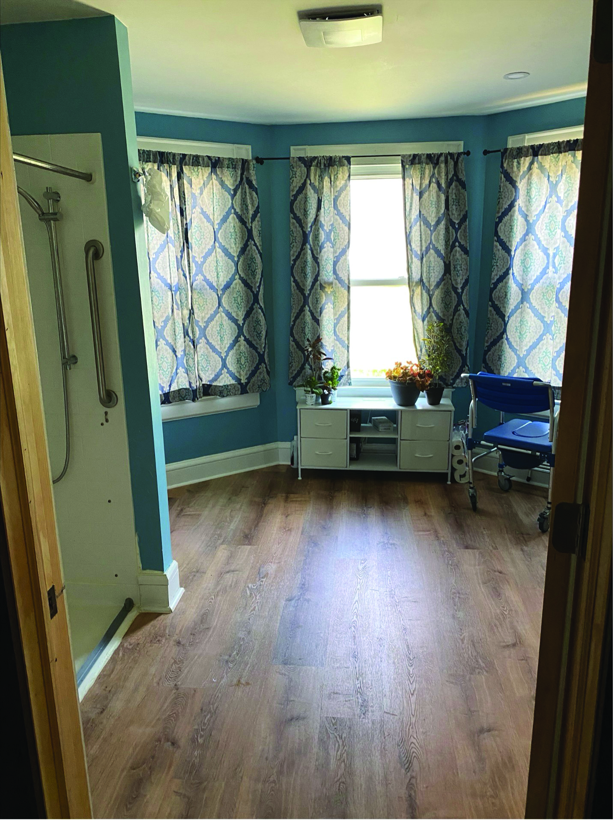

**Olmstead Voices: Maria and Meylin**Programs: MassHealth Continuous Skilled Nursing program, Complex Care Assistant program

Maria is the mother of two daughters living with disabilities. Her 16-year-old daughter Meylin is nonverbal and has complex medical needs that require skilled nursing. Meylin receives services through the MassHealth Continuous Skilled Nursing (CSN) program which provide the support she needs to stay in her home and out of an institution.

Taking care of her daughters meant that Maria was unable to work and contribute to the family income. Her husband’s job was not enough to cover their expenses and for some time, they struggled to pay the bills, choosing between housing, food, and other necessities. Even with the support of the CSN program, their unstable housing combined with Meylin’s complex needs resulted in frequent hospital admissions.

In 2023, when Massachusetts developed the Complex Care Assistant (CCA) program, one of Meylin’s nurses, Cathy Costa, suggested Maria consider this option for her family. Through CCA, Maria underwent training to provide enhanced care for her daughter’s complex medical needs. Employed by a CSN agency and under the supervision of an RN, Maria can now provide oxygen therapy and other enhanced care services that her daughter needs. This program has resulted in reduced hospital admissions for Meylin as Maria now has the knowledge and skills to respond to medical issues that arise. Maria’s income as a CCA has resulted in financial stability, stable housing, and food security. Meylin is living in her family home, receiving the care she needs. Maria considers Cathy Costa to be an “angel sent to her family” and is extremely grateful for the services and support they receive.

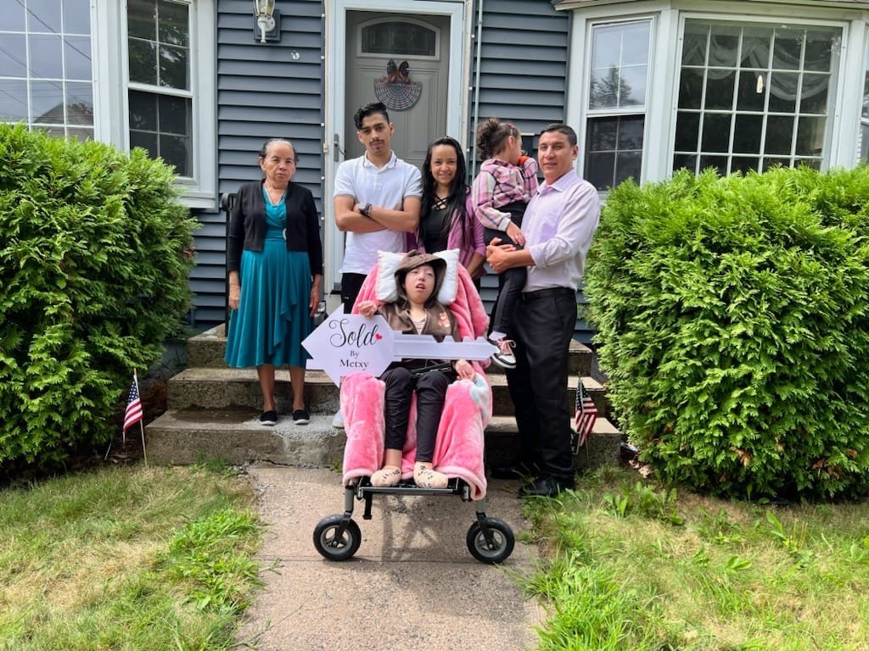

**Olmstead Voices: Robert**Program: MFP Demonstration; MFP-CL Waiver

Robert was accepted into the Moving Forward Plan - Community Living (MFP-CL) waiver operated by MassAbility on January 26, 2023. In May 2023, while continuing to reside in a nursing facility, he also enrolled in the Money Follows the Person Demonstration (MFP Demo) program, becoming a dual participant in both programs. Through the assistance of his MFP Demo transitional assistant worker, Robert completed multiple housing applications,

Eventually, his name was selected for an apartment in his preferred location. However, he was denied the subsidized apartment due to a prior eviction. Upon further investigation by Robert’s MFP-CL waiver case manager and his MFP Demo transitional assistant worker, they discovered that he owed several thousand dollars in arrears. This debt posed a significant barrier to securing housing and would remain an obstacle until it was resolved.

The setback left Robert feeling hopeless. Having lived in a nursing facility since October 2021 and faced with housing challenges, his future seemed uncertain. However, with continued support from the MFP Demo and MFP-CL waiver programs, Robert's circumstances improved dramatically. After nearly two years of waiting and uncertainty, he successfully moved into an apartment on July 31, 2023.

Robert is deeply grateful for these two programs that helped him transition to independent living. He has formed friendships with several neighbors and is thriving in his new community. As he embraces this new chapter, he is focused on improving his physical and mental health while enjoying the stability and independence he has longed for.

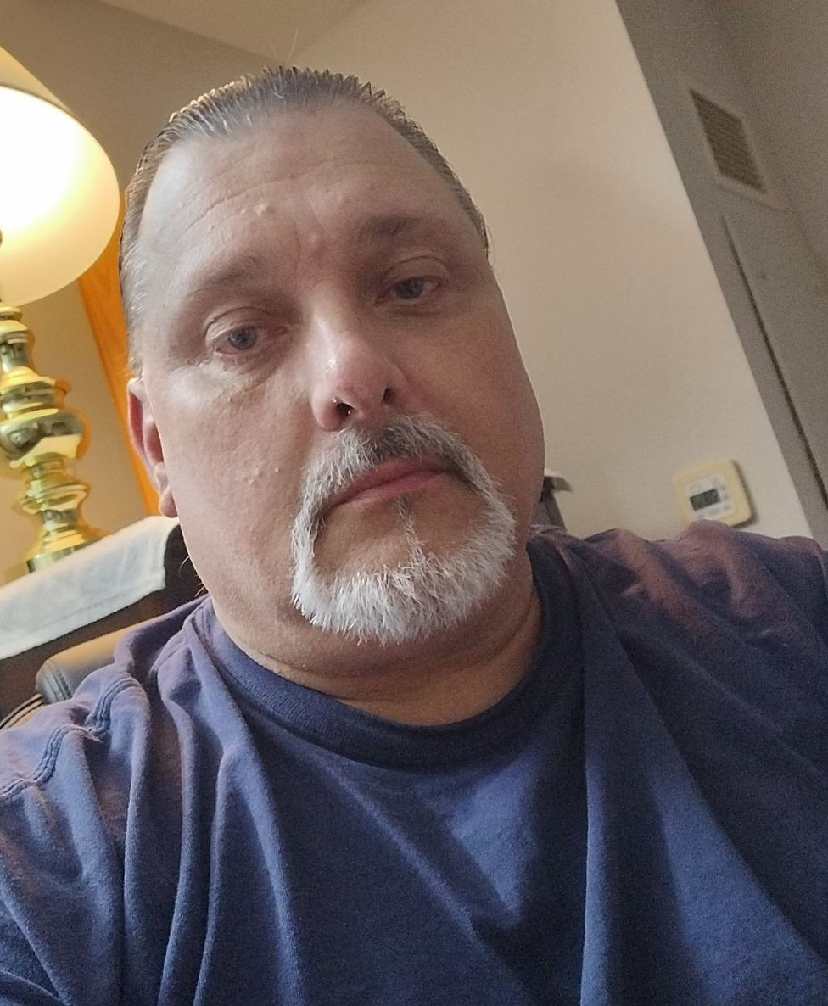

**Olmstead Voices: Aidan**Program: MassAbility Vocational Rehabilitation

Not long ago, Aidan was working in a local supermarket, making pizza for minimum wage. It was not a job he believed held much promise for him. Then he started a free, intensive cybersecurity training program for people with disabilities offered by Holyoke Community College and MassAbility. Ten months later, he is now poised to begin a career as a cybersecurity analyst.

"I liked working at Big Y and I could pay my bills, but there was nothing I could really do with that," he said. "Now I'm looking at positions that have salaries and benefits. That's a big change for me. It's fantastic. This class has just opened so many doors. It's life-altering or at least has the potential to be."

He had an internship with NetWerks Strategic Services, an Agawam-based technology company, and he has interviewed for full-time benefitted positions at the Massachusetts Educational Collaborative and the Department of Youth Services. Aidan qualified for the program through their involvement with MassAbility. He was recommended by his caseworker. Candidates were screened and then took an entrance exam to make sure they could handle the material and the workload.

“People with disabilities don't necessarily get the same opportunities as others," said Aidan. "There's a stigma to it, and MassAbility is out there trying to erase that and show that we have value. That's what I really appreciate about them. They don't care about our labels and what's happened in our past. They just want to get us into a position where we can be fully functioning members of society and feel more useful."



1. EOHHS is the largest secretariat of Massachusetts and comprises 11 agencies, including the Department of Mental Health and the Department of Developmental Services. In addition, EOHHS is the single state agency responsible for administering Massachusetts’ Medicaid program and its Children’s Health Insurance Program (CHIP) (together, MassHealth).
2. EOHLC is the executive office of Massachusetts tasked with creating housing policy and advancing innovative solutions to provide safe, accessible, affordable, and livable communities throughout Massachusetts.
3. National Low Income Housing Coalition, “The Gap: A Shortage of Affordable Homes,” <https://nlihc.org/gap>.
4. MassAbility, formerly the Massachusetts Rehabilitation Commission.
5. Publicly supported rental developments are defined as receiving state or federal capital subsidies, tax credits, or project-based rental assistance through state housing agencies.
6. Housing Navigator Massachusetts (n.d.). About us. Housing Navigator Massachusetts. Retrieved September 9, 2024 from https://housingnavigatorma.org/about-us/
7. Report available at: <https://files.hudexchange.info/reports/published/CoC_PopSub_State_MA_2023.pdf>
8. Massachusetts’ full ARPA 9817 spending plan is available at <https://www.medicaid.gov/medicaid/home-community-based-services/downloads/ma-spend-pln-july2023-amend.pdf>. The spending plan outlines over 70 projects and initiatives across three key areas: ‘HCBS Workforce,’ ‘HCBS Technology and Infrastructure,’ and ‘Access to and Promotion of HCBS.’ All of the projects and initiatives in the state’s ARPA spending plan are designed to enhance, expand, and strengthen Medicaid-covered HCBS in Massachusetts.
9. SFY 2023 Options Counseling Legislative Report
10. Id.
11. Id.
12. SMI as defined under federal PASRR regulations at 42 CFR 483.102 (b)(1).
13. **2023 Long-Term Services & Supports State Scorecard**: Indicator: Pace Enrollment, <https://ltsschoices.aarp.org/scorecard-report/2023/dimensions-and-indicators/pace-enrollment>
14. **2023 Long-Term Services & Supports State Scorecard**: Indicator: Self-Directed Program Enrollment, https://ltsschoices.aarp.org/scorecard-report/2023/dimensions-and-indicators/self-directed-program-enrollment
15. These numbers include all nursing facility residents regardless of payer and include residents receiving short-term benefits (e.g., a short term post-acute stay covered under Medicare or commercial insurance).
16. AARP 2023 LTSS Scorecard is available at: <https://ltsschoices.aarp.org/scorecard-report/2023>.
17. For more information on this individual’s story, visit: <https://youtu.be/9oc1RmMn-Ek>