Blue Hills Reservation White-Tailed Deer Management Program 2024 Program Overview & Results

The results of the 2024 hunt area as follows.

Archery hunting was permitted in certain designated areas of the Blue Hills Reservation for a total of fifteen (15) days. The hunt ran on Mondays through Thursdays between November 4and November 27.There was no hunt on Thursday, November 28, due to observance of the Thanksgiving holiday. A brush fire in the area of Great Blue Hill the week of November 18 likely impacted hunter turn out and success as nearby roads and parking areas were temporarily closed. In accordance with state hunting regulations, hunters were allowed to hunt one-half hour before sunrise to one-half hour after sunset.

Licensed hunters were offered the opportunity to apply on-line using a web-based form. The application process was open from August 5 through August 30, 2024. A total 215 of hunters submitted applications for the permitted archery hunt.

In total, 186 access permits were issued. Access permits were valid for all eleven days in which archery hunting was allowed. Once registered hunters completed the orientation, they were eligible to purchase doe tags.

The table below provides archery hunt applicants and permittees according to state of residence:

|  |  |  |
| --- | --- | --- |
| **State of Residence** | **Number of Applicants** | **Number of Permittees** |
| Connecticut | 1 | 1 |
| Florida | 1 | 1 |
| Massachusetts | 208 | 180 |
| Maine | 1 | 1 |
| New Hampshire | 3 | 2 |
| New York | 1 | 1 |
| **TOTAL** | **215** | **186** |

Archery hunting was limited to the areas outlined on the map below. Approximately 3,900 acres of the reservations 7,000 acres were opened to permitted archery hunting across twelve (12) management areas. Archery hunters were not separated into groups or assigned specific zones this year. All management areas were open to all permitted hunters throughout the duration of the hunt. No hunter conflicts were reported.

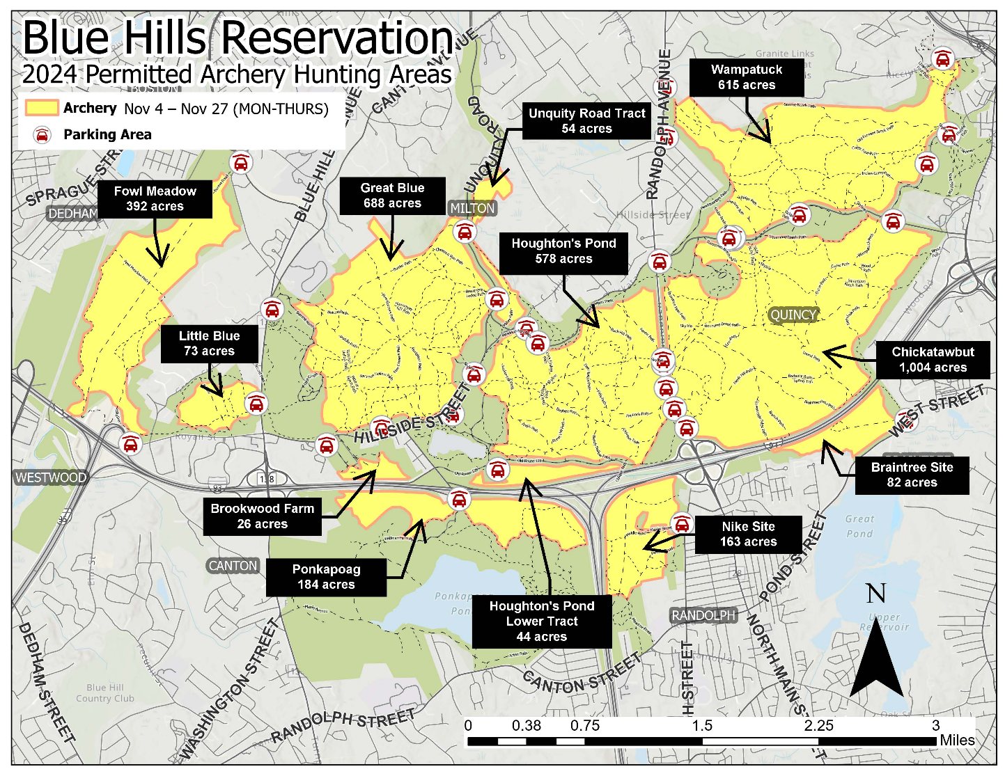

# 2024 Harvest Results

A total of 30 deer were harvested from approximately 6 mi2 of forest land opened to hunting. Over the 15-day hunt, there was an average of 28 hunters who checked-in to participate each day. The table below provides more detailed information of deer harvest results:

|  |  |  |
| --- | --- | --- |
| **Date** | **# Hunters Checked In** | **# Deer Harvested** |
| Monday, November 4, 2024 | 45 | 8 |
| Wednesday, November 5, 2025 | 35 | 4 |
| Thursday, November 6, 2025 | 22 | 0 |
| Friday, November 7, 2025 | 22 | 2 |
| Tuesday, November 11, 2025 | 43 | 2 |
| Wednesday, November 12, 2025 | 28 | 1 |
| Thursday, November 13, 2025 | 37 | 2 |
| Friday, November 14, 2025 | 25 | 2 |
| Tuesday, November 18, 2025 | 31 | 3 |
| Wednesday, November 19, 2025 | 18 | 2 |
| Thursday, November 20, 2025 | 29 | 2 |
| Friday, November 21, 2025 | 9 | 0 |
| Tuesday, November 25, 2025 | 29 | 2 |
| Wednesday, November 26, 2025 | 13 | 0 |
| Thursday, November 27, 2025 | 27 | 0 |
| **TOTAL** | **413** | **30** |

Harvest results from this year’s archery hunt (30 deer) were higher than the 2024 results (24 deer). The chart below provides annual harvest results (by sex) for reach of the nine controlled hunts conducted thus far:

# Synopsis of the 2024 Deer Management Program

As was acknowledged in the initial [Blue Hills Deer Management Plan](https://www.mass.gov/doc/2015-blue-hills-deer-management-plan/download), effective deer management programs must incorporate and maintain a good degree of flexibility in order to make modifications and adjustments that are grounded in experience and ongoing assessment.

The 2024 permitted archery hunt represents continued progress toward addressing deer overabundance and its impacts in the Reservation.

From the perspective of public safety, all agencies involved in the coordination and implementation of the 2024 controlled hunt were satisfied. A brush fire during the third week of hunting likely had an impact on hunter turnout and hunter success; however, this brush fire did not impact public safety. Communication was promptly sent to permitted hunters to alert them of the location of the brush fire and logistical considerations and DCR coordinated with state officials regarding road closures.

Considerable time was spent assessing a myriad of operational aspects associated with conducting controlled hunting within the Reservation and developing a plan that addressed these operational concerns. A change from prior years, all management areas were open to all permitted hunters and hunters were not assigning specific zones did not result in any hunter conflicts. The successful execution of this plan and support from permitted hunters for the overall goal of safety represents a significant achievement. Like the previous eight controlled hunting programs, the 2024 program demonstrated that hunting can be safely conducted in a suburban/urban setting.