



Annual Report FY24

Agency Impact


Contents
10 Fiscal Year at a Glance
12 Career Services
20 Statewide Rehabilitation Council Report
32 Home & Community Life 35 Disability Determination
Services

08 Exploring Possibility at the Annual Summit

14 Harnessing the Power of Partnership

16 Unseen Struggles

22 SRC Committee Reports

28 SRC Recommendations

34 Embracing Creativity

38 An Internship with MassAbility



Helping you do you.
For people with disabilities.
From the
Commissioner
Dear MassAbility Community:

Wow does it feel good to write that! On September 12, 2024, the Massachusetts Rehabilitation Commissioner (MRC) became MassAbility. We could not be more grateful to Governor Maura Healy, Secretary Kate Walsh, and members of the Massachusetts Legislature for their unwavering support as we usher in a new era for our agency.

Over the years, MassAbility has expanded its role in the community, providing services that meet people with disabilities where they are, literally and metaphorically. MassAbility today is about pride and self-determination. We’re about rights and equal access. We’re about building a future and being fully present and counted in the world. That’s the truth at the heart of MassAbility.

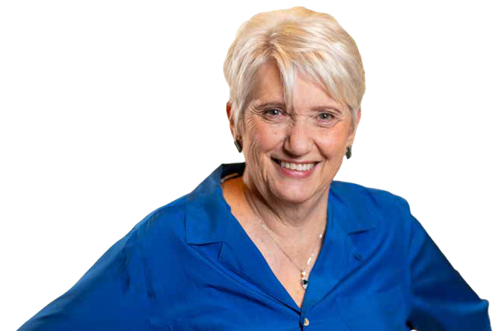
In this report you’ll see facts, data, and numbers. But more importantly, you’ll meet the people and see the impact our agency has in Massachusetts every day. For too long, people with disabilities have faced social and
physical barriers in their path to independence and self-determination. We cannot reach
our true potential unless everyone can participate fully and contribute their talent, will, and ingenuity. Inclusivity is good for society, good for business, good for our culture. When we break down barriers, we make life better for all.

Toni Wolf
Commissioner of MassAbility

“Language has the power to shape people and culture, tackle stigmas, biases, and stereotypes.

Toni Wolf
Commissioner of MassAbility

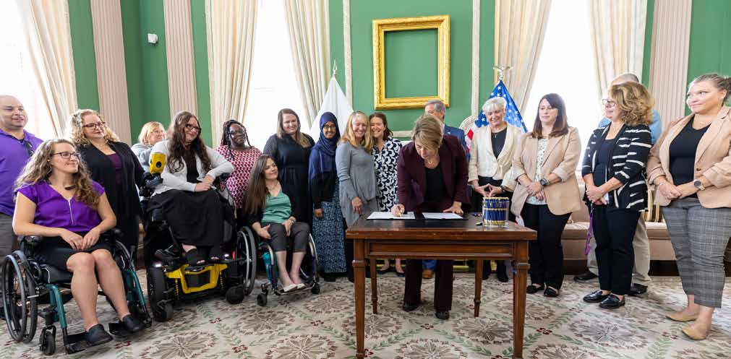
We Are MassAbility
Governor Healey Signs Legislation Renaming Massachusetts Rehabilitation Commission to ‘MassAbility’

04
On Thursday, September 12, Governor Maura Healey signed legislation that renamed the Massachusetts Rehabilitation Commission to MassAbility.

Governor Healey filed this bill last year to reflect the administration’s goal of expanding the agency’s reach and ushering in a new, more inclusive model for disability career services and independent living.The legislation also
removes outdated terms from the general laws like “handicap,” “handicapped,” and “retarded,” replacing them with “barrier,” “person with a disability,” and person with an “intellectual disability.”
“Words matter. This legislation ensures that the names and terms we use accurately reflect the strength and capabilities of the disability community, supports our goal of helping the people
we serve achieve autonomy and independence, and breaks down stigma,” said Governor Maura Healey. “I’m grateful to our partners in the Legislature for advancing this legislation, and to the members of the disability community and our team at MassAbility and the Executive Office of Health and Human Services who advocated to make this a reality in Massachusetts.”

“MassAbility exemplifies a sense of community and belonging,” said Lieutenant Governor Kim Driscoll. “By updating these laws, we are putting outdated terms aside while honoring the disability
community’s tenacity. MassAbility today provides services that break down barriers, cultivate diversity and empower people to thrive
in their workplaces and their communities.”

The new name directly resulted from feedback from the disability community and was selected following significant research, focus groups, surveys, and conversations with the community, businesses, providers, and advocacy organizations.

“The new name MassAbility and language changes reflect both the state and agency’s commitment to inclusivity, because we know that words matter,” said Health and Human Services Secretary Kate Walsh. “MassAbility represents pride and self-determination. It’s about rights and equal access.

05

It’s about building a future and being fully present and counted in the world.”

“This historic legislation represents the state’s commitment to propelling the disability movement forward,” said MassAbility Commissioner Toni Wolf.

“Language has the power to shape people and culture, tackle stigmas, biases, and stereotypes.
For too long, the words we’ve used have not reflected the strengths, resilience, and
determination of the disability community. This legislation changes that. We are changing life
in Massachusetts for the better, making it more equitable, accessible, and inclusive for people with disabilities.”


“MassAbility signals the intentionality of the Healey-Driscoll Administration for driving a more inclusive workforce, workplace, and work
opportunities for individuals with all capabilities,” said Labor and Workforce Development Secretary Lauren Jones. “Massachusetts is dedicated to fostering an equitable workforce system, and
the Executive Office of Labor and Workforce Development looks forward to building on shared strategies to achieve this in collaboration with

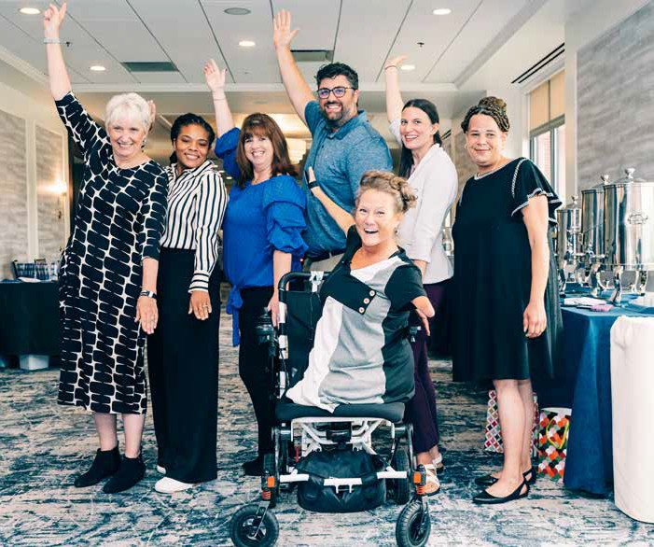
MassAbility.”

“Every person has the right to live an independent and meaningful life regardless of ability, with the same access to work, housing, and services that every resident deserves,” said Senate President Karen E. Spilka (D-Ashland). “With the Governor’s signature, we change this name to one which reflects the strong work of MassAbility to deliver that access to every individual who works with them, and we remove
archaic laws — an important step towards becoming a more equitable Commonwealth. I am deeply grateful to the Governor for her signature, my colleagues for their support, Speaker Mariano, and our partners in the House.”

“This legislation is our latest effort to ensure that our state laws do not use antiquated words that carry negative connotations, words that also serve as a reminder of past injustices,” said Speaker of the House Ronald J. Mariano (D-Quincy). “I would like
06
to thank Governor Healey for filing the bill originally, as well as all my colleagues in the House and our partners in the Senate for working to pass this important legislation.”

Working alongside the disability community, MassAbility provides services that break down barriers, cultivate diversity, and empower people to thrive in their workplaces and their communities.

To learn more, visit mass.gov/MassAbility.




Exploring Possibility at MassAbility’s
Annual Summit

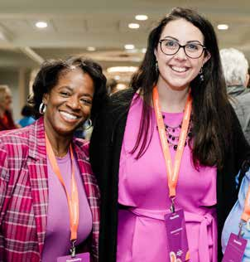
MassAbility hosted its third annual Explore Possibility Summit this year at the Marriott Boston Quincy on October 29 and 30. For the first time, the Summit was held under our new identity, MassAbility, reflecting a fresh chapter in the agency’s history.
Day 1, held on Tuesday, October 29, was designed specifically for agency participants, offering workshops and activities to connect them with services, celebrate their accomplishments, and inspire personal and professional growth. Day 2 brought together members of the provider community for networking, educational sessions, and workshops to improve service delivery.

The Summit kicked off with opening remarks from Commissioner Toni Wolf, who reinforced the purpose of MassAbility, “we want to make sure there’s equal access and equity for individuals with disabilities.” Participants viewed MassAbility’s powerful new video, showcasing the disability community along with staff intertwined with our vibrant new brand and messaging
that speaks to what we do best: expanding what’s possible for people with disabilities.

Reflections from the Community
Attendees were captivated by this year’s keynote speaker’s, MassAbility’s very own Disability Inclusion Leader’s and Family Inclusion Ambassador’s. This moving panel of individuals sharing their lived experiences, including Destiny Lomonte, a disability inclusion leader.

“The summit this year not only showcased our new name, but the power behind that name. The workshops centered on empowering the community. We taught how
to share our stories to have a maximum impact, we looked at our futures through the young adult panels and fiscal planning, we took charge of our social and recreational life showing we don’t just have to go to doctor appointments and work, but to truly live our full lives. That’s the power behind MassAbility and making these connections at Summit- we show not just our vendors and caseworkers but each other just how able we really are.”

A Day to Celebrate Connection and Resilience
The lobby buzzed with excitement on the morning of
October 29 as attendees, including individuals with disabilities, families, providers, and MassAbility staff, arrived at the Marriott Boston Quincy. By the afternoon, the venue was filled with meaningful connections and a palpable sense of community.

Day 1 included hands-on activities such as staff-led workshops, assistive technology and adaptive recreation demonstrations, speed networking opportunities for the disability community, and so much more. Day 2 provided an in depth opportunity for provider partners to understand the agency’s new brand, ask questions, and build community
as organizations that provide services for the disability community.

The Explore Possibility Summit reinforced MassAbility’s commitment to creating spaces where the disability community and its allies can thrive, connect, and celebrate their shared purpose.

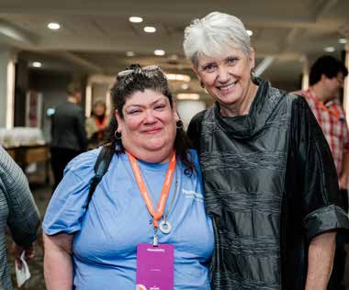
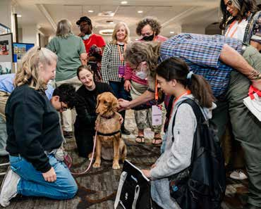
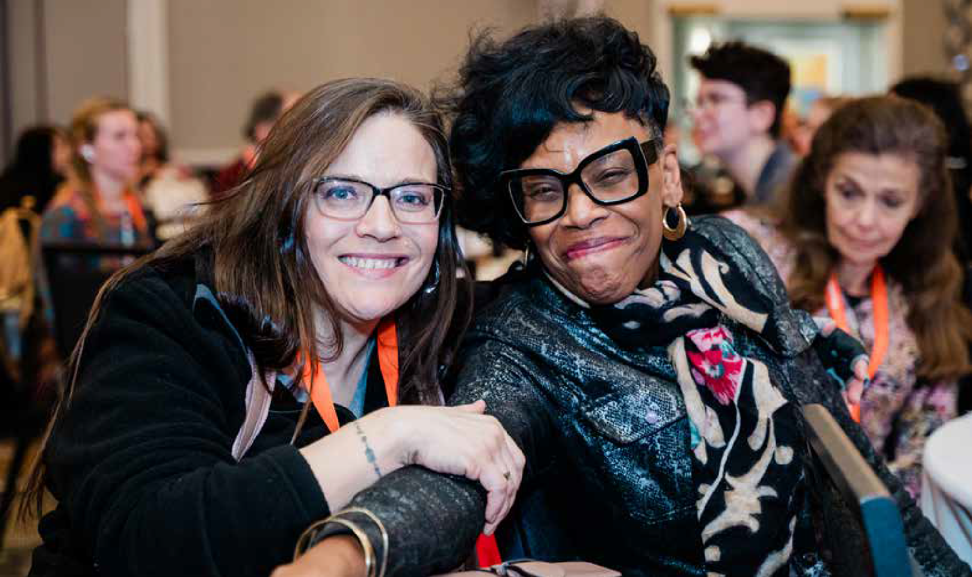
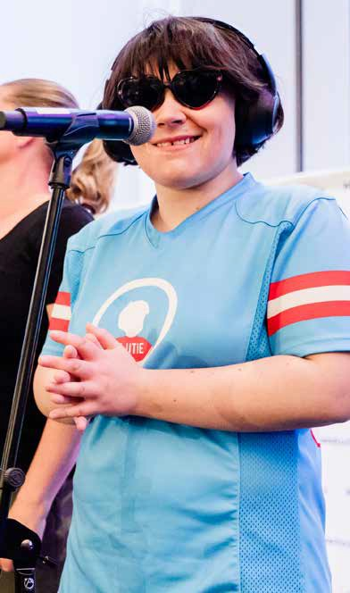
08

Fiscal Year at a Glance

Career Services
23,283
17,291
participants receiving career services
participants enrolled in training/education

Cost for individual served
$
FY24 Funding  FUNDING AREA | STATE | Funding Source  FEDERAL TRUST CAPITAL |  |  | TOTAL
Career Services | $37,733,229 | $57,717,556 | $3,879,502 | - | $99,330,287
Home & Community Life | $75,901,106 | $3,329,468 | $4,026,606 | $3,801,159 | $87,058,339
NextGen Careers | - | $4,103,676 | - | - | $4,103,676
Disability Determination Services | - | $50,806,437 | - | - | $50,806,437
Commissioner’s Office | $388,930 | - | - | - | $388,930
Agency Funding Total | $114,023,265 | $115,957,137 | $7,906,108 | $3,801,159 | $241,687,669

$4,266

11,572 new applicants for Career Services

9,875 applicants determined eligible

Home & Community Life

Disability Determination Services

11,014
participants served
$
Cost for individual served
$7,904







Funding By Program

Funding By Source



claims received  97% 
60,305




claims processed
60,453
Career Services
Home & Community Life NextGen Careers
Disability Determination Services
41%
36%
2%
21%
State Federal Trust Capital
47%
48%
3%
2%

claims processed for individuals applying for SSI/SSDI benefit

99.3% of participants maintained independence in the community

10
accurately


Commissioner’s Office 0%

By the Numbers

Type of Disability
Psychiatric 60.2%
Learning 11.7%
Orthopedic 8%
Substance Use Disorder 6.7% Deaf & Hard of Hearing 4.9%
Developmental/Intellectual 3.3%
Other 2.4%
Neurological 1.5% Traumatic Brain Injury 1.2%

10% 20% 30% 40% 50% 60% 70% 80%

Career Services
MassAbility’s Career Services team works with you to explore industries and career paths that suit your interests and professional goals.
Whether it’s for personalized career counseling, vocational training, accommodation assistance, or job search support, our team is here to champion your success. We’re not just creating opportunities—we’re cultivating an accessible and inclusive environment where everyone can thrive.

Together with public colleges and universities, professional training programs, and employers statewide, people with disabilities are breaking down barriers and expanding what’s possible.

Service Offerings for Jobseekers
+ Counseling and guidance
+ Job-driven training
+ Interest and aptitude testing
+ Job placement assistance
+ Diagnostic evaluations
+ College or vocational training
+ Assistive technology
+ Financial wellness
+ Pre-Employment Transition Services for students (Pre-ETS)
+ Communication access services: ASL interpreters, oral transliterators, CART, multiple language translation

Race

White 71.8%
Black 16.4%
Hispanic/Latinx 13.6%
Asian/Pacific Islander 3.5%
Native American 0.6%
Multiracial 1.9%
Choose not to identify 5.7%
10% 20% 30% 40% 50% 60% 70% 80%

Gender

Male 53.4%
Female 44.2%
Did Not Identify 2.3%
10% 20% 30% 40% 50% 60% 70% 80%

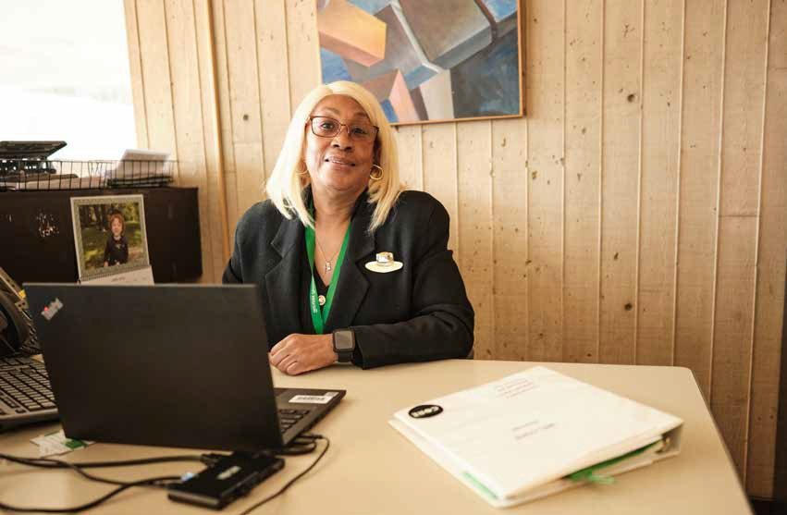

33.9
The average age at application.

$80.02 million
The earnings of these successfully placed employees in MA in the first year.

$21.02 million
The estimated public benefits savings from people placed in MA.
2,802
Citizens with disabilities were placed into competitive employment based on their choices, interests, needs, and skills.
12

Harnessing the
Power of Partnership
By Lynh Chau

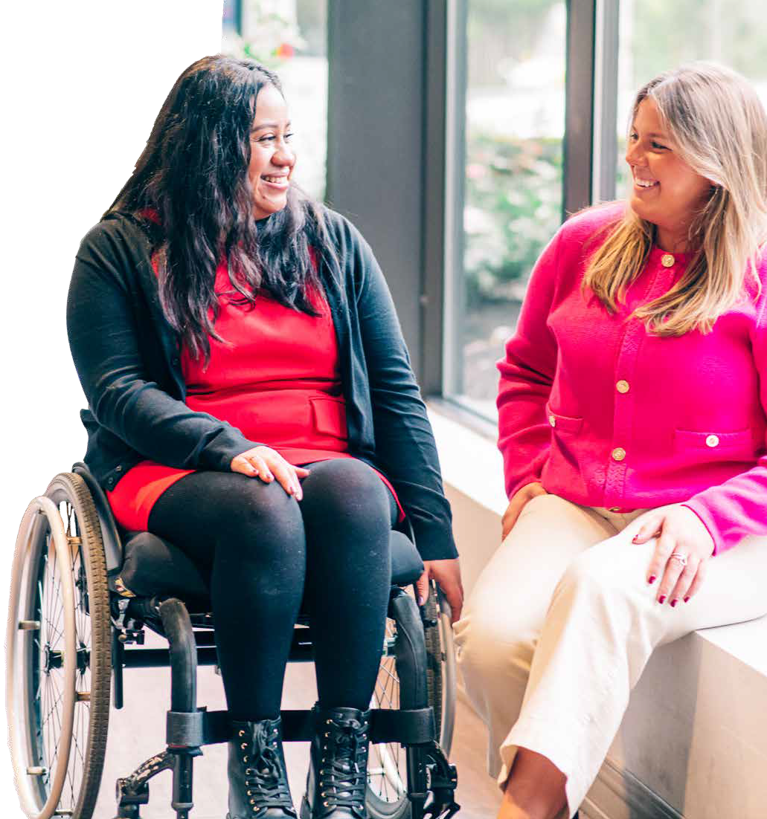
Cindy Cruz is no stranger to the annual MassAbility Hiring Event.

As a former MassAbility participant, she is intimately familiar with the challenges individuals with disabilities face when
it comes to seeking a meaningful and rewarding career. This year she returned to the event in a different capacity–as a hiring manager and partner in possibility.

Cruz shared her journey of transformation from being a job seeker at the event to becoming a leader who hires others. “I first came here as a client a while back, said Cruz. “[MassAbility] helped me find a job, which has been a full circle moment. Now I’m here from a Human Resources perspective, hiring candidates and finding them positions. Thanks to MassAbility, I’m here because of them.”

She is now a Senior Talent Sourcing Partner at Mass General Brigham (MGB), driven by her passion for helping others with disabilities find meaningful work.
MGB focuses on filling roles for satellite locations, often partnering with high schools, trade schools, and other diverse talent sources to offer inclusive job opportunities.

Courtney Regiannini, a talent acquisition partner at MGB, returned to the hiring event this year with Cruz by her side. She hired Cruz two years ago because of her ability to identify and share how her skills could align with new opportunities—an attribute highly valued at MGB. Regiannini emphasized the importance of “helping job candidates discover their passions and identify how their skills can translate into meaningful roles.”

“MGB is committed to continuing these conversations [with job candidates] beyond the hiring event to stay connected and support their career journeys.”

Cruz’s journey is a powerful example

14
of how creating opportunities for job candidates to share their unique skills and experiences can lead to meaningful careers, “It’s critical to allow MassAbility job candidates to shine and tell their stories in terms of how their skills can be transferred into a position. “Whether it’s a new career opportunity or guidance on new roles that might interest them”.

Cruz shared her successful career and leadership growth, through both promotional opportunities and self- confidence. “I’ve definitely grown and
learned a lot,” Cruz said. “I started as an associate talent sourcing partner, then grew to a talent sourcing partner, and now I’m a senior talent sourcing partner. I’ve been promoted twice, gaining valuable skills, building confidence, and learning important leadership skills. What I do makes me happy—helping others find jobs is truly my passion.”

Hiring a person with a disability is not a gamble or a risk. According to the U.S. Department of Labor, employers who have embraced disability as a component of their talent strategy have seen a 90 percent increase in retention of valued employees, a 72 percent increase in employee productivity, and a 45 percent increase in workplace safety. Yet, societal stigma around disability remains a barrier in many organizations hiring practices.
MassAbility is working to change that.

For the past 13 years MassAbility, in partnership with the Office of Federal Contracts Compliance Programs (OFCCP), has hosted the annual Hiring Event as part of the agency’s continuous effort
to connect candidates from varied backgrounds with employers from various market sectors. MassAbility’s Career
and Business Relations team prepares candidates for a full day of interviews and networking opportunities. By bridging the gap between businesses and job seekers, MassAbility continues to champion
an inclusive hiring culture that allows individuals with disabilities to thrive and find meaningful careers. The agency has
placed more than 625 individuals into
successful careers as a direct result from the event.

MassAbility and MGB provided Cruz with the opportunity to cultivate her skills and build a career
she is truly passionate about. Reflecting on
her journey, Cruz shared “it brings me so much joy to help others find their path.”

Cindy Cruz (left) & Courtney Regiannini

Unseen Struggles


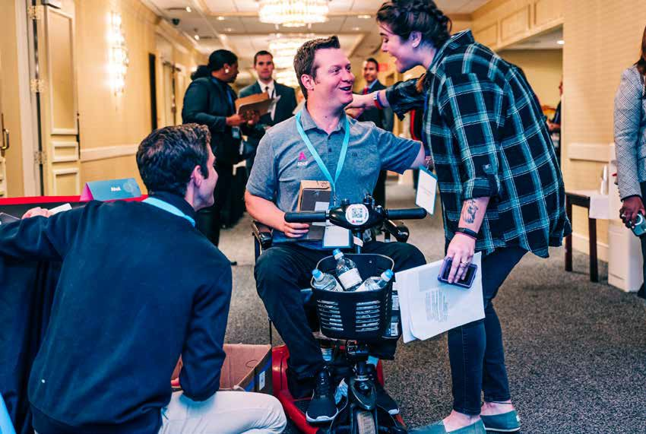
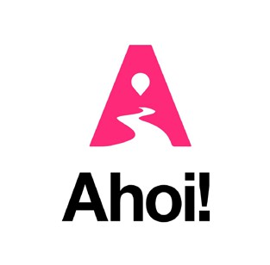
Navigating an Inaccessible World

By Cindy Walker

Jake Haendel didn’t plan to become a disability advocate and entrepreneur, but when Acute Toxic Progressive Leukoencephalopathy locked him in a coma for 10 months, his new life began.
Jake was initially believed to be brain-dead, but he was actually suffering from Locked-In Syndrome. Trapped in a coma, he remained completely conscious and completely aware of his surroundings, but unable to move and communicate with the outside world. Jake kept himself calm, continually reminding himself that he would find a way out and let his family and team of medical staff know he was still with them, hearing, seeing, feeling, and smelling everything that was going on around him. Eventually Jake began to communicate through eye and finger movements that were thankfully noticed by the nurses who cared for him.

As days turned to weeks, and months into years, 2017 became 2024 and Jake continues to make great strides in his recovery journey. Jake became a MassAbility service

recipient to help him transition from living in a nursing and rehabilitation facility to a handicapped accessible apartment. While learning to navigate his new reality, Jake continued to encounter barriers when trying to spend time with family and friends outside his safe and barrier free apartment.

He enlisted the help of some friends to brainstorm what is now called Ahoi, an app that uses crowdsourcing technology to rate the accessibility of public spaces. Users create profiles and add preferences on the types of accessible features that pertain to them. The algorithm then shows them businesses in the area that fit those needs, based on the ratings and reviews of other users. Some refer to the app as the “Waze for accessibility”, a space for people living with disabilities to help others living with similar disabilities navigate.

Through word-of-mouth among MassAbility staff members, Jake was approached to be our Keynote Speaker at our annual Explore Possibility Summit in the Fall of 2023, and to have an exhibitor table so attendees could learn about his journey and how to interact with the Ahoi app. Jake and his business partner, Chris Beissel, were also hoping to
continued >
17

connect with a larger audience and create awareness for the app. During his keynote, Jake commented, “With the help of MassAbility, we can create a comprehensive map of Boston and Massachusetts to share with people living
with a disability so they can find the best way to experience their community.”

Fast-forward to the Fall of 2024, the MassAbility Career and Business Relations Team partnered with Jake and Chris to create an internship cohort! Since Ahoi has gained momentum this past year interns were needed in all departments of the company. From marketing, user engagement, platform enhancements, and general Q&A, MassAbility Interns worked directly with Jake and Chris to create a strong sense of community and support for app users and the cohort. They were also able to go into their own communities and provide feedback on spaces and businesses using the app. In the spirit of fostering a tight-
knit team Jake and Chris would often schedule outings that celebrated this partnership and showed appreciation for the hard work and commitment of the team.

Most notably, Jake, Chris, the interns and some MassAbility staff cheered on the Boston Red Sox at a September 10 baseball game. We also had the privilege of working with
a couple of Ahoi interns at the 12th annual Hiring Event on September 26. They had the opportunity to schedule interviews with the employer partners at the event, as well as tabling an exhibitor table to interact with attendees.
They shared their experiences of working with Ahoi and

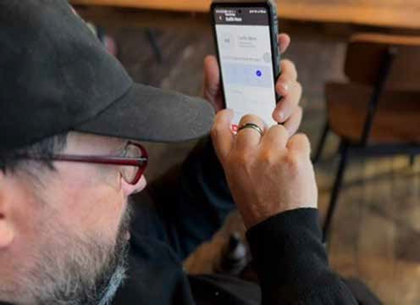
how this type of professional partnership differs from conventional career services experiences.

Jake’s incredibly unique perspective with living with a disability and starting his own business that caters to the disability community has been refreshing and what makes this type of collaboration so successful. Creating true partnerships with companies and organizations that
foster the talents and passions of our job seekers is game- changing in the career services field. MassAbility has committed to continue working with companies like Ahoi and with like-minded entrepreneurs like Jake and Chris.

As an Ahoi intern, I had the incredible opportunity to meet and collaborate with others who, like me, aimed to secure employment without letting their disabilities define them.
This community has been a beacon of inspiration, showing me that our abilities, determination, and spirit are what truly matter. For a long time, I hid behind my disability, lacking the confidence to fully embrace my potential. However, the support and encouragement I received through this internship changed everything.
“

Through my work with Ahoi, I learned to confidently present my skills and talents to potential employers, without letting the conversation be dominated by my anxiety about my disability. This newfound confidence enabled me to secure a job with a great salary, granting me the independence and self-reliance I had always hoped for. This achievement is not just a personal milestone; it is a testament to the efficacy and impact of the Ahoi internship program.

I should also highlight the incredible connections I made during my time at Ahoi. Working closely with Founder Jake Heandel, Co-founder Chris Beissel, and the team
of interns has been a profoundly enriching experience. These relationships have not only provided professional growth but have also fostered friendships that I cherish deeply and will never forget.

This experience has truly changed my life, and I am eternally grateful for it. I sincerely hope that the Ahoi internship program continues to thrive and expand. My wish is to see every individual succeed, gain confidence, become independent, and realize their potential, just as I have.

Thank you for your unwavering support and for fostering programs that create real, positive change.

Sherly Veras
2024 Ahoi Internship Cohort Participant



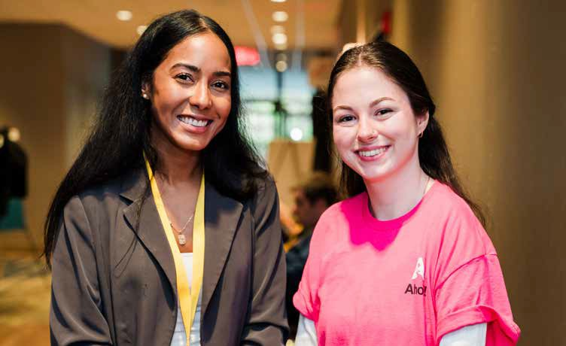
18
Sherly Veras (left) & Heidi Holm


Statewide Rehabilitation Council

The SRC is a diverse, inclusive, and equitable advisory body that gathers representative voices from the disability community to provide input to MassAbility’s Career Services.

The Council’s collective and individual thinking plays a substantive role in how the agency operates and contributes to the innovation of career and counseling services. Members of the SRC collaborate with MassAbility
in developing goals and priorities for the state plan, and offer input and consultation on policies, practices, and procedures that impact jobseekers.

A Letter from the Chair
Heather Wood

If you are an employer, individual with a disability, family member, advocate, service provider, and/or someone who wants to make a difference in people’s career-goals, this is the group for you!
With immense pride and enthusiasm, I present the MassAbility’s (SRC) Annual Report for FY24, marking my first year as Council Chair. This year has been both fulfilling and transformative as we
strengthened our role as the advisory body to MassAbility while driving initiatives that enhanced our operational effectiveness and impact. Supported by reallotment
restructuring committees to improve efficiency, collaborating with MassAbility on Diversity, Equity, Inclusion, and Accessibility (DEIA) efforts, promoting the Disability Employment Tax Credit (DETC) to employers, supporting self-employment strategies for job seekers, and improving employment outcomes for recipients of DMH’s Adult Community Clinical Services

Vision

FY24 SRC Members
Matthew Bander Disabilities Rep

Youcef J. Bellil Disabilities Rep

Kate Biebel Ex-officio
Deputy Commissioner

Dawn E. Clark Disabilities Rep

Rebecca Davis Parenting Training/Info Center Rep

Paula Euber
Career Services Rep

Naomi Goldberg
Client Assistance Program (CAP)

Steve LaMaster Community Rehab Services Provider Rep

Lusa Lo
Higher Education Rep

Steve Higgins Workforce Investment Board (WIB)

Tay Silveira Disabilities Rep

Heather Wood
Dept. of Elementary & Secondary Education

Rosanna Woodmansee Business/Labor/Industries

Vacant Business/Labor/Industries (3)

Mission

20

We envision a world where all individuals with disabilities are supported to live their best lives, through person-driven, meaningful, competitive, and integrated employment and sustainable careers.

We work to promote competitive and sustainable employment for all people with disabilities, including those marginalized by inequalities.
funding, the SRC partnered with the National Association of State Head Injury Administrators (NASHIA) to address critical governance and operational needs.
This collaboration enabled us to update bylaws, establish an Ad Hoc Membership Committee, and formalize internal processes, ensuring alignment with best practices and better reflecting the diversity of those served by MassAbility. These efforts have strengthened the SRC’s role as an advisory body and laid a foundation for enhanced leadership and membership engagement moving forward.
As we look to FY25, the SRC remains committed to expanding its impact, enhancing governance, and ensuring individuals with disabilities have the support and opportunities needed for meaningful employment. Priorities include
(ACCS) program.
In closing, FY24 was a year of significant progress for the SRC as we advanced governance, outreach, and advocacy for individuals with disabilities. Our collaboration with NASHIA has further strengthened our capacity to advise MassAbility and promote inclusive
employment across the Commonwealth.
As we look to FY25, the SRC remains steadfast in its commitment to expanding its impact, refining governance, and ensuring individuals with disabilities have the support and opportunities they need to achieve meaningful employment.
I am proud of all we have accomplished together and confident that this progress has laid the foundation for sustained growth and continued success in the years ahead.

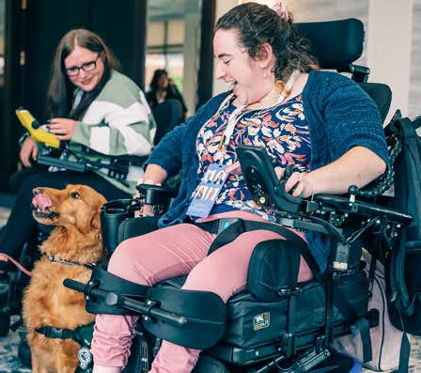
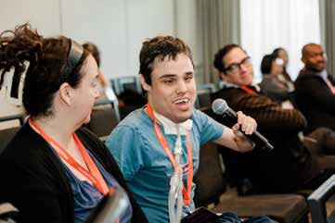
Committee
Reports
Fiscal year updates from the Statewide Rehabilitation Council Committees.

Ad Hoc Committee on Membership

Chairperson: Naomi Goldberg
The ad hoc membership committee was established to focus on orientation and diversity strategies for future SRC recruitment. The creation of this committee was among recommendations made by
National Association of State Head Injury Administrators (NASHIA) the organization with whom MassAbility contracted to implement the SRC’s diversity goals.

The membership committee met four times from May-August and advised NASHIA
on the development of a council survey to determine current demographics. The committee members emphasized getting
information on multi-occurring disabilities, disability categories, and geographic parts of the state for the best understanding of current representation.

The demographic survey was distributed to the SRC members and the information
gathered resulted in new information related
22
to geographic representation, disability/multiple disabilities, disability category (sensory, physical, mental health, cognitive), family member/caregiver, as well as race and ethnicity. Survey data was placed into pie charts for review by the executive committee as well as the full council.

Tools and resources for recruitment
NASHIA developed a new membership and recruitment tracking tool for the SRC. The committee worked to clarify member positions by category, though this effort was complicated by pending memberships/non-appointments. NASHIA researched community organizations that would result in the recruitment of people with disabilities for the council from minority communities.

The committee reviewed the most recent council brochure and agreed on the need to modify language to better describe the role and function of the SRC and the council’s diversity efforts. The committee reviewed the most
recent council application and determined the need for modifications to remove inaccurate language and to add demographic information. The application and brochure recommendations are being passed to MassAbility with the request to revise both tools.

A new orientation set of slides for future onboarding was developed and is being finalized by NASHIA. It is inclusive of open meeting law information and guidance, executive order updates, as well as key information on important topics to include the public vocational rehabilitation system, the Rehabilitation Services Administration, MassAbility,
for better understanding by new members. The aim of the new orientation slides is to acquaint new members to more specifically understand the purpose of the SRC and the specific ways it advises MassAbility in the areas of employment outcomes, policy, customer satisfaction, etc.

Looking ahead
A future goal is to record council member videos describing their experience with the SRC and personal areas of focus.

Business and Employment Opportunity Committee

Chairperson: Steve LaMaster
The SRC Business and Employment Opportunity (BEO) Committee is responsible for reviewing, analyzing, and providing guidance to the
MassAbility on methods and best practices for employment and employment services.
Develop practical strategies for sharing work incentives information with the business community/ The Business and Employment Opportunity Committee worked with MassAbility to promote the rollout of the Disability Employment Tax Credit (DETC). As of June, 2024 there were 40 certifications, demonstrating that the certification process is streamlined and working. The data collected is safeguarded. Staff from MassAbility’s Department of Finance certifies individuals for both the DETC and the federally-based Work Opportunity Tax
Credit (WOTC). The company/employer who has employed a person with a disability for a year gets a unique identification number, checks a box for DETC, and submits a photocopy of the employee’s certification with its tax
return. This is the first tax year that employers can claim the credit.

Information about how to apply for the DETC has been shared by the BEO Committee with the Executive Director of the Massachusetts Clubhouse Coalition (MCC), and it was subsequently presented at a monthly employment forum by the MCC. While MassAbility awaits a name change for the active marketing of the DETC to start, it is now able to be shared “word-of-mouth”. Once MassAbility’s name change is completed and the full marketing campaign begins, the capacity to market the Tax Credit in a more formalized and robust manner is anticipated. The BEO Committee has recommitted to assisting and advising to the continued rollout of this work incentive.

Assess and enhance current strategies and mechanisms to support Job Seekers in pursuing self- employment vocational goals.
The Business and Employment Opportunity Committee received several updates from MassAbility over the year, and provided information from a committee member
on the existence and training/resources available from an organization supporting Self-Employment, the VCU-
RRTC’s Center on Self Employment. MassAbility has been working with a consultant to identify the most salient trends in Self-employment which has thus far generated four recommendations, as follows:

- Choose and Implement Foundational Self-Employment Training for Counselors
- Update, Develop, and Make Available Internal and External Self-Employment Resources
- Create a New Role Focused on Self-Employment: Counselor for Entrepreneurship
- Strengthen Partnerships with Incubators, Entrepreneurship Communities, & Academic Institutions


Diversity, Equity, Inclusion & Accessibility Council

SRC Representative: Douglas Mason
The Diversity, Equity, Inclusion, and Accessibility Council is an executive body related to the DEIA strategy and implementation plan. The Council provides a space for problem-solving,
prioritization, collaboration, idea generation, and peer support.

MassAbility’s Diversity Plan Goals
The DEIA Council is charged with the responsibility of assisting MassAbility in the implementation of its diversity plan goals. Goals include prioritizing and incorporating the DEIA lens and strategies within all aspects of internal and external engagement, service delivery, and workplace interactions. Ensuring that MassAbility workplaces and technology are fully accessible to all staff. Recruiting and retaining a workforce that reflects the diversity of our population and in the citizens the agency serves, with a focus on veterans as it is a population MassAbility has
not hit the benchmark for in recent years. Ensuring that
24

the voice and choice of Individuals that we serve, as well as their family members, are front and center in the
design, development and delivery of services and supports. Advancing equity in the workplace for individuals with disabilities by ensuring that individuals with disabilities have equal opportunities to lead at every level.

Progress
Membership on the Council consists of a representative from each Employee Resource Group as well as members of the public. Theoretically, by including a representative from each employee resource group, there is representation from the full staff at MassAbility. Through collaboration with management, the Council developed a DEIA Scorecard which is used to assign responsibility to specific individuals in order to monitor progress. It also allows the councill to prioritize the plan-specific actions that are necessary for implementation.

Using the census data for the Commonwealth of Massachusetts, the Council compared the demographic statistics of the Commonwealth to the employee demographics at MassAbility. The performance of this exercise is to make sure that the agency’s employees are demographically representative of the Commonwealth of Massachusetts. We then looked at a breakout of the staff by demographics to determine if focus should be given to underrepresentation within the agency itself. Historically,
veterans have been underrepresented and that continues to be the case. A concerted and concentrated effort is

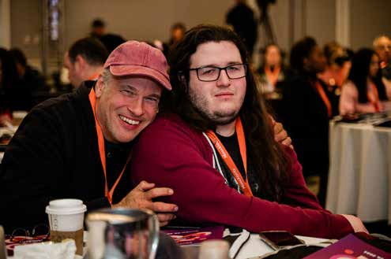
underway to address this situation. Training has been made available for employees to know and understand the importance of the Diversity Plan Goals.

A major focal point in our work is to make sure that we are providing the best service to our participants that can possibly be provided. In
this regard, a participant satisfaction survey was distributed, and the Council analyzed the results. Through collaboration with management and our counselors, we are continually addressing concerns raised. We are also making an effort to manage
the expectations of the population that we serve. This requires an open line of communication between the counselors and the participants. We also plan to develop training materials for our service providers to ensure everyone is on the same page.

The successful implementation of the Diversity Plan Goals is a very detailed and massive undertaking. The DEIA Council is committed to continued collaboration with management and everyone necessary to implement MassAbility’s diversity plan goals successfully.

Executive Committee

Chairperson: Heather Wood
The Executive Committee ensures the Council acts in accordance with federal and state vocational rehabilitation regulations; manages the affairs of the
Council in the interim between meetings; reviews the appointment categories
the Council has vacant and maintains a list of potential candidates to fill the
vacancies; and submits selected candidates for the following year to the Governors for consideration.

The Executive Committee of the Massachusetts State Rehabilitation Council (SRC) has focused on enhancing the Council’s effectiveness, diversity, and alignment with federal mandates. To achieve these goals, the Committee has refined membership guidelines, strengthened collaboration
efforts, and addressed structural challenges to improve overall Council efficiency.

Throughout FY24, the Executive Committee prioritized broadening the SRC’s membership to represent a wider spectrum of backgrounds.
A key recommendation was to work closely with MassAbility to recruit job seekers and other stakeholders from communities required by federal regulations, including unserved
and underserved populations, individuals with disabilities, and business representatives. To advance this goal, we partnered with the National Association of State Head Injury Administrators (NASHIA) and established an ad-hoc Membership Committee. This committee has been instrumental in identifying outreach strategies and developing training and orientation materials for current and future Council members.

The Executive Committee is also addressing ongoing challenges in the member appointment process, recognizing the importance of a well-supported and representative
council. Both the SRC and MassAbility are deeply committed to continuous recruitment efforts, ensuring diverse engagement and representation of MassAbility participants across the council, regardless of appointment status.

Recent updates to our bylaws and a new Executive Order from the Governor have allowed the Executive Committee to streamline membership requirements and improve functionality.
Reducing the required number of Council members has enabled the SRC to operate more efficiently while remaining fully aligned with federal
mandates, ultimately strengthening our ability to achieve our mission.

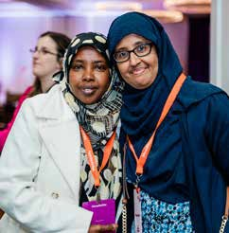

Participant Satisfaction/ Needs Assessment Committee

Chairpersons: Heather Wood & Dawn Clark
The Participant Satisfaction/Needs Assessment Committee ensures job candidate perspectives are included in the process of evaluating vocational rehabilitation (VR) services. MassAbility and the SRC jointly conduct an annual needs assessment; resultant information and findings are incorporated into the VR section of the Massachusetts WIOA Combined State Plan, strategic planning efforts, and the agency’s quality assurance activities. The Committee provides the agency with detailed information regarding the needs of participants served by MassAbility, and fulfills the federal requirements that the agency and the SRC jointly conduct a needs assessment at least every three years. As part of this process, a Participant Satisfaction Survey is also sent annually to consumers with closed cases to gauge their satisfaction with Career Services received through MassAbility.
Reconvening of the PSNAC
The PSNAC last met in August 2023, before its chair, Ronaldo Fuji, stepped down from the SRC to focus on
work responsibilities. With no replacement at the time, the committee remained inactive through late 2023 and early 2024.

Following a survey conducted by NASHIA after the March Quarterly meeting, members emphasized the importance of the consumer survey and noted that spring was a critical time to begin drafting recommendations for MassAbility.
Recognizing the need for consumer insights, the SRC decided to resume regular PSNAC meetings. Dawn Clark volunteered to chair the committee, but after the first meeting, she was unable to continue. Subsequently, SRC Chair Heather Wood took over as interim chair.

Broadening the PSNAC’s Mission and Work
At its May meeting, the committee expanded its focus beyond participant survey results to include surveys from MassAbility staff, vendors, and employers. Members
recognized that dissatisfaction among these groups could impact participant satisfaction and success. Additionally, the committee highlighted the importance of reviewing MassAbility’s employment outcomes. To reflect this broader focus, a possible update to the committee’s name and mission
was discussed.

Review of Survey Results
The committee reviewed results from the Participant Experience, Staff Experience, Business, and Provider/ Vendor Surveys. While no immediate recommendations were made to MassAbility, the discussions identified key areas of dissatisfaction and potential trends to monitor.

Looking Ahead
Initially planning to meet quarterly, the committee revised its schedule to bimonthly meetings. Going forward, meetings will alternate between reviewing Consumer Experience Survey results and results from the Staff
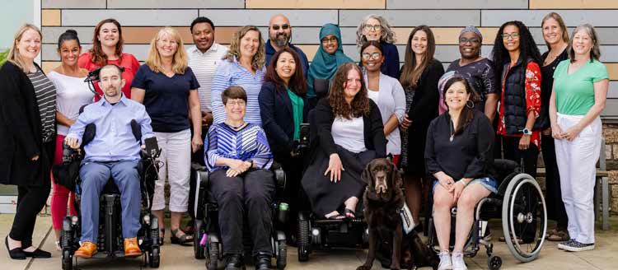
Experience, Business, and Provider/Vendor Surveys. State Plan and Interagency Relations Committee

Chairperson: Joe Belil
The State Plan and Interagency Relations Committee (State Plan Committee) ensures the SRC meets its obligations regarding input
from jobseekers in the development of both the MassAbility public VR (vocational rehabilitation) State Plan and the Workforce Innovation and Opportunity Act (WIOA) Combined State Plan.
Supported Committees through the SRC
Recommendation Process
Committee members reviewed and discussed MassAbility’s responses to the SRC FY24 recommendations, evaluating the progress at each State Plan meeting. A final SRC FY24 Recommendation document was developed and shared with all members.

Throughout this process, members had the opportunity to share and discuss thoughts and ideas on diversity, equity, inclusion, and accessibility. The committee emphasized the importance of continually addressing these critical issues.

Provided input to the Workforce Innovation and Opportunity Act (WIOA) Massachusetts Combined State Plan State Plan
In December 2023, MassAbility staff presented a progress update on the overall State Plan to the entire SRC body.
The State Plan Committee members appreciated the informative presentation by MassAbility’s staff liaisons, who have been consistently providing updates and research to the committee.

In February 2024, two members of the State Plan Committee attended and provided comments at the 2024 WIOA State Plan Public Listening Sessions.

Supported the SRC FY25 Recommendation process
In February 2024, the committee drafted the schedule and tasks for the State Plan and Annual Reports, along with guidelines for FY25 State Plan recommendations.

The committee also explored outreach strategies to engage the MassAbility community. Through the Office of Learning and Community Engagement’s Spring Newsletter, the
State Plan Committee invited the MassAbility community to provide input and recommendations on how Career Services can better support the disability community.
The committee remains enthusiastic about continuing discussions on enhancing the recommendation process to ensure alignment with DEIA (Diversity, Equity, Inclusion, and Accessibility) principles.

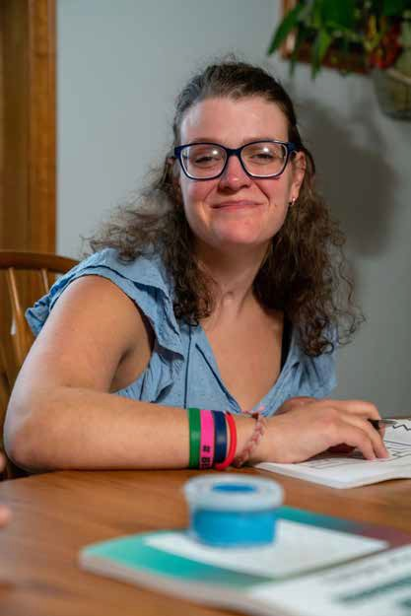
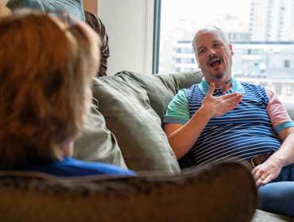

26

Recommendations
Join us.

- Consult with MassAbility to prepare a proposal to restructure the SRC committees by merging redundant ones, establishing distinct objectives, harnessing technology, and offering training to boost productivity and impact.

- MassAbility to provide an overview of DEIA work across the agency to SRC members, to help educate on current efforts and identify areas of meaningful partnership with the SRC. One area that the MassAbility could partner with the SRC on DEIA is in the review of in-development training modules.

- This SRC will advise MassAbility on strategies to enhance business and employer awareness of the Disability Employment Tax Credit (DETC): a state- sponsored incentive to promote employment of people with disabilities.

- MassAbility has been involved in the receipt of a year-long examination of national best practices in self-employment of people with disabilities, the final recommendations of which are expected in October 2024. The SRC will then work with MassAbility to involve stakeholders in presenting it’s findings and discuss a future MassAbility self-employment strategy to support Job Seekers with disabilities in pursuing self-employment vocational goals.

- For the last several years, MassAbility has implemented a model of employment service delivery for Department of Mental Health Services ACCS service recipients. SRC will collaborate with MassAbility and DMH stakeholders to enhance stakeholder awareness of the current collaborative delivery model and associated employment outcomes.

Be a voice in breaking down career barriers.
Contact the mrc.staterehabcouncil@mass.gov today.



28

Boost employee productivity Improve employee retention

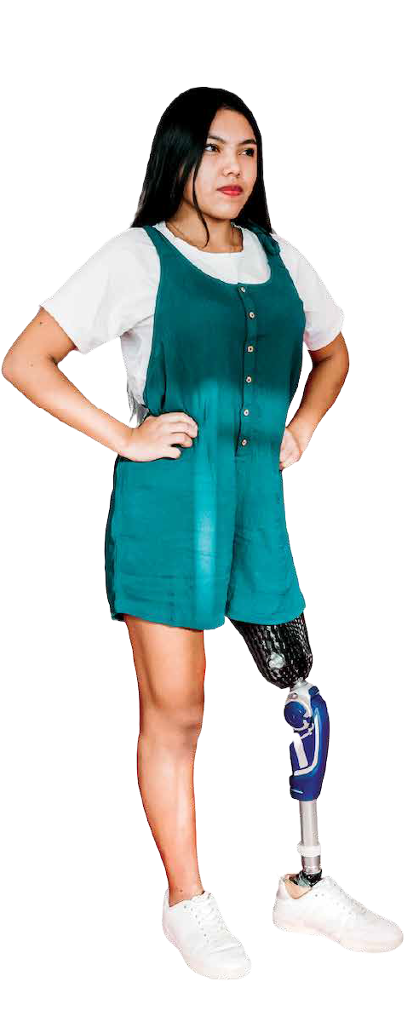
Hire people
with disabilities?
Not a chance. Not a risk.
Not a gamble. It’s a smart move for businesses
that want to grow.
Hiring people with disabilities increases employee productivity by 72% and improves employee retention by 90%




Attract more customers

Building a life on your own terms

Home +
Community Life
MassAbility’s Home and Community Life services empower you to participate in your community and build a better life on your own terms. We partner with you to expand what’s possible for adults and youth with disabilities, providing you with the support, technology, and training you need to become self- sufficient. Together, we’re breaking down barriers to create a Massachusetts that’s truly equitable, accessible, and inclusive.

Home and Community Life services

Our programs and services include

+ Turning 22 youth transition to adult human services

+ Supported living and home care

+ Independent living centers

+ Home modification loans
+ Accessible housing registry

+ Assistive technology training, devices, and resources

+ Community-based residential, day, and support services for people with brain injuries

+ Moving Forward Program

By the Numbers
+ 5,161 served by Independent Living Centers
+ 535 served by Turning 22 Services
+ 1,323 individuals received Assistive Technology
+ 297 indivduals received Supported Living sevices

+ 1,258 individuals received brain injury services
+ 1,148 individuals received home care
+ 319 received protective services

+ 966 received services from the Moving Forward Program

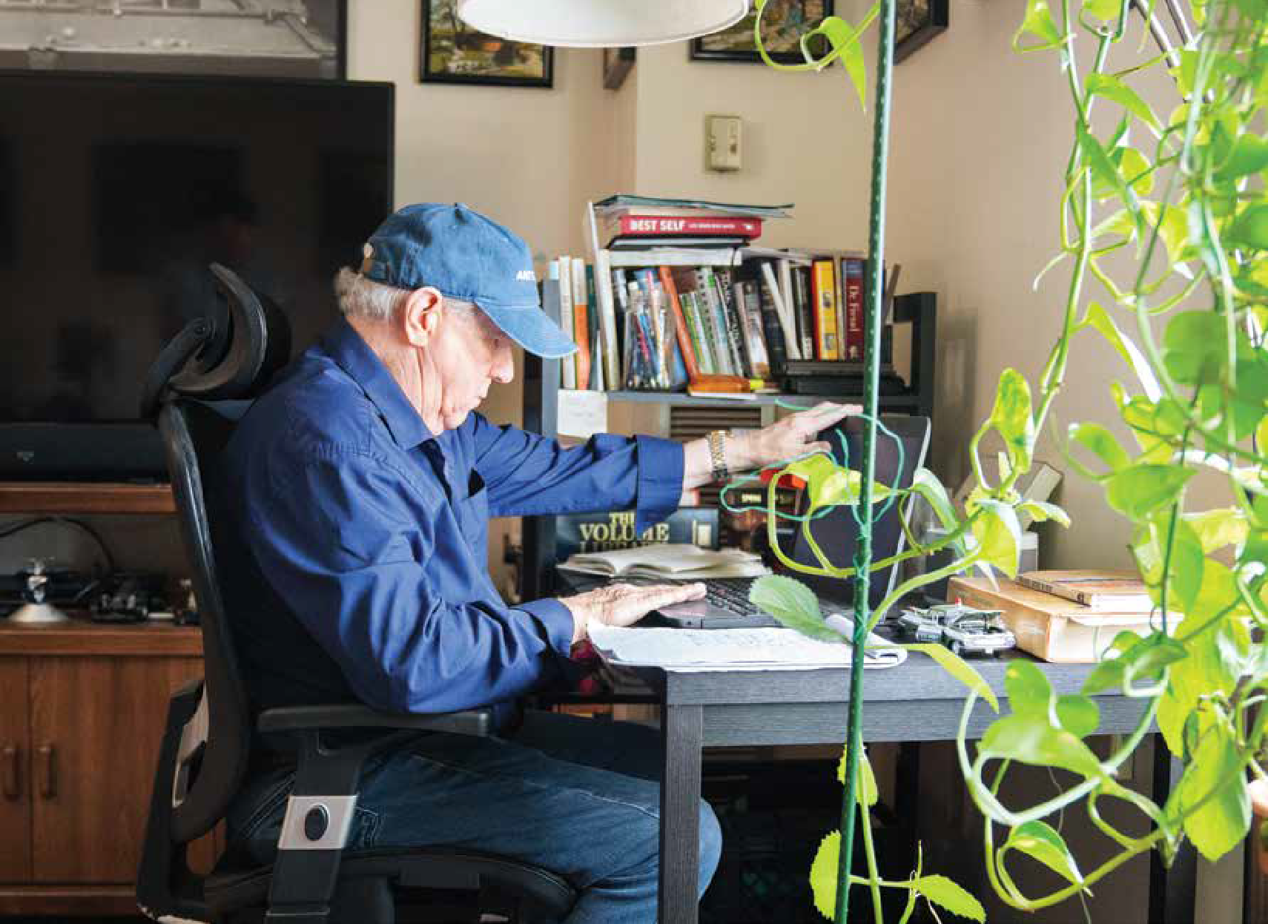
33

Following a workplace accident that resulted in a brain injury, Serina found herself grappling with
a newfound challenge: expressing herself.
Despite this, she realized that while words may sometimes elude her, she could vividly envision imagery, which she skillfully translated into art. Turning her inner turmoil into tangible expressions of creativity, she discovered a powerful outlet for self-expression and healing.

“I was always afraid of not being good enough,” Serina shared. “After my brain injury, I thought, if I’m going to be a perfectionist, I’m going to be a perfectionist about making a mess and make a perfect mess. As messy as I can.”

Seeking Support and Community

Initially, Serina discovered MassAbility’s Statewide Head Injury Program (SHIP) online and applied for services. “I felt completely
lost, and my life was utterly unmanageable,” she reminisced. Despite initially forgetting about her application, SHIP reached out to her through mail and phone calls to provide support.

Notably, Robert Mendel, a Regional Program Coordinator with SHIP, became pivotal in her journey. “She was facing eviction from her apartment because she hadn’t followed through with the home inspection,” Robert said. “I met with her, and SHIP intervened with housing. We got things settled
and from there we got her case management support.”

“This is why advocacy is so important,” Serina explains, “Rob single-handedly changed my whole life. If it weren’t for the SHIP program, my life would not be looking like this
right now.” Robert recommended that she seek the assistance of a case manager, which would later transform her life. He explains, “She’s got a case manager that obviously listens to her. She feels heard, she feels supported, and she’s making great gains.”


“Everything changed when Catherine Gonzalez came into my life through Community Rehab Care,” Serina said. “She is just a breath of fresh air that helps me keep things in order so that when I think about any tasks

that I have, I don’t go into an instant freak-out mode.” Since working with Catherine, Serina has embraced support and has been able to navigate the challenges of daily tasks and single parenthood with grace and resilience.

Healing Through Art

Amidst the healing process, Serina found solace in art, realizing its power to heal and express. With the support of friends and a tenacious spirit, her passion for art flourished.

Witnessing the impact of Serina’s art, Catherine proposed showcasing her work at a museum. Serina
was beyond ecstatic about this
opportunity she had never once thought was attainable.

“We went to the Fuller Craft Museum and the guy was magically there that day and they took 10 of my pieces to sell in the gift shop. It was a super cool feeling. That’s when I realized this is real and happening. I started to feel more that this is something that could be possible” Serina recalled.

Inspiring Others Through Her Adversity

Serina continues to face struggles as she heals from her brain injury, however, she references the accident as a
“hardware upgrade” that rewired her brain and has allowed her to accept self-love. As she continues to regain her voice, Serina discovers that the power of her story can inspire others.

“When I realized my story spoke to people and inspired them, I got over feeling self-conscious about my words. I’m going to stumble and ramble, but there is a message in there and it’s
a message of love. I think it’s something desperately needed in the world today”.

“It started with Rob advocating for me and then Catherine in Community Rehab Care and here I am now. It’s just really kind of blown me away that there are so many people that I’ve been a part of this that has really uplifted my journey and I’m so grateful for that.”

Serina’s journey, marked by perseverance and self-discovery, is a testament to the human spirit’s resilience. Her story inspires hope and underscores the transformative power of determination and support. She stands as a beacon of strength, embodying the profound truth
that, even in the face of adversity, there exists the potential for growth, self-love, and extraordinary transformation.


Embracing Creativity and Self-Acceptance After Brain Injury
Serina Gordon
Serina’s recovery from a brain injury is a tale of resilience, self-discovery, and purpose. Confronting initial fears of inadequacy head-on, she embraced her transformed self with unwavering determination.
34

Opening doors

Disability
Determination Services
If your ability to work is limited because of a disability, MassAbility’s Disability Determination Services (DDS) division is here to help determine if you are eligible for disability benefits.
You can apply for Supplemental Security Income (SSI) and/or Social Security Disability Insurance (SSDI) through the Social Security Administration (SSA). SSA works to assess your situation and eligibility. If you are determined eligible, SSA sends your application to DDS, and we will work with you to gather necessary information, make a determination, and return your application to SSA for you to get the assistance you need.
If you are found to be disabled, you may also be eligible for health care coverage through Medicaid and Medicare. For many Massachusetts residents like you, DDS is part of our team that can improve your quality of life by helping you live more independently.

By the Numbers

+ Number of claims processed for individuals applying for SSI/SSDI benefit: 60,453

+ Number of claims received:
60,305

+ Claims processed accurately:
97%
+ Number of continuing review claims successfully completed by DDS : 13,776

+ Number of initial claims processed by DDS: 38,512

+ Percentage of claims allowed by DDS: 44%

Massachusetts SSI/SSDI Summary

+ Total MA Population:
7 million

+ MA SSI Recipients, 2023:
164,783

+ MA SSDI Recipients, 2023:
190,364
+ Annual SSDI Benefits Paid:
$3.34 billion

+ Annual SSI Benefits Paid: $1.31 billion


37

My
INTERNSHIP

with MassAbility

Michael D’Antoni shares his experience working as a marketing intern at MassAbility

“ I worked with

I started my internship at MassAbility with the
Communications team at the beginning of January 2024.
I began by meeting my team and being walked through what I’ll be doing as an intern, meeting other MassAbility staff, and setting specific career goals for my internship. I helped the agency create campaigns that shared their mission and vision.

Every week, my supervisor provided a writing prompt or task for me to complete. I took part in researching, writing, and editing a PowerPoint presentation and a writing assignment looking into artificial intelligence (AI) in career services.
I write drafts and then share them with my co-workers and supervisor, who provide feedback. My work was shared with the team during team meetings, and we found ways to use it in agency campaigns and communications.

Once, during a team meeting, we discussed how to share with people how to dress professionally and
for job interviews. I was asked to create a “Wardrobe Do’s and Don’ts” infographic.
I worked with team members to create content we could share on MassAbility’s social media. It was challenging at first to understand what was needed when I started working on TikTok videos, which were unfamiliar to me. However, the team helped me understand the platform and showed me ways to contribute to video pre-production and production.

I spent time reading about MassAbility so I could understand the agency’s work we do and help better contribute to the content that the team created.

I enjoyed my internship at MassAbility. Working from home allowed me to be more flexible and has made working more accessible. The feedback I received from my supervisor has helped me improve my work. The general atmosphere of meetings with everyone was relaxed, but work was always getting done.

I’m working toward my bachelor’s degree, with a focus on marketing. I’m happy I had this experience interning with the MassAbility Communications department.

team members to create content we could share on MassAbility’s social media. The team helped me understand the platform and
showed me ways to contribute to video pre-production and production.”


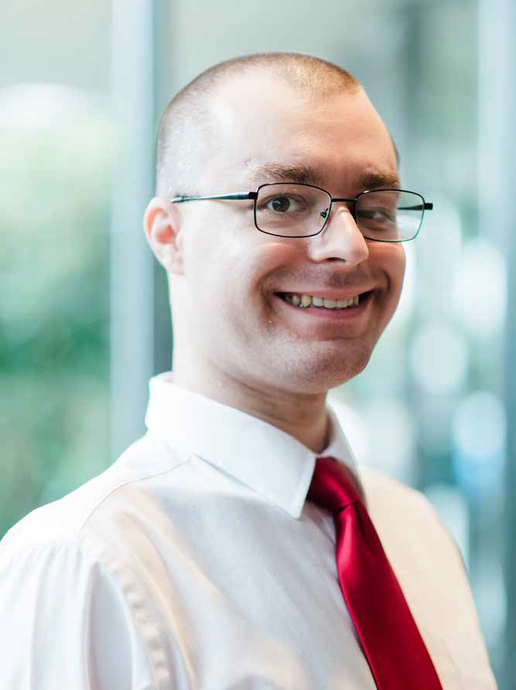
39




Expanding equity
and access for people with disabilities.

