

Massachusetts Department of Public Health
Bureau of Infectious Disease and Laboratory Sciences

Erin Mann, MPH
Esther Rei, MPH
Rashida Haye, MPH
Petra Schubert, MPH
Kate Hamdan, MPH
Anthony Osinski, MPH
Lindsay Bouton, MSc
305 South St.
Jamaica Plain, MA 02130
2024
Viral Hepatitis Surveillance Report

TABLE OF CONTENTS
Introduction 4
Hepatitis A 9
Figure 1. Number of confirmed hepatitis A cases by outbreak status, MA, 2015-2024 9
Figure 2. Number of confirmed hepatitis A cases by recorded sex or gender, MA, 2015-2024 10
Figure 3. Number and average rate of confirmed hepatitis A cases by age group, MA, 2020-2024 11
Figure 4. Number of confirmed hepatitis A cases by risk factors, MA, 2020-2024 11
Figure 5. Number and average rate of confirmed hepatitis A cases by county, MA, 2020-2024 12
Figure 6. Map of number of confirmed hepatitis A cases by county, MA, 2020-2024 13
Figure 7. Map of rate of confirmed hepatitis A cases by county, MA, 2020-2024 14
Figure 8. Number and age-adjusted average rate of confirmed hepatitis A cases by race/ethnicity, MA, 2020-2024 14
Hepatitis B 15
Acute Hepatitis B 16
Figure 9. Rate of confirmed and probable acute hepatitis B in Massachusetts compared to the United States, 2015-2024 16
Figure 10. Number of confirmed and probable acute hepatitis B cases by year, MA, 2015-2024 16
Figure 11. Number of confirmed and probable acute hepatitis B cases by recorded sex or gender, MA, 2015-2024 17
Figure 12. Number and rate of confirmed and probable acute hepatitis B cases by age group, MA, 2020-2024 18
Figure 13. Number and age-adjusted rate of confirmed and probable acute hepatitis B cases by race/ethnicity, MA, 2020-2024 18
Figure 14. Number and rate of confirmed and probable acute hepatitis B cases by county, MA, 2020-2024 19
Figure 15. Number of confirmed and probable acute hepatitis B cases by country of birth, MA, 2015-2024 19
Figure 16. Number of confirmed and probable acute hepatitis B cases by reported risk factors, MA, 2020-2024 20
Table 1: Acute hepatitis B and hepatitis C coinfection by recorded sex or gender, MA, 2020-2024 21
Table 2: Acute hepatitis B and hepatitis C coinfection by race/ethnicity, MA, 2020-2024 21
Table 3: Acute hepatitis B and hepatitis C coinfection by age group, MA, 2020-2024 21
Chronic Hepatitis B 22
Figure 17. Number of confirmed and probable chronic hepatitis B cases by year, MA, 2015-2024 22
Figure 18. Number of confirmed and probable chronic hepatitis B cases by recorded sex or gender, MA, 2015-2024 23
Figure 19. Rate of confirmed and probable chronic hepatitis B cases by age group, MA, 2015-2024 23
Figure 20. Number of confirmed and probable chronic hepatitis B cases by race/ethnicity, MA, 2015-2024 24
Figure 21. Age-adjusted rate of confirmed and probable chronic hepatitis B cases by race/ethnicity, MA, 2015-2024 25
Figure 22. Number and rate of confirmed and probable chronic hepatitis B cases by county, MA, 2020-2024 26
Figure 23. Map of confirmed and probable chronic hepatitis B cases by city/town, MA, 2024 26
Figure 24. Map of rate of confirmed and probable chronic hepatitis B cases by city/town, MA, 2024 27
Figure 25. Map of confirmed and probable chronic hepatitis B cases, MA by city/town, 2015-2024 28
Figure 26. Map of average rate of confirmed and probable chronic hepatitis B cases by city/town, MA, 2015-2024 28
Figure 27. Number of confirmed and probable chronic hepatitis B cases by country of birth, MA, 2015-2024 29
Figure 28. Confirmed and probable chronic hepatitis B cases by country of birth for those known to have been born outside the United States, 2015-2024 30
Hepatitis D 30
Figure 29. Number of confirmed and probable hepatitis D cases by year, MA, 2015-2024. 30
Perinatal Hepatitis B 32
Figure 30. Outcomes of infants managed by the Massachusetts PHBPP, by birth cohort, MA, 2019-2023 32
Figure 31. Gestational parents enrolled in case management with Massachusetts PHBPP by race/ethnicity, 2023 birth cohort 33
Hepatitis C 34
Figure 32. Rate of acute hepatitis C cases in Massachusetts compared to the United States, 2017-2024 34
Figure 33. Number and rate of confirmed and probable hepatitis C cases by recorded sex or gender, age group, race and ethnicity, and county, MA, 2024 35
Figure 34. Map of rate of confirmed and probable hepatitis C cases by city/town of residence, MA, 2019-2024 37
Figure 35. Confirmed and probable hepatitis C cases by year, MA, 2016-2024 37
Figure 36. Number of acute hepatitis C cases reported by age and injection drug use risk, MA, 2016-2024 38
Table 2. Number of confirmed perinatal hepatitis C cases reported by year, MA, 2018-2024 39
Figure 37. Rate of confirmed and probable hepatitis C cases by age group and year, MA, 2016-2024 39
Figure 38. Map of rate of confirmed and probable hepatitis C cases ages 18-39 by city/town of residence, MA, 2019-2024 40
Figure 39. Number and rate of confirmed and probable hepatitis C cases by recorded sex or gender and year, MA, 2016-2024 41
Figure 40. Pie chart of confirmed and probable hepatitis C cases by recorded sex or gender and injection drug use status, MA, 2024 42
Figure 41. Age-adjusted rate of confirmed and probable hepatitis C cases by race/ethnicity and year, MA, 2016-2024 43
Figure 42. Histograms of number of hepatitis C cases by age and recorded sex or gender, MA, years 2009, 2014, 2019, and 2024 44
Figure 43. Number of confirmed chronic hepatitis C cases by risk factor, MA, 2016-2024 45
Figure 44. Number of confirmed and probable acute hepatitis C cases by risk factor, MA, 2016-2024 46
Figure 45. Laboratory-based hepatitis C virus clearance cascade, MA, 2015-2024 47
Appendix 48

Introduction

Suggested citation:
Massachusetts Department of Public Health (DPH), Bureau of Infectious Disease and Laboratory Sciences. 2024 Viral Hepatitis Surveillance Report. https://www.mass.gov/ lists/infectious-disease-data-reports-and-requests. Published February 2026. Accessed [date].

Requests for additional data:
https://www.mass.gov/infectious-disease-surveillance-reporting-and-control

List of Commonly Used Acronyms
ACIP Advisory Committee on Immunization Practices
BIDLS Bureau of Infectious Disease and Laboratory Sciences
COVID-19 Coronavirus Disease 2019
HAV Hepatitis A Virus
HBV Hepatitis B Virus
HCV Hepatitis C Virus
IDU Injection Drug Use
MAVEN Massachusetts Virtual Epidemiologic Network
DPH Department of Public Health
MSM Male-to-Male sex or Men Who Have Sex with Men
nH/nL Non-Hispanic/Non-Latine
PEP Post-Exposure Prophylaxis
PHBPP Massachusetts Perinatal Hepatitis B Prevention Program
PVST Post-Vaccination Serologic Testing
PWUD People Who Use Drugs

Background
Hepatitis A
Hepatitis A is a viral liver disease caused by the hepatitis A virus (HAV). There is a vaccine to prevent infection. HAV infection can cause mild to severe illness. It is usually transmitted person-to-person through the fecal-oral route or through consumption of contaminated food or water. Hepatitis A is a self-limited disease that does not result in chronic infection.
HAV infection is immediately reportable in Massachusetts, and reported cases are investigated by the local health jurisdiction, with support from DPH.
In a typical year, fewer than 60 confirmed cases of HAV infection are reported in Massachusetts, many of which are associated with international travel.
Hepatitis B
Hepatitis B is a viral liver disease caused by the hepatitis B virus (HBV). There is a vaccine to prevent infection. Acute HBV infection can cause mild to severe illness. Transmission occurs via contact with blood or other body fluids, including but not limited to transmission from gestational parent to infant at birth, via sexual contact, and through sharing of drug injection equipment. Most people who get the disease recover from it and cannot be re-infected. However, about 10% of adults who get hepatitis B will go on to have chronic (long-term) infection and can pass it on to others. When it is chronic, it can be a serious disease that can lead to cirrhosis (scarring of the liver), liver cancer, and death. The younger a person is when infected, the more likely they are to go on to have chronic infection and to develop serious liver disease. The burden of chronic hepatitis B in the US is greater among people born in regions of the world with high or moderate prevalence of chronic hepatitis B, including much of Asia and the Pacific Islands.
Acute, chronic, and perinatal HBV infections are reportable in Massachusetts. Due to resource limitations, not all cases are investigated by public health officials. Acute cases are thoroughly investigated in an effort to characterize current transmission patterns and detect potential outbreaks. Chronic HBV infections among pregnant people are also thoroughly investigated to help prevent vertical transmission.
Each year, between 1,100 and 2,200 cases of confirmed and probable chronic HBV infection are newly reported to DPH. Chronic cases are predominantly among Asian/Pacific Islander, non-Hispanic/non-Latine (nH/nL) and, more recently, Black nH/nL, persons, as well as non-US-born persons (where demographic characteristics are known). The highest rates of newly reported chronic cases are in the 30-39 year and the 40-49 year age groups. Suffolk, Norfolk, and Middlesex Counties have higher chronic HBV rates than the Massachusetts state average.
Between 10 and 60 cases of confirmed acute (newly infected) HBV infection are also reported each year. Acute cases are predominantly among White nH/nL persons, although Black nH/nL persons have the highest rate of infection (where demographic characteristics are known). Injection drug use (IDU) is a significant risk factor for acquisition of acute HBV infection.
HBV infection in a pregnant person poses a serious risk to their infant. However, the risk of transmission of HBV from gestational parent to child can be significantly reduced by providing post-exposure prophylaxis (PEP) to the infant within 12 hours of birth. The Massachusetts Perinatal Hepatitis B Prevention Program (PHBPP) provides case management to HBV-infected gestational parents and their infants, ensuring that the infants receive appropriate PEP, complete the HBV vaccine series, and receive the recommended post-vaccination serologic testing (PVST). The Massachusetts PHBPP provides case management to between 200 and 400 infected parents and their infants each year. It is very rare for an enrolled infant to become infected with HBV.
Infection with hepatitis D virus (HDV), also known as hepatitis delta, is also reportable in Massachusetts. HDV can only infect people who are infected with HBV and therefore HDV data are presented in the HBV section of this report. Fewer than 50 cases of HDV infection are reported each year.
Hepatitis C
Hepatitis C is a liver infection caused by the hepatitis C virus (HCV). There is no vaccine for hepatitis C. The majority of acutely (newly) infected individuals are asymptomatic, but symptoms can include fatigue, loss of appetite, nausea, vomiting, abdominal pain, and jaundice. The majority of people who have acute HCV infection go on to develop chronic infection. Over time, chronic HCV infection can cause liver damage, leading to cirrhosis, liver cancer, and death. HCV infection is spread by direct contact with the blood of another person with HCV infection. Transmission mechanisms can include: sharing equipment used to inject drugs, blood transfusions and organ transplants (primarily prior to 1992 when widespread screening of the blood supply began), from gestational parent to child at birth, sharing personal items such as toothbrushes or razors, tattoos and piercings in non-sterile environments, infection control breaches in healthcare settings, and, rarely, through sexual contact (more likely with HIV co-infection). With the advent of direct-acting antivirals, HCV infection is curable for most people with a weeks-long, well-tolerated course of treatment.
Acute, chronic, and perinatal HCV infections are reportable in Massachusetts. Those cases suspected to be acute infections (based on liver function tests, the presence of jaundice, or seroconversion) are actively investigated by local health jurisdictions, with support from DPH epidemiologists, in order to track the leading edge of the epidemic, identify where and in what groups transmission is actively occurring, and identify outbreaks. Completed case report forms containing basic demographic, clinical, and risk history information are requested from medical providers on any newly reported confirmed cases (i.e., cases with positive RNA test results).
The surveillance case definitions for acute and chronic HCV were updated in 2016, with important differences from prior definitions, such as improving acute case capture and specifying what is considered evidence of infection for confirmed cases. An updated case definition applied in 2020 allowed for more permissive identification of acute cases by removing the requirement for specific symptoms to be associated with a case report. Due to the substantial changes in case definitions, 2016 is most often the earliest year included for HCV data in this report. Since a standardized case definition for perinatal HCV cases was not defined until 2018, that is the earliest year for which those specific data are shown in this report.
In recent years, the number of newly reported confirmed and probable HCV cases in Massachusetts has decreased 72%, from 7,444 in 2017 to 2,116 in 2024. The highest numbers and the highest rates of newly reported infections were observed in individuals between the ages of 30 and 39 years, reflecting the burden of disease among younger adults who have injected drugs. While the highest number of newly reported infections was among individuals identifying as White, nH/nL, the highest rates of infection were observed among individuals identifying as Hispanic and individuals identifying as Black, nH/nL, potentially indicative of inequitable access to prevention services such as syringe service programs or medical treatment including curative antiviral therapies. HCV affects residents across the state, with the highest number of cases in Middlesex, Suffolk, and Worcester Counties, and the highest case rates in Franklin, Hampden, Berkshire, and Suffolk Counties.
The number of acute (newly infected) cases of HCV reported in Massachusetts also declined over time, dropping 24% from 182 in 2017 to 138 in 2023, even with the implementation of a more sensitive case definition implemented in 2020, allowing for increased identification of acute cases. A slight uptick in acute cases is observed in 2024, with 183 identified, attributable in part to better capture of seroconversion in surveillance practices. Injection drug use was the most commonly reported risk factor for individuals with acute HCV infection between 2016 and 2023, reported by 83% of those for whom injection drug use status was known. The HCV clearance cascade in Massachusetts, involving analysis of HCV laboratory results, shows that while 60% of those with a positive viral test for HCV have cleared infection, many individuals are still in need of confirmatory testing (at least 13,150 people), and many individuals are living with HCV infection and in need of curative treatment (at least 27,377 people).

Technical notes
When reviewing data throughout this report, please note that in some instances data for a particular group (whether it be a city/town or race and ethnicity group) are not displayed due to the Bureau of Infectious Disease and Laboratory Sciences (BIDLS) data standards and suppression rules. This rule requires that if a particular group has case counts of between 1 and 4, and a population of under 50,000, then the data must be suppressed (e.g., not shown at all or displayed as “<5”) to protect patient privacy. In order to present as many data as possible without violating suppression rules, data are aggregated for certain figures. In the instances where pooling multiple years together increased the numerator to ≥5, data could then be provided for that group, which would otherwise be suppressed.
For report data addressing race and ethnicity, please note that all rates that are shown for these data are age-adjusted using the 2000 US standard population, and any difference between groups should not be affected by differences in age distributions across groups.
HAV data in the report are current as of October 21, 2025, HBV data are current as of October 17, 2025, except for the co-infection data (Table 1) which are current as of October 20, 2025. HCV data are current as of June 18, 2025.
Both HBV and HCV are chronic conditions for which both acute and chronic infection are reportable. In this report, acute HBV and chronic HBV cases are largely considered separately from each other, whereas acute HCV and chronic HCV cases are usually aggregated. Acute HBV cases and chronic HBV cases are thought to represent two somewhat distinct groups in the US—the former consisting of individuals recently exposed in the US (with injection drug use the most commonly reported risk factor) and the latter largely consisting of non-US born individuals who may have been exposed as children. Because there is a serologic marker for acute HBV infection, we are relatively confident in our ability to distinguish acute from chronic infection among those who seek testing. Therefore, it is appropriate to separate acute from chronic cases in surveillance reports. There is no such serologic marker for acute HCV infection, and many acute infections are asymptomatic, making it more challenging to distinguish between acute and chronic HCV infection among newly reported cases. Both acute HCV cases and chronic HCV cases also report similar risk histories and are thought to be largely overlapping in terms of population characteristics and transmission routes. Thus, acute and chronic cases are aggregated in many instances in this report.
Data from 2020 through 2022 should be interpreted with caution, as the COVID-19 pandemic affected the identification of cases. Significant changes in access to medical services including testing, as well as changes in care-seeking behavior, likely account for some portion of the decreases observed in case counts during these years.
As of January 1, 2020, BIDLS calculates rates per 100,000 population using denominators estimated by the University of Massachusetts Donahue Institute using a modified Hamilton-Perry model., Note that rates and trends calculated using previous methods cannot be compared to these.
Viral hepatitis cases described in this report in a given year were classified with the appropriate case definition for that year, consistent with standards used by CDC. Case definitions are available for reference at: https://ndc.services.cdc.gov/

Hepatitis A
Hepatitis A is a liver infection caused by the hepatitis A virus (HAV). It is highly contagious and can be spread easily from one person to another, primarily via the fecal-oral route. The disease is rarely fatal and does not cause chronic infection or chronic liver disease. Once a person has had hepatitis A, they cannot get it again. There is a vaccine that can prevent HAV infection.
HAV infection is immediately reportable in Massachusetts, and every reported case is investigated by the local health jurisdiction, with support from DPH. Health officials collect demographic, clinical and risk data, and make vaccine recommendations for close contacts. Data in this section of the report are current as of October 2025. In some graphs and tables, ten years of data are displayed to show broad trends over time. In others, the most recent five years of data are aggregated to show other patterns, such as differences among demographic groups. From April 2018 to May 2020, an outbreak of over 500 cases occurred primarily among people who use drugs and people with recent experiences of homelessness or unstable housing. A similar, smaller outbreak occurred between September 2023 and May 2024.
Figure 1. Number of confirmed hepatitis A cases by outbreak status, MA, 2015-2024
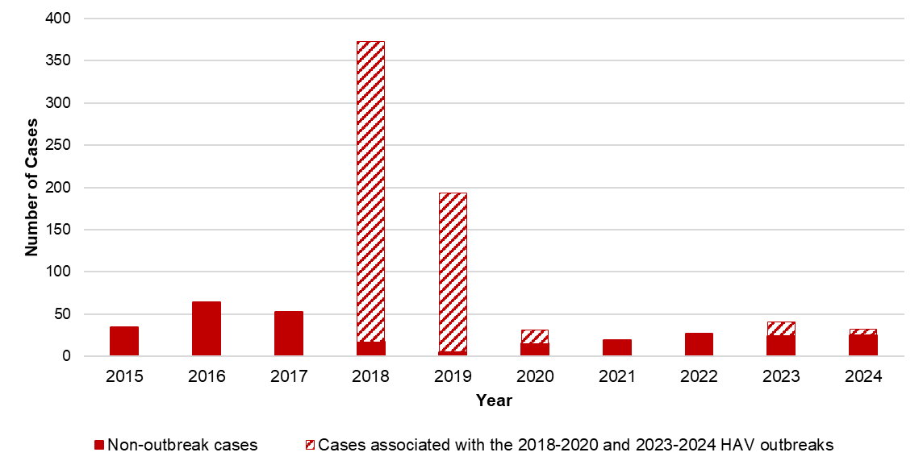
N=867
 | 2015 | 2016 | 2017 | 2018 | 2019 | 2020 | 2021 | 2022 | 2023 | 2024
Outbreak-associated | 0 | 0 | 0 | 356 | 188 | 16 | 0 | 0 | 17 | 7
Non-outbreak associated | 34 | 64 | 53 | 17 | 5 | 15 | 19 | 27 | 24 | 25
Total | 34 | 64 | 53 | 373 | 193 | 31 | 19 | 27 | 41 | 32
In a typical year, between 30 and 70 cases of confirmed hepatitis A virus (HAV) infection are reported to DPH; many of these cases are associated with international travel as opposed to local transmission. Between 2018 and 2020, DPH and local health jurisdictions responded to a statewide outbreak that primarily affected individuals experiencing homelessness or unstable housing and/or substance use disorder. Other states observed similar outbreaks. DPH partnered with local health jurisdictions and clinical and community-based providers to implement a vaccination response by deploying mobile vaccination providers to shelters, correctional facilities, harm reduction programs, and outreach venues. The outbreak was declared over in spring of 2020, and case counts among individuals with homelessness/unstable housing or substance use disorder remained low through 2022. However, a small outbreak (24 total cases) affecting the same populations occurred between September 2023 and May 2024.
DPH continues to encourage vaccination of vulnerable populations in accordance with recommendations found here:
https://www.mass.gov/info-details/dph-recommended-guidance-for-vaccines
Figure 2. Number of confirmed hepatitis A cases by recorded sex or gender, MA, 2015-2024
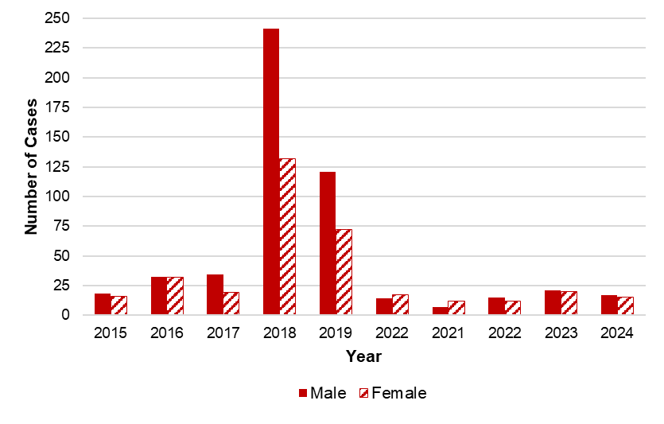
N=867
 | 2015 | 2016 | 2017 | 2018 | 2019 | 2022 | 2021 | 2022 | 2023 | 2024
Male | 18 | 32 | 34 | 241 | 121 | 14 | 7 | 15 | 21 | 17
Female | 16 | 32 | 19 | 132 | 72 | 17 | 12 | 12 | 20 | 15
Total | 34 | 64 | 53 | 373 | 193 | 31 | 19 | 27 | 41 | 32
More cases of HAV infection have been reported among males than females, particularly during the 2018-2020 outbreak. There have been no reported cases of HAV among those who are reported to DPH as transgender.
Figure 3. Number and average rate of confirmed hepatitis A cases by age group, MA, 2020-2024
Number of cases | Rate per 100,000
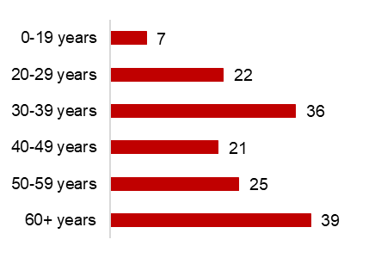 | 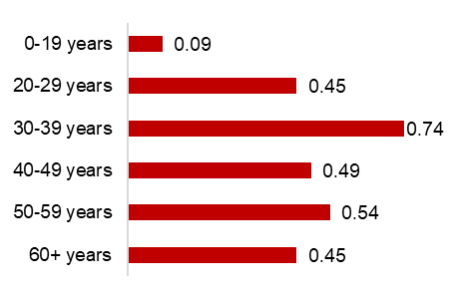
N=150
Massachusetts residents in the 60+ year age group account for the greatest number of HAV cases (ages range from 60-96 years), while residents in the 30-39 year age group have the highest rate of infection. Children are rarely infected with HAV in the US since the introduction of the vaccine, which is recommended by DPH as part of routine childhood immunizations beginning at 12 months of age.
Figure 4. Number of confirmed hepatitis A cases by risk factors, MA, 2020-2024
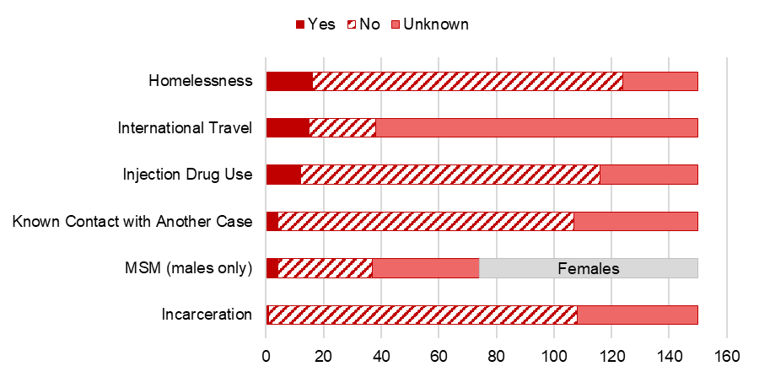
N=150
MSM N=74; 76 females are represented in gray in the MSM bar because MSM (men who have sex with men), by definition, excludes females. Reported cases may include more than one risk factor.

 | Yes | No | Unknown
Homelessness | 16 | 108 | 26
International Travel | 15 | 23 | 112
Injection Drug Use | 12 | 104 | 34
Known Contact with Another Case | 4 | 103 | 43
MSM (males only) | 4 | 33 | 37
Incarceration | 1 | 107 | 42

Among confirmed cases in 2020-2024, homelessness was the most commonly reported risk factor. This identified risk factor, as well as injection drug use (IDU), reflects the demographic and social groups impacted by the 2018-2020 and 2023-2024 outbreaks – which are also populations that may have more challenging access to vaccination and effective hand hygiene. In addition to the childhood vaccination recommendation, DPH recommends vaccination for people who use injection or non-injection drugs, people experiencing homelessness, international travelers, men who have sex with men, and others. Vaccination is also given as post-exposure prophylaxis to individuals who are known to have had contact with someone with HAV infection.
Figure 5. Number and average rate of confirmed hepatitis A cases by county, MA, 2020-2024
Number of cases | Rate per 100,000
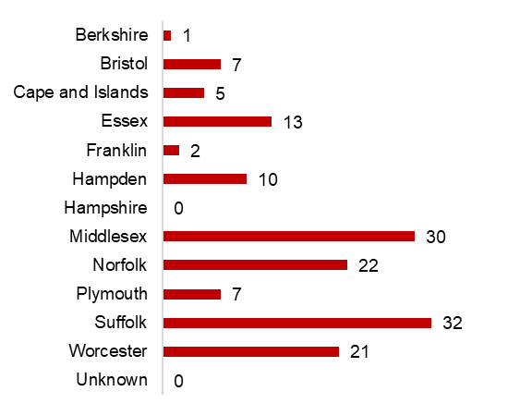 | 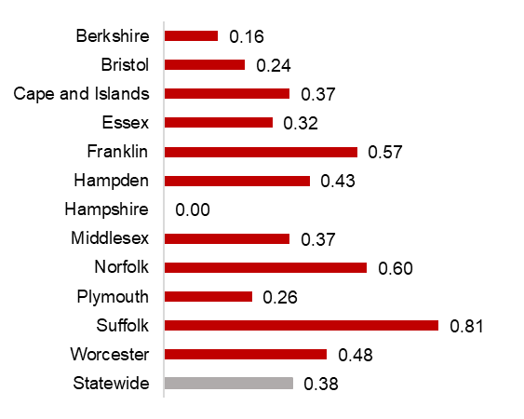
N=150
Franklin, Hampden, Norfolk, Suffolk, and Worcester Counties have higher rates of HAV infection than the Massachusetts state average.

Figure 6. Map of number of confirmed hepatitis A cases by county, MA, 2020-2024
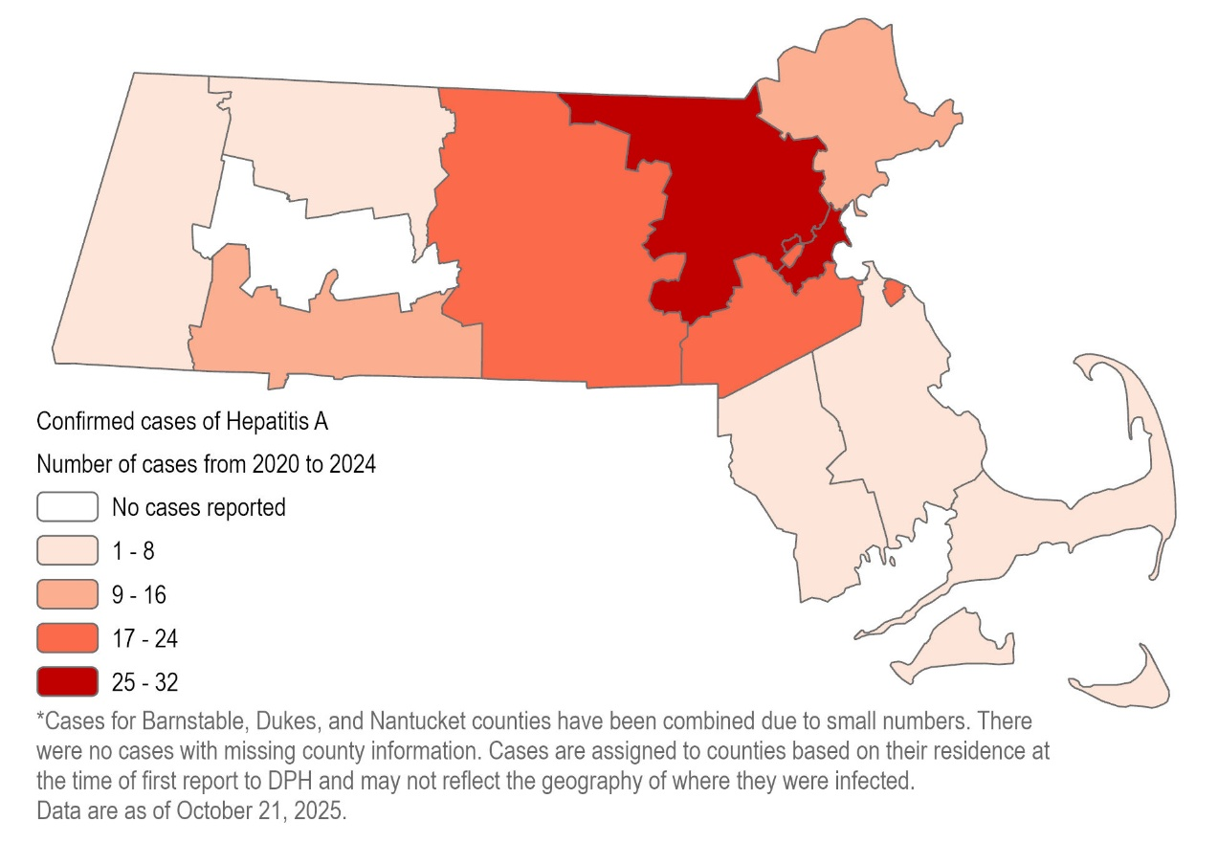
N=150
Middlesex and Suffolk Counties had the highest number of cases between 2020 and 2024. Berkshire, Bristol, Franklin, Hampshire and Plymouth Counties, as well as the Cape and Islands, had the lowest number of cases.
Figure 7. Map of rate of confirmed hepatitis A cases by county, MA, 2020-2024
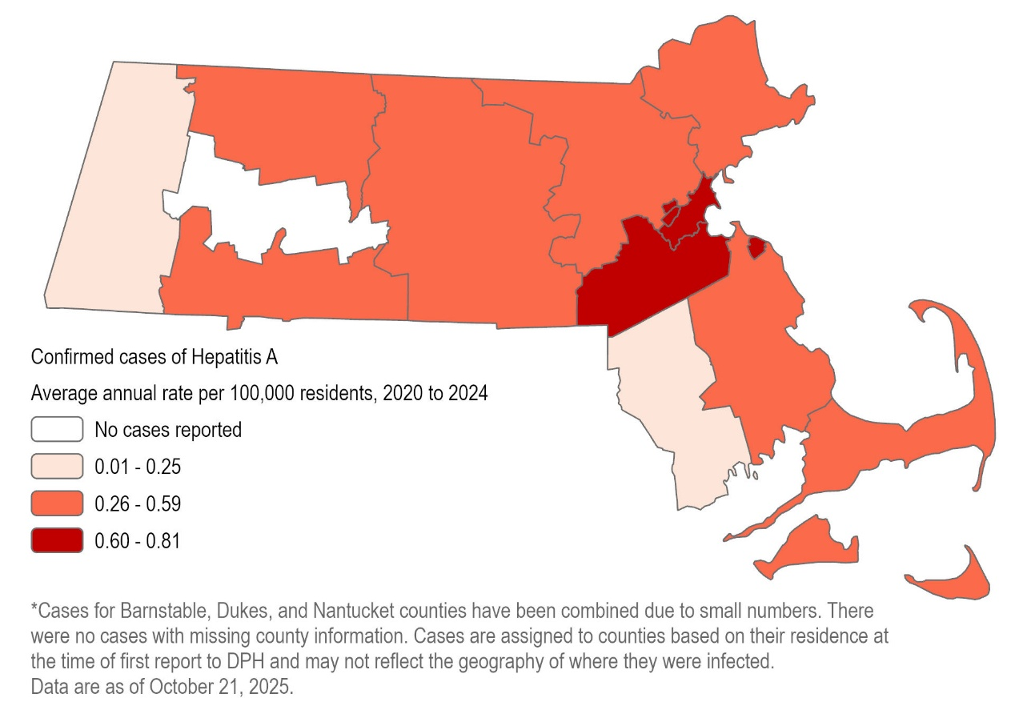
N=150

Norfolk and Suffolk Counties had the highest rates of HAV infection between 2020 and 2024. Berkshire, Bristol, and Hampshire Counties had the lowest rates.

Figure 8. Number and age-adjusted average rate of confirmed hepatitis A cases by race/ethnicity, MA, 2020-2024
Number of cases | Rate per 100,000
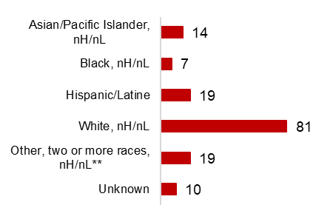 | 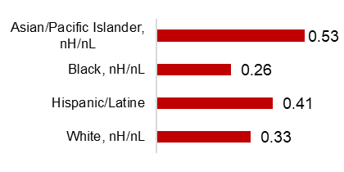
N=150
*The “Other race, two or more races" category refers to combinations of two or more of the following: "White," "Black," “American Indian or Alaska Native," "Asian/Pacific Islander" or "Other"). American Indian or Alaska Natives are included in this category because data for this group alone cannot be displayed due to small case counts (1-4 cases) and small populations (<50,000).
The highest rates of HAV infection are among Asian/Pacific Islander, non-Hispanic/non-Latine individuals and Hispanic/Latine individuals.

Hepatitis B
Hepatitis B is a liver infection caused by the hepatitis B virus (HBV). There is a vaccine to prevent infection. HBV is bloodborne, and transmission can occur through contact with blood or other body fluids, including but not limited to: direct contact with blood (including via sharing of drug injection equipment), through sexual contact, or from gestational parent to infant. Most adults who get the disease recover from it and can never get it again. However, about 10% of adults who get hepatitis B will develop chronic infection and can spread it to others. When it is chronic, it can be a serious disease that can lead to cirrhosis (scarring of the liver) and/or liver cancer. The younger a person is when infected, the more likely they are to go on to have chronic infection and to develop serious liver disease. People with chronic infection are recommended to have routine bloodwork so that their healthcare providers can evaluate if treatment is necessary.
Cases of acute, chronic, and perinatal HBV infection are reportable in Massachusetts. A particular serologic marker makes it possible to readily distinguish between acute and chronic infection in newly reported cases. DPH epidemiologists investigate acute cases in order to characterize current transmission patterns and detect potential outbreaks. The Perinatal Hepatitis B Prevention Program (PHBPP) provides case management to HBV-infected pregnant people and their infants.
The Council for State and Territorial Epidemiologists (CSTE) recently adopted new case definitions for acute and chronic HBV cases, which apply to cases from 2024 and later. The new acute case definition widens the criteria for classifying a case as confirmed acute, as well as introduces a probable acute classification; thus it is expected that acute case counts for 2024 and later would be higher. The new chronic case definition widens the criteria for classifying a case as confirmed rather than probable chronic, so it is expected that confirmed chronic case counts would be higher and probable chronic case counts lower for 2024 and later.
Acute HBV cases and chronic HBV cases are thought to represent two somewhat distinct groups in the US. Acute cases are typically those who were recently exposed in the US and chronic cases are predominantly non-US born individuals who may have been exposed as children. Because of these two different populations and because of our ability to distinguish between acute and chronic infection, acute HBV cases and chronic HBV cases are presented separately in this report.
Data related to hepatitis D virus (HDV) infection are also presented in this section of the report. Only individuals who are also infected with HBV can be infected with HDV. Because a national case definition for HDV infection was established in 2024, HDV data are being reported here for the first time this year.
Data in this section of the report are current as of October 2025. In some graphs and tables, ten years of data are displayed in order to show broad trends over time. In others, especially for acute HBV infection, which has small case counts, the most recent five years of data are aggregated in order to show other patterns.

Acute Hepatitis B
Figure 9. Rate of confirmed and probable acute hepatitis B in Massachusetts compared to the United States, 2015-2024
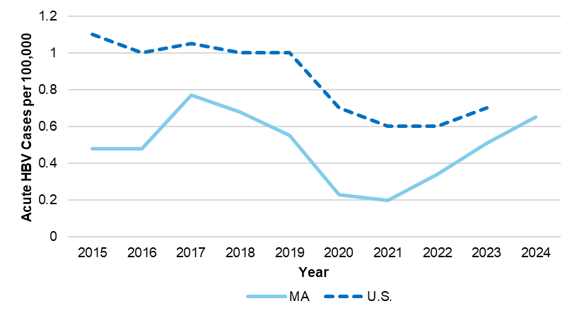
 | 2015 | 2016 | 2017 | 2018 | 2019 | 2020 | 2021 | 2022 | 2023 | 2024
MA | 0.48 | 0.48 | 0.77 | 0.68 | 0.55 | 0.23 | 0.20 | 0.34 | 0.51 | 0.65
U.S. | 1.10 | 1.00 | 1.05 | 1.00 | 1.00 | 0.70 | 0.60 | 0.60 | 0.70 | -
In Massachusetts, the rate of acute hepatitis B virus (HBV) infection is historically lower than the national rate. This may reflect robust disease prevention work including adult and childhood vaccination and harm reduction services including syringe services. At the time of this report’s writing, the US rate for 2024 had not yet been published. The increase in rate from 2023 to 2024 in Massachusetts was attributed in part to the updated case definition.
Figure 10. Number of confirmed and probable acute hepatitis B cases by year, MA, 2015-2024
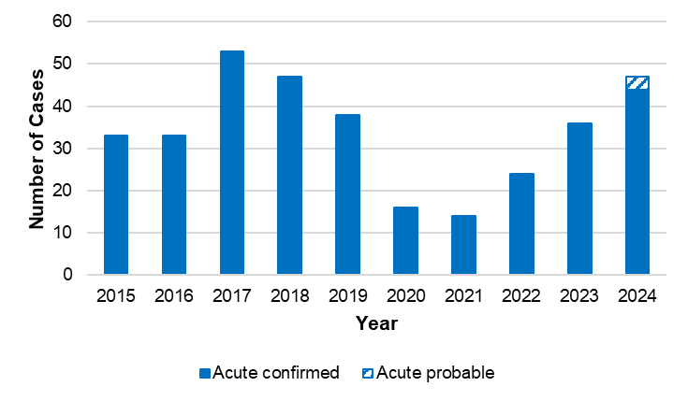
N=341
In a typical year, between 20 and 50 cases of confirmed acute HBV infection are reported to DPH. In 2017 and 2018 there was a higher number of cases due to a small outbreak in Bristol County that was associated with injection drug use. The increase in cases from 2023 to 2024 is attributed in part to the updated case definition. A probable acute HBV case classification was not used prior to the 2024 case definition update.
Figure 11. Number of confirmed and probable acute hepatitis B cases by recorded sex or gender, MA, 2015-2024
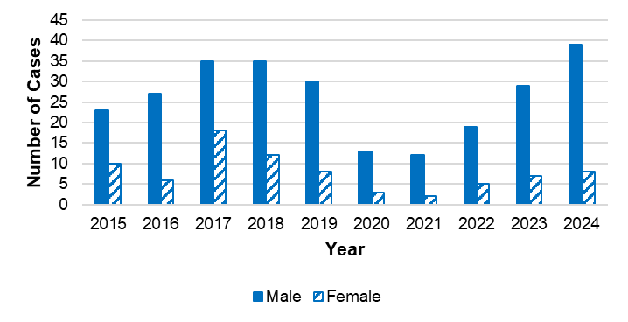
N=341
 | 2015 | 2016 | 2017 | 2018 | 2019 | 2020 | 2021 | 2022 | 2023 | 2024
Male | 23 | 27 | 35 | 35 | 30 | 13 | 12 | 19 | 29 | 39
Female | 10 | 6 | 18 | 12 | 8 | 3 | 2 | 5 | 7 | 8
Total | 33 | 33 | 53 | 47 | 38 | 16 | 14 | 24 | 36 | 47
There are more cases of acute HBV infection reported among males than females in Massachusetts, consistent with national trends. There have been no reported cases of HBV infection among those who were reported to DPH as transgender.

Figure 12. Number and rate of confirmed and probable acute hepatitis B cases by age group, MA, 2020-2024
Number of cases | Rate per 100,000
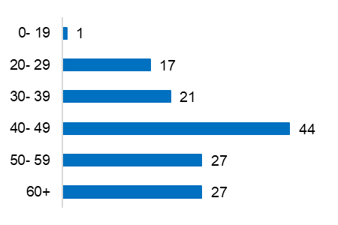 | 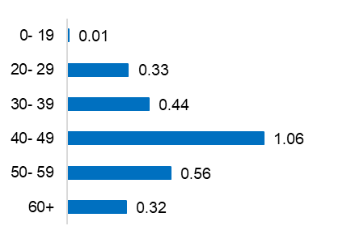
N=137
Massachusetts residents in the 40-49 year age group have the highest rate of acute HBV infection, consistent with national trends. Individuals in this age group were too old to have been vaccinated as children, as the Advisory Committee on Immunization Practices (ACIP) recommendation that all infants in the US be vaccinated by 18 months was not made until 1991.
Figure 13. Number and age-adjusted rate of confirmed and probable acute hepatitis B cases by race/ethnicity, MA, 2020-2024
Number of cases | Rate per 100,000
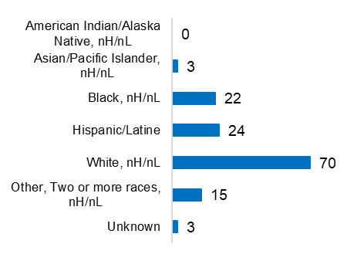 | 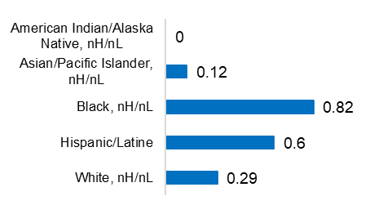
N=137
The “Other” category includes combinations of two or more of the following race categories: "White," "Black," “American Indian or Alaska Native," "Asian/Pacific Islander "or "Other."

Although the highest number of acute HBV infections is among White, non-Hispanic/non-Latine individuals, the highest rate is among Black, non-Hispanic/non-Latine individuals, which may suggest unequal access to prevention strategies including vaccination.
Figure 14. Number and rate of confirmed and probable acute hepatitis B cases by county, MA, 2020-2024
Number of cases | Rate per 100,000 people
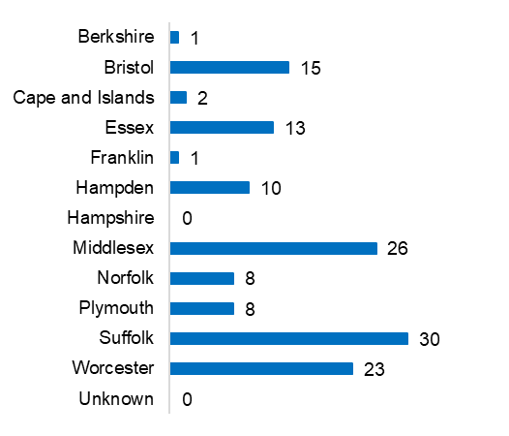 | 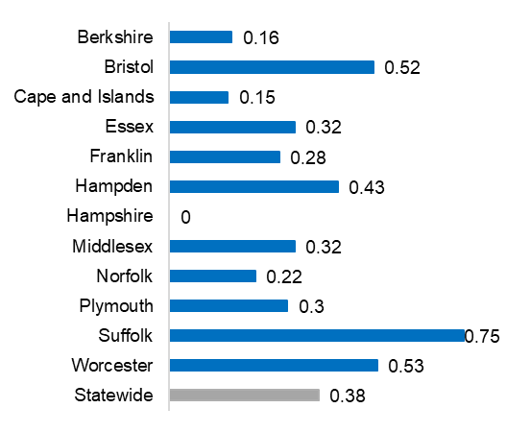
N=137
Bristol, Hampden, Suffolk, and Worcester Counties have higher rates of acute HBV than the Massachusetts state average.
Figure 15. Number of confirmed and probable acute hepatitis B cases by country of birth, MA, 2015-2024
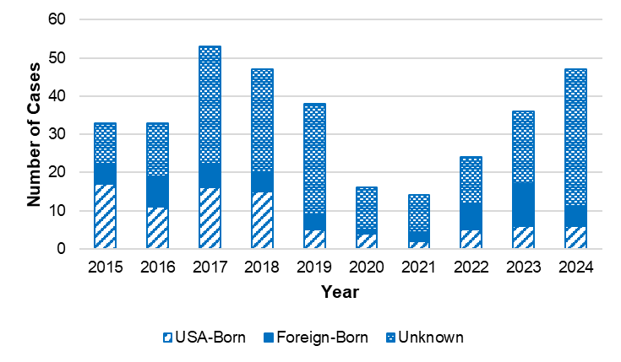
N=341
 | 2015 | 2016 | 2017 | 2018 | 2019 | 2020 | 2021 | 2022 | 2023 | 2024
USA-Born | 17 | 11 | 16 | 15 | 5 | 4 | 2 | 5 | 6 | 6
Foreign-Born | 5 | 8 | 6 | 5 | 4 | 1 | 2 | 7 | 11 | 5
Unknown | 11 | 14 | 31 | 27 | 29 | 11 | 10 | 12 | 19 | 36
Total | 33 | 33 | 53 | 47 | 38 | 16 | 14 | 24 | 36 | 47
In a typical year, there are more acute HBV cases reported among US-born persons than among non-US-born persons, although in 2022 and 2023, there were more reported among non-US-born persons than among US-born persons. It should be noted, however, that there are significant missing data for country of birth and these data should be interpreted with caution.
Figure 16. Number of confirmed and probable acute hepatitis B cases by reported risk factors, MA, 2020-2024
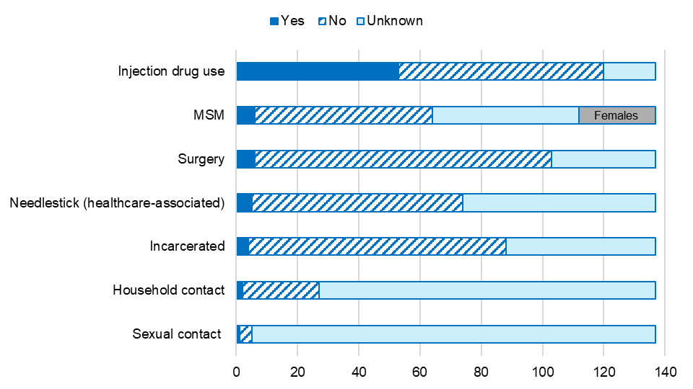
N=137
MSM N=112; 25 females are represented in gray in the MSM bar because MSM (men who have sex with men), by definition, excludes females. Reported cases may include more than one risk behavior/exposure.

 | Yes | No | Unknown
Injection drug use | 53 | 67 | 17
MSM | 6 | 58 | 48
Surgery | 6 | 97 | 34
Needlestick | 5 | 69 | 63
Incarcerated | 4 | 84 | 49
Household contact | 2 | 25 | 110
Sexual contact | 1 | 4 | 132
Among confirmed acute HBV cases between 2020-2024, injection drug use (IDU) was the most commonly reported risk factor. Because HBV is known to be transmitted via the sharing of drug injection equipment, there is a longstanding recommendation that adults who inject drugs should be vaccinated against HBV; thus, these cases represent missed opportunities for vaccination.
In addition to recommending HBV vaccine for all children, DPH recommends that all adults aged 19-59 years old be vaccinated against HBV, as well as adults 60 years or older with risk factors including IDU. DPH immunization recommendations are found here:
https://www.mass.gov/info-details/dph-recommended-guidance-for-vaccines
Table 1: Acute hepatitis B and hepatitis C coinfection by recorded sex or gender, MA, 2020-2024
 | Acute HBV cases | Number (%) coinfected with HCV
Male | 111 | 39 (35%)
Female | 23 | 8 (35%)
Total | 134 | 47 (35%)

Table 2: Acute hepatitis B and hepatitis C coinfection by race/ethnicity, MA, 2020-2024
 | Acute HBV cases | Number (%) coinfected with HCV
American Indian/Alaskan Native, nH/nL | 0 | 0 (0%)
Asian/Pacific Islander, nH/nL | 3 | 0 (0%)
Black, nH/nL | 22 | 2 (9%)
Hispanic/Latinx | 24 | 6 (25%)
White, nH/nL | 67 | 34 (51%)
Other, Two or more races, nH/nL | 15 | 4 (27%)
Unknown | 3 | 1 (33%)
Total | 134 | 47 (35%)

Table 3: Acute hepatitis B and hepatitis C coinfection by age group, MA, 2020-2024
 | Acute HBV cases | Number (%) coinfected with HCV
Age <5 years | 0 | 0 (0%)
Age 5-14 years | 0 | 0 (0%)
Age 15-24 years | 2 | 1 (50%)
Age 25-34 years | 23 | 6 (26%)
Age 35-44 years | 37 | 20 (54%)
Age 45-54 years | 35 | 13 (37%)
Age 55-64 years | 20 | 5 (25%)
Age 65+ years | 17 | 2 (12%)
Total | 134 | 47 (35%)
Data in these tables are current as of 10/20/2025. Only confirmed acute (not probable acute) cases included.
Of 134 confirmed acute HBV cases in 2020-2024, 47 (35%) also had confirmed or probable hepatitis C infection. Of those 47 coinfected individuals, 38 (81%) had hepatitis C reported first. These 38 individuals represent missed opportunities for HBV vaccination, as there is a longstanding recommendation that those with chronic hepatitis C should be vaccinated against HBV. Most (83%) of the coinfected individuals reported a history of IDU.

Chronic Hepatitis B
Figure 17. Number of confirmed and probable chronic hepatitis B cases by year, MA, 2015-2024
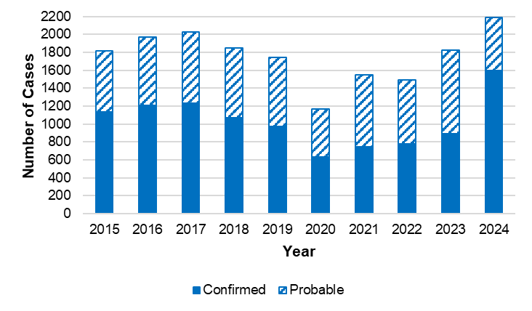
N=17,622
 | 2015 | 2016 | 2017 | 2018 | 2019 | 2020 | 2021 | 2022 | 2023 | 2024
Confirmed | 1,139 | 1,206 | 1,236 | 1,068 | 971 | 636 | 743 | 778 | 896 | 1,596
Probable | 675 | 761 | 789 | 783 | 769 | 533 | 809 | 714 | 931 | 589
Total | 1,814 | 1,967 | 2,025 | 1,851 | 1,740 | 1,169 | 1,552 | 1,492 | 1,827 | 2,185
In a typical year, between 1,500 and 2,200 cases of confirmed and probable chronic hepatitis B virus (HBV) infection are newly reported to DPH. It is likely that many of these new reports represent longstanding infections (only being diagnosed and reported for the first time in Massachusetts) as opposed to new infections.
The recent increase in reported cases likely has two causes. First, in March 2023, the CDC broadened their HBV screening recommendations to include a one-time screening for all adults, which should result in more chronic infections being diagnosed and reported. Second, the new case definition, which applies to cases from 2024 and later, broadens the criteria for classifying a case as confirmed chronic. For cases from 2023 and earlier, the confirmed chronic case definition typically required two positive tests taken at least six months apart. Cases would be classified as probable until the second test result was received. For cases from 2024 and later, certain one-time testing can also classify a case as confirmed, so we expect to see a larger percentage of cases immediately classified as chronic.
Because many probable cases do become confirmed over time, confirmed and probable cases are aggregated in subsequent figures.
Figure 18. Number of confirmed and probable chronic hepatitis B cases by recorded sex or gender, MA, 2015-2024
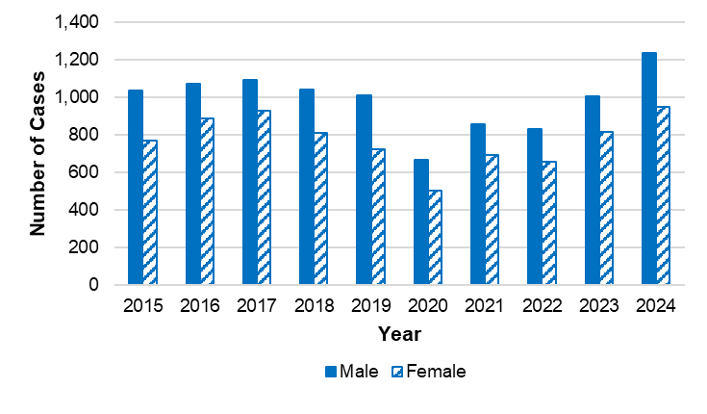
N=17,622
 | 2015 | 2016 | 2017 | 2018 | 2019 | 2020 | 2021 | 2022 | 2023 | 2024
Male | 1,036 | 1,068 | 1,092 | 1,038 | 1,010 | 667 | 853 | 827 | 1,003 | 1,232
Female | 767 | 887 | 928 | 811 | 724 | 501 | 693 | 656 | 815 | 946
Unknown | 11 | 12 | 5 | 2 | 6 | 1 | 6 | 9 | 9 | 7
Cases with recorded sex or gender as Transgender reported are included in “Unknown” because data for this group alone cannot be displayed due to small case counts (1-4 cases) and small populations (<50,000).
More cases of chronic HBV infection are reported among males than among females, consistent with national trends.
Figure 19. Rate of confirmed and probable chronic hepatitis B cases by age group, MA, 2015-2024
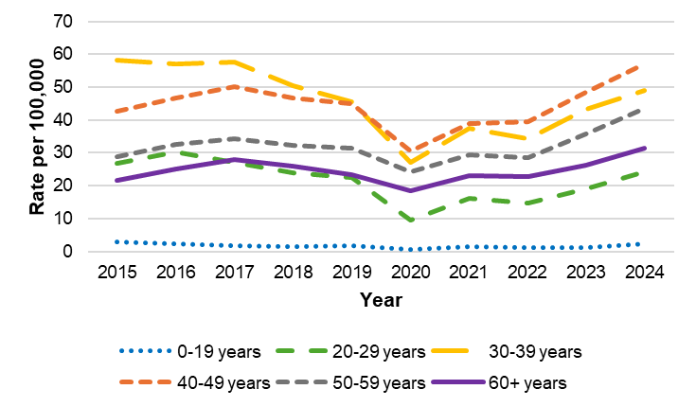
N=17,574
From 2015-2024, there were 48 confirmed and probable chronic hepatitis B cases with missing age.
N
 | 2015 | 2016 | 2017 | 2018 | 2019 | 2020 | 2021 | 2022 | 2023 | 2024
0-19 years​ | 49 | 37 | 28 | 22 | 27 | 10 | 25 | 20 | 19 | 38
20-29 years​ | 270 | 309 | 278 | 246 | 230 | 96 | 165 | 151 | 195 | 248
30-39 years​ | 498 | 499 | 513 | 458 | 417 | 257 | 356 | 326 | 409 | 464
40-49 years​ | 381 | 407 | 433 | 396 | 379 | 254 | 323 | 329 | 403 | 475
50-59 years​ | 287 | 322 | 336 | 314 | 300 | 234 | 284 | 276 | 347 | 423
60+ years​ | 320 | 381 | 434 | 414 | 382 | 315 | 392 | 390 | 448 | 535

Rates
 | 2015 | 2016 | 2017 | 2018 | 2019 | 2020 | 2021 | 2022 | 2023 | 2024
0-19 years​ | 3 | 2.3 | 1.7 | 1.4 | 1.7 | 0.6 | 1.6 | 1.3 | 1.2 | 2.4
20-29 years​ | 26.9 | 30.4 | 27.1 | 23.9 | 22.4 | 9.4 | 16.1 | 14.8 | 19.1 | 24.3
30-39 years​ | 58.1 | 57.1 | 57.6 | 50.6 | 45.6 | 27.1 | 37.6 | 34.4 | 43.2 | 49
40-49 years​ | 42.7 | 46.6 | 50.3 | 46.6 | 45.1 | 30.5 | 38.8 | 39.6 | 48.5 | 57.1
50-59 years​ | 28.8 | 32.5 | 34.2 | 32.4 | 31.4 | 24.1 | 29.3 | 28.5 | 35.8 | 43.6
60+ years​ | 21.7 | 25.2 | 27.9 | 25.9 | 23.4 | 18.5 | 23 | 22.9 | 26.3 | 31.4

Individuals in the 30-39 year and 40-49 year age groups have the highest rates of newly reported chronic HBV infection. Rates are very low in the 0-19 year age group due to high childhood vaccination rates and a strong Perinatal Hepatitis B Prevention Program (PHBPP).
Figure 20. Number of confirmed and probable chronic hepatitis B cases by race/ethnicity, MA, 2015-2024
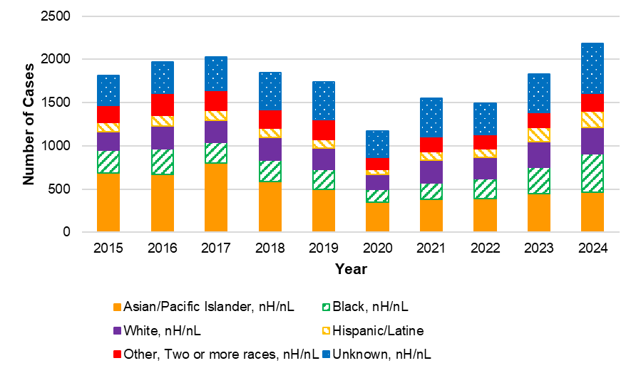
N=17,622
Where race and ethnicity data are available, chronic cases are predominantly among Asian/Pacific Islander, nHc/nL individuals, consistent with national trends. Black, nH/nL individuals comprise a larger portion of newly reported chronic cases in more recent years.

 | 2015 | 2016 | 2017 | 2018 | 2019 | 2020 | 2021 | 2022 | 2023 | 2024
Asian/Pacific Islander, nH/nL | 689 | 669 | 797 | 590 | 497 | 344 | 380 | 388 | 445 | 461
Black, nH/nL | 262 | 297 | 239 | 247 | 226 | 152 | 193 | 228 | 307 | 448
White, nH/nL | 210 | 266 | 260 | 257 | 252 | 171 | 262 | 247 | 293 | 303
Hispanic/Latine | 109 | 121 | 114 | 111 | 94 | 60 | 101 | 103 | 164 | 191
Other, two or more races, nH/nL | 202 | 258 | 234 | 212 | 232 | 139 | 167 | 161 | 177 | 208
Unknown | 342 | 356 | 381 | 434 | 439 | 303 | 449 | 365 | 441 | 574

Figure 21. Age-adjusted rate of confirmed and probable chronic hepatitis B cases by race/ethnicity, MA, 2015-2024
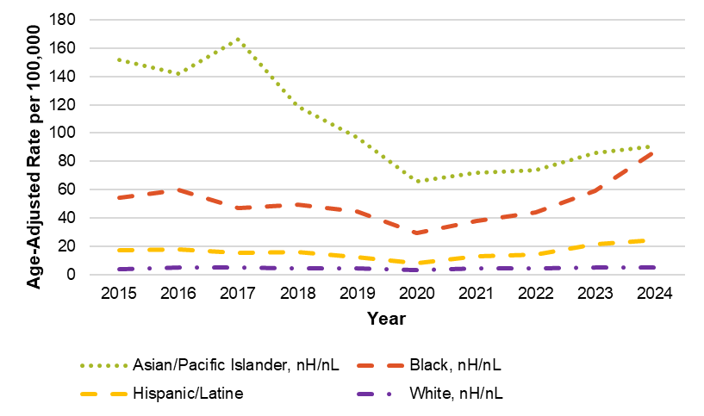
N=17,622
 | 2015 | 2016 | 2017 | 2018 | 2019 | 2020 | 2021 | 2022 | 2023 | 2024
Asian/Pacific  Islander, nH/nL | 151.75 | 141.89 | 166.53 | 118.72 | 96.94 | 65.76 | 71.97 | 74.06 | 86.24 | 91.03
Black, nH/nL | 54.53 | 60.07 | 46.88 | 49.71 | 44.41 | 29.59 | 37.83 | 44.08 | 59.35 | 87.1
Hispanic/Latine | 17.07 | 18.03 | 15.74 | 16.11 | 12.63 | 8.04 | 13.24 | 14.4 | 21.42 | 24.63
White, nH/nL | 3.87 | 5.05 | 4.82 | 4.66 | 4.65 | 3.03 | 4.72 | 4.39 | 5.38 | 5.12
Chronic case counts and rates are highest among Asian/Pacific Islander, nH/nL individuals, consistent with national trends. Rates are also elevated for Black, nH/nL individuals, especially in recent years. It should be noted that there are significant missing data for race/ethnicity, especially in recent years, which may affect the calculation and interpretation of rates, especially if data are missing in a nonrandom or biased way. For example, if cases among Asian/Pacific Islander, nH/nL individuals were less likely to have an accurate race or ethnicity reported in more recent years, it will appear as though rates in this group are decreasing when they are not.
Figure 22. Number and rate of confirmed and probable chronic hepatitis B cases by county, MA, 2020-2024
Number of cases | Rate per 100,000
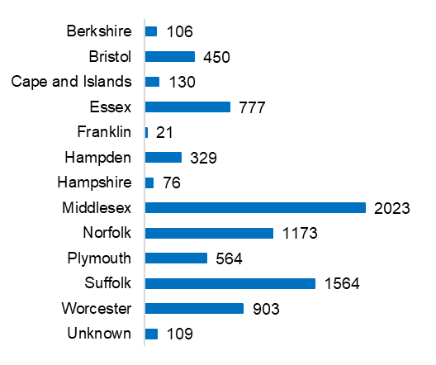 | 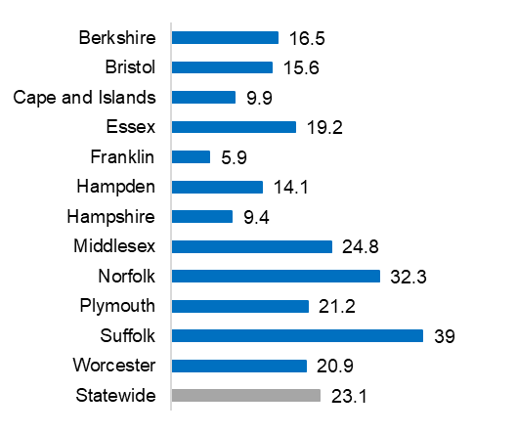
N=8,225
Middlesex, Norfolk, and Suffolk Counties have chronic HBV rates higher than the Massachusetts state average. Note that county is based on the patient’s residence at the time of report and does not necessarily represent where the patient was exposed to HBV.
Figure 23. Map of confirmed and probable chronic hepatitis B cases by city/town, MA, 2024
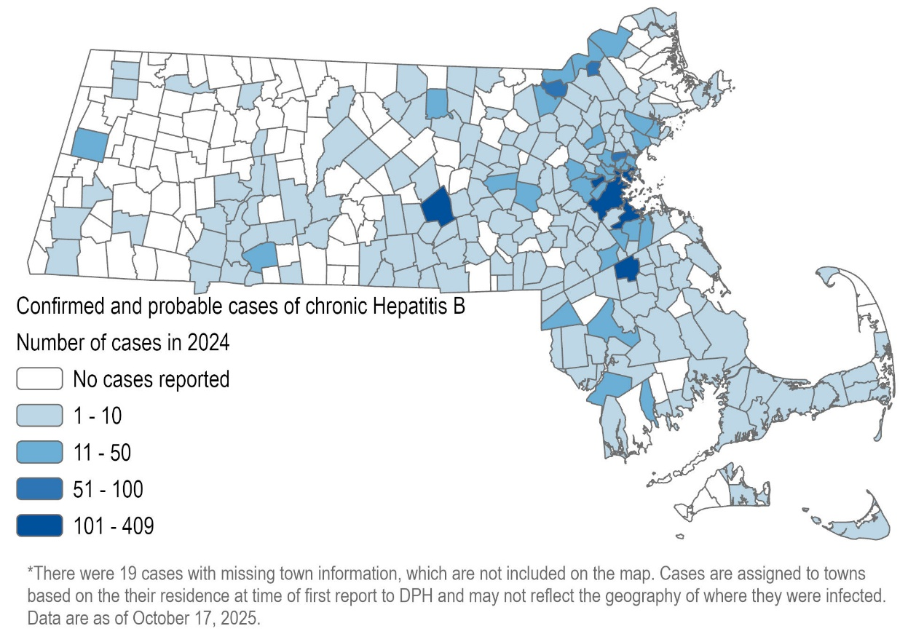
N=2,166
More than 200 Massachusetts municipalities had newly reported cases in 2024. Boston, Worcester, Brockton, Quincy, Lowell, Malden, and Lawrence each had more than 50 cases reported.
Figure 24. Map of rate of confirmed and probable chronic hepatitis B cases by city/town, MA, 2024
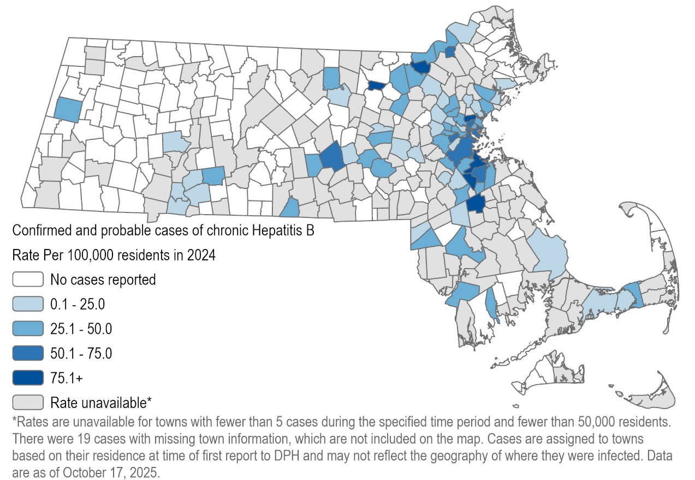
N=2,166

Municipalities with higher rates of chronic HBV in 2024 include Brockton, Lowell, Malden and Quincy. Many cities and towns cannot have their rates published due to data suppression rules.

Figure 25. Map of confirmed and probable chronic hepatitis B cases, MA by city/town, 2015-2024
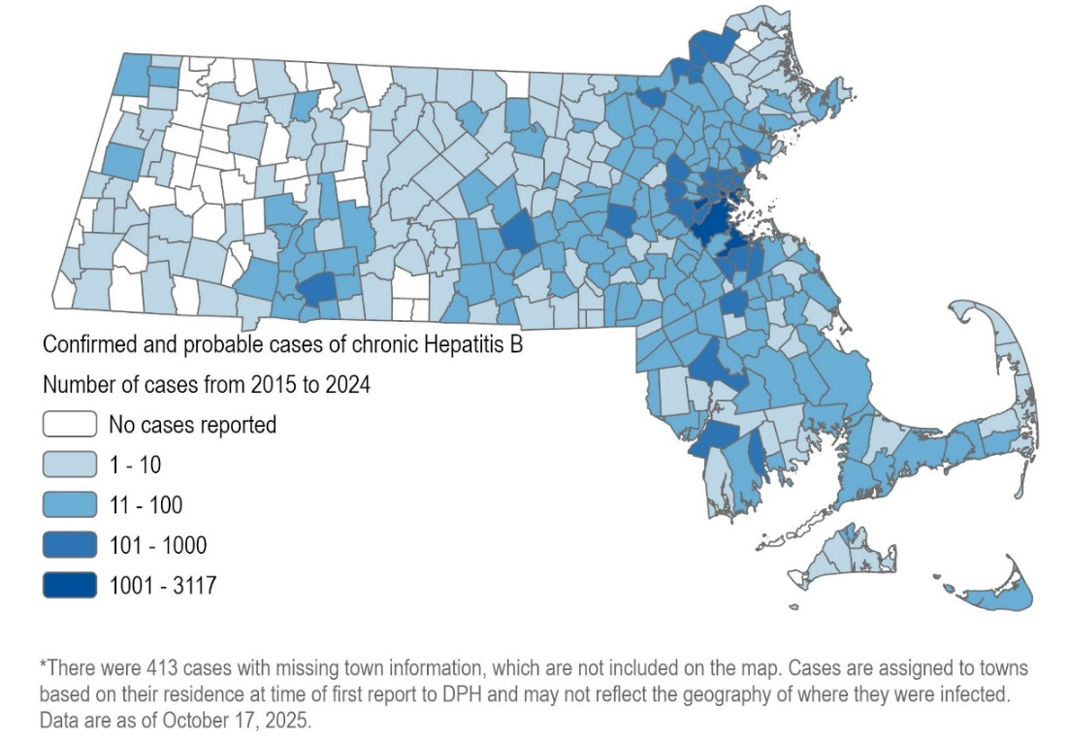
N=17,209

More than 300 municipalities had newly reported cases between 2015 and 2024. Boston and Quincy each had more than 1,000 cases reported in this ten-year span.

Figure 26. Map of average rate of confirmed and probable chronic hepatitis B cases by city/town, MA, 2015-2024
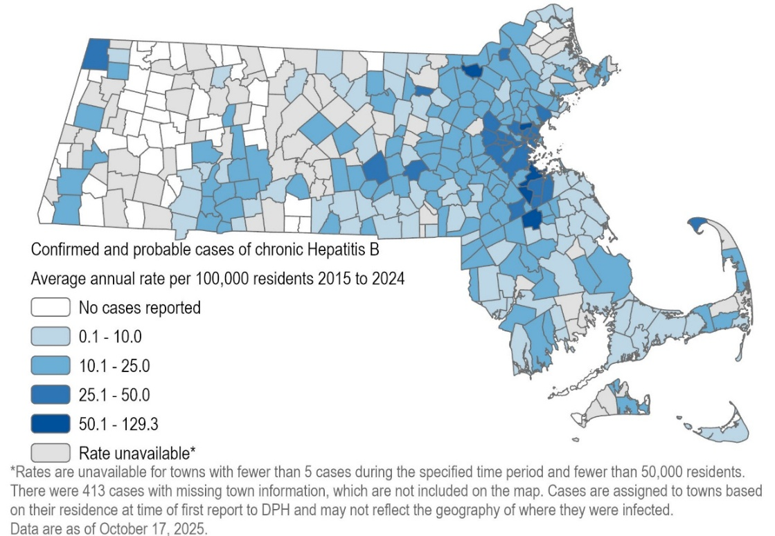
N=17,209
Municipalities with higher rates of chronic HBV between 2015 and 2024 include Brockton, Lowell, Malden and Quincy. Many cities and towns cannot have their rates published due to data suppression rules.

Figure 27. Number of confirmed and probable chronic hepatitis B cases by country of birth, MA, 2015-2024
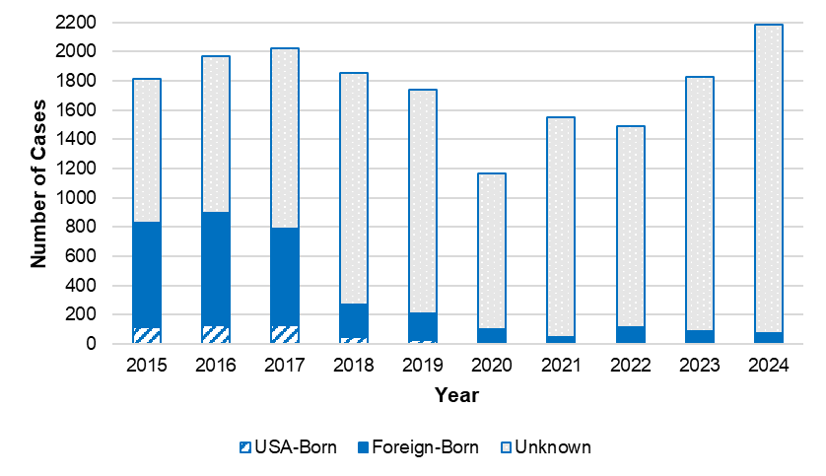
N=17,622
 | 2015 | 2016 | 2017 | 2018 | 2019 | 2020 | 2021 | 2022 | 2023 | 2024
USA-Born | 117 | 130 | 127 | 50 | 26 | 14 | 7 | 12 | 14 | 6
Foreign-Born | 713 | 769 | 659 | 223 | 185 | 87 | 42 | 102 | 71 | 69
Unknown | 984 | 1068 | 1,239 | 1,578 | 1,529 | 1,068 | 1,503 | 1,378 | 1,742 | 2,110
Total | 1,814 | 1,967 | 2,025 | 1,851 | 1,740 | 1,169 | 1,552 | 1,492 | 1,827 | 2,185

Chronic HBV cases are predominantly among non-US-born individuals, where country of birth is known. Chronic cases are not typically investigated unless the individual is pregnant, and a provider reporting form for chronic cases was discontinued in 2017, so missing data are significant. It is likely that many of these individuals were infected before moving to the US, as there are parts of the world where HBV is endemic, including parts of Africa and Asia.
Figure 28. Confirmed and probable chronic hepatitis B cases by country of birth for those known to have been born outside the United States, 2015-2024
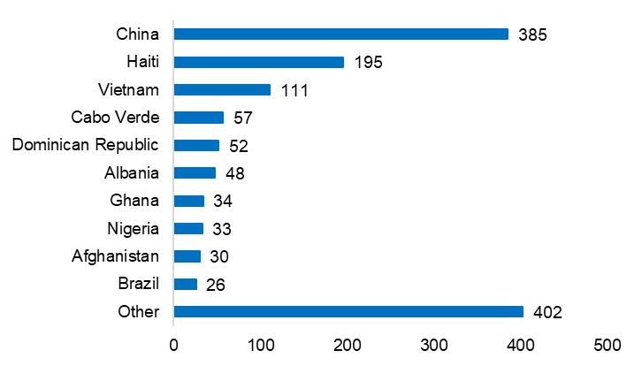

Of 2,920 chronic HBV cases known to have been born outside the US, country of birth is known for 1,373. Foreign-born chronic HBV cases come from a variety of countries, with the highest number of cases from China. These data reflect both the demographics of Massachusetts as well as which countries have higher HBV prevalence.

Hepatitis D
Figure 29. Number of confirmed and probable hepatitis D cases by year, MA, 2015-2024.
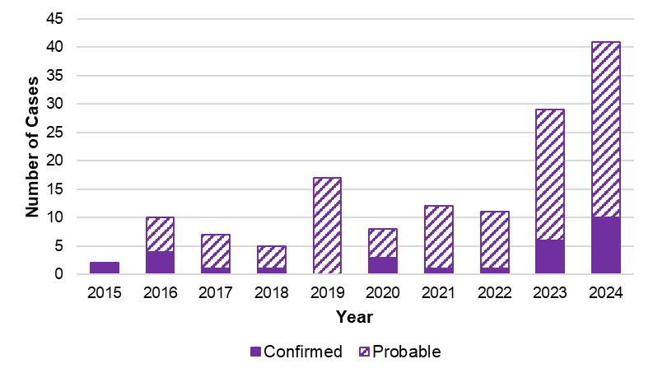
N=142. Cases are classified according to the national case definition established in 2024.

 | 2015 | 2016 | 2017 | 2018 | 2019 | 2020 | 2021 | 2022 | 2023 | 2024
Confirmed | 2 | 4 | 1 | 1 | 0 | 3 | 1 | 1 | 6 | 10
Probable | 0 | 6 | 6 | 4 | 17 | 5 | 11 | 10 | 23 | 31
Total | 2 | 10 | 7 | 5 | 17 | 8 | 12 | 11 | 29 | 41

Hepatitis D virus (HDV), also known as hepatitis delta, can only infect people also infected with HBV. People with HDV infection often have more severe symptoms than those infected with HBV alone. While HDV infection is not reportable nationally, it has been reportable in Massachusetts since 2015. Because a national case definition was established in 2024, HDV data are being reported here for the first time this year. Cases with a positive RNA result are classified as confirmed, while cases with only a positive antibody result are classified as probable. Because negative results are not reportable, we cannot know if low case counts reflect low prevalence or low screening rates.

Perinatal Hepatitis B
HBV infection in a pregnant person poses a serious risk to their infant. Unless they receive proper post-exposure prophylaxis (PEP), up to 90% of infants born to pregnant persons with HBV get infected, and 85% to 95% of those will become chronically infected. Infants are also at risk due to other blood exposures, for example shared personal care items such as toothbrushes, nail clippers, etc. Up to one in four chronically infected individuals who were infected as infants will die from primary hepatocellular carcinoma (liver cancer) or cirrhosis of the liver later in life. However, the risk of transmission of HBV from gestational parent to child can be significantly reduced by providing PEP to the infant within 12 hours of birth; PEP consists of hepatitis B immune globulin (HBIG) and the first dose of hepatitis B vaccine. The Massachusetts Perinatal Hepatitis B Prevention Program (PHBPP) provides case management to HBV-infected gestational parents and their infants, promoting and helping to coordinate appropriate PEP, completion of the HBV vaccine series, and recommended post-vaccination serologic testing (PVST) for enrolled infants.
Figure 30. Outcomes of infants managed by the Massachusetts PHBPP, by birth cohort, MA, 2019-2023
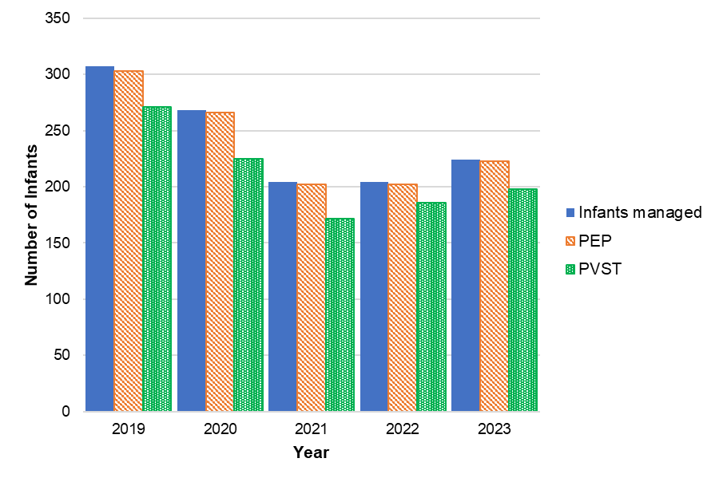
N=1,207
Birth cohort | Infants managed (N) | Received PEP at birth (N) | Received PEP at birth (%) | Completed vaccine series by 12 months of age (N) | Completed vaccine series by 12 months of age (%) | Received PVST (N) | Received PVST (%)
2019 | 307 | 303 | 99% | 291 | 95% | 271 | 88%
2020 | 268 | 266 | 99% | 252 | 94% | 225 | 84%
2021 | 204 | 202 | 99% | 194 | 95% | 172 | 84%
2022 | 204 | 202 | 99% | 196 | 96% | 186 | 91%
2023 | 224 | 223 | >99% | 212 | 95% | 198 | 88%
Data reflect tracking through the next calendar year. For example, the 2019 birth cohort outcomes are calculated at the end of 2020. Infants without the full vaccine series and/or PVST by this cut-off will continue to be case managed and may receive additional doses/testing later.
The Massachusetts PHBPP provides case management to between 200 and 400 HBV-infected gestational parents and their infants each year. Nearly all case managed infants receive PEP at birth, more than 90% complete the vaccine series by 12 months of age, and more than 80% receive PVST. The number of case managed infants has decreased over the last several years, consistent with national trends.
Figure 31. Gestational parents enrolled in case management with Massachusetts PHBPP by race/ethnicity, 2023 birth cohort
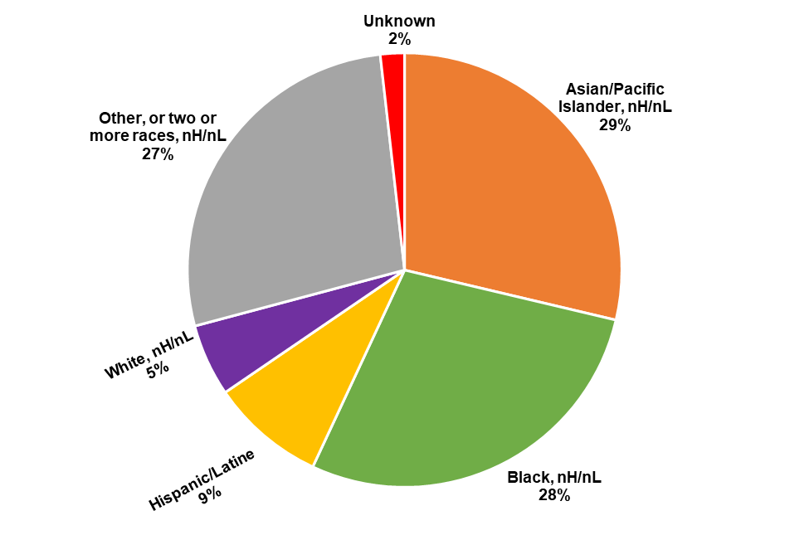
N=223
For the 2023 birth cohort, gestational parents enrolled in PHBPP case management mirrored statewide chronic HBV cases in terms of demographic characteristics. The most common race/ethnicities reported were: Asian/Pacific Islander, nH/nL; Black, nH/nL; and Other, or two or more races nH/nL. Of parents where country of birth was known, 88% were born outside the US. Middlesex County (27%) and Suffolk County (22%) had the highest number of case managed parents.

Hepatitis C
Hepatitis C is a liver infection caused by the hepatitis C virus (HCV). The majority of people who have acute HCV infection go on to develop chronic infection. Over time, chronic HCV infection can cause liver damage, leading to cirrhosis, liver cancer, and death. HCV infection is spread by direct contact with the blood of another person with HCV infection. As seen in the analyses below, injection drug use is the most commonly reported risk factor among HCV cases. With the advent of direct-acting antivirals, HCV infection is curable for most people with a weeks-long, well-tolerated course of treatment.
Acute, chronic, and perinatal HCV infections are reportable in Massachusetts. Acute cases are actively investigated by local health jurisdictions, in conjunction with DPH epidemiologists, and case report forms detailing basic demographic, clinical, and risk history information are requested from providers on all newly reported confirmed (i.e., RNA-positive) cases. Due to the lack of a serologic marker for acute infection, as well as many newly infected individuals showing no symptoms, acute and chronic HCV cases are combined in many of the figures and tables in this section.
Data in this section of the report are current as of June 18, 2025. Given important updates to the acute and chronic case definitions for HCV infection in 2016, that is the first year included in the majority of HCV figures and tables in this report. Standardized classification of perinatal HCV cases was not possible until 2018, which is the first year for which those specific data are shown in this report.
Figure 32. Rate of acute hepatitis C cases in Massachusetts compared to the United States, 2017-2024
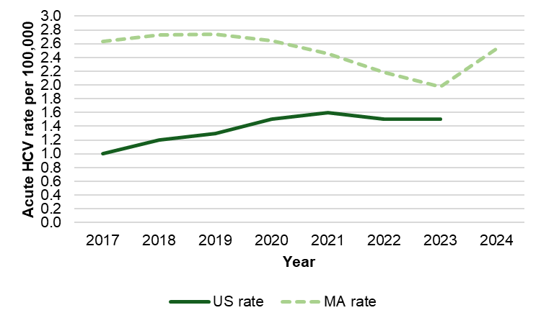
US Rate for 2024 not yet available
Rates of acute hepatitis C virus (HCV) infection in Massachusetts were consistently higher than national rates between 2017 and 2023. On average, the rate of acute HCV infection was 1.8 times higher than the national rate across this time period, though the difference decreased over time. At the time of this report’s writing, the US rate for 2024 had not yet been published.
Figure 33. Number and rate of confirmed and probable hepatitis C cases by recorded sex or gender, age group, race and ethnicity, and county, MA, 2024
Figure 33A. Recorded sex or gender
Number of cases | Rate per 100,000
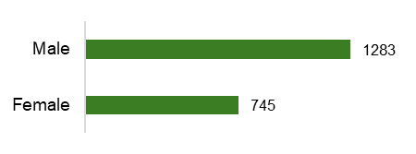 | 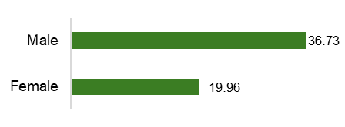
N=2,028; includes acute, chronic, and perinatal cases
88 cases not included because recorded sex or gender was either transgender or missing. The number of transgender cases is not explicitly included as it is <5.
People with a recorded sex or gender of male in Massachusetts in 2024 had both higher numbers of HCV cases and rates of infection per 100,000 population. Case counts were 1.7 times higher in males than females, and rates of infection were 1.8 times higher in males than females.
Figure 33B. Age group
Number of cases | Rate per 100,000
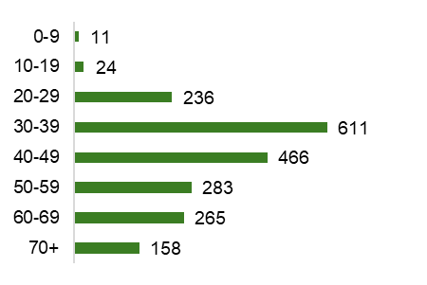 | 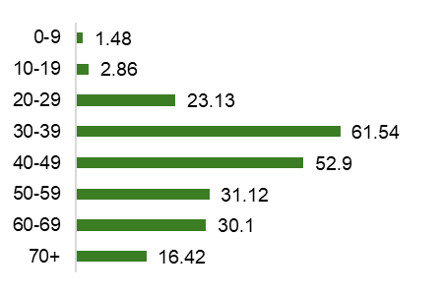
N=2,054
62 cases not included due to missing age
The highest numbers and rates of hepatitis C infections were observed in individuals between the ages of 30 and 39, reflecting the burden of disease among younger adults with current or past injection drug use.
Figure 33C. Age-adjusted race and ethnicity
Number of cases | Rate per 100,000
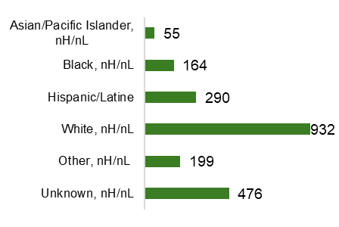 | 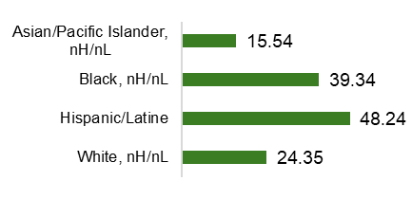
N=2,116
The “Other” category includes combinations of two or more of the following race categories: "White," "Black," “American Indian or Alaska Native," "Asian/Pacific Islander "or "Other." American Indian or Alaska Natives are included in this category because data for this group alone cannot be displayed due to small case counts (1-4 cases) and small populations (<50,000).
Though the highest number of hepatitis C cases in Massachusetts in 2024 was observed among people identifying as White, nH/nL, the highest rates of infection were observed among individuals identifying as Hispanic/Latine and Black, nH/nL, which may be driven by inequitable access to prevention services such as syringe service programs or medical treatment including curative therapies for hepatitis C infection. It should be noted that there are significant missing data for race/ethnicity, which may affect the calculation and interpretation of rates, especially if data are missing in a nonrandom or biased way. For example, if cases among Asian/Pacific Islander, nH/nL individuals were less likely to have an accurate race or ethnicity reported, rates in this group will appear artificially low.
Figure 33D. County of residence
Number of cases | Rate per 100,000
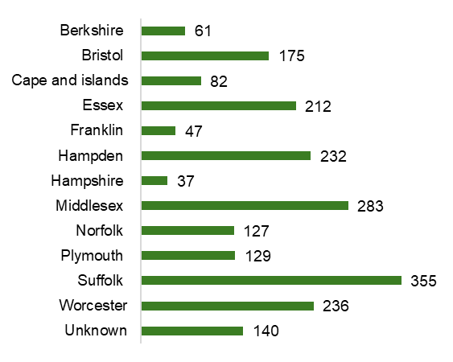 | 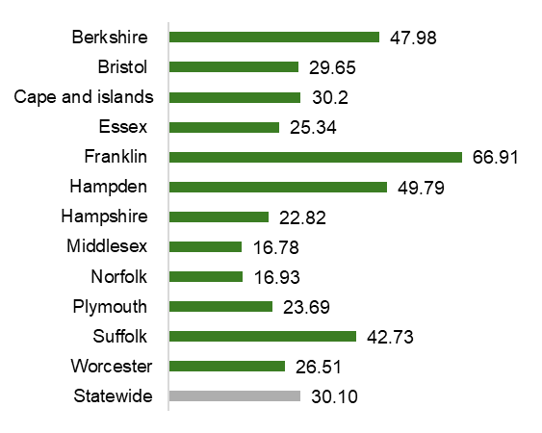
N=2,116
By county, the highest numbers of hepatitis C cases were observed in Middlesex, Suffolk, and Worcester Counties, which all contain significant population centers. The rates of infection by county, however, demonstrate that hepatitis C infection is a statewide issue, with the highest rates of infection in Franklin, Hampden, Berkshire, and Suffolk Counties.
Figure 34. Map of rate of confirmed and probable hepatitis C cases by city/town of residence, MA, 2019-2024
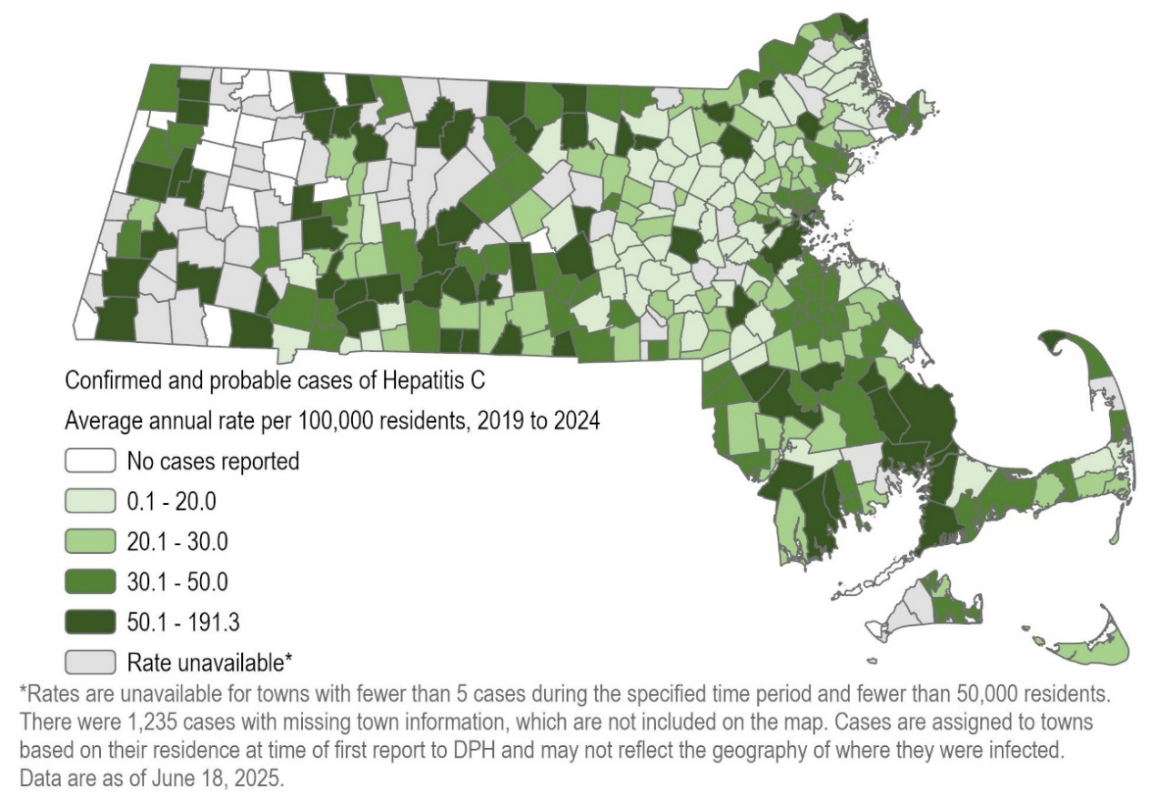
N=17,197; includes acute, chronic, and perinatal cases.
As displayed in this map, hepatitis C affects communities statewide, with very few local jurisdictions reporting no cases between 2019 and 2024, emphasizing the need for broadly available prevention and treatment services. More than 60 cities or towns had rates higher than 50 confirmed and probable cases per 100,000 residents.
Figure 35. Confirmed and probable hepatitis C cases by year, MA, 2016-2024
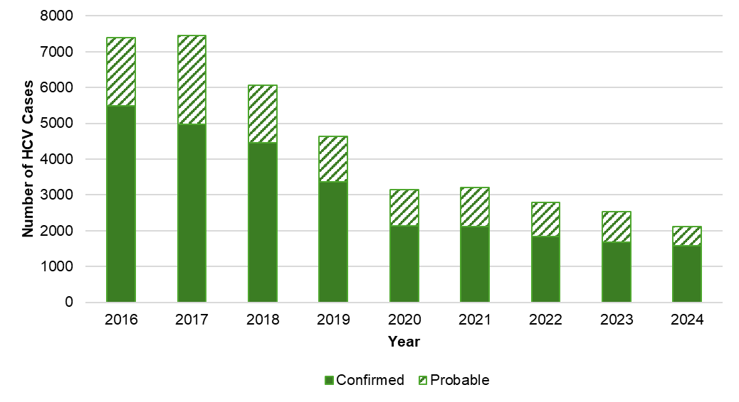
N=39,334
 | 2016 | 2017 | 2018 | 2019 | 2020 | 2021 | 2022 | 2023 | 2024
Confirmed acute | 525 | 176 | 183 | 187 | 178 | 167 | 144 | 130 | 178
Confirmed chronic | 4,954 | 4,795 | 4,259 | 3,181 | 1,941 | 1,940 | 1,680 | 1,543 | 1,395
Probable acute | 60 | 6 | 7 | 4 | 8 | 5 | 8 | 8 | 5
Probable chronic | 1,864 | 2,467 | 1,591 | 1,265 | 1,017 | 1,087 | 948 | 837 | 532
Perinatal | - | - | 15 | 5 | 8 | 8 | 10 | 7 | 6
Total | 7,403 | 7,444 | 6,055 | 4,642 | 3,152 | 3,207 | 2,790 | 2,525 | 2,116
The number of newly reported confirmed and probable HCV cases has decreased substantially between 2016 and 2024, from a high of 7,444 cases in 2017, down 72% to 2,116 cases in 2024. In Figure 35, the specific types of HCV infection (i.e., acute, chronic, and perinatal) are collapsed, and cases are divided only into probable cases (those with only positive HCV antibody results) and confirmed cases (those with positive viral testing). While data should be interpreted with caution between 2020-2022 due to the impact on screening and clinical services from the COVID-19 pandemic, this decrease is also likely driven in part by the effect of increases in MA of prevention strategies such as syringe service programs, with many cities and towns in MA now providing such services. The number of acute HCV cases dropped 24% between 2017 and 2023 from 182 cases to 138, despite an update to the acute HCV case definition in 2020 that led to more sensitive capture of acute cases. An uptick in acute cases is observed in 2024, with 183 identified. Improved surveillance practices, including better identification of cases whose test results change from negative to positive, contributed to identifying more acute cases in 2024. Additionally, because the case definition for perinatal hepatitis C infection was first implemented in 2018, these cases could not be counted in a standardized manner before then.
Figure 36. Number of acute hepatitis C cases reported by age and injection drug use risk, MA, 2016-2024
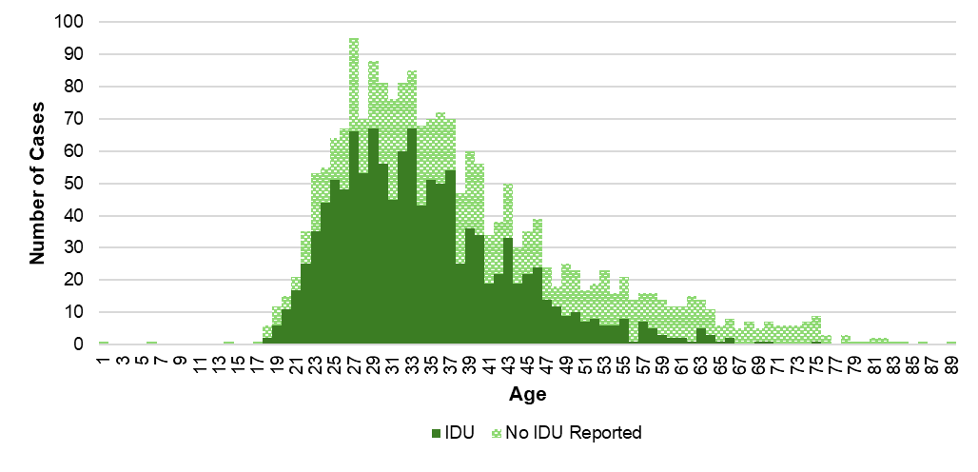
N=1,975
4 cases not included due to missing age, the “No IDU Reported” category includes cases with unknown IDU status.
Acute cases of hepatitis C infection between 2016 and 2024 primarily occurred among adults under 40 years of age, and the predominant risk factor among acute cases is injection drug use.
Table 2. Number of confirmed perinatal hepatitis C cases reported by year, MA, 2018-2024
 | 2018 | 2019 | 2020 | 2021 | 2022 | 2023 | 2024
2 to <6 months old | 2 | 0 | 2 | 3 | 1 | 4 | 4
6 to <12 months old | 2 | 1 | 2 | 0 | 1 | 0 | 0
12 to <18 months old | 1 | 0 | 0 | 0 | 1 | 1 | 0
18 to <24 months old | 8 | 4 | 2 | 5 | 4 | 1 | 1
24 to <30 months old | 1 | 0 | 1 | 0 | 2 | 0 | 1
30 to ≤36 months old | 1 | 0 | 1 | 0 | 1 | 1 | 0
Total Cases | 15 | 5 | 8 | 8 | 10 | 7 | 6

The total number of confirmed perinatal cases of hepatitis C infection was 15 in 2018 and 6 in 2024; no clear trend is evident from year to year. The majority of perinatal cases of hepatitis C infection were identified between 18 and 24 months of age. Testing recommendations for perinatally exposed children were released by CDC in 2023, and recommend that testing take place as early as 2 months of age, with an RNA test. Follow-up of suspect perinatal HCV cases is much more limited in comparison to HBV as there is no PEP recommendation at this time.
Figure 37. Rate of confirmed and probable hepatitis C cases by age group and year, MA, 2016-2024
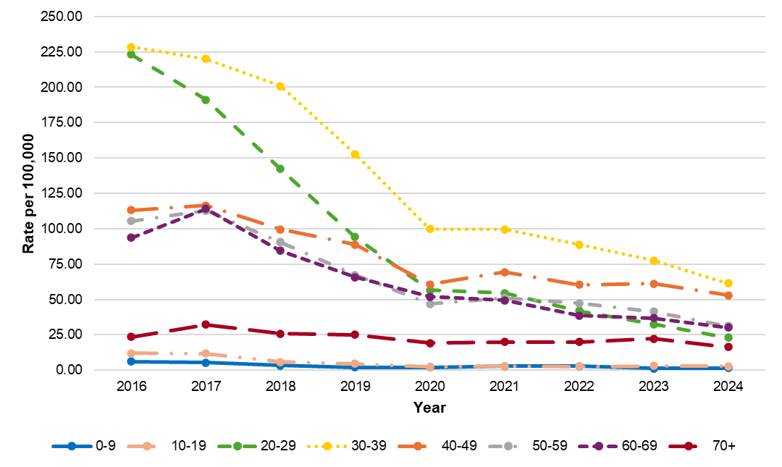
N=38,910, 424 cases not included due to missing age
Rates
Age | 2016 | 2017 | 2018 | 2019 | 2020 | 2021 | 2022 | 2023 | 2024
0-9 | 6.11 | 5.30 | 3.28 | 2.06 | 1.97 | 2.78 | 2.81 | 1.41 | 1.48
10-19 | 12.09 | 11.74 | 5.88 | 4.52 | 2.34 | 2.81 | 2.50 | 2.99 | 2.86
20-29 | 223.13 | 191.24 | 142.17 | 94.24 | 56.57 | 54.58 | 41.94 | 32.40 | 23.13
30-39 | 228.55 | 220.13 | 200.81 | 152.72 | 99.91 | 99.45 | 88.80 | 77.59 | 61.54
40-49 | 113.24 | 116.54 | 99.50 | 88.83 | 60.61 | 69.29 | 60.48 | 61.16 | 52.90
50-59 | 105.49 | 112.79 | 90.70 | 67.21 | 46.83 | 51.18 | 47.32 | 41.36 | 31.12
60-69 | 93.61 | 114.20 | 84.56 | 65.84 | 52.05 | 49.33 | 38.72 | 36.90 | 30.10
70+ | 23.53 | 32.14 | 25.73 | 25.07 | 19.14 | 20.09 | 19.99 | 22.38 | 16.42
N
Age | 2016 | 2017 | 2018 | 2019 | 2020 | 2021 | 2022 | 2023 | 2024
0-9 | 45 | 39 | 24 | 15 | 14 | 20 | 20 | 10 | 11
10-19 | 105 | 102 | 51 | 39 | 20 | 24 | 21 | 25 | 24
20-29 | 2269 | 1959 | 1462 | 969 | 578 | 526 | 401 | 310 | 236
30-39 | 1996 | 1960 | 1817 | 1398 | 946 | 962 | 860 | 755 | 611
40-49 | 989 | 1003 | 846 | 747 | 504 | 582 | 508 | 519 | 466
50-59 | 1046 | 1108 | 880 | 643 | 454 | 491 | 443 | 377 | 283
60-69 | 749 | 926 | 699 | 554 | 451 | 431 | 342 | 329 | 265
70+ | 168 | 239 | 198 | 199 | 160 | 164 | 169 | 196 | 158
Total | 7,367 | 7,336 | 5,977 | 4,564 | 3,127 | 3,200 | 2,764 | 2,521 | 2,054
424 cases were excluded due to missing age
Between 2016 and 2024, the rates of newly reported confirmed and probable hepatitis C cases decreased in all age groups, though there are clear differences across age groups. Individuals between the ages of 30 and 39 consistently had the highest rates of infection. Between 2016 and 2019, this was followed by those aged 20 to 29 years; beginning in 2020, the second highest rate was observed among those aged 40 to 49 years. The lowest rates of infection were observed among children and teenagers.
Figure 38. Map of rate of confirmed and probable hepatitis C cases ages 18-39 by city/town of residence, MA, 2019-2024
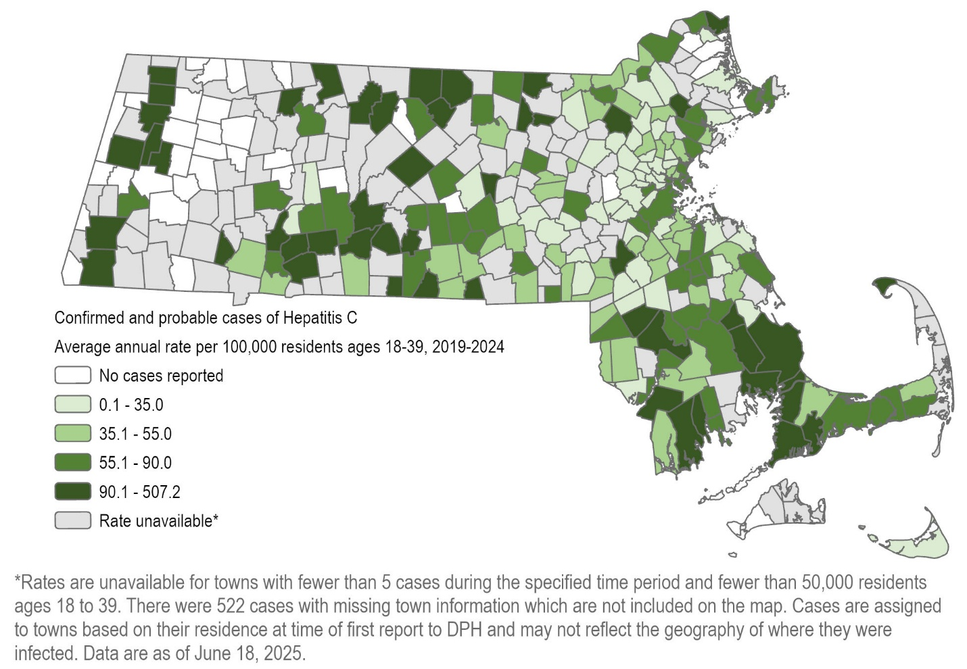
N=7,637, includes acute and chronic cases.
When limited to those individuals between the ages of 18 and 39 years, the map of the rate of confirmed and probable HCV infections between 2018 and 2023 similarly demonstrates that HCV infections are a statewide issue among adults under 40. In this age group, southeastern Massachusetts is an example of an area with relatively high rates of infection. There are 50 cities or towns with rates higher than 90 confirmed and probable cases per 100,000 residents ages 18-39.
Figure 39. Number and rate of confirmed and probable hepatitis C cases by recorded sex or gender and year, MA, 2016-2024
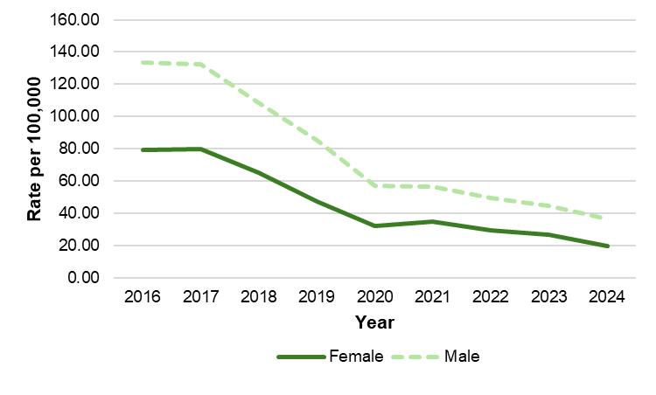
N=38,671
Rate
 | 2016 | 2017 | 2018 | 2019 | 2020 | 2021 | 2022 | 2023 | 2024
Female | 79.13 | 80.05 | 65.09 | 47.12 | 31.91 | 34.94 | 29.57 | 26.75 | 19.96
Male | 133.71 | 132.15 | 108.43 | 85.38 | 57.32 | 56.59 | 49.62 | 44.79 | 36.73
N
 | 2016 | 2017 | 2018 | 2019 | 2020 | 2021 | 2022 | 2023 | 2024
Female | 2,800 | 2,849 | 2,328 | 1,689 | 1,159 | 1,249 | 1,056 | 958 | 745
Male | 4,461 | 4,437 | 3,658 | 2,888 | 1,952 | 1,934 | 1,693 | 1,532 | 1,283
663 cases not included because recorded sex or gender was either transgender or missing. The number of transgender cases is not explicitly included as it is <5 in some years.
The rate of confirmed and probable HCV cases is higher among males as compared to females for every year between 2016 and 2024, though rates for both decrease significantly over time.
Figure 40. Pie chart of confirmed and probable hepatitis C cases by recorded sex or gender and injection drug use status, MA, 2024
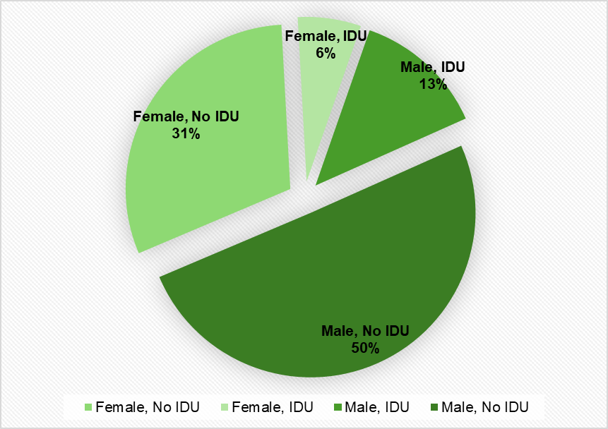
N=2,028. There are a total of 2,116 HCV cases in 2024; 88 cases not included because recorded sex or gender was either transgender or missing. The number of transgender cases is not explicitly included as it is <5. The “No IDU” groups include those cases for whom the risk factor was unknown.
Males made up a greater share of all HCV cases reported in 2023 (63%) than did females (37%). Further, males with HCV were also more likely to report injection drug use as a risk factor than were females with HCV.
Figure 41. Age-adjusted rate of confirmed and probable hepatitis C cases by race/ethnicity and year, MA, 2016-2024
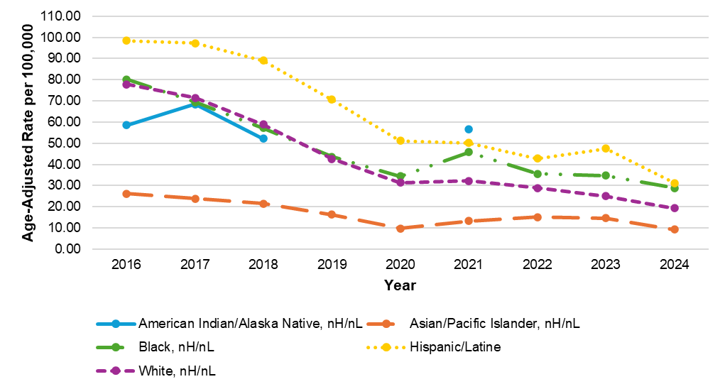
*Rates for the American Indian/Alaska Native population are not displayed for years 2019, 2020, 2023, and 2024 due to N <5
Rates
Race/ethnicity | 2016 | 2017 | 2018 | 2019 | 2020 | 2021 | 2022 | 2023 | 2024
American Indian/Alaska Native, nH/nL | 58.47 | 68.42 | 52.11 |  |  | 56.61 | --
Asian/Pacific Islander, nH/nL | 26.12 | 23.91 | 21.56 | 16.24 | 9.77 | 13.35 | 15.17 | 14.69 | 9.26
Black, nH/nL | 80.10 | 69.49 | 57.17 | 43.68 | 34.38 | 45.80 | 35.58 | 34.80 | 28.86
Hispanic/Latine | 98.33 | 97.20 | 88.95 | 70.62 | 51.21 | 50.22 | 42.85 | 47.42 | 31.26
White, nH/nL | 77.76 | 71.39 | 58.89 | 42.68 | 31.47 | 32.26 | 28.86 | 25.08 | 19.25

N
Race/ethnicity | 2016 | 2017 | 2018 | 2019 | 2020 | 2021 | 2022 | 2023 | 2024
American Indian/Alaska Native, nH/nL | 8 | 9 | 7 |  |  | 7 | 0
Asian/Pacific Islander, nH/nL | 108 | 107 | 98 | 76 | 50 | 72 | 83 | 83 | 55
Black, nH/nL | 394 | 362 | 298 | 232 | 182 | 250 | 196 | 196 | 164
Hispanic/Latine | 767 | 780 | 723 | 555 | 435 | 440 | 376 | 415 | 290
White, nH/nL | 3,791 | 3,584 | 2,918 | 2,082 | 1,569 | 1,580 | 1,385 | 1,210 | 932
Other, nH/nL | 735 | 663 | 530 | 532 | 358 | 335 | 316 | 245 | 195

Rates of newly reported confirmed and probable HCV cases declined for all racial and ethnic groups in Massachusetts between 2016 and 2024, though disparities are evident across groups. Individuals identifying as Hispanic/Latine had the highest rates of reported infection in 2024, followed by individuals identifying as Black, nH/nL, potentially pointing to inequitable access to prevention services and curative therapies. The lowest rates of reported infections were observed among individuals identifying as Asian/Pacific Islander, nH/nL. Note that due to small cell sizes, rates for individuals identifying as American Indian or Alaska Native, nH/nL can only be displayed for 2016-2018 and 2021.
It should be noted that there are significant missing data for race/ethnicity (a total of 8,546 cases [22%] with unknown race/ethnicity between 2016-2024) which may affect the calculation and interpretation of rates, especially if data are missing in a nonrandom or biased way. For example, if cases among Black, nH/nL individuals were less likely to have an accurate race or ethnicity reported than cases among White, nH/nL individuals, the calculated rate for Black, nH/nL will be artificially low.
Figure 42. Histograms of number of hepatitis C cases by age and recorded sex or gender, MA, years 2009, 2014, 2019, and 2024
Confirmed & probable hepatitis C cases by age and recorded sex or gender
2009 | 2014
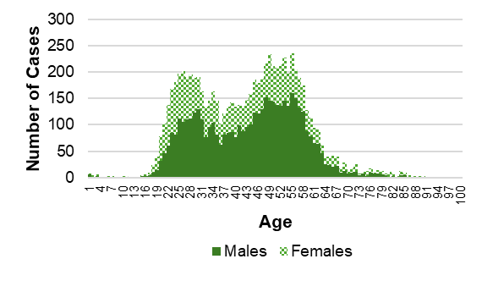  N=7,688, 52 missing age or sex | 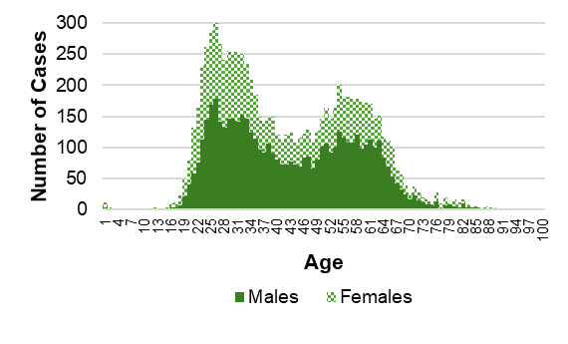  N=8,645, 40 missing age or sex
2019 | 2024
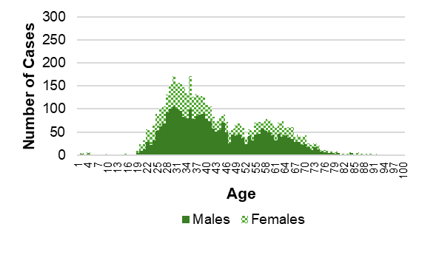  N=4,523, 119 missing age or sex | 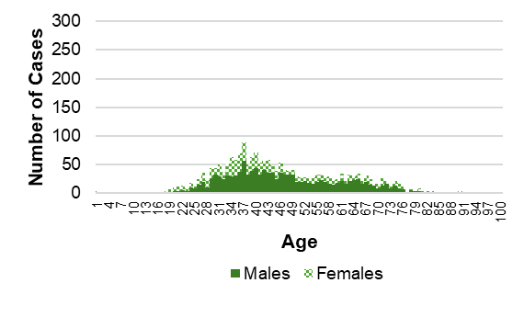  N=2,025, 91 missing age or sex
Tracking newly reported confirmed and probable cases by age over time enables the monitoring of the leading edge of the HCV epidemic. In 2009, an increase in cases among young people, driven by injection drug use, was evident. The age distribution of newly reported cases took the form of a bimodal curve. As time went on, through 2014, 2019, and 2024, newly reported cases continued to shift into younger age groups. In each year displayed, individuals with a recorded sex or gender of male made up the majority of cases. Additionally, by 2024, the number of newly reported cases had dropped significantly from years prior.
Figure 43. Number of confirmed chronic hepatitis C cases by risk factor, MA, 2016-2024
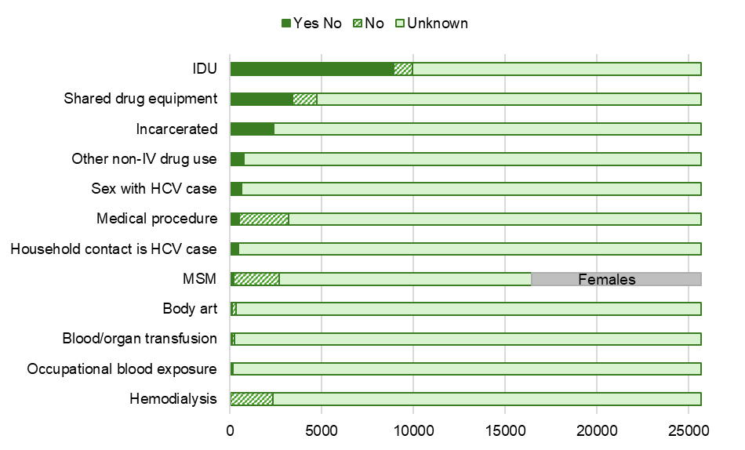
N=25,688
MSM N=16,457 (includes MSM unknown); 9,231 females are represented in gray in the MSM bar because MSM (men who have sex with men), by definition, excludes females.
The most commonly reported risk factor among confirmed chronic HCV cases between 2016 and 2024 was injection drug use. Other commonly reported risk factors included reporting sharing drug equipment, as well as a history of incarceration. There are significant amounts of missing data in the risk factor analyses (61% unknown for injection drug use, for example). Of those for whom injection drug use status was known, 90% reported it as a risk factor. Less common risk factors include body art such as tattoos or piercings, receiving blood transfusion or organ transplantation, occupational exposure to blood, and hemodialysis.
Figure 44. Number of confirmed and probable acute hepatitis C cases by risk factor, MA, 2016-2024
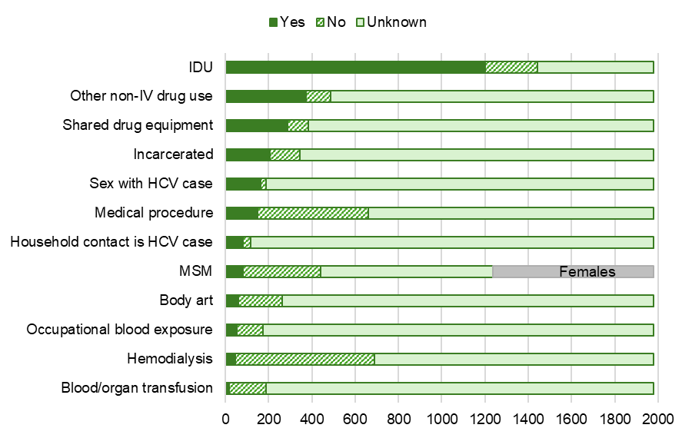
N=1,979
MSM N=1,238 (includes MSM unknown); 741 females are represented in gray in the MSM bar because MSM (men who have sex with men), by definition, excludes females.
Acute cases of HCV infection in Massachusetts are actively investigated by staff at local health departments in conjunction with epidemiologists at DPH. Because of this, completeness for risk history is significantly higher for acute cases than for chronic cases. Among confirmed and probable acute HCV cases reported between 2016 and 2024, injection drug use was again the most commonly reported risk factor (reported by 61% of all acute cases, and 83% of acute cases for whom injection drug use status was known). Other commonly reported risk factors included other, non-injection drug use, sharing drug equipment, and sexual contact with someone with HCV infection. As with chronic cases, potential sources of exposure such as hemodialysis and blood transfusion or organ transplantation were less commonly reported.

Figure 45. Laboratory-based hepatitis C virus clearance cascade, MA, 2015-2024
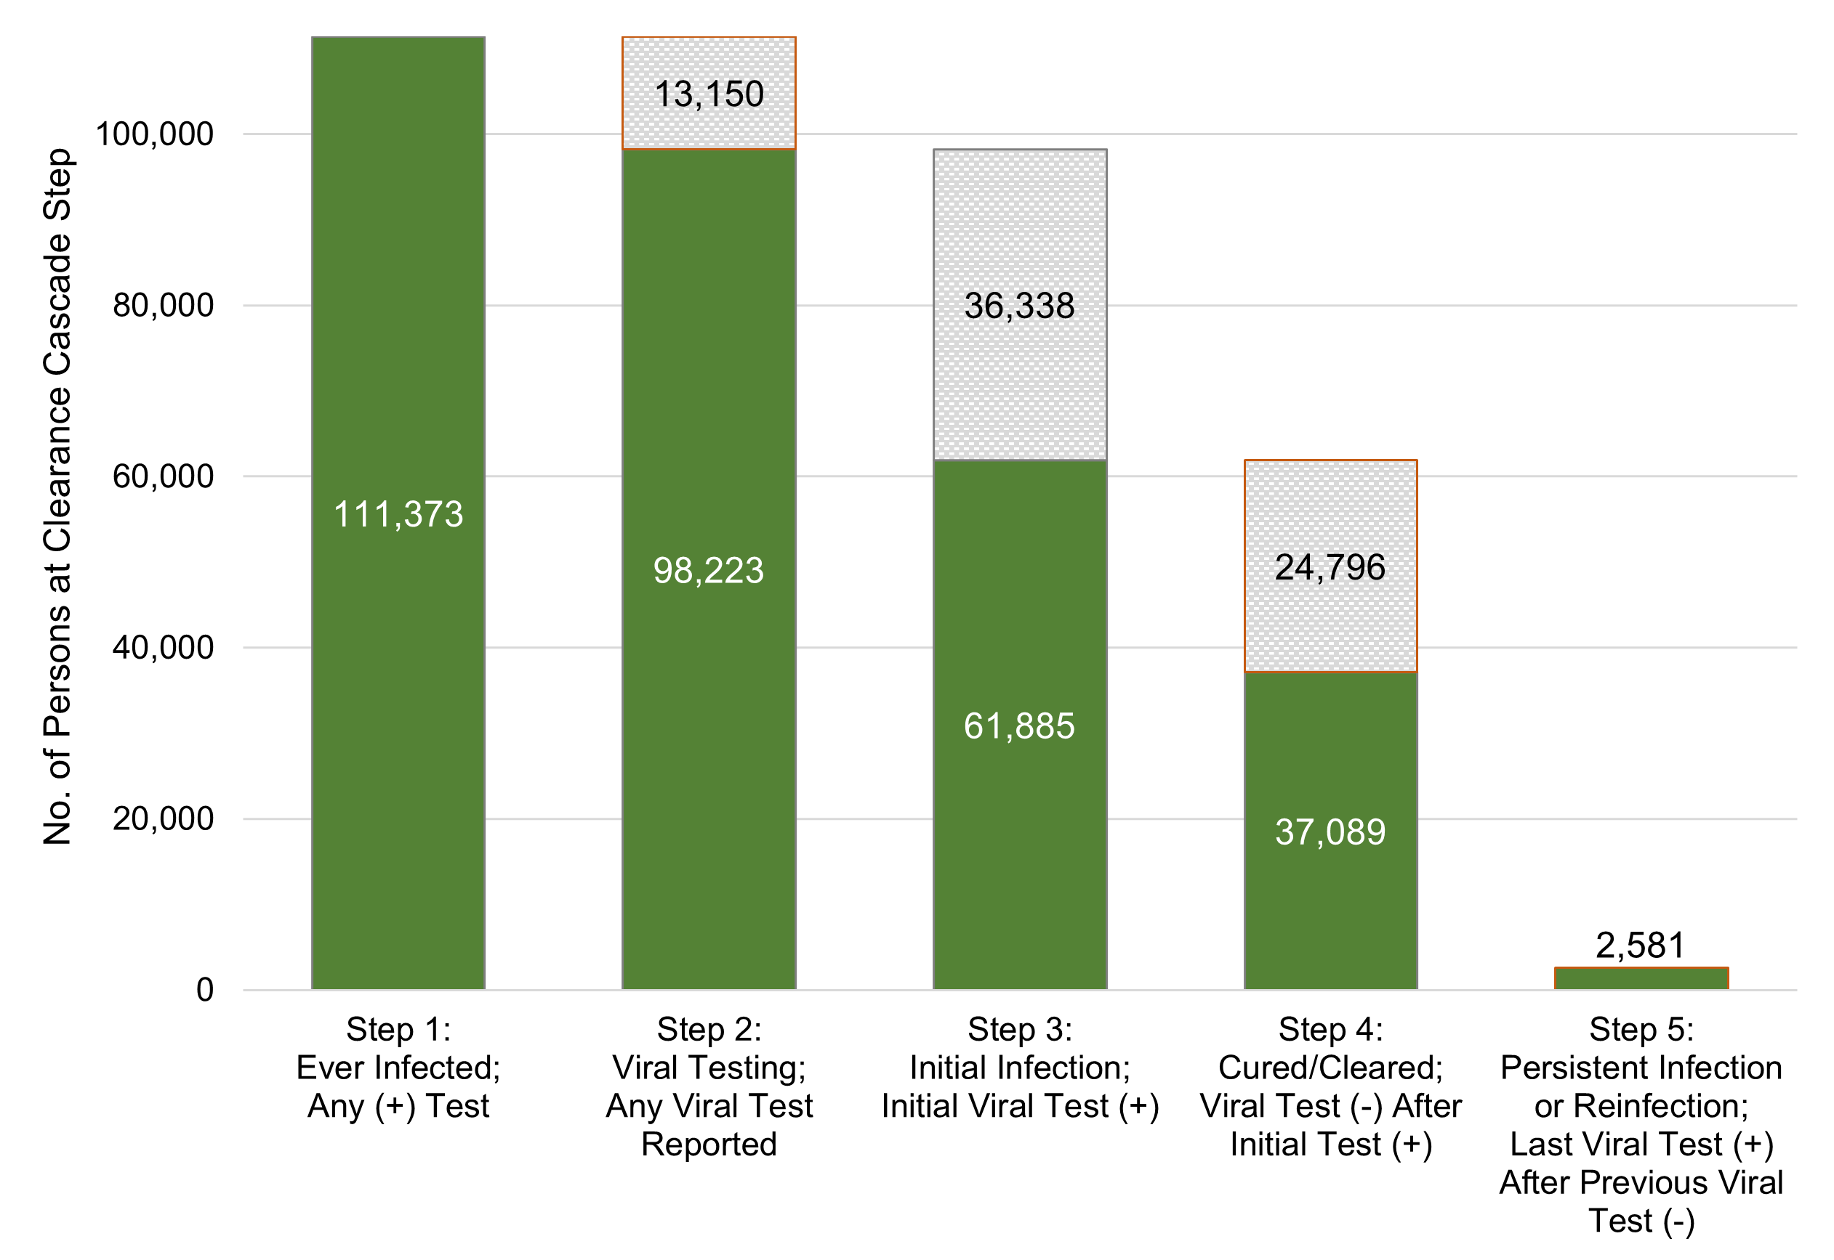
The hepatitis C virus clearance cascade is a framework to measure population-level progress toward HCV clearance or cure. Individuals were included in the cascade if they had a positive HCV test (antibody, RNA, or genotype) reported between January 1, 2014 and December 31, 2023 (Step 1). These ever-infected individuals were then conditionally categorized, using HCV viral tests (RNA, genotype) reported between January 1, 2014 and December 31, 2024, into the remaining steps:
- Step 2 - Viral test performed; any viral test reported
- Step 3 - Initial infection; initial viral test positive
- Step 4 - Cured/cleared; viral test negative after viral test positive
- Step 5 - Persistent infection/reinfection; last viral test positive after previous viral test negative
A total of 111,373 individuals had at least one positive test for hepatitis C during the time period assessed. Of those, 98,223 (88%) had a confirmatory test performed. Of those with confirmatory testing, 61,885 (63%) tested positive, and of those testing positive, 37,089 (60%) cleared infection. Persistent infection or reinfection was noted for 2,581 (4%) of all of those who cleared infection. This iteration of the cascade shows slight progress over the prior iteration, with those with initial infection decreasing from 65% to 63% (Step 3), and those clearing infection increasing from 58% to 60% (Step 4).
While Massachusetts outperformed recent national estimates of 34%, 60% cleared/cured is short of the 80% goal by 2030 set by the US Viral Hepatitis National Strategic Plan and included in the Massachusetts HCV Elimination Plan. Developing a laboratory-based HCV clearance cascade illuminates gaps in confirmatory testing and treatment, as indicated by the sections of the figure highlighted in orange. At least 13,150 people need HCV confirmatory testing and at least 27,377 people need HCV treatment.

Appendix
Confirmed and probable hepatitis C cases by city/town, MA, 2017-2024
City/Town | N | Population | Rate
Abington | 58 | 17,153 | 42.27
Acton | 22 | 24,027 | 11.45
Acushnet | 39 | 10,501 | 46.42
Adams | 59 | 8,136 | 90.65
Agawam | 94 | 28,428 | 41.33
Alford | 0 | 473 | 0
Amesbury | 69 | 17,269 | 49.94
Amherst | 42 | 41,249 | 12.73
Andover | 51 | 36,472 | 17.48
Aquinnah | 0 | 447 | 0
Arlington | 98 | 46,068 | 26.59
Ashburnham | 25 | 6,313 | 49.5
Ashby | 18 | 3,176 | 70.84
Ashfield | 0 | 1,689 | 0
Ashland | 33 | 18,865 | 21.87
Athol | 111 | 11,872 | 116.87
Attleboro | 192 | 46,577 | 51.53
Auburn | 52 | 16,799 | 38.69
Avon | 18 | 4,794 | 46.93
Ayer | 91 | 8,452 | 134.58
Barnstable | 231 | 49,907 | 57.86
Barre | 26 | 5,516 | 58.92
Becket | 5 | 1,943 | 32.17
Bedford | 30 | 14,257 | 26.3
Belchertown | 49 | 15,201 | 40.29
Bellingham | 48 | 16,811 | 35.69
Belmont | 56 | 27,182 | 25.75
Berkley | 22 | 6,794 | 40.48
Berlin | 6 | 3,170 | 23.66
Bernardston | 11 | 2,094 | 65.66
Beverly | 125 | 42,494 | 36.77
Billerica | 304 | 41,640 | 91.26
Blackstone | 43 | 9,148 | 58.76
Blandford | 6 | 1,199 | 62.55
Bolton | 11 | 5,723 | 24.03
Boston | 3,828 | 652,495 | 73.33
Bourne | 133 | 20,961 | 79.31
Boxborough | 10 | 5,555 | 22.5
Boxford | 5 | 8,155 | 7.66
Boylston | 11 | 4,873 | 28.22
Braintree | 141 | 39,069 | 45.11
Brewster | 20 | 10,425 | 23.98
Bridgewater | 166 | 28,888 | 71.83
Brimfield | 11 | 3,662 | 37.55
Brockton | 505 | 106,878 | 59.06
Brookfield | 23 | 3,410 | 84.31
Brookline | 73 | 63,040 | 14.47
Buckland | <5 | 1,810
Burlington | 42 | 26,120 | 20.1
Cambridge | 280 | 116,314 | 30.09
Canton | 56 | 24,400 | 28.69
Carlisle | 9 | 5,206 | 21.61
Carver | 70 | 11,602 | 75.42
Charlemont | 6 | 1,176 | 63.78
Charlton | 36 | 13,259 | 33.94
Chatham | 15 | 6,614 | 28.35
Chelmsford | 89 | 36,168 | 30.76
Chelsea | 152 | 40,437 | 46.99
Cheshire | 14 | 3,250 | 53.85
Chester | 7 | 1,209 | 72.37
Chesterfield | <5 | 1,155
Chicopee | 506 | 55,298 | 114.38
Chilmark | <5 | 1,231
Clarksburg | 6 | 1,653 | 45.37
Clinton | 55 | 15,523 | 44.29
Cohasset | 12 | 8,391 | 17.88
Colrain | 8 | 1,597 | 62.62
Concord | 42 | 18,359 | 28.6
Conway | <5 | 1,740
Cummington | <5 | 808
Dalton | 28 | 6,273 | 55.79
Danvers | 78 | 27,822 | 35.04
Dartmouth | 268 | 33,484 | 100.05
Dedham | 129 | 25,261 | 63.83
Deerfield | 16 | 5,076 | 39.4
Dennis | 68 | 14,778 | 57.52
Dighton | 15 | 8,226 | 22.79
Douglas | 36 | 8,974 | 50.14
Dover | 7 | 5,867 | 14.91
Dracut | 98 | 32,450 | 37.75
Dudley | 42 | 11,839 | 44.34
Dunstable | 5 | 3,362 | 18.59
Duxbury | 17 | 16,153 | 13.16
East Bridgewater | 47 | 14,465 | 40.62
East Brookfield | 5 | 2,211 | 28.27
East Longmeadow | 20 | 16,296 | 15.34
Eastham | 13 | 5,853 | 27.76
Easthampton | 47 | 15,914 | 36.92
Easton | 59 | 25,061 | 29.43
Edgartown | 15 | 5,342 | 35.1
Egremont | <5 | 1,365
Erving | 8 | 1,760 | 56.82
Essex | 6 | 3,647 | 20.56
Everett | 174 | 49,223 | 44.19
Fairhaven | 59 | 15,732 | 46.88
Fall River | 810 | 94,254 | 107.42
Falmouth | 207 | 32,789 | 78.91
Fitchburg | 229 | 41,762 | 68.54
Florida | <5 | 683
Foxborough | 40 | 18,644 | 26.82
Framingham | 446 | 71,544 | 77.92
Franklin | 72 | 33,202 | 27.11
Freetown | 16 | 9,192 | 21.76
Gardner | 170 | 21,226 | 100.11
Georgetown | 13 | 8,402 | 19.34
Gill | <5 | 1,544
Gloucester | 122 | 29,344 | 51.97
Goshen | 0 | 925 | 0
Gosnold | 0 | 70 | 0
Grafton | 36 | 19,751 | 22.78
Granby | 19 | 6,012 | 39.5
Granville | 7 | 1,519 | 57.6
Great Barrington | 52 | 7,129 | 91.18
Greenfield | 208 | 17,782 | 146.22
Groton | 14 | 11,304 | 15.48
Groveland | 11 | 6,710 | 20.49
Hadley | 11 | 5,278 | 26.05
Halifax | 27 | 7,752 | 43.54
Hamilton | 12 | 7,445 | 20.15
Hampden | 14 | 4,880 | 35.86
Hancock | 0 | 750 | 0
Hanover | 31 | 14,902 | 26
Hanson | 32 | 10,660 | 37.52
Hardwick | 12 | 2,620 | 57.25
Harvard | 8 | 6,865 | 14.57
Harwich | 41 | 13,646 | 37.56
Hatfield | 9 | 3,298 | 34.11
Haverhill | 339 | 67,850 | 62.45
Hawley | 0 | 349 | 0
Heath | 0 | 715 | 0
Hingham | 39 | 24,228 | 20.12
Hinsdale | 17 | 1,903 | 111.67
Holbrook | 47 | 11,356 | 51.73
Holden | 30 | 20,049 | 18.7
Holland | 17 | 2,594 | 81.92
Holliston | 23 | 14,983 | 19.19
Holyoke | 414 | 37,748 | 137.09
Hopedale | 13 | 5,996 | 27.1
Hopkinton | 32 | 19,257 | 20.77
Hubbardston | 14 | 4,300 | 40.7
Hudson | 47 | 19,889 | 29.54
Hull | 50 | 9,948 | 62.83
Huntington | 9 | 2,050 | 54.88
Ipswich | 26 | 13,630 | 23.84
Kingston | 39 | 13,829 | 35.25
Lakeville | 36 | 11,610 | 38.76
Lancaster | 17 | 8,428 | 25.21
Lanesborough | 11 | 3,035 | 45.3
Lawrence | 442 | 89,901 | 61.46
Lee | 29 | 5,733 | 63.23
Leicester | 40 | 10,989 | 45.5
Lenox | 15 | 5,053 | 37.11
Leominster | 187 | 43,716 | 53.47
Leverett | <5 | 1,865
Lexington | 45 | 34,191 | 16.45
Leyden | <5 | 729
Lincoln | 8 | 6,784 | 14.74
Littleton | 14 | 10,227 | 17.11
Longmeadow | 16 | 15,664 | 12.77
Lowell | 820 | 114,323 | 89.66
Ludlow | 314 | 20,765 | 189.02
Lunenburg | 24 | 11,905 | 25.2
Lynn | 555 | 101,603 | 68.28
Lynnfield | 17 | 13,038 | 16.3
Malden | 216 | 65,659 | 41.12
Manchester | <5 | 5,289
Mansfield | 45 | 23,988 | 23.45
Marblehead | 34 | 20,111 | 21.13
Marion | 6 | 5,350 | 14.02
Marlborough | 114 | 41,475 | 34.36
Marshfield | 100 | 25,738 | 48.57
Mashpee | 49 | 15,275 | 40.1
Mattapoisett | 15 | 6,483 | 28.92
Maynard | 26 | 10,679 | 30.43
Medfield | 12 | 12,897 | 11.63
Medford | 173 | 58,606 | 36.9
Medway | 22 | 13,080 | 21.02
Melrose | 64 | 29,768 | 26.87
Mendon | 8 | 6,249 | 16
Merrimac | 13 | 6,717 | 24.19
Methuen | 165 | 53,043 | 38.88
Middleborough | 104 | 24,261 | 53.58
Middlefield | <5 | 413
Middleton | 177 | 9,841 | 224.82
Milford | 70 | 30,379 | 28.8
Millbury | 57 | 13,762 | 51.77
Millis | 23 | 8,448 | 34.03
Millville | 7 | 3,154 | 27.74
Milton | 49 | 28,534 | 21.47
Monroe | 0 | 118 | 0
Monson | 25 | 8,032 | 38.91
Montague | 48 | 8,601 | 69.76
Monterey | 5 | 1,099 | 56.87
Montgomery | <5 | 802
Mount Washington | 0 | 158 | 0
Nahant | 9 | 3,262 | 34.49
Nantucket | 41 | 14,506 | 35.33
Natick | 58 | 36,943 | 19.62
Needham | 30 | 32,100 | 11.68
New Ashford | 0 | 246 | 0
New Bedford | 802 | 101,504 | 98.76
New Braintree | <5 | 985
New Marlborough | <5 | 1,517
New Salem | <5 | 976
Newbury | 16 | 6,624 | 30.19
Newburyport | 48 | 18,017 | 33.3
Newton | 143 | 87,647 | 20.39
Norfolk | 40 | 11,709 | 42.7
North Adams | 164 | 12,909 | 158.8
North Andover | 46 | 30,805 | 18.67
North Attleborough | 95 | 30,944 | 38.38
North Brookfield | 24 | 4,703 | 63.79
North Reading | 43 | 15,440 | 34.81
Northampton | 146 | 29,479 | 61.91
Northborough | 19 | 15,893 | 14.94
Northbridge | 59 | 16,276 | 45.31
Northfield | 13 | 2,859 | 56.84
Norton | 113 | 19,071 | 74.07
Norwell | 25 | 11,486 | 27.21
Norwood | 80 | 31,547 | 31.7
Oak Bluffs | 12 | 5,460 | 27.47
Oakham | <5 | 1,831
Orange | 47 | 7,533 | 77.99
Orleans | 17 | 6,345 | 33.49
Otis | 11 | 1,633 | 84.2
Oxford | 52 | 13,201 | 49.24
Palmer | 65 | 12,382 | 65.62
Paxton | <5 | 4,974
Peabody | 180 | 53,851 | 41.78
Pelham | <5 | 1,248
Pembroke | 58 | 18,370 | 39.47
Pepperell | 43 | 11,482 | 46.81
Peru | <5 | 806
Petersham | <5 | 1,176
Phillipston | 7 | 1,724 | 50.75
Pittsfield | 470 | 43,741 | 134.31
Plainfield | <5 | 614
Plainville | 30 | 10,031 | 37.38
Plymouth | 365 | 61,349 | 74.37
Plympton | 16 | 2,939 | 68.05
Princeton | <5 | 3,496
Provincetown | 18 | 3,769 | 59.7
Quincy | 438 | 101,224 | 54.09
Randolph | 130 | 35,000 | 46.43
Raynham | 55 | 15,239 | 45.11
Reading | 37 | 25,206 | 18.35
Rehoboth | 28 | 12,536 | 27.92
Revere | 271 | 62,307 | 54.37
Richmond | <5 | 1,389
Rochester | 10 | 5,772 | 21.66
Rockland | 87 | 17,798 | 61.1
Rockport | 12 | 6,822 | 21.99
Rowe | 0 | 421 | 0
Rowley | 9 | 6,126 | 18.36
Royalston | <5 | 1,236
Russell | 9 | 1,629 | 69.06
Rutland | 19 | 9,139 | 25.99
Salem | 167 | 44,342 | 47.08
Salisbury | 73 | 9,174 | 99.47
Sandisfield | <5 | 986
Sandwich | 45 | 20,509 | 27.43
Saugus | 105 | 28,455 | 46.13
Savoy | <5 | 643
Scituate | 43 | 19,084 | 28.16
Seekonk | 43 | 15,661 | 34.32
Sharon | 32 | 18,509 | 21.61
Sheffield | 14 | 3,331 | 52.54
Shelburne | 10 | 1,878 | 66.56
Sherborn | 6 | 4,370 | 17.16
Shirley | 125 | 7,362 | 212.24
Shrewsbury | 81 | 38,329 | 26.42
Shutesbury | 5 | 1,718 | 36.38
Somerset | 54 | 18,148 | 37.19
Somerville | 166 | 78,993 | 26.27
South Hadley | 45 | 18,198 | 30.91
Southampton | 8 | 6,167 | 16.22
Southborough | 20 | 10,545 | 23.71
Southbridge | 191 | 17,715 | 134.77
Southwick | 20 | 9,104 | 27.46
Spencer | 63 | 11,907 | 66.14
Springfield | 1,229 | 155,692 | 98.67
Sterling | 14 | 7,923 | 22.09
Stockbridge | 5 | 2,012 | 31.06
Stoneham | 71 | 23,094 | 38.43
Stoughton | 112 | 29,197 | 47.95
Stow | 7 | 7,147 | 12.24
Sturbridge | 28 | 9,839 | 35.57
Sudbury | 20 | 18,998 | 13.16
Sunderland | 7 | 3,643 | 24.02
Sutton | 16 | 9,357 | 21.37
Swampscott | 19 | 15,096 | 15.73
Swansea | 55 | 17,129 | 40.14
Taunton | 375 | 59,525 | 78.75
Templeton | 35 | 8,102 | 54
Tewksbury | 93 | 31,078 | 37.41
Tisbury | 26 | 4,917 | 66.1
Tolland | <5 | 455
Topsfield | 12 | 6,519 | 23.01
Townsend | 29 | 9,038 | 40.11
Truro | 9 | 2,516 | 44.71
Tyngsborough | 32 | 12,352 | 32.38
Tyringham | <5 | 419
Upton | 14 | 8,030 | 21.79
Uxbridge | 40 | 14,124 | 35.4
Wakefield | 70 | 26,911 | 32.51
Wales | 7 | 1,808 | 48.4
Walpole | 202 | 26,454 | 95.45
Waltham | 177 | 64,376 | 34.37
Ware | 57 | 9,919 | 71.83
Wareham | 154 | 23,401 | 82.26
Warren | 28 | 4,918 | 71.17
Warwick | 7 | 769 | 113.78
Washington | <5 | 485
Watertown | 109 | 34,894 | 39.05
Wayland | 18 | 13,909 | 16.18
Webster | 108 | 17,716 | 76.2
Wellesley | 31 | 29,174 | 13.28
Wellfleet | 12 | 3,687 | 40.68
Wendell | <5 | 924
Wenham | <5 | 5,010
West Boylston | 145 | 7,840 | 231.19
West Bridgewater | 20 | 7,792 | 32.08
West Brookfield | 23 | 3,792 | 75.82
West Newbury | <5 | 4,483
West Springfield | 134 | 28,672 | 58.42
West Stockbridge | <5 | 1,334
West Tisbury | 8 | 3,666 | 27.28
Westborough | 48 | 21,838 | 27.48
Westfield | 140 | 40,486 | 43.22
Westford | 36 | 24,784 | 18.16
Westhampton | <5 | 1,593
Westminster | 17 | 8,278 | 25.67
Weston | 5 | 11,680 | 5.35
Westport | 58 | 16,194 | 44.77
Westwood | 26 | 16,343 | 19.89
Weymouth | 261 | 57,166 | 57.07
Whately | 0 | 1,624 | 0
Whitman | 62 | 15,173 | 51.08
Wilbraham | 21 | 14,532 | 18.06
Williamsburg | 16 | 2,451 | 81.6
Williamstown | 21 | 7,478 | 35.1
Wilmington | 41 | 23,165 | 22.12
Winchendon | 71 | 10,296 | 86.2
Winchester | 23 | 22,815 | 12.6
Windsor | <5 | 823
Winthrop | 78 | 19,277 | 50.58
Woburn | 112 | 40,465 | 34.6
Worcester | 1,320 | 207,253 | 79.61
Worthington | 0 | 1,158 | 0
Wrentham | 29 | 12,236 | 29.63
Yarmouth | 93 | 25,244 | 46.05
Unknown | 2,295 | -- | --

Confirmed and probable HCV cases by county, 2017-2024
County | N | Population | Rate
Berkshire County | 954 | 128,388 | 92.88
Bristol County | 3,203 | 579,760 | 69.06
Cape and Islands | 1,075 | 267,957 | 50.15
Essex County | 2,965 | 807,369 | 45.91
Franklin County | 411 | 70,990 | 72.37
Hampden County | 3,079 | 462,856 | 83.15
Hampshire County | 475 | 163,130 | 36.4
Middlesex County | 4,907 | 1,617,262 | 37.93
Norfolk County | 2,190 | 724,484 | 37.79
Plymouth County | 2,182 | 533,064 | 51.17
Suffolk County | 4,329 | 774,516 | 69.87
Worcester County | 3,866 | 862,217 | 56.05
Statewide | 31,931 | 6,991,993 | 57.08
Unknown County | 2,295 | -- | --

Population Estimates 2011-2019, version 2020, Massachusetts Department of Public Health, Bureau of Environmental Health. Version 2020 years 2018-2019 apply updates from U.S. Census Bureau’s County Population by Characteristics, vintage 2020; all previous years apply updates from U.S. Census Bureau’s County Population by Characteristics, vintage 2019 or earlier. These estimates were developed by the University of Massachusetts Donahue Institute (UMDI) in partnership with the Massachusetts Department of Public Health, Bureau of Environmental Health.
Small Area Population estimates 2020-2030, Massachusetts Department of Public Health, Office of Population. Developed by University of Massachusetts Donohue Institute’s Economic & Public Policy Research Group using 2020 census data, including 2020 census counts for age groups and sex and in spring 2025, the modified age race census file for final estimates released August 2025 for use by DPH.
Terrault, Norah A.*,1; Lok, Anna S. F.2; McMahon, Brian J.3; Chang, Kyong‐Mi4; Hwang, Jessica P.5; Jonas, Maureen M.6; Brown, Robert S. Jr7; Bzowej, Natalie H.8; Wong, John B.9. Update on Prevention, Diagnosis, and Treatment of Chronic Hepatitis B: AASLD 2018 Hepatitis B Guidance. Clinical Liver Disease 12(1):p 33-34, July 2018. | DOI: 10.1002/cld.728
https://ndc.services.cdc.gov/case-definitions/hepatitis-b-acute-and-chronic-2024/
https://www.cdc.gov/hepatitis-b/hcp/diagnosis-testing/index.html
Panagiotakopoulos L, Sandul AL, et al. CDC Recommendations for Hepatitis C Testing Among Perinatally Exposed Infants and Children — United States, 2023. MMWR Recomm Rep 2023;72(No. RR-4):1–19. DOI: http://dx.doi.org/10.15585/mmwr.rr7204a1
https://www.mass.gov/info-details/massachusetts-hcv-elimination-plan

