BR Filing for 2025 Reporting Year

Open the following link: https://rcrainfo.epa.gov/rcrainfoprod/action/secured/login
Log in
Select facility by clicking on the Site Name
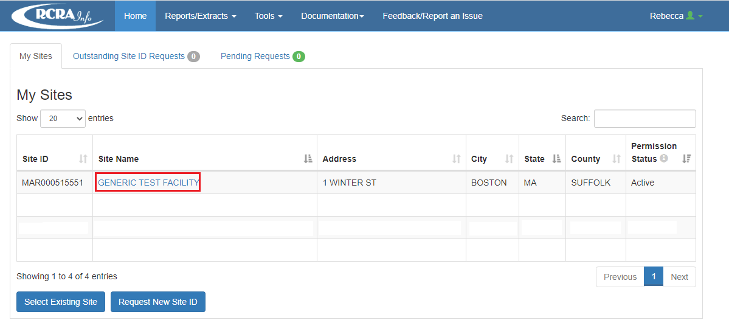
That will load on a Site Details Page. Select the tab entitled Biennial Report.
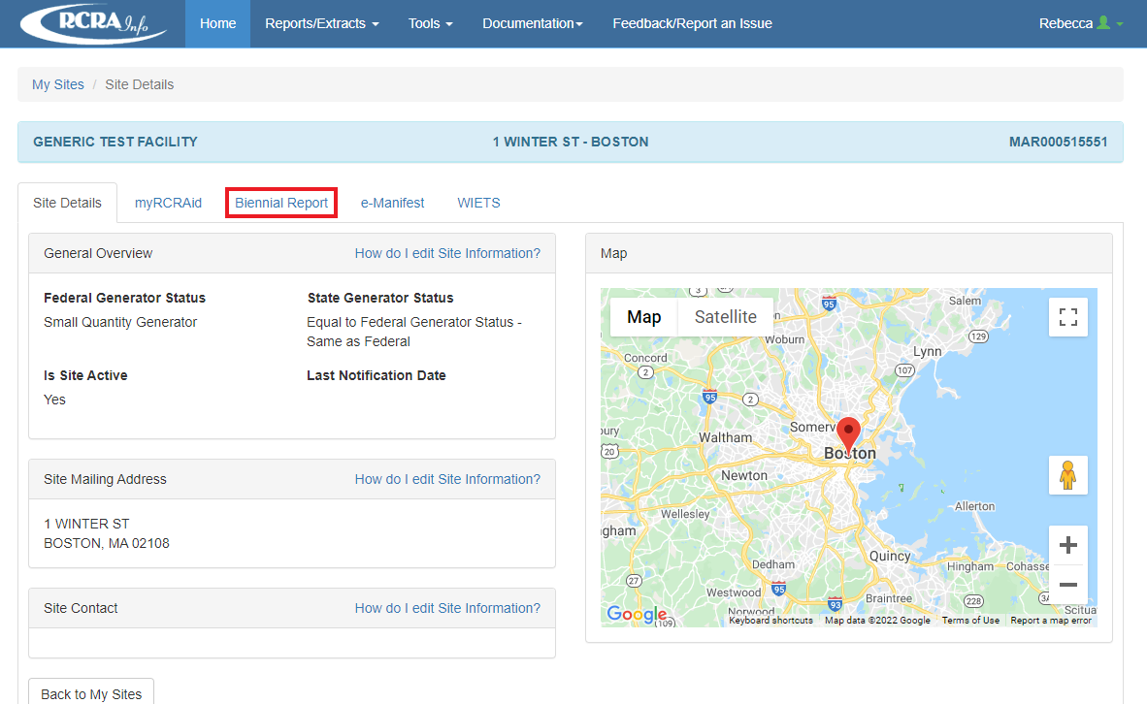

Click on the create New Submission button.
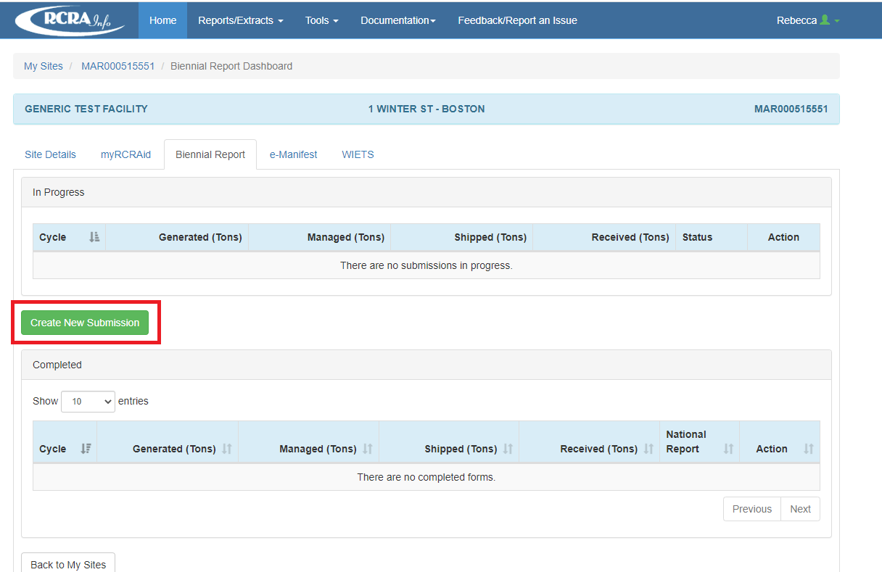

Click on Continue to Data Entry to fill out form
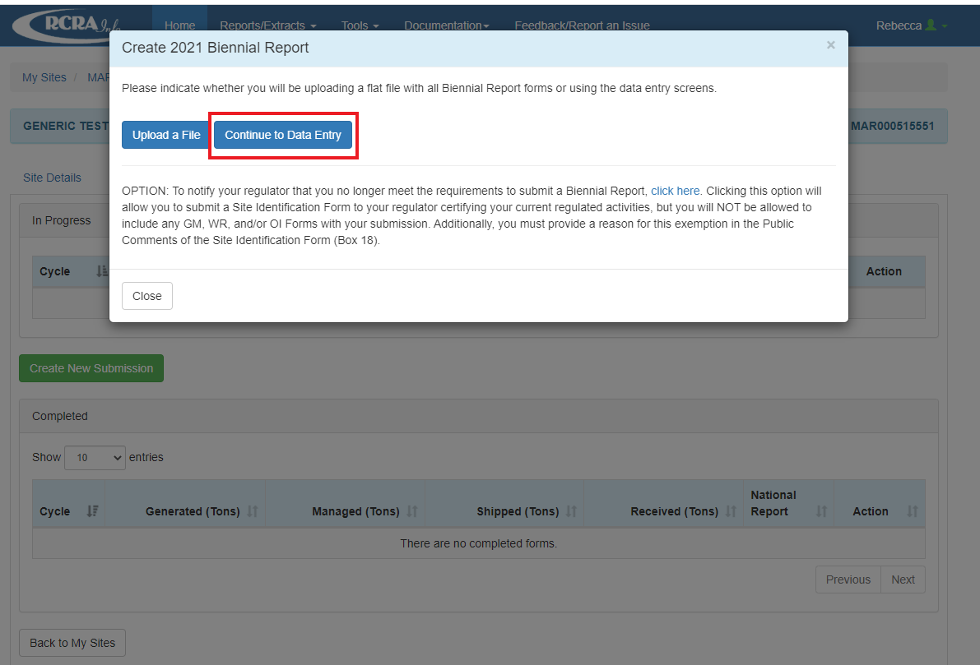
Or if not subject to BR for the calendar year click on the “Click Here” button and fill out the notification form. Be sure to include reason why not subject to BR in the comments section. This is what must be done in lieu of sending a letter to DEP.
