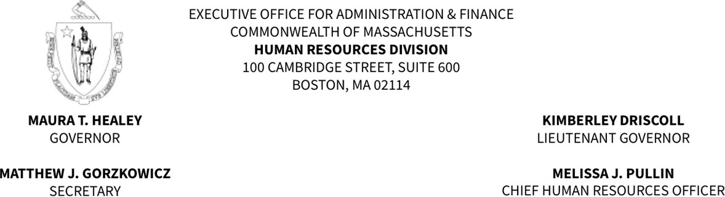

Amended August 4, 2025

READING LIST ANNOUNCEMENT – PLEASE POST PROMINENTLY

TO: Commissioner Shawn Jenkins, Department of Correction FROM: Regina Caggiano, Director of Civil Service
DATE: May 6, 2025
SUBJECT: Reading List Correctional Program Officer C Examination

CORRECTIONAL PROGRAM OFFICER C EXAMINATION DATE – SATURDAY, OCTOBER 4, 2025

This reading list will pertain to the Human Resources Division Written Examination for Correctional Program Officer C administered on October 4, 2025.

Candidates are responsible for reading all the texts and other materials listed below and on all pages of this announcement. Please note carefully which edition and/or date of publication is listed for each item. All technical knowledge examination questions will be based on these materials.

Code of Massachusetts Regulations (103 CMR), as amended through the release date of this reading list.

Entire CMR is included unless specified.
CMR 491: only 491.09 and 491.14
CMR 505: only 505.01 - 505.10, 505.13, 505.15,
and 505.18
CMR 157
CMR 420
CMR 430: only 430.09
CMR 481: only 481.09
CMR 483: only 483.06, 483.07, 483.10, 483.11,
483.13, 483.14 and all CMR 483 attachments and linked forms

Note: All Attachments are excluded unless otherwise noted

Commonwealth of Massachusetts Department of Correction (103 DOC), as amended through the release date of this reading list.

Entire DOC Policy is included unless specified.

DOC 100: only 100.01 - 100.04
DOC 101
DOC 119: only 119.02 - 119.04 and 119.08 - 119.09
DOC 153
DOC 155
DOC 157
DOC 209
DOC 222: only 222.01 - 222.07
DOC 224: only 224.02
DOC 225
DOC 230: only 230.03 - 230.05
DOC 237
DOC 238
DOC 239
DOC 400
DOC 401: only 401.03
DOC 404
DOC 408: only 408.07
DOC 417
DOC 426: only 426.01 - 426.05
DOC 493
DOC 501: only 501.05A1 and 501.06
DOC 502: only 502.01 - 502.09
DOC 504: only 504.04 and 504.05
DOC 511: only 511.03
DOC 512: only 512.04A
DOC 513
DOC 519: only 519.03 - 519.06
DOC 521: only 521.04 - 521.06
DOC 525
DOC 527
DOC 550: only 550.03 but exclude 550.03E
DOC 560: only 560.09, 560.10, and 560.12
DOC 562: only 562.02 but exclude 562.02B2
DOC 758

Note: All Attachments are excluded unless otherwise noted

Commonwealth of Massachusetts Department of Correction (103 SOP), as amended through the release date of this reading list.
Entire SOP is included unless specified.

SOP 420: both [“Subsequent Reviews” and “Audio Recording of Hearing for Lifers...”]
SOP 463
SOP 488: only I.B and VI.A
SOP 491

ICM Manual: Integrated Case Management: the role of a Correctional Program Officer, as amended through the release date of this reading list.

Section 1 "Integrated Case Management"
Section 2 "DOC Mission and Evidence Based Practice"
Section 3 "Offender Population": exclude pg. 18 – 22 (“Other Subpopulations” to End of Section) and
all Population numbers and Percentages
Section 4 "Motivational Interviewing Overview"
Section 5 "CHRI"
Section 6 "Reading and Interpreting CJIS" Section 7 "Official Versions"
Section 8 “Date Comp Overview": exclude pg. 70 – 72 (“Weekend Sentences” to End of Section) Section 9 "Sex Offender Overview": exclude pg. 75 – 84 (“Applicable IMS screens regarding Sex Offender Information” to End of Section)
Section 10 "Motivational Interviewing Techniques"
Section 11 "Risk/Need Assessment": exclude pg. 102 (“Note”) and pg. 105 – 110 (“Reentry Assessment” to End of Section)
Section 13 "Classification Preparation" Section 14 "Classification Report Exemplars" Section 15 "Classification Hearing"
Section 16 "Classification Recommendations": exclude pg. 147 (“BSH Work Unit”) and pg. 147 – 150 (“Custody Levels” to End of Section”)

Rules and Regulations Governing All Employees of the Massachusetts Department of Correction (“Blue Book”), as amended through the release date of this reading list.

Entire Source

Training Academy Material on Report Writing, as amended through the release date of this reading list.

Only: Phase I – exclude Phase II – IV

All above readings are found in DOC Policies. Check with your agency for assistance in locating a copy.

Please note that the Human Resources Division does not recommend specific retailers for the purchase of reading list texts. For local vendors, contact the publishers at the telephone number or website listed. Many local retailers will be able to special-order any text not carried in stock.

Any questions regarding the reading list may be directed to Shelagh Herbert at shelagh.herbert@mass.gov. A copy of the reading list is posted on the Human Resources Division’s Civil Service Unit website. Examination Preparation Guides and Reading Lists | Mass.gov

