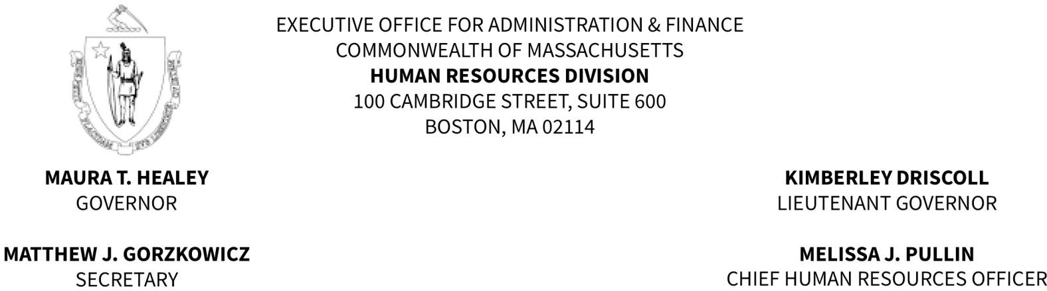

MEMORANDUM

TO: Fire Department Appointing Authorities and Fire Chiefs FROM: Regina Caggiano, Director of Civil Service
DATE: April 2, 2025

RE: Municipal Firefighter Eligible List Maintenance

Please be advised that the existing Municipal Firefighter eligible list is scheduled to be updated on May 1, 2025. Eligibility for those placed on the list in April 2023 will have expired and candidates who took and passed the most recent examination will be merged with those appearing on the current list, resulting in a new list.

Appointments made from a current eligible list will be valid if the selected individuals are under consideration from a certification issued prior to the establishment of the new list pursuant to Massachusetts General Laws, Chapter 31, § 25. Appointees from a Firefighter certification must pass a medical examination and a Physical Ability Test before their appointments can be finalized.

Pursuant to Personnel Administration Rule .08, any requisition to fill vacancies to the title of Firefighter received by the Human Resources Division, Civil Service Unit, after the issuance of this memorandum will be processed from the eligible list scheduled to be established on May 1, 2025.
If you have any questions or concerns, please do not hesitate to contact our office.

