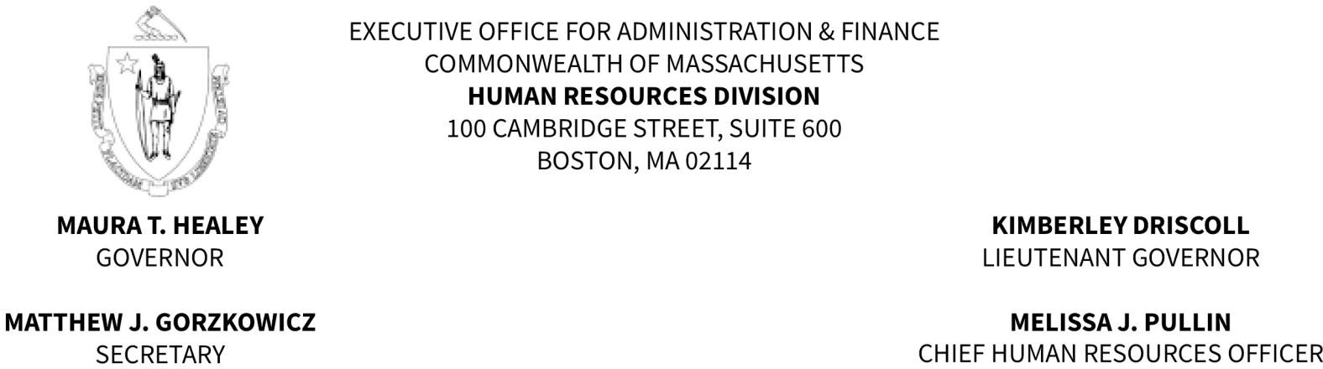

MEMORANDUM

TO: Police Department Appointing Authorities and Police Chiefs FROM: Regina Caggiano, Director of Civil Service
DATE: May 12, 2025

RE: Police Officer Eligible List Maintenance

Please be advised that the existing Police Officer eligible list is scheduled to change on June 1, 2025. The period of eligibility for those placed on the list in July 2023 will expire. Candidates who took and passed the most recent Municipal Police Officer and MBTA Transit Police Officer examination in March 2025, will be merged with those appearing on the current list with an eligible date of June 1, 2024.

Appointments made from a current eligible list will be valid if the selected individuals are under consideration from a certification issued prior to the establishment of the new list pursuant to Massachusetts General Laws, Chapter 31, § 25. Appointees from a Police Officer certification must pass a medical examination and a Physical Ability Test before their appointments can be finalized.

Pursuant to Personnel Administration Rule .08, any requisition to fill vacancies to the title of Police Officer received by the Human Resources Division, Civil Service Unit, after the issuance of this memorandum will be processed from the eligible list scheduled to be established on June 1, 2025, unless otherwise requested.

If you have any questions or concerns, please do not hesitate to contact our office.

