**Massachusetts Department of Public Health**

**Spinal Cord Injuries in Massachusetts and the Thomas P. Kennedy Spinal Cord Injury Trust Fund**

**Spinal Cord Injury Awareness Day | September 17, 2025**

Kelley Cunningham



Director, Division of Violence and Injury Prevention Bureau of Community Health and Prevention

Jeanne Hathaway Epidemiologist, Injury Surveillance Program, Bureau of Community Health and Prevention

# Hospital Stays1 for Nonfatal Spinal Cord Injuries

## By Treatment Type, Individual-level Counts, MA Residents, FFY2019-FFY20232

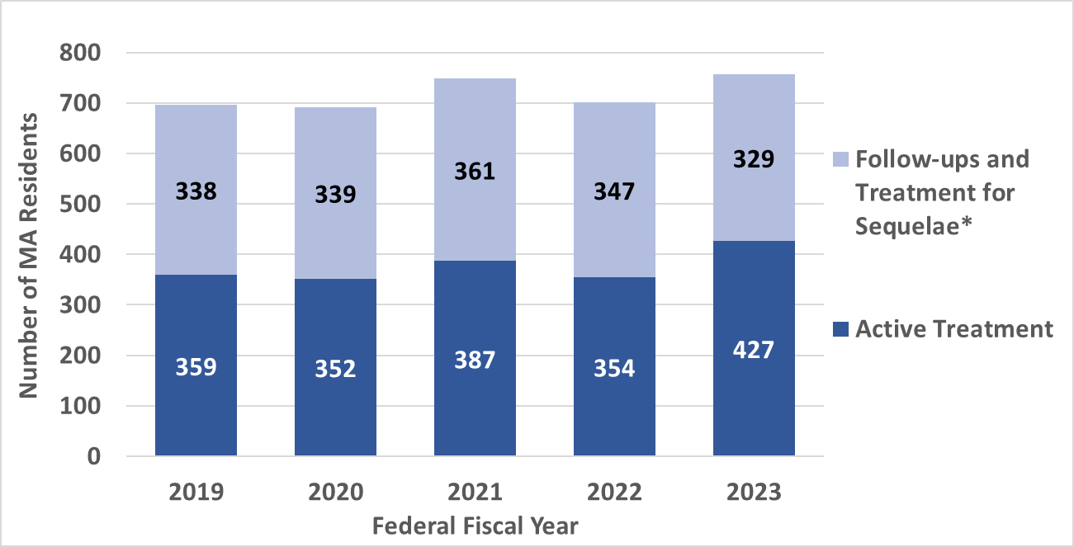

**697**

**691**

**701**

**756**

**748**

1. Hospital Stays include hospital discharges and observation stays at all MA acute care hospitals.
2. FFY = Federal fiscal year (Oct. 1 – Sep. 30).

**\*** Follow-up treatment and treatment for sequela were combined due to relatively low counts for follow-up treatments

**Data Sources:** Inpatient Hospital Discharge and Outpatient Observation Stay data, MA Center for Health Information and Analysis. Data are collected and reported by FFY.

**Analysis** : MA Department of Public Health Injury Surveillance Program.

# Emergency Department (ED) Visits for Nonfatal Spinal Cord Injuries

## By Treatment Type, Individual-level Counts, MA Residents, FFY2019-FFY20231

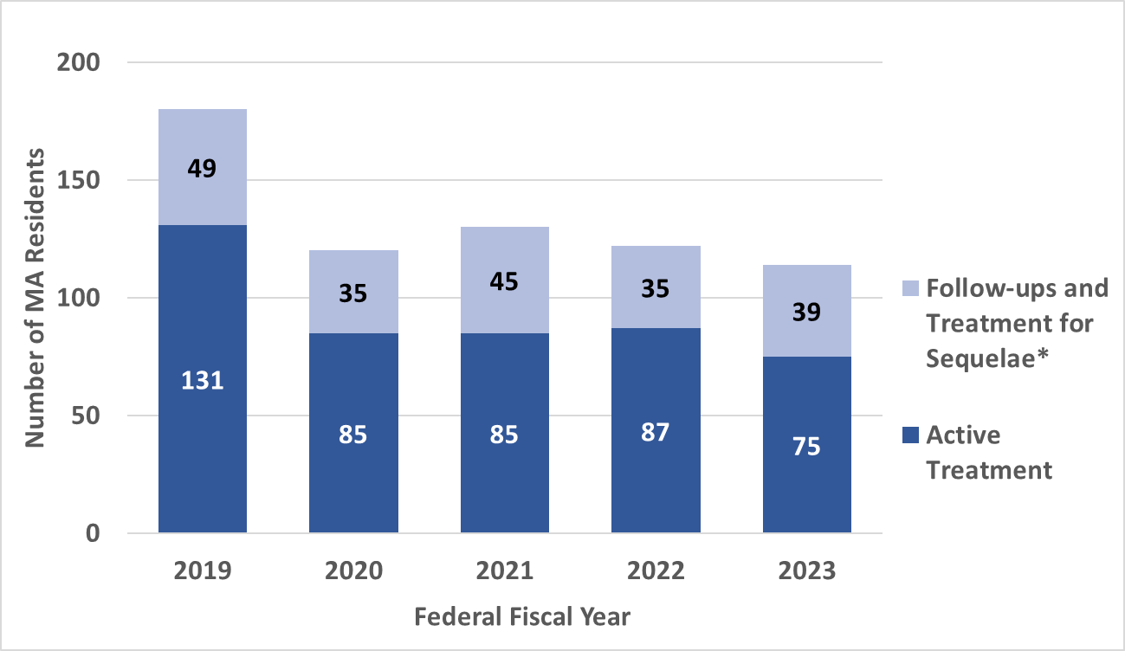

**180**

**120**

**130**

**122**

**114**

1. FFY = Federal fiscal year (Oct. 1 – Sep. 30)

**\***Follow-up treatment and treatment for sequelae were combined due to low counts for follow-up treatment.

**Data Source:** Emergency Department Discharge data, MA Center for Health Information and Analysis. Data are collected and reported by FFY.

**Analysis:** MA Department of Public Health Injury Surveillance Program.

# Highest Level of Nonfatal Spinal Cord Injury

## Combined Hospital Stays and ED Visits1, Active Treatment, Individual- Level, FFY20231 N = 492 MA Residents

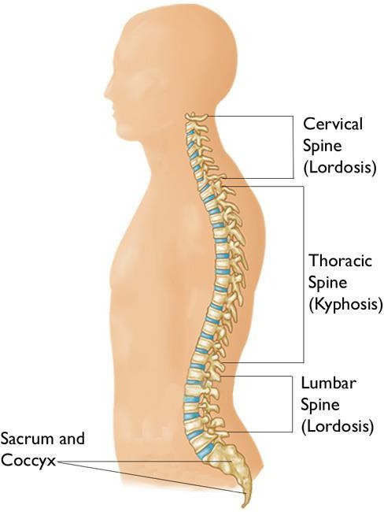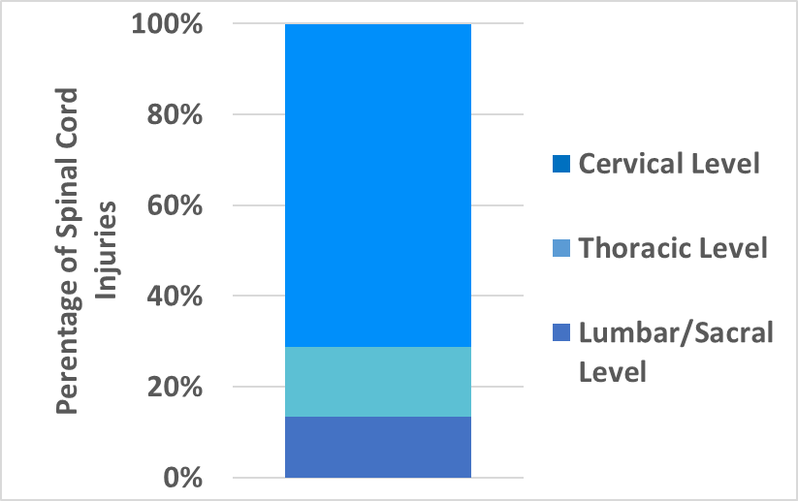

**71.1%, n=350**

**15.4%, n=76**

**13.4%, n=66**

1. FFY = Federal fiscal year (Oct. 1 – Sep. 30).

**Data Sources:** Inpatient Hospital Discharge, Outpatient Observation Stay, and ED Discharge data, MA Center for Health Information and Analysis

**Analysis:** MA Department of Public Health Injury Surveillance Program.

# Groups at Highest Risk of Nonfatal Spinal Cord Injury (SCI)

## Combined Hospital Stays and ED Visits, Active Treatment, Individual-Level, FFY20231, N=492 MA Residents

**35.0**

**SCI Rates by Sex and Age Group**

**33.0**

**25.2**

**14.2**

**8.9**

**7.6**

**5.3**

**3.8**

**1.9**

**30.0**

**Rate per 100,000 MA Residents**

**25.0**

**20.0**

**15.0**

**10.0**

**5.0**

**0.0**

**Female Male <24 25-44 45-64 65-74 75-84 85+**

**Age in Years**

1. FFY = Federal fiscal year (Oct. 1 – Sep. 30).

# Groups at Highest Risk of Nonfatal Spinal Cord Injury (SCI)

## Combined Hospital Stays and ED Visits, Active Treatment, Individual-Level, FFY20231

**N=492 MA Residents**

**14.0**

**Rate per 100,000 MA Residents**

**12.0**

**SCI Rates by Race and Ethnicity2**

**12.4**

**10.0**

**7.2**

**3.3**

**3.4**

**8.0**

**6.0**

**4.0**

**2.0**

**0.0**

**Asian, nH/nL 3**

**Hispanic White, nH/nL Black, nH/nL**

1. FFY = Federal fiscal year (Oct. 1 – Sep. 30).
2. Includes only groups where counts were 11 are greater due to confidentiality guidelines.
3. nH/nL = non-Hispanic/non-Latinx

# Leading Causes of Nonfatal Spinal Cord Injury

## Combined Hospital Stays and ED Visits, Active Treatment, Individual-Level, FFY20231 N=492 MA Residents

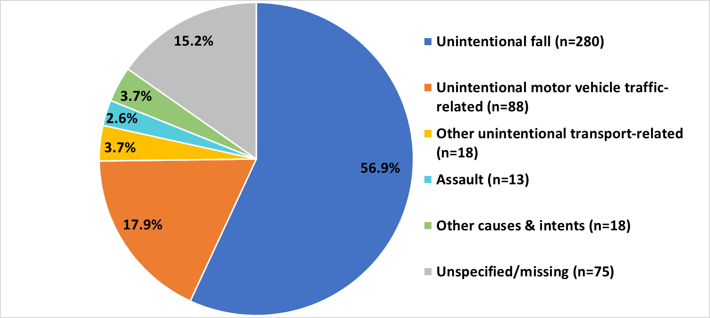

**2**

1. FFY = Federal fiscal year (Oct. 1 – Sep. 30).
2. Includes 65 motor vehicle (MV) occupants, 13 motorcyclists, fewer than 11 pedestrians, and fewer than 11 pedal cyclists.

**Data Sources:** Inpatient Hospital Discharge, Outpatient Observation Stay, and ED Discharge data, MA Center for Health Information and Analysis

**Analysis:** MA Department of Public Health Injury Surveillance Program.

# Age Differences in Nonfatal Spinal Cord Injury by Race & Ethnicity,

## Combined Hospital Stays and ED Visits, Active Treatment, Individual-Level, FFY20231 N = 492 MA Residents

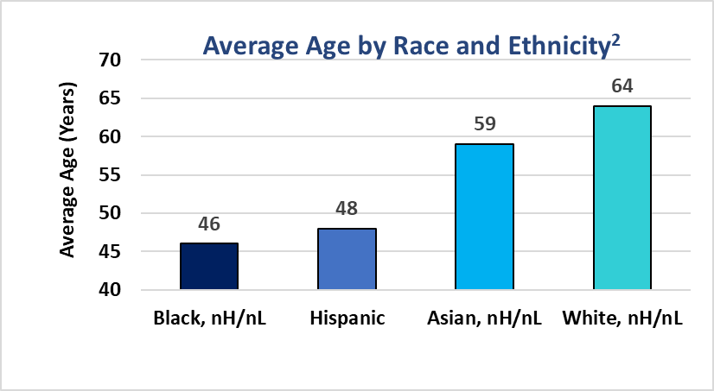

1. FFY = Federal fiscal year (Oct. 1 – Sep. 30).

* The average age of

Black, nH/nL and Hispanic residents who experienced spinal cord injury was significantly younger than that of White, nH/nL residents (46 and 48 years vs. 64 years).3

* There were no significant differences across racial and ethnic groups in terms

of sex distribution or highest level of spinal cord injury.

1. Includes only groups where counts were 11 are greater due to confidentiality guidelines. nH/nL = non-Hispanic/non-Latinx
2. Tukey post-hoc comparisons (conducted as part of an ANOVA) indicate that the mean ages of 46 (Black, nH/nL) and 48 (Hispanic) were statistically significantly

different from the mean age of 64 (White, nH/nL) (p < .0001), but no other statistically significant differences in mean ages between these four groups were found.

**Data Sources:** Inpatient Hospital Discharge, Outpatient Observation Stay, and ED Discharge data, MA Center for Health Information and Analysis

**Analysis:** MA Department of Public Health Injury Surveillance Program.

# Leading Causes of Nonfatal Spinal Cord Injury by Race & Ethnicity1,

## Combined Hospital Stays and ED Visits, Active Treatment, Individual-Level, FFY20232

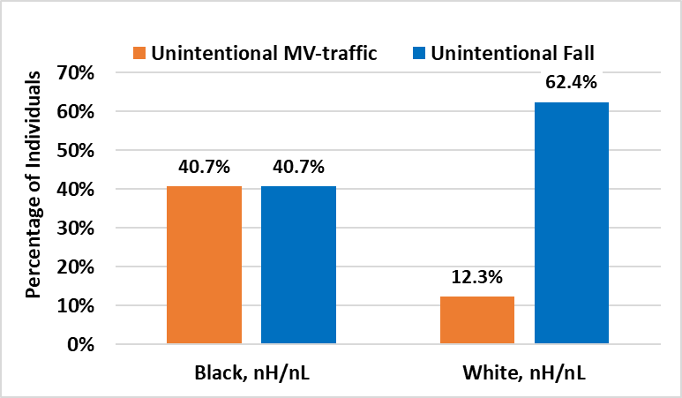**N = 492 MA Residents**

* + Among Black, nH/nL3 residents, unintentional MV-traffic crashes and unintentional falls contributed equally to nonfatal SCIs (both 40.7%).
  + Among White, nH/nL residents, nonfatal SCIs resulted more often from unintentional falls than unintentional MV-traffic crashes (62.4% vs. 12.3%).

1. Counts for other leading causes of SCI and among other race and ethnicity groups were too low to report.
2. FFY = Federal fiscal year (Oct. 1 – Sep. 30).
3. nH/nL: non-Hispanic/non-Latinx

**Data Sources:** Inpatient Hospital Discharge, Outpatient Observation Stay, and ED Discharge data, MA Center for Health Information and Analysis

**Analysis:** MA Department of Public Health Injury Surveillance Program.

# Financial Costs Associated with Spinal Cord Injury Cases:

**Hospital Charges**

## Combined Hospital Stays and ED Visits, MA Residents, FFY20231

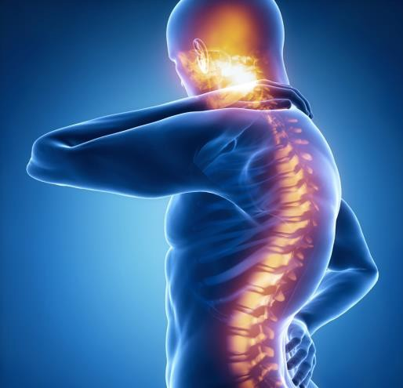**119 ED Visits2**

**976 Hospital Stays2**

**~$917,000**

**~$107 Million**

**$108 Million**

**in Hospital Charges at MA Acute Care Hospitals**

## These costs do not include those associated with rehabilitation, outpatient treatment, long-term care, lost wages, or the intangible costs of pain and suffering.

1. FFY = Federal fiscal year (Oct. 1 – Sep. 30).
2. These counts differ from those on previous slides in this presentations because they Include all SCI visits, including deaths and transfers, multiple visits for the same person, and active treatment, follow-up visits, and treatment for SCI sequelae. Some charges may be related to the treatment of other medical conditions or injuries.

**Data Sources:** Injuries - Inpatient Hospital Discharge, Outpatient Observation Stay, and ED Discharge data, MA Center for Health Information and Analysis

**Analysis:** MA Department of Public Health Injury Surveillance Program..

**Thomas P. Kennedy**

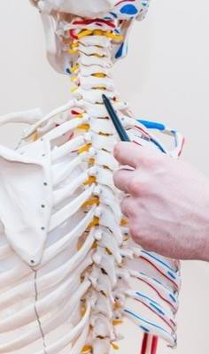

**Spinal Cord Injury Trust Fund**

To promote treatments to overcome the effects of chronic

spinal cord injury.

Revenue obtained from a $50 surcharge to persons seeking to

reinstate their driver’s licenses after suspension for multiple moving violations.

FY25 (July 1, 2024) Starting Balance: $1,162,560.26

Deposited FY25 (July 1, 2024-June 30, 2025): $782,653.00

Massachusetts Department of Public Health | mass.gov/dph 11

11

# Previous SCI Contracts: FY20-FY24

**Program to be reprocured.**

Organization

Principal

Investigator

Boston

Children's

Hospital

Zhigang He

Boston

University

Christopher

Gabel

Harvard

University

Jeffrey

Macklis

Massachusetts

General

Hospital

Andrew

Reisner

Spaulding

Rehab

Hospital

Yang (Ted)

Teng

# Future RFR

* **Keep a look out on COMMBuys for new procurement (date to be determined)** [**https://www.commbuys.com/bso/**](https://www.commbuys.com/bso/)
* **We anticipate posting sometime in 2026**
* **Interested in receiving link when the RFR is posted? Please see sheet by registration table**

**Connect with DPH**

Massachusetts Department of Public Health | mass.gov/dph

14

@MassDPH

Massachusetts Department of Public Health mass.gov/dph

**Contacts**

**Kelley Cunningham**

[**Kelley.Cunningham@mass.gov**](mailto:Kelley.Cunningham@mass.gov)

Director, Division of Violence and Injury Prevention Bureau of Community Health and Prevention Massachusetts Department of Public Health

**Jeanne Hathaway** [**Jeanne.Hathaway@mass.gov**](mailto:Jeanne.Hathaway@mass.gov)Epidemiologist, Injury Surveillance Program Bureau of Community Health and Prevention Massachusetts Department of Public Health

15

Massachusetts Department of Public Health | mass.gov/dph

15