Massachusetts Department of Public Health

2026
Massachusetts Arbovirus Surveillance and Response Plan

Bureau of Infectious Disease and Laboratory Sciences
Massachusetts Department of Public Health

Contributors* (in alphabetical order):
Catherine M. Brown, DVM, MSc, MPH
Alfred DeMaria, Jr., MD
Glen R. Gallagher, Ph.D., MLS(ASCP)CM
Matthew Osborne, MPH
Cynthia Stinson, PhD
Sandra Smole, PhD, HCLD(ABB)
Barbara G. Werner, PhD

*Includes individuals who were involved in the original development of this document or in previous drafts

TABLE OF CONTENTS

Executive Summary | 3
Introduction | 3
Disease History & Background: Eastern Equine Encephalitis Virus | 4
Disease History & Background: West Nile Virus | 5
Program Goals | 6
Agency Roles | 6
Massachusetts Department of Public Health | 6
State Reclamation and Mosquito Control Board | 6
Mosquito Control Districts | 7
Local Boards of Health | 7
Surveillance | 7
Mosquito | 7
Avian | 8
Animal | 9
Human | 9
Communication of Surveillance Information | 11
Prevention and Response | 12
Risk Assessment | 13
Risk Reduction and Prevention Guidance with Increased EEE Risk | 15
Emerging Arbovirus Issues | 18
Expanding EEE Virus Habitat | 18
Introduced Mosquito Species | 19
Introduced or Emerging Diseases | 20
Insecticide Resistance | 20
Multi- Agency Response | 22
Table 1: Guidelines for Phased Response - WNV | 24
Table 2: Guidelines for Phased Response - EEE | 27
Table 3: Guidelines for Phased Response - Aedes albopictus | 31
Figure 1: County of Residence of EEE Human Cases | 31
Figure 2: County of Residence of WNV Cases | 32
Figure 3: Location of DPH Long-term Trap Sites | 32
Figure 4: Month of Symptom Onset, Human Cases of EEE and WNV | 33
Figure 5: Location of Aedes albopictus Collections- map | 33
Appendix 1: Mosquitoes Associated with Arboviral Activity in MA | 34
Appendix 2: Recommended Cancellation Times for Outdoor  Activities in Areas of Elevated Risk for EEE | 35
References | 37

Executive Summary

The 2026 Massachusetts Department of Public Health’s (DPH) Arbovirus Surveillance and Response plan provides surveillance and phased response guidance for arthropod-borne viruses (arboviruses) affecting Massachusetts residents, eastern equine encephalitis virus (EEE) and West Nile virus (WNV) in particular. Since 2000, there have been 275 cases of WNV among Massachusetts residents, resulting in at least 17 deaths, and 47 cases of EEE resulting in at least 23 deaths. This plan reflects a comprehensive review of surveillance activities, mosquito control efforts, public information, and risk communication related to arbovirus control in Massachusetts.

The purpose of the plan is to provide guidance on operational aspects of surveillance and response by state and local agencies responsible for the prevention of mosquito-borne disease in the 2026 season. DPH will continue to seek advice from its partners and collaborators and modify the plan, as appropriate. This document is open to continual review and evaluation. Information is provided to guide planning and actions to reduce the risk of human disease from endemic arbovirus including EEE and WNV, and to respond to concerns about the introduction of Zika virus, or other emerging arboviruses, into regions of the Americas.

This plan does not address long-term, municipal planning activities. EEE and WNV are endemic diseases in Massachusetts which, although rare, are serious and likely to pose continued threats to human health. Municipalities are encouraged to consider these threats, identify contributing issues in their communities, and include mitigation activities as part of sustainable community development (e.g. source reduction, low-impact development).

Key components of the plan include:

- Monitoring trends in EEE and WNV activity in Massachusetts;
- Timely collection and dissemination of information on the distribution and intensity of EEE and WNV in the environment;
- Laboratory diagnosis of EEE and WNV cases in humans, horses, and other animals;
- Effective communication, advice, and support of activities that may reduce the risk of infection;
- Phased response to provide measures to suppress the risk of infection; and
- Monitoring for evidence of introduced and emerging arboviruses and new mosquito vector species.

This document provides information about EEE and WNV disease and program goals, and specific guidelines for mosquito, equine, and human surveillance. Additionally, this document provides guidance for the dissemination of information, including routine information, media advisories of positive EEE and WNV findings in mosquitoes, as well as public health alerts related to positive EEE and WNV human cases.

This plan describes DPH’s public outreach efforts to provide helpful and accurate communication with Massachusetts residents about their risk from arboviral diseases and specific actions that individuals and municipalities can take to reduce this risk. Routine precautions should include: avoiding outdoor activity during times of day with increased mosquito activity; use of mosquito repellents containing an EPA-approved active ingredient; and use of clothing to reduce mosquito access to skin. These personal protective measures form the basis of all risk reduction; the need to utilize them is not reduced by any mosquito control activities, including aerial spraying.

I. INTRODUCTION

The Massachusetts Department of Public Health, in collaboration with the State Reclamation and Mosquito Control Board (SRMCB) and regional Mosquito Control Districts (MCD) conducts surveillance for mosquito-borne viruses that pose a risk to human health. Surveillance currently focuses on West Nile and eastern equine encephalitis viruses, which are found in the local environment and can cause serious illness and death in humans, horses, and other mammals.

The 2026 Massachusetts Surveillance and Response Plan for mosquito-borne diseases is based on a comprehensive plan initially developed for WNV in 2001 in collaboration with local health agencies, other state agencies, academic institutions, the Centers for Disease Control and Prevention (CDC), and interested groups and individuals. It incorporates components of the state’s EEE surveillance activities, which began in the 1950s and have continued since that time. Monitoring for WNV began following a 1999 outbreak of human WNV disease in the New York City area, the first known occurrence of this disease in North America. WNV was identified in birds and mosquitoes in Massachusetts during the summer of 2000, in humans in 2001, and has been detected during each consecutive season.

To address the complexity and seriousness of the human disease risk posed by EEE, DPH convened a panel of experts in 2011-2012 who represented the fields of ecology, biology, public health, infectious disease, and toxicology to review DPH’s surveillance and response program and make recommendations for enhancing the program. Those recommendations were incorporated into the plan in 2012 and continue to serve as important components of the current plan.

Following the 2019 season, DPH conducted an extensive after-action evaluation and review, which included gathering input from state agencies involved in the response, vendors contracted for response, local Boards of Health, municipal officials, mosquito biology and control experts, organic farmers, beekeepers, environmental groups, and the public. The updated 2020 plan was a result of analyses of surveillance data and an updated literature review and incorporates comments from stakeholders and the experiential knowledge of subject matter experts involved in arbovirus response in Massachusetts. The 2026 plan includes all of the updates made in 2020. The purpose of the plan is to guide operational aspects of surveillance and response by state and local agencies with responsibilities for the prevention of mosquito-borne disease. DPH continues to seek advice from its partners and collaborators to modify the plan, as appropriate. This document is open to continual review and evaluation, with changes made when there is an opportunity for improvement.

II. DISEASE HISTORY AND BACKGROUND

A. Eastern Equine Encephalitis Virus

1. Background
Eastern equine encephalitis is a serious disease that occurs sporadically in Massachusetts, with 30-50% mortality and lifelong neurological disability among many survivors. The first symptoms of EEE are fever (often 103º to106ºF), stiff neck, headache, and lack of energy. These symptoms emerge three to ten days after a bite from an infected mosquito. Inflammation and swelling of the brain, called encephalitis, is the most dangerous and frequent serious complication. The disease rapidly worsens and some patients may go into a coma within a week. There is no treatment for EEE. In Massachusetts, approximately half of the people identified with EEE have died from the infection. People who survive this disease will often be permanently disabled due to neurologic damage. Few people recover completely.

There have been 47 cases of EEE in Massachusetts residents between 2000-2025; 23 (49%) of those have resulted in death. Demographic information about cases and deaths from EEE that have occurred since 2000 are included below.

 |  | Cases (n=47) | Deaths (n=23)
Sex (male) |  | 60% | 65%
Median age in years (range) |  | 63 years (<1 to 90) | 65 years (<1 to 85)
Residence in Bristol or Plymouth Counties |  | 49% | 49%
Median time from symptom onset to death in days (range) |  |  | 15 days (2 – 4257)

Historically, clusters of human cases have occurred over a period of two to three years, with a variable number of years between clusters. In the years between these case clusters or outbreaks, isolated cases can and do occur. Outbreaks of human EEE disease in Massachusetts occurred in 1938-39, 1955-56, 1972-74, 1982-84, 1990-92, 2004-06, 2010-2012, 2019-2020, and 2024.

Massachusetts Eastern Equine Encephalitis Experience
Year(s) | Human EEE Cases | Human EEE Deaths
1938-39 | 35 | 25
1955-56 | 16 | 9
1973-74 | 6 | 4
1982-84 | 10 | 3
1990-92 | 4 | 1
2000-01 | 2 | 0
2004-06 | 13 | 8
2008 | 1 | 1
2010-12 | 9 (plus 2 non-residents) | 5
2013 | 1 | 1
2019-2020 | 17 | 7
2024 | 4 | 1

The U.S. Public Health Service, in collaboration with DPH, initiated a field surveillance program in 1957 following a 1955-56 outbreak of EEE. The purpose of the program was to gather data to guide prevention and risk reduction for this disease. This program formed the basis for the Commonwealth’s current arbovirus program.

2. Risk Factors for Disease Transmission
Eastern equine encephalitis virus is a virus in the genus Alphavirus that is native to the Massachusetts environment (enzootic) and is naturally found in some passerine (perching) bird species living in and around fresh-water swamp habitats. Although infection with EEE virus can kill some birds, the virus does not kill large proportions of these species. These habitats also support populations of the primary mosquito vector, Culiseta melanura, which feeds predominantly on birds. The swamp habitats, which support large populations of Cs. melanura and are the initial source of EEE, are known as enzootic foci. Although portions of the ecology of EEE virus have yet to be clarified, the virus has a cycle of natural infection among bird populations with occasional ‘‘incidental” symptomatic infections in susceptible species, including humans. The appearance of EEE in late June or early July coincides with the hatching of highly susceptible bird populations. The virus is circulated among the bird populations by Cs. melanura and under some circumstances Cs. morsitans, another bird-biting mosquito. Initially, a relatively smaller proportion of birds and mosquitoes carry the virus; throughout the mosquito season, continuous transmission between mosquito vectors and bird reservoir hosts increases the proportion of infected birds and mosquitoes leading to an overall greater amount of virus present in the environment. This is called the virus amplification cycle. Depending on when virus circulation begins, the size of the Culiseta populations, weather conditions, and probably additional, currently unidentified factors, this virus amplification cycle may eventually spill over and involve secondary, or "bridge", mosquito vectors that feed on both birds and mammals. In the Northeast, these bridge vectors are mosquito species, such as Aedes vexans, Coquillettidia perturbans, Culex salinarius and Ochlerotatus (formerly Aedes) canadensis. These bridge vectors, of which Cq. perturbans is considered to be the most important in Massachusetts, are presumed to be responsible for the transfer of EEE to incidental hosts, including mammals such as humans, horses, llamas, and alpacas; and large birds such as emus and ostriches. For the purposes of risk assessment and communication with the public, Cs. melanura is considered to be and will be reported as a “bird-biter” while Cq. perturbans, Oc. canadensis, and Ae. vexans are considered to be and will be reported as “mammal-biters”. Culex pipiens and Culex restuans mosquitoes found positive for EEE are not considered to play a significant role in transmission of the virus to humans or animals and are considered to be, and will be reported as, bird-biters.

In the Northeast, the EEE enzootic foci are large hardwood swamps of mature white cedars and red maples. To grow in the permanently wet swamps, tree roots spread out across the peat soils characteristic of these habitats. These root systems create dark holes, or crypts, that are generally filled with water. These crypts are the preferred ovipositing (egg-laying) sites for Cs. melanura and are where the larvae develop. Cs. melanura survives the winter as larvae in these crypts. The amount of rainfall occurring during the summer and fall of the preceding year affects the survival of the larvae during the winter and, in part, determines the population of adult mosquitoes the following year.

The risk of EEE in humans varies by geographical area in Massachusetts, as well as in the United States, and is correlated with the location of the necessary swamp habitats. In Massachusetts, these areas occur across the state, but are most common in southeastern Massachusetts. The majority of EEE cases have occurred in Norfolk, Bristol, and Plymouth counties, with some cases also occurring in Essex, Hampden, Middlesex, and Worcester Counties (Figure 1). While few EEE cases have occurred in the western two-thirds of Massachusetts, case counts in this area are growing. Historically, Barnstable County and the Islands of Martha’s Vineyard and Nantucket have not had human cases of EEE. 2012 was unusual in that five of seven human cases and four of seven animal cases resided outside southeastern Massachusetts. 2019 – 2020 and 2024 also followed this trend with 14 of 20 human cases and seven of nine animal cases residing outside of southeastern Massachusetts. The occurrence of so much activity outside of the area of historical risk requires additional information to understand the full significance. Strategic mosquito surveillance activities outside of southeastern Massachusetts have been ongoing and are planned for 2026 for communities in Central, Northern, and Western Massachusetts.

Currently, it is impossible to predict, with complete accuracy, the appearance of EEE and the probability of human EEE infection in any given year although during outbreaks, clusters of human cases occur over a period of two to three years. However, over 50 years of surveillance for EEE in Massachusetts has enabled the development of a mosquito-based EEE surveillance system and the identification of several factors that help provide an estimate of human risk. These estimates are used to alert the residents of the state and guide mosquito control activities. Risk estimates are based on the current level of EEE activity in both bird-biting and mammal-biting mosquito species mosquito infection rates, population levels of these species, seasonal timing of virus identification in these species, recent and historic levels of EEE activity, and prevailing weather conditions.

Human cases are more likely when multiple factors indicate that risk is increasing in a given place at a given time. Identification of EEE in the enzootic mosquito vector, Cs. melanura, is useful for determining areas of virus amplification and as a proxy measure of the amount of EEE virus in the environment. The presence or absence of EEE virus in the environment correlates with the presence/absence of the primary mosquito vector, Cs. melanura. In years when EEE virus is present, abundant populations of this species provide greater opportunity for the virus to perpetuate or amplify within the bird population. Theoretically, the more virus that is circulating between mosquitoes and birds, the more likely it will be to be picked up by a bridge vector mosquito and transmitted to humans. Identification of EEE in bridge vector mosquito species confirms the presence of EEE virus in a species known to feed on humans. The more virus that is in bridge vector species, the greater the chance that a person will be exposed to the virus. Warm temperatures increase the rate of both mosquito development and virus replication within mosquitoes. Consistently elevated temperatures increase mosquito populations of all species, speed up virus multiplication within mosquitoes, and therefore act to increase the amount of virus in the environment overall.

Other factors that affect the risk of EEE infection for humans include the abundance of the primary mosquito vector species and key bridge vector species at critical periods of the transmission season, groundwater levels, and the timing of rainfall and flooding during the mosquito season. Long-term weather patterns during the fall and winter that produce high ground water levels and snow cover, or warmer than average winter conditions coupled with steady precipitation, may enhance over-wintering survival of Cs. melanura larvae. The abundance of these larval populations may serve as an early indicator of the potential for human disease later in the year, although large Cs. melanura populations in the absence of EEE virus and without corresponding populations of bridge vector species are insufficient to drive EEE outbreaks.

Multiple factors affect the development, survival, and abundance of mosquitoes. It is not currently possible to accurately forecast either the abundance of mosquitoes or the risks for encountering an infected vector later in the season. Risk assessment relies upon a robust mosquito surveillance system to monitor both mosquito populations and virus amplification as the season progresses.

B. West Nile Virus

1. Background
West Nile virus (WNV) first appeared in the United States in 1999. Since the initial outbreak in New York City, the virus has spread across the US from east to west. Following the identification of WNV in birds and mosquitoes in Massachusetts during the summer of 2000, DPH arranged meetings between local, state, and federal officials, academicians, environmentalists and the public to develop recommendations to adapt the arbovirus surveillance and response plan to include activities appropriate for WNV. Four workgroups addressed the issues of surveillance, risk reduction interventions, pesticide toxicity, and communication.

WNV infection may be asymptomatic in some people, but it leads to morbidity and mortality in others. WNV causes sporadic disease of humans, and occasionally significant outbreaks. Nationally, 2,076 human cases of WNV neuroinvasive disease (meningitis and encephalitis) and WNV fever were reported to the CDC in 2025. The majority of people who are infected with WNV (approximately 80%) will have no symptoms. A smaller proportion of people who become infected (~ 20%) will have symptoms such as fever, headache, body aches, nausea, vomiting, and sometimes swollen lymph glands. They may also develop a skin rash on the chest, stomach, and back. Less than 1% of people infected with WNV will develop severe illness, such as encephalitis or meningitis. The symptoms of severe illness can include high fever, headache, neck stiffness, stupor, disorientation, coma, tremors, convulsions, muscle weakness, vision loss, numbness, and paralysis. Persons older than 50 years of age have a higher risk of developing severe illness. In Massachusetts, there were at least 17 fatal WNV human cases identified between 2002 and 2025. More than half (52%) of these fatalities were in individuals 80 years of age or older; all of them were in individuals over 60.

2. Risk Factors for Disease Transmission
West Nile virus is amplified by a cycle of continuous transmission between mosquito vectors and bird reservoir hosts. Infected mosquitoes carry virus and transmit it to susceptible bird species. WNV infection can be fatal in some species of birds, particularly American crows and blue jays (corvids), and some species of hawks and owls (raptors). Confirmation of WNV in dead birds historically provided sentinel information used for assessing the risk of human WNV infections. However, the proportion of susceptible birds has decreased over time so that testing dead birds for the presence of virus is no longer considered an efficient surveillance tool in Massachusetts.

The principal mosquito vectors for West Nile virus on the East Coast are members of the genus Culex, primarily Cx. pipiens and Cx. restuans. These species may be abundant in urban areas, breeding easily in artificial containers, such as birdbaths, discarded tires, buckets, clogged gutters, catch basins, and other standing water sources. Both species feed mainly on birds and occasionally on mammals, including humans. Peak feeding activity for these species occurs from dusk into the late evening. Consistently high temperatures and lower precipitation rates are factors that have been associated with higher mosquito infection and human illness rates. Additionally, warmer winter temperature conditions may result in larger numbers of Culex species overwintering as adults, with resulting increases in early season Culex abundance.

There are additional mosquito species in Massachusetts that can be involved in the transmission of WNV to humans. Culex salinarius lives in brackish and freshwater wetlands and feeds on amphibians, birds, and mammals; it is well known for biting humans. Ochlerotatus japonicus may be involved in the transmission of both WNV and EEE. This species utilizes natural and artificial containers, such as tires and rock pools as larval habitat. It feeds mainly on mammals and is an aggressive human biter. Unlike EEE, distinguishing between bird- and mammal-biting species of mosquitoes is of less importance for risk assessment purposes and these designations are not routinely used.

West Nile virus activity varies from year to year. When large numbers of infected birds and elevated mosquito populations occur in a relatively small geographic area, the result is a high mosquito infection rate and an increased risk of transmission of virus to humans. In addition, there is evidence that when meteorologic conditions are such that Cx. pipiens populations are increased relative to Cx. restuans, the risk of transmission to humans may be increased. Surveillance evidence indicates that WNV is established in the United States and that virus activity is likely to occur annually.

Most municipalities in Massachusetts will only have sporadic human cases of WNV and are unlikely to have more than one per year. However, several highly urbanized areas in Massachusetts have accounted for over 80% of the human WNV infections between 2001 and 2025 (Figure 2).

During the season, information is provided daily with current surveillance information and risk assessments which can be found through the same site.

III. PROGRAM GOALS

Timely and accurate information based on surveillance information is used to provide an estimate of the level of risk for human disease from EEE and WNV. Based on this surveillance information, plans and actions to reduce risk can be developed and implemented when needed. Program activities include:

- Standardized and routine trapping of mosquito species that contribute to EEE and WNV activity;
  - Testing subsets of trapped mosquitoes to detect the presence of EEE and WNV;
  - Estimating relative abundance of populations of these mosquito species;
  - Estimating viral infection rates in mosquitoes;
- Conducting surveillance for human and animal disease including testing horses, other appropriate animals, and humans to identify EEE and WNV infections;
- Tracking trends in incidence and prevalence of EEE and WNV infections by geographic area;
- Stratifying risk of human disease by geography; educating human and animal medical practitioners on the appropriate procedures for detecting infections and disease caused by mosquito-borne viruses;
- Recommending measures to reduce virus transmission and disease risk;
- Educating the public on mosquito-borne diseases and disease risk and common-sense precautions to reduce the risk of infection;
- Conducting surveillance to detect emerging arboviruses, such as Jamestown Canyon virus, and arbovirus infections in travelers to areas with transmission of non-native arboviruses, such as dengue, chikungunya and Zika viruses;
- Conducting surveillance to detect the introduction, establishment and geographic spread of new mosquito vector species including Aedes aegypti, and Aedes albopictus;
- Participating in the national Arbovirus Surveillance Network.

IV. Agency Roles

Massachusetts Department of Public Health (DPH)

The central purpose of arbovirus surveillance is to provide information that will guide prevention education, planning and activities to reduce the risk of human disease from EEE and WNV infection. To achieve this, the main objectives are to monitor trends in EEE and WNV in Massachusetts; provide timely information on the distribution and intensity of EEE and WNV activity in the environment; perform laboratory diagnosis of EEE and WNV cases in humans, horses and other animals; communicate effectively with officials and the public; provide guidelines, advice, and support on activities that effectively reduce risk for disease; and provide information on the safety, anticipated benefits, and potential adverse effects of proposed prevention interventions. The arbovirus surveillance program should also have the capacity to respond to concerns about the potential for introduction of travel-associated diseases, like Zika virus, by monitoring for evidence of introduced and emerging arboviruses and new mosquito vector species.

B. State Reclamation and Mosquito Control Board (SRMCB)

The SRMCB oversees mosquito control programs and activities in the Commonwealth of Massachusetts. The SRMCB consists of three members representing the Department of Agricultural Resources (MDAR), Department of Conservation and Recreation (DCR), and Department of Environmental Protection (DEP). Additionally, the SRMCB advises its respective state agency Commissioners on actions to reduce mosquito populations based on DPH findings and characterization of risk.

The SRMCB works cooperatively with DPH, regional Mosquito Control Districts, local Boards of Health and other agencies to collectively identify and support the use of safe and effective mosquito control measures based on integrated pest management (IPM) principles. The use of pesticides as a means to reduce human risk is one of several methods used as part of an overall strategy.

The SRMCB’s ‘Operational Response Plan to Reduce the Risk of Mosquito-Borne Disease in Massachusetts’ addresses the issues related to the operational aspects of adult mosquito surveillance and control to prevent and/or reduce the risk of mosquito-borne diseases. The plan may be accessed online from Massachusetts Emergency Operations Response Plan for Mosquito-Borne Illness | Mass.gov.

In 2006, the SRMCB created the Mosquito Advisory Group (MAG) to provide independent, scientific advice to the SRMCB regarding the justification, timing, location and options for intervention tactics to prevent, suppress, or contain infected mosquito populations that may otherwise result in an outbreak of disease in people and animals. The MAG has been involved in all decisions to recommend aerial spray interventions since 2006. MDAR and DPH meet with the MAG at the beginning of each season, regularly throughout any season with activity, and as needed to seek advice on any emergent situations.

C. Mosquito Control Districts (MCDs)

There are 11 organized Mosquito Control Districts or Projects (MCDs) located throughout Massachusetts. All the mosquito control activities of these agencies are performed under the aegis of the SRMCB. MCDs collaborate with local boards of health in their jurisdictions to perform public education, promote the use of personal protection and to control mosquitoes. Locally authorized mosquito control efforts employ a variety of targeted activities for source reduction, larviciding and adulticiding that are in compliance with the SRMCB Operational Response plan. Additional details relating to MCDs may be found within the SRMCB Operational Plan and online at:
State Reclamation and Mosquito Control Board (SRMCB) | Mass.gov and
Massachusetts Emergency Operations Response Plan for Mosquito-Borne Illness | Mass.gov.

D. Local Boards of Health (LBOHs)

LBOHs are the local health authorities and the primary points of contact within a municipality for DPH. Surveillance information is communicated to the LBOH who may work with their MCD (if any) to determine mosquito control response activities, conduct educational outreach via the media and/or other means, investigate cases, disseminate surveillance and risk assessment information to other municipal leaders, and undertake other activities based on their needs.

V. SURVEILLANCE

A. Mosquito Surveillance

Mosquito surveillance activities are the foundation of all arbovirus risk assessment and inform appropriate response. Surveillance of certain species of mosquitoes for arboviruses is a core function of DPH and the MCDs. Although there are at least 52 species of mosquitoes found in Massachusetts, only species involved in the spread of EEE and WNV are tested for surveillance purposes. Monitoring mosquitoes for the presence of virus provides information to estimate risk to humans. Massachusetts has a long-term field surveillance program in Bristol and Plymouth counties that was initiated in 1957 for EEE and was enhanced in 2000 to include WNV surveillance. The extensive experience in Massachusetts with surveillance for mosquito-borne disease provides expertise and capacity to guide risk reduction efforts. DPH uses a comprehensive and flexible strategy that modifies certain surveillance activities in response to trends in disease risk. However, limitations exist.

With evidence of geographic expansion of EEE activity, it continues to be a challenge that 40% of municipalities, primarily in Central and Western MA, are not currently members of established MCDs. This presents significant gaps in the surveillance system, making evidence-based risk assessment in those areas difficult. The DPH Arbovirus Program conducts trapping in these areas, prioritizing those that have experienced arbovirus activity (especially EEE) in the past and those with evidence of current activity as indicated by animal or human cases. The establishment of MCDs in these areas would increase knowledge of local habitat likely to produce vector species of mosquitoes and allow for routine data collection throughout the season over a period of years which would greatly enhance the precision of risk assessment in these municipalities.

On an ongoing basis, DPH monitors national and regional surveillance data and current scientific literature to assess risk of newly emerging arboviruses in Massachusetts. In addition, a defined subset of mosquitoes will be tested for the presence of new or emerging viruses using tissue culture methods.

1. Fixed and Long-Term Trap Sites

DPH field staff trap mosquitoes at long-term sites maintained primarily in the EEE high-risk areas of southeastern and eastern Massachusetts (Figure 3) and from other areas as circumstances demand and resources allow. For 2026, DPH will continue extended routine EEE monitoring into areas of Central and Western Massachusetts not currently covered by active MCDs and that have recently produced EEE activity. Trapping of gravid (egg-bearing) mosquitoes for WNV testing is conducted both by MCDs and DPH field staff at various locations throughout the state during the arbovirus season. After trapping, all collected mosquitoes are sorted into groups by species and manually counted. At the Massachusetts State Public Health Laboratory (MA SPHL), these samples are sorted by species and grouped, or pooled, into sets of 10-50 mosquitoes for EEE and WNV testing. These are frequently referred to as “mosquito pools” which indicates the grouping of mosquitoes for testing purposes and is not a reference to any body of water. Test results from routine mosquito collections are usually available within 24 hours after delivery of mosquitoes to the MA SPHL. Routine collections from fixed and long-term trap sites provide the best available baseline information for detecting trends in mosquito abundance and virus prevalence, and for estimating the relative risk for human infection from EEE virus and WNV. DPH field staff monitor larvae from select sites in late fall and early spring to determine end-season and pre-season larval abundance. Informal monitoring of larval abundance from these sites continues on a weekly basis during the arbovirus season.

2. Supplemental Trap Sites
When EEE or WNV activity is detected in an area, additional trap sites and/or trap types are used to obtain more information regarding the intensity of virus activity in mosquitoes in that area. Risk indicators that may result in the implementation of more intensive mosquito trapping include: 1) virus isolations in mosquitoes; 2) emergence of large numbers of human-biting mosquitoes in an area with a high rate of virus activity and 3) identification of human or animal cases.

3. Mosquito Control District Trap Sites
MCDs use a variety of available control strategies to impact mosquito abundance. Monitoring mosquito abundance is accomplished through various surveillance methods including but not limited to larval dip counts and the use of CO₂ baited light traps and gravid traps.

4. Results
Results of mosquito trapping and testing provide information on:
- The numbers of positive mosquito samples (mosquito pools) from a municipality;
- General measures of mosquito populations; and
- Relative EEE infection rates in mosquito populations.

B. Avian Surveillance

DPH discontinued avian surveillance for WNV as of April 2009. When the virus was first introduced into the United States, WNV caused high mortality rates in certain species of birds, particularly corvids, thus reporting and testing of dead birds was a productive way to detect and monitor WNV activity in an area. However, in recent years, the tracking and testing of dead birds has become significantly less useful as a surveillance tool. Monitoring mosquitoes for presence of virus is the primary predictive indicator of human arbovirus disease risk. Therefore, the routine laboratory testing of dead wild birds for West Nile virus (WNV) has been eliminated. This is consistent with recent policy changes in multiple states.

Most birds that are infected with EEE virus survive the viremia, making individual dead bird EEE monitoring impractical. Non-native bird species such as emus, ostriches, and exotic game birds are highly susceptible to EEE and infections within farmed flocks and collections in zoos have occurred in Massachusetts. Testing of highly suspect bird specimens for EEE and/or WNV infection is done on an as-needed basis as determined by DPH.

C. Animal Surveillance

Specimens from horses and other domestic animals that have severe neurological disease suspected of being caused by EEE or WNV infection are tested at the MA SPHL. Testing can take up to several weeks to complete depending upon the type of sample submitted and the testing protocol required to obtain a definitive result. Veterinarians, MDAR, the United States Department of Agriculture (USDA) and Tufts University Cummings School of Veterinary Medicine collaborate with DPH to identify and report suspect animal cases. In addition, blood and/or tissue samples from animals from other sources, such as zoos, horse stables, or the wild are tested, as appropriate. Current information on EEE and WNV infections in horses, along with clinical specimen submission procedures, are disseminated to large animal veterinarians, stable owners, and others through various distribution methods and are posted on the DPH arbovirus website at Mosquito-borne Diseases | Mass.gov. Horses and other animals can be immunized against infection with EEE and WNV with available veterinary vaccines. Vaccination is the primary means of preventing infection in animals.

Due to the time delay inherent in specimen acquisition and testing, specimens from animal with an illness compatible with either EEE and WNV infection that test positive on the screening test will be reported as a preliminary result to the ordering veterinarian, the local board of health in the town of the animal’s residence, the local board of health in the likely city/town of exposure (if different from place of residence), and the local mosquito control project, if there is one. This information may be used to inform clinical decisions first and foremost, and secondarily to inform planning for public health and mosquito control activities. This animal will not be considered to represent a confirmed case until testing is completed; appropriate changes to risk levels will be made following confirmatory testing.

D. Human Surveillance

1. Routine surveillance
Specimens from human cases of encephalitis and meningoencephalitis shall be submitted to the MA SPHL for EEE and WNV testing in accordance with 105 CMR 300.172. Testing for both viruses usually consists of a preliminary screening test (an enzyme immunoassay (EIA) for antibody to the viruses), followed by confirmatory testing by plaque reduction neutralization test (PRNT) for specific antibody. Certain specimens, cerebrospinal fluid (CSF) drawn shortly after symptom onset, may be tested by polymerase chain reaction (PCR). Generally, only specimens that meet confirmatory criteria through testing at the MA SPHL are considered to represent true cases and will be used for risk assessment. Increasing availability of commercial laboratory testing for WNV has diverted submission of samples away from the MA SPHL. Current commercially available testing is equivalent to the screening test that DPH runs but does not extend to the confirmatory testing capability available at the MA SPHL. Not all specimens reported to be positive based on commercial laboratory testing will confirm with the more specific confirmatory testing that is performed by the MA SPHL. Specimens from any individual reported to be positive based on commercial laboratory testing may be requested for additional testing. The table below shows the most common test and sample types with their associated interpretations. Please note that test results must always be interpreted in conjunction with clinical information about the patient and their exposure histories.
Testing Laboratory: MA SPHL
Specimen Type | Test Type | Result | Interpretation
Serum | IgM - EIA | Negative | No evidence of current infection
Serum | IgM - EIA | Positive | May represent current infection, PRNT testing required
Serum | IgM - EIA | Inconclusive | Results not definitive, repeat testing and/or perform PRNT testing or send to CDC for additional testing
Serum | PRNT | Negative | No evidence of current infection
Serum | PRNT | Positive | Confirmed infection if combined with positive IgM - EIA
CSF | IgM - EIA | Negative | No evidence of current infection
CSF | IgM - EIA | Positive | Confirmed infection
CSF | IgM - EIA | Inconclusive | Results not definitive, repeat test or send to CDC for additional testing
CSF | PCR | Negative | No evidence of current infection; consider IgM -EIA test on same or follow-up specimen
CSF | PCR | Positive | Confirmed infection

Testing Laboratory: Other non-public health laboratory
Specimen Type | Test Type | Result | Interpretation
Serum | IgM - EIA | Negative | No evidence of current infection
Serum | IgM - EIA | Positive | May represent infection, PRNT testing required, forward to MA SPHL for remainder of testing
Serum | IgG - EIA | Positive | Evidence of previous infection, not a current case
Serum | PCR | Negative | No evidence of current infection; consider IgM -EIA test on same or follow-up specimen
Serum | PCR | Positive | Confirmed infection
CSF | IgM - EIA | Negative | No evidence of current infection
CSF | IgM - EIA | Positive | May be considered to be a confirmed current infection depending on laboratory performing test, OR may require PRNT testing, forward to MA SPHL for remainder of testing
CSF | PCR | Negative | No evidence of current infection; consider IgM -EIA test on same or follow-up specimen
CSF | PCR | Positive | Confirmed infection

Testing may take several weeks to complete dependent upon the type of sample submitted, whether the sample was sent to a commercial or public health laboratory, and the testing protocol necessary to obtain a definitive result. Under certain circumstances, definitive results cannot be obtained by the MA SPHL and samples are forwarded to the Centers for Disease Control and Prevention (CDC) for additional testing. Time to receipt of final results is variable. Current information on EEE and WNV infections in humans, along with clinical specimen submission procedures, are disseminated to physicians (infectious disease, emergency medicine and primary care), emergency department directors, hospital infection control practitioners, and local boards of health through various distribution methods and are posted on the DPH arbovirus website at Mosquito-borne Diseases | Mass.gov.

Due to the time delay inherent in specimen acquisition and testing, specimens from patients with an illness compatible with either EEE and WNV infection that test positive on the screening test will be reported as a preliminary result to the ordering provider, the local board of health in the town of the patient’s residence, the local board of health in the likely city/town of exposure (if different from place of residence), and the local mosquito control project, if there is one. This information may be used to inform clinical decisions first and foremost, and secondarily to inform planning for public health and mosquito control activities. These patients will not be considered to represent confirmed cases until testing is completed; appropriate changes to risk levels will be made following confirmatory testing. Samples reported to be preliminarily positive from blood donor screening programs will also be reported to the local board of health and the mosquito control project, if there is one, for similar reasons.

Because antibodies to WNV can persist for months, a positive laboratory test alone does not necessarily indicate evidence of current infection. Laboratory data must be correlated with clinical information and exposure risk in order to identify current, confirmed cases for the purposes of surveillance. The frequency of positive laboratory tests from individuals who otherwise do not appear to represent true, current instances of infection will be highest immediately following very active years, such as occurred in 2018.

2. Active surveillance
If surveillance data estimate a high risk of human disease, active surveillance may be instituted in targeted areas. Active surveillance involves regularly contacting local health care facilities to communicate current surveillance information, promoting disease prevention strategies, reviewing specimen submission procedures, and highlighting the need for testing patients presenting with signs and symptoms possibly representing infection with EEE or WNV.

3. Pesticide related surveillance
Outreach on pesticide illness reporting is coordinated by the DPH’s Bureau of Climate and Environmental Health.

VI. Communication of Information

A. Prior to the Arbovirus Season

Local boards of health (LBOH) are asked to provide routine and emergency contact information for primary and secondary arbovirus contacts during the season. These individuals, referred to as Arbovirus Coordinators, are DPH’s first and primary point of contact with regard to arbovirus season information. It is the responsibility of the municipality’s Arbovirus Coordinators to ensure that information is shared routinely with others in the municipality as appropriate. Although routine surveillance specimen notifications are scheduled during normal business hours, test results sometimes become available after hours and at least one of the Arbovirus Coordinators must be available at all times, 24/7, throughout the arbovirus season.

General information and fact sheets are available publicly on the DPH arbovirus website and are provided to local boards of health.

B. During the Arbovirus Season

Communication to Local Boards of Health occurs through multiple mechanisms. Routine communications and initial communication about any findings primarily occur through the HHAN to the identified Arbovirus Coordinators. Important summary communications (such as weekly reports) are also sent out through the DPH Office of Local and Regional Health (OLRH) listserv. Urgent communications impacting multiple municipalities may be sent through the HHAN to Arbovirus Coordinators, other local Board of Health members and the OLRH listserv. Although this may result in duplicate messages to some people, it serves to distribute important messages most widely. The DPH OLRH and the Office of Preparedness and Emergency Management (OPEM) Regional Public Health Preparedness Coordinator offer assistance with local response and assist with communication. MDPH recommends that all LBOH Arbovirus Coordinators, primary and secondary, set their HHAN preferences to receive messages through text at a minimum. Options to receive as an email and/or a telephone call are also available.

The initial identification of WNV virus in mosquitoes of the season is reported to the LBOH Arbovirus Coordinator and MCD by telephone. Following the first evidence of WNV in mosquitoes in the state, city/towns will not be notified by telephone of their first positives but will be sent a HHAN message with a number to call for more information. All initial identifications of EEE virus in mosquitoes from any city/town are reported to the LBOH Arbovirus Coordinator and MCD by telephone.

The remainder of notifications about positive mosquito results are identical whether the results are for WNV or EEE viruses. Adjacent town Arbovirus Coordinators are notified via a moderate level HHAN alert. In order to encourage risk communication on a larger area level rather than a city/town level, all subsequent positive findings in mosquitoes are reported once daily to the Arbovirus Coordinators of all affected towns and adjacent towns, via a moderate level HHAN alert. These subsequent positive mosquito findings will also be reported once daily to all MCDs, the SRMCB and MAG. Press releases are sent out for the first identifications of EEE and WNV for the year. Coincident with a press release, other state agencies and LBOHs in affected regions or counties will be notified. Statewide notification will occur based on DPH judgment.

Laboratory confirmation of a human EEE or WNV case is immediately reported to the submitting physician, submitting laboratory and Arbovirus Coordinator in the town where the case resides. If the Arbovirus Coordinator cannot be reached in a timely manner, a severe level HHAN alert is sent. The MCD, the SRMCB and the MAG and the Arbovirus Coordinators in adjacent towns are notified next. Coincident with a press release, other state agencies and LBOHs in affected regions or counties will be notified. Statewide notification will occur based on DPH judgment.

Laboratory confirmation of EEE or WNV in a veterinary specimen is immediately reported by telephone to the submitting veterinarian, the MDAR Division of Animal Health, and the Arbovirus Coordinator. If the Arbovirus Coordinator cannot be reached via telephone in a timely manner, a severe level HHAN alert is sent. The SRMCB, the MCD and the Arbovirus Coordinators in adjacent towns are notified next. Coincident with a press release, other state agencies and LBOHs in affected regions or counties will be notified. Statewide notification will occur based on DPH judgment.

Risk assessment changes will be reported to the Arbovirus Coordinator, the SRMCB, the MCD and the Arbovirus Coordinators of any immediately adjacent municipalities. Routine risk assessment level changes from low to moderate will be conducted twice per week on Mondays and Thursdays. Assessed changes to high or critical will be communicated immediately. For changes to high or critical, the Arbovirus Coordinator in the affected towns is notified first. If the Arbovirus Coordinator cannot be reached in a timely manner, a severe level HHAN alert is sent. The MCD, the SRMCB and the MAG and the Arbovirus Coordinators in adjacent towns are notified next. Coincident with a press release, other state agencies and LBOHs in affected regions or counties will be notified. Statewide notification will occur based on DPH judgment.

At the time of notification, DPH encourages LBOHs to share the information with other local agencies and high-risk populations in their municipality, as appropriate. DPH has sample press releases for use by the LBOHs as requested.

Once all appropriate individuals and agencies have been notified, positive surveillance findings are made available to the media and general public on the DPH Arbovirus website at Massachusetts arbovirus update | Mass.gov. In order to protect patient confidentiality, only certain information is released about any individual. DPH releases gender, age range, county or area of exposure, and communities moving to high or critical risk based on exposure information​. Updates about cases, including deaths, are not provided. Deaths are identified via review of death certificates and reported in the annual surveillance summary compiled at the end of the year. This website, which also includes links to a variety of educational materials related to mosquito-borne diseases, is updated on a daily basis throughout the arbovirus season. Results are also reported to the CDC’s ArboNET reporting system.

DPH usually issues public health alerts through the media when surveillance information indicates an increased risk of human disease or if a significant surveillance event occurs. Significant surveillance events that trigger a press release include:
- First finding of WNV or EEE in mosquitoes of the current season;
- Any increase in risk level that includes communities at high or critical risk;
- Identification of WNV or EEE infection in an animal when they are identified when transmission to humans is still likely (through mid-October for WNV and through mid-September for EEE);
- Any identification of EEE in a person prior to the first hard frost; and
- Each identification of WNV in a person through the end of August followed by weekly press release with all WNV human cases identified that week until the first hard frost.
- Exceptions to any of these usual triggers should be made if the public health need for communication changes and either requires more outreach or less.

In general, alerts include current surveillance information and emphasize prevention strategies.
Weekly summaries of surveillance findings are compiled and released on Monday afternoons to local boards of health, MCDs and legislators.

VII. Prevention and Response: Recommendations for Phased Response to Surveillance Data

The guidance provided here is based on current knowledge of risk for human disease, and appropriateness and efficacy of interventions available to reduce that risk. Multiple factors contribute to the risk for mosquito-transmitted human disease. Decisions about risk reduction measures should be made after consideration of surveillance information.

Public awareness of what can be done to reduce risk of infection is of utmost importance. Typically, risk for any individual is expected to be relatively low, and the routine precautions taken by individuals may be sufficient to reduce opportunities for infection. Routine precautions should include:
- Use of mosquito repellents containing an EPA-registered active ingredient;
- Use of clothing to reduce mosquito access to skin;
- Frequent and routine emptying of containers that collect water and may serve as breeding sites for the Culex spp. mosquitoes that spread WNV;
- Repair of damaged window and door screens to cover holes that allow mosquitoes to enter the home; and
- Consideration of reducing or avoiding outdoor activity in areas, and during times of day, with increased mosquito vector activity.

These personal protective measures must form the basis of all risk reduction and the need to utilize them is not reduced by any mosquito control activities, including aerial spraying. When multiple factors that indicate an increased risk for transmission to humans are present, additional risk reduction measures may be necessary. These guidelines take into consideration the complexity of reducing risk of human disease from EEE and WNV infection and form a framework for decision-making by both individuals and agencies.

General guidelines are provided for an array of situations as noted in the Surveillance and Response Plan tables that follow. Specific situations must be evaluated individually and options discussed before actions are taken. Estimating risk from mosquito-borne disease(s) is complex and many factors modify specific risk factors. DPH assesses risk and works with LBOHs, MCDs, and the SRMCB to develop the most appropriate response activities to reduce the risk of human disease. There is no single indicator that can provide a precise measure of risk, and no single action that can completely ensure prevention of infection.
DPH works collaboratively with other state agencies, the SRMCB and MCDs to collectively identify and support the use of safe and effective mosquito control measures based on integrated pest management (IPM) principles.

A. Risk Assessment

Human cases of EEE and WNV occur primarily in August and September although the specific timing of the peak disease transmission season is affected by mosquito populations, level of virus activity and weather conditions (Figure 4). Assessing the risk of human disease is an imprecise science that relies on an understanding of the complex ecologic system which supports the virus, knowledge of historical patterns of virus activity, and experience. Municipalities without access to MCD membership pose challenges for accurate and timely risk assessments. Surveillance in these areas relies on the resources of the DPH Arbovirus Program and may not occur reliably throughout the season. This is particularly true during an EEE outbreak cycle when demand for surveillance resources peaks. The municipalities without an MCD also do not have the advantage of multiple years of surveillance data for comparisons or the intimate knowledge and understanding of the local habitat that an established MCD provides.

DPH uses data from arbovirus surveillance to assess human risk levels as outlined in the phased response tables of this plan. Risk levels are defined for "focal areas". Focal areas frequently, but not always, incorporate multiple towns, or cities. Factors considered in the assessment of human risk and the outlining of a particular focal area include: mosquito habitat, virus isolations in surveillance specimens from previous years, human population densities, type and timing of recent isolations of virus in mosquitoes, occurrence of human case(s) in the current or previous years, current and predicted weather patterns, and seasonality of conditions needed to present risk of human disease. In general, focal areas are likely to include the municipality with the positive finding and most adjacent municipalities. In general, assignment of risk will involve identifying the highest risk municipalities and then setting surrounding municipalities at the next highest risk level. For example, when evidence exists that a focal area is at high risk for EEE, in most cases, adjacent municipalities will be set at moderate. Geographic areas commonly associated with human cases will have larger focal areas than those without a repeated history of human cases.

Due to the required interaction between specific mosquito species and infected bird species that underly both EEE and WNV activity, each virus has particular types of habitat where activity is likely to be greatest. Culex pipiens and Cx restuans, mosquito species that transmit WNV, are more common in urban and densely populated suburban areas. Many bird species can carry WNV but some of the most important species in the northeast are American robins, House sparrows and Gray catbirds; all of these birds are commonly found in those same urban and suburban areas. EEE activity involves different vectors, habitat and bird species. Culiseta melanura, the species that amplifies EEE virus within bird populations, is produced in acidic hardwood swamps, specifically red maple and white cedar swamps. Bird species likely to play significant roles in EEE amplification and which occur in these habitats, include Woodthrush, American Robin and Tufted Titmouse. The greatest density of this type of habitat occurs in Bristol and Plymouth counties. However, this habitat is also found throughout Massachusetts typically in smaller fragmented wetlands. Cattail marshes and other habitats that support Cq.perturbans, the species most likely to be involved in transmission of EEE to humans, are essential. The prevalence of these various types of habitats in municipalities is factored into risk assessments.

Prolonged heat promotes risk from both EEE and WNV by increasing the rate of mosquito reproduction and development, as well as decreasing the amount of time it takes for an infected mosquito to become able to transmit the virus. Weather conditions favorable for development of elevated WNV risk include hot, generally dry weather with rain occurring as downpours rather than light precipitation. Weather conditions favorable for development of elevated EEE risk include increased rainfall in the preceding fall and/or spring and mild winters or those with insulating snow cover. Evidence for elevated risk is also indicated by EEE activity in the preceding year, isolation of virus from a mammal-biting species of mosquito and isolations of the virus before mid-July.

In Massachusetts both EEE and WNV have factors that drive their seasonal patterns. This seasonality is driven broadly by the life cycle (when eggs are laid, emergence of adults, and death of the adults) of the mosquito species involved in transmission. Within that broad seasonality, weather conditions can shift the timing of those population-level life cycle events by several weeks. Given large enough mosquito populations and weather conditions supportive of those populations, detection of virus early (July) in the season provides opportunity for risk to escalate through August and into early September. If detectable virus is not found until late (second half of August) opportunity for escalation of risk is more limited.

Mosquito feeding activity varies by species, with different species engaged in feeding behavior (biting) at different times of day. Both Cx. pipiens and Cx.restuans (primary vectors of WNV) and Cq. perturbans (primary vector of EEE) have peak feeding times that begin shortly before sunset (around civil dusk) and end about dawn. Civil dusk is defined as the time of day when the sun is 6⁰ below the horizon. The timing of feeding is not a precise event; some daytime feeding can occur and peak feeding can start somewhat earlier than dusk especially when it is cloudy. The activity of these mosquito species is inhibited by low temperatures, wind and sunlight; activity is supported by warmth and high humidity.

Risk for mosquito-borne disease is virtually eliminated by the first local hard frost which kills most remaining adult mosquitoes. Since Culex species, which spread WNV, find warm, protected areas to survive the winter, isolated cases of WNV may rarely occur even after a hard frost. A hard, or killing frost/freeze, has variable definitions but is often considered to be when temperatures fall below 28ºF. According to the National Weather Service: “The occurrence of sub-freezing temperatures inhibits mosquito development and activity. A freeze (28°F) represents relatively severe freezing conditions, whereas a frost (32°F) is generally less detrimental to cold-sensitive biological activity.” Hard frosts will occur at different times for different communities, and there may even be variation within municipalities based on local geography. DPH does not record meteorologic data and cannot determine when individual communities have experienced a hard frost. The Northeast Regional Climate Center includes maps with information on the daily minimum temperature in the Northeast region (NRCC Daily Maps). Additional sources of information to assist local officials with determining when a hard frost has occurred can be found on the weather reports from local media outlets, through the National Weather Service (Climate), and other online resources such as Weather Underground (Local Weather Forecast, News and Conditions | Weather Underground). Municipal officials may be aware of additional local resources that are available.

Criteria for re-evaluating late season risk in municipalities that reached high or critical levels of risk from EEE are not clearly defined. Surveillance cannot be used to accurately predict declining risk, toward the end of the mosquito season and prior to the occurrence of a hard frost. Multiple challenges exist including potentially increasing infection rates among surviving late-season mosquitoes yet decreasing trapping success as evenings cool. This limits data available to assess accurate mosquito abundance and infection rates. Although mosquitoes are not killed until a hard frost occurs, they are extremely unlikely to be active when temperatures fall below 50 degrees in the evening. Additionally, only 2 out of 47 (5%) human EEE cases that occurred since 2000 have had onset dates later than September 15. One likely reason for this is the seasonal decline of Cq. perturbans populations which occurs due to aging and death of adult mosquitoes. Municipalities may wish to consider this information when making decisions about scheduling or cancelling planned outdoor events late in the season. If temperatures are reliably below 50 and surveillance indicates that Cq. perturbans have substantially declined, DPH will review data and, in consultation with MDAR, MCDs and the MAG, may reduce municipalities at high and critical risk to moderate risk after September 30.

B. Risk Reduction and Prevention Guidance for Seasons with Indicators of Increased EEE Risk

Based on historical experience with EEE, DPH has identified specific critical indicators for overall EEE risk and provides specific risk reduction and prevention guidance for seasons with an anticipated increased EEE risk. There are multiple tools available to help reduce risk of human infections with EEE. No tool is 100% effective or precise and risk is most effectively mitigated by using combinations of tools. Activities that may be undertaken in response to indicators of increased risk include:

- Awareness: DPH will release public health alerts throughout the season to notify the public as to when and where risk is occurring and to remind them of the steps to take to reduce their risk of exposure to mosquitoes. Local boards of health are encouraged to conduct their own outreach.
- Personal Protective Behaviors: Personal prevention measures such as: avoiding outdoor activity during times of day with increased mosquito activity; use of mosquito repellents containing an EPA-approved active ingredient; and use of clothing to reduce mosquito access to skin are essential. These personal protective measures must form the basis of all risk reduction and the need to utilize them during the arbovirus season is not reduced by any mosquito control activities, including aerial spraying.
- Rescheduling of Outdoor Community Activities: Local municipalities may be encouraged to reschedule outdoor evening events to avoid the period between dusk and dawn which correspond to peak mosquito activity. Closing campgrounds to reduce outdoor exposures between dusk and dawn may also be recommended in areas at highest risk.
- Larviciding and Source Reduction: For municipalities that participate in a local mosquito control district, MCDs may increase their source reduction activities to reduce mosquito-breeding habitats and to reduce adult mosquito abundance. Additional activities may include ground and aerial larviciding. The efficacy of this tool to help reduce WNV risk is established. Data on larviciding that effectively reduces EEE risk are limited. Habitats that support C. melanura are difficult to access by vehicle and penetration of larvicidal products into the underground mosquito breeding sites following aerial application appears limited. Habitats that produce Cq. perturbans are more accessible but the species is less susceptible to larvicides due to its feeding and breathing habits.
- Ground-based Adulticiding: For municipalities that participate in a local mosquito control district, response to findings of positive mosquito isolates can include adult mosquito control efforts such as targeted ground adulticiding operations. The purpose of ground-based adulticiding is to reduce populations of vector species of mosquitoes in proximity to people. This reduction decreases the number of infected mosquitoes available to infect humans and can interrupt the bird-mosquito virus amplification cycle. This approach is most effective in areas where there is sufficient density of roads to make areas accessible. Ultra-low volume pesticide mists can disperse approximately 300 ft from the source but the actual distance can be decreased by dense vegetation and buildings. Dispersal is also impacted by wind and temperature gradients. Repeated applications result in greater efficacy. The decision to use ground-based adulticiding for vector control will depend on critical modifying variables including the time of year, mosquito population abundance, proximity of virus activity to populations, and acceptability of this tool to the residents.
- Aerial Adulticiding: When data indicate that risk for multiple human infections with EEE virus is increasing and is not being adequately reduced by other measures, DPH will work with MDAR and convene the MCDs, SRMCB and MAG to get their recommendation for appropriate mosquito control interventions to reduce public health risk. The group will provide recommendations on appropriate pesticide(s), route(s), and means of treatment for specific areas. Recommended interventions may include state-funded aerial application of mosquito adulticide. Assessment of the need for and utility of a focal or large-scale aerial application of mosquito adulticide includes evaluating evidence that the seasonal and biological conditions present a persistent risk of human disease, and that those same conditions permit the effective use of an aerially applied pesticide. The goal of aerial adulticiding is to reduce populations of vector species of mosquitoes in areas where ground-based control is not possible due to insufficient roads and when there is a need to treat large geographic areas quickly. This reduction decreases the number of infected mosquitoes available to infect humans and can interrupt the bird-mosquito virus amplification cycle. Aerial applications cannot and do not eliminate risk and must not be viewed by the public or municipalities as a solution to EEE risk; aerial applications are one tool that can be used in conjunction with all other available risk mitigation tools.

DPH and the affected MCDs assess the efficacy of each aerial spray by conducting pre- and post-spray trapping, both in areas not covered by the aerial spray (control traps) and inside the aerial spray zone (treatment traps). The efficacy of a spray event is then assessed by calculating the percent reduction in the mosquito population, using the Henderson-Tilton Formula:
Corrected % = (1 - |  | ) * 100
  n in Co before treatment * n in T after treatment
  n in Co after treatment * n in T before treatment
Where n = Insect population, T = treated, and Co = control

Efficacy data from all aerial sprays conducted in Massachusetts from 2006 through 2024 are included in the table below.

Aerial Spray Efficacy: Percent Reduction in Mosquitoes Trapped
Comparing Pre-Spray Trapping Numbers to Post-spray Trapping Numbers
Aerial Intervention Location | Start Date | End Date | Total Reduction in Primary Mosquito Vector^{1,2} | Total Reduction in Mosquitoes Trapped | Temperature Range (°F)³ | Dewpoint Range⁴ (°F) | Acres per hour (average across all hours of spray)
Bristol/Plymouth | 8/8/2006 | 8/9/2006 | 35-92% | 59-86% | 59-64 | 53-57 | 17,499
Bristol/Plymouth | 8/22/2006 | 8/24/2006 | 0-94% | 60-89% | 57-69 | 55-62 | 34,191
Bristol/Plymouth | 8/5/2010 | 8/7/2010 | 87-89% | 77-87% | 58-79 | 57-73 | 26,194
Bristol/Plymouth | 7/20/2012 | 7/22/2012 | 14-84% | 42-81% | 56-73 | 54-61 | 30,701
Bristol/Plymouth | 8/13/2012 | 8/14/2006 | 46-60% | 36-47% | 66-73 | 64-66 | 21,981
Bristol/Plymouth | 8/8/2019 | 8/11/2019 | 66% | 58% | 55-72 | 50-70 | 20,112
Bristol/Plymouth | 8/21/2019 | 8/25/2019 | 91% | 25% | 57-77 | 51-74 | 15,066
Middlesex/Worcester | 8/26/2019 | 8/27/2019 | 38% | 20% | 53-64 | 45-57 | 16,212
Middlesex/Norfolk/  Worcester | 9/10/2019 | 9/18/2019 | ND | ND | 52-70 | 42-69 | 16,975
Hampden/Hampshire/Worcester | 9/16/2019 | 9/17/2019 | ND | ND | 48-58 | 47-51 | 14,388
Bristol/Plymouth | 9/18/2019 | 9/24/2019 | ND | 53% | 54-70 | 51-67 | 12,125
Bristol/Plymouth | 8/10/2020 | 8/11/2020 | 82% | 70% | 73-78 | 68-72 | 29,833
Plymouth | 8/27/2024 | 8/27/2024 | 71% | 89% | 67-71 | 57-67 | 19,233
ND = Control not detected; calculations may be affected by small sample sizes
¹Primary mosquito vector is the mammal-biting species Coquillettidia perturbans considered to be the mosquito most likely to spread EEE to humans
²Data sources include DPH, and Bristol and Plymouth County Mosquito Control Districts. 2006-2012 data shown as ranges inclusive of all three data sources. 2019 combines data from all three sources into a single calculation.
^{3,4}Weather data taken from Plymouth, Worcester and Westover airports and may not accurately represent actual temperature and dewpoint at location of spraying.

Key lessons learned from previous operations include that:
- Any reduction in population is expected to be temporary, lasting no more than 2 weeks.
- Factors affecting efficacy:
  - The greater the mosquito activity, the greater the efficacy;
    - Mosquito activity is minimal at 60 degrees, and increases with increasing temperature.
    - Mosquito activity generally increases with increasing humidity, but is reduced when raining.
  - Coverage of large spray blocks improves efficacy over smaller, separate strips; and
  - Coverage of the spray area in the shortest amount of time possible improves efficacy.
- The life cycle of the mammal-biting mosquito species of greatest concern is such that the majority of populations are gone by end of August/first week of September.
- Mosquito surveillance and weather pattern data are essential in helping to determine need and timing for aerial spray interventions.

VIII. Emerging Arbovirus Issues

A. Expanding EEE Virus Habitat

As indicated by virus activity surveillance, the geographic area of risk for EEE has increased outside the historical areas of southeastern Massachusetts. Human and animal cases have occurred in Essex, Franklin, Hampden, and Worcester counties. EEE risk has also increased throughout New England; New Hampshire, Maine, and Vermont have all detected unusual activity. Based on the surveillance data tracked by DPH, there are municipalities outside of the southeastern region of the state that either do not belong to an established MCD or do not have an MCD operating in their region, that are now at increased risk for EEE virus activity. In response to EEE activity which occurred outside historical boundaries during the 2012 and 2019 - 2020 seasons DPH expanded the mosquito virus surveillance network into municipalities within central and western Massachusetts not actively covered by an MCDs. These measures are required to provide adequate surveillance data to assess the public’s risk for arboviral diseases.

B. Introduced Mosquito Species

DPH and the MCDs are taking proactive measures to conduct surveillance for mosquito species that are expanding northward, especially Aedes albopictus, known as the Asian Tiger mosquito. Ae. albopictus is an aggressive mammal-biting species that was introduced to North America from Asia around 1985; it has been implicated in the transmission of arboviruses such as dengue, chikungunya, yellow fever, and Zika, where these viruses circulate. Where it occurs, this species is generally more abundant in urban areas, breeding easily in artificial containers, such as birdbaths, discarded tires, buckets, clogged gutters, catch basins, and other standing water sources. These mosquitoes are aggressive biters that actively seek out mammals, including humans, including during daytime hours, unlike the more familiar mosquito vectors for EEE and WNV. The adult mosquitoes are black with distinctive white stripes on their legs and thorax. While Ae. albopictus has displaced native mosquito species across the southern US, its establishment in northern latitudes has been limited to date.

The range of Ae. albopictus is expanding into the Northeast likely due to changes in the climate and based on new surveillance data, there is evidence that focal Ae. albopictus populations can over-winter, particularly during mild winters or in protected environments such as tire piles, in Massachusetts. Surveillance specifically targeting the adult stage of this species in Massachusetts began in 2008. Beginning in 2014, DPH and the MCD’s began a more coordinated effort to systematically survey for the presence of Ae. albopictus in MA. This survey centers on areas and activities known to correlate with Ae. albopictus introduction in other states. The targeted areas are closely monitored using traps specifically designed to capture both adult Ae. albopictus and their eggs. Adult Ae. albopictus are identifiable based on their distinctive appearance; eggs must be allowed to develop into the adult stage in captivity in order to identify the species. Surveillance for this invasive species of mosquito is critically important at this time and requires the continued collaboration and cooperation of all MCDs and DPH.

Because these mosquitoes almost exclusively feed on mammals and not the bird species that serve as reservoirs for EEE and WNV, these mosquitoes are not expected to play a significant role in spreading either EEE or WNV. However, if large populations of this mosquito species become established in Massachusetts over time, as has been suggested may happen with changes in climate, it could eventually serve as a vector for other arboviruses that do not currently circulate in the area. See Table 3 for recommendations related to a phased response for surveillance and response to Ae. albopictus and Figure 5 for a map of areas with any finding of Aedes albopictus since 2009.

Control of Ae. albopictus is difficult once it is established although its flight range is quite limited at approximately 150 yards. Commonly used larval control measures include: environmental sanitation focused on the permanent elimination of containers producing Ae. albopictus; chemicals or biological agents used as larvacides to kill or prevent development of mosquito immature stages; and biological control which relies on aquatic predators. Both larvaciding and biological control measures are limited in efficacy due to the preference of this species for breeding in small containers. Identification and removal of non-essential containers (e.g. refuse and tires) and reduction and regular cleaning of useful containers (e.g. toys, bird baths, and gutters) are critical to reduce breeding sites and therefore mosquito populations. Because this species is most active during the day, mosquito control techniques employed during the dusk to dawn hours when local vector mosquito species are most active, will be less effective. The use of personal precautions such as avoiding outdoor activity in areas with increased mosquito activity, use of mosquito repellents containing an EPA registered active ingredient, and use of clothing to reduce mosquito access to skin must form the basis of all risk reduction, as they do for all mosquito-borne diseases.

Any identifications of Ae. albopictus will be reported to the LBOH and MCD by telephone and will be shared with the SRMCB and MAG by email. DPH will work with the MCD, if there is one, to perform any necessary enhanced surveillance. Simply identifying the presence of the species in a particular area is not evidence of any immediate public health risk.

In the extremely unlikely event that a human case of dengue, chikungunya, Zika, yellow fever, or other non-endemic arbovirus is reported, and patient history does not include out-of-region travel, then surveillance for and testing of Ae. albopictus may be indicated in the area. If any virus of public health importance is identified from Ae. albopictus mosquitoes, both mosquito control and public health intervention measures may be necessary. Appropriate responses will be determined in collaborative efforts between state and local health and the MCDs.

Aedes aegypti, another important vector species for arboviral diseases, has been reported as far north as New York state, and its range may also be expanding northward; however, it has not been detected in Massachusetts. DPH and MCDs will continue to be vigilant for the appearance of this, or any other invasive mosquito vector species.

C. Introduced or Emerging Arboviral Diseases

DPH is continuing to work with its partner agencies to monitor for emerging arboviral diseases. Every year, Massachusetts residents traveling abroad, become infected with mosquito-borne diseases such as dengue, malaria, chikungunya and Zika. Given the species of mosquitoes that are currently found in Massachusetts, it is very unlikely that these diseases will become established at this time.

However, the diagnosis of any arboviral disease in Massachusetts residents is reportable to the LBOH and DPH (105 CMR 300.00: Reportable diseases, surveillance, and isolation and quarantine requirements | Mass.gov) and requires public health investigation. If an investigation indicates that the disease was acquired locally (i.e. NOT acquired through foreign travel), DPH may test banked mosquito specimens for the presence of the virus and/or perform enhanced mosquito surveillance, alone or in conjunction with a local MCD, to assess the risk to public health. Specific surveillance and response activities will be situation dependent and will be determined drawing on the expertise of all partners. Specific public health risk messages will be developed, shared with local partners, and communicated to the public as indicated.

In addition, DPH, as part of its routine surveillance, has the potential to test a portion of trapped and submitted mosquitoes with a non-specific screening test which, if positive, would trigger more specific testing to detect an introduced or emerging disease.

Testing for non-endemic arboviruses is not routinely performed at the MA SPHL. Decisions to perform surveillance for any arboviral pathogen within local mosquitoes will be based on information indicating new or unusual activity and/or local environmental detection of mosquito vectors that could support new viral agents. This continues to be part of an ongoing risk assessment performed by DPH and CDC’s Arbovirus Surveillance Network.

D. Insecticide Resistance

Adulticiding products used to control vector species for arboviral diseases endemic should be assessed routinely to ensure they are efficacious. In 2024, MDPH, MDAR, and partnering MCDs conducted ground insecticide bioassay cage trials on mosquito vectors critical for EEE transmission. The purpose of this assay was to monitor for development of resistance to two insecticidal products licensed for mosquito control applications in Massachusetts. The products, Anvil 10+10 and Zenivex, were tested on the main mammal-biting mosquito vector, Coquillettidia perturbans, and other associated mosquito vectors implicated in the transmission of EEE virus.

As shown in the table below, mortality exceeded 90% at one and 12 hours after exposure to the insecticide for both Anvil 10+10 and Zenivex E4. These data support that Coquillettidia perturbans and a wild-caught mix including Culiseta melanura are susceptible to both products at label rates. Further, mosquito samples were obtained from locations previously treated with both products, indicating that insecticide resistance was not observed. Insecticide resistance evaluations will be repeated at routine intervals to ensure early detection of insecticide resistance in target mosquito species.

Table: Ground Cage Orientation at 100 - 300ft
Product | 1 Hour Knockdown | 12 Hour Mortality | 24 Hour Mortality
Anvil 10 + 10 | 94 - 100 | 96 - 100 | 92 - 100
Zenivex | 97 - 100 | 98 - 100 | 98 - 100

Aerial Adulticide Application in Response to Threat of EEE
2026 Multi-Agency Response Flowchart

1. Determination of Appropriate Pesticide
- Prior to July 1 of each season, MDAR consults with DPH, DEP, DFG, and MAG to determine the options for pesticide to be used in an aerial application.
- The recommendation is made to the SRMCB, which votes on the final product choice.

2. Determination of Response
- When human risk is elevated to a high level of concern as indicated by the MPH Surveillance and Response Plan; DPH will consult with MDAR, the Mosquito Control Districts, SRMCB staff, and the MAG to determine whether aerial application is warranted to help mitigate risk.

3. Characterization of Area of Risk
- Once consensus is obtained, MPH characterizes the area of risk and delineates the perimeter of the spray area based on current surveillance information, habitat, areas of historical activity and known patterns of virus spread.
- DPH provides a GIS perimeter map of the targeted spray area to inter-agency collaborators as soon as possible.
- When risk is evolving rapidly, this process may require several iterations.

4. Commissioner Certification
- DPH requests that the Commissioner of Public Health issue a “Certification of Public Health Hazard That Requires Pesticide Application to Protect Public Health” pursuant to 333 CMR 13.03 and 321 CMR 10.04(3)(e).
- SRMCB meets in accordance with the Open Meeting Law to authorize aerial operations and for SRMCB/MDAR staff to coordinate and take all necessary steps in response to the Certification

Action Items 4a-4c Occur Simultaneously:

4a. Determination of Exclusion (No-Spray) Zones
- Aerial exclusion zones (mosquito treatment sensitive areas data layers) defined:
1) Certified organic farms, commercial fish hatcheries/aquaculture, and hemp fields
2) Priority habitats for species listed in the Massachusetts Endangered Species Act
3) Surface water supply resource areas
- MDAR reviews any emergency waivers needed to use pesticides on school property and ensure compliance with pesticide laws.
- Within 30 days of the emergency operation being conducted, if the operation included pesticide application over a body of water, the SRB Operations Coordinator will submit a Notice of Intent (NOI) to the EPA through their Central Data Exchange (CDX) website, in order to satisfy the reporting requirements of the National Pollutant Discharge Elimination System (NPDES).

4b. Exclusion/Inclusion of Priority Habitats:
- DPH will determine, in consultation with SRMCB, MDAR and DFW, whether any part of the area being recommended for mosquito treatment by the SRMCB includes Priority Habitat areas.
- If spraying in these Priority Habitat areas is necessary to reduce the risk to public health, then:
  - MDAR/SRMCB requests that a permit from DFW be issued for the taking of endangered, threatened, or special concern species. The permit is issued to the SRMCB, MDAR, and DPH to cover work performed under a certificate of public health hazard or other DPH determination

4c. Spray Efficacy Monitoring
- MDAR/SRMCB and DPH initiate plans for standardized monitoring of pre- and post-spray mosquito activity as part of spray efficacy determination.

5. Preparation of Final GIS Data Map
- GIS Team coordinates integration of aerial exclusion zone data layers (using data developed by MDAR, DFW, and DEP) with the map of the spray area developed by DPH, to produce a final map.

6. Environmental Monitoring
- DEP, MDAR, DFW and DPH notify partner environmental agency collaborators of any planned environmental monitoring to provide opportunity for input/collaboration.
- DEP initiate plans for pre-/post-monitoring for public drinking water reservoirs and surface waters, in designated spray area.
- DEP and MDAR, initiate plans for pre-/post-monitoring of honeybees in designated spray area.

7. Notification of Date & Time of Application
- MDAR/SRMCB and DPH provide public notices regarding the locations, dates, and times of aerial spraying.
- MDAR will maintain and keep current a website with interactive maps of aerial spray areas.
- DPH and MDAR will provide information regarding the spray area, precautionary measures, and telephone numbers to report fish kills or other environmental impacts.

8. Operational Procedures-Aerial Application
- MDAR/SRMCB initiates aerial spray operations using collective guidance and consensus developed through a multi-agency, cross-secretariat process.
- The aerial application operational procedures are followed as described in the SRMCB Operational Response Plan.

9. Post-operation Activities
- SRMCB provides a report of the intervention.
- MDAR/SRMCB and DPH calculate spray efficacy
- DPH looks at syndromic surveillance data to assess changes in volume of ED visits related to respiratory complaints.

DPH - Department of Public Health
DFW - Division of Fisheries and Wildlife
MDAR - Department of Agricultural Resources
SRMCB - State Reclamation and Mosquito Control Board
MAG - Mosquito Advisory Group

Table 1. Guidelines for Phased Response to WNV Surveillance Data

Risk Category | Probability of locally acquired human disease | Definition of Risk Category for a Focal Area | Recommended Response
1 | WNV – Low | All localities begin the year at low  Current Year  1. No evidence of WNV activity in mosquitoes in the focal area  OR  2. Sporadic WNV activity in mosquitoes in the focal area  AND  3. No animal or human cases  Definitions:  Sporadic WNV activity- when 1-2 mosquito isolates are detected during non-consecutive weeks within one focal area.  Sustained WNV activity- when mosquito isolates are detected for at least 2 consecutive weeks within one focal area. (NOTE: Two consecutive weekly findings from the same trap location may not always be considered indicative of sustained activity). | 1. DPH staff provides educational materials and clinical specimen submission protocols to targeted groups involved in arbovirus surveillance, including, but not limited to, local boards of health, physicians, veterinarians, animal control officers, and stable owners.  2. Educational efforts directed to the general public on personal prevention steps and source reduction, particularly to those populations at higher risk for severe disease (e.g., the elderly).  3. Passive human and animal surveillance.  4. Public health alert sent out by DPH in response to first WNV virus positive mosquito sample detected during the season. The alert will summarize current surveillance information and emphasize personal prevention strategies.  5. Emphasize the need for schools to comply with MA requirements for filing outdoor IPM plans.  For localities participating in local Mosquito Control Districts:  6. Assess mosquito populations, monitor larval and adult mosquito density.  7. Routine collection and testing of mosquitoes.  8. Initiate source reduction; use larvicides at specific sites identified by entomologic survey. In making a decision to use larvicide consider the abundance of Culex larvae, intensity of prior virus activity and weather.  9. Locally determined, standard, adult mosquito vector control activities are implemented. No specific supplemental control efforts are recommended.
2 | WNV - Moderate | Current Year  1. Sustained or increasing WNV activity in mosquitoes in the focal area.  OR  2. One confirmed human case in the focal area (focal area based on exposure history not necessarily residence)  OR  3. At least one animal case in the focal area (focal area based on exposure history not necessarily residence) with conditions suggesting risk is likely to increase  Definitions:  Sporadic WNV activity- when 1-2 mosquito isolates are detected during non-consecutive weeks within one focal area.  Sustained WNV activity- when mosquito isolates are detected for at least 2 consecutive weeks within one focal area. (NOTE: Two consecutive weekly findings from the same trap location may not always be considered indicative of sustained activity) | Response as in category 1, plus:  1. Expand municipality outreach and public education programs, particularly among high-risk populations, focused on risk potential and personal protection, emphasizing source reduction.  2. Local boards of health are contacted via phone or HHAN (Health and Homeland Alert Network) upon confirmation of WNV in any specimen. Advise health care facilities of increased risk status and corresponding need to send specimens to the MA SPHL for testing.  3. Supplemental mosquito trapping and testing may be performed in areas with positive WNV findings.  For localities participating in local Mosquito Control Districts:  4. Increase larval control and source reduction measures.  5. If not already in progress, standard, locally determined adult mosquito vector control efforts including targeted ground adulticiding operations should be considered against Culex mosquitoes and other potential vectors, as appropriate. The decision to use ground-based adult mosquito control will depend on critical modifying variables including the time of year, mosquito population abundance and proximity of virus activity to populations.
3 | WNV – High | Current year  1. Sustained or increasing WNV activity in mosquitoes in the focal area followed by multiple isolations during the same week (but not the same trap) from the focal area  OR  2. Two or more confirmed human cases of WNV occurring within the focal area with exposures clustered in time (focal area based on exposure history not necessarily residence)  AND  3. Combination of the following factors indicative of persistent or increasing risk  - Time of season with enough time remaining for additional amplification of virus  - Weather conditions likely to increase risk (e.g. above average temperatures, drier than average)  - Larger than average Culex pipiens/restuans populations | Response as in category 2, plus:  1. Intensify public education on personal protection measures including avoiding outdoor activity during peak mosquito hours, wearing appropriate clothing, using repellents and source reduction.  a. Utilize multimedia messages including public health alerts from DPH, press releases from local boards of health, local newspaper articles, cable channel interviews, etc.  b. Encourage local boards of health to actively seek out high-risk populations in their municipalities (nursing homes, etc.) and educate them on personal protection and avoiding outdoor evening events.  2. Intensify and expand active surveillance for human cases.  For localities participating in local Mosquito Control Districts:  3. Intensify larviciding and/or adulticiding control measures where surveillance indicates human risk. Local, ground- based ULV applications of adulticide may be repeated as necessary to achieve adequate mosquito control.  4. Duly authorized local officials may request that the DPH Commissioner issue a certification that pesticide application is necessary to protect public health in order to preempt homeowner private property no-spray requests.
4 | WNV - Critical | Current year  1. More than 5 human cases of WNV with exposures clustered in time and space (focal area based on exposure history not residence)  AND  2. Combination of the following factors indicative of persistent or increasing risk  - Time of season with enough time remaining for additional amplification of virus  - Weather conditions likely to increase risk (e.g. above average temperatures, drier than average)  - Larger than average Culex pipiens/restuans populations | Response as in category 4, plus:  1. DPH will confer with local boards of health, the SRMCB and Mosquito Control Districts to discuss the need for additional interventions.  If additional mosquito control activities are indicated, the SRMCB will determine the appropriate pesticide and extent, route and means of treatment.  2. DPH recommends reduction of outdoor activities, during peak mosquito activity hours, especially by the elderly and others at higher risk for severe WNV disease, in areas of intensive virus activity for high risk populations or individuals.

Table 2. Guidelines for Phased Response to EEE Surveillance Data

Risk Category | Probability of locally acquired human disease | Definition of Risk Category for a Focal Area | Recommended Response
1 | EEE - Remote | All of the following conditions must be met:  Prior Year  No EEE activity detected in the municipality or focal area in at least 10 years  AND  Current Year  1. No current surveillance findings indicating EEE activity in mosquitoes in the focal area  AND  2. No confirmed animal or human EEE cases in the focal area (focal area based on exposure history not necessarily residence). | 1. DPH staff provides educational materials and clinical specimen submission protocols to targeted groups involved in arbovirus surveillance, including, but not limited to, local boards of health, physicians, veterinarians, animal control officers, and stable owners.  2. Educational efforts directed to the general public on personal prevention steps and source reduction, particularly to those populations at higher risk for severe disease (e.g., children and the elderly).  3. Passive human and horse surveillance.  4. Emphasize the need for schools to comply with MA requirements for filing outdoor IPM plans.  For localities participating in local Mosquito Control Districts:  5. Assess mosquito populations, monitor larval and adult mosquito density.  6. Routine collection and testing of mosquitoes.  7. Locally determined, standard, adult mosquito vector control activities are implemented. No specific supplemental control efforts are recommended.
2 | EEE - Low | Prior Year  Any EEE activity detected within the last 10 years  OR  Current Year  1. Sporadic EEE isolations in Cs. melanura mosquitoes in the municipality or focal area  AND  2. No confirmed animal or human cases (focal area based on exposure history not necessarily residence)  Definitions:  Sporadic EEE activity- when 1-2 mosquito isolates are detected during non-consecutive weeks within one focal area. | Response as in category 1, plus:  1. Expand municipality outreach and public education programs, particularly among high-risk populations, focused on risk potential and personal protection, emphasizing source reduction.  2. Public health alert sent out by DPH in response to the first EEE virus positive mosquito sample detected during the season. The alert will summarize current surveillance information and emphasize personal prevention strategies  For localities participating in local Mosquito Control Districts:  3. Locally established standard adult mosquito vector control activities continue.
3 | EEE - Moderate | Prior Year Sustained EEE activity in bird-biting mosquitoes; or EEE isolate from mammal-biting mosquitoes; or confirmation of one human or animal EEE case with exposure in the municipality or focal area  OR  Current Year  1. Sustained EEE activity in Cs. melanura with minimum infection rates that are above mean levels for focal area trap sites  OR  2. A single EEE isolate from mammal-biting mosquitoes (bridge vector species)  OR  3. Combination of the following factors indicative of persistent or increasing risk  - Time of season with enough time remaining for additional amplification of virus  - Weather conditions likely to increase risk (e.g. above average temperatures, above average precipitation particularly the prior fall and spring)  - Larger than average Culiseta melanura and Cq. perturbans populations  AND  4. No confirmed animal or human EEE cases in the current year (focal area based on exposure history not necessarily residence)  Definitions:  Sustained EEE activity- when mosquito isolates are detected for 2 or more consecutive weeks within one focal area | Response as in category 2, plus:  1. Outreach and public health educational efforts are intensified including media alerts as needed.  2. Public health alert may be sent out by DPH in response to first sample of EEE positive mammal-biting mosquitoes detected during the season. The alert will summarize current surveillance information and emphasize personal prevention strategies.  3. HHAN (Health and Homeland Alert Network) alerts or phone calls are provided to local boards of health upon confirmation of EEE in any specimen; advise health care facilities of increased risk status and corresponding needs to send specimens to the MA SPHL for testing.  4. Supplemental mosquito trapping and testing in areas with positive EEE findings if DPH resources allow. Notify all boards of health of positive findings.  5. In years with evidence of early and escalating activity, especially during outbreak cycles, DPH may begin consulting with MDAR, MCDs, the SRMCB and MAG about the possible need for intensifications of mosquito control methods.  For localities participating in local Mosquito Control Districts:  6. If not already in progress, standard, locally established adult mosquito vector control efforts including targeted ground adulticiding operations should be considered where surveillance indicates human risk. The decision to use ground-based adult mosquito control will depend on critical modifying variables including the time of year, mosquito population abundance and proximity of virus activity to at-risk populations.  7. Duly authorized local officials may request that the DPH Commissioner issue a certification that pesticide application is necessary to protect public health to preempt homeowner private property no-spray requests.  8. Supplemental mosquito trapping and testing in areas with positive EEE findings. Notify all boards of health of positive findings.
4 | EEE - High | Current Year  1. Sustained or increasing EEE activity in Cs. melanura with weekly mosquito minimum infection rates above the mean  OR  2. Two or more EEE isolates in mammal-biting mosquitoes from two different trap locations, in the same week, and in the focal area  OR  3. A single confirmed animal case in current year  AND  4. Combination of the following factors indicative of persistent or increasing risk  - Time of season with enough time remaining for additional amplification of virus  - Weather conditions likely to increase risk (e.g. above average temperatures, above average precipitation particularly the prior fall and spring)  - Larger than average Culiseta melanura and Cq. perturbans populations  AND  5. No confirmed human EEE prior to late August | Response as in category 3, plus:  1. Intensify public education on personal protection measures including avoiding outdoor activity during peak mosquito hours, wearing appropriate clothing, using repellents and source reduction.  a. Utilize multimedia messages including public health alerts from DPH, press releases from local boards of health, local newspaper articles, cable channel interviews, etc.  b. Encourage local boards of health to actively seek out high-risk populations in their municipalities (nursing homes, schools, workers employed in outdoor occupations, etc.) and educate them on personal protection  c. Urge towns and schools to move practices, games and other outdoor activity occurring between dusk and dawn to venues outside the area of risk. If that is not possible, recommend rescheduling outdoor, evening events to avoid the hours between dusk and dawn. Focus on highest risk populations, children and elderly.†  For localities participating in local Mosquito Control Districts:  2. Intensify adulticiding control measures where surveillance indicates human risk. Local, ground-based ULV applications of adulticide may be repeated as necessary to achieve adequate mosquito vector control. Duly authorized local officials may request that the DPH Commissioner issue a certification that pesticide application is necessary to protect public health in order to preempt homeowner private property no-spray requests.  3. Active surveillance for human cases is intensified. Health care facilities are advised of increased risk status and corresponding needs to send specimens to the MA SPHL for testing.  4. Local officials should evaluate all quantitative indicators including population density and time of year and may proceed with focal area aerial adulticiding.  5. DPH will confer with local health officials, SRMCB and MCDs to determine if the risk of disease transmission warrants classification as level 5.  6. DPH will confer with local health agencies, SRMCB and Mosquito Control Districts to discuss the use of intensive mosquito control methods. If elevated risk is assessed in multiple jurisdictions and evidence exists that risk is likely to either increase (based on time of season, weather patterns, etc.) or remain persistently elevated, the interventions may include state-funded aerial application of mosquito adulticide which, if conditions warrant, may be repeated as necessary to interrupt the virus transmission cycle and protect public health.
5 | EEE - Critical | Current Year  1. Multiple measures indicating critical risk of human infection  - Sustained high mosquito infection rates  - Time of season with enough time remaining for additional amplification of virus  - Weather conditions likely to increase risk (above average temperatures, above average precipitation particularly the prior fall and spring)  - Larger than average Culiseta melanura and Cq. perturbans populations  AND  2. A single confirmed EEE human prior to late August (focal area based on exposure history not residence)  OR  3. Multiple animal cases clustered in time and space (focal area based on exposure history not residence) | Response as in category 4, plus:  1. Continued highly intensified public outreach messages on personal protective measures. Frequent media updates and intensified municipality-level education and outreach efforts. Strong recommendation for rescheduling of outdoor, evening events†  2. DPH will confer with local health agencies, SRMCB and Mosquito Control Districts to discuss the use of intensive mosquito control methods and determine the measures needed to be taken by the agencies to allow for and ensure that the most appropriate mosquito control interventions are applied to reduce risk of human infection. These interventions may include state-funded aerial application of mosquito adulticide.  Factors to be considered in making this decision include the seasonal and biological conditions needed to present a continuing high risk of EEE human disease and that those same conditions permit the effective use of an aerially applied pesticide.  Once critical human risk has been identified, the SRMCB will determine the adulticide activities that should be implemented in response to identified risk by making recommendations on:  A. Extent, route and means of treatment  B. Targeted treatment areas  3. DPH will designate high-risk areas where individual no spray requests may be preempted by local and state officials based on this risk level. If this becomes necessary, notification will be given to the public.  4. DPH strongly recommends restriction of all group outdoor activities, during peak mosquito activity hours from dusk to dawn, in areas of intensive virus activity.  5. DPH will communicate with health care providers in the affected area regarding surveillance findings and encourage prompt sample submission from all clinically suspect cases.
† See Appendix 2 for schedule of recommended cancellation time for use during 2026 season

Table 3. Guidelines for Phased Response to Aedes albopictus

Risk Category | Definition of Risk Category | Recommended Response
1 | No identification of Aedes albopictus activity in a given area | -DPH, SRMCB and MCDs identify areas proven to serve as routes of entry for A. albopictus (examples: shipping ports, tire recyclers, etc.)  -Coordinate surveillance in these areas
2 | Isolated or intermittent identification in a given area of adult Aedes albopictus likely to represent introduction or repeated reintroductions | -Continue or expand surveillance  -Submit any adult mosquitoes for storage and possible testing at the MA SPHL as the situation warrants  -Work with LBOH to identify possible habitat/potential breeding sites and initiate clean-up as necessary
3 | Consistent findings of adult Aedes albopictus or evidence of possible overwintering | -Submit any adult mosquitoes for storage and possible testing at the MA SPHL as the situation warrants  -Expand surveillance to detect extent of geographic distribution  -Work with LBOH to identify possible habitat/potential breeding sites and initiate clean-up  - Educational efforts directed to the general public on personal prevention steps and source reduction  -DPH consultation with MCDs, SRMCB, and MAG to assess and evaluate the need for larviciding or adulticiding interventions

Figure 1: County of Residence of EEE Human Cases, 2000-2025

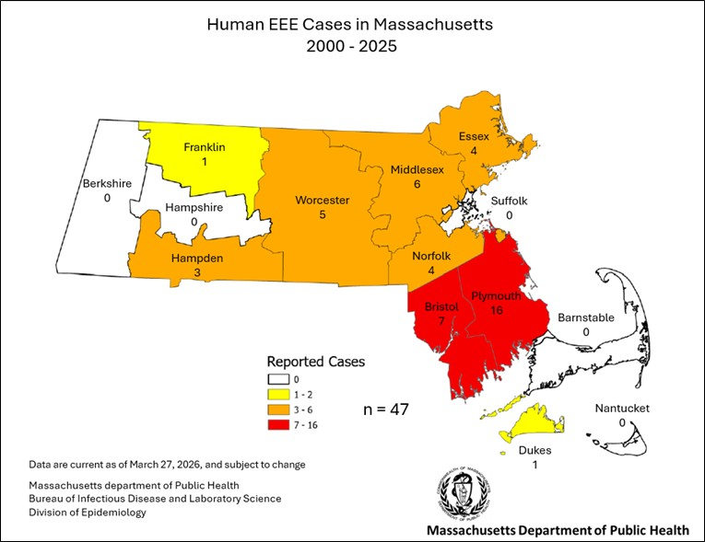

Figure 2: County of Residence of West Nile Virus Human Cases, 2001-2025

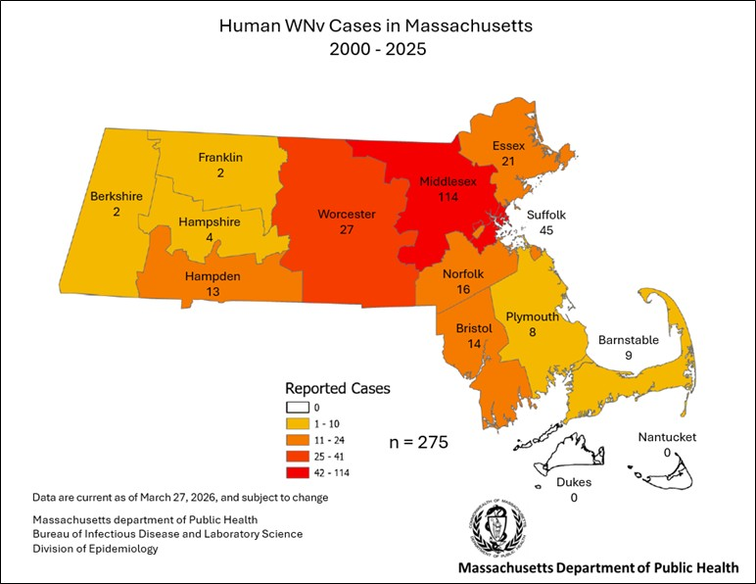

Figure 3: Location of DPH Long-Term Mosquito Trap Sites

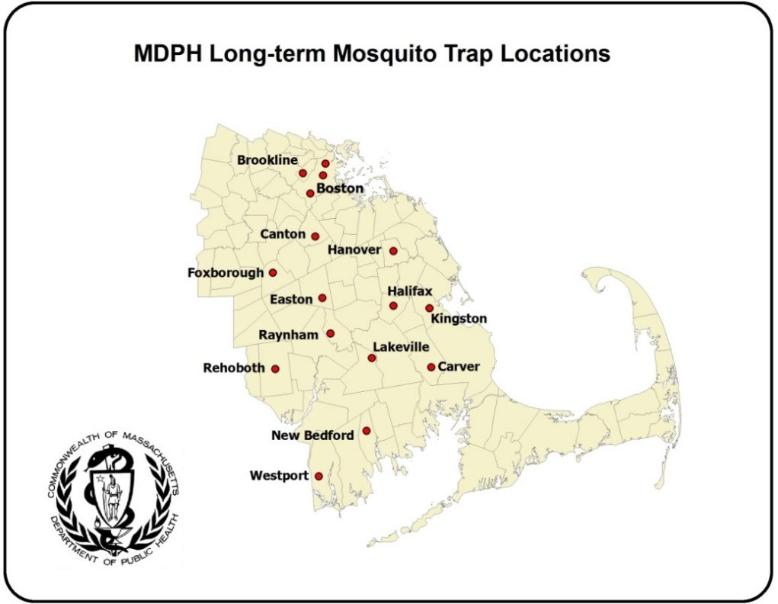

Figure 4: Date of Symptom Onset of WNV and EEE Human Cases in Massachusetts, 2000-2025
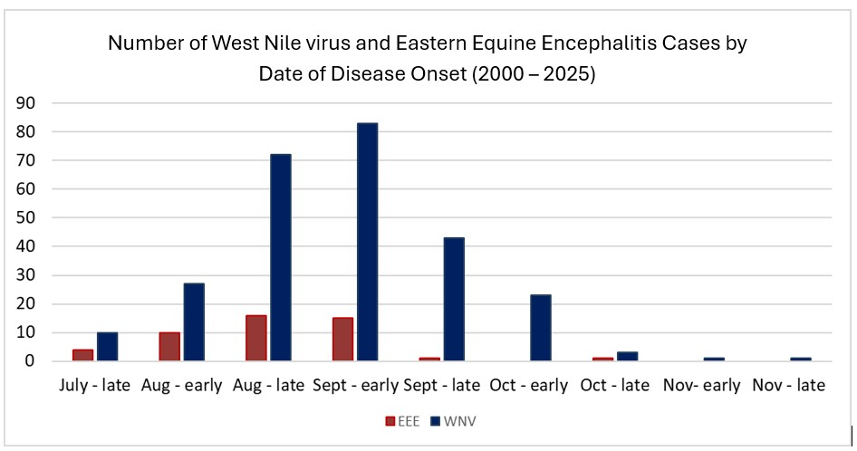
Note: Early = Days 1-15 in month, Late = Days 16+ in month

Figure 5: Communities surveyed for Aedes albopictus, 2025

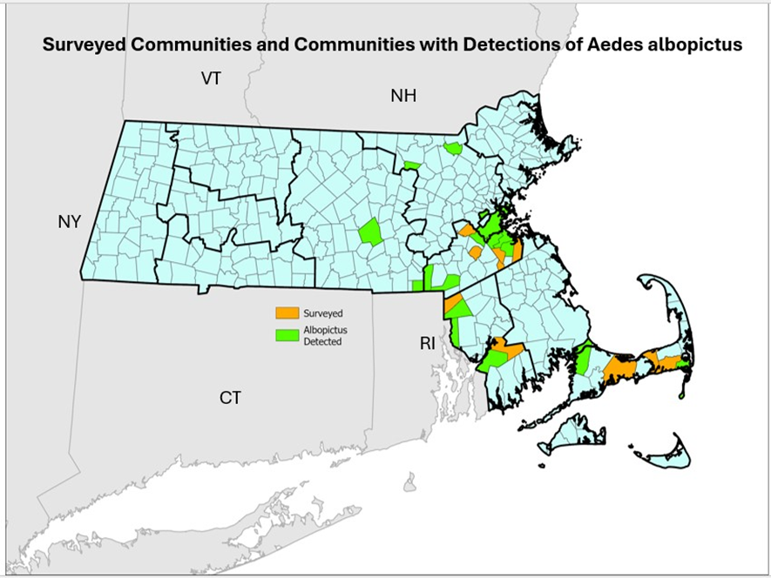

Appendix 1: Mosquitoes Associated with Arboviral Activity in Massachusetts

Aedes vexans – Is a common nuisance mosquito. Temporary flooded areas such as woodland pools and natural depressions are the preferred larval habitat of this mosquito. It feeds on mammals and is an aggressive human biter. This species is typically collected from May to October. Ae vexans is an epizootic (bridge) vector of eastern equine encephalitis (EEE) virus.

Coquillettidia perturbans - Cattail marshes are the primary larval habitat of this mosquito. It feeds on both birds and mammals. It is a persistent human biter and one of the most common mosquitoes in Massachusetts. This species is typically collected from June to September. Cq perturbans is an epizootic (bridge) vector of EEE virus.

Culex pipiens – Artificial containers are the preferred larval habitat of this mosquito. It feeds mainly on birds and occasionally on mammals. It will bite humans, typically from dusk into the evening. This species is regularly collected from May to October but can be found year-round as it readily overwinters in man-made structures. Cx pipiens is the primary vector of West Nile Virus (WNV).

Culex restuans – Natural and artificial containers are the preferred larval habitat of this mosquito. It feeds almost primarily on birds but has been known to bite humans on occasion. This species is typically collected from May to October but can be found year-round as it readily overwinters in man-made structures. Cx restuans has been implicated as a vector of WNV.

Culex salinarius – Brackish and freshwater wetlands are the preferred habitat of this mosquito. It feeds on birds, mammals, and amphibians and is well known for biting humans. This species is typically collected from May to October but can be found year-round as it readily overwinters in natural and man-made structures. Cx salinarius is implicated in in the transmission of both WNV and EEE.

Culiseta melanura –White cedar and red maple swamps are the preferred larval habitat of this mosquito. It feeds almost exclusively on birds. This species is typically collected from May to October. Cs melanura is the primary enzootic vector of EEE.

Ochlerotatus canadensis – Shaded woodland pools are the preferred larval habitat of this mosquito. It feeds mainly on birds and mammals but is also known to take blood meals from amphibians and reptiles. This mosquito can be a fierce human biter near its larval habitat. This species is typically collected from May to October. Oc canadensis is an epizootic (bridge) vector of eastern equine encephalitis EEE virus.

Ochlerotatus japonicus – Natural and artificial containers such as tires, catch basins, and rock pools are the preferred larval habitat of this mosquito. It feeds mainly on mammals and is an aggressive human biter. This species is typically collected from May to October. Oc japonicus may be involved in the transmission of both WNV and EEE.

APPENDIX 2: RECOMMENDED CANCELLATION TIMES FOR OUTDOOR ACTIVITIES IN AREAS OF HIGH RISK FOR EASTERN EQUINE ENCEPHALITIS (EEE)

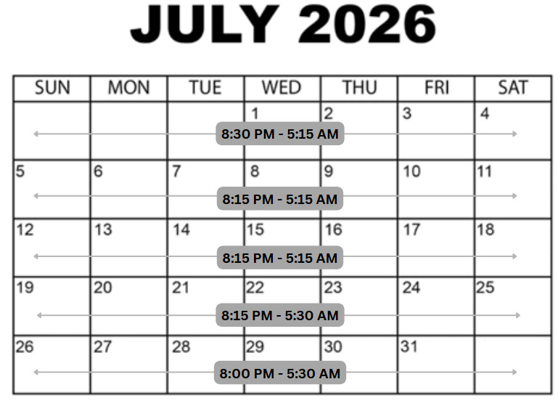
The types of mosquitoes most likely to transmit EEE infection are likely to be out searching for food (an animal to bite) from dusk to dawn, the time period between sunset and sunrise. The exact timing of this increased activity is influenced by many factors including temperature, cloud cover, wind and precipitation and cannot be predicted precisely for any given day. Here, time of civil twilight was used to establish standardized recommendations for cancellation times of outdoor activities during periods of high EEE risk.

This does not eliminate risk nor does it alleviate the need for the use of repellants or clothing for protection from mosquitoes.

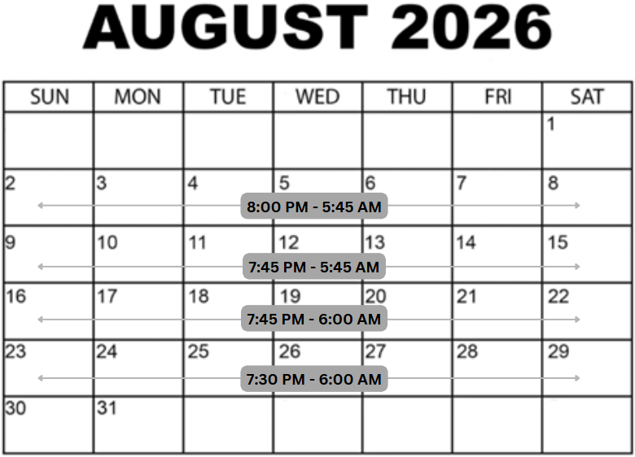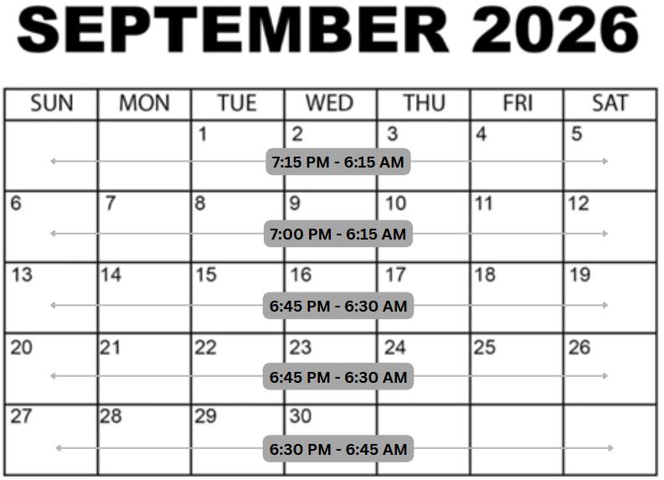
APPENDIX 2: RECOMMENDED CANCELLATION TIMES FOR OUTDOOR ACTIVITIES IN AREAS OF HIGH RISK FOR EASTERN EQUINE ENCEPHALITIS (EEE)

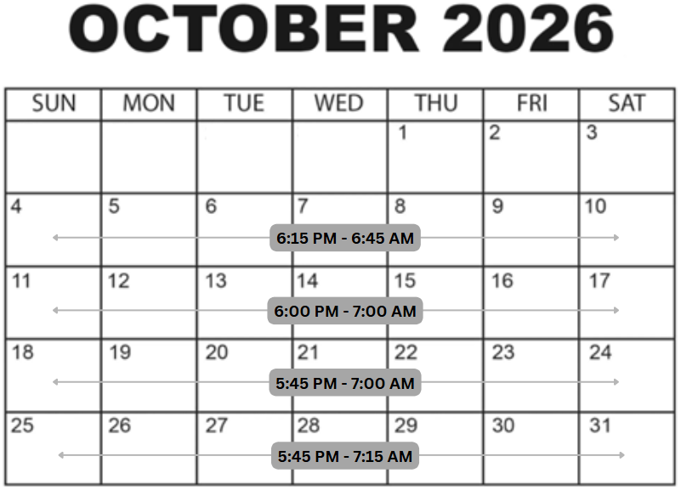
The types of mosquitoes most likely to transmit EEE infection are likely to be out searching for food (an animal to bite) from dusk to dawn, the time period between sunset and sunrise. The exact timing of this increased activity is influenced by many factors including temperature, cloud cover, wind and precipitation and cannot be predicted precisely for any given day. Here, the approximate time of civil twilight was used to establish standardized recommendations for cancellation times of outdoor activities during periods of high EEE risk.

This does not eliminate risk nor does it alleviate the need for the use of repellants or clothing for protection from mosquitoes.

References:

Anderson JF, et al. (2007). Nocturnal activity of mosquitoes (Diptera: Culicidae) in a West Nile virus focus in Connecticut. Journal of medical entomology, 44(6), 1102-1108.

Armstrong PM, et al. (2010). Eastern equine encephalitis virus in mosquitoes and their role as bridge vectors. Emerg Infect Dis.16(12):1869-74.

Armstrong PM, et al. (2013). Eastern equine encephalitis virus-old enemy, new threat. N Engl J Med.368:1670–3.

Bonds JAS. (2012). Ultra-low volume space sprays in mosquito control: a critical review. Med Vet Entomol 26:121–130.

Bosak PJ, and Crans WJ. (2001). Habitat preference of host-seeking Coquillettidia perturbans (Walker) in. Journal of Vector Ecology.

Centers for Disease Control and Prevention (CDC). (2006). Eastern equine encephalitis--New Hampshire and Massachusetts, August-September 2005. MMWR Morb Mortal Wkly Rep. 55(25):697-700.

Centers for Disease Control and Prevention (CDC) (2010). West Nile virus activity - United States, 2009. MMWR Morb Mortal Wkly Rep. Jul 2;59(25):769-72.

Fritz ML, et al. (2014). Daily blood feeding rhythms of laboratory-reared North American Culex pipiens. Circadian Rhythms.12:1.

Griffing SM, et al. (2007). Mosquito landing rates on nesting American robins (Turdus migratorius). Vector-Borne and Zoonotic Diseases, 7(3), 437-443.

Grimstad PR, et al. (1975). Mosquito nectar feeding in Wisconsin in relation to twilight and microclimate. Journal of Medical Entomology, 11(6):691-698.

Hachiya M, et al. (2007). Human eastern equine encephalitis in Massachusetts: predictive indicators from mosquitoes collected at 10 long-term trap sites, 1979-2004. Am J Trop Med Hyg. 76(2):285-92.

Jiang Y. (2016). Lunar phase impact on Coquillettidia perturbans and Culex erraticus host seeking in northern Florida. Technical Bulletin of the Florida Mosquito, 10:44-49.

Lindsey NP, et al. (2010). Surveillance for human West Nile virus disease - United States, 1999-2008. MMWR Surveill Summ. Apr 2;59(2):1-17.

Molaei G, et al. (2006). Host Feeding Patterns of Culex Mosquitoes and West Nile Virus Transmission, Northeastern United States. EID, 2006; 12:3.

Molaei G, et. al. (2103). Vector-host interactions and epizootiology of eastern equine encephalitis virus in Massachusetts. Vector Borne Zoonotic Dis.13:312–23.

Molaei G. et. al. (2016). Dynamics of Vector-Host Interactions in Avian Communities in Four Eastern Equine Encephalitis Virus Foci in the Northeastern U.S. PLoS Negl Trop Dis.10(1): e0004347.

Rizzoli A, et al. (2015). Understanding West Nile virus ecology in Europe: Culex pipiens host feeding preference in a hotspot of virus emergence. Parasites Vectors. (8): 213.
Ruiz MO, et al. (2010). Local impact of temperature and precipitation on West Nile virus infection in Culex species mosquitoes in northeast Illinois, USA. Parasit Vectors.Mar 19;3(1):19.
Trueman, D and McIver, S. (2011). Temporal patterns of host-seeking activity of mosquitoes in Algonquin Park, Ontario. Canadian Journal of Zoology. 64. 731-737. 10.1139/z86-108.

Wright RE, and Knight KL. (1968). Evening crepuscular activity of some Iowan mosquitoes (Diptera: Culicidae). Journal of the Kansas Entomological Society, 45-47.

Focal Area- May incorporate multiple communities, towns or cities. Factors considered in the assessment of human risk and the outlining of a particular focal area include: mosquito habitat, prior virus isolations in surveillance specimens from previous years, human population densities, type and timing of recent isolations of virus in mosquitoes, occurrence of human case(s) in the current or previous years, current and predicted weather patterns, and seasonality of conditions needed to present risk of human disease.
Focal Area- May incorporate multiple communities, towns or cities. Factors considered in the assessment of human risk and the outlining of a particular focal area include: mosquito habitat, prior virus isolations in surveillance specimens from previous years, human population densities, type and timing of recent isolations of virus in mosquitoes, occurrence of human case(s) in the current or previous years, current and predicted weather patterns, and seasonality of conditions needed to present risk of human disease.

