Brief Guidance on logging into the IGX CDBG RFP Environment and completing an application (FFY26)
Questions on any of the following information or regarding the new application itself should be directed to Mark Southard at Mark.Southard@mass.gov with a cc to Kathryn McNelis at Kathryn.McNelis@mass.gov.
Please use this link to login into the testing environment for the new EOHLC IGX CDBG RFP LOGIN
It is recommended that applicants have a copy of the draft 2026 CDBG One Year Plan, as well as the 2026 Application Guidance on hand when completing an application. Both can be found on the CDBG webpage Community Development Block Grant (CDBG) | Mass.gov
- All users must use the New User registration link when logging in for the first time. Once you have registered, EOHLC will have to approve the registration. You will receive notice when approved.

- When you login, you will be directed to the RFP Dashboard (Home Page) and will see two panels. My Opportunities from which you will select the RFP and My Tasks where you will find documents that you are working on including the RFP once it is created. If the panels are not there, find the PowerPoint training on the CDBG webpage under 2026 Information and slides 69 and 70 will show what to do.

- My Opportunities currently has two templates, the Community Development Fund (CDF) and the Mini Entitlement (ME). Please be sure to select the correct template. Only, the ten identified Mini Entitlement communities may use the ME template. See the One Year Plan for this information.

- Click on the link for the correct template and a confirmation page will appear. If you are associated with more than one organization (municipality)*, the page will have a dropdown to select the correct one. Click Proceed. This will create the CDF or ME RFP which will now be found in the My Tasks panel where it will remain until submitted. Follow the same procedure if you intend to create more than one application.
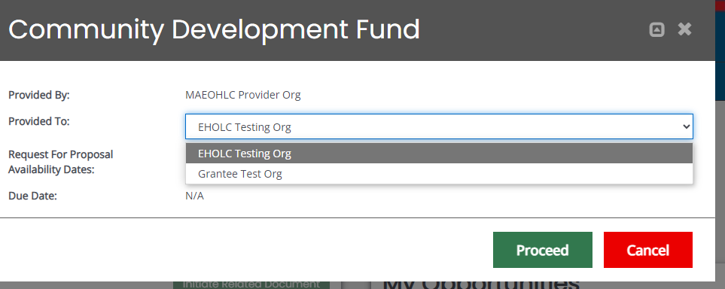
Multiple Organizations
* If you intend to be associated with more than one application, please contact Mark Southard so that we can set you up.
- In the My Tasks panel, Click on the link for the RFP in the Name column and you will be directed to the Home Page of the application. On the left side of the page, underneath Home and Searches, you will see the application name CDF/ME - 2026 – Name of Organization – Document Number. Underneath that is the application forms, tools, status options and other items. The entire application will be completed from this side bar.
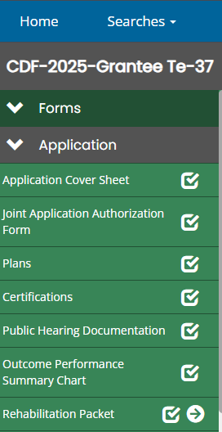
- You will make component (packet) selections in the Application Cover Sheet link. You must click save after making the component selection(s). Any packets that are created will show up on the sidebar and will appear below the Outcome Performance Summary Chart. If you are creating more than one packet within a component i.e. multiple PSS programs, you will create the additional packets within the original packet using the Add button.

- Please note that the first field in a packet is Project Name. This will be the name that follows the packet through the application.
- There are a number of symbols to be aware of that are related to the packets and other items on the sidebar. All of the symbols will provide a brief explanation if you hover over them.
- All of the links, including the packets, will initially show up with an empty box symbol until saved
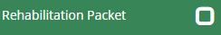

- When they are completed successfully, they will have a check mark 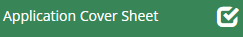

- When saved but not completed, you will get an exclamation warning 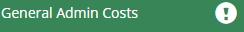

- When there are multiple forms associated with a link, you will see a folder and an arrow

- Clicking on the above arrow will show the packet(s) that has been created. The below arrow indicates that there are multiple forms within the packet which will include the program delivery budget form. Clicking on this arrow will show the forms.
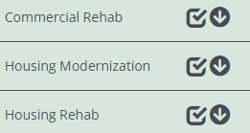
3 activities using the Rehabilitation Packet
- Please use this link to navigate the forms within a packet.
- You will see Previous Form, Next Form links at the bottom of each page and they should not be used at this time.
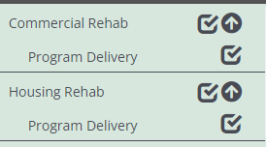

General Notes:
- In order to complete an application, you should click on a link on the sidebar and follow the instructions on that form. Each page will include a link to the CDBG webpage in case you need to access instructive information there in the One Year Plan or Application Guidance.

- When you add budget information to the packet, including the program delivery link, the budget summary will automatically update when you access it. However, it is recommended that you click save to ensure all updates are current.

- It is important when working on a packet to select the eligible activity and correct national objective first as some things may appear or not appear based on these selections.

- The Tool, Document Validation, will give you a list of errors as you go along. You will also be alerted to any missing required information when you try to submit the application.

- When you save a page, if there is missing, required information an attention message will appear in the upper right area of the screen, alerting you to what is missing.
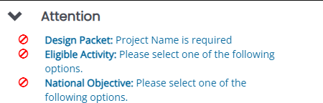
- Authorized Official is the only local role available in the application. An Authorized Official may add others to the application, using the Add/Edit tool on the sidebar. Users must be registered and associated with the organization (municipality) that is submitting the application.

- If you forget/lose your password (or username), click on the Forgot Password link on the login page. Using your email, it will allow you back in to reset the password. It is pretty fast.

- Both the Budget Summary and Application Cover Sheet have an imbedded link that will produce a PDF version of the page. In the case of the cover sheet, this is the document that you will have signed and upload to Other Attachments.

