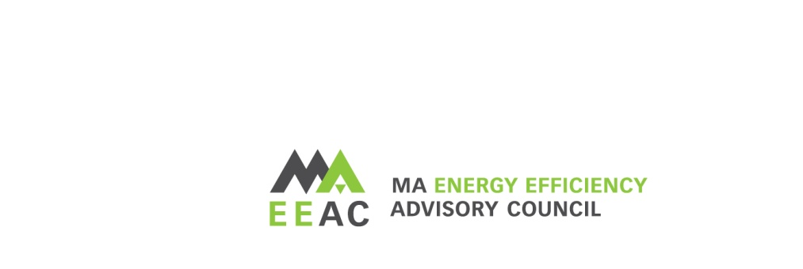
2028-2030 Three-Year Planning Public Comment Listening Sessions

June 9, 2026, 6:00pm
Meeting Registration: https://zoom.us/webinar/register/WN_fuk2RabuRjeni6J4g6nDbw

Public Comment Session Overview:
The Massachusetts Energy Efficiency Advisory Council (EEAC) will be holding a Public Comment Session, as it develops its recommendations for the next Three-Year Plan. The purpose of this session is for the EEAC to hear from members of the public on issues related to the Massachusetts energy efficiency programs, branded as Mass Save®.
While public comment on any topic related to the energy efficiency programs and the development of the 2028-2030 Three-Year Plan are welcome, the EEAC is interested in feedback on its guiding principles and EEAC generated ideas that will be used as a foundation of the EEAC planning workshops.

Public Comment Session Format:
- The listening session will be held virtually via Zoom.
- Stakeholders who would like to provide public comment are asked to register for the session by emailing ma-eeac@mass.gov by 4pm on June 8, 2026.
- Written public comment via email is also encouraged and will be posted on the EEAC website. Written comments should be submitted no later than Friday June 12, 2026.
Each person providing public comment will be given 3 minutes to speak, in order to allow time for more to participate. Once everyone who has pre-registered has provided comment, others may have a chance to speak, as time allows.

