Commonwealth of Massachusetts
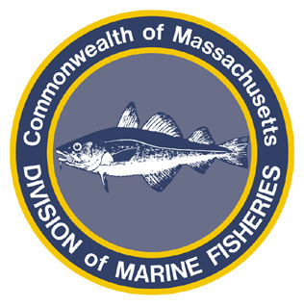
Paul J. Diodati
Director

Deval Patrick
Governor
Richard K. Sullivan, Jr.
Secretary
Mary B. Griffin
Commissioner

Division of Marine Fisheries
251 Causeway Street, Suite 400
Boston, Massachusetts 02114
(617)626-1520
fax (617)626-1509

February 18, 2011
MarineFisheries Advisory
2010/2011 Northern Shrimp Closure

On February 18, 2011 the Atlantic States Marine Fisheries Commission Northern Shrimp Section voted to enact an emergency closure to the northern shrimp fishery. Beginning at 00:01 hours on March 1, 2011 it shall be unlawful to take, possess, or land northern shrimp, and for dealers to purchase northern shrimp from commercial fishermen.
Further information on public hearings and public comment regarding the management of northern shrimp can be found on the ASMFC and MarineFisheries websites:
www.asmfc.org
www.mass.gov/marinefisheries.

