|  |
| --- |
| PROPOSED MASSACHUSETTS TAX EXPENDITURES  EVALUATION SUMMARY |
| EVALUATION YEAR: 2020 |

|  |  |
| --- | --- |
|  |  |
| **TAX EXPENDITURE TITLE** | Life Sciences Tax Incentive Program (tax credits, corporate excise deduction, and sales tax exemption) |
| **TAX EXPENDITURE NUMBER** | 2.617, 3.005 |
| **TAX EXPENDITURE CATEGORY** | Credits against tax (personal income tax, corporate and business tax), corporate excise deduction, sales and use tax exemption |
| **TAX TYPE** | Personal income tax; corporate excise; sales and use tax |
| **LEGAL REFERENCE** | M.G.L. c. 62, §§ 6(m), (n), (r), and (t); c.63, §§ 31M, 38M(k), 38U, 38W, 38V, and 38CC; c. 64H, § 6(xx) |
| **YEAR ENACTED** | 2008 (St. 2008, c. 130) for the original life sciences tax credits, corporate excise deduction, and sales and use tax exemption; 2011 (St. 2011, c. 58, §§ 65, 70) for the Refundable Jobs Tax Credit; 2016 (St. 2016, c. 219, § 139) for the Angel Investor Tax Credit. |
| **REPEAL/EXPIRATION DATE** | All of the original life sciences tax incentives are set to expire on December 31, 2028. The other life sciences tax incentives do not have an expiration date. |
| **ANNUAL REVENUE IMPACT** | Tax loss of from $20 million up to a cap of $30 million annually FY16-FY22 |
| **NUMBER OF TAXPAYERS** | Typically, 20 to 30 selected Life Sciences companies annually. |
| **AVERAGE TAXPAYER BENEFIT** | Varies depending on credit. |

|  |  |
| --- | --- |
| **Description of the Tax Expenditure:**  The Life Sciences Tax Incentive Program is a series of state tax credits, corporate excise deduction, and a sales and use tax exemption, capped at $30 million annually, that is administered and awarded by the Massachusetts Life Sciences Center. | **Is the purpose defined in the statute?**  The preamble to the enacting legislation, St. 2008, c. 130, notes it was intended to “provide forthwith for the immediate investment in and expansion of the life sciences in the commonwealth.” |
| **What are the policy goals of the expenditure?**  The goal of the tax expenditures is to establish, develop, and promote the life sciences industry in Massachusetts. | **Are there other states with a similar Tax Expenditure?**  Both New York and Rhode Island provide limited tax incentives for businesses engaged in life sciences. In addition, Connecticut provides a credit similar to the Massachusetts angel investor credit. |

|  |
| --- |
| Incentive Evaluation Results |

**INTRODUCTION**

While often referred to as a singular “Life Science credit,” Massachusetts offers an array of life sciences tax incentives for the life sciences industry, which consist of multiple tax credits, a corporate excise deduction, and a sales and use tax exemption. The original tax incentives enacted in “An Act Providing for the Investment in and Expansion of the Life Sciences Industry in the Commonwealth,” (St. 2008, c. 130), include the following tax credits: the Life Sciences FDA User Fees Tax Credit, the Life Sciences Refundable Investment Tax Credit, and the Life Sciences Research Tax Credit (and also a modified version of the standard Research Tax Credit); as well as a corporate excise deduction allowing for the deduction of qualified clinical expenses for certain drugs that would not be fully deductible otherwise, and a sales and use tax exemption for materials used to construct a life sciences facility. Effective January 1, 2011, the Life Sciences Refundable Jobs Tax Credit was added to this program (St. 2011, c. 58, §§ 65, 70). Most recently, the Angel Investor Tax Credit was added to the ambit of life sciences tax incentives (St. 2016, c. 219, § 139).

While most of the tax credits are available to life sciences companies subject to either the personal income tax or the corporate excise, the Life Sciences Research Tax Credit and the modified version of the standard Research Tax Credit are available only to life sciences companies subject to a corporate excise, and the Angel Investor Tax Credit is only available to personal income taxpayers. Additional information about the scope of the life sciences tax incentives is provided in greater detail in the “Costs” section below.

The Life Sciences Tax Incentive Program is administered by the Massachusetts Life Sciences Center (MLSC). The MLSC is charged with reviewing and, as appropriate, approving applications from life sciences companies, which certifies them as eligible for various life sciences tax incentives. The life sciences tax incentives are available only to certified life sciences companies to the extent authorized by the MLSC. Prior to receiving any life sciences tax incentives, a company must be certified by the MLSC. To become a certified life sciences company, the company must apply to the MLSC by a date set by the MLSC. The company must be registered to do business in Massachusetts, maintain at least 10 full-time employees as of the end of the previous calendar year, and be in good standing with the Secretary of the Commonwealth and the Massachusetts Department of Revenue.[1]

In evaluating an applicant, the MLSC considers certain criteria, such as whether the applicant has shown it has the ability to create and retain jobs for five years, as well as general considerations including a wide geographic distribution of life sciences operations in Massachusetts, a wide distribution of life sciences technologies and industries supported by the MLSC, and diversity among businesses at different stages of product development and commercialization. The MLSC particularly encourages companies from outside Greater Boston to apply.

All of the life sciences tax incentives provided to a life sciences company are subject to recapture if the life sciences company’s certification is revoked by the MLSC.

**POLICY GOALS**

The intent of these tax expenditures is to foster the life sciences industry as a whole in Massachusetts by encouraging job creation and investment in the sector, while easing tax and administrative compliance burdens.

**COSTS**

Originally, the amount of life sciences tax incentives that could be authorized annually was capped at $25 million. However, in 2018 the cap was raised to $30 million. The original life sciences tax incentives were set to expire on December 31, 2018 but have since been extended until December 31, 2028.[2]

The combined cost of all the life sciences tax incentives is limited by the cap. In any given year, the MLSC may only authorize life sciences tax incentives up to $30 million, including any incentives carried forward and the current year cost of incentives allowed in previous years. M.G.L. c. 23I, § 5(d). Although it is not a requirement, in recent years the MLSC has authorized only about 80% of tax incentive allowed by the annual cap.

Below, a summary of the incentives is presented first, followed by a more detailed discussion of each individual incentive and its cost.

**Life Sciences Tax Incentives**

1. **Life Sciences Refundable Jobs Tax Credit**

Certified life sciences companies subject to either the personal income tax or the corporate excise may claim a Life Sciences Refundable Jobs Tax Credit. This particular credit has the largest tax impact of the life sciences tax incentives, with the MLSC authorizing this credit in amounts up to $13.7 million annually. A life sciences company claiming the credit must commit to the creation of a minimum of 50 net new permanent full-time positions in Massachusetts.

If the credit claimed by a taxpayer exceeds the tax otherwise due, 90% of the balance of such credit may, at the option of the taxpayer and to the extent authorized by the MLSC, be refundable.

## Life Sciences Research Tax Credit

Certified life sciences companies subject to a corporate excise mayclaim a Life Sciences Research Tax Credit, equal to 10% of excess qualified research expenses, including expenditures for legally mandated clinical trial activities performed both inside and outside of Massachusetts, and 15% of basic research payments. The Life Sciences Research Tax Credit is not refundable. However, unused portions of the credit may be carried forward for 15 years. While the amounts vary from year to year, the average annual award for this credit has been $3.5 million.

The Life Sciences Tax Incentive Program also modifies the Research Credit provisions in M.G.L. c. 63, § 38M to make the Research Credit refundable in certain circumstances for life sciences companies specifically. While the standard Research Credit is not ordinarily refundable, where a life science company’s Research Credit exceeds the tax due, 90% of the balance of the credit may, at the option of the taxpayer and to the extent authorized by the MLSC, be refundable to the taxpayer. If the taxpayer does not opt to make the credit refundable, the credit may be carried forward for up to 15 years.

1. **Life Sciences Refundable Investment Tax Credit**

Certified life sciences companies subject to the personal income tax or the corporate excise may claim a Life Sciences Refundable Investment Tax Credit equal to 10% of the cost of qualifying property acquired, constructed, reconstructed, or erected and used exclusively in Massachusetts. Annual awards of this credit are $2.5 million on average.

If the credit exceeds the tax due, 90% of the balance of the credit may, at the option of the taxpayer and to the extent authorized by the MLSC, be refundable to the taxpayer for the tax year in which the qualified property giving rise to the credit is placed in service. If the taxpayer does not opt to make the credit refundable, the credit may be carried forward for up to 10 years.

1. **Life Sciences Refundable FDA User Fees Tax Credit**

Certified life sciences companies subject to either the personal income tax or the corporate excise may claim the Life Sciences Refundable FDA User Fees Tax Credit. The credit is equal to 100% of the user fees paid on or after June 16, 2008, to the US Food and Drug Administration (FDA) upon submission of an application to manufacture a human drug in Massachusetts. The amount of this credit awarded annually is negligible, averaging less than $0.05 million annually. In many years, no claims of this credit are made at all.

The credit may be claimed in the tax year in which the application for licensure of an establishment to manufacture the drug is approved by the FDA. To be eligible for the credit, more than 50% of the research and development costs for the drug must have been incurred in Massachusetts. At the option of the taxpayer and to the extent authorized by the MLSC, where the credit exceeds the tax due, 90% of the balance of the excess credit is refundable.

## Angel Investor Tax Credit

The MLSC is also responsible for determining whether taxpayers subject to the personal income tax credit qualify for the Angel Investor Tax Credit. The credit itself is equal to 20% of the amount of qualifying investments in a qualifying business, and 30% of the amount of qualifying investments made by a taxpayer investor in a qualifying business located in a “Gateway municipality,” as defined in M.G.L. c. 23A, § 3A. A taxpayer cannot claim more than $50,000 of the credit for a single calendar year. The credit may be taken in either the tax year of the initial investment or may be carried forward to any of the 3 subsequent taxable years, as long as the qualifying business maintains its principal place of business in Massachusetts. To date no amount of this credit has been claimed.

1. **Corporate Excise Deduction -Qualified Clinical Testing Expenses for Orphan Drugs**

A certified life sciences company subject to the corporate excise is allowed to deduct the full amount of expenses incurred for the clinical testing of certain drugs for which the company claimed the federal Orphan Drug Credit under Internal Revenue Code (IRC) § 45C. In Massachusetts, corporations subject to the corporate excise are generally allowed to deduct expenses that are deductible federally. M.G.L. c. 63, § 30.4. However, under federal law, a taxpayer claiming a credit for certain clinical testing expenses is prohibited from also deducting such expenses. IRC § 280C(b). This particular incentive allows a certified life science company to deduct these clinical testing expenses as though they were deductible federally, thereby allowing the company to deduct the full amount of the expense in Massachusetts.

1. **Sales and Use Tax Exemption**

Purchases of tangible personal property made on behalf of a life sciences company to be used in the in the construction, alteration, remodeling, repair or remediation of research, development or manufacturing facilities and utility support systems are exempt from the Massachusetts sales and use tax. M.G.L. c. 64H, § 6(xx). Authorizations of this sales and use tax exemption are forecasted to be $0.9 million annually on average.

**Total Costs**

As previously noted, the MLSC generally has awarded less than the full amount of the credit allowed; we expect this pattern to continue at the new higher cap of $30 million annually. This is reflected in the forecasted tax impact through FY22.

**Actual and Forecast Tax Loss from Life Science Tax Incentives ($millions)**



**BENEFITS**

The direct costs and direct benefits are of any tax incentive are equal. When the Commonwealth issues credits to some taxpayers, the credits are the benefits to these taxpayers. However, some people will bear the cost in the same amount as reduced government spending or reduce tax incentives. These are the direct costs and benefits. Given that the dollar amounts of costs and benefits are equal, the impact of a tax incentive depends on how it changes behavior in the economy.

The Life Sciences Incentive Program provides a subsidy to certified life sciences companies in Massachusetts. Estimating the number of jobs directly supported by the program best demonstrates the direct effects of the program’s expenditures. The average wage in the life sciences industry is relatively high, averaging $98,480 annually in 2019.[3] As a result, assessing the incentives in terms of direct jobs supported, the $17.7 million spent in FY19 on the life sciences tax incentives would have supported only 180 jobs.

However, beyond the direct effects, the life sciences tax incentives may also be influential in attracting or retaining life sciences companies in Massachusetts. This aspect of the incentives is addressed in the “Evaluation” section.

**EVALUATION: COMPARING COSTS AND BENEFITS**

The direct costs and benefits of the life sciences tax incentives are fairly easy to compare and evaluate. The $20 to $25 million spent annually on these incentives results in an expenditure of state funds that could be spent elsewhere. Since state spending tends to be captured by the local economy, the *direct* impacts of the substitution of the general expenditure of state funds with spending on the life sciences tax incentives likely has a minor negative impact on the local economy. The life sciences tax incentives may also promote inequity in the tax structure by diverting state resources to supporting life sciences jobs, which tend to be held by highly educated workers who generally do not need state support to be successful.

The indirect / economy-wide benefits generated by this program are more difficult to quantify, but may be sufficient to offset any negative impact. The life sciences tax incentives are intended to influence the locational decisions of life sciences companies. Given that the life sciences industry is relatively new and is still growing, the life sciences tax incentives may be contributing to the “clustering effect that has manifested in Massachusetts. This effect is a tendency for new companies to establish themselves near pre-existing companies in the same industry. If an area becomes known for a particular type of industry, it tends to attract workers with the necessary talents, further increasing the desirability of the area to new companies.[4]

Life sciences companies have tended to “cluster” in a few areas around the country, and Massachusetts has without a doubt established itself as a leading state for the life sciences industry. Massachusetts stands out from other states when measuring the total number of jobs, annual investment, and growth in this industry, especially when examined on a per-capita basis. In the research and development subsector of the industry for example, Massachusetts has almost as many of these jobs as California, despite having less than one-fifth of that state’s population.

**5 Leading States for Biotech R&D Jobs in 2019**

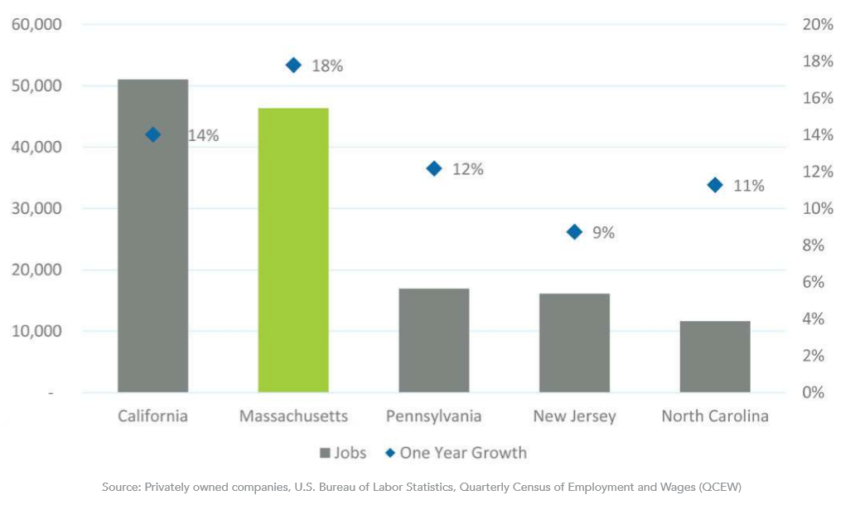

<https://www.massbio.org/industry-snapshot/>

Given that Massachusetts has successfully established a life sciences cluster, to what extent is this attributable to the life sciences tax incentives as opposed to the other advantages, such as the cluster of universities and hospitals? This is addressed in the “Is the Incentive as Designed Accomplishing Its Purpose” section below.

**SIMILAR TAX EXPENDITURES OFFERED BY OTHER STATES**

As part of this review, the life sciences company tax incentives of neighboring states were examined. While Connecticut, New York, and Rhode Island do have life sciences company tax incentives, they are smaller in scope, breadth, and in the total amount of incentives that can be authorized in a particular year. States with alternative life sciences clusters do not provide incentives specifically geared towards the life sciences industry, although New Jersey provides its own Angel Investor Credit.

**Connecticut**

Connecticut also provides an Angel Investor Credit that can be claimed by income taxpayers. The credit is equal to 25% of an accredited investor’s investments of not less than $25,000 in the securities of a Connecticut business, capped at $500,000 per accredited investor. Conn. Gen. Stat. § 12-704d(b). The credit is not refundable, but unused portions of the credit may be carried forward for up to 5 years, and the credit may be sold or transferred. Id. The amount of credits allowed to be authorized in one of Connecticut’s fiscal years is capped at $5,000,000. Conn. Gen. Stat. § 12-704d(e)(1). Each fiscal year, up to 75% of credits may be authorized on behalf of investments in emerging technology businesses, which includes life sciences businesses.

**New Jersey**

New Jersey offers an Angel Investor Tax Credit to taxpayers subject to New Jersey’s income tax or corporation business tax. Taxpayers are allowed, subject to the approval of the New Jersey Economic Development Authority, to claim a credit equal to 20% of the investment made in a New Jersey emerging technology business, which include life sciences companies. N.J. Stat. § 54A:4-13.a(1); N.J. Stat. § 54:10A-5.30.a(1). The amount of the credit is increased to 25% where the New Jersey emerging technology business is located in a qualified opportunity zone or is a certified minority or women owned business. N.J. Stat. § 54A:4-13.a(2); N.J. Stat. § 54:10A-5.30.a(2). Taxpayers may claim no more than $500,000 of this credit with respect to a particular investment in a given tax year. Unused amounts of credit can be carried forward for up to 15 tax years. Altogether, this credit is capped at $25 million annually.

**New York**

In 2017, New York implemented a life sciences credit of its own, though only with respect to research and development costs. Under NY CLS Tax § 43, New York provides income and corporate tax credits pertaining to life sciences companies. A life sciences company that employs 10 or more people during the taxable year may apply a tax credit equal to 15% of the company’s research and development costs made in New York. NY CLS Tax § 43(a)(2)(i). Life sciences companies employing fewer than 10 people may apply a credit equal to 20% of their research and development costs made in New York. This credit is fully refundable, may be used consecutively for up to 3 years, is capped at $500,000 per taxpayer with a $1.5 million lifetime cap for a particular taxpayer, and the total amount of credits allowed in a particular year is capped at $10 million. The credit is also limited to new businesses, which are independent businesses that have been subject to tax for 5 years or less. NY CLS Tax § 210-B(f).

**Rhode Island**

Rhode Island has a life sciences jobs incentive program. Upon certification by the I-195 redevelopment commission, a life sciences company’s corporate tax rate is reduced by the aggregate amount of the life sciences company’s (and subsidiaries) new employment. Life sciences companies may reduce their corporate tax liability by .20% for each unit of new employment for each taxable year up to a maximum reduction of 4%. R.I. Gen. Laws § 42-64.14-11(b). This program is set to expire on December 31, 2021. R.I. Gen. Laws § 42-64.14-21(a). Certified life sciences companies are also awarded Rhode Island’s innovation investment tax credit, research and development expense credit, research and development property credit, and the elective deduction for research and development facilities. R.I. Gen. Laws § 42-64.14-9(c).

Companies not certified as life sciences companies may obtain a biotechnology investment tax credit. A company engaged in commercial biological research and development or manufacturing and sale of biotechnology products or active pharmaceutical ingredients and pays its employees that more than 30 hours a week a weekly wage equal or greater than 125% of the state’s average annual wage are allowed a credit equal to 10% of the cost or tangible property, including buildings and structural components of buildings acquired, constructed, reconstructed, or leased with situs in Rhode Island and principally used in the production of biotechnology products after December 31, 2001. R.I. Gen. Laws § 44-31-1.1(a). The credit may be carried forward for up to 15 years in total, but unless it meets certain employment criteria, it may only carry forward the credit for 7 years. R.I. Gen. Laws § 44-31-1.1. R.I. Gen. Laws § 44-31-1.1(b)(1).

**IS THE INCENTIVE AS DESIGNED ACCOMPLISHING ITS PURPOSE?**

Since the debut of the life sciences tax incentives in 2008, Massachusetts has seen rapid growth in the life sciences industry. However, it should be noted that Massachusetts had a significant life sciences industry prior to 2008. The table below shows that there were already over 40,000 jobs in the biopharma industry, an industry that constitutes a significant component of the Massachusetts life sciences industry as a whole, in Massachusetts in 2005. The table also shows that even during the 2009 recession, employment in this industry in Massachusetts continued to grow.

**Massachusetts Biopharma Employment, 2005 to 2019**

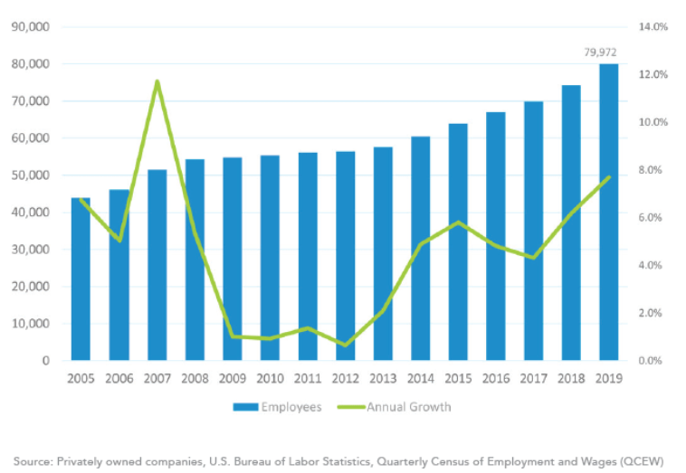

<https://www.massbio.org/industry-snapshot/>

One way to evaluate the effectiveness of the life sciences tax incentives is to compare the life sciences industry job growth in Massachusetts with the nation as a whole. This comparison supports the conclusion that Massachusetts has been successful in establishing itself as an attractive location for the life sciences industry. Between 2010 and 2019, biotechnology employment in the US showed little overall growth, while the number of jobs in this industry in Massachusetts significantly increased. In 2016, the Boston Business Journal noted that Massachusetts was experiencing steady growth in this industry, despite declines elsewhere in the US.[5]

Outside of Massachusetts, a number of states have life sciences clusters that could be attractive alternatives to companies looking to start or expand. Silicon Valley in California is the most obvious location, but there are smaller clusters in North Carolina and New Jersey. While it is possible that the life sciences industry would have gravitated to Massachusetts even absent the life sciences tax incentives, the incentives are a visible commitment by the state to supporting the life sciences industry.

To be completed further by TERC

Conclusion/Recommendations: [To be Entered by TERC]

1. For further details, see M.G.L. c. 23I, § 5(b) and Life Sciences Tax Incentive Program Solicitation No. 2019 TAX-01.
2. See St. 2018, c. 112, § 4 and St. 2018, c. 112, § 10.
3. Bureau of Labor Statistics estimate of median wage for Biological scientists in Massachusetts, 2019. <https://www.bls.gov/oes/current/oes_ma.htm#19-0000>
4. See the Harvard Business School: “Clusters are geographic concentrations of interconnected companies, specialized suppliers, service providers, and associated institutions in a particular field that are present in a nation or region. Clusters arise because they increase the productivity with which companies can compete. The development and upgrading of clusters is an important agenda for governments, companies, and other institutions.” <https://web.archive.org/web/20100513031423/http://www.isc.hbs.edu/econ-clusters.htm>
5. <https://www.bizjournals.com/boston/blog/bioflash/2016/08/drug-manufacturing-jobs-grow-in-mass-despite.html>