Commonwealth of Massachusetts
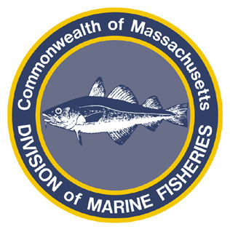
Paul J. Diodati
Director

Deval Patrick
Governor
Timothy P. Murray
Lt. Governor
Richard K. Sullivan, Jr.
Secretary
Mary B. Griffin
Commissioner

Division of Marine Fisheries
251 Causeway Street, Suite 400
Boston, Massachusetts 02114
(617)626-1520
fax (617)626-1509

March 10, 2011

MarineFisheries Advisory
Period I Summer Flounder (Fluke) Trip Limit to be lowered to 100 lbs on March 15

The commercial landings of fluke are projected to reach 25% (289,238 lb.) of the state’s annual allocation by March 14, 2011. Therefore, from March 15, 2011 through June 9, 2011, vessels shall not possess or land more than 100 lbs. of summer flounder during any 24-hour day (322 CMR 6.22 (2)(c)(3)).

