|  |
| --- |
| PROPOSED MASSACHUSETTS TAX EXPENDITURES  EVALUATION SUMMARY |
| EVALUATION YEAR: 2020 |

|  |  |
| --- | --- |
|  |  |
| **TAX EXPENDITURE TITLE** | Exemption for Alcoholic Beverages |
| **TAX EXPENDITURE NUMBER** | 3.201 |
| **TAX EXPENDITURE CATEGORY** | Exempt, Taxed under Another Excise |
| **TAX TYPE** | Sales and use tax |
| **LEGAL REFERENCE** | M.G.L. c. 64H § 6(g) |
| **YEAR ENACTED** | 1967. Repealed 2009. Reinstated 2010. |
| **REPEAL/EXPIRATION DATE** | None |
| **ANNUAL REVENUE IMPACT** | Tax loss of $120.9 - $131.6 million per year during FY18-FY22 |
| **NUMBER OF TAXPAYERS** | Buyers and Sellers of Alcoholic Beverages at the Retail Level |
| **AVERAGE TAXPAYER BENEFIT** | $43 per Massachusetts Household in FY18. |

|  |  |
| --- | --- |
| **Description of the Tax Expenditure:**  Alcoholic beverages, except those sold as part of a meal, are exempt from sales tax. They are instead subject to an excise tax determined by volume rather than retail price under another provision of state law. | **Is the purpose defined in the statute?**  The statute does not explicitly state the purpose of this tax expenditure. |
| **What are the policy goals of the expenditure?**  DOR infers that the goal of the expenditure is to avoid double taxation of alcoholic beverages. Alcoholic beverages are subject to a separate excise under another provision of state law, M.G.L. c. 138, s. 21. The cost of that excise, generally paid by a manufacturer, is usually passed on to consumers. A sales tax on alcoholic beverages would also be borne by consumers. | **Are there other states with a similar Tax Expenditure?**  All the New England states, other than New Hampshire, and New York impose a sales tax on the sale of alcoholic beverages. New Hampshire does not have a sales tax. Nearly every state, other than the 5 states with no sales tax, imposes a sales tax on the sale of alcoholic beverages.  Generally, every state either imposes an excise on alcoholic beverages or the sales are state controlled and so the state earns the revenue, so no additional excise is necessary. For example, Maine imposes an excise on beer and wine, but liquor can only be sold in a state owned or controlled store. The state sets the price of the liquor and receives all the profit, no excise is imposed. |

|  |
| --- |
|  |
| Conclusion/Recommendations: [To be Entered by TERC] |

**INTRODUCTION**

Alcoholic beverages, except those sold as part of a meal, are exempt from

sales tax. They are instead subject to an excise tax determined by volume rather than

retail price.

The table below reports the current excise tax rates on alcoholic beverages.

**Table 1. Massachusetts Alcoholic Beverage Tax Rates**

|  |  |
| --- | --- |
| Alcoholic Beverages Item | Tax Rate |
| Malt Beverages | $3.30/31 gal. bbl. |
| Still Wine, including Vermouth | $.55/wine gallon |
| Champagne and all other sparkling Wines | $.70/wine gallon |
| Alcoholic Beverages, other than Malt Beverages, Wine and Vermouth, containing 15% or less of Alcohol by volume at 60 degrees Fahrenheit | $1.10/wine gallon |
| Alcohol Beverages containing more than 15% of Alcohol but not more than 50% of Alcohol by volume at 60 degrees Fahrenheit | $4.05/wine gallon |
| Alcoholic Beverages containing more than 50% of Alcohol by volume at 60 degrees Fahrenheit | $4.05/proof gallon |
| Alcohol sold in containers of one gallon or less | $4.05/proof gallon |
| Cider containing more than 3% but not more than 6% of Alcohol by weight at 60 degrees Fahrenheit | $.03/wine gallon |

The Department of Revenue (DOR) collected $87.6 million in alcoholic beverages excise in Fiscal Year 2020. See Appendix I for more details.

In 2009, the Legislature repealed the sales tax exemption for alcoholic beverages as of August 1, 2009. St. 2009, c. 27. However, as the result of a referendum question on the November 2, 2010 ballot, this exemption was reinstated, effective for sales on or after January 1, 2011. St. 2010, c. 426.

**POLICY GOALS**

DOR infers that the goal of the expenditure is to avoid double taxation of alcoholic beverages. Alcoholic beverages are subject to a separate excise under another provision of state law, M.G.L. c. 138, s. 21. The cost of that excise, generally paid by a manufacturer, is usually passed on to consumers. A sales tax on alcoholic beverages would be imposed at the retail level and therefore would also be borne by consumers.

**DIRECT COSTS**

The revenue loss resulting from this tax expenditure is estimated to be $120.9- $131.6 million per year during FY18-FY22. See Table 2.

**Table 2. Tax Revenue Loss Estimates for Sales Tax Exemption**

**for Alcoholic Beverages**

|  |  |  |  |  |  |
| --- | --- | --- | --- | --- | --- |
| Fiscal Year | 2018 | 2019 | 2020 | 2021 | 2022 |
| Estimated Revenue Loss ($Million) | $120.9 | $123.2 | $124.8 | $127.5 | $131.6 |

**DIRECT BENEFITS**

The Massachusetts consumers and businesses who buy and sell alcoholic beverages at retail are the direct beneficiaries of the sales tax exemption. Buyers benefit from the sales tax exemption in the form of paying a lower “after tax price” while sellers benefit from the sales tax exemption in the form of receiving a higher “before tax price”. The exact split of the direct benefits depends on the interaction of demand and supply and is often difficult to quantify.

Businesses in many industries sell alcoholic beverages at the retail level, including supermarkets, convenience stores, beer, wine, and liquor stores, electronic shopping and mail-order houses, etc. Among all these industries, “beer, wine, and liquor stores” is the largest industry selling alcoholic beverages. According to the Massachusetts Alcoholic Beverages Control Commission (ABCC)[1], in calendar year 2018, ABCC issued 12,925 retail alcohol licenses. According to the U.S. Census Bureau, Massachusetts had 1,359 beer, wine, and liquor stores in 2017.

For simplicity, we assume that the entire tax savings due to the sales tax exemption is passed on to buyers. Based on this assumption, Table 3 reports the distribution of estimated tax saving in FY18 among households in different income ranges. The table is based primarily on the 2018 Consumer Expenditure Survey data published by the U.S. Bureau of Labor Statistics and data from other sources such as Moody’s Analytics and the Massachusetts Department of Revenue. The Consumer Expenditure Survey reports average annual expenditures on alcoholic beverages and number of households by different income groups. Please note that, although alcoholic beverages are purchased by both consumers (households) and businesses, the distribution of tax savings reported in Table 3 is for consumers (households) only.

According to Table 3, the average tax savings from the exemption is estimated to be $42.90 per Massachusetts household in FY18, varying from $13.99 for households with annual income of $15,000 to $29,999, to $151.14 for households with annual income of at least $200,000. By percentage, 22.96% of all tax savings went to households with annual income of at least $200,000 while 4.5% went to households with annual income of less than $15,000. The tax savings reduced the households’ effective tax rate (the ratio of tax to income) by 0.05 percentage points on average, but the reduction was much higher for households with annual income of less than $15,000. For this group, the effective tax rate was reduced by 0.19 percentage points, more than three times the average reduction of 0.05 percentage points for all households. The reason for this difference is that the average household in this bracket spent a much higher percentage of their income on alcoholic beverages.

**Table 3. Estimated Distribution of Tax Savings to MA Households**

**by Income Level in FY18**

|  |  |  |  |  |  |
| --- | --- | --- | --- | --- | --- |
| Annual Income Range | Number of MA Households (Millions) | Tax Savings  (Millions) | Average Tax Savings  ($) | Tax Savings Distribution | Change in Households’ Effective Tax Rate |
| Less than $15,000 | 0.349 | $5.17 | $14.80 | 4.50% | -0.19% |
| $15,000 to $29,999 | 0.419 | $5.86 | $13.99 | 5.11% | -0.06% |
| $30,000 to $39,999 | 0.265 | $6.36 | $24.01 | 5.55% | -0.07% |
| $40,000 to $49,999 | 0.217 | $6.13 | $28.21 | 5.34% | -0.06% |
| $50,000 to $69,999 | 0.346 | $13.05 | $37.71 | 11.37% | -0.06% |
| $70,000 to $99,999 | 0.388 | $16.27 | $41.91 | 14.18% | -0.05% |
| $100,000 to $149,999 | 0.351 | $22.08 | $62.90 | 19.24% | -0.05% |
| $150,000 to $199,999 | 0.165 | $13.49 | $81.61 | 11.75% | -0.05% |
| $200,000 to more | 0.174 | $26.35 | $151.14 | 22.96% | -0.05% |
| Total | 2.676 | $114.77 | $42.90 | 100.00% | -0.05% |

Source: Estimated by Massachusetts Department of Revenue.

**EVALUATION: COMPARING COSTS AND BENEFITS**

In the previous sections, we reported the direct costs (to the Commonwealth, or to the residents and businesses who ultimately bear the costs when the Commonwealth cuts government spending or increases tax to finance the sales tax exemption for alcoholic beverages) and direct benefits (to buyers and sellers of alcoholic beverages at retail) of this tax expenditure. Since the direct costs to the Commonwealth are the direct benefits to taxpayers, they are equal.

However, when looking at the broader economy, there are, in addition to direct impacts, indirect and induced impacts on other residents and businesses in Massachusetts, such as wholesalers, importers, and producers of alcoholic beverages, as well as other individuals and businesses. See Appendix II for more discussion.

To determine the net impact of the tax expenditure, i.e., the total benefits (including direct, indirect and induced benefits) offset by the total costs (including direct, indirect and induced costs), we employed the model of “Tax-PI” developed by Regional Economic Models Incorporated (“REMI”).[2] See Appendix II for details.

The estimated net impact of the tax expenditure for fiscal years 2018 through 2022 are shown in Tables 4 and 5. As shown, the sales tax exemption for alcoholic beverages combined with a cut in state government spending results in less economic activity, with real state GDP decreasing by $164 million-$178 million. The net impact on total employment is negative, decreasing by 1,838 – 2,030 jobs annually. The net additional impact on state revenues[3] is also negative, decreasing by $2.1 million to $5.4 million annually.

Note that because the tax expenditure has a specific purpose (in this case, the avoidance of double taxation of alcoholic beverages), the net negative impacts do not necessarily imply that the tax expenditure is not desirable.

**Table 4. Net Additional Revenue Impact of Sales Tax Exemption**

**for Alcoholic Beverages\***

|  |  |  |  |  |  |
| --- | --- | --- | --- | --- | --- |
| Fiscal Year | 2018 | 2019 | 2020 | 2021 | 2022 |
| Net additional revenue impact ($000) | -$2,144 | -$4,536 | -$4,778 | -$5,104 | -$5,437 |

* assuming state government spending is cut by the same amount as the revenue loss due to the sales tax exemption for alcoholic beverages to balance budget.

**Table 5. Net Economic Impacts of Sales Tax Exemption**

**for Alcoholic Beverages by Selected Economic Measure\***

|  |  |  |  |  |  |
| --- | --- | --- | --- | --- | --- |
| Calendar Year | 2018 | 2019 | 2020 | 2021 | 2022 |
| Impact on total employment | -2,030 | -1,896 | -1,868 | -1,838 | -1,841 |
| Impact on private non-farm employment | -648 | -510 | -491 | -473 | -476 |
| Impact on GDP ($000), real dollars (2012) | -$178,000 | -$167,000 | -$165,000 | -$164,000 | -$166,000 |
| Impact on personal income ($000) | -$139,000 | -$144,000 | -$153,000 | -$160,000 | -$170,000 |

* assuming state government spending is cut by the same amount as the revenue loss due to the sales tax exemption for alcoholic beverages to balance budget.

**Similar Tax Expenditures Offered by Other States**

All the New England states, excluding Massachusetts and New Hampshire, impose a sales tax on the sale of alcoholic beverages. Alaska, Delaware, Montana, New Hampshire, and Oregon do not have a general sales tax.

The tables and charts below from Federation of Tax Administration(FTA) (<https://www.taxadmin.org/>) and Tax Foundation (<https://taxfoundation.org/>)

provide information on state alcoholic beverages tax rates and sales tax exemption comparison.

In evaluating the Massachusetts sales tax exemption relative to the rules in other states, it may be helpful to consider how the Massachusetts alcoholic beverages excise tax rates compare to those in other states. The Tax Foundation ranked Massachusetts 36th in distilled spirits excise tax rate with a rate of $4.05 per gallon (the state with the highest tax rate was ranked 1st); 33rd in wine excise tax rate with a rate of $0.55 per gallon; and 44th in beer excise tax rate with a rate $0.11 per gallon. See the state tax comparison maps below following the FTA’s three state alcoholic beverages tax rate tables.

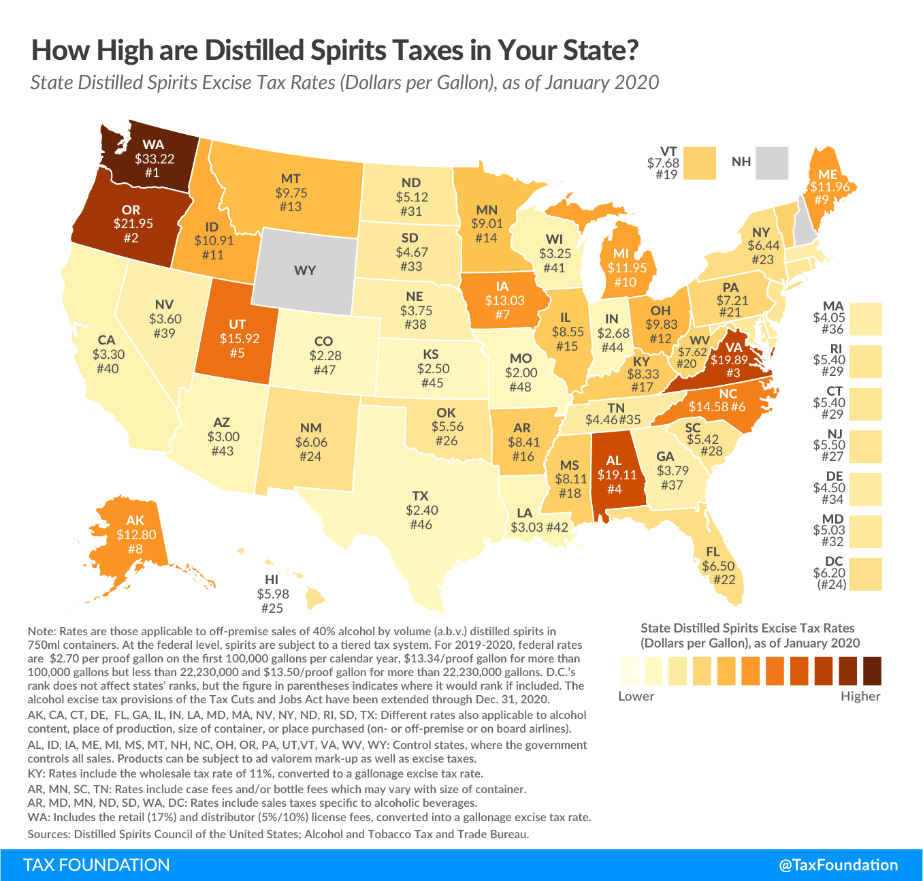

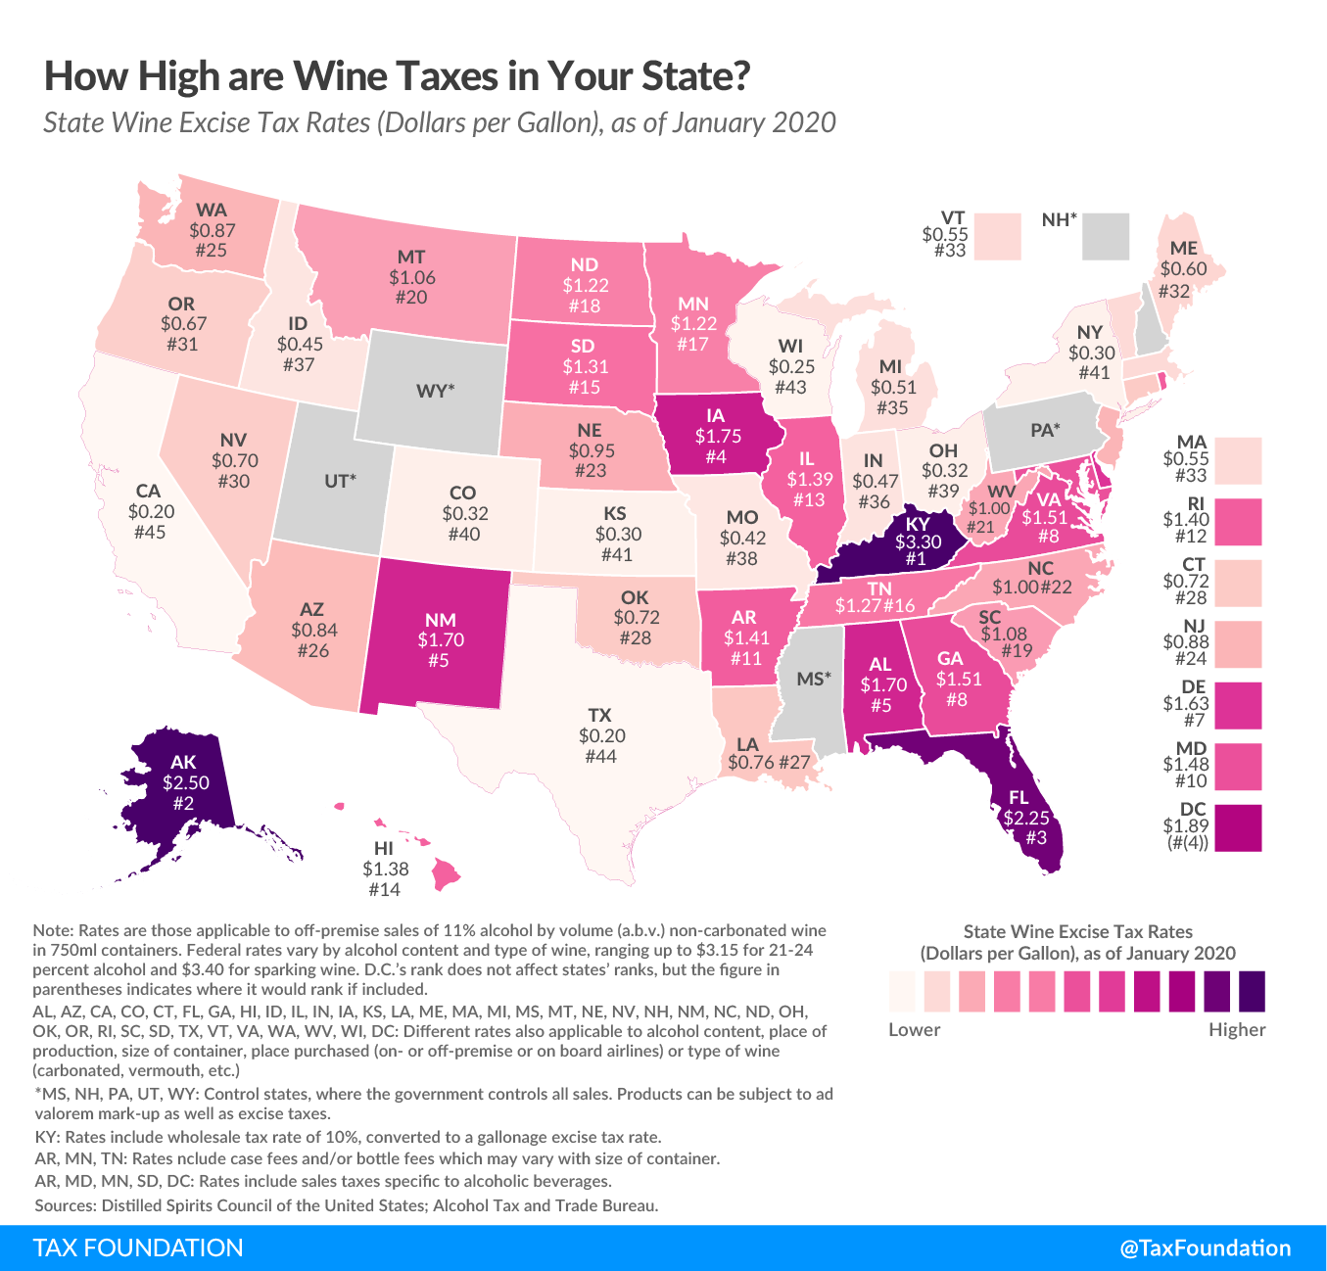

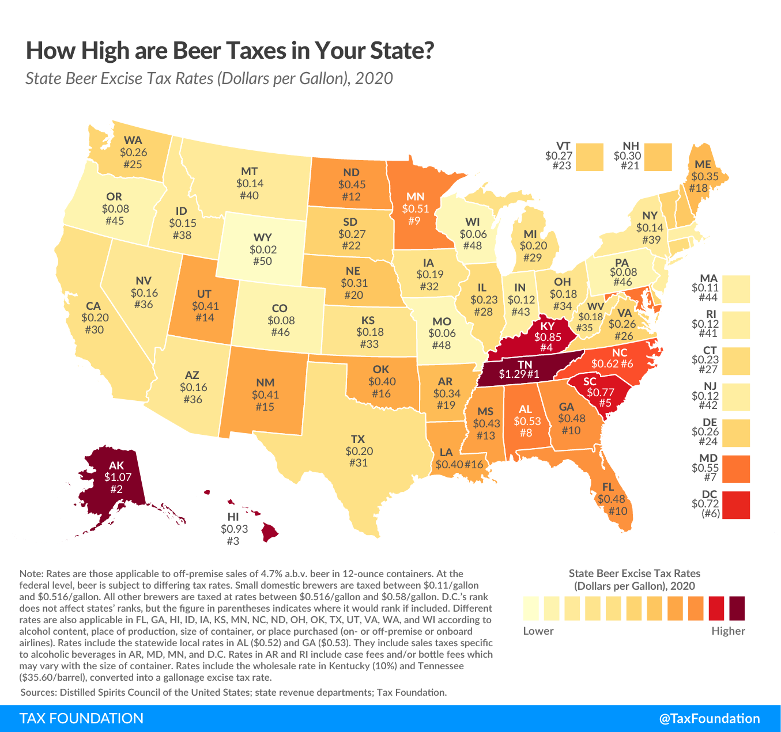

**IS THE INCENTIVE AS DESIGNED ACCOMPLISHING ITS PURPOSE?**

[FOR TERC TO COMPLETE]

**Appendix I: Statistics on Alcoholic Beverage Excise Tax, by Alcohol Type**

In FY20, DOR collected $87.6 million in excise tax from the sale of 160 million gallons of alcohol. Table A1 below reports the gallonage and revenue breakdown by types of alcohol products.

**Table A1. Alcoholic Beverage Gallons and Revenue for FY20**

|  |  |  |  |  |  |  |  |  |  |
| --- | --- | --- | --- | --- | --- | --- | --- | --- | --- |
|  | Malt | Still Wine | Champagne | Alcoholic Beverage 15% or Less | Alcoholic Beverage 15-50% | Alcoholic Beverage 50% or More | Alcohol sold in container of 1 gallon or less | Cider | Total |
| Gallons  (in millions) | 113.75 | 26.61 | 1.78 | 1.24 | 14.14 | 0.22 | 0.00 | 2.34 | 160.07 |
| % Share | 71.06% | 16.62% | 1.11% | 0.78% | 8.83% | 0.13% | 0.00% | 1.46% | 100% |
| Revenue  (in millions of $) | $12.11 | $14.63 | $1.24 | $1.37 | $57.27 | $0.87 | $0.00 | $0.07 | $87.57 |
| % Share | 13.83% | 16.71% | 1.42% | 1.56% | 65.40% | 1.00% | 0.00% | 0.08% | 100% |

**Appendix II: Further Discussion on Costs and Benefits**

The text of the report discusses the direct costs (to the Commonwealth, or more specifically, to the Massachusetts residents or businesses who benefit from state expenditures[4]) and direct benefits (to buyers and sellers of alcoholic beverages at the retail level) of this tax expenditure. It also summarizes indirect and induced costs and benefits associated with this tax expenditure. This appendix will discuss the indirect and induced costs and benefits in more detail.

**Other costs and benefits: Indirect and Induced**

*Indirect and Induced Costs*

Regardless of its size, the existence of a specific tax incentive means less revenue for other spending given the Commonwealth’s balanced budget requirement, assuming no increase in state revenues. Reduced spending on other expenditure items means forgone benefits from those items. This is an **“opportunity cost”** to the Commonwealth. The opportunity cost to the state includes not only the impact on the individuals and businesses that directly benefit from those expenditure items (this is called “direct impact”), but also the indirect impact on the chain of businesses that provide intermediate products and services to the directly impacted businesses (this is called “indirect impact”). In addition, there is the cost to the chain of businesses that benefit when the employees working for the directly impacted businesses spend their wages and salaries to buy goods and services (this is called “induced impact”). The total forgone benefits to the whole economy are larger than the initial forgone benefits. This phenomenon is called the “Multiplier Effect”.[5]

To estimate the total forgone benefits of the reduced spending, we employed Tax-PI, an economic analysis tool for evaluating the total fiscal and economic effects of tax policy changes. Tax-PI is built on over 30 years of experience in modeling the economic effects of tax policy changes, according to MODELS: TAX-PI[6] . The popularity of the model has grown substantially since it was introduced. Note that while the tax incentive has a specific purpose, the reduced spending is assumed to be proportionally distributed across the Commonwealth’s current expenditures.

*Quantifying total costs (direct, indirect and induced)*

The period of study is limited to the five years from 2018 through 2022, for which we prepared input data to run the model. Tables A2 and A3 report the model results. The figures for 2018 and 2019 are estimates of forgone benefits (opportunity costs) that the Massachusetts economy experienced due to having the expenditure, and those for 2020, 2021 and 2022 are projections of forgone benefits that the Massachusetts economy will experience going forward. The effects are displayed as negative numbers as reduced spending has a negative impact on the state economy.

Tables A2 and A3 show that the reduction in state government spending results in lost economic activities, with real state GDP declining by $276 million-$292 million and total employment declining by 3,170 -3,322 jobs annually. Lost economic activities result in further loss of state revenues, ranging from $5.8 million to $16.2 million annually. Note that the revenue impact reported in Table A2 does not include the estimated direct impact of the tax expenditure from Table 2, but only the additional indirect/induced impact.

**Table A2. Additional Revenue Impact due to Decreased Government Spending\***

|  |  |  |  |  |  |
| --- | --- | --- | --- | --- | --- |
| Fiscal Year | 2018 | 2019 | 2020 | 2021 | 2022 |
| Additional revenue impact ($000) | -$5,799 | -$12,812 | -$14,376 | -$15,461 | -$16,152 |

* This table reports the lost revenues from the foregone economic activities as the state reduced government spending to finance the sales tax exemption for alcoholic beverages.

**Table A3. Economic Impacts due to Decreased Government Spending by Selected Economic Measure\***

|  |  |  |  |  |  |
| --- | --- | --- | --- | --- | --- |
| Calendar Year | 2018 | 2019 | 2020 | 2021 | 2022 |
| Impact on total employment | -3,195 | -3,280 | -3,322 | -3,252 | -3,170 |
| Impact on private non-farm employment | -1,762 | -1,808 | -1,839 | -1,772 | -1,685 |
| Impact on GDP ($000), real dollars (2012) | -$276,000 | -$286,000 | -$292,000 | -$290,000 | -$287,000 |
| Impact on personal income ($000) | -$230,000 | -$262,000 | -$289,000 | -$305,000 | -$317,000 |

*This table reports the lost economic activities as the state reduced government spending to finance the sales tax exemption for alcoholic beverages.

*Indirect and Induced Benefits*

The tax savings to buyers and sellers of alcoholic beverages at the retail level encourages directly affected consumers to buy more of other products and services and directly affected businesses to invest, expand, hire additional workers, etc. Such decisions would increase demand for goods and services provided by other individuals and businesses in the economy (including wholesalers, importers, and producers of alcoholic beverages), or put another way, generate a “Multiplier Effect” (see discussion in the previous section) from the initial or direct benefits as reported in the text. As a result, the total benefits of the sales tax exemption for alcoholic beverages would be larger than the initial or direct benefits.

*Quantifying total benefits (direct, indirect and induced)*

To quantify the total benefits, including indirect/induced benefits, we again employed Tax-PI. A summary of the revenue impact of the sales tax exemption for alcoholic beverages is reported in Table A4, and the economic benefit from the sales tax exemption for alcoholic beverages is reflected in Table A5 below. The figures for 2018 and 2019 are estimates of benefits that the Massachusetts economy experienced and those for 2020, 2021 and 2022 are projections of the benefits that the Massachusetts economy will experience going forward.

Tables A4 and A5 show that the sales tax exemption for alcoholic beverages results in more economic activity, with real state GDP increasing by $98 million - $128 million and total employment increasing by 1,165-1,454 jobs annually. More economic activity results in more state revenues, ranging from $3.7 million to $10.7 million annually, which partially offsets the cost of this tax incentive.

**Table A4. Additional Revenue Impact of Sales Tax Exemption**

**for Alcoholic Beverages**

|  |  |  |  |  |  |
| --- | --- | --- | --- | --- | --- |
| Fiscal Year | 2018 | 2019 | 2020 | 2021 | 2022 |
| Additional revenue impact ($000) | $3,656 | $8,279 | $9,602 | $10,362 | $10,713 |

**Table A5. Economic Impacts of Sales Tax Exemption**

**for Alcoholic Beverages by Selected Economic Measure**

|  |  |  |  |  |  |
| --- | --- | --- | --- | --- | --- |
| Calendar Year | 2018 | 2019 | 2020 | 2021 | 2022 |
| Impact on total employment | 1,165 | 1,384 | 1,454 | 1,415 | 1,327 |
| Impact on private non-farm employment | 1,114 | 1,299 | 1,349 | 1,299 | 1,208 |
| Impact on GDP ($000), real dollars (2012) | $98,000 | $119,000 | $128,000 | $127,000 | $121,000 |
| Impact on personal income ($000) | $91,000 | $119,000 | $136,000 | $145,000 | $147,000 |

**Comparison of costs and benefits**

Ignoring the opportunity cost of the tax incentive, total benefits are greater than costs. Considering the opportunity cost means asking what benefits would be reaped if the Commonwealth used the dollars spent on the tax incentive for other purposes. Those dollars could be spent in many other ways, and examining them is beyond the scope of the current evaluation report. Nonetheless, we reported net impacts of the tax incentive in Tables A6 and A7 below under the balanced budget requirement, which are the combined effects in Tables A2-A5.

Tables A6 and A7 show that the sales tax exemption for alcoholic beverages combined with a cut in state government spending results in less economic activity, with real state GDP decreasing by $164 million-$178 million. The net impact on total employment is negative, decreasing by 1,838 – 2,030 jobs annually. The net additional impact on state revenues is also negative, decreasing by $2.1 million to $5.4 million annually.

Note that because the tax expenditure has a specific purpose (in this case, the avoidance of double taxation of alcoholic beverages), the net negative impacts do not necessarily imply that the tax expenditure is not desirable.

**Table A6. Net Additional Revenue Impact of Sales Tax Exemption**

**for Alcoholic Beverages \***

|  |  |  |  |  |  |
| --- | --- | --- | --- | --- | --- |
| Fiscal Year | 2018 | 2019 | 2020 | 2021 | 2022 |
| Net additional revenue impact ($000) | -$2,144 | -$4,536 | -$4,778 | -$5,104 | -$5,437 |

* assuming state government spending is cut by the same amount as the revenue loss due to the sales tax exemption for alcoholic beverages to balance budget.

**Table A7. Net Economic Impacts of Sales Tax Exemption**

**for Alcoholic Beverages by Selected Economic Measure\***

|  |  |  |  |  |  |
| --- | --- | --- | --- | --- | --- |
| Calendar Year | 2018 | 2019 | 2020 | 2021 | 2022 |
| Impact on total employment | -2,030 | -1,896 | -1,868 | -1,838 | -1,841 |
| Impact on private non-farm employment | -648 | -510 | -491 | -473 | -476 |
| Impact on GDP ($000), real dollars (2012) | -$178,000 | -$167,000 | -$165,000 | -$164,000 | -$166,000 |
| Impact on personal income ($000) | -$139,000 | -$144,000 | -$153,000 | -$160,000 | -$170,000 |

* assuming state government spending is cut by the same amount as the revenue loss due to the sales tax exemption for alcoholic beverages to balance budget.

1. <https://www.mass.gov/doc/fiscal-year-2019-annual-report/download>
2. Regional Economic Models Inc. is a recognized leader in economic analysis at the state level. See their website for background information and further details <https://www.remi.com/>
3. Including both tax and non-tax revenues but excluding the revenue loss reported in Table 2.
4. Spending on a specific tax incentive means less spending on other expenditure items for the Commonwealth under balanced budget requirement if there is no increase in state revenues. Reduced spending on other expenditure items means forgone benefits from those items. This is an opportunity cost to the Commonwealth, which, more specifically, is borne by the Massachusetts residents or businesses who benefit from those expenditure items.
5. For an illustration of “Multiplier Effect”, see Slide 4 of: <https://www.ilw.com/seminars/JohnNeillCitation.pdf>
6. https://www.remi.com/model/tax-pi/