|  |
| --- |
| PROPOSED MASSACHUSETTS TAX EXPENDITURES  EVALUATION SUMMARY |
| EVALUATION YEAR: 2020 |

|  |  |
| --- | --- |
|  |  |
| **TAX EXPENDITURE TITLE** | Exemption for Motor Fuels |
| **TAX EXPENDITURE NUMBER** | 3.202 |
| **TAX EXPENDITURE CATEGORY** | Exempt, Taxed under Another Excise |
| **TAX TYPE** | Sales and use tax |
| **LEGAL REFERENCE** | M.G.L. c. 64H § 6(g) |
| **YEAR ENACTED** | 1967. Last amended in 2010 |
| **REPEAL/EXPIRATION DATE** | None |
| **ANNUAL REVENUE IMPACT** | Tax loss of $536.7 - $549.0 million per year during FY18-FY22 |
| **NUMBER OF TAXPAYERS** | Buyers and Sellers of Motor Fuels at the Retail Level |
| **AVERAGE TAXPAYER BENEFIT** | $185 per Massachusetts Household in FY18. |

|  |  |
| --- | --- |
| **Description of the Tax Expenditure:**  Motor fuels are exempt from sales and use tax. They are instead subject to an excise tax determined by price per gallon under another provision of state law. | **Is the purpose defined in the statute?**  The statute does not explicitly state the purpose of this tax expenditure. |
| **What are the policy goals of the expenditure?**  DOR infers that the goal of the expenditure is to avoid double taxation of motor fuels. Motor fuels are subject to a separate excise under another provision of state law, M.G.L. c. 64A. The cost of that excise, generally paid by a distributor, is usually passed on to consumers. A sales tax on motor fuels would also be borne by consumers. | **Are there other states with a similar Tax Expenditure?**  Yes. See the link below to a list of federal and state motor fuels taxes issued by the U.S. Energy Information Administration and updated in February 2020. |

|  |
| --- |
|  |
| Conclusion/Recommendations: [To be Entered by TERC] |

**INTRODUCTION**

Motor fuels are exempt from sales and use tax. They are instead subject to an excise determined by tax per gallon rather than the retail price under another provision of state law.

Effective July 31, 2013, the tax rate on gasoline and diesel is $0.24 per gallon and the tax is included in the price charged at the retail level. Other fuels are taxed at different tax rates as shown in the following link: <https://www.mass.gov/doc/massachusetts-fuels-excise-rate-table-4th-quarter-2020/download>. In Fiscal Year 2020, the Department of Revenue (DOR) collected $707.9 million from motor fuels tax excluding jet fuel tax and $31.2 million from jet fuel tax, which is a local option tax.

**POLICY GOALS**

DOR infers that the goal of the expenditure is to avoid double taxation of motor fuels. Motor fuels are subject to a separate excise under another provision of state law, M.G.L. c. 64A. The cost of that excise, generally paid by distributors, is usually passed on to consumers. A sales tax on motor fuels would be imposed at the retail level and therefore would also be borne by consumers.

The following is a link to a list of Federal and state motor fuels taxes/excises as of February 2020 and issued by the U.S. Energy Information Administration: <https://www.eia.gov/petroleum/marketing/monthly/xls/fueltaxes.xls>. All fifty states, the five United State possessions and the District of Columbia impose various levies on petroleum products. While the terminology varies from state to state, the chart shows the maximum amount each state charges and can serve as a comparative basis for evaluation.

**DIRECT COSTS**

The revenue loss resulting from this tax expenditure is estimated to be $536.7 - $549.0 million per year during FY18-FY22. See Table 1.

**Table 1. Tax Revenue Loss Estimates for Sales Tax Exemption**

**for Motor Fuels**

|  |  |  |  |  |  |
| --- | --- | --- | --- | --- | --- |
| Fiscal Year | 2018 | 2019 | 2020 | 2021 | 2022 |
| Estimated Revenue Loss ($Million) | $549.0 | $568.0 | $545.2 | $539.1 | $536.7 |

**DIRECT BENEFITS**

The Massachusetts consumers and businesses who buy and sell motor fuels at the retail level are the direct beneficiaries of the sales tax exemption. Buyers benefit from the sales tax exemption in the form of paying a lower “after tax price” while sellers benefit from the sales tax exemption in the form of receiving a higher “before tax price”. The exact split of the direct benefits depends on the interaction of demand and supply and is often difficult to quantify.

Businesses selling motor fuels at the retail level are mainly gas stations. According to U.S. Census Bureau, in 2017, Massachusetts had 1,419 “Gasoline stations with convenience stores” and 639 “Other gasoline stations”[1].

For simplicity, we assume that the entire tax saving due to the sales tax exemption is passed on to buyers. Based on this assumption, Table 2 reports the distribution of estimated tax saving in FY18 among households in different income ranges. The table is based primarily on the 2018 Consumer Expenditure Survey data published by the U.S. Bureau of Labor Statistics and data from other sources such as Moody’s Analytics and the Massachusetts Department of Revenue. The Consumer Expenditure Survey reports average annual expenditures on “gasoline, other fuels, and motor oil” and number of households by different income groups. Please note that, although motor fuels are purchased by both consumers (households) and businesses, the distribution of tax savings reported in Table 2 is for consumers (households) only.

According to Table 2, the average tax savings from the exemption is estimated to be $185.27 per Massachusetts household in FY18, varying from $83.64 for households with annual income of less than $15,000, to $298.89 for households with annual income of at least $200,000. By percentage, 18.89% of all tax savings went to the households with annual income of $100,000 to $149,999 while 5.89% went to households with annual income of less than $15,000. The tax savings reduced the households’ effective tax rate (the ratio of tax to income) by 0.24 percentage points on average. This reduction varied from 0.09 percentage points for the households with annual income of at least $200,000 to 1.1 percentage points for households with annual income of less than $15,000. On average, households with annual income of less than $15,000 spent a much higher percentage of their income on motor fuels than other income groups.

**Table 2. Estimated Distribution of Tax Savings to MA Households**

**by Income Level in FY18**

|  |  |  |  |  |  |
| --- | --- | --- | --- | --- | --- |
| Annual Income Range | Number of MA Households (Millions) | Tax Savings  (Millions) | Average Tax Savings  ($) | Tax Savings Distribution | Change in Households’ Effective Tax Rate |
| Less than $15,000 | 0.349 | $29.21 | $83.64 | 5.89% | -1.10% |
| $15,000 to $29,999 | 0.419 | $44.78 | $106.92 | 9.03% | -0.48% |
| $30,000 to $39,999 | 0.265 | $40.06 | $151.12 | 8.08% | -0.44% |
| $40,000 to $49,999 | 0.217 | $36.72 | $168.86 | 7.41% | -0.38% |
| $50,000 to $69,999 | 0.346 | $65.41 | $188.98 | 13.20% | -0.32% |
| $70,000 to $99,999 | 0.388 | $85.97 | $221.40 | 17.34% | -0.27% |
| $100,000 to $149,999 | 0.351 | $93.63 | $266.74 | 18.89% | -0.22% |
| $150,000 to $199,999 | 0.165 | $47.81 | $289.32 | 9.64% | -0.17% |
| $200,000 to more | 0.174 | $52.12 | $298.89 | 10.51% | -0.09% |
| Total | 2.676 | $495.70 | $185.27 | 100.00% | -0.24% |

Source: Estimated by Massachusetts Department of Revenue.

The consumer side of direct beneficiaries can also be looked at from a rider’s point of view. According to MassDOT[2], with an estimated population of over 6.79 million Massachusetts residents, about 80% (over 5.42 million) are of driving age (16 and over), while about 70% of all residents (4.75 million) are licensed drivers. The Federal Highway Administration at the U.S. Department of Transportation reported that there were 2.2 million private and commercial automobiles (including taxicabs) registered in Massachusetts in 2018.[3]

**EVALUATION: COMPARING COSTS AND BENEFITS**

In the previous sections, we reported the direct costs (to the Commonwealth, or to the residents and businesses who ultimately bear the costs when the Commonwealth cuts government spending or increases taxes to finance the sales tax exemption for motor fuels) and direct benefits (to buyers and sellers of motor fuels at the retail level) of this tax expenditure. Since the direct costs to the Commonwealth are the direct benefits to taxpayers, they are equal.

However, when looking at the broader economy, there are, in addition to direct impacts, indirect and induced impacts on other residents and businesses in Massachusetts, such as wholesalers, importers, and producers of motor fuels, as well as other individuals and businesses. See the Appendix for more discussion.

To determine the net impact of the tax expenditure, i.e., the total benefits (including direct, indirect and induced benefits) offset by the total costs (including direct, indirect and induced costs), we employed the model of “Tax-PI” developed by Regional Economic Models Incorporated (“REMI”).[4] See the Appendix for details.

The estimated net impact of the tax expenditure for fiscal years 2018 through 2022 are shown in Tables 3 and 4. As shown, the sales tax exemption for motor fuels combined with a cut in state government spending results in less economic activity, with real state GDP decreasing by $45 million-$385 million. The net impact on total employment is negative, decreasing by 738 – 4,323 jobs annually. The net additional impact on state revenues[5] is positive, increasing by $27.2 million to $69.5 million annually.

Note that because the tax expenditure has a specific purpose (in this case, the avoidance of double taxation of motor fuels), the net negative impacts on economic activity (real state GDP) do not necessarily imply that the tax expenditure is not desirable.

**Table 3. Net Additional Revenue Impact of Sales Tax Exemption**

**for Motor Fuels\***

|  |  |  |  |  |  |
| --- | --- | --- | --- | --- | --- |
| Fiscal Year | 2018 | 2019 | 2020 | 2021 | 2022 |
| Net additional revenue impact ($000) | $27,201 | $59,966 | $67,808 | $69,477 | $68,908 |

* assuming state government spending is cut by the same amount as the revenue loss due to the sales tax exemption for motor fuels to balance budget.

**Table 4. Net Economic Impacts of Sales Tax Exemption**

**for Motor Fuels by Selected Economic Measure\***

|  |  |  |  |  |  |
| --- | --- | --- | --- | --- | --- |
| Calendar Year | 2018 | 2019 | 2020 | 2021 | 2022 |
| Impact on total employment | -4,323 | -1,868 | -787 | -738 | -1,186 |
| Impact on private non-farm employment | 1,687 | 4,060 | 4,648 | 4,392 | 3,729 |
| Impact on GDP ($000), real dollars (2012) | -$385,000 | -$160,000 | -$56,000 | -$45,000 | -$82,000 |
| Impact on personal income ($000) | -$167,000 | $13,000 | $106,000 | $129,000 | $101,000 |

* assuming state government spending is cut by the same amount as the revenue loss due to the sales tax exemption for motor fuels to balance budget.

**Similar Tax Expenditures Offered by Other States**

Different states approach excise tax on motor fuels based on their revenue requirements and other tax policy goals. For example, Arkansas adds environmental fee with sales tax on gas; California includes prepaid sales tax in gas excise tax; Florida, Hawaii, Michigan, and West Virginia add additional sales tax on top of gas tax.

The tables and charts below from the Federation of Tax Administration (<https://www.taxadmin.org/>) and Tax Foundation (<https://taxfoundation.org/>)

may be useful for some additional information on states’ motor fuel tax rates and sales tax exemption comparison.

In the July 2020 report, Tax Foundation ranked Massachusetts 33rd with motor fuel tax rate including fees of 26.54 cents per gallon (The state with the highest tax rate was ranked 1st).



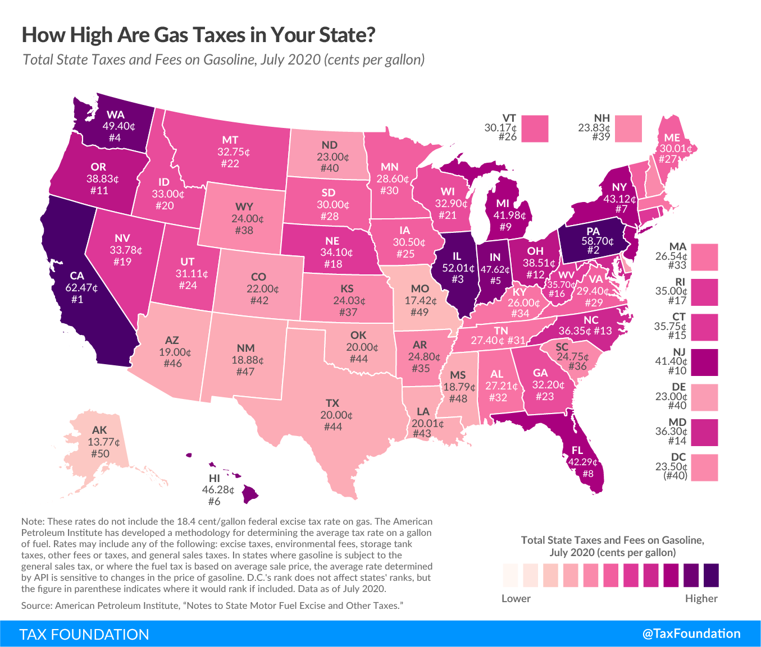

**IS THE INCENTIVE AS DESIGNED ACCOMPLISHING ITS PURPOSE?**

[FOR TERC TO COMPLETE]

**Appendix: Further Discussion on Costs and Benefits**

The text of the report discusses the direct costs (to the Commonwealth, or more specifically, to the Massachusetts residents or businesses who benefit from state expenditures[6]) and direct benefits (to buyers and sellers of motor fuels at the retail level) of this tax expenditure. It also summarizes indirect and induced costs and benefits associated with this tax expenditure. This appendix will discuss the indirect and induced costs and benefits in more detail.

**Other costs and benefits: Indirect and Induced**

*Indirect and Induced Costs*

Regardless of its size, the existence of a specific tax incentive means less revenue for other spending given the Commonwealth’s balanced budget requirement, assuming no increase in state revenues. Reduced spending on other expenditure items means forgone benefits from those items. This is an **“opportunity cost”** to the Commonwealth. The opportunity cost to the state includes not only the impact on the individuals and the businesses that directly benefit from those expenditure items (this is called “direct impact”), but also the indirect impact on the chain of businesses that provide intermediate products and services to the directly impacted businesses (this is called “indirect impact”). In addition, there is the cost to the chain of businesses that benefit when the employees working for the directly impacted businesses spend their wages and salaries to buy goods and services (this is called “induced impact”). The total forgone benefits to the whole economy are larger than the initial forgone benefits. This phenomenon is called the “Multiplier Effect”.[7]

To estimate the total forgone benefits of the reduced spending, we employed Tax-PI, an economic analysis tool for evaluating the total fiscal and economic effects of tax policy changes. Tax-PI is built on over 30 years of experience in modeling the economic effects of tax policy changes, according to MODELS: TAX-PI[8]. The popularity of the model has grown substantially since it was introduced. Note that while the tax incentive has a specific purpose, the reduced spending is assumed to be proportionally distributed across the Commonwealth’s current expenditures.

*Quantifying total costs (direct, indirect and induced)*

The period of study is limited to the five years from 2018 through 2022, for which we prepared input data to run the model. Tables A1 and A2 report the model results. The figures for 2018 and 2019 are estimates of forgone benefits (opportunity costs) that the Massachusetts economy experienced due to having the expenditure, and those for 2020, 2021 and 2022 are projections of forgone benefits that the Massachusetts economy will experience going forward. The effects are displayed as negative numbers as reduced spending has a negative impact on the state economy.

Tables A1 and A2 show that the reduction in state government spending results in lost economic activities, with real state GDP declining by $1,169 million-$1,316 million and total employment declining by 12,929 -15,103 jobs annually. Lost economic activities result in further loss of state revenues, ranging from $26.3 million to $67.9 million annually. Note that the revenue impact reported in Table A2 does not include the estimated direct impact of the tax expenditure from Table 1, but only the additional indirect/induced impact.

**Table A1. Additional Revenue Impact due to Decreased Government Spending\***

|  |  |  |  |  |  |
| --- | --- | --- | --- | --- | --- |
| Fiscal Year | 2018 | 2019 | 2020 | 2021 | 2022 |
| Additional revenue impact ($000) | -$26,295 | -$58,524 | -$64,612 | -$67,071 | -$67,913 |

* This table reports the lost revenues from the foregone economic activities as the state reduced government spending to finance the sales tax exemption for motor fuels.

**Table A2. Economic Impacts due to Decreased Government Spending by Selected Economic Measure\***

|  |  |  |  |  |  |
| --- | --- | --- | --- | --- | --- |
| Calendar Year | 2018 | 2019 | 2020 | 2021 | 2022 |
| Impact on total employment | -14,496 | -15,103 | -14,543 | -13,787 | -12,929 |
| Impact on private non-farm employment | -7,990 | -8,323 | -8,054 | -7,510 | -6,852 |
| Impact on GDP ($000), real dollars (2012) | -$1,253,000 | -$1,316,000 | -$1,280,000 | -$1,230,000 | -$1,169,000 |
| Impact on personal income ($000) | -$1,044,000 | -$1,206,000 | -$1,272,000 | -$1,304,000 | -$1,310,000 |

*This table reports the lost economic activities as the state reduced government spending to finance the sales tax exemption for motor fuels.

*Indirect and Induced Benefits*

The tax savings to buyers and sellers of motor fuels at the retail level encourages directly affected consumers to buy more of other products and services and directly affected businesses to invest, expand, hire additional workers, etc. Such decisions would increase demand for goods and services provided by other individuals and businesses in the economy (including wholesalers, importers, and producers of motor fuels), or put another way, generate a “Multiplier Effect” (see discussion in the previous section) from the initial or direct benefits as reported in the text. As a result, the total benefits of the sales tax exemption for motor fuels would be larger than the initial or direct benefits.

*Quantifying total benefits (direct, indirect and induced)*

To quantify the total benefits, including indirect/induced benefits, we again employed Tax-PI. A summary of the revenue impact of the sales tax exemption for motor fuels is reported in Table A3, and the economic benefit from the sales tax exemption for motor fuels is reflected in Table A4 below. The figures for 2018 and 2019 are estimates of benefits that the Massachusetts economy experienced and those for 2020, 2021 and 2022 are projections of the benefits that the Massachusetts economy will experience going forward.

Tables A3 and A4 show that, the sales tax exemption for motor fuels results in more economic activities, with real state GDP increasing by $870 million - $1,227 million and total employment increasing by 10,203-13,786 jobs annually. More economic activities result in more state revenues, ranging from $53.6 million to $137.1 million annually, which partially offsets the cost of this tax incentive.

**Table A3. Additional Revenue Impact of Sales Tax Exemption**

**for Motor Fuels**

|  |  |  |  |  |  |
| --- | --- | --- | --- | --- | --- |
| Fiscal Year | 2018 | 2019 | 2020 | 2021 | 2022 |
| Additional revenue impact ($000) | $53,629 | $118,759 | $132,714 | $136,874 | $137,080 |

**Table A4. Economic Impacts of Sales Tax Exemption**

**for Motor Fuels by Selected Economic Measure**

|  |  |  |  |  |  |
| --- | --- | --- | --- | --- | --- |
| Calendar Year | 2018 | 2019 | 2020 | 2021 | 2022 |
| Impact on total employment | 10,203 | 13,261 | 13,786 | 13,078 | 11,755 |
| Impact on private non-farm employment | 9,705 | 12,407 | 12,729 | 11,929 | 10,591 |
| Impact on GDP ($000), real dollars (2012) | $870,000 | $1,159,000 | $1,227,000 | $1,187,000 | $1,088,000 |
| Impact on personal income ($000) | $880,000 | $1,222,000 | $1,382,000 | $1,436,000 | $1,412,000 |

**Comparison of costs and benefits**

Ignoring the opportunity cost of the tax incentive, total benefits are greater than costs. Considering the opportunity cost means asking what benefits would be reaped if the Commonwealth used the dollars spent on the tax incentive for other purposes. Those dollars could be spent in many other ways, and examining them is beyond the scope of the current evaluation report. Nonetheless, we reported net impacts of the tax incentive in Tables A5 and A6 below under the balanced budget requirement, which are the combined effects in Tables A1-A4.

Tables A5 and A6 show that the sales tax exemption for motor fuels combined with a cut in state government spending results in less economic activity, with real state GDP decreasing by $45 million-$385 million. The net impact on total employment is negative, decreasing by 738 – 4,323 jobs annually. The net additional impact on state revenues is positive, increasing by $27.2 million to $69.5 million annually.

Note that because the tax expenditure has a specific purpose (in this case, the avoidance of double taxation of motor fuels), the net negative impacts on economic activity (real state GDP) do not necessarily imply that the tax expenditure is not desirable.

**Table A5. Net Additional Revenue Impact of Sales Tax Exemption**

**for Motor Fuels\***

|  |  |  |  |  |  |
| --- | --- | --- | --- | --- | --- |
| Fiscal Year | 2018 | 2019 | 2020 | 2021 | 2022 |
| Net additional revenue impact ($000) | $27,201 | $59,966 | $67,808 | $69,477 | $68,908 |

* assuming state government spending is cut by the same amount as the revenue loss due to the sales tax exemption for motor fuels to balance budget.

**Table A6. Net Economic Impacts of Sales Tax Exemption**

**for Motor Fuels by Selected Economic Measure\***

|  |  |  |  |  |  |
| --- | --- | --- | --- | --- | --- |
| Calendar Year | 2018 | 2019 | 2020 | 2021 | 2022 |
| Impact on total employment | -4,323 | -1,868 | -787 | -738 | -1,186 |
| Impact on private non-farm employment | 1,687 | 4,060 | 4,648 | 4,392 | 3,729 |
| Impact on GDP ($000), real dollars (2012) | -$385,000 | -$160,000 | -$56,000 | -$45,000 | -$82,000 |
| Impact on personal income ($000) | -$167,000 | $13,000 | $106,000 | $129,000 | $101,000 |

* assuming state government spending is cut by the same amount as the revenue loss due to the sales tax exemption for motor fuels to balance budget.

1. These numbers are counts of “establishments”, not counts of “firms”.
2. <https://www.mass.gov/doc/massachusetts-transportation-facts/download#:~:text=With%20an%20estimated%20population%20of,and%202015%20UMass%20Donahue%20Institute>
3. <https://www.fhwa.dot.gov/policyinformation/statistics/2018/mv1.cfm>
4. Regional Economic Models Inc. is a recognized leader in economic analysis at the state level. See their website for background information and further details <https://www.remi.com/>
5. Including both tax and non-tax revenues but excluding the revenue loss reported in Table 1.
6. Spending on a specific tax incentive means less spending on other expenditure items for the Commonwealth under balanced budget requirement if there is no increase in state revenues. Reduced spending on other expenditure items means forgone benefits from those items. This is an opportunity cost to the Commonwealth, which, more specifically, is borne by the Massachusetts residents or businesses who benefit from those expenditure items.
7. For an illustration of “Multiplier Effect”, see Slide 4 of: <https://www.ilw.com/seminars/JohnNeillCitation.pdf>
8. https://www.remi.com/model/tax-pi/