PROPOSED MASSACHUSETTS TAX EXPENDITURES
EVALUATION SUMMARY

EVALUATION YEAR: 2020
TAX EXPENDITURE TITLE | Exemption for Materials, Tools, Fuels and Machinery Used in Research and Development
TAX EXPENDITURE NUMBER | 3.303
TAX EXPENDITURE CATEGORY | Exempt Component of a Product or Consumed in Production
TAX TYPE | Sales and use tax
LEGAL REFERENCE | M.G.L. c. 64H, § 6(r) and (s)
YEAR ENACTED | (1977) Chapter 620 of the Acts of 1977
REPEAL/EXPIRATION DATE | None
ANNUAL REVENUE IMPACT | Tax loss of $82.8 - $95.1 million per year during FY18-FY22
NUMBER OF TAXPAYERS | Buyers and Sellers who buy and sell exempt items
AVERAGE TAXPAYER BENEFIT | Annual tax saving of about $17,300 per business who buy exempt items

Description of the Tax Expenditure:  Materials, tools, fuels, machinery, and replacement parts used directly and exclusively in research and development by manufacturing or research and development corporations are exempt from sales tax. | Is the purpose defined in the statute?  The statute does not explicitly state the purpose of this tax expenditure. We inferred that the purpose is to encourage research and development activity in Massachusetts.
What are the policy goals of the expenditure?  To encourage research and development activity by providing companies with a sales tax exemption for the purchase of materials, machinery and other items used in research and development. | Are there other states with a similar Tax Expenditure?  Yes. However, the majority of states only exempt purchases of machinery or equipment used directly and exclusively in research and development. It is less common for states to allow the credit for purchases of all materials, tools, fuels, and replacement parts used directly and exclusively in research and development
Conclusion/Recommendations: [To be Entered by TERC]

INTRODUCTION
This tax expenditure exempts purchases of materials, tools, fuels and machinery, and replacement parts used directly and exclusively in research and development (R&D) in Massachusetts by manufacturing or research and development corporations. Corporations need not apply for classification as manufacturing or research and development corporations in order to qualify for the exemption. Rather, it is sufficient that the corporations meet the statutory definition of a manufacturing or research and development corporation.

POLICY GOALS
The goal of the tax expenditure is to encourage research and development activity in Massachusetts by allowing certain research and development and manufacturing corporations to make tax-free purchases of machinery, materials, tools, fuels, repair parts, and other items used in research and development in Massachusetts. The exemption encourages the purchase of such items and saves such companies capital they can use to otherwise expand their business activities in Massachusetts, such as increasing the capital available to hire additional employees, rent or purchase additional office, manufacturing, or laboratory space, or make other investments in Massachusetts.

DIRECT COSTS
The revenue loss resulting from this tax expenditure is estimated to be $82.8 - $95.1 million per year during FY18-FY22. See Table 1.

Table 1. Tax Revenue Loss Estimates for Sales Tax Exemption for
Materials, Tools, Fuels, and Machinery Used in Research and Development
Fiscal Year | 2018 | 2019 | 2020 | 2021 | 2022
Estimated Revenue Loss ($Million) | $82.8 | $88.4 | $92.3 | $94.2 | $95.1

DIRECT BENEFITS
The businesses that buy and sell exempt products (materials, tools, fuels, and machinery) used in research and development conducted in Massachusetts are the direct beneficiaries of the sales tax exemption. Buyers benefit from the sales tax exemption in the form of paying a lower “after tax price” while sellers benefit from the sales tax exemption in the form of receiving a higher “before tax price”. The exact split of the direct benefits depends on the interaction of demand and supply and is often difficult to quantify.

Eligible buyers are the manufacturing or research and development corporations that conduct research and development in Massachusetts. However, data on eligible buyers who actually used this sales tax exemption in a year is not available. But the data presented below give a rough estimate of buyers who might have used this exemption.

According to the U.S. Census Bureau, in 2017, Massachusetts had 1,259 scientific research and development firms. These firms employed 60,061 people generating $8.2 billion in annual payroll and $17.5 billion in annual sales.

Table 2 reports the number of corporations who self-reported on their corporate tax returns as a classified manufacturing corporation or a research and development corporation. These corporations are eligible for the sales tax exemption. Table 2 does not reflect the additional corporations that are eligible for the exemption but have not applied for manufacturing classification or did not identify as research and development corporations on their returns. Therefore, the actual number of taxpayers who used this tax exemption may be higher than the numbers reported in Table 2.

Table 2. Number of Corporations Self-Reporting as a Classified Manufacturing
Corporation or a R&D Corporation on Corporate Tax Return
Tax Year | 2014 | 2015 | 2016 | 2017 | 2018
Classified Manufacturing Corporation | 4,255 | 4,215 | 4,304 | 4,217 | 3,899
Research and Development Corporation | 1,181 | 1,318 | 1,244 | 1,388 | 1,479
Total | 5,436 | 5,533 | 5,548 | 5,605 | 5,378
Source: Department of Revenue (corporate excise return)
Note: The data for tax year 2018 are preliminary and subject to change.

If we assume that the entire tax saving due to the sales tax exemption is passed on to buyers and on average 5,500 buyers used this tax exemption annually, the average tax saving per buyer would be about $17,300 in FY22 (=$95.1 million divided by 5,500).

EVALUATION: COMPARING COSTS AND BENEFITS
In the previous sections, we report the direct costs (to the Commonwealth, or to the residents and businesses who ultimately bear the costs when the Commonwealth cuts government spending or increases taxes to finance the sales tax exemption for materials, tools, fuels, and machinery used in research and development) and direct benefits (to buyers and sellers of exempt items) of this tax expenditure. Since the direct costs to the Commonwealth are the direct benefits to taxpayers, they are equal.

Besides the direct costs and benefits, there are indirect and induced costs and benefits associated with this tax expenditure. The indirect impact (cost or benefit) is felt by the chain of businesses that provide intermediate products and services to the directly impacted businesses. The induced impact (cost or benefit) results from any overall change in the economy derived from the tax expenditure, such as where a chain of businesses benefits when the employees working for the directly impacted businesses spend their additional wages and salaries attributable to the tax expenditure to buy goods and services. The total benefits or costs to the whole economy are larger than the initial direct impacts. This phenomenon is called the “Multiplier Effect”.

To measure these indirect and induced costs and benefits, economists often need to utilize complicated models, such as REMI (Regional Economic Models, Inc.) or IMPLAN (Impact Analysis for Planning) models. Appendix 1 shows one such attempt by DOR.

However, the modeling presented in Appendix 1 does not incorporate the positive externalities generated by business research and development. Positive externalities occur when there is a positive gain on both the private level and social level. Research and development conducted by a company can have positive externalities. Research and development increases the private profits of a company but also has the added benefits of increasing the general level of knowledge within a society and promoting economic growth through its positive effect on innovation and productivity. Since positive externalities cannot be paid for through the market, government intervention, such as subsidy (or public funding to research and development), is often viewed as necessary. The sales tax exemption for materials, tools, fuels, machinery used in the research and development can also be viewed as a tax policy, along with other policies, to encourage an activity that has positive externalities. However, to quantify the effectiveness of policies, especially a single policy, in encouraging research and development is challenging. In Appendix 2, we present some data on business research and development in Massachusetts without attempting to identify the impact of the sales tax exemption for materials, tools, fuels, machinery used in the research and development. We also present a report showing how research contributes to Massachusetts innovation economy.

Similar Tax Expenditures Offered by Other States
Most states provide a sales tax exemption for the purchase of qualified machinery and equipment used in the manufacturing and research and development process. The following discussion sets out some examples.

Ohio exempts business from the entire state and county sales tax for purchases of qualified machinery and equipment used primarily for research and development. This exemption provides significant savings for companies undertaking research and development activities in Ohio. The exemption applies to machinery and equipment included in research and development activity in both direct and pure research. Direct research refers to research conducted to design, create or formulate new or better products, equipment or processes. Pure research refers to scientific or technological inquiry and experimentation in the physical sciences.

In New York, purchases of tangible personal property for use or consumption directly and predominantly in research and development in the experimental or laboratory sense can be made without paying sales tax.

In California, manufacturers and certain research and developers may qualify for a partial exemption of sales and use tax on certain manufacturing and research and development equipment purchases and leases.

There is a 100 percent sales tax exemption for qualified research and development equipment and property purchased in Indiana.

IS THE INCENTIVE AS DESIGNED ACCOMPLISHING ITS PURPOSE?
[FOR TERC TO COMPLETE]

Appendix 1: Further Discussion on Costs and Benefits
The text of the report discusses the direct costs (to the Commonwealth, or more specifically, to the Massachusetts residents or businesses who benefit from state expenditures) and direct benefits (to qualified buyers and sellers of materials, tools, fuels and machinery, and replacement parts used directly and exclusively in research and development) of this tax expenditure. It also summarizes indirect and induced costs and benefits associated with this tax expenditure. This appendix will discuss the indirect and induced costs and benefits in more detail.
Other costs and benefits: Indirect and Induced
Indirect and Induced Costs
Regardless of its size, the existence of a specific tax incentive means less revenue for other spending given the Commonwealth’s balanced budget requirement, assuming no increase in state revenues. Reduced spending on other expenditure items means forgone benefits from those items. This is an “opportunity cost” to the Commonwealth. The opportunity cost to the state includes not only the impact on the individuals and the businesses that directly benefit from those expenditure items (this is called “direct impact”), but also the indirect impact on the chain of businesses that provide intermediate products and services to the directly impacted businesses (this is called “indirect impact”). In addition, there is the cost to the chain of businesses that benefit when the employees working for the directly impacted businesses spend their wages and salaries to buy goods and services (this is called “induced impact”). The total forgone benefits to the whole economy are larger than the initial forgone benefits. This phenomenon is called the “Multiplier Effect”.

To estimate the total forgone benefits of the reduced spending, we employed Tax-PI, an economic analysis tool for evaluating the total fiscal and economic effects of tax policy changes. Tax-PI is built on over 30 years of experience in modeling the economic effects of tax policy changes, according to MODELS: TAX-PI. The popularity of the model has grown substantially since it was introduced. Note that while the tax incentive has a specific purpose, the reduced spending is assumed to be proportionally distributed across the Commonwealth’s current expenditures.

Quantifying total costs (direct, indirect and induced)
The period of study is limited to the five years from 2018 through 2022, for which we prepared input data to run the model. Tables A1-1 and A1-2 report the model results. The figures are estimates or projections of forgone benefits (opportunity costs) that the Massachusetts economy experiences due to having the expenditure. The effects are displayed as negative numbers as reduced spending has a negative impact on the state economy.

Tables A1-1 and A1-2 show that the reduction in state government spending results in lost economic activities, with real state GDP declining by $189 million-$216 million and total employment declining by 2,188 -2,450 jobs annually. Lost economic activities result in further loss of state revenues, ranging from $4.0 million to $11.8 million annually. Note that the revenue impact reported in Table A1-1 does not include the estimated direct impact of the tax expenditure from Table 1, but only the additional indirect/induced impact.

Table A1-1. Additional Revenue Impact due to Decreased Government Spending*
Fiscal Year | 2018 | 2019 | 2020 | 2021 | 2022
Additional revenue impact ($000) | -$3,972 | -$8,974 | -$10,408 | -$11,353 | -$11,793
* This table reports the lost revenues from the foregone economic activities as the state reduced government spending to finance the sales tax exemption for certain products used in research and development.

Table A1-2. Economic Impacts due to Decreased Government Spending
by Selected Economic Measure*
Calendar Year | 2018 | 2019 | 2020 | 2021 | 2022
Impact on total employment | -2,188 | -2,350 | -2,450 | -2,401 | -2,296
Impact on private non-farm employment | -1,206 | -1,295 | -1,356 | -1,309 | -1,222
Impact on GDP ($000), real dollars (2012) | -$189,000 | -$205,000 | -$216,000 | -$214,000 | -$208,000
Impact on personal income ($000) | -$158,000 | -$187,000 | -$212,000 | -$224,000 | -$230,000
*This table reports the lost economic activities as the state reduced government spending to finance the sales tax exemption for certain products used in research and development.

Indirect and Induced Benefits
The tax savings to buyers and sellers of exempt products used in research and development encourage directly affected buyers and sellers to expand business activities, hire additional employees, rent or purchase additional office or laboratory space, or make other investments, etc. Such decisions would increase demand for goods and services provided by other individuals and businesses in the economy, or put another way, generate a “Multiplier Effect” (see discussion in the previous section) from the initial or direct benefits as reported in the text. As a result, the total benefits of this sales tax exemption would be larger than the initial or direct benefits.

Quantifying total benefits (direct, indirect and induced)
To quantify the total benefits, including indirect/induced benefits, we again employed Tax-PI. A summary of the revenue impact of the sales tax exemption for materials, tools, fuels and machinery, and replacement parts used directly and exclusively in research and development is reported in Table A1-3, and the economic benefit from this sales tax exemption is reflected in Table A1-4 below. The figures are estimates or projections of benefits that the Massachusetts economy experiences.

Tables A1-3 and A1-4 show that, the sales tax exemption for materials, tools, fuels and machinery, and replacement parts used directly and exclusively in research and development results in more economic activities, with real state GDP increasing by $190 million - $257 million and total employment increasing by 1,719-2,242 jobs annually. More economic activities result in more state revenues, ranging from $3.7 million to $12.9 million annually, which partially offsets the cost of this tax incentive.

Table A1-3. Additional Revenue Impact of Sales Tax Exemption
for Certain Products used in Research and Development
Fiscal Year | 2018 | 2019 | 2020 | 2021 | 2022
Additional revenue impact ($000) | $3,666 | $8,645 | $10,639 | $12,063 | $12,915

Table A1-4. Economic Impacts of Sales Tax Exemption for Certain Products
used in Research and Development by Selected Economic Measure
Calendar Year | 2018 | 2019 | 2020 | 2021 | 2022
Impact on total employment | 1,719 | 2,029 | 2,215 | 2,242 | 2,184
Impact on private non-farm employment | 1,652 | 1,916 | 2,073 | 2,082 | 2,015
Impact on GDP ($000), real dollars (2012) | $190,000 | $224,000 | $248,000 | $256,000 | $257,000
Impact on personal income ($000) | $131,000 | $170,000 | $202,000 | $221,000 | $233,000

Comparison of costs and benefits
Ignoring the opportunity cost of the tax incentive, total benefits are greater than costs. Considering the opportunity cost means asking what benefits would be reaped if the Commonwealth used the dollars spent on the tax incentive for other purposes. Those dollars could be spent in many other ways, and examining them is beyond the scope of the current evaluation report. Nonetheless, we reported net impacts of the tax incentive in Tables A1-5 and A1-6 below under the balanced budget requirement, which are the combined effects in Tables A1-1 to A1-4.

Tables A1-5 and A1-6 show that the sales tax exemption for materials, tools, fuels and machinery, and replacement parts used directly and exclusively in research and development combined with a cut in state government spending results in more economic activity, with real state GDP increasing by $1 million-$49 million. The net impact on total employment is negative, decreasing by 112 – 469 jobs annually. However, the net impact on private non-farm employment is positive, increasing by 445-792 jobs annually. The net additional impact on state revenues is mixed, from a decrease of $0.3 million to an increase of $1.1 million annually.

Note that in general the tax expenditure has a positive net impact on economic activities (real GDP) though it has net negative impacts on some economic variables for some years like employment and personal income. In addition, as discussed in the text, the analysis in this appendix does not take into account the positive externalities of research and development. Such positive externalities are very important for promoting economic growth. That may be why governments adopt various policies, including this tax expenditure, to encourage research and development activity.

Table A1-5. Net Additional Revenue Impact of Sales Tax Exemption
for Certain Products used in Research and Development *
Fiscal Year | 2018 | 2019 | 2020 | 2021 | 2022
Net additional revenue impact ($000) | -$307 | -$332 | $228 | $707 | $1,118
* assuming state government spending is cut by the same amount as the revenue loss due to the sales tax exemption for certain products used in research and development to balance budget.

Table A1-6. Net Economic Impacts of Sales Tax Exemption for Certain Products
used in Research and Development by Selected Economic Measure*
Calendar Year | 2018 | 2019 | 2020 | 2021 | 2022
Impact on total employment | -469 | -321 | -235 | -159 | -112
Impact on private non-farm employment | 445 | 621 | 717 | 772 | 792
Impact on GDP ($000), real dollars (2012) | $1,000 | $20,000 | $32,000 | $42,000 | $49,000
Impact on personal income ($000) | -$27,000 | -$17,000 | -$10,000 | -$3,000 | $3,000
* assuming state government spending is cut by the same amount as the revenue loss due to the sales tax exemption for certain products used in research and development to balance budget.

Appendix 2: Business R&D in Massachusetts and Index of the Massachusetts Innovation Economy
Business R&D in Massachusetts compared with other states
2017 business R&D in Massachusetts totaled $23.7 billion. See the table below from a publication by National Science Foundation (NSF).
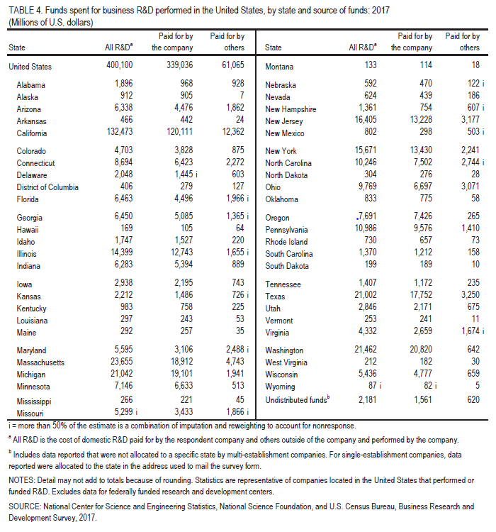

Business R&D performance in New England States in 2017 ($ Millions)

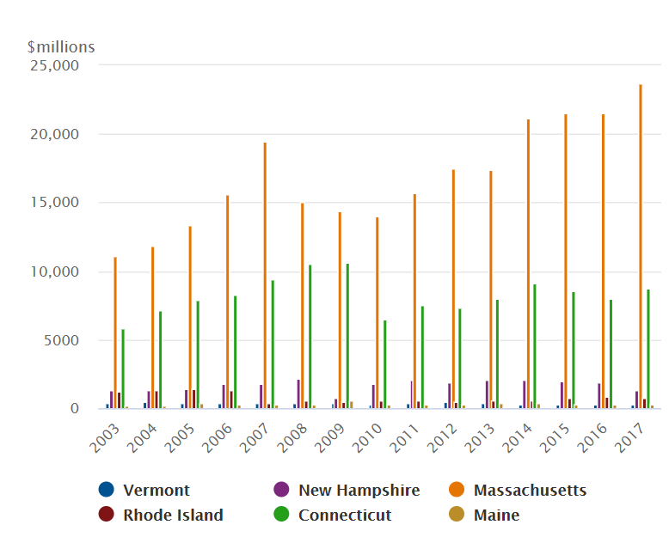
Source: National Science Foundation

Business R&D performance in MA, WA, CA, NJ, NY, MI, and CT in 2017 ($ Millions)
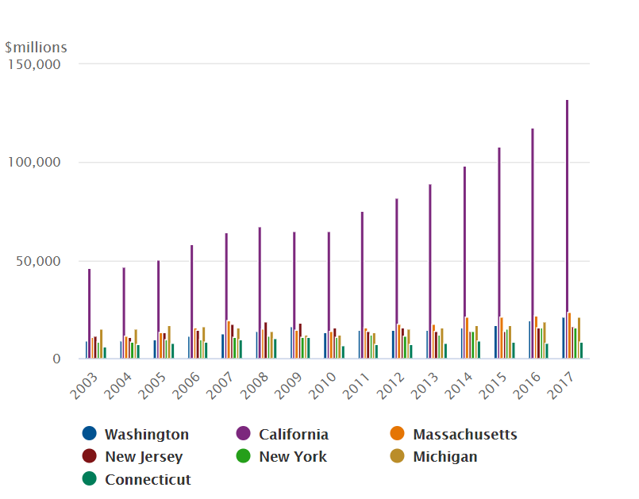
Source: National Science Foundation

Index of the Massachusetts Innovation Economy
The 2019 Edition of the Index of the Massachusetts Innovation Economy (https://masstech.org/index) published by the Innovation Institute at the Massachusetts Technology Collaborative ranked Massachusetts 1st among 10 leading technology states. See the table below.
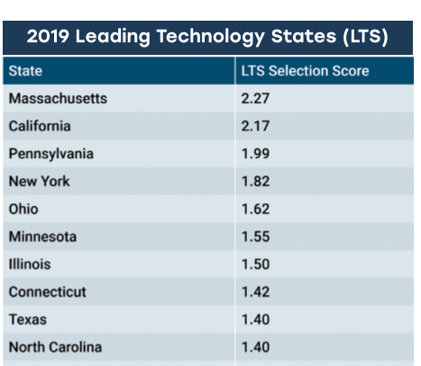

Every year, the Index compares Massachusetts’ performance on several metrics (talent, research, capital) to a group of “Leading Technology States” (LTS). The LTS have economies with a significant level of economic concentration and size in the 11 key sectors that compose the Innovation Economy (IE) in Massachusetts (see below). The Index accounts for three metrics deemed representative of not only the intensity of the Innovation Economy, but also the size and breadth of a state’s Innovation Economy and evaluates them simultaneously.
Eleven Key Innovation Economy Sectors
- Advanced Materials
- Biopharmaceuticals & Medical Devices
- Business Services
- Computer and Communications Hardware
- Defense Manufacturing and Instrumentation
- Diversified Industrial Manufacturing
- Financial Services
- Healthcare Delivery
- Postsecondary Education
- Scientific, Technical, and Management Services
- Software and Communications Services

Besides talent and capital, one of the three pillars forming the driving force of the Innovation Economy is research. Massachusetts received more R&D investment ($30.9B) as a % of GDP (5.7%) than any of the LTS in 2016 and received the most federal funding for R&D relative to GDP (0.6%) as well. Massachusetts had both the most Technology Patents per capita of any of the LTS (871 per million residents in 2018) and the most Science & Engineering academic articles per doctorate holder in academia of any of the LTS and internationally (1,328 per 1,000 doctorate holders in 2017).

https://malegislature.gov/Laws/GeneralLaws/PartI/TitleIX/Chapter63/Section42B
Firms in the industry with 4-digit NAICS of 5417.
For an illustration of “Multiplier Effect”, see Slide 4 of: https://www.ilw.com/seminars/JohnNeillCitation.pdf
Spending on a specific tax incentive means less spending on other expenditure items for the Commonwealth under balanced budget requirement if there is no increase in state revenues. Reduced spending on other expenditure items means forgone benefits from those items. This is an opportunity cost to the Commonwealth, which, more specifically, is borne by the Massachusetts residents or businesses who benefit from those expenditure items.
https://www.remi.com/model/tax-pi/
Including both tax and non-tax revenues but excluding the revenue loss reported in Table 1.
https://www.nsf.gov/statistics/2019/nsf19326/nsf19326.pdf

