PROPOSED MASSACHUSETTS TAX EXPENDITURES
EVALUATION SUMMARY

EVALUATION YEAR: 2020
TAX EXPENDITURE TITLE |  | Exemption for Vessels, Materials, Tools, Fuels, and Machinery Used in Commercial Fishing
TAX EXPENDITURE NUMBER |  | 3.309
TAX EXPENDITURE CATEGORY |  | Exempt Products that are consumed and used directly and exclusively in the production of an exempt item
TAX TYPE |  | Sales and use tax
LEGAL REFERENCE |  | M.G.L. c. 64H, §§ 6(o), (r), and (s)
YEAR ENACTED |  | 1967 (Chapter 757 of the Acts of 1967, § 1)
REPEAL/EXPIRATION DATE |  | None.
ANNUAL REVENUE IMPACT |  | Tax loss of $12.7 - $15.0 million per year during FY18-FY22
NUMBER OF TAXPAYERS |  | Buyers and Sellers who buy and sell exempt items
AVERAGE TAXPAYER BENEFIT |  | About $4,500 per commercial fishing business
Description of the Tax Expenditure:  Vessels, materials, tools, fuels, and machinery, and replacement parts which are consumed and used directly and exclusively in commercial fishing are exempt from sales tax. | Is the purpose defined in the statute?  The statute does not explicitly state the purpose of this tax expenditure.
What are the policy goals of the expenditure?  To (i) encourage and support commercial fishing activity in Massachusetts and (ii) avoid imposing a tax at the intermediate stages in the economic process of producing food, an exempt item, by exempting purchases of vessels, machinery and consumables used directly and exclusively in commercial fishing. | Are there other states with a similar Tax Expenditure?  Yes. Most coastal states or states near large freshwater fishing areas offer similar exemptions.
Conclusion/Recommendations: [To be Entered by TERC]

INTRODUCTION
Vessels, materials, tools, fuels, and machinery, including replacement parts, used in commercial fishing are exempt from sales tax if they are consumed or directly used in commercial fishing.

POLICY GOALS
The exemption is intended to encourage and support the Massachusetts commercial fishing industry by exempting equipment and materials (e.g., vessels, fuels and other supplies and equipment) used directly and exclusively in commercial fishing activities. Furthermore, food is generally exempt from sales and use tax in Massachusetts. By exempting property used in commercial fishing (e.g., vessels, materials, tools, fuels, and machinery, including replacement parts), Massachusetts avoids imposing a tax at the intermediate stages in the economic process of producing food, which would lead to ultimately taxing an exempt item.

DIRECT COSTS
The revenue loss resulting from this tax expenditure is estimated to be $12.7 - $15.0 million per year during FY18-FY22. See Table 1.

Table 1. Tax Revenue Loss Estimates for Sales Tax Exemption
for Vessels, Materials, Tools, Fuels, and Machinery Used in Commercial Fishing
Fiscal Year | 2018 | 2019 | 2020 | 2021 | 2022
Estimated Revenue Loss ($Million) | $12.7 | $13.2 | $13.8 | $14.4 | $15.0

DIRECT BENEFITS
The Massachusetts businesses that buy and sell exempt products (vessels, materials, tools, fuels, and machinery) used in commercial fishing are the direct beneficiaries of the sales tax exemption. Buyers benefit from the sales tax exemption in the form of paying a lower “after tax price” while sellers benefit from the sales tax exemption in the form of receiving a higher “before tax price”. The exact split of the direct benefits depends on the interaction of demand and supply and is often difficult to quantify. Out-of-state businesses that sell the exempt products to Massachusetts commercial fishing businesses also benefit from this sales tax exemption.

According to the U.S. Census Bureau, in 2012, Massachusetts had 3,121 businesses in the commercial fishing industry, including businesses with or without paid employees. If we assume that the entire tax saving due to the sales tax exemption is passed on to buyers, the average tax saving per year to commercial fishing businesses is estimated to be about $4,500.

EVALUATION: COMPARING COSTS AND BENEFITS
In the previous sections, we report the direct costs (to the Commonwealth, or to the residents and businesses who ultimately bear the costs when the Commonwealth cuts government spending or increases taxes to finance the sales tax exemption for vessels, materials, tools, fuels, and machinery used in commercial fishing) and direct benefits (to buyers and sellers of exempt items) of this tax expenditure. Since the direct costs to the Commonwealth are the direct benefits to taxpayers, they are equal.

Besides the direct costs and benefits, there are indirect and induced costs and benefits associated with this tax expenditure. The indirect impact (cost or benefit) is felt by the chain of businesses that provide intermediate products and services to the directly impacted businesses. The induced impact (cost or benefit) results from any overall change in the economy derived from the tax expenditure, such as where a chain of businesses benefits when the employees working for the directly impacted businesses spend their additional wages and salaries attributable to the tax expenditure to buy goods and services. The total benefits or costs to the whole economy are larger than the initial direct impacts. This phenomenon is called the “Multiplier Effect”.

To measure these indirect and induced costs and benefits, economists often need to utilize complicated models, such as REMI (Regional Economic Models, Inc.) or IMPLAN (Impact Analysis for Planning) models. Given that the amount of direct costs and benefits are small for this tax expenditure, less than $20 million per year, DOR did not attempt to quantify such costs and benefits.

The indirect benefits of this tax expenditure include that to consumers. The exemption results in a lower retail cost of food purchased for human consumption, such that the price of seafood purchased for human consumption will not include tax previously imposed on materials used to catch the fish. The indirect benefits also include that to the entire seafood industry, which comprises the commercial fishing sector, seafood processors and dealers, seafood wholesalers and distributors, importers, and seafood retailers. The appendix provides some data for the seafood industry compiled by the National Oceanic and Atmospheric Administration (NOAA) of the U.S. Department of Commerce.

Besides the economic costs and benefits discussed so far, this tax expenditure may have other costs or benefits. For example, by encouraging commercial fishing, this tax expenditure may have a negative impact on environment by aggravating the problem of overfishing if there are no other policies to offset this impact. Overfishing is a classic example of “negative externality” or “tragedy of the commons”. According to the Food Empowerment Project, the commercial fishing industry has been depleting fish populations around the world for decades, driving many species toward extinction. Scientists estimate that the fishing industry kills between 0.97 and 1.97 trillion wild fish worldwide every year, further straining fragile oceans and other waterways that are already poisoned by pollution from oil spills, agricultural runoff and immense amounts of garbage.

Similar Tax Expenditures Offered by Other States
All states that Border Massachusetts, which impose sales tax, provide for some form of exemption for purchases related to commercial fishing:
- In Connecticut, Conn. Gen. Stat. §12-412(40) exempts from sales and use taxes any vessel used exclusively in commercial fishing and any machinery or equipment used on a commercial fishing vessel if the purchaser qualifies for and has been issued a Fisherman Tax Exemption Permit by the Department of Revenue Services (DRS).
- Maine exempts sales of vessels, depreciable machinery and equipment used in commercial fishing. This exemption is detailed in Maine Revenue Services, Sales, Fuel, and Special Tax Division, Instructional Bulletin No. 59.
- Per N.Y. Tax Law § 1115 (24), New York exempts sales of fishing vessels used directly and predominantly in the harvesting of fish for sale, and property used by or purchased for the use of such vessels for fuel, provisions, supplies, maintenance and repairs.
- The Rhode Island sales and use tax does not apply to the sale of and the storage, use or other consumption in this state of vessels which are in excess of five (5) net tons and which are used exclusively for commercial fishing. The exemption also applies to the nets, cables, tackle, and other fishing equipment appurtenant to or used in connection with the commercial fishing of said vessels. Property purchased for the use of such vessels and other watercraft including provisions, supplies, and material for the maintenance and/or repair of such vessels or watercraft is also exempt.
- In 23 VAC 10-210-351, Vermont generally exempts all materials and machinery used directly in commercial fishing.

Several other states, e.g., Louisiana and Washington, also have similar sales tax incentive for commercial fishing activities.

IS THE INCENTIVE AS DESIGNED ACCOMPLISHING ITS PURPOSE?
[FOR TERC TO COMPLETE]

Appendix: Some Statistics on the Seafood Industry
Composed of commercial fishing, suppliers that service commercial fishing, marine aquaculture, fish processing and wholesaling, and retail and food service sales, the seafood industry covers many activities in the commonwealth’s coastal cities and towns. The seafood industry accounts for less than two percent of the commonwealth’s labor force but is an important component of coastal communities such as New Bedford, Gloucester, and some of the towns on Cape Cod. Fishing also retains important links to tourism and the appeal of coastal life.

The tables and charts in the rest of this section are taken from the 2016 Fisheries Economics of the United Sates report (https://www.fisheries.noaa.gov/content/fisheries-economics-united-states-2016) published by NOAA. The tables and charts contain some key data on sales, income, total landings, etc. for the United States, the New England area, and Massachusetts.

In 2016, Massachusetts was ranked 4th in terms of total seafood industry sales, which totaled $7.7 billion, 5.3% of total US sales. Seafood industry in Massachusetts also created 87,201 jobs with imports or 55,384 jobs without imports.

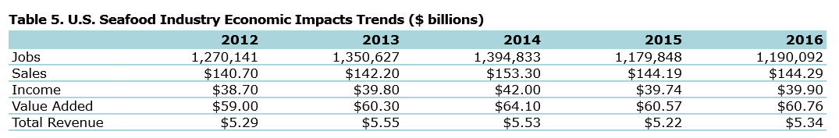

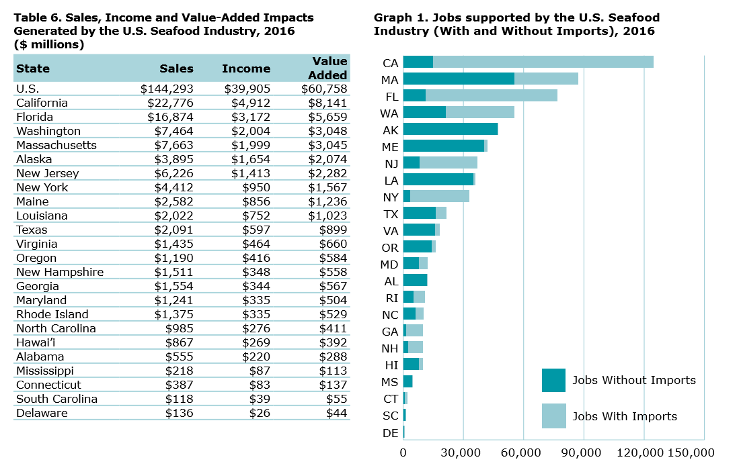

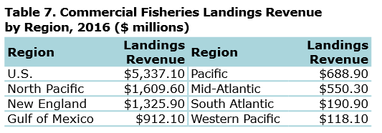

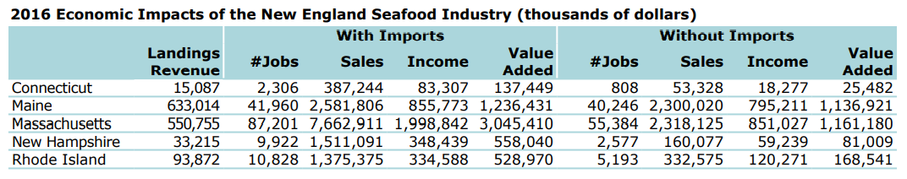

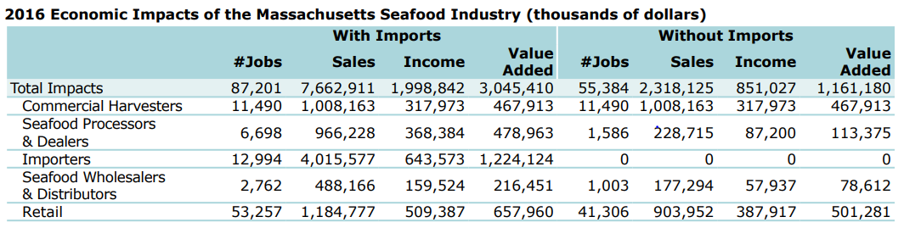

The following table is for Massachusetts:
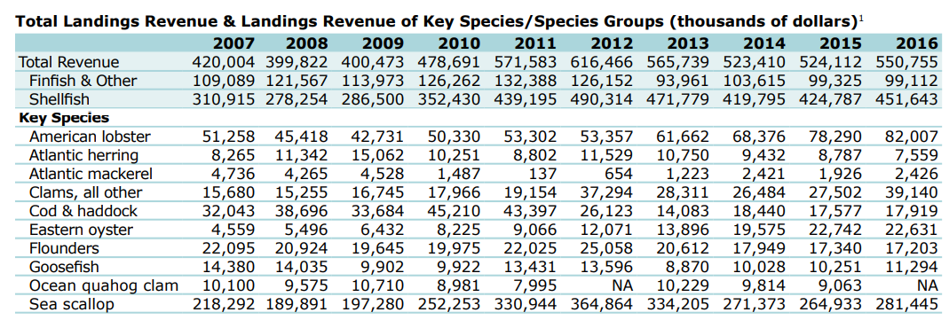

For an illustration of “Multiplier Effect”, see Slide 4 of: https://www.ilw.com/seminars/JohnNeillCitation.pdf
https://www.investopedia.com/terms/t/tragedy-of-the-commons.asp
https://foodispower.org/animals-of-the-sea-2/commercial-fishing/

