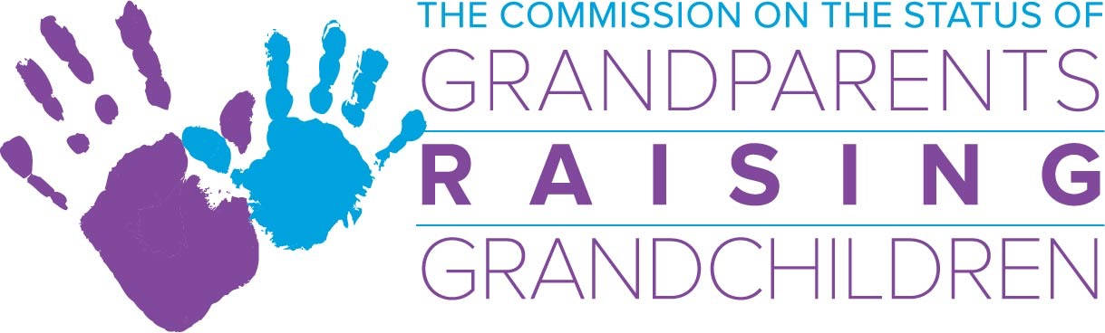

April 3, 2019
Commission Meeting, 2-4 p.m. .
One Ashburton Place 5th Floor Boston, Ma.
Commission Bridge Number: 240-454-0887
Meeting Access Code: 731860817

Agenda

- Acceptance of meeting minutes
*Action required

- Financial Report/Budget
- GP Commission budget
- MCOA budget

- Sub-Committee Updates:
- Information and Referral Sub-Committee:
- Support Group Sub-Committee:
- Legal Sub-Committee:
- Resource Development Sub-Committee:

- Directors Report

- Chairwoman’s Report

- Other Business:

