Commonwealth of Massachusetts
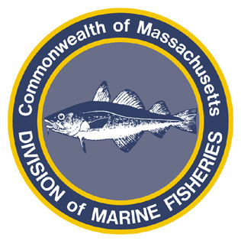
Paul J. Diodati
Director

Deval Patrick
Governor
Timothy P. Murray
Lt. Governor
Richard K. Sullivan, Jr.
Secretary
Mary B. Griffin
Commissioner

Division of Marine Fisheries
251 Causeway Street, Suite 400
Boston, Massachusetts 02114
(617)626-1520
fax (617)626-1509

April 14, 2011
MarineFisheries Advisory
MFC APPROVES 2011 SPINY DOGFISH SPECIFICATIONS
Fishery to open May 1st at 3,000-lbs

On April 7, 2011 the Marine Fisheries Advisory Commission approved a 3,000 lb commercial spiny dogfish trip limit for 2011. This fishery shall open on May 1, 2011 and will remain open until it has been determined that the Period I fishery has taken its 58% allocation of the 20-million lb 2011 quota. The Massachusetts fishery will then remain closed through April 30, 2011.
State trip limits apply to all permit holders (state and federal) landing in the Commonwealth. When the Period I commercial fishery allocation is reached, MarineFisheries will close the fishery, and all retention and landings of dogfish (by state or federal permit holders) will be prohibited in the Commonwealth of Massachusetts through the end of the fishing year.
For more information, contact MarineFisheries at 617-626-1520 or online at www.mass.gov/marinefisheries.

