Commonwealth of Massachusetts
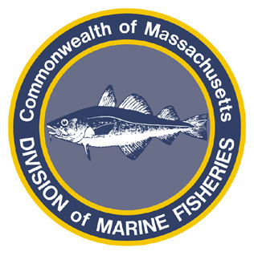
Paul J. Diodati
Director

Deval Patrick
Governor
Timothy P. Murray
Lt. Governor
Richard K. Sullivan, Jr.
Secretary
Mary B. Griffin
Commissioner

Division of Marine Fisheries
251 Causeway Street, Suite 400
Boston, Massachusetts 02114
(617)626-1520
fax (617)626-1509

April 15, 2011
MarineFisheries Advisory
Rules Governing the 2011 Commercial and Recreational Tautog Fishery
MarineFisheries has received a number of queries regarding the 2011 recreational and commercial tautog fisheries. No changes were made to the rules governing these fisheries and the current rules are as follows:

Commercial Tautog

Open Season | Gear Type | Open Days | Trip Limit | Minimum Size
April 16 – May 15 or 28% of quota | All | All | 40 fish/vessel | 16”
September 1 – November 30 | All | All | 40 fish/vessel | 16”

Recreational Tautog

Mode | Season | Bag Limit | Minimum Size
Private (shore or vessel) | Open | 3 fish/angler | 16”
For Hire | Open | 3 fish/angler | 16”

For more information, contact MarineFisheries at 617-626-1520 or online at www.mass.gov/marinefisheries.

