Commonwealth of Massachusetts
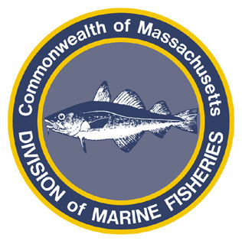
Paul J. Diodati
Director

Deval Patrick
Governor
Timothy P. Murray
Lt. Governor
Richard K. Sullivan, Jr.
Secretary
Mary B. Griffin
Commissioner

Division of Marine Fisheries
251 Causeway Street, Suite 400
Boston, Massachusetts 02114
(617)626-1520
fax (617)626-1509

April 15, 2011
MarineFisheries Advisory
Rules Governing the 2011 Commercial Fisheries for Scup, Black Sea Bass and Fluke
Commercial Scup
Open Season | Gear Type | Open Days | Trip Limit | Minimum Size
May – Quota | Fish Weir | All | 275,000 lb in aggregate | 9”
April 23 – June 9 | Nets During Squid Fishery | All | 800 lbs/day | 9”
June 10 – Quota | Nets During Fluke Fishery | Sunday – Thursday | 800 lbs/day | 9”
May 1 – May 31 | Fish Pot and Hook and Line | Sunday, Tuesday, Wednesday | 400 lbs/day | 9”
July 1 – Quota | Fish Pot and Hook and Line | Sunday – Thursday | 800 lbs/day | 9”

Commercial Black Sea Bass
Open Season | Gear Type | Open Days | Trip Limit | Minimum Size
January 1 – April 30 | All Authorized Gears | All | 100 lbs/day | 12”
May 1 – May 31 | Fish Pot and Weir | Sunday, Tuesday, Wednesday | 200 lbs/day | 12”
May 1 – May 31 | All Other Authorized Gears | Sunday, Tuesday, Wednesday | 80 lbs/day* | 12”
August 1 – Quota | Fish Pot | Sunday – Thursday | 200 lbs/day | 12”
August 1 – Quota | All Other Authorized Gears | Sunday – Thursday | 80 lbs/day* | 12”
* Those taking black sea bass under the authority of a coastal lobster permit shall not take more black sea bass than the weight of lobsters on the 80 lb trip limit, whichever is more restrictive.

Commercial Fluke
Open Season | Gear Type | Open Days | Trip Limit | Minimum Size
February 1 – April 22 | Nets | All | 500 lb/day* | 14”
April 23 – June 9 | Nets and Longlines | All | 100 lb/day | 14”
June 10 – Quota | Nets | Sunday - Thursday | 300 lb/day | 14”
June 10 – Quota | Hook and Line | Sunday - Thursday | 200 lb/day | 14”
* Permit holders with a letter of authorization to participate in the 2011 experimental Period I Winter Fluke Pilot Program may retain and land up to 2,000 lbs/week until the designated Period I allocation is met.

For more information, contact MarineFisheries at 617-626-1520 or online at www.mass.gov/marinefisheries.

