Commonwealth of Massachusetts
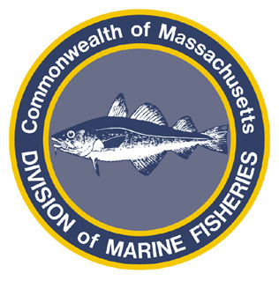
Paul J. Diodati
Director

Deval Patrick
Governor
Timothy P. Murray
Lt. Governor
Richard K. Sullivan, Jr.
Secretary
Mary B. Griffin
Commissioner

Division of Marine Fisheries
251 Causeway Street, Suite 400
Boston, Massachusetts 02114
(617)626-1520
fax (617)626-1509

April 15, 2011
MarineFisheries Advisory
Rules Governing the 2011 Recreational Fisheries for Scup, Black Sea Bass and Fluke

Recreational Scup

Mode | Season | Bag Limit | Minimum Size
Private (shore or vessel) | May 24 – September 26 | 10 fish/angler | 10.5”
For Hire | May 15 – June 18 | 40 fish/angler | 11”
For Hire | June 19 – September 26 | 10 fish/angler | 11”

Recreational Black Sea Bass

Mode | Season | Bag Limit | Minimum Size
Private (shore or vessel) | May 22 – October 10 | 10 fish/angler | 14”
For Hire | May 22 – October 10 | 10 fish/angler | 14”

Recreational Fluke

Mode | Season | Bag Limit | Minimum Size
Private (shore or vessel) | May 22 – September 30 | 5 fish/angler | 17.5”
For Hire | May 22 – September 30 | 5 fish/angler | 17.5

For more information, contact MarineFisheries at 617-626-1520 or online at www.mass.gov/marinefisheries.

