Commonwealth of Massachusetts
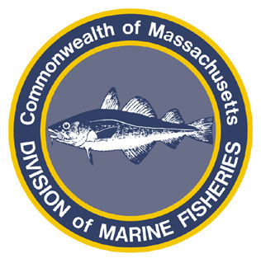
Paul J. Diodati
Director

Deval Patrick
Governor
Timothy P. Murray
Lt. Governor
Richard K. Sullivan, Jr.
Secretary
Mary B. Griffin
Commissioner

Division of Marine Fisheries
251 Causeway Street, Suite 400
Boston, Massachusetts 02114
(617)626-1520
fax (617)626-1509

April 21, 2011
MarineFisheries Advisory
RENEWAL OF SPRING AND WINTER COD CONSERVATION ZONES

The Commonwealth’s Marine Fisheries Advisory Commission met on April 7 and approved proposed regulations to renew the Spring and Winter Cod Conservation Zones (CCZs). Due to the late timing of the action, MarineFisheries is enacting emergency regulations. This action will maintain protection for cod spawning aggregations, while decreasing the overall area closed to allow greater fishing access.
Based on industry requests to allow for greater groundfishing access in concert with the growing research on the timing and location of spawning aggregations, the new CCZ regulations include revisions to the size and dates for both closures. The Spring CCZ is expanded to the east and west, and the closure goes into effect two weeks earlier and closes the same date as last year. The Winter CCZ is reduced in size by 48% (58 nm2) through three boundary revisions: (1) lowering the northern boundary to the south by 2.4 nm; (2) opening a portion of the northeast corner of the closure; and (3) raising the southern boundary by 1 nm. The closure goes into effect two weeks earlier. Additionally, access is being provided to groundfish fishermen in the May and June “rolling closures” (see separate Advisory issued April 21).
Spring Cod Conservation Zone Rules:
- Comprised of waters under the jurisdiction of the Commonwealth north of latitude 42° 30’, south of latitude 42° 33’, east of 70° 44.5’, and west of 70° 38.5’;
- All persons are prohibited from landing or possession cod in the Spring CCZ from April 16 through July 21;
- Vessels are allowed to transit the Spring CCZ from April 16 through July 21 with cod in possession provided said cod were caught outside of the spring CCZ and all fishing gear is stowed; and
- All persons are prohibited from fishing, setting, or abandoning gillnets in the Spring CCZ from April 16 through July 21.
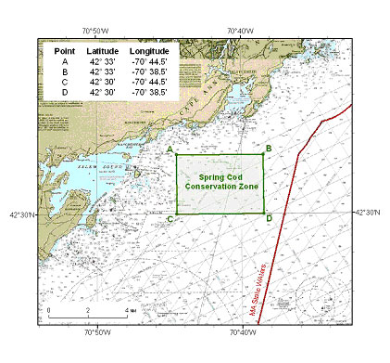
Winter Cod Conservation Rules:
- Comprised of waters under the jurisdiction of the Commonwealth bounded by straight lines connecting the following points in the order stated and starting in the southwest:
North Latitude | West Longitude
42º 21.0' | MA Coast
42º 21.0' | 70º 40.0'
42º 23.6' | 70º 39.2'
42º 27.5' | 70º 42.4'
42º 27.5' | MA Coast
- All persons are prohibited from landing or possession cod in the Winter CCZ from November 15 through January 31;
- Vessels are allowed to transit the Winter CCZ from November 15 through January 31 with cod in possession provided said cod were caught outside of the Winter CCZ and all fishing gear is stowed; and
- All persons are prohibited from fishing, setting, or abandoning any gear capable of harvesting cod in the Winter CCZ from November 15 through January 31. This prohibition applies to all gillnets, otter trawls, mid-water trawls, seines, and all hook-and-line gears including longlines, rod-and-reel, and handlines; lobster traps and drags used for scallops and urchins are exempt.
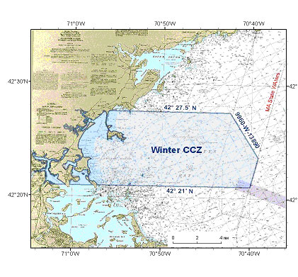
A public hearing will be scheduled for this summer to discuss permanently renewing the closures. Contact MarineFisheries for additional information at 617-626-1520 or visit the website at: www.mass.gov/marinefisheries.

