Background

INDOOR AIR QUALITY ASSESSMENT

Executive Office of Health and Human Services Center
Shetland Park Office Complex
45 Congress Street
Salem, MA

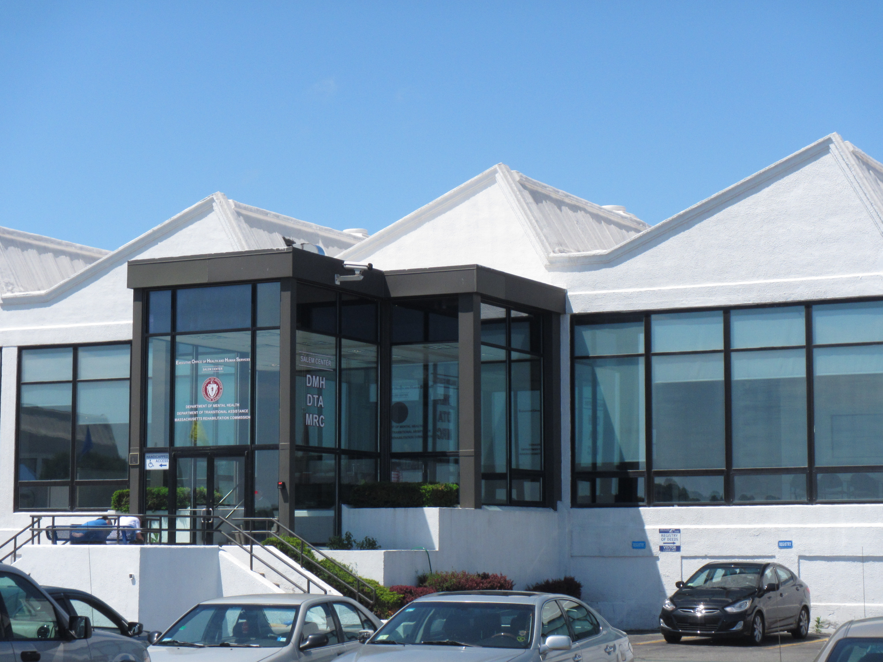

Prepared by:
Massachusetts Department of Public Health
Bureau of Environmental Health
Indoor Air Quality Program
September 2015

Building: | EOHHS Center
Address: | 45 Congress Street, Salem, MA
Assessment Requested by: | Virginia Platt, Project Manager, Division of Capital Asset Management and Maintenance (DCAMM)
Date of Assessment: | August 27, 2015
BEH/IAQ Staff Conducting Assessment: | Jason Dustin, Environmental Analyst/Inspector
Date of Building Construction: | Mid 1800’s, recently renovated
Reason for Request: | Follow-up on August 21 reassessment

Building Description
The EOHHS service center occupies a portion of a one-story building originally constructed as a large commercial textile factory. The office space assessed has undergone a complete renovation including interior walls/paint, dropped ceilings, floors, appliances, carpeting, and heating, ventilating and air conditioning (HVAC) systems. The majority of areas have carpet tiles. Windows are not openable.

Results
The space is occupied by approximately 145 employees. Over 400 members of the public also visit the space daily. Test results are presented in Table 1.

Discussion

Ventilation
It can be seen from Table 1 that carbon dioxide levels were above 800 parts per million (ppm) in 10 of 44 areas tested, indicating acceptable air exchange in the majority of occupied spaces at the time of the assessment (Table 1). It should be noted that carbon dioxide levels in the waiting area have been consistently elevated in the last three assessments of this space. This likely indicates that the air exchange rate for this room may be inadequate for the occupancy levels experienced at the EOHHS center.
Air-handling units (AHUs) are mounted above the ceiling tiles and provide fresh air to the office space via air intakes ducted from the roof. The AHUs are ducted to ceiling-mounted supply air diffusers and return/exhaust vents. To maximize air exchange, the MDPH recommends that both supply and exhaust ventilation operate continuously during periods of occupancy. In order to have proper ventilation with a mechanical supply and exhaust system, the systems must be balanced to provide an adequate amount of fresh air to the interior of a room while removing stale air from the room. It is recommended that heating, ventilating and air-conditioning (HVAC) systems be re-balanced every five years to ensure adequate function (SMACNA, 1994). The HVAC system was reportedly last balanced in July of 2015.

Temperature
Indoor temperature measurements at the time of the assessment ranged from 71°F to 75°F (Table 1), which were within the MDPH recommended comfort range.

Relative Humidity
Indoor relative humidity measurements at the time of the assessment ranged from 47 to 55 percent (Table 1), which were within the MDPH recommended comfort range in areas tested. The MDPH recommends a comfort range of 40 to 60 percent for indoor air relative humidity.

Microbial/Moisture Concerns
In order for building materials to support mold growth, a source of water exposure is necessary. No evidence of water damage or mold growth on building materials was observed.
Plants were noted in some areas. Plants can be a source of pollen and mold, which can be respiratory irritants to some individuals. Plants should be properly maintained and equipped with drip pans and should be located away from air diffusers to prevent the aerosolization of dirt, pollen and mold.
Some water coolers were still located directly on top of carpeting (Picture 1). Spills or leaks from this equipment can moisten the carpeting. EOHHS staff reported that more waterproof mats were ordered to place under the water coolers as a protective measure.
The backsplash area of the kitchen was noted to be unsealed (Picture 2). It is recommended that the gap between the upper and lower counter be sealed with a silicone-based caulking to prevent porous building materials to become chronically moistened.

Other IAQ Evaluations
Indoor air quality can be negatively influenced by the presence of respiratory irritants, such as products of combustion. The process of combustion produces a number of pollutants. Common combustion emissions include carbon monoxide, carbon dioxide, water vapor, and smoke (fine airborne particle material). Of these materials, exposure to carbon monoxide and particulate matter with a diameter of 2.5 micrometers (μm) or less (PM2.5) can produce immediate, acute health effects upon exposure. To determine whether combustion products were present in the indoor environment, BEH/IAQ staff obtained measurements for carbon monoxide and PM2.5.

Carbon Monoxide
Carbon monoxide should not be present in a typical, indoor environment. If it is present, indoor carbon monoxide levels should be less than or equal to outdoor levels. On the day of the assessment, outdoor carbon monoxide concentrations were non-detect (ND) (Table 1). No measurable levels of carbon monoxide were detected inside the building (Table 1).

Particulate Matter
Outdoor PM2.5 was measured at 11 μg/m³ (Table 1). PM2.5 levels measured indoors ranged from 2 to 5 μg/m³ (Table 1), which were below the NAAQS PM2.5 level of 35 μg/m³.

Volatile Organic Compounds
In order to determine if VOCs were present, BEH staff examined rooms for products containing VOCs. BEH/IAQ staff noted photocopiers, hand sanitizer, cleaners and dry erase materials at the time of the assessment. All of these have the potential to be irritants to the eyes, nose, throat and respiratory system of sensitive individuals.

Other Conditions
Other conditions that can affect IAQ were observed during the assessment. BEH/IAQ staff observed a total of three ducted exhaust vents in the kitchen area. It was difficult to determine if one of these vents was the newly-installed dedicated direct exhaust for this space since the fan controls were locked.
BEH/IAQ observed large gaps beneath the rear doors leading to the shared hallway adjacent to light manufacturing space (Picture 3). Installing tight-fitting door sweeps/gaskets under doors leading to the rear hallway will help to avoid any manufacturing-generated pollutants from entering the EOHHS occupied space.
BEH/IAQ staff noted the accumulation of large numbers of items on flat surfaces. To prevent excessive dust build up, items should be relocated periodically to allow for cleaning.

Conclusions/Recommendations
In view of the findings at the time of the visit, the following recommendations are made:
- Contact HVAC engineer to implement methods to increase air exchange in the waiting area of the EOHHS.
- Confirm the installation of direct exhaust vent in the kitchen area by temporarily turning general ventilation fans off in that area and testing vents for dedicated kitchen exhaust flow.
- Continue to operate thermostats with fan set to “on” to achieve continuous air circulation/filtration and adequate fresh air supply during business hours.
- It is recommended that the gap between the upper and lower counter in the kitchen be sealed with a silicone-based caulking to prevent porous building materials from becoming chronically moistened.
- Install tight-fitting door sweeps/gaskets under doors leading to the rear hallway to avoid any manufacturing generated pollutants from entering the EOHHS occupied space.
- For buildings in New England, periods of low relative humidity during the winter are often unavoidable. Therefore, scrupulous cleaning practices should be adopted to minimize common indoor air contaminants whose irritant effects can be enhanced when the relative humidity is low. To control for dusts, a high efficiency particulate arrestance (HEPA) filter equipped vacuum cleaner in conjunction with wet wiping of all surfaces is recommended. Avoid the use of feather dusters. Drinking water during the day can help ease some symptoms associated with a dry environment (throat and sinus irritations).
- Plants should be properly maintained and equipped with drip pans and should be located away from air diffusers to prevent the aerosolization of dirt, pollen and mold.
- Avoid the accumulation of large numbers of items on flat surfaces. To prevent excessive dust build up, items should be relocated periodically to allow for cleaning.
- Once the waterproof mats are available, place them under all water coolers that are located directly on carpeting or relocate these appliances to non-carpeted areas.
- Consider limiting the use of hand sanitizer, dry erase boards, air fresheners/deodorizers and harsh cleaning products, which can cause eye, nose and throat irritations in sensitive individuals.
- Refer to resource manual and other related indoor air quality documents located on the MDPH’s website for further building-wide evaluations and advice on maintaining public buildings. These documents are available at http://mass.gov/dph/iaq.

References
SMACNA. 1994. HVAC Systems Commissioning Manual. 1st ed. Sheet Metal and Air Conditioning Contractors’ National Association, Inc., Chantilly, VA.
Picture

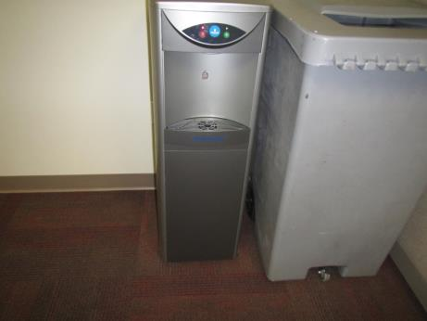

Water cooler located directly on carpeting
Picture

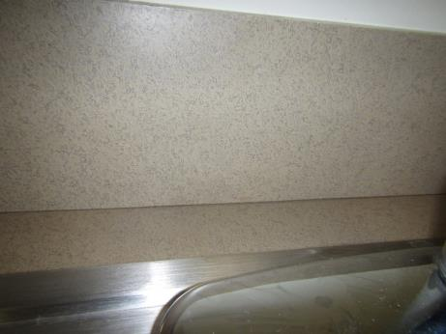

Gap between backsplash and kitchen counter lacking silicone caulking

Picture

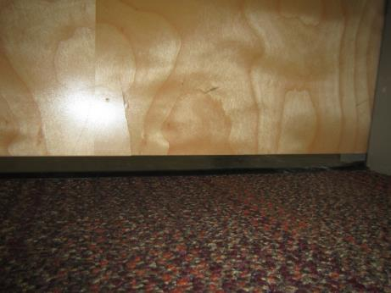

Large gap beneath door leading to hallway shared with light manufacturing space

Location | Carbon  Dioxide  (ppm) | Carbon Monoxide  (ppm) | Temp  (°F) | Relative  Humidity  (%) | PM2.5  (µg/m³) | Occupants  in Room | Windows  Openable | Ventilation |  |  | Remarks
 |  |  |  |  |  |  |  | Intake | Exhaust
Background (outside) | 388 | ND | 75 | 60 | 11
1151 | 646 | ND | 74 | 50 | 4 | 2 | N | Y |  | Y
Reception | 656 | ND | 74 | 53 | 5 | 4 | N | Y |  | Y
1154 | 644 | ND | 74 | 52 | 4 | 1 | N | Y |  | Y | HS
1157 | 624 | ND | 74 | 53 | 4 | 1 | N | Y |  | Y
1168-1166 | 600 | ND | 74 | 52 | 4 | 3 | N | Y |  | Y
1186-1164 | 642 | ND | 74 | 52 | 4 | 2 | N | Y |  | Y
1185-1162 | 646 | ND | 74 | 52 | 4 | 3 | N | Y |  | Y
1196-1193 | 600 | ND | 74 | 51 | 4 | 2 | N | Y |  | Y
1202 | 605 | ND | 75 | 53 | 4 | 4 | N | Y |  | Y
1201-1207 | 604 | ND | 73 | 53 | 4 | 2 | N | Y |  | Y
1206-1204 | 580 | ND | 73 | 52 | 4 | 2 | N | Y |  | Y
1198 | 602 | ND | 72 | 53 | 4 | 0 | N | Y |  | Y
1197 | 652 | ND | 72 | 54 | 4 | 0 | N | Y |  | Y
1171 Break room | 567 | ND | 72 | 53 | 3 | 2 | N | Y |  | Y | Dedicated exhaust reportedly installed
1211 shared conference room | 559 | ND | 72 | 54 | 4 | 0 | N | Y |  | Y
1116-1097 | 710 | ND | 72 | 51 | 2 | 3 | N | Y |  | Y
1096-1093 | 718 | ND | 72 | 49 | 2 | 2 | N | Y |  | Y
1091-1090 | 763 | ND | 72 | 51 | 2 | 1 | N | Y |  | Y
1089-1087 | 807 | ND | 72 | 51 | 3 | 2 | N | Y |  | Y
1086-1085 | 799 | ND | 73 | 50 | 2 | 1 | N | Y |  | Y
Reception | 806 | ND | 74 | 50 | 3 | 3 | N | Y |  | Y
1041-1063 | 806 | ND | 75 | 48 | 3 | 3 | N | Y |  | Y
1043-1065 | 801 | ND | 74 | 47 | 3 | 0 | N | Y |  | Y
1045-1067 | 798 | ND | 74 | 47 | 3 | 2 | N | Y |  | Y
1068-1049 | 782 | ND | 74 | 47 | 2 | 3 | N | Y |  | Y
1050-1073 | 785 | ND | 73 | 47 | 2 | 0 | N | Y |  | Y
1074-1075 | 772 | ND | 73 | 47 | 3 | 1 | N | Y |  | Y
1055-1077 | 763 | ND | 72 | 47 | 3 | 1 | N | Y |  | Y
1057-1080 | 795 | ND | 72 | 51 | 3 | 1 | N | Y |  | Y
1060-1082 | 755 | ND | 72 | 49 | 2 | 1 | N | Y |  | Y
1016-1039 | 738 | ND | 72 | 49 | 3 | 1 | N | Y |  | Y
1038-1013 | 742 | ND | 72 | 49 | 2 | 1 | N | Y |  | Y
1011-1030 | 794 | ND | 71 | 52 | 3 | 1 | N | Y |  | Y
1009-1027 | 807 | ND | 72 | 51 | 3 | 2 | N | Y |  | Y
1006-1023 | 854 | ND | 72 | 51 | 3 | 1 | N | Y |  | Y
1022-1020 | 826 | ND | 72 | 52 | 3 | 3 | N | Y |  | Y
Interview hall (1172-1175) | 711 | ND | 72 | 55 | 3 | 2 | N | Y |  | Y
Interview hall (1149-1125) | 715 | ND | 72 | 55 | 3 | 0 | N | Y |  | Y
1135 | 714 | ND | 72 | 54 | 3 | 0 | N | Y |  | Y
1134 Interview room | 721 | ND | 72 | 54 | 3 | 0 | N | Y |  | Y
Hall (1137-1141) | 762 | ND | 72 | 54 | 3 | 2 | N | Y |  | Y
Waiting room-front | 1138 | ND | 72 | 49 | 5 | 37 | N | Y |  | Y
Waiting room-mid | 1213 | ND | 72 | 49 | 5 | 37 | N | Y |  | Y
Waiting room-rear | 1234 | ND | 72 | 49 | 5 | 37 | N | Y |  | Y

