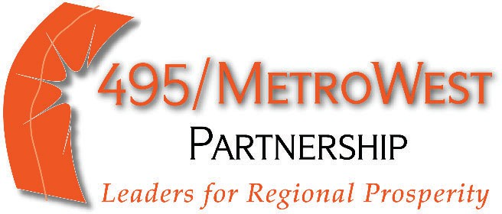

200 Friberg Parkway, Suite 1003
Westborough, MA 01581
(774) 760-0495
www.495Partnership.org
April 23, 2025

Mr. Dennis Renaud, Director, Determination of Need Program Massachusetts Department of Public Health
67 Forest Street, Marlborough MA 01752 DPH.DON@massmail.state.ma.us

RE: Determination of Need Application UMMH-25021208-HE Registration of Ten Taxpayer Group (TTG)

Dear Mr. Renaud,
Pursuant to the provisions of 105 CMR. §§ 100.100 and 100.435, please accept the following request for registration of a TTG relative to Determination of Need (DoN) Application UMMH-25021208-HE for a substantial change in service and substantial capital expenditure to develop a Proton Therapy Service at the UMass Memorial Medical Center Cancer Center at Marlborough. Please note the following:
- The name and resident address of each TTG member is attached.
- Each TTG member is a resident of the Commonwealth of Massachusetts and is subject to any Massachusetts state income, excise or property tax during 2025, the year in which the Application was filed.
- The representative of the 495/MetroWest Partnership TTG designated to be the recipient of all written communications concerning the Application relative to this request is Jason Palitsch, Executive Director of the 495/MetroWest Partnership. All materials can be sent to Jason@495Partnership.org and/or 200 Friberg Parkway, Suite 1003, Westborough MA 01581.
We have discussed the DoN Application with the Applicant and are in support of UMass Memorial Health’s plans to develop a Proton Therapy Service at the UMass Memorial Medical Center Cancer Center at Marlborough. We believe bringing this service to Marlborough will improve access to life-saving cancer care in our region, boost innovation and job creation, and enhance health equity and patient outcomes.
Thank you for your attention to this matter.

Sincerely,

[signature on file]

Jason Palitsch Executive Director
The 495/MetroWest Partnership

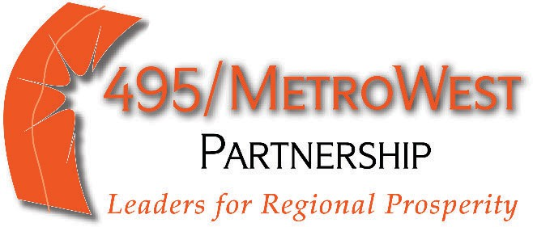

April 23, 2025

To Whom It May Concern:

I am signing below as a member of the 495/MetroWest Partnership Ten Taxpayer Group regarding Determination of Need Application UMMH-25021208-HE for a substantial change in service and substantial capital expenditure to develop a Proton Therapy Service at the Cancer Center in Marlborough.

Name | Residential Address | Signature
Jason Palitsch | [address redacted] | [signature on file]
Danielle Gregoire | [address redacted] | [signature on file]
Thomas Driscoll | [address redacted] | [signature on file]
Daniel Feeney | [address redacted] | [signature on file]
Hannah Kane | [address redacted] | [signature on file]
Peter Martin | [address redacted] | [signature on file]
Kate Donaghue | [address redacted] | [signature on file]
Robert Nagi | [address redacted] | [signature on file]
Beth Reynolds | [address redacted] | [signature on file]
Reyad Shah | [address redacted] | [signature on file]

