521 CMR 10.00: PUBLIC USE AND COMMON USE SPACES IN MULTIPLE DWELLINGS

10.1 GENERAL
The public use and common use spaces of multiple dwellings in existing buildings consisting of 12 or more units in a building, shall be accessible and shall comply with 521 CMR. The public use and common use spaces of multiple dwellings in new construction consisting of three or more units shall comply with 521 CMR. Public and common use spaces are those spaces inside or outside a building that are used by residents and/or visitors. Public use and common use spaces shall include but not be limited to community facilities, meeting rooms, restaurants, recreation spaces, health facilities, pools, public toilet rooms, laundry areas, trash areas, storage areas, mailboxes, walks, sidewalks, parking lots and garages, entrances, elevators, lobbies and foyers, as well as corridors and stairways leading to dwelling units.

10.2 ACCESSIBLE ROUTES
There shall be an accessible route at least 36 inches (36" = 914mm) wide connecting accessible parking, accessible entrances, public and common use spaces, and dwelling units. Wherever possible, the accessible route shall be the shortest possible route, see 521 CMR 20.00: ACCESSIBLE ROUTE

10.3 PARKING SPACES FOR DWELLING UNIT OCCUPANTS
Where parking is provided, it shall comply or be capable of complying with the provisions of 521 CMR 23.2, Number through 521 CMR 23.8, Valet Parking. The number of accessible spaces shall not be limited in number by 521 CMR 23.2.1, Number but shall be provided in sufficient numbers to meet the needs of the dwelling unit occupants. If parking spaces are assigned to individual units, those spaces designated for accessible units shall have signage reserving said space. An international symbol of accessibility need not be used.

10.3.1 Visitor Parking Spaces: Where parking is provided for visitors, it shall comply fully with the requirements of 521 CMR 23.00: PARKING AND PASSENGER LOADING ZONES.

10.4 DOORS
All doorways and openings located in common use and public use spaces and along accessible routes shall comply with 521 CMR 26.2, Revolving Doors through 521 CMR 26.11, Door Hardware.

10.5 STORAGE
If remote storage is available to residents, equivalent accessible storage shall be provided to residents.

10.6 ALARMS
Where a fire alarm is provided, it shall comply with 521 CMR 40.00: ALARMS.
10.00: PUBLIC USE AND COMMON USE SPACES IN MULTIPLE DWELLINGS

10.7 HEIGHT OF CONTROLS
The highest position of the operable parts of any control, dispenser, receptacle, or other operable equipment shall be located within the zone of reach as defined in
521 CMR 5.00: DEFINITIONS.

10.8 LAUNDRY FACILITIES
If laundry facilities are provided in Multiple dwellings, then equivalent, accessible laundry facilities shall be provided.

10.8.1 Location: Laundry facilities shall be on an accessible level and on an accessible route.

10.8.2 At least one washing machine and at least one clothes dryer shall be front loading, shall have a side hinged door, and shall be located so that the door can be opened 180°. See Fig. 10a.

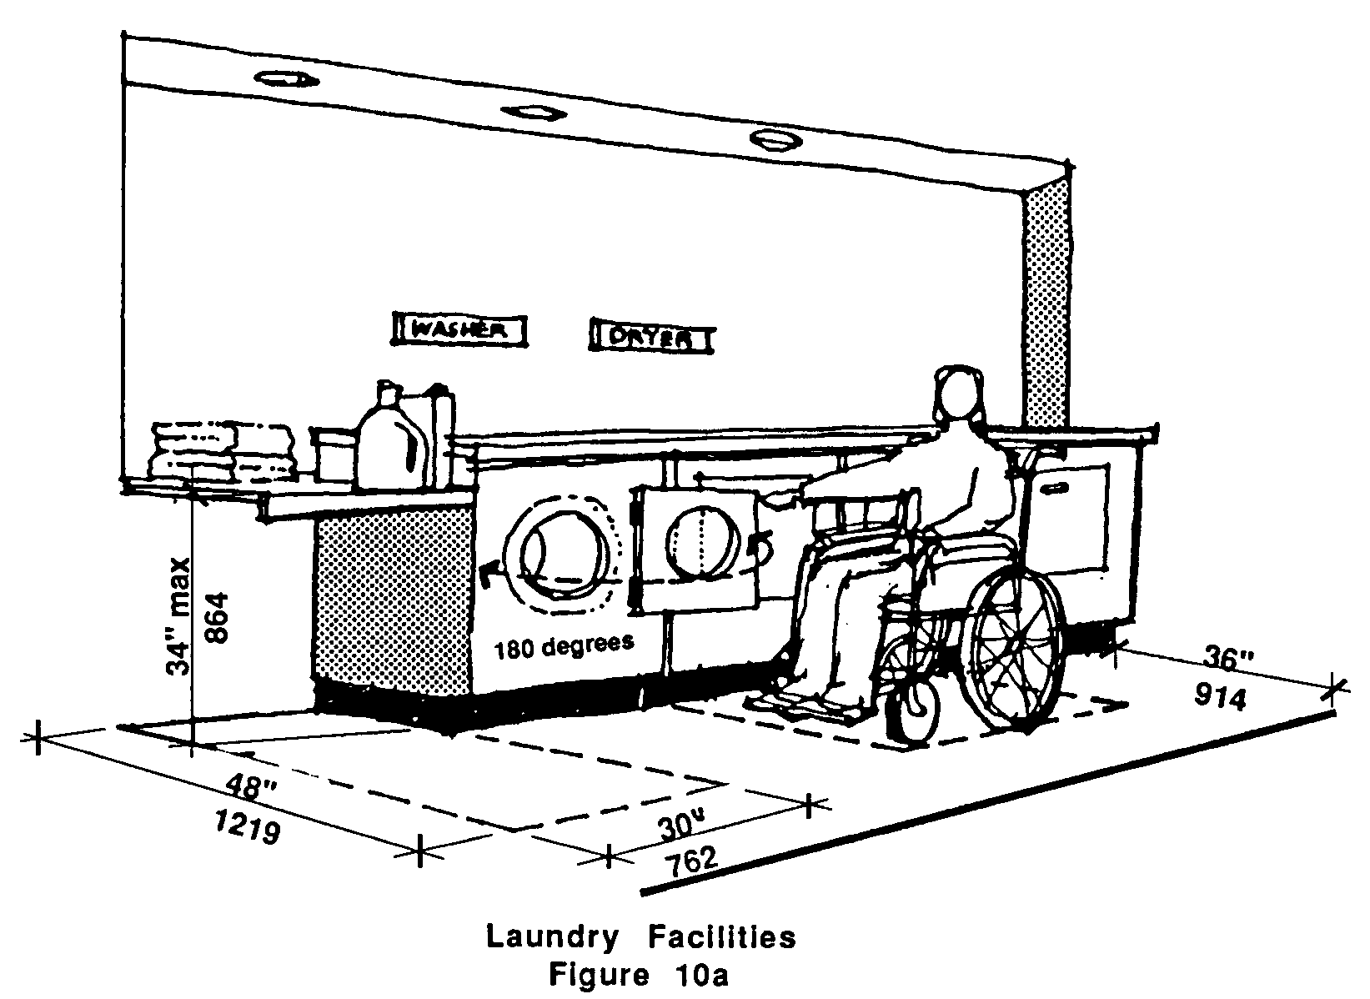

10.8.3 Where laundry work space, such as a folding table, is provided, it shall comply with 521 CMR 35.00: TABLES AND SEATING.

10.8.4 Controls, including the payment mechanism, shall fall within the zone of reach as defined in 521 CMR 5.00: DEFINITIONS.
10.00: PUBLIC USE AND COMMON USE SPACES IN MULTIPLE DWELLINGS

10.9 KITCHEN FACILITIES
Sinks, counters, and cooking facilities provided in common use spaces shall comply with 521 CMR 32.00: KITCHENS.

