521 CMR 12.00: EDUCATIONAL FACILITIES

12.1 GENERAL
Educational facilities shall comply with 521 CMR, except as specified or modified in 521 CMR 12.00. Educational facilities shall include but not be limited to: public and private schools, nurseries, pre-schools, day care facilities, colleges and universities, libraries, galleries, museums, and training facilities.

12.1.1 Applicability: Administrative spaces, instructional spaces, and areas open to students or the general public shall comply with 521 CMR.

12.1.2 Dormitories shall comply with the requirements of 521 CMR 8.00: TRANSIENT LODGING FACILITIES.

12.1.3 Amphitheaters, lecture halls and classrooms of educational facilities shall comply with 521 CMR 14.00: PLACES OF ASSEMBLY.

12.2 LIBRARIES
Shall comply with the following and Figure 12a.

12.2.1 General: All public areas of a library, including but not limited to, reading and study areas, stacks, reference rooms, reserve areas, and special facilities or collections, shall comply with 521 CMR 12.00.

12.2.2 Reading Areas, Study Areas and Computer Workstations: Where tables, study carrels, computer workstations, or fixed seating are provided, at least 5% with a minimum of one of each element shall be accessible, be on an accessible route, and comply with the following:

a. Access aisles: A 36 inch (36" = 914mm) access aisle shall be provided between tables and between study carrels. No seating shall overlap the access aisle. See Fig. 12a.
b. Clear floor space as defined in 521 CMR 5.00: DEFINITIONS shall be provided at each seating space. Such clear floor space shall not overlap knee space by more than 19 inches (19" = 483 mm). See Fig. 12a.
c. Knee Clearances: If seating for disabled persons is provided at tables or counters, kneespaces at least 27 inches (27" = 686mm) high, 30 inches (30" = 762mm) wide, and 19 inches (19" = 483mm) deep shall be provided. See Fig. 12a.
d. Height of Tables or Counters: The tops of accessible tables and counters shall be from 28 inches to 34 inches (28" to 34" = 711mm to 864mm) above the finished floor or ground.
12.00: EDUCATIONAL FACILITIES

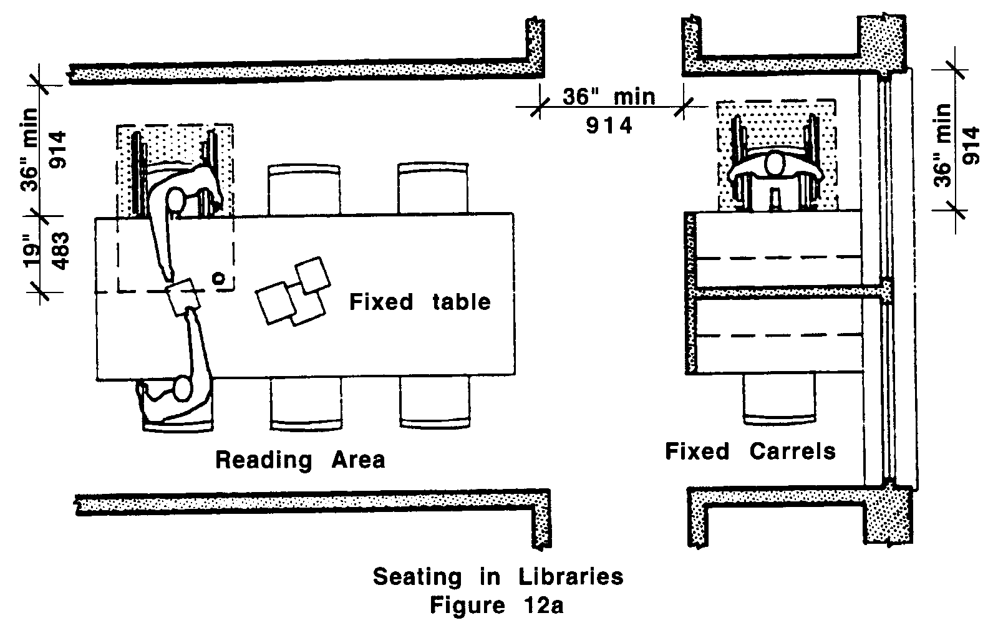

12.2.3 Check-Out Areas: At least one lane at each check-out area shall have a counter a minimum of 36 inches (36" = 914mm) in length and a maximum of 36 inches (36" = 914mm) in height. See Fig. 7a.

12.2.4 Security Devices: Any traffic control or book security gates or turnstiles shall not prevent access or egress to people in wheelchairs. Security gates shall have a 32 inch (32" = 812mm) clear opening. If turnstiles are used, an adjacent accessible, unlocked door or gate shall be provided. Any level changes created by such devices shall comply with 521 CMR 20.00: ACCESSIBLE ROUTE and 521 CMR 29.00: FLOOR SURFACES.

12.2.5 Card Catalogs: Clear aisle space at card catalogs shall be a minimum of 36 inches (36" = 914mm) and comply with Fig. 12b. Maximum reach height shall be between 18 inches (18" = 457mm) and 54 inches (54" = 1372mm), with a height of 48 inches (48" = 1219mm) preferred.

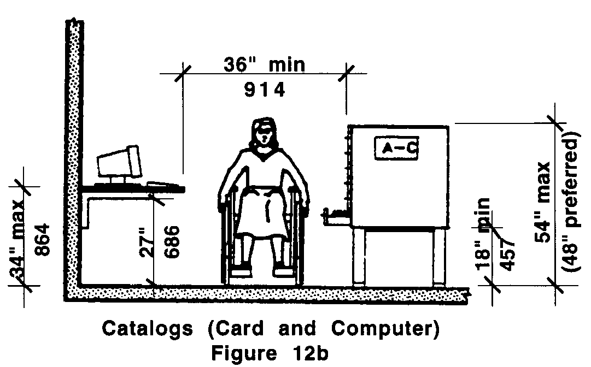
12.00: EDUCATIONAL FACILITIES

12.2.6 Stacks: Aisles between stacks shall have a minimum clear width of 36 inches (36" = 914mm) and preferably 42 inches (42" = 1067mm), where possible, as shown in Fig. 12c. Shelf height in stack areas is unrestricted.

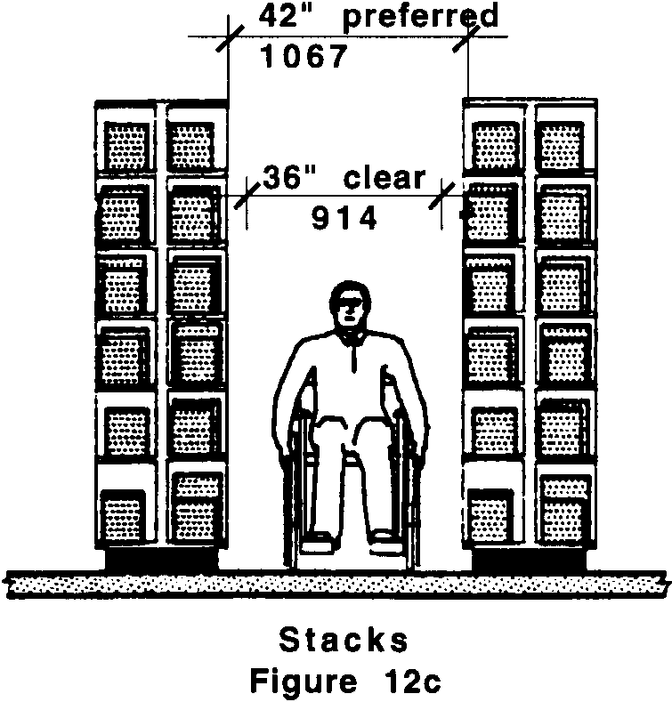

12.3 KITCHENS IN CLASSROOMS:
Kitchens in classrooms shall comply with the requirements of 521 CMR 32.00: K ITCHENS.

12.4 SINKS, COUNTERS, AND OTHER WORK AREAS IN CLASSROOMS OR LABORATORIES
At least 5%, with a minimum of one of each type of element, in each classroom or laboratory shall comply with the following:

a. Countertops and sinks shall comply with 521 CMR 12.2.2 b, 12.2.2 c. and 12.2.2d.
b. Accessible storage: At least 50% of shelf space in cabinets or refrigerator/freezers shall comply with 521 CMR 6.5, Forward Reach and 521 CMR 6.6, Side Reach and space shall be designed to allow for the operation of cabinet and/or appliance doors so that all cabinets and appliances are accessible and usable.
c. Controls and operating mechanisms shall comply with 521 CMR 39.00: CONTROLS.

12.5 DRINKING FOUNTAINS IN CLASSROOMS:
Shall comply with the requirements of 521 CMR 36.00: DRINKING FOUNTAINS.

12.6 RECREATIONAL FACILITIES AT EDUCATIONAL FACILITIES shall comply with the requirements of 521 CMR 19.00: RECREATIONAL FACILITIES
12.00: EDUCATIONAL FACILITIES

NON-TEXT PAGE

