521 CMR 14.00: PLACES OF ASSEMBLY

14.1 GENERAL
Places of assembly shall comply with all parts of 521 CMR, except as specified or modified in 521 CMR 14.00. Places of assembly shall include but not be limited to theaters, auditoriums, armories, lecture halls, arenas, stadiums, banquet rooms and conference rooms. Associated, support, or related areas, including but not limited to press boxes, lobbies, ticket offices, seating, stages, backstage areas, dressing rooms, toilet rooms, showers and green rooms, shall also be accessible.

14.2 NUMBER OF ACCESSIBLE SEATS
Wheelchair spaces: In places of assembly with fixed seating, the minimum number of accessible spaces shall be computed in accordance with the following table:

Total Seating Wheelchair Spaces
4 to 25 1
26 to 50 2
51 to 300 4
301 to 500 6
over 500 6, one additional space for each total seating capacity increase of 100.

14.2.1 Armless seats: In addition to wheelchair seating locations, 1% of all fixed seats, but not less than one seat, shall be aisle seats with no armrests on the aisle side, or shall have removable or folding armrests on the aisle side. Each such seat shall be identified by a sign or marker. Signage notifying patrons of the availability of such seats shall be posted at the ticket office. Aisle seats are not required to be on a level surface. See Fig. 14a.
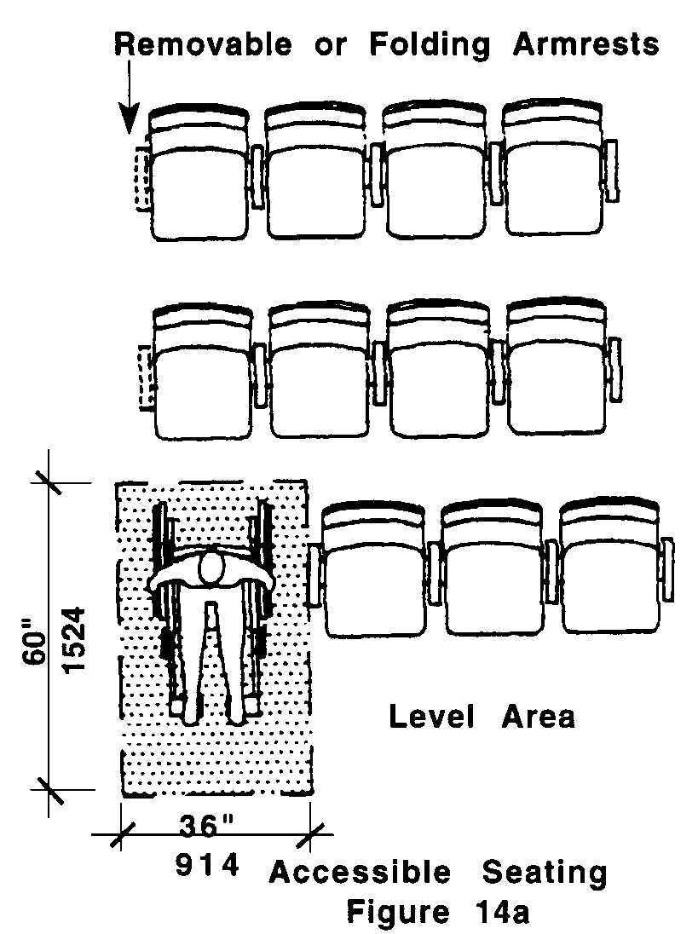

14.00: PLACES OF ASSEMBLY

14.3 ACCESSIBLE SPACE
Each wheelchair space shall be 60 inches (60" = 1524mm) long and 36 inches (36" = 914mm) wide, shall be level, and shall comply with 521 CMR 29.00: FLOOR SURFACES.

14.4 PLACEMENT OF WHEELCHAIR SPACES
Wheelchair spaces shall be an integral part of any fixed seating plan.

14.4.1 Distribution: Whenever more than 150 seats are provided, wheelchair seating locations must be provided in more than one location. Wheelchair seating locations shall be dispersed throughout all seating areas so as to provide a choice of admission prices and views comparable to those for the general public. Wheelchair seating locations shall also be provided in all areas including sky boxes and specialty areas. Where 150 or less seats are provided, wheelchair spaces may be provided in one location. In movie theaters, accessible seating locations shall not be located in the front third of the theater.

Exception: Accessible viewing positions may be clustered for bleachers, balconies, and other areas having sight lines that require slopes of greater than 5%. Equivalent accessible viewing positions may be located on levels having accessible egress.

14.4.2 Accessible Route: Accessible seats shall adjoin, but in no way interfere with, an accessible route that also serves as a means of egress in case of emergency.

14.4.3 Companion seats: At least one companion fixed seat or portable seat, shall be provided next to each wheelchair seating space, for designated used by a companion. Companion seats must be comparable to the seats for the general public, i.e., comfort, cup holders, etc. Companion seats must have signage installed indicating that the seats are reserved as companion seating for the accessible seating areas.

14.4.4 Placement of Accessible Seats: Readily removable seats may be installed in wheelchair spaces when the spaces are not required to accommodate wheelchair users. See Fig. 14a.

14.5 ASSISTIVE LISTENING SYSTEMS
In spaces such as concert and lecture halls, playhouses, movie theaters, and meeting rooms, assembly areas shall comply with the following:

14.5.1 An assembly area shall have a permanently installed assistive listening system if:

a. the assembly area accommodates at least 50 persons, or
b. if it has an audio-amplification system, and fixed seating.

14.5.2 For other assembly areas, a permanently installed assistive listening system, or other supplementary wiring necessary to support a portable assistive listening system shall be provided. The minimum number of receivers to be provided shall be equal to 4% of the total number of seats, but not less than two receivers.
14.00: PLACES OF ASSEMBLY

14.5.3 Placement of Listening Systems: If the listening system serves individual fixed seats, then such seats shall be located within a 50 foot (50' = 15m) viewing distance of, and including the stage or playing area, and shall have a complete view of the stage or playing area.

14.5.4 Signage shall be installed to notify patrons of the availability of a listening system and shall comply with 521 CMR 41.00: SIGNAGE.

14.6 ACCESS TO PERFORMING AREAS
Where access is provided to the stage from within the place of assembly, an accessible route, within the place of assembly, from the wheelchair seating locations, to the stage/performing area must be provided. See Fig. 14b. In addition, an accessible route that coincides with the route for performers must be provided to the backstage area.

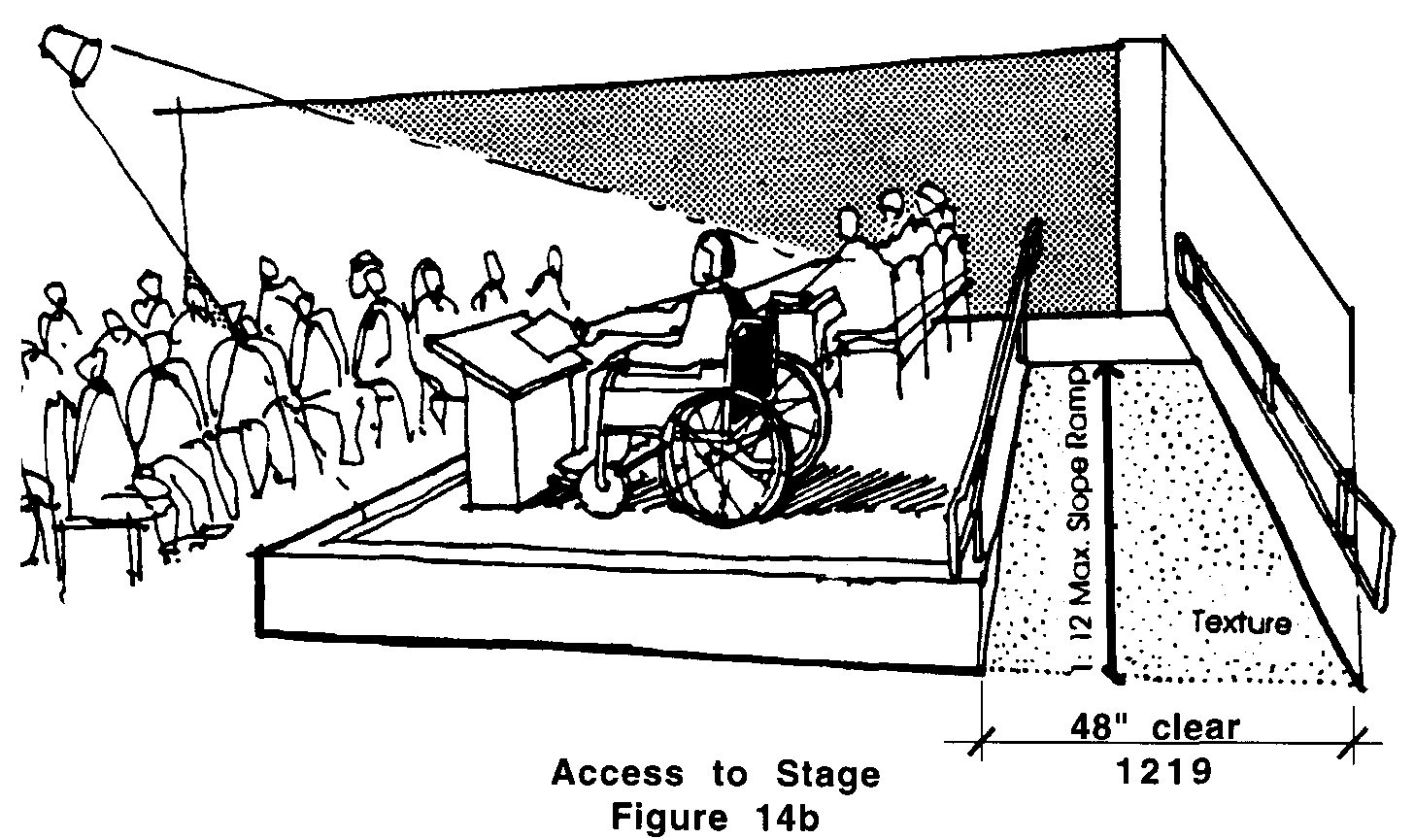

14.6.1 Access to the stage may be by the following:

a. a ramp complying with 521 CMR 24.00: RAMPS
b. a wheelchair lift complying with 521 CMR 28.12, Wheelchair Lifts

14.7 BOX OFFICE TICKET COUNTERS AND CONCESSION STANDS
Shall comply with the following:
a. Location: The counter shall be on an accessible route.
b. Length: A portion of the counter or an auxiliary counter shall be at least 36 inches (36" = 914mm) in length.
c. Height: The counter shall not exceed 36 inches (36" = 914mm) above the finish floor.
d. Clear Floor Area: Provide clear floor area as defined in 521 CMR 5.00: DEFINITIONS.
e. Space Allowance and Reach Ranges: See 521 CMR 6.5, Forward Reach and 512 CMR 6.6, Side Reach.

14.00: PLACES OF ASSEMBLY

14.8 DRESSING ROOMS
Where provided, shall comply with 521 CMR 33.00: DRESSING, FITTING AND CHANGING ROOMS

14.9 SLOPE IN AUDITORIUMS/ASSEMBLY AREAS (Reserved)

