521 CMR 16.00: HOUSES OF WORSHIP

16.1 GENERAL
Houses of worship shall comply with 521 CMR, except as specified or modified in 521 CMR 16.00. Houses of worship include but are not limited to churches, chapels, temples, synagogues and mosques. Spaces that must be accessible include those areas open to the congregation, administrative offices, and religious meeting halls and classrooms.

Exception: Day care centers located in houses of worship are educational facilities and shall comply with 521 CMR 12.00: EDUCATIONAL FACILITIES.

16.2 NUMBER OF ACCESSIBLE SEATS
Shall comply with the following:

16.2.1 Wheelchair spaces: In houses of worship with fixed seating, the minimum number of accessible spaces shall be computed in accordance with the following table.

Total Seating Wheelchair Spaces
4 to 25 1
26 to 50 2
51 to 300 4
301 to 500 6
over 500 6, plus 1 additional space for each seating capacity increase of 100

16.3 ACCESSIBLE SPACE
Each wheelchair space shall be 60 inches (60" = 1524mm) long and 36 inches (36" = 914mm) wide, shall be level, and shall comply with 521 CMR 29.00: FLOOR SURFACES. See Fig. 16a.

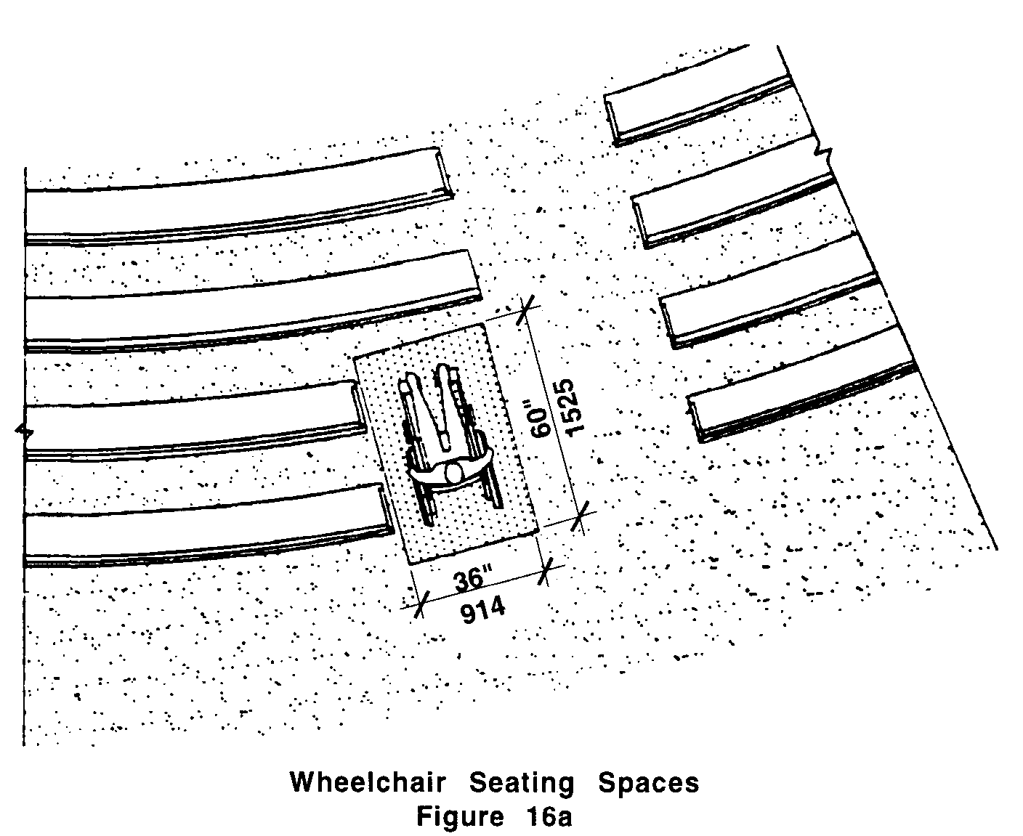
16.00: HOUSES OF WORSHIP

16.4 PLACEMENT OF WHEELCHAIR SPACES
Wheelchair spaces shall be an integral part of any fixed seating plan.

16.4.1 Distribution: Wheelchair spaces shall be proportionally distributed to provide people with physical disabilities a choice of lines of sight comparable to those for members of the general public.

16.4.2 Accessible Route: Wheelchair spaces shall adjoin, but in no way interfere with, an accessible route that also serves as a means of egress in case of emergency.

16.4.3 Companion seats: At least one companion fixed seat shall be provided next to each wheelchair seating area.

16.4.4 Removable seats or pews: Readily removable seats or sections of pews may be installed in wheelchair spaces when the spaces are not required to accommodate wheelchair users.

16.5 ASSISTIVE LISTENING SYSTEMS
Where audible communication is integral to the use of the space, the space shall comply with the following:

16.5.1 An assembly area shall have a permanently installed assistive listening system if:

a. the assembly area accommodates at least 50 persons, has an audio-amplification system; and
b. it has fixed seating.

16.5.2 For other assembly areas, a permanently installed assistive listening system, or a portable listening system and an adequate number of electrical outlets or other supplementary wiring necessary to support a portable assistive listening system, shall be provided. The minimum number of receivers to be provided shall be equal to 4% of the total number of seats, but in no case less than two receivers.

16.5.3 Placement of Assistive Listening Systems: If the assistive listening system serves individual fixed seats, then such seats shall be located within a 50 foot (50' = 15m) viewing distance of the speaker's podium and shall have a complete view of the podium. The assistive listening system should serve all participants whether seated in balconies, among the general audience or upon the altar and the podium areas.

16.5.4 Signage shall be installed to notify patrons of the availability of a listening system and shall comply with 521 CMR 41.00: SIGNAGE.
16.00: HOUSES OF WORSHIP

NON-TEXT PAGE

