521 CMR 17.00: RESTAURANTS

17.1 GENERAL
Restaurants shall comply with 521 CMR, except as specified or modified in 521 CMR 17.00. Restaurants shall include, but not be limited to, cafeterias, lounges, bars, and other places open to the public where food or beverages are served.

17.2 SEATING
At least 5% but not less than one, of the tables shall be accessible, be on an accessible route, and in compliance with the following:

17.2.1 Distribution: Accessible tables shall be distributed by size and location throughout the space or facility. In establishments where separate areas are designated for smoking and non-smoking patrons, the required number of accessible tables shall be proportionally distributed between the smoking and non-smoking areas.

17.2.2 A 36 inch (36" = 914mm) access aisle shall be provided between all accessible tables. No seating shall overlap the access aisle. See Fig. 17a.

17.2.3 Clear floor space as defined in 521 CMR 5.00: DEFINITIONS shall be provided at each seating space. Such clear floor space shall not overlap knee space by more than 19 inches (19" = 483mm). See Fig. 17a.

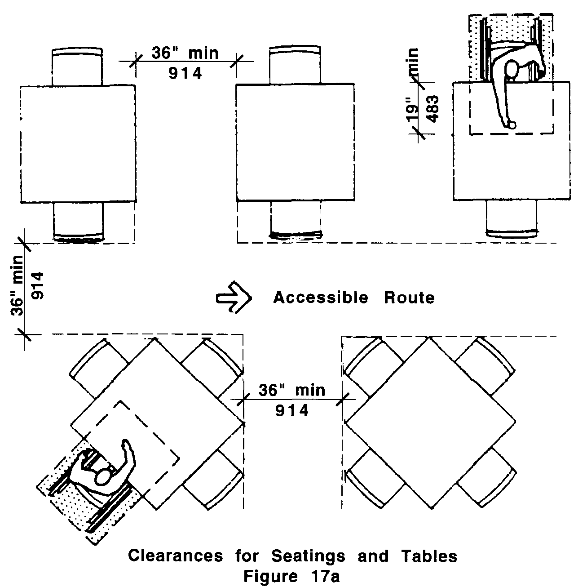
17.00: RESTAURANTS

17.2.4 Knee Clearances: If seating for people in wheelchairs is provided at tables or counters, knee spaces at least 27 inches (27" = 686mm) high, 30 inches (30" = 762mm) wide, and 19 inches (19" = 483mm) deep shall be provided. See Fig. 17b.

17.2.5 Height of Tables or Counters: The tops of accessible tables and counters shall be from 28 inches to 34 inches (28" to 34" = 711mm to 864mm) above the finish floor or ground. See Fig 17b.

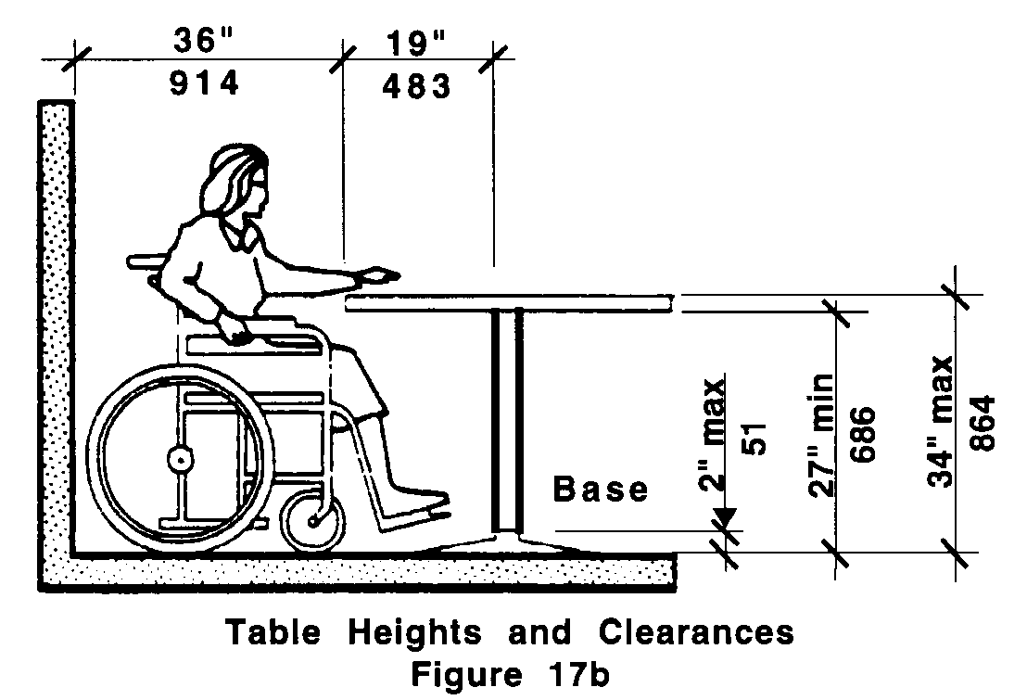

17.3 DINING COUNTERS WITHOUT SERVICE
At counters where food is consumed but there is no service, a 60 inch (60" = 1524mm) portion of the dining counter shall be accessible, on an accessible route, and in compliance with 521 CMR 17.2.5

17.4 COUNTERS AND BARS WITH SERVICE
At counters exceeding 34 inches (34" = 864mm) in height, where food or drink is served for consumption by customers seated on stools or standing at the counter, a portion of the main counter shall be accessible or service shall be available at accessible tables within the same area. The accessible portion shall be a minimum of 60 inches (60" = 1524mm) in length and comply with 521 CMR 17.2.4 and 17.2.5.

17.5 DINING AREAS
All dining areas, including raised or sunken dining areas, mezzanines, loggias, and outdoor seating areas, shall be accessible.

17.6 FOOD SERVICE LINES
Food service lines, including but not limited to: cafeterias, buffet tables and salad bars, shall comply with the following:

17.6.1 Clear Width: Food selection aisles, including entrance and exit, shall have a minimum clear width of 36 inches (36" = 914mm), with a preferred clear width of 42 inches (42" = 1067mm) to allow passage by other customers around a person using a wheelchair. See Fig. 17c.
17.00: RESTAURANTS

17.6.2 Tray slides shall be mounted no higher than 34 inches (34 " = 864mm) above the floor. See Fig. 17c.

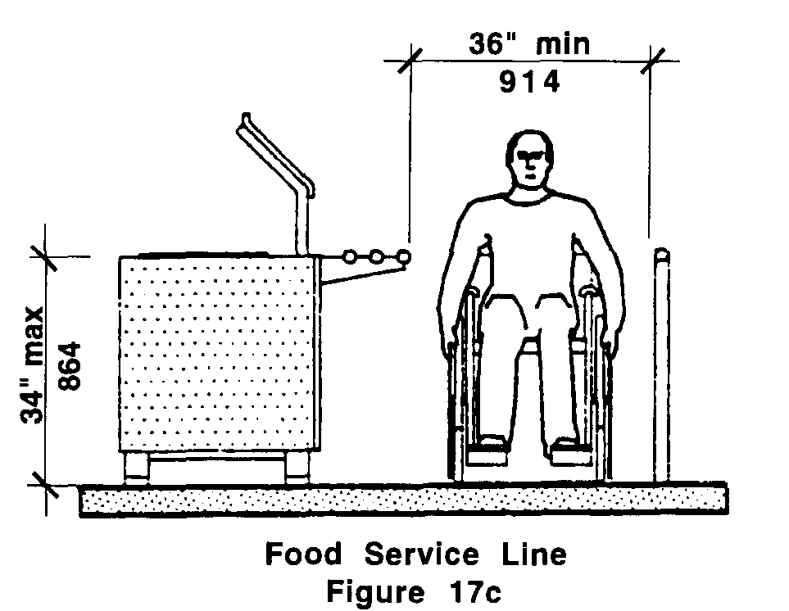

17.6.3 If self-service shelves are provided, at least 50% of each type must be within the zone of reach defined in 521 CMR 5.00: DEFINITIONS.

17.7 TABLEWARE AND CONDIMENT AREAS
Self-service shelves and dispensing devices for tableware, dishware, condiments, food and beverages shall be installed to comply with zone of reach as defined in 521 CMR 5.00: DEFINITIONS. See Fig. 17d.

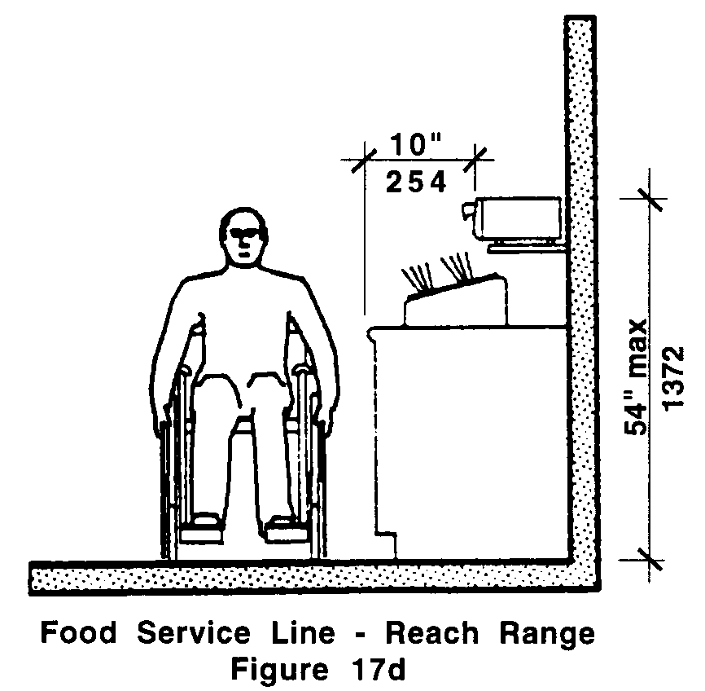

17.8 RAISED PLATFORMS
Where a head table or speaker's lectern is located on a raised platform, the platform shall be accessible in compliance with 521 CMR 24.00: RAMPS, or 521 CMR 28.00: ELEVATORS. Open edges of a raised platform shall be protected by a curb or by placement of tables.
17.00: RESTAURANTS

17.9 VENDING MACHINES AND OTHER EQUIPMENT
Spaces for vending machines and other equipment shall be located on an accessible route and shall comply with zone of reach as defined in 521 CMR 5.00: DEFINITIONS.

17.10 CASH REGISTER
Where payment is made at a cash register, the counter shall be no higher than 36 inches (36" = 914mm) from the floor to the top of the counter. See Fig. 17e.

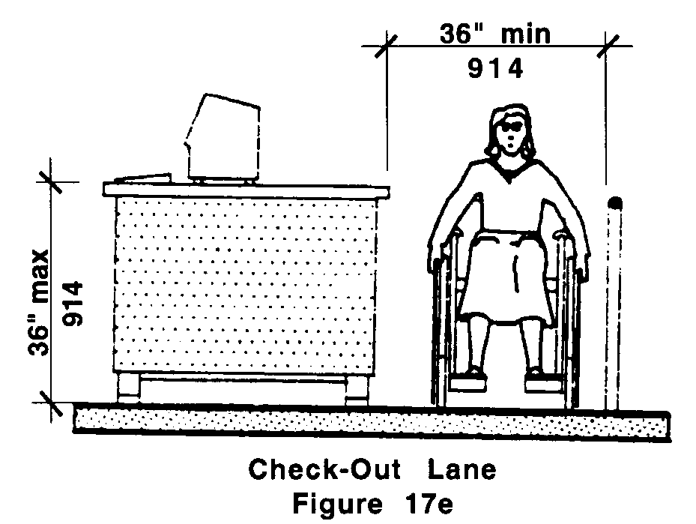

17.11 TELEVISIONS
Where televisions are provided in restaurants, the television shall be equipped with a closed caption decoder.
17.00: RESTAURANTS

NON-TEXT PAGE

