521 CMR 19.00: RECREATIONAL FACILITIES

19.1 GENERAL
Recreational facilities shall comply with 521 CMR, except as specified or modified in 521 CMR 19.00. Recreational facilities shall include but not be limited to courts, rinks, swimming pools, gymnasiums, stadiums, health and sports clubs, radio control facilities, whirlpools, jacuzzis, gyms, weightlifting areas, playgrounds, zoos, fairgrounds, beaches, piers, docks, bandstands, gazebos, parks, bowling alleys, picnic areas, video arcades and campsites. All areas open to and used by the public, including but not limited to locker rooms, shower facilities, saunas, steam rooms, suntanning rooms, weight rooms, aerobics and dance rooms, tennis, racquet and squash courts and spectator areas in recreation facilities shall be accessible.

19.2 WATER FACILITIES
Swimming pools, lap pools, wading pools, diving pools used for scuba or general swimming, and whirlpools and jacuzzis in all locations subject to 521 CMR shall be accessible .

19.2.1 Access Devices: Accessibility to water facilities shall be by means of any of the following:

a. A 34 inch (34" = 864mm) wide ramp with a slip resistant surface extending into the shallow end of the pool. Such ramps shall have a slope not exceeding one-in-six (1:6), and shall have handrails on both sides. See Fig. 19a.

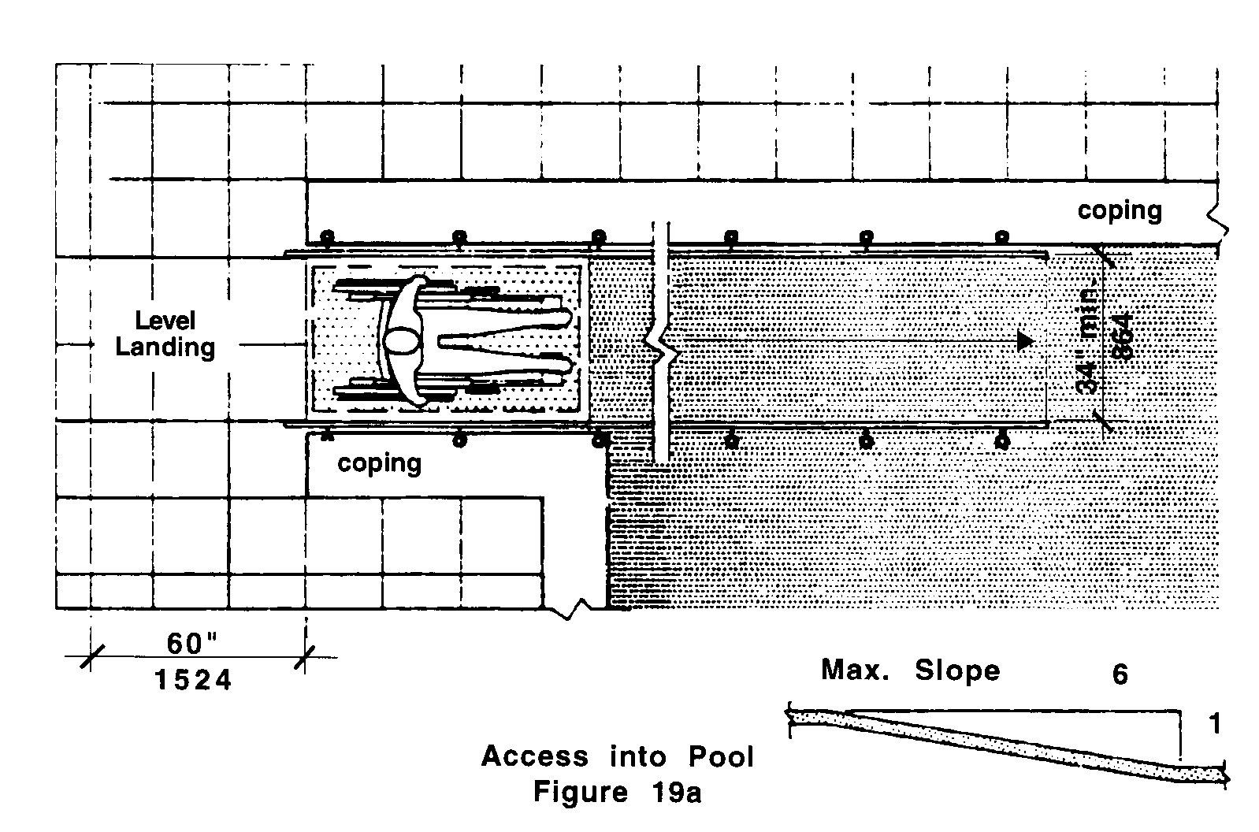

b. A lifting device.
c. When the water level of the pool is above the level of the path of travel, a raised coping may be utilized as a transfer area, if it is 18 inches (18" = 457mm) above the path of travel and is a minimum of 18 inches wide (18" = 457mm). See Fig. 19b.
19.00: RECREATIONAL FACILITIES

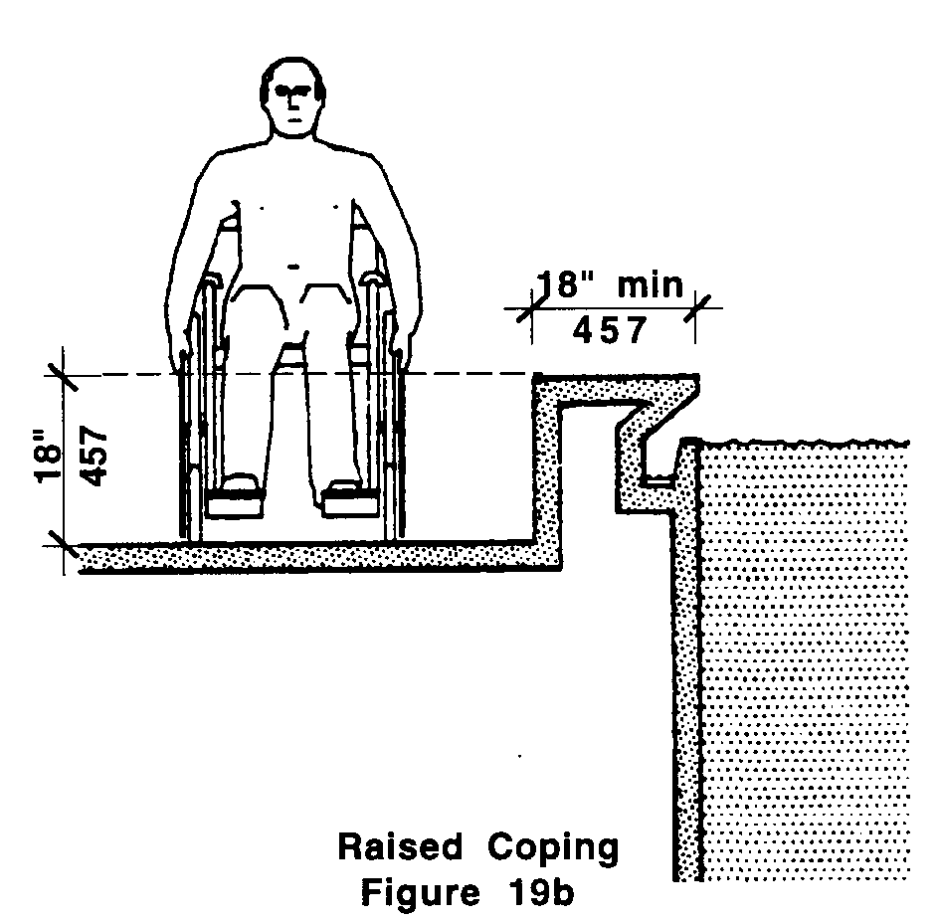

19.2.2 Path of travel: There shall be an accessible route not less than 48 inches (48" = 1219mm) wide around such pools. These paths shall have a surface that is slip resistant.

19.3 BOWLING ALLEYS
Shall provide an accessible route to at least two adjacent lanes.

19.4 LOCKER ROOMS
Shall have a 36 inch (36" = 914mm) wide accessible route around all lockers.

19.4.1 Lockers: At least 5% of the lockers, but not less than one, shall be accessible and shall have locking/opening devices that are operable with a closed fist and mounted no higher than 42 inches (42" = 1067mm) from the floor.

19.4.2 Seating: If benches are provided, there shall be a 36 inch (36" = 914mm) wide aisle between benches and lockers and a five foot turning diameter near the accessible lockers. See Fig. 19c.
19.00: RECREATIONAL FACILITIES

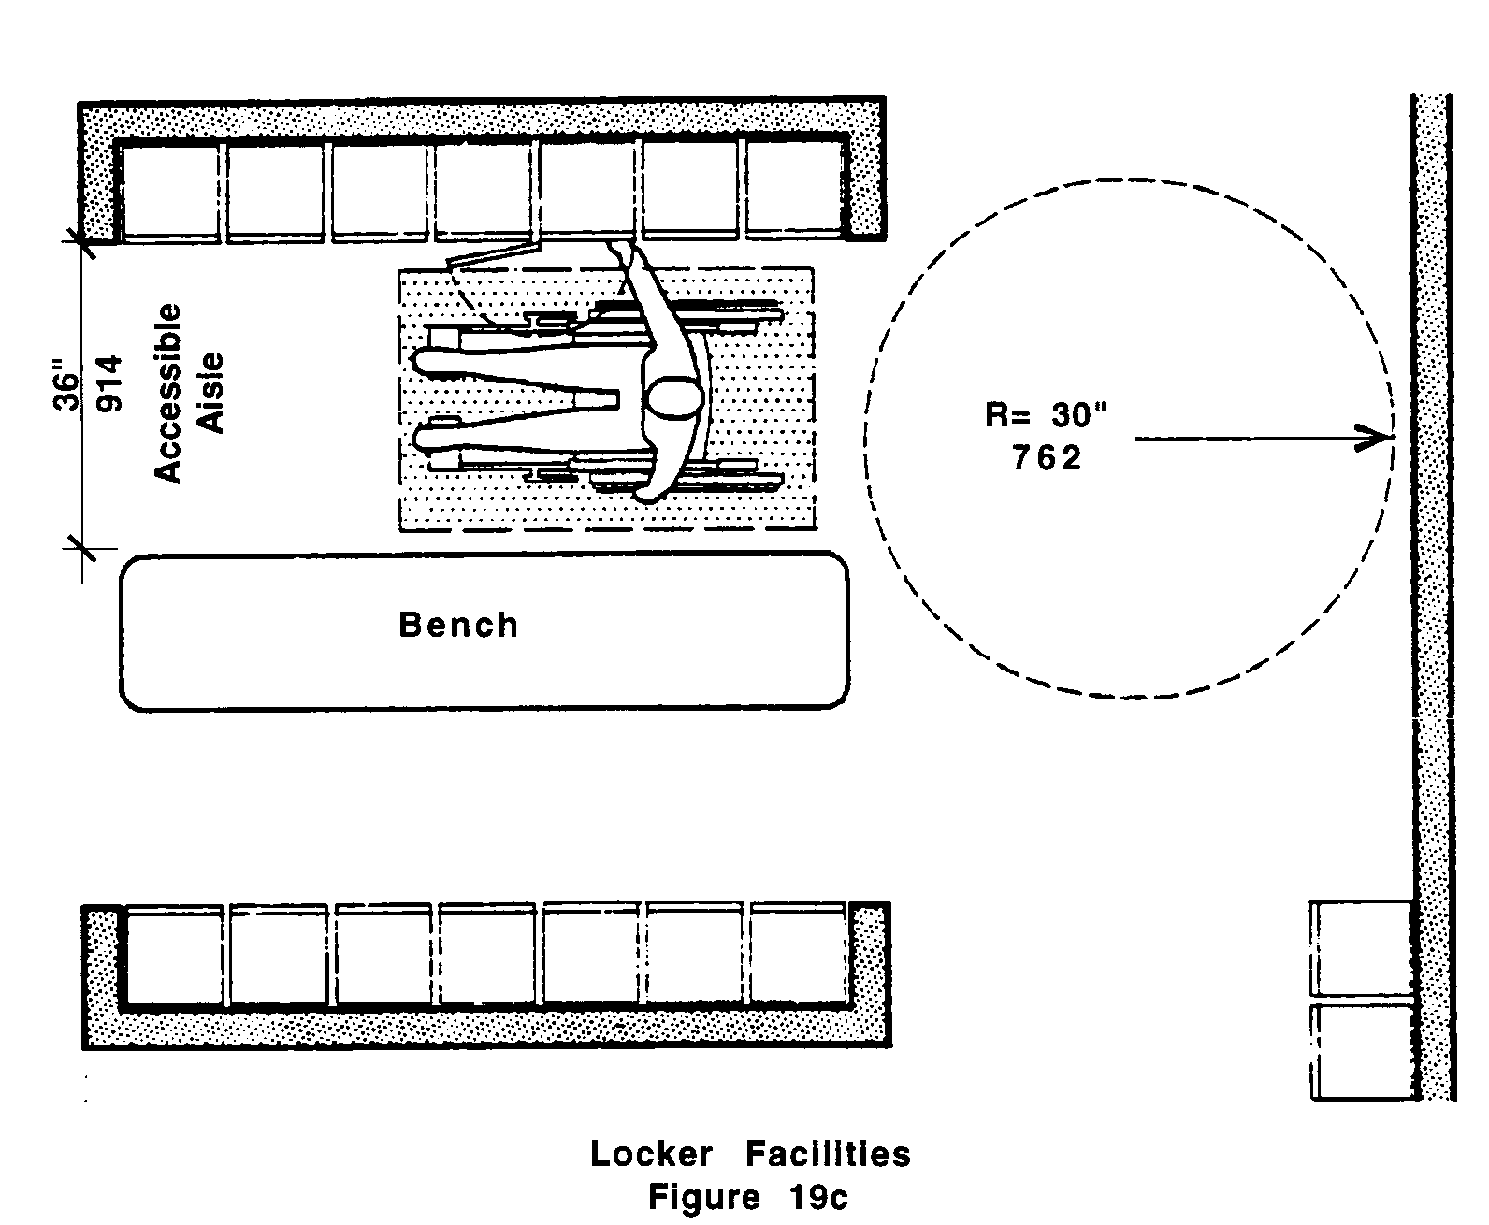

19.5 CAMPSITES
Shall comply with the following:

19.5.1 Campsite Access: At least 5% of campsites shall be accessible and dispersed among those campsites that could be reached from an accessible route. Areas leading into such sites should be paved or hard packed.

19.5.2 Tables: At least 5% of tables shall be accessible . Tables for the accessible sites shall provide clear space under the table top not less than 30 inches wide (30" = 762mm) and 19 inches (19" = 483mm) deep per seating space and not less than 27 inches (27" = 686mm) clear from the ground to the underside of the table. See Fig. 19d.

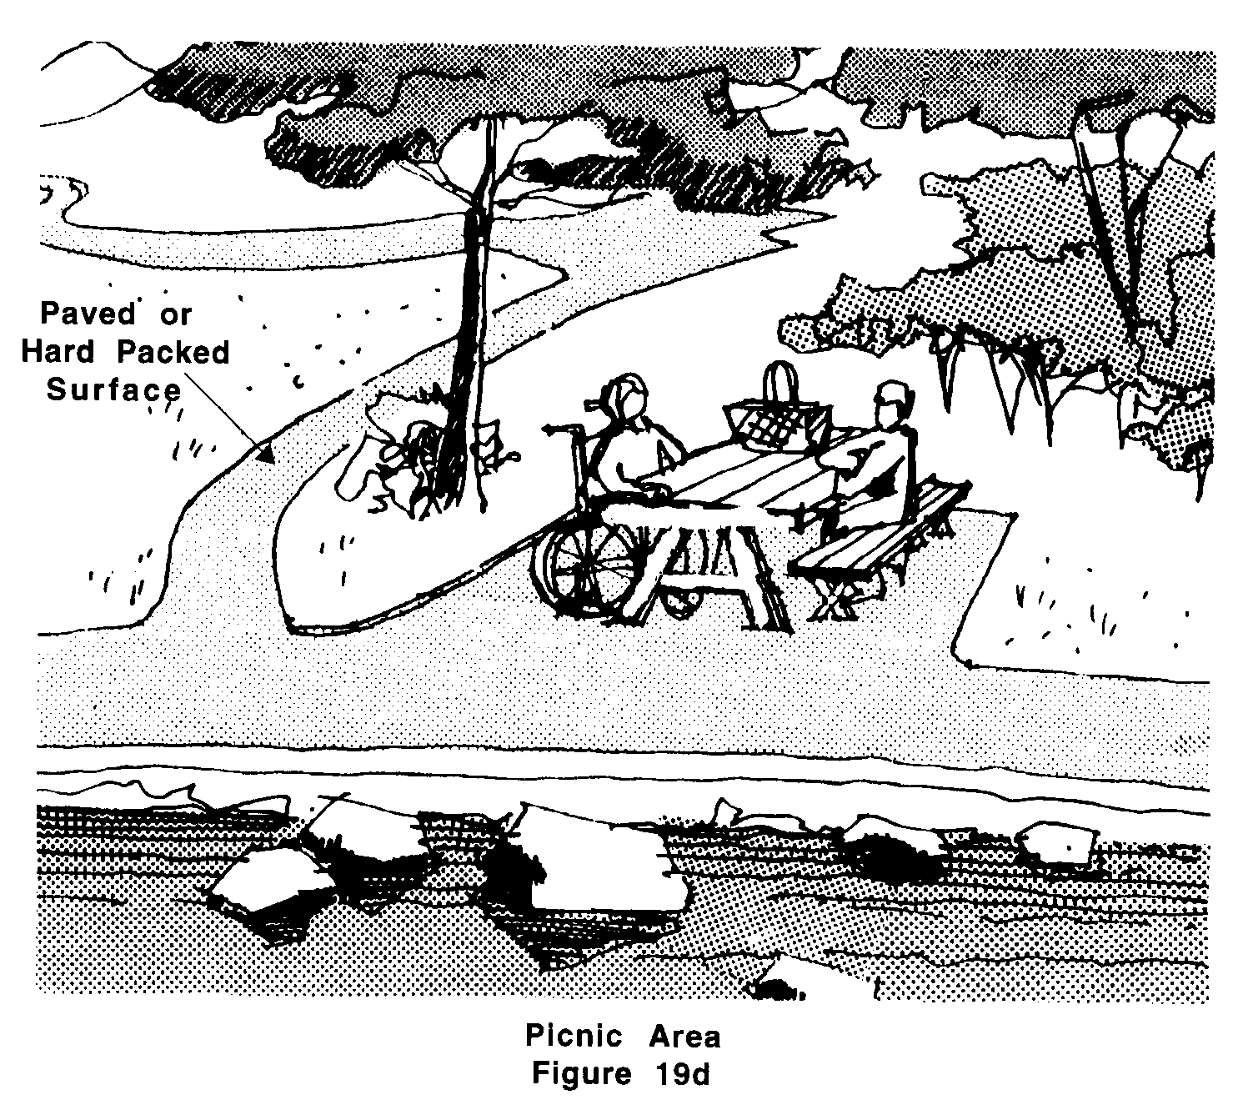
19.00: RECREATIONAL FACILITIES

19.5.3 Public restrooms and shower facilities, where provided, shall comply with 521 CMR 30.00: PUBLIC TOILET ROOMS and 521 CMR 31.00: BATHING ROOMS.

19.6 PICNIC AREAS AND HIGHWAY REST AREAS
Shall comply with the following:

19.6.1 Access: All facilities shall be accessible and shall be on an accessible route that is paved or hard packed. If curb cuts are provided, they shall comply with 521 CMR 21.00: CURB CUTS.

19.6.2 Tables: At least 5% of tables, where provided shall be accessible and shall comply with 521 CMR 19.5.2.

19.6.3 Public restrooms, where provided, shall comply with 521 CMR 30.00: PUBLIC TOILET ROOMS and 521 CMR 31.00: BATHING ROOMS.

19.6.4 Public telephones, where provided, shall comply with 521 CMR 37.00: PUBLIC TELEPHONES.

19.7 PLAYGROUNDS
An accessible route, complying with 521 CMR 20.00: ACCESSIBLE ROUTE shall be provided to reach playground equipment and around the playground.

19.8 MARINE FACILITIES:
Marine facilities are docks and/or piers that service waterborne passenger vessels with a vessel length of 40 feet (40' = 12m) or greater. These facilities shall provide persons with disabilities unassisted access measured under nominal marine conditions throughout spring tide range or 9½ feet (9½' = 2996mm) whichever is less. Marine facilities shall comply with the following:

19.8.1 Unassisted Access between the land or fixed facility and a floating vessel, with or without an intervening floating structure, shall be provided.

19.9 MARINE RAMPS
shall comply with the following:

19.9.1 Handrails: Marine ramps shall be equipped with handrails which comply with 521 CMR 24.5 Handrails.

Exception: At the top and bottom of the marine ramp the upper and lower rails shall be connected with a circular return extending a minimum of 12 inches (12" = 305mm) beyond the edge of the ramp. It is not intended that handrail extensions be horizontal during all tidal or weather conditions.
19.00: RECREATIONAL FACILITIES

19.9.2 Width: The clear width of the marine ramp shall be a minimum of 36 inches (36" = 914mm) measured between the handrails.

19.9.3 Platforms: Marine ramps shall terminate in level platforms that are a minimum of 48 inches (48"= 1219mm) by 48 inches (48" = 1219mm), clear and unobstructed by handrails, door swings, entrances, or other projections. Such platforms shall occur at the top and bottom of each ramp and at intervals not exceeding the maximum ramp length as described in Table 1:

Table 1
RAMPS MAXIMUM RAMP LENGTH
(excluding transition plates)
1:12 but less than 1:14 Not to exceed 30 feet (9m)
1:14 but less than 1:16 Not to exceed 35 feet (11m)
1:16 but less than 1:18 Not to exceed 40 feet (12m)
1:18 but less than 1:20 Not to exceed 45 feet (14m)
1:20 and over Unlimited length

19.9.4 Transition Plates shall be a maximum of eight feet (8' = 2438mm) in length and shall have slopes less than or equal to 1:12. Transition plates longer than 18 inches (18" = 457mm) shall be equipped with handrails complying with 521 CMR 19.9.1. These handrails must be parallel to the handrails on the marine ramp(s), but may not necessarily be continuous with them. Transition plates shall be at least as wide as the ramp. The change in level between the end of the transition plate and the adjoining level surface shall be no greater than ½ an inch (½" = 13mm).

19.10 BRIDGE PLATES
Vessels using bridge plates to provide access at boarding and disembarking areas shall comply with the following:

19.10.1 A maximum slope of 1:8 to 1:10 is allowed for a maximum rise of three inches (3" = 76mm). A maximum slope that is less steep than 1:10 and no steeper than 1:12 is allowed for a maximum rise of six inches (6" = 152mm).

19.10.2 Bridge plates shall have a minimum clear width of at least 36 inches (36" = 914mm).

19.10.3 Bridge Plates longer than six feet (6' = 1829mm) are marine ramps and shall comply with 521 CMR 19.9, Marine Ramps.

19.11 FLOATING AND FIXED DOCKS
The edge of all floating and fixed docks shall provide at least one of the following:

a. Handrails that comply with 521 CMR 24.5, Handrails;
b. Curbs that are at least four inches (4" = 102mm) high and are preceded by detectable warnings that comply with 521 CMR; or
c. Detectable warnings that comply with 521 CMR.
19.00: RECREATIONAL FACILITIES

19.12 ACCESSIBLE ROUTE
There shall be an accessible route to and throughout the marine facility that connects the vessels boarding area with all other areas and services available to the public within the marine facility. The accessible route shall comply with 521 CMR 20.00: ACCESSIBLE ROUTE.

19.13 ANCILLARY FACILITIES
Where provided within the marine facility, ancillary facilities such are fare transaction areas, public toilets, public telephones, vendor(s) stands, etc., shall comply with 521 CMR.

19.14 MARINE FACILITIES THAT SERVICE WATERBORNE PASSENGER VESSELS WITH A VESSEL LENGTH OF LESS THAN 40 FEET (40' = 12m) - Reserved.

