521 CMR 2.00: PURPOSE AND SCOPE

2.1 PURPOSE
521 CMR is designed to make public buildings and facilities accessible to, functional for, and safe for use by persons with disabilities.

2.2 INTENT
It is the intent of 521 CMR to provide persons with disabilities full, free and safe use of all buildings and facilities so that all such persons may have the educational, living and recreational opportunities necessary to be as self-sufficient as possible and to assume full responsibilities as citizens.

2.3 VIOLATIONS
521 CMR is deemed to be a specialized code as referred to in M.G.L. c. 143, § 96, the violation of which shall constitute gross negligence for the purpose of M.G.L. c. 112, § 60G, clause (d), and shall be subject to the additional powers granted to the Board by M.G.L. c. 22, § 13A.

2.3.1 The Board shall receive complaints of non-compliance with any rule or regulation from any person or may receive complaints initiated by its own staff. If the Board finds, after notice and opportunity for a hearing, that any person is not in compliance with any rule or regulation, it may issue an order to compel such compliance. Such order may specify the date and the manner by which such person shall cure the noncompliance found by the Board and may require that pending the cure of such noncompliance a performance bond be furnished, payable to the Commonwealth, in such penal sum as the Board finds reasonable.

2.3.2 In the event that a person fails to cure such noncompliance by the date specified in the Board's order, the Board shall be empowered, after further hearing, to impose a fine payable to the Commonwealth not to exceed $1,000 per day per violation for each day of noncompliance that the Board finds was without justification.

2.3.3 The Board shall also have the power, if it determines that such failure to cure noncompliance is without justification, to bring a complaint before any appropriate licensing or permit granting authority against the license or permit of such person.

2.3.4 The Board shall have the authority to issue subpoenas.

2.4 GENERAL CONVENTIONS
The following conventions apply when using 521 CMR:

2.4.1 Graphic and other illustrations are provided in 521 CMR to illustrate a solution only. They are not to be taken as the best solution or the only solution, but are provided to clarify the intent of the written regulations. The written word always prevails.
2.00: PURPOSE AND SCOPE

2.4.2 Graphic conventions are shown in Figure 2a. Dimensions that are not marked minimum or maximum shall comply with 521 CMR 2.4.4, unless otherwise noted in the text or captions.

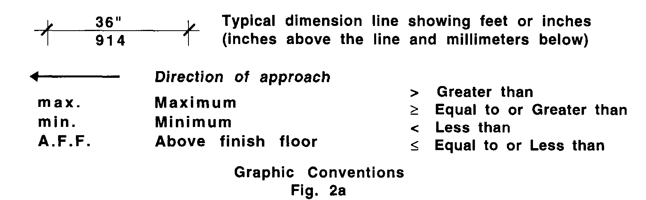

2.4.3 Words italicized in the text indicate that a definition of that word is provided in 521 CMR 5.00: DEFINITIONS.

2.4.4 Tolerances on all dimensions, unless otherwise noted, shall not exceed the following:

a. Dimensions between zero and two inches, (0" and 2" = 0mm and 51mm) inclusive, shall have a maximum tolerance of plus or minus one-eighth inch (1/8" = 3mm).
b. Dimensions more than two inches and less than 36 inches (>2" and <36" = >51mm and <914mm) shall have a maximum tolerance of plus or minus one-half inch (½" =13mm).
c. Dimensions 36 inches or greater (36" or > = 914mm or >) shall have a maximum tolerance of plus or minus one inch (1" = 25mm).
d. Slopes may not exceed maximums. Slopes shall be measured in two-foot increments.

Note: Tolerances do not apply to minimums or maximums.

2.4.5 When a percentage is calculated to determine the number of accessible elements , if the number ends in a fraction of five-tenths (.5) or more, the number shall be rounded up to the next whole number. If the number ends in a fraction less than five-tenths (.5), the number shall be rounded down.

2.4.6 When calculating the conversion from inches to millimeters (using 1"=25.4mm), if the number ends in a fraction of five-tenths (.5) or more, the number shall be rounded up to the next whole number. If the number ends in a fraction less than five-tenths (.5), the number shall be rounded down.

2.5 REASONABLE MODIFICATIONS
Reasonable modifications to public use and common use spaces in a multiple dwelling must comply with 521 CMR. Reasonable modifications to an individual unit do not need to comply with 521 CMR.

2.5.1 Departures from particular technical and scoping requirements of 521 CMR by the use of other designs and technologies are permitted without a variance, where the alternative designs and technologies used will provide substantially equivalent or greater access and usability of the facility.
2.00: PURPOSE AND SCOPE

2.6 MAINTENANCE OF ACCESS FEATURES
At all times, accessibility features must be maintained and fully operational. (i.e. access aisles kept clear at all times, mechanical devices be kept in operating condition, etc.).

