521 CMR 20.00: ACCESSIBLE ROUTE

20.1 GENERAL
An accessible route shall provide a continuous unobstructed path connecting accessible spaces and elements inside and outside a facility. Accessible routes may include but are not limited to walks, halls, corridors, aisles, skywalks, and tunnels. Accessible routes may not include stairs, steps, or escalators, even if the stairs and steps are required to be accessible under 521 CMR.

20.2 LOCATION
Within the boundary of the site, an accessible route(s) shall be provided from accessible parking, accessible passenger loading zones, and public streets or sidewalks to the accessible building entrance they serve. The accessible route(s) shall coincide with the route for the general public.

20.2.1 At least one accessible route shall connect accessible buildings, facilities, elements and spaces that are on the same site.

20.3 WIDTH
An accessible route shall have a minimum clear width of 36 inches (36" = 914 mm) except at doors and at openings less than 24 inches (24" = 610mm) deep where it shall comply with 521 CMR 26.00: DOORS AND DOORWAYS.

20.4 TURNS
If a person in a wheelchair must make a turn around an obstruction, the minimum clear width of the accessible route shall comply with Fig. 20a or 20b.

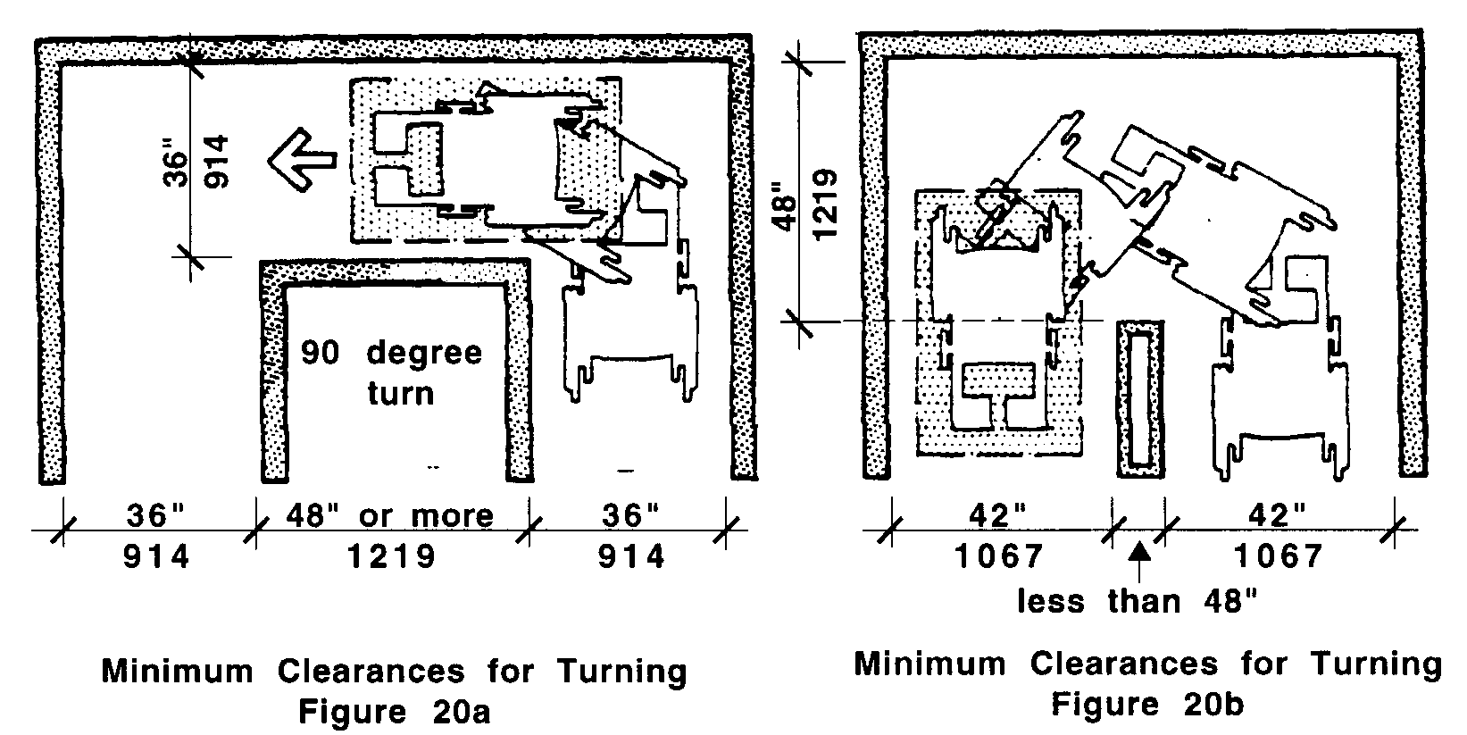

20.5 PASSING SPACE
If an accessible route has less than 60 inches (60" = 1524mm) clear width, then passing spaces at least 60 inches by 60 inches (60" x 60" = 1524mm by 1524mm) shall be located at intervals not to exceed 200 feet (200' = 61m). A T-intersection of two corridors or walks is an acceptable passing place.

20.00: ACCESSIBLE ROUTE

20.6 PROTRUDING OBJECTS
Objects shall not reduce the clear width of an accessible route or maneuvering space (see Fig. 20c) and must comply with 521 CMR 20.6.1.

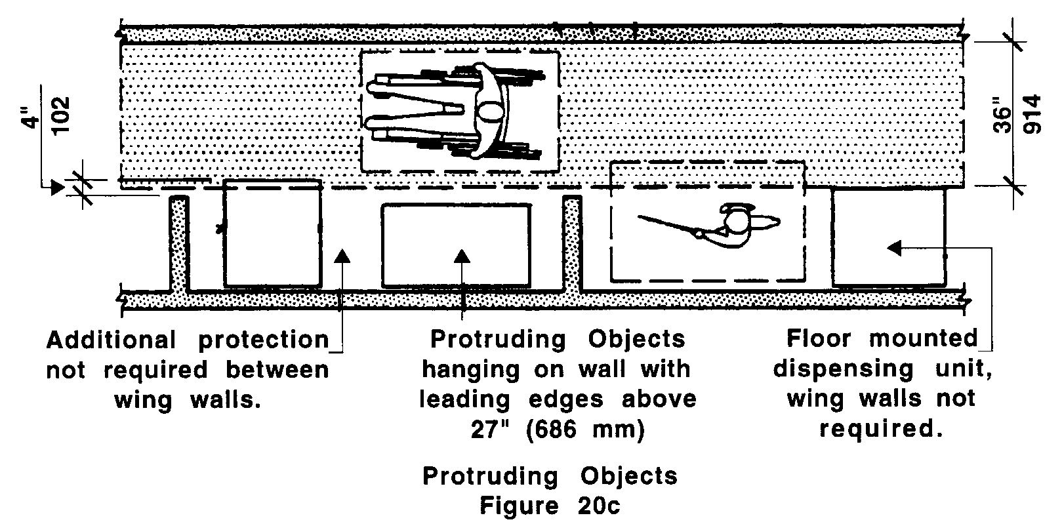

20.6.1 Objects projecting from walls (for example, telephones) with their leading edges between 27 inches and 80 inches (27" and 80" = 686mm and 2032mm) above the finished floor shall protrude no more than four inches (4" = 102mm) into walks, halls, corridors, passageways, or aisles and shall not have sharp or abrupt edges. See Fig. 20d.

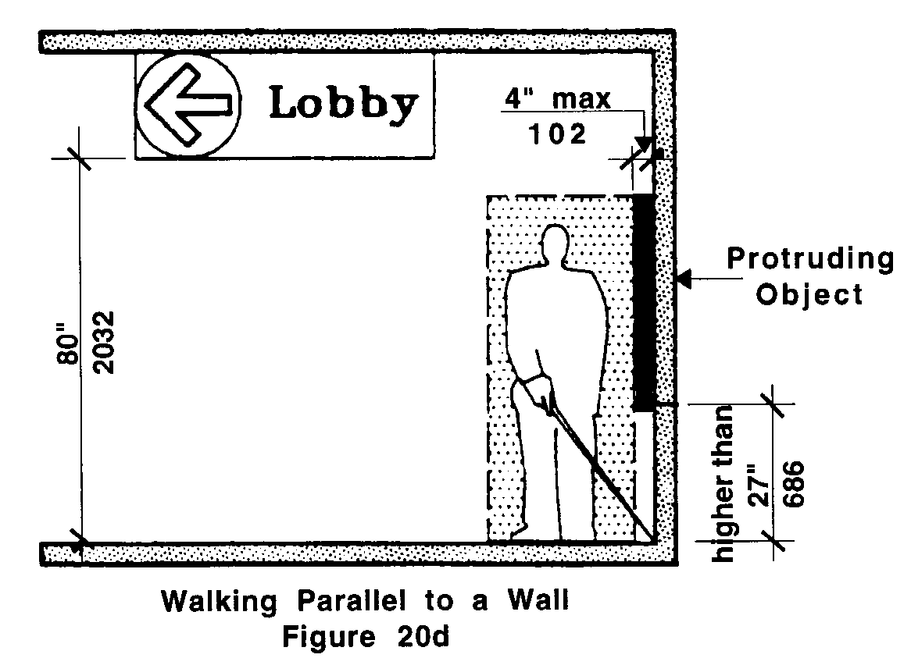

20.6.2 Objects mounted with their leading edges at or below 27 inches (27" = 686mm) above the finished floor may protrude any distance as long as they do not reduce the accessible route below 36 inches (36" = 914mm). See Fig. 20e.
20.00: ACCESSIBLE ROUTE

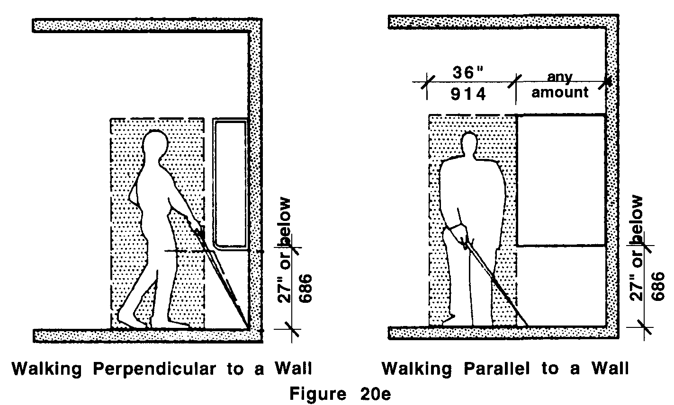

20.6.3 Free-standing objects mounted on posts or pylons may have a maximum overhang of 12 inches (12" = 305mm) measured between 27 inches and 80 inches (27" and 80" = 686mm and 2032mm) above the ground or finished floor. See Fig. 20f.

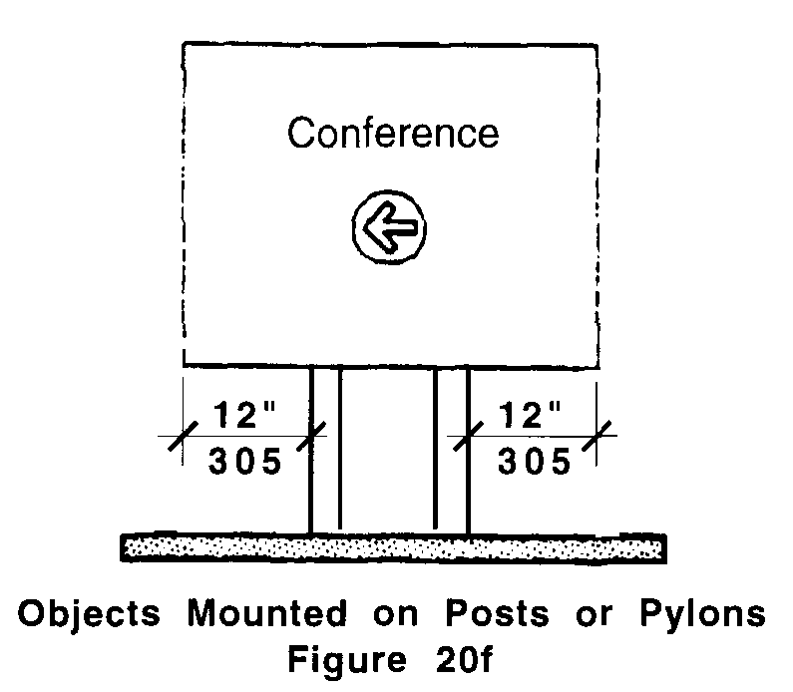

20.7 HEADROOM
Walks, halls, corridors, passageways, aisles, or other circulation spaces shall have a minimum of 80 inches (80" = 2032mm) clear headroom. See Fig. 20d. If vertical clearance of an area adjoining an accessible route is reduced to less than 80 inches (80" = 2032mm), a barrier shall be provided to warn blind or visually-impaired persons of the reduced headroom. See Fig. 20g.
20.00: ACCESSIBLE ROUTE

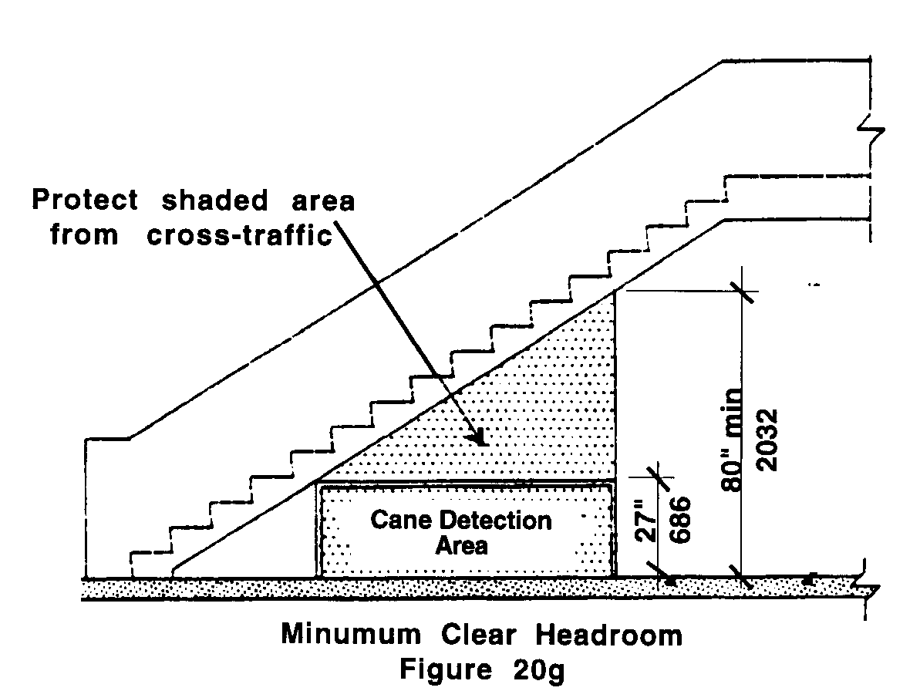

20.8 SURFACE TEXTURES
The surface of an accessible route shall comply with 521 CMR 29.00: FLOOR SURFACES.

20.9 SLOPE AND CROSS SLOPE
An accessible route with a running slope steeper than 1:20 (5%) is a ramp and shall comply with 521 CMR 24.00: RAMPS. Nowhere shall the cross slope of an accessible route exceed 1:50 (2%). (Refer to 521 CMR 2.4.4d)

20.10 CHANGES IN LEVELS
Changes in levels along an accessible route shall comply with 521 CMR 29.2, Level Changes. See Fig 20h.

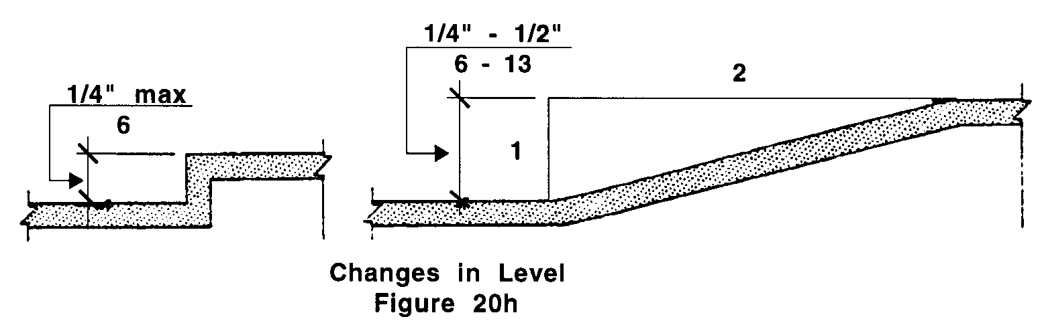

20.11 EGRESS
Accessible routes serving any accessible space or element shall also serve as a means of egress for emergencies or connect to an accessible area of rescue assistance.
20.00: ACCESSIBLE ROUTE

20.11.1 All spaces or elements required to be accessible by 521 CMR shall be provided with no less than one accessible means of egress.

a. Where more than one means of egress is required under 780 CMR (The Massachusetts State Building Code) from any accessible space or element, each space or element shall be served by not less than two accessible means of egress.

Exception: For the purpose of 521 CMR 20.11, fire escapes shall be exempt.

20.11.2 The exit discharge shall provide a continuous path of travel from an exit to a public way by means of a walkway or a ramp.

a. Where public ways are further than 100 feet from an exit, exterior areas of rescue assistance complying with 20.12.2 may be constructed along the exit discharge located no closer than 100 feet from the building.
b. in buildings where the grade at the level of exit discharge prohibits construction of either a walkway or a ramp, a portion of an exterior exit balcony located immediately adjacent to an emergency exit complying with 521 CMR 20.12.2 may be constructed as an area of rescue assistance.

20.12 AREAS OF RESCUE ASSISTANCE
Shall be provided where an accessible means of egress is not provided and shall comply with the following requirements:

Exception: Areas of rescue assistance are not required in:
a. existing buildings undergoing alterations, remodeling, reconstruction
b. buildings or facilities having a supervised automatic sprinkler systems
c. tunnels;
d. open air parking garages and open air transit stations

20.12.1 Location and Construction: An area of rescue assistance shall be one of the following:

a. A portion of a stairway landing within a smokeproof enclosure (complying with applicable requirements of 780 CMR (The Massachusetts State Building Code). See Fig. 20i.
20.00: ACCESSIBLE ROUTE

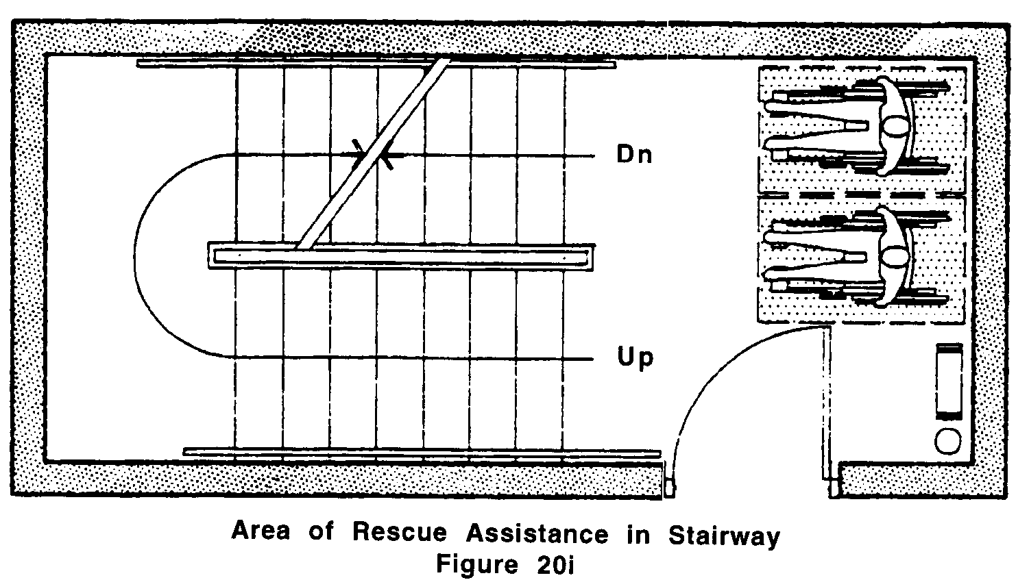

b. A portion of an exterior exit balcony located immediately adjacent to an exit stairway when the balcony complies with applicable requirements of 780 CMR (The Massachusetts State Building Code) for exterior exit balconies. Openings to the interior of the building located within 20 feet (20' = 6m) of the area of rescue assistance shall be protected with fire assemblies having a ¾ hour fire protection rating.
c. A portion of a one hour fire-resistive corridor (complying with applicable requirements of 780 CMR: the State Building Code for fire-resistive construction and for openings) located immediately adjacent to an exit enclosure. (See Fig. 20j)

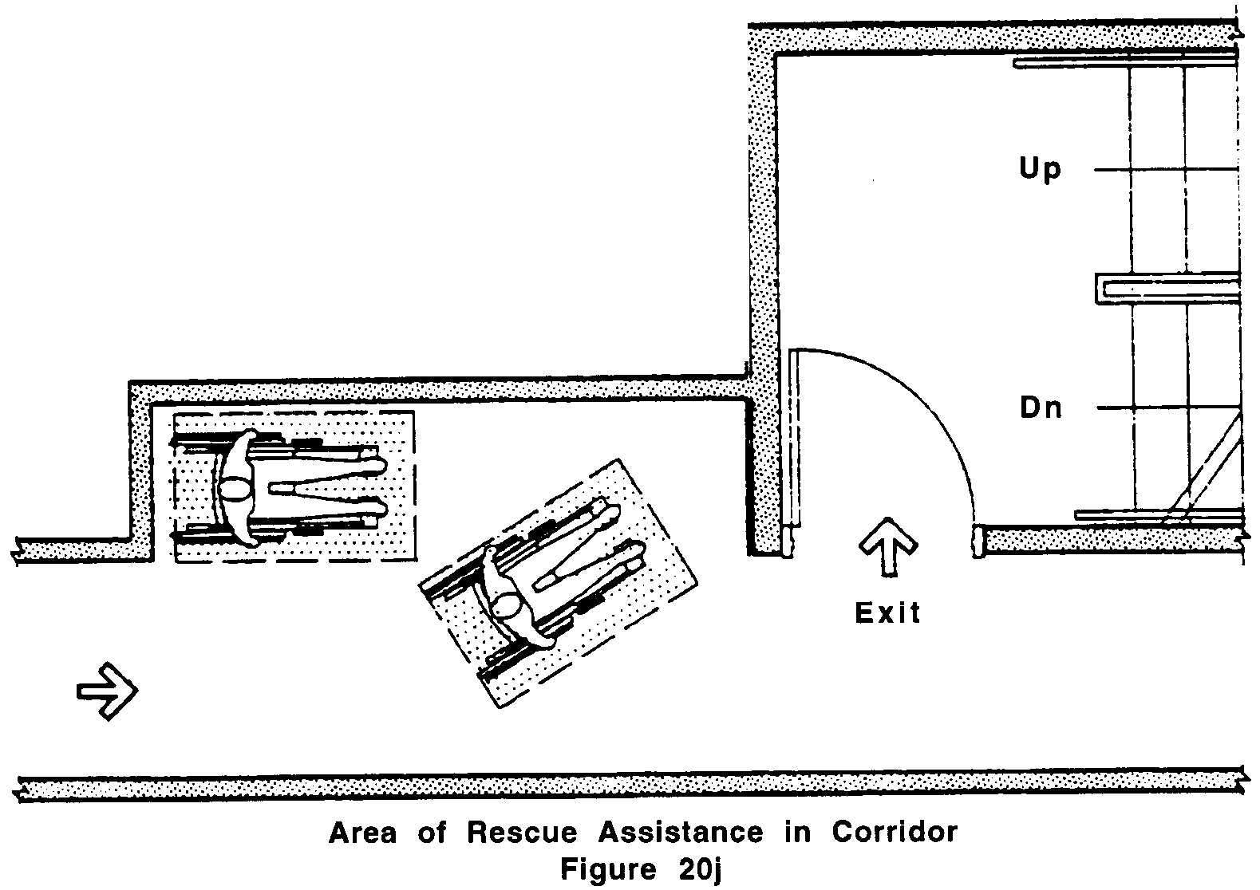

d. A vestibule located immediately adjacent to an exit enclosure and constructed to the same fire-resistive standards controlling corridors and openings.
e. A portion of a stairway landing within an exit enclosure which is vented to the exterior and is separated from the interior of the building with not less than one hour fire-resistive doors.
f. When approved by the appropriate applicable building official, an area or a room that is separated from other portions of the building by a smoke barrier. Smoke barriers shall have a fire-resistive rating of not less than one hour and shall completely enclose the area or room. Doors in the smoke barrier shall be tight-fitting smoke- and draft-control assemblies having a fire-protection rating of not less than 20 minutes and shall be self-closing or automatic closing. The area or room shall be provided with an exit directly to an exit enclosure. Where the room or area exits into an exit enclosure which is required to be of more than one hour fire-resistive construction, the room or area shall have the same fire-resistive construction, including the same opening protection, as required for the adjacent exit enclosure.
20.00: ACCESSIBLE ROUTE

g. An elevator lobby where elevator shafts and adjacent lobbies are pressurized as required for smokeproof enclosures by 780 CMR: the State Building Code or 524 CMR: the State Board of Elevator Regulations, and when complying with requirements herein for size, communication, and signage. Such pressurization system shall be activated by smoke detectors on each floor located in a manner approved by the appropriate local authority. Pressurization equipment and its duct work within the building shall be separated from other portions of the building by a minimum two-hour fire restrictive construction.
h. A flat level area that is stable, firm and slip resistant adjacent to the exit discharge in locations where the public way is further than 100 feet from the building.

20.12.2 Size: Each area of rescue assistance shall provide at least two accessible spaces, not less than 30 inches by 48 inches (30" x 48" = 762mm by 1219mm) each.

a. The area of rescue assistance shall not encroach on any required exit width.
b. The total number of such 30 inch by 48 inch (30" x 48" = 762mm by 1219mm) areas per story shall be not less than one for every 200 persons of calculated occupant load served by the area of rescue assistance.

20.12.3 Stairway Width: Each stairway adjacent to an area of rescue assistance shall have a minimum clear width of 48 inches (48" = 1219mm) between handrails.

20.12.4 Two-way Communication: A method of two-way communication, with both visible and audible signals, shall be provided between each area of rescue assistance and the primary entrance to the building. The fire department or appropriate building official may approve a location other than the primary entrance to the building. Any operable mechanism shall comply with 521 CMR 39.00: CONTROLS.

20.12.5 Identification: Each area of rescue assistance shall be identified by a sign that states "area of rescue assistance" and displays the international symbol of accessibility. The sign shall be illuminated when exit sign illumination is required. Signage shall also be installed at all inaccessible exits and where otherwise necessary to clearly indicate the direction to areas of rescue assistance. In each area of rescue assistance, instructions on the use of the area under emergency conditions shall be posted adjoining the two-way communication system.

