521 CMR 21.00: CURB CUTS

21.1 GENERAL
Whenever sidewalks, walkways, or curbs on streets and ways are constructed, reconstructed, or repaired, curb cuts are required. All curb cuts shall comply with the following:

21.2 LOCATION
Curb cuts shall occur wherever an accessible route crosses a curb and at the following locations:

21.2.1 Curb cuts are required at each corner of each intersection, located within the crosswalk and/or the pedestrian path of travel. Curb cuts shall be perpendicular to the curb at street crossings and each shall have a level landing at the top. At marked crossings, the bottom of the ramp run, exclusive of flared sides, shall be wholly contained with the marked crossing. See Fig. 21a. The crosswalk/pedestrian path of travel must also be perpendicular to the curb.

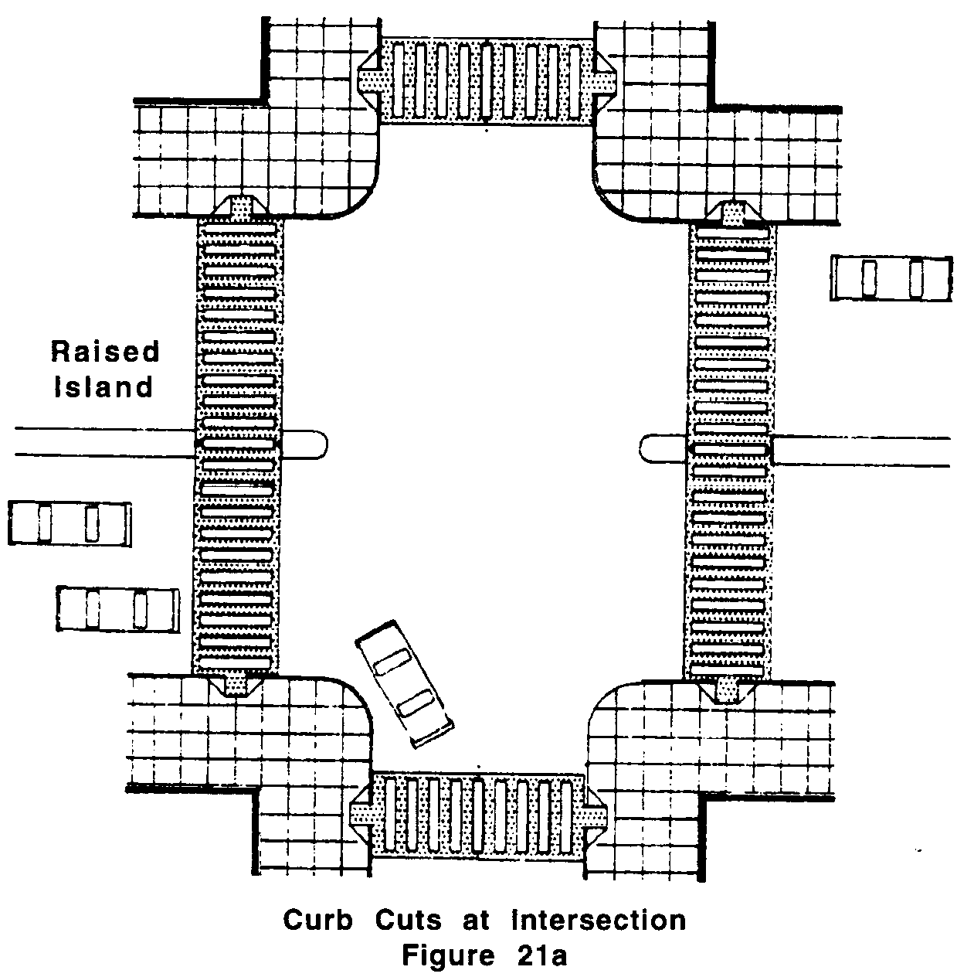

Exception: Where pedestrian right-of-way established width will not accommodate a perpendicular curb cut and landing, a parallel public sidewalk curb cut with a level landing at its bottom shall be provided instead of a perpendicular curb cut.

21.2.1.1 Apex curb cuts: Where site constraints prevent the installation of a perpendicular curb cut or a parallel curb cut with a level landing, an apex curb cut is allowed. Site constraints include the following:
21.00: CURB CUTS

a. Driver or pedestrian line of sight to or from the front of the level landing on the ramp is impaired, preventing safe observation of crosswalks or approaching traffic at the intersection by a significant immovable or unalterable streetscape feature such as a building, structure or historic element, etc.
b. Stop line is beyond the allowed limit as stated in the Manual on Uniform Traffic Control Devices.
c. Vaults containing electrical, telecommunications, etc. that are under or on the existing sidewalk.
d. Large radius intersections which are 30 feet or greater.

21.2.1.2 When apex curb cuts are installed a 48 inch (48" = 1219mm) landing shall also be provided at the bottom of the curb cut and located within the marked crosswalk.

21.2.2 Reciprocal curb cuts: When curb cuts or sidewalks are being constructed or reconstructed on one side of the street, and when such curb cuts or sidewalks are connected to an opposite side of the street by one or more pedestrian paths of travel, then at least one curb cut shall be provided on the opposite side of the street where such side is controlled by the same owner.

21.2.3 Driveways: Curb cuts are required at driveways intersecting sidewalks when the driveway has side curbs.

21.2.4 Raised Islands: Any raised islands in crossings shall be cut through level with the street or have curb cuts at both sides and a level area at least 48 inches (48" = 1219mm) long between the curb cuts in the part of the island intersected by the crossings.

21.2.5 Obstructions: Curb cuts shall be located or protected to prevent their obstruction by parked vehicles.

21.3 SLOPE
The least possible slope should be used for any ramp. The maximum slope shall be one-in-12 (1:12) (8.3%). Where sidewalks are too narrow to install a straight-line curb cut at a slope of one-in-12 (1:12) (8.3%), the sides of the curb cut shall not exceed one-in-12 (1:12) (8.3%). See Fig. 21b. The maximum cross-slope for any curb cut shall be 1:50 (2%). (There is no tolerance allowed on slope requirements). (Refer to 521 CMR 2.4.4d).

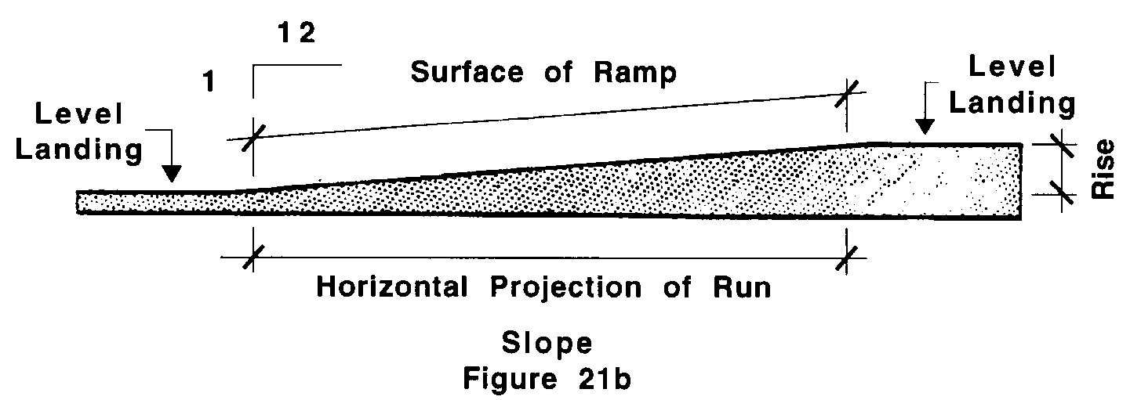
21.00: CURB CUTS

21.4 TRANSITIONS
Transitions from curb cuts to walks, gutters, or streets shall be flush or free of changes in level greater than ½ inch (½" = 13mm). Maximum slopes of adjoining gutters, road surface immediately adjacent to the curb cuts, or accessible route shall not exceed one-in-20 (1:20) (5%).

21.5 DRAINAGE
Grading and drainage shall be designed to minimize pooling of water, accumulation of ice, or flow of water across the base of the curb cut.

21.6 WIDTH
The minimum width of a curb cut shall be 36 inches (36" = 914mm), exclusive of flared sides. See Fig. 21c.

21.6.1 Landing width: Where a perpendicular curb cut is provided, a landing the width of the curb cut shall be provided at the top of the curb cut. The landing shall be 48 inches (48"= 1219mm) in length. The slope of said landing shall not exceed one-in-50 (1:50) (2%) in any direction.

21.7 FLARED SIDES
Sides of curb cuts shall extend at least 24 inches (24" = 610mm) at the curb. The maximum slope of the flare is one-in-ten (1:10) (10%). Curbing at the flared sides must blend with the slope of the flared sides. See Fig. 21c.

21.8 RETURNED SIDES
Curb cuts with returned sides are only permitted where they are protected by handrails pursuant to 521 CMR 24.5, Handrails or where pedestrian travel across the ramp is obstructed by permanently installed street hardware or landscaping. See Fig. 21d.
21.00: CURB CUTS

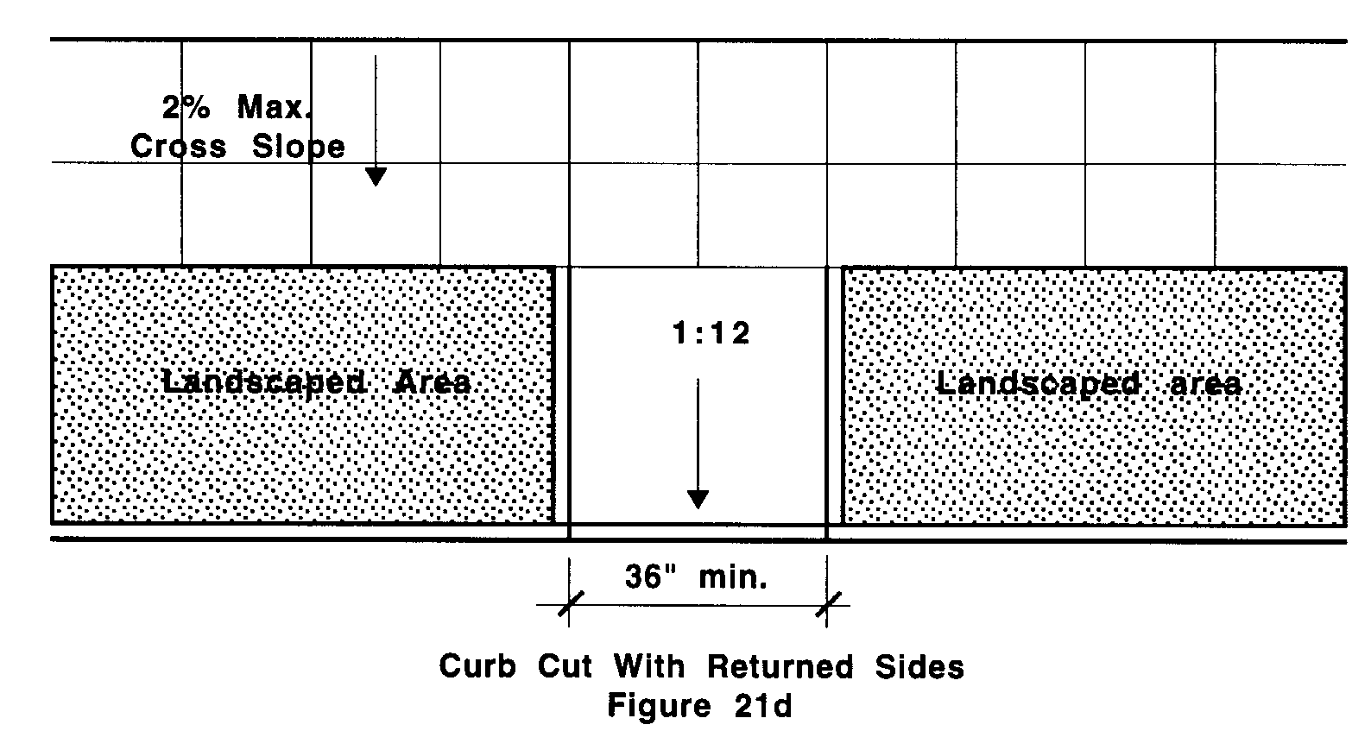

21.9 BUILT-UP CURB CUTS
Built-up curb cuts are allowed only where they do not project into vehicular traffic lanes. See Fig. 21e.

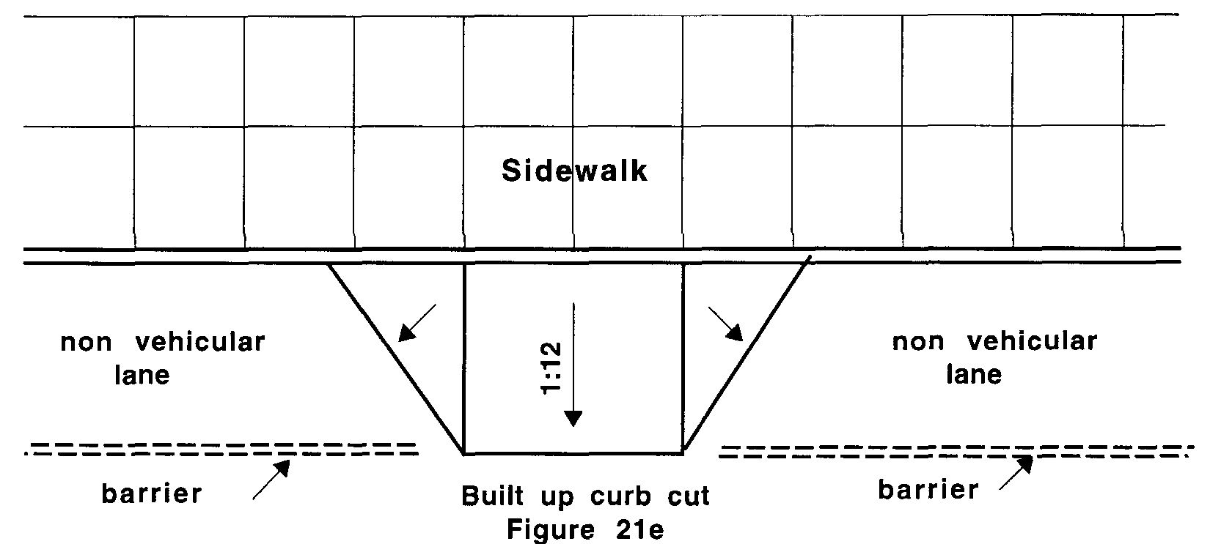

21.10 PEDESTRIAN STREET CROSSINGS
Where provided, pedestrian street crossings at, above, or below grade shall comply with the following:

21.10.1 Crossing controls shall be raised from or flush with their housings and shall be a minimum of two inches (2" = 51mm) in the smallest dimension. The force required to activate controls shall be no greater than 5 lbs.

21.10.2 Location: Controls shall be located as close as practicable to the curb cut serving the controlled crossing and shall permit operation from a clear ground space.

21.00: CURB CUTS

21.10.3 Mounting Height: Pedestrian-actuated crossing controls shall be a maximum of 42 inches (42" = 1067mm) above the finished sidewalk.

21.10.4 Clear ground space: A stable and firm area, complying with 521 CMR 6.5, Forward Reach, or 521 CMR 6.6, Side Reach shall be provided at the controls. Where a parallel approach is provided, controls shall be within ten inches (10" = 254mm) horizontally of and centered on the clear ground space. Where a forward approach is provided, controls shall abut and be centered on the clear ground space.

21.11 DETECTABLE WARNINGS - Reserved until further notice.

21.12 ACCESSIBLE PEDESTRIAN SIGNALS - Reserved.

