521 CMR 22.00: WALKWAYS

22.1 GENERAL
Walkways shall include but not be limited to all walks, sidewalks, overpasses, bridges, tunnels, underpasses, plazas, courts and other pedestrian pathways, and shall comply with the following requirements:

22.2 WIDTH
Width of walkways shall be not less than 48 inches (48"= 1219mm), excluding curb stones. An unobstructed path of travel shall be provided which is at least 36 inches (36" = 914mm) clear, excluding curb stones.

22.3 GRADE
Walkways with a running slope greater than one-in-20 (1:20) (5%) are ramps and shall comply with 521 CMR 24.00: RAMPS.

22.3.1 Nowhere shall the cross slope of walkways exceed one-in-50 (1:50) (2%). (Refer to 521 CMR 2.4.4d.)

Exception: Sidewalks on streets and ways shall be considered walkways, with the exception that if the slope of the natural topography exceeds one-in-20 (1:20) (5%) a ramp is not required.

22.3.2 Nowhere shall the surface slope of any plaza area exceed one-in-50 (1:50) (2%).

22.4 LEVEL CHANGES
Walkways shall have continuous common surfaces, not interrupted by steps or changes in level greater than ¼ inch (¼" = 6mm).

22.4.1 Changes in level between ¼ inch and ½ inch (¼" and ½" = 6mm and 13mm) shall be beveled with a slope no greater than 1:2 (50%). See Fig. 22a.

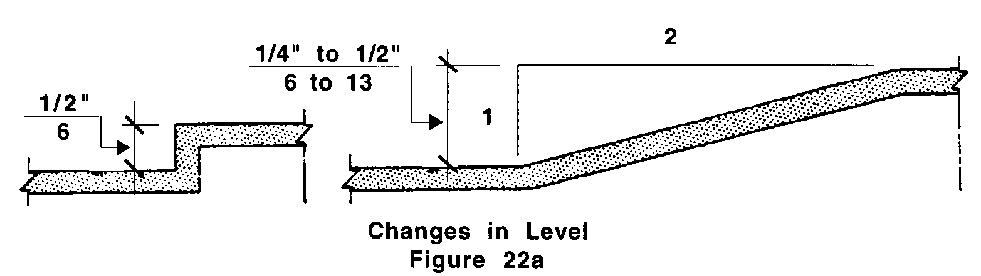

22.4.2 Changes in level greater than ½ inch (½" = 13mm) shall require a curb cut, walkway, ramp, elevator, or platform lift that complies with 521 CMR 21.00: CURB CUTS, 521 CMR 22.00: WALKWAYS, 521 CMR 24.00: RAMPS or 521 CMR 28.00: ELEVATORS.
22.00: WALKWAYS

22.5 SURFACE
Walkway surfaces shall be stable, and firm and shall lie generally in a continuous plane with a minimum of surface warping.

22.6 DRAINAGE
Grading and drainage shall be designed to minimize pooling of water or accumulation of ice or flow of water across walkways.

22.7 GRATINGS
If gratings are located in walking surfaces, they shall have spaces no greater than ½ inch (½" = 13mm) wide in the direction of the flow of travel. If gratings have elongated openings, then they shall be placed so that the long dimension is perpendicular to the dominant direction of travel. See Fig. 22b.

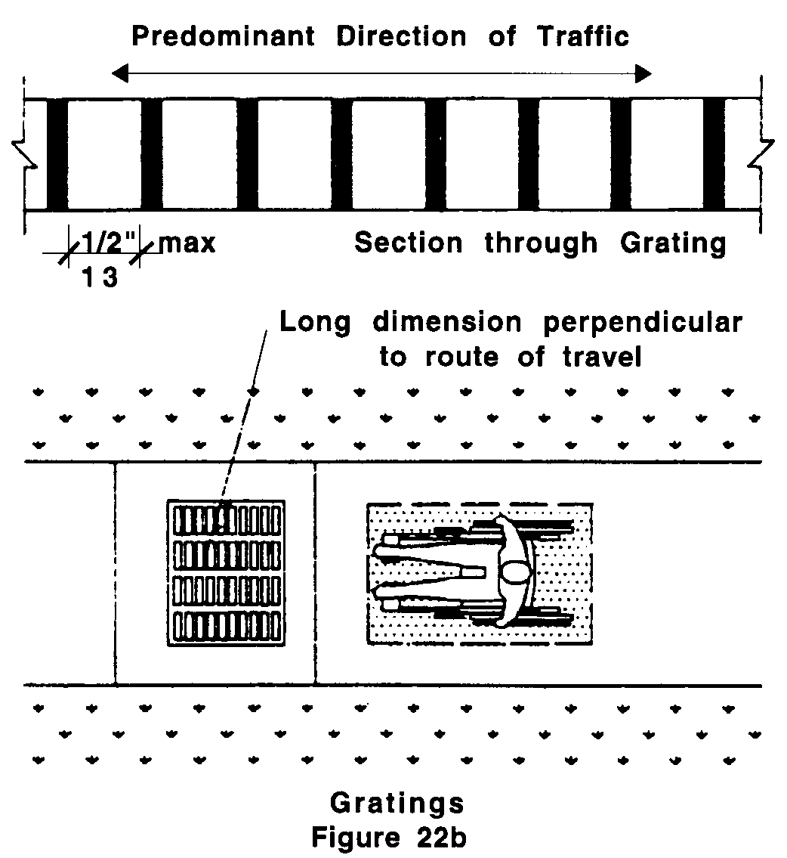

22.8 INTERSECTIONS
Wherever a walkway crosses or joins streets, public ways, driveways or parking lots, it shall comply with the following:

22.8.1 The intersecting surfaces shall blend to a common level with a slope no greater than 1:20 (5%), or a curb cut shall be installed in compliance with 521 CMR 21.00: CURB CUTS.

