521 CMR 23.00: PARKING AND PASSENGER LOADING ZONES

23.1 GENERAL
Any person who has lawful control of improved or enclosed private property used as off-street parking for businesses, auditoriums, sporting or recreational facilities, cultural centers, or general public use where the public has the right of access as invitees or licensees, shall cause such parking areas, including temporary parking areas to comply with 521 CMR. For parking related to residential and transient lodging facilities, See 521 CMR 8.00: TRANSIENT LODGING FACILITIES and 521 CMR 10.3, Parking Spaces.

23.2 NUMBER
Accessible spaces shall be provided as follows:

23.2.1 Total Parking in Lot Required Minimum Number of Accessible Spaces
15-25 1
26-50 2
51-75 3
76- 100 4
101-150 5
151-200 6
201-300 7
301-400 8
401-500 9
501-1,000 2% of total
1,001 and over 20 plus 1 for each 100 over 1000

23.2.2 One in every eight accessible spaces, but not less than one, shall be van accessible, See 521 CMR 23.4.7.

23.2.3 Spaces required by the table in 521 CMR 23.2.1 need not be provided in a particular lot. They may be provided in a different location if equivalent or greater accessibility, in terms of distance from an accessible entrance, cost and convenience, is ensured.

23.2.4 Specialized Medical Facilities: At facilities providing medical care for persons with mobility impairments, parking spaces shall comply with the following:

a. Outpatient units and facilities: 10% of the total number of parking spaces provided to serve each such outpatient unit or facility shall be accessible.
b. Units and facilities that specialize in treatment or services for persons with mobility impairments: 20% of the total number of parking spaces provided, serving each such unit or facility, shall be accessible.
23.00: PARKING AND PASSENGER LOADING ZONES

23.3 LOCATION
Accessible parking spaces shall be located as follows:

23.3.1 Accessible parking spaces serving a particular building, facility or temporary event shall be located on the shortest accessible route of travel from adjacent parking to an accessible entrance.

23.3.2 In parking facilities that do not serve a particular building, accessible parking shall be located on the shortest accessible route of travel to an accessible pedestrian entrance of the parking facility.

23.3.3 In buildings with multiple accessible entrances with adjacent parking, accessible parking spaces shall be dispersed and located closest to the accessible entrances, but in no case, more than three spaces from the accessible entrance.

Exception: Where accessible spaces cannot be located within 200 feet (200' = 61m) of an accessible entrance, an accessible passenger drop-off area shall be provided within 100 feet (100' = 30m) of an accessible entrance.

23.3.4 Garages: In multi-level garages where no elevator is provided, such spaces shall all be located near the accessible entrance. See special van requirement in 521 CMR 23.4.7.

23.4 PARKING SPACES
Shall comply with the following:

23.4.1 Width: Accessible parking spaces shall be at least eight feet (8' = 2438mm) wide, plus the access aisle.

23.4.2 Length: The length of accessible parking spaces shall be at least the same as for parking spaces generally in accordance with 780 CMR: The State Building Code or local zoning requirements. Parked vehicles shall not reduce the clear width of an accessible route by overhanging or protruding into it.

23.4.3 Slope: Parking spaces shall be level with surface slopes not exceeding 1:50 (2%) in all directions.

Exception: When temporary accessible parking is located within a field or otherwise unpaved area, when such site has not been improved in accordance with 521 CMR, the spaces shall be located on the least sloping area of the parking lot.

23.4.4 Surface: Spaces shall have a uniform, paved or hard packed smooth surface.

Exception: Temporary accessible parking spaces shall have, at minimum, a hard packed, smooth surface with a minimum amount of pooling or draining water.
23.00: PARKING AND PASSENGER LOADING ZONES

23.4.5 Delineation: Accessible spaces shall be marked by high contrast painted lines or other high contrast delineation.

Exception: Temporary accessible parking spaces shall be easily identifiable, such as lined with field markings, paint or field tape. Traffic cones or barrels may be used to identify parking spaces where field markings, paint, or field tape cannot be used given the surface condition.

23.4.6 Access aisles: All accessible spaces shall have access aisles that comply with the following:

a. Parking access aisles shall be part of an accessible route to the building or facility entrance and shall comply with 521 CMR 20.00: ACCESSIBLE ROUTE.

Exception: For temporary accessible parking, directional signage along the entire accessible route, using the international symbol of accessibility and an arrow, shall be used to direct people to the closest accessible entrance.

b. Access aisles adjacent to accessible spaces shall be five feet (5' = 1524mm) wide minimum, except adjacent to van accessible spaces the access aisle shall be a minimum of eight feet (8' = 2438mm) wide.

Exception: When temporary accessible parking is located within a field or otherwise unpaved site, when such area has not been improved in accordance with 521 CMR, the spaces shall be located on the least sloping area of the parking lot in conjunction with the temporary accessible parking spaces.

c. Two accessible parking spaces may share a common access aisle. See Fig. 23a and 23b.

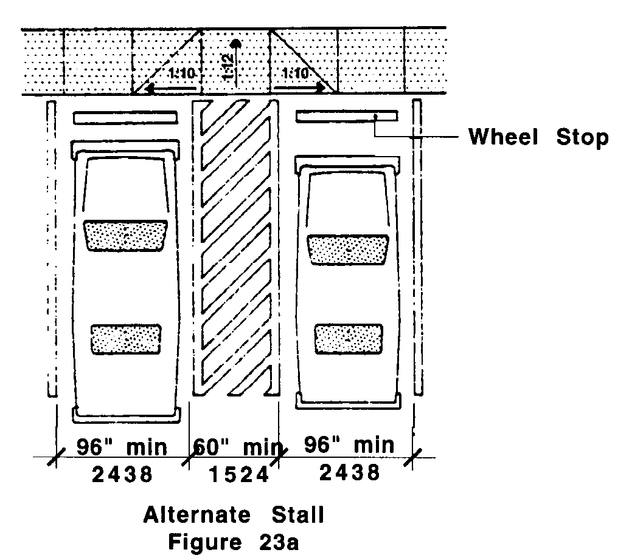
23.00: PARKING AND PASSENGER LOADING ZONES

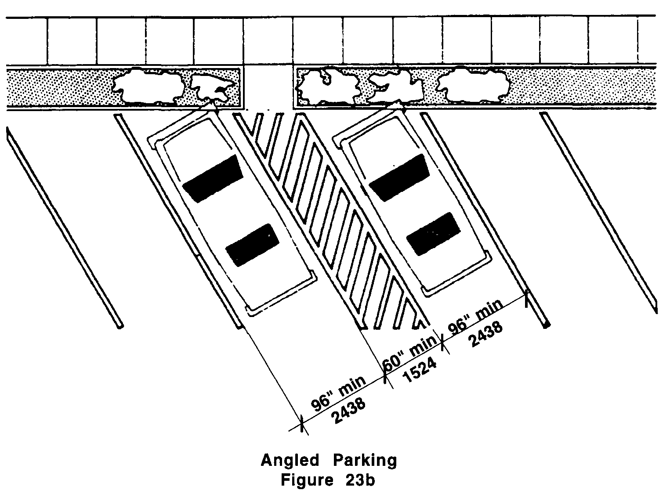

d. Access aisles shall be level with surface slopes not exceeding 1:50 (2%) in all directions.
e. Access aisles shall be clearly marked by means of diagonal stripes.

23.4.7 Van Accessible spaces shall comply with the following:

a. Provide minimum vertical clearance of eight feet, two inches (8’2” = 2489mm) at the parking space and along at least one vehicle access route to such spaces from site entrance(s) and exit(s). See Fig. 23c.
23.00: PARKING AND PASSENGER LOADING ZONES

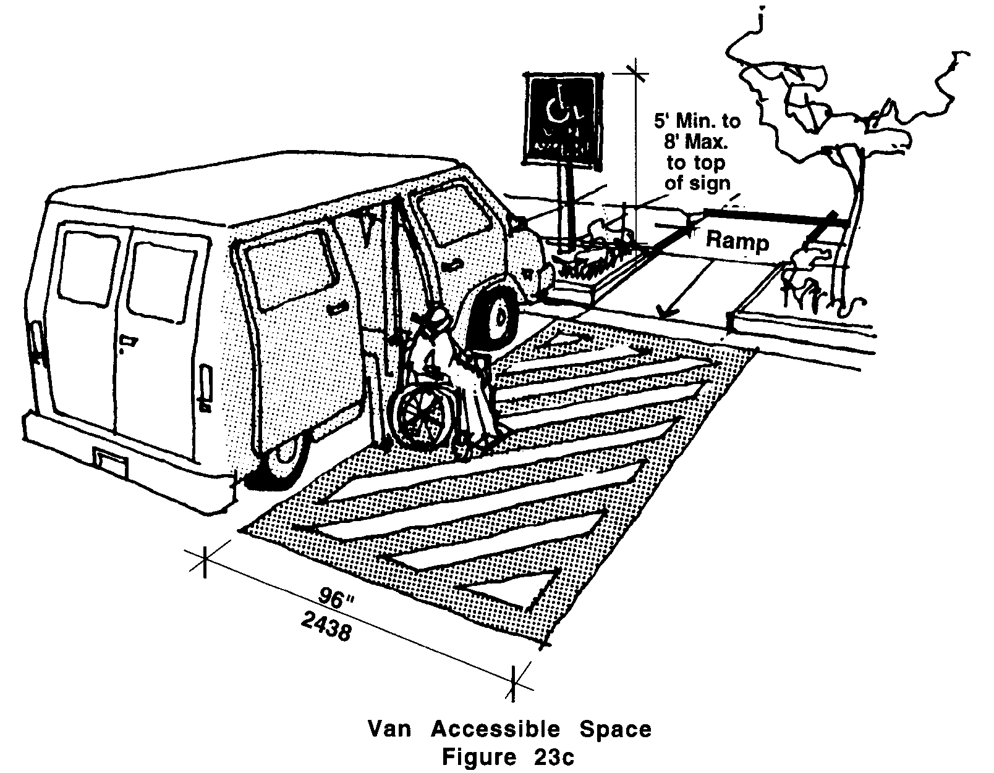

b. Each space shall have a sign designating it "Van Accessible" as required by 521 CMR 23.6, Signage.
c. All such spaces may be grouped on one level of a parking structure.
d. Eight foot minimum (8' = 2438mm) wide space.
e. Provide an access aisle of eight feet (8' = 2438mm).

Exception: Van accessible spaces do not have to be separately provided if all required accessible parking spaces are 11 feet wide (11' = 3353mm) with a five foot (5' = 1524mm) access aisle.

23.5 SIDEWALKS
Where sidewalks are provided at accessible parking spaces, a curb cut shall be installed at the access aisle of each accessible space or pair of spaces.

Exception: Where walkways and sidewalks are provided at temporary accessible parking spaces, there shall be a firm, stable path of travel, not less than 36 inches wide, from the temporary accessible parking spaces to said walkway or sidewalk. There shall be no abrupt changes in level greater than ½ inch. If there is a change of level greater than ½ inch, then vertical access shall be provided either via temporary curb ramps or via a temporary ramp.

23.6 SIGNAGE
Accessible parking spaces shall be identified by signs indicating that they are reserved.

23.6.1 A sign shall be located at the head of each space and no more than ten feet (10' = 3048mm) away, and at accessible passenger loading zones and may also include wording identifying its use.
23.00: PARKING AND PASSENGER LOADING ZONES

Exception: Signs for temporary accessible parking spaces located within a field or otherwise unpaved area shall be located at the head of each space if there are no attendants directing people to park, or signs indicating a general area designated for accessible vehicles if parking attendants are directing people to park.

23.6.2 The sign shall show the international symbol of accessibility.

23.6.3 Van accessible spaces shall includes the words: "Van-Accessible".

23.6.4 Such signs shall be permanently located at a height of not less than five feet (5' = 1524mm), nor more than eight feet (8' = 2438) to the top of the sign.

Exception: Signage for temporary accessible parking spaces may be permanently attached to a pole within a bucket.

23.7 PASSENGER LOADING ZONE
If passenger loading zones are provided, at least one of them shall comply with the following:

23.7.1 Wherever a passenger loading zone or parking area is provided, an accessible route to an accessible entrance is required.

23.00: PARKING AND PASSENGER LOADING ZONES

23.7.2 Passenger loading zones shall provide an access aisle at least 60 inches (60" = 1524mm) wide and 20 feet (20' = 6096mm) long, adjacent and parallel to the vehicle pull-up space.

23.7.3 If there are curbs between the access aisle and the vehicle pull-up space, then a curb cut complying with 521 CMR 21.00: CURB CUTS, shall be provided.

23.7.4 Vehicle standing spaces and access aisles shall be level with surface slopes not exceeding 1:50 (2%) in all directions.

23.7.5 Vertical Clearance: A minimum of nine feet, six inches (9'6" = 2896mm) of vertical clearance shall be provided at accessible passenger loading zones and along at least one vehicle access route to such areas from site entrance(s) and exit(s).

23.8 VALET PARKING
Valet parking facilities shall provide a passenger loading zone complying with 521 CMR 23.7, Passenger Loading Zone located on an accessible route to the entrance of the facility. 521 CMR 23.2 Number and 521 CMR 23.4.7 Van Accessible Spaces, do not apply to valet parking facilities.

