521 CMR 25.00: ENTRANCES

25.1 GENERAL
All public entrance(s) of a building or tenancy in a building shall be accessible. Public entrances are any entrances that are not solely service entrances, loading entrances, or entrances restricted to employee use only.

25.1.1 Service entrances: If the only entrance to a building, or tenancy in a facility, is a service entrance, that entrance shall be accessible.

25.2 APPROACH
The approach to an accessible entrance shall be a paved walk or ramp with a slip resistant surface, uninterrupted by steps. Entrance(s) shall have a level space on the interior and exterior of the entrance doors complying with Fig. 25a and 25b.

25.3 VESTIBULES
Between any two hinged or pivoted doors, there shall be a minimum of 48 inches (48" = 1219mm) plus the width of any door swinging into the space. See Fig. 25a and 25b.

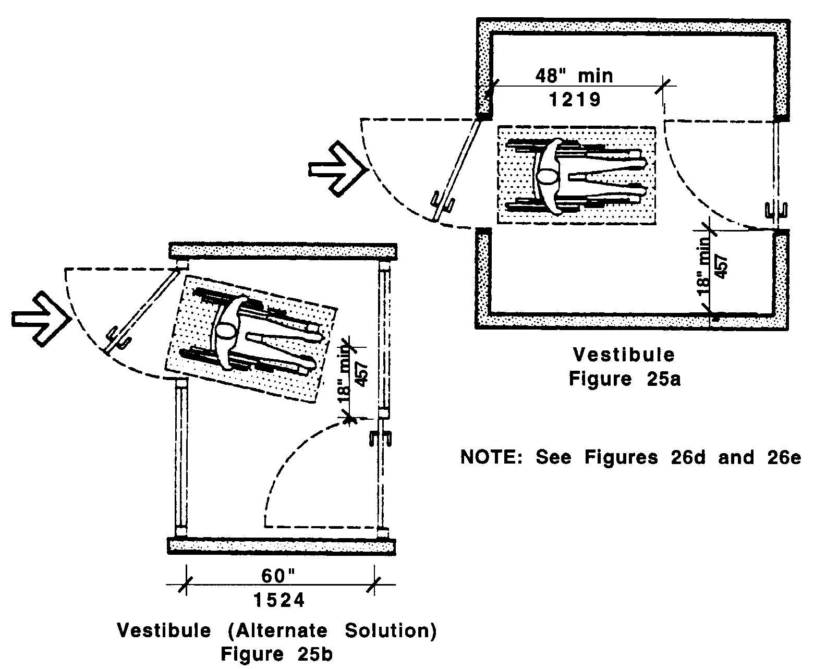
25.00: ENTRANCES

25.4 MATS AND GRATES
Door mats ½ inch (½" = 13mm) thick or less shall be securely anchored at all edges to avoid tripping. Door mats between ¼ inch (¼" = 6mm) and ½ inch (½" = 13mm) thick must be secured with beveled edging that slopes no more than 1:2 (50%). Door mats thicker than ½ inch (½" = 13mm) shall be recessed. Grates shall have openings not exceeding ½ inch (½" = 13mm) in the path of travel. See Fig. 25c.

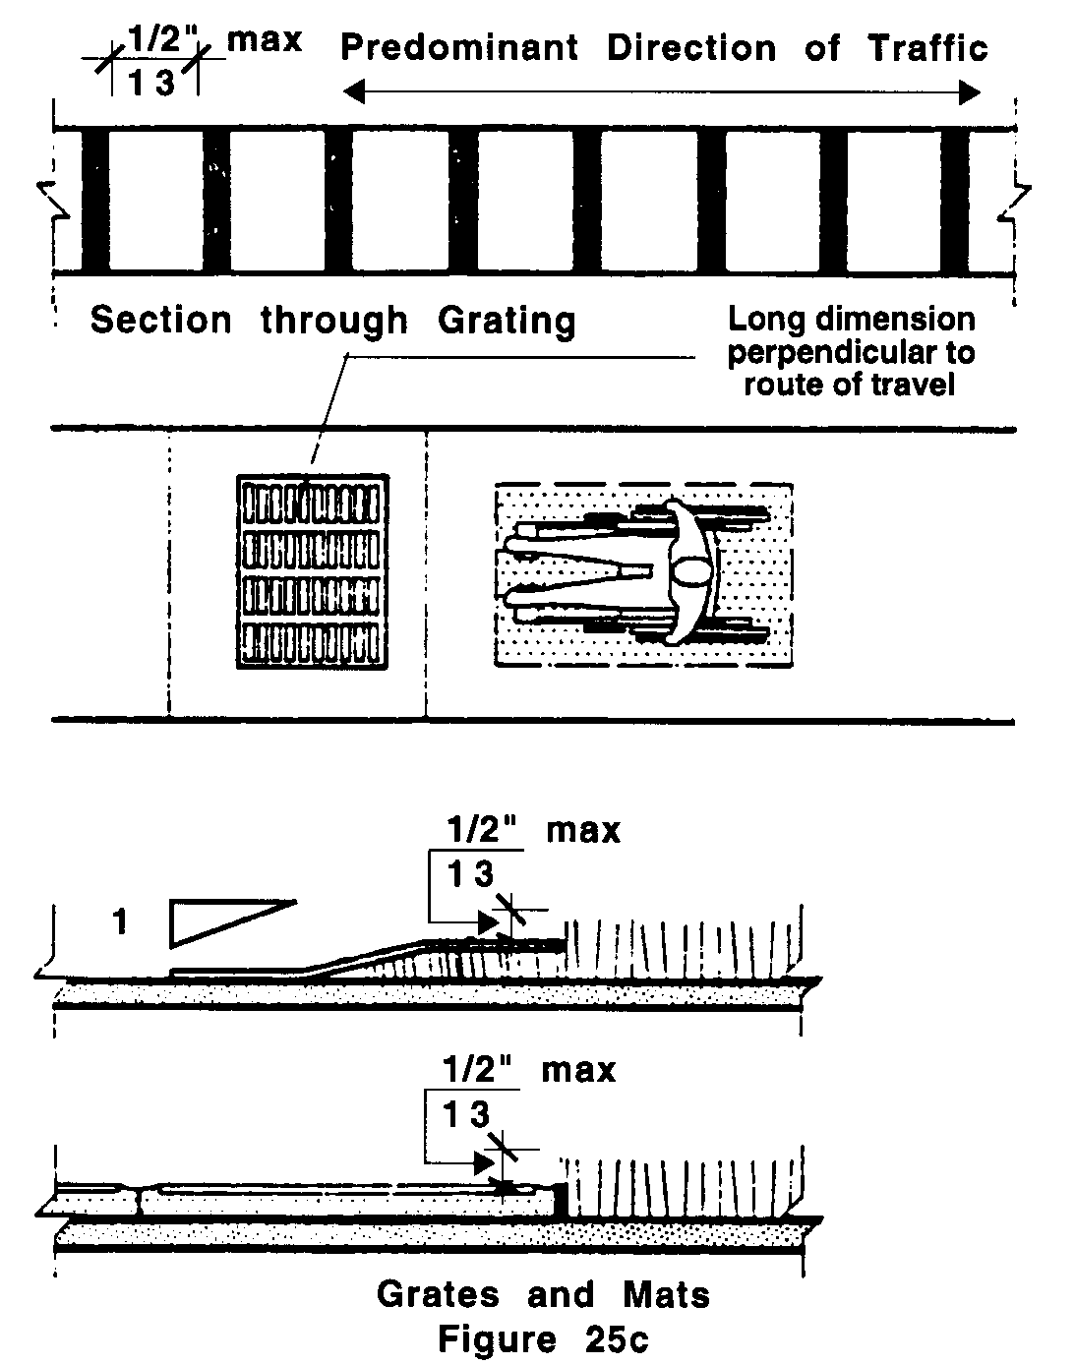

25.5 PROTRUDING OBJECTS
Objects that protrude into entranceways, (suspended lights, signs, fixtures, door closers, etc.) shall comply with 521 CMR 20.6, Protruding Objects.

25.6 SIGNAGE
Any entrance/exit of a facility not accessible by persons in wheelchairs shall have a sign clearly indicating the location of the accessible entrance/exit.

