521 CMR 27.00: STAIRS

27.1 GENERAL
All stairs are required to comply with the following:

27.2 TREADS AND RISERS
On any given flight of stairs, all steps shall have uniform riser heights and uniform tread widths. Open risers are not permitted. See Fig. 27a.

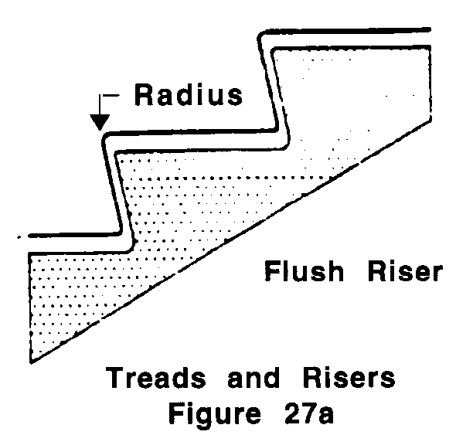

27.3 NOSINGS
The undersides of nosings shall not be abrupt. The radius of curvature at the leading edge of the tread shall be no greater than ½ inch (½" = 13mm). Risers shall be sloped or the underside of the nosing shall have an angle not less than 60 degree from the horizontal. Nosings shall project no more than 1½ inches (1½" = 38mm). See Fig. 27b.

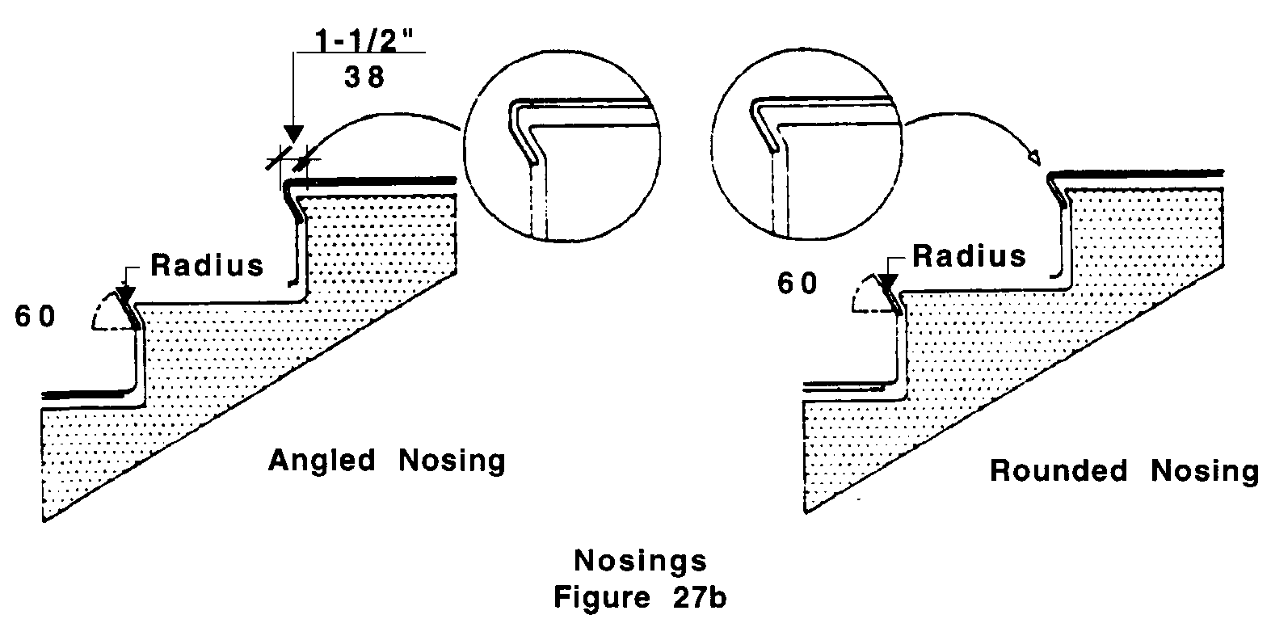

27.00: STAIRS

27.4 HANDRAILS
Handrails shall have the following features:

27.4.1 Location: Stairways shall have continuous handrails at both sides of all stairs. The inside handrail on switchback or dogleg stairs shall always be continuous. See Fig. 27c.

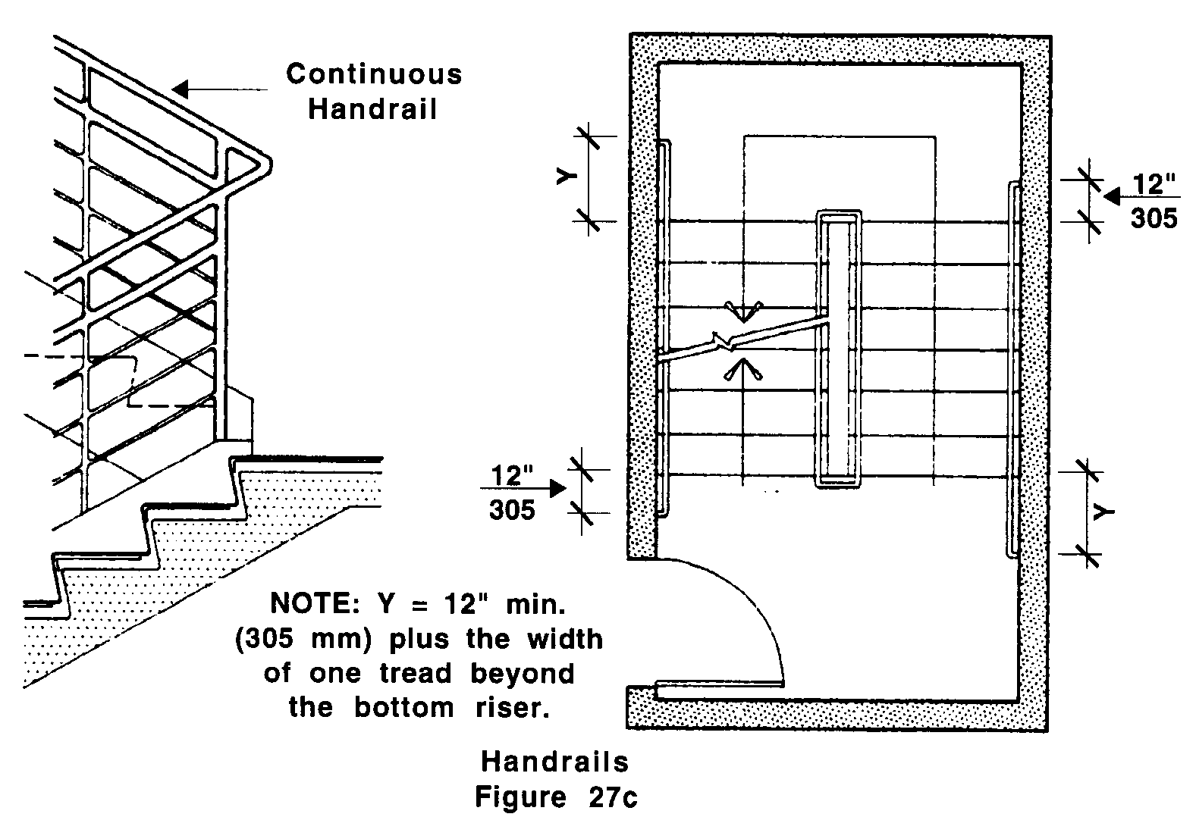

27.4.2 Height: Top of handrail gripping surface shall be mounted between 34 inches (34" = 864mm) and 38 inches (38" = 965mm) above stair nosings. Handrails shall be measured vertically from the top of the gripping surface of the handrails to the stair nosing.

27.4.3 Extensions: Where handrails terminate at the top and bottom of a stair run, they shall have extensions that comply with the following:

a. At the top, extend at least 12 inches (12" = 305mm) beyond the top riser and parallel with the floor or ground surface. See Fig. 27d.
27.00: STAIRS
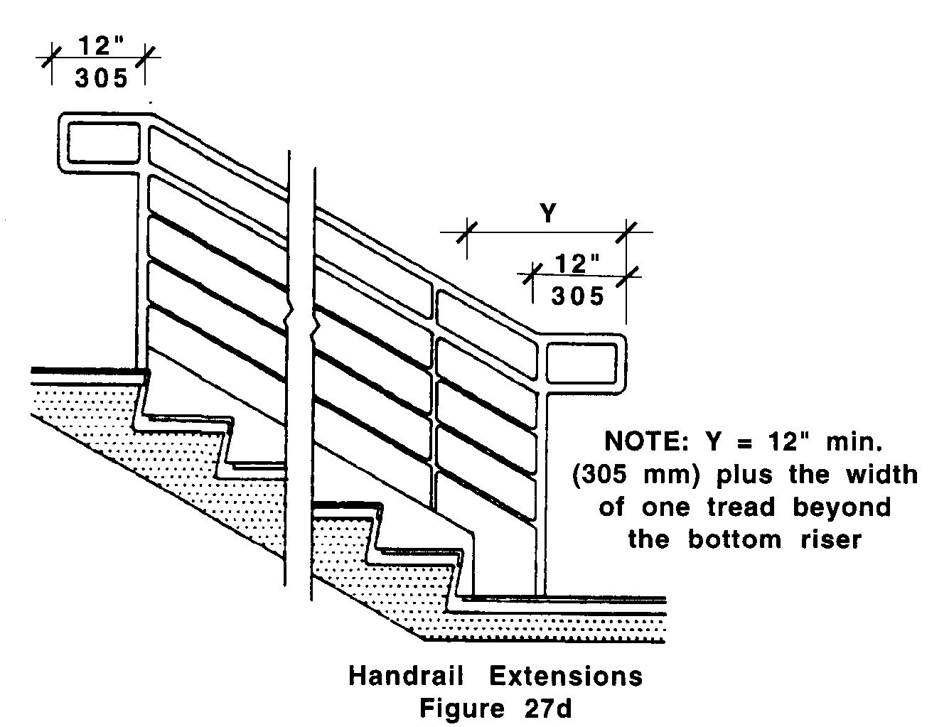

b. At the bottom, extend at least 12 inches (12" = 305mm) plus the width of one tread beyond the bottom riser. The handrail shall continue to slope for a distance of the width of one tread from the bottom riser; the remainder of the extension shall be horizontal. See Fig. 27d.
c. Handrail extensions need not extend if it would cause a safety hazard or if space does not permit. Extensions shall comply with 521 CMR 20.6, Protruding Objects.

27.4.4 Size: Handrails shall have a circular cross section with an outside diameter of 1¼ inches (32mm) minimum and two inches (51mm) maximum.

27.4.5 Shape: The handgrip portion of the handrail shall be round or oval in cross-section. See Fig. 27e.
27.00: STAIRS
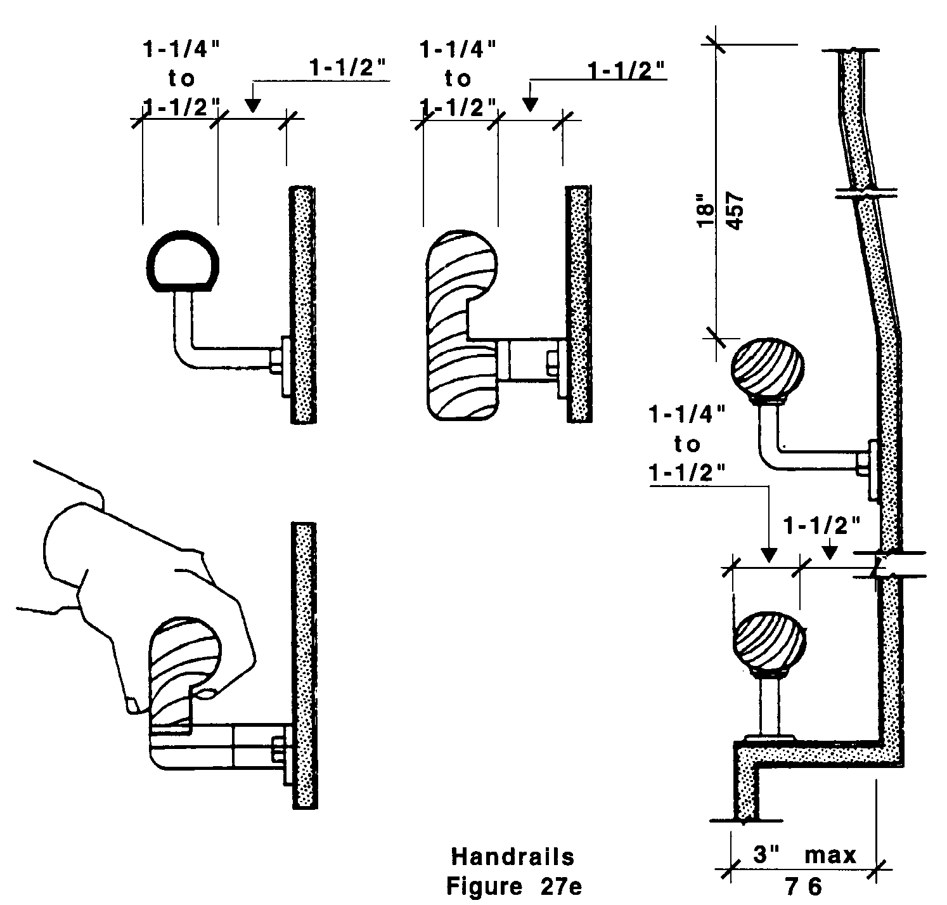

27.4.6 Surface: The gripping surface shall be continuous so that a hand can move from end to end without interruption by newel posts or other obstructions, and shall be free of any sharp or abrasive elements.

27.4.7 Clearance: When a handrail is mounted adjacent to a wall, the clear space between the handrail and the wall shall be 1½ inches (1½" = 38mm). Handrails may be located in a wall recess if the recess is a maximum of three inches (3" = 76mm) deep and extends at least 18 inches (18" = 457mm) above the top of the rail.

27.4.8 End condition: Ends of handrails shall be either rounded or returned smoothly to floor, wall, or post. Extensions on handrails which are not attached to walls shall be returned smoothly to the floor or a post.

27.4.9 Handrails shall not rotate within their fittings.

27.5 DETECTABLE WARNINGS AT STAIRS: Reserved until further notice.

27.6 OUTDOOR CONDITIONS
Outdoor stairs and their approaches shall be designed so that water will not accumulate on walking surfaces.

