521 CMR 29.00: FLOOR SURFACES

29.1 GENERAL
Ground and floor surfaces including floors, walks, ramps, and curb cuts shall be stable, firm, slip resistant, and maintained with materials that ensure continued slip resistance.

29.2 LEVEL CHANGES
Ground and floor surfaces shall be of a common level throughout, except for the following permitted changes in level.

29.2.1 Changes in level up to and including ¼ inch (¼" = 6mm) may be vertical and without edge treatment. See Fig. 29a.

29.2.2 Changes in level greater than ¼ inch (¼" = 6mm) and less than ½ inch (½" = 13mm) shall be beveled with a slope no greater than one-in-two (1:2) (50%). See Fig. 29a.

29.2.3 Changes in level greater than ½ inch (½" = 13mm) are not allowed unless a ramp, walkway, or means of vertical access complying with 521 CMR is provided.

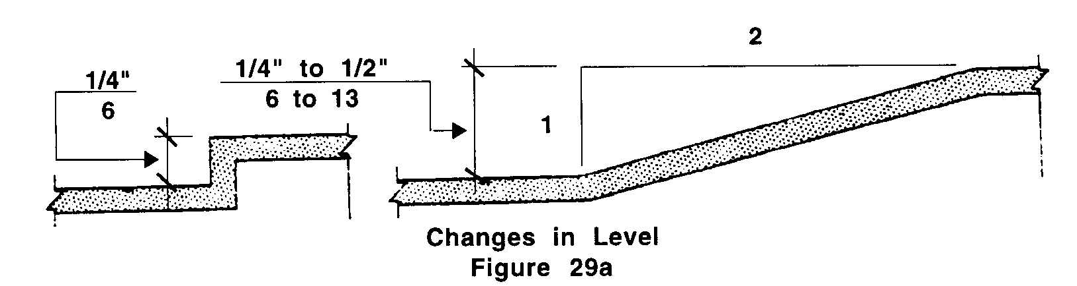

29.3 CARPET
When carpet or carpet tile is used on a ground or floor surface, it shall comply with the following:

29.3.1 Material: Carpet material shall be high density, non-absorbent, and the maximum pile thickness shall be ½ inch (½" = 13mm).

29.3.2 Installation: Carpet shall be adhered directly to the floor or shall be stretched tautly and securely fastened to floor surfaces at all edges.

29.3.3 Exposed edges: Edges of carpet exposed to traffic shall have trim along the entire length of the exposed edge. Edges perpendicular to the path of travel shall have edging strips no higher than _ of an inch (_" = 10mm) above the floor and shall have a beveled edge with a slope no greater than one-in-two (1:2) (50%).

29.3.4 Padding: If padding is installed, it shall not exceed ¼ of an inch (¼" = 6mm) in thickness and shall be secured taut to the floor.

29.00: FLOOR SURFACES

29.4 GRATINGS
If gratings are located in walking surfaces, then they shall have spaces no greater than ½ inch (½" = 13mm) wide in one direction. If gratings have elongated openings, then they shall be placed so that the long dimension is perpendicular to the dominant direction of travel. See Fig. 29b.
