521 CMR 31.00: BATHING ROOMS

31.1 GENERAL
Each public bathing room provided on a site or in a building shall comply with 521 CMR. Bathing rooms in Multiple dwellings shall comply with 521 CMR 42.00: GROUP 1 BATHROOMS and 521 CMR 44.00: GROUP 2 BATHROOMS instead of 521 CMR 31.00. Showers in hotels shall also comply with the requirements of 521 CMR31. In each bathing room where a shower or bathtub is provided at least one of each shall be accessible to persons in wheelchairs or an accessible unisex bathing room shall be provided.

31.2 LOCATION
Accessible bathing rooms shall be on accessible routes.

31.3 VESTIBULES
Where vestibules are provided, they shall comply with 521 CMR 26.7, Two Doors in a Series.

31.4 DOORS
All doors to accessible bathing rooms shall comply with 521 CMR 26.00: DOORS AND DOORWAYS. Doors shall not swing into the clear floor space required for any fixture.

31.5 OTHER FIXTURES
If bathing rooms have water closets and/or sinks, those fixtures shall comply with the requirements of 521 CMR 30.00: PUBLIC TOILET ROOMS.

31.6 CLEAR FLOOR SPACE
The accessible fixtures and controls required in 521 CMR 31 shall be on an accessible route. An unobstructed wheelchair turning space complying with 521 CMR 6.3, Wheelchair Turning Space shall be provided. The clear floor spaces at fixtures and controls, the accessible route, and the wheelchair turning space may overlap.

31.7 SHOWER STALLS
Accessible shower stalls shall comply with the following:

31.7.1 Size: Shower stall size and clear floor space shall comply with Fig. 31a or b. The shower stall in Fig. 31a shall be 36 inches by 36 inches (36" by 36" = 914mm by 914mm). The shower stall in Fig. 31b will fit into the 30 by 60 inch (30" by 60" = 762mm by 1524mm) space required for a bathtub. There shall be no more than a ½ inch (½" = 13mm) lip, beveled at a slope no steeper than one-in-two (1:2) (50%).
31.00: BATHING ROOMS

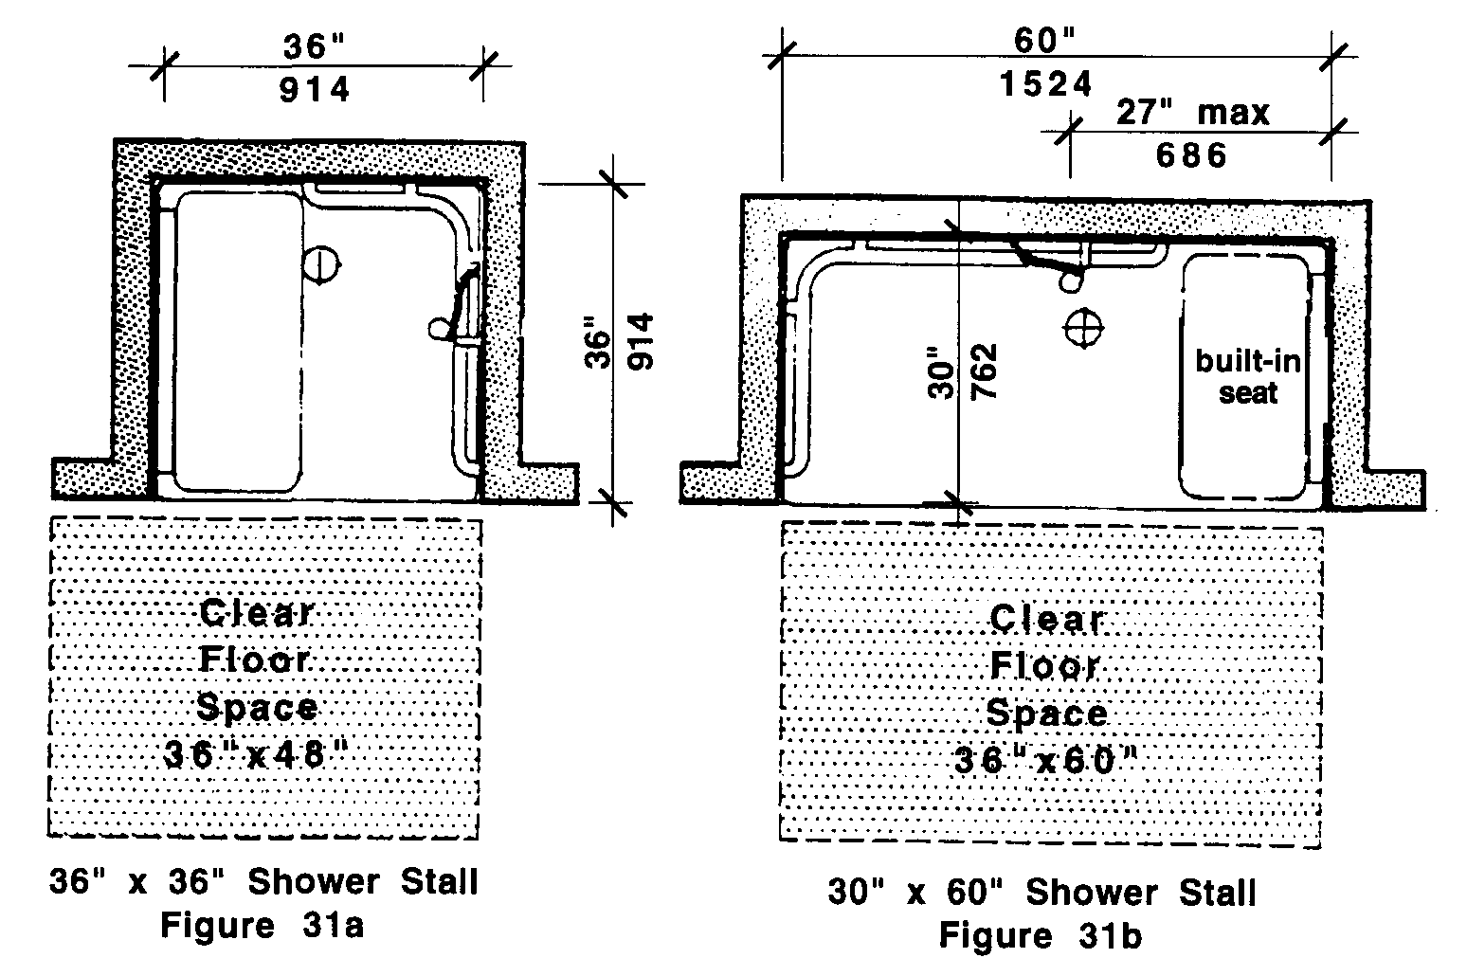

31.7.2 Floors: Floors shall be pitched to drain within the stall no steeper than one-in-50 (1:50) or (2%). Floors shall be carborundum, grit-face tile, or other slip resistant surface.

31.7.3 Controls: Showers shall operate by a single lever with a thermostatic and/or pressure balance mixing valve, and except in shower stalls 36 by 36 inches (36" by 36" = 914mm by 914mm) all controls shall be located on the center wall adjacent to the hinged seat. Faucets and other controls shall be located as shown in Fig. 31c and d and shall comply with 521 CMR 39.00: CONTROLS.
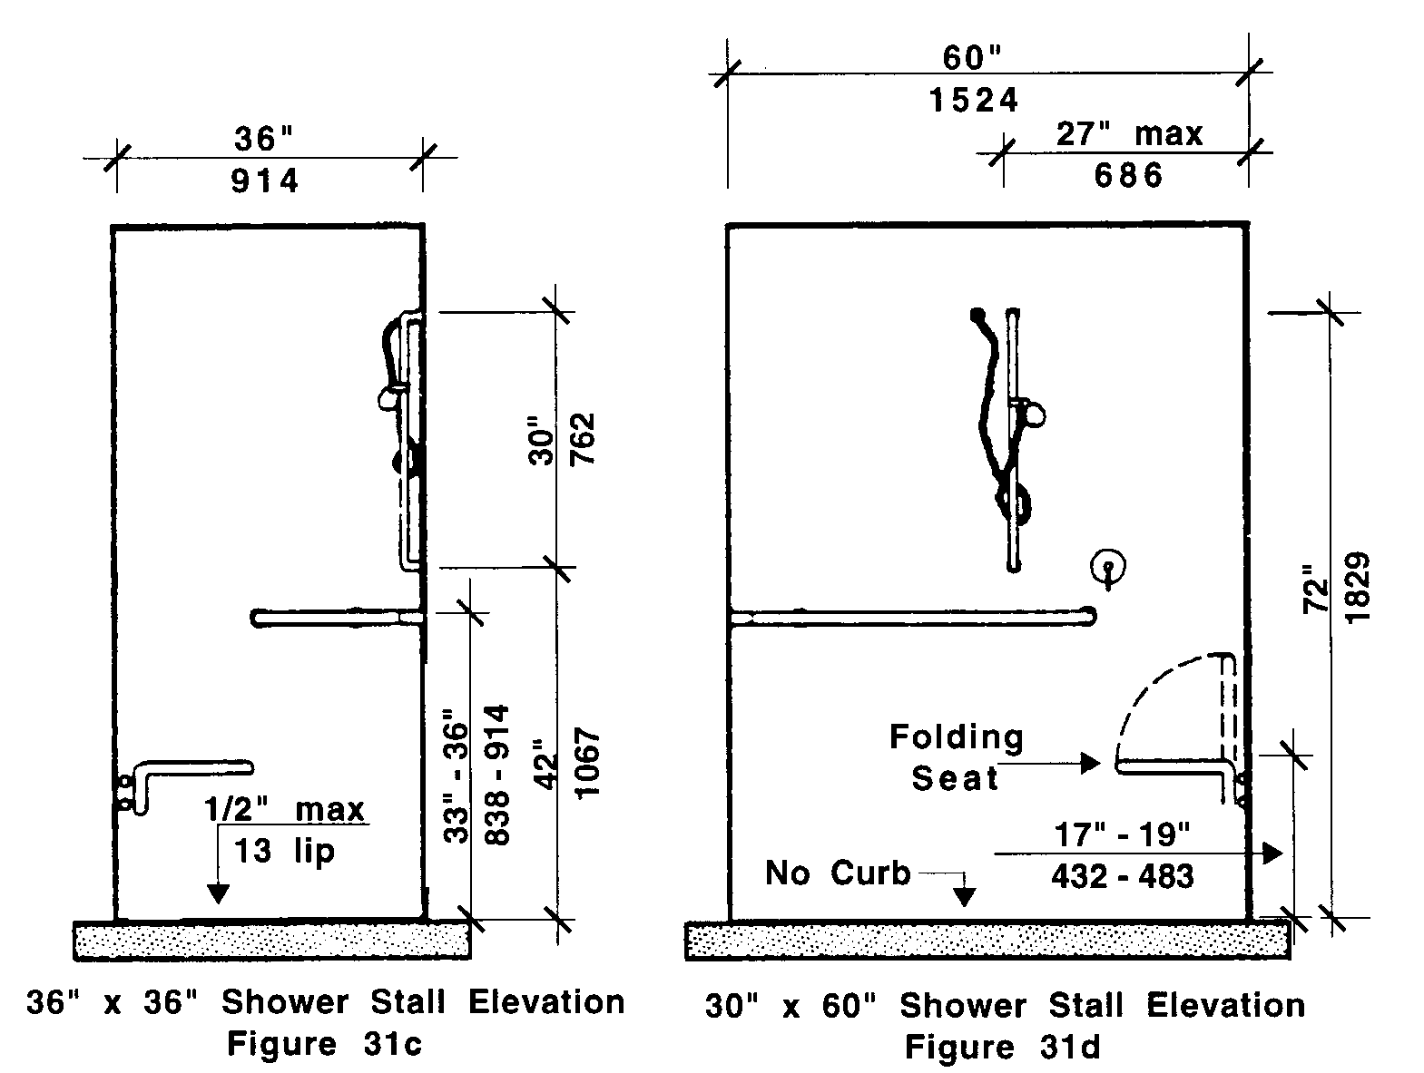

31.00: BATHING ROOMS

31.7.4 Seat: A folding seat shall be provided in the 36 inch by 36 inch (36" by 36" = 914mm by 914mm) shower stalls and shall be as shown in Fig. 31c. The seat shall be on the wall opposite the controls. In a 30 inch by 60 inch minimum (30" by 60" = 762mm by 1524mm) shower stall, a seat shall be provided. It shall be a folding type and shall be mounted on the wall adjacent to the controls as shown in Fig. 31d.

a. The seat shall be mounted 17 inches to 19 inches (17" to 19" = 432mm to 483mm) above the bathroom floor and shall extend the full depth of the stall.
b. The structural strength of seats and their attachments shall comply with the definition of structural strength in 521 CMR 5.00: DEFINITIONS.
c. The seat shall be padded.

31.7.5 Grab bars: Two grab bars shall be provided as shown in Fig. 31c and 31d.

a. They shall be placed horizontally between 33 and 36 inches (33" to 36" = 838mm to 914mm) above the floor line. In a 36 by 36 inch (36" by 36" = 914mm by 914mm) stall, two 30 inch (30" =762mm) grab bars shall be provided, one on the back wall and one on the wall opposite the seat. In a 30 inch by 60 inch (30" by 60" = 762mm by 1524mm), two grab bars, one 42 inches (42"= 1067mm) long and one 24 inches (24 " = 608mm) long shall be installed on the long wall and the short wall opposite the seat. In the alternative, a continuous L-shaped grab bar in the shower is acceptable.
b. The structural strength of grab bars and their attachments shall comply with the definition of structural strength in 521 CMR 5.00: DEFINITIONS.
c. Grab bars shall be 1¼ inches to 1½ inches (1¼" to 1½" = 32mm to 38mm) in outside diameter, and have a 1½ inch (1½" = 38mm) clearance between the bar and the wall. See Fig. 25a.
d. Grab bars shall also be non-rusting and acid-etched or roughened.

31.7.6 Soap trays shall not incorporate hand hold features unless they can support 250 pounds for five minutes.

31.7.7 Spray Shower Unit. A shower spray unit attached to a flexible metal hose at least 60 inches (60" = 1524mm) long and adjustable from 42 inches to 72 inches (42" to 72" = 1067mm to 1829mm) that can be used both as a fixed shower head and as a hand-held shower shall be provided.

Exception: In unmonitored facilities where vandalism is a consideration, a fixed shower head mounted at 48 inches (48" = 1219mm) above the shower floor may be used in lieu of a hand-held shower head.

31.7.8 Curbs: If provided, curbs in shower stalls 36 inches by 36 inches (36" by 36" = 914mm by 914mm) shall be no higher than ½ inch (½" = 13 mm). Shower stalls that are 30 inches by 60 inches (30" by 60" = 762mm by 1524mm) minimum shall not have curbs.
31.00: BATHING ROOMS

31.7.9 Shower Enclosures: If provided, enclosures for shower stalls shall not obstruct controls or obstruct transfer from wheelchairs onto shower seats.

31.8 GANG SHOWERS
Shall also comply with 521 CMR 31 except for the provisions contained in 521 CMR 31.7.1.

31.9 BATHTUBS
Accessible bathtubs shall comply with the following:

31.9.1 Clear floor space: Clear floor space in front of bathtubs shall be as shown in Fig. 31e and 31f.

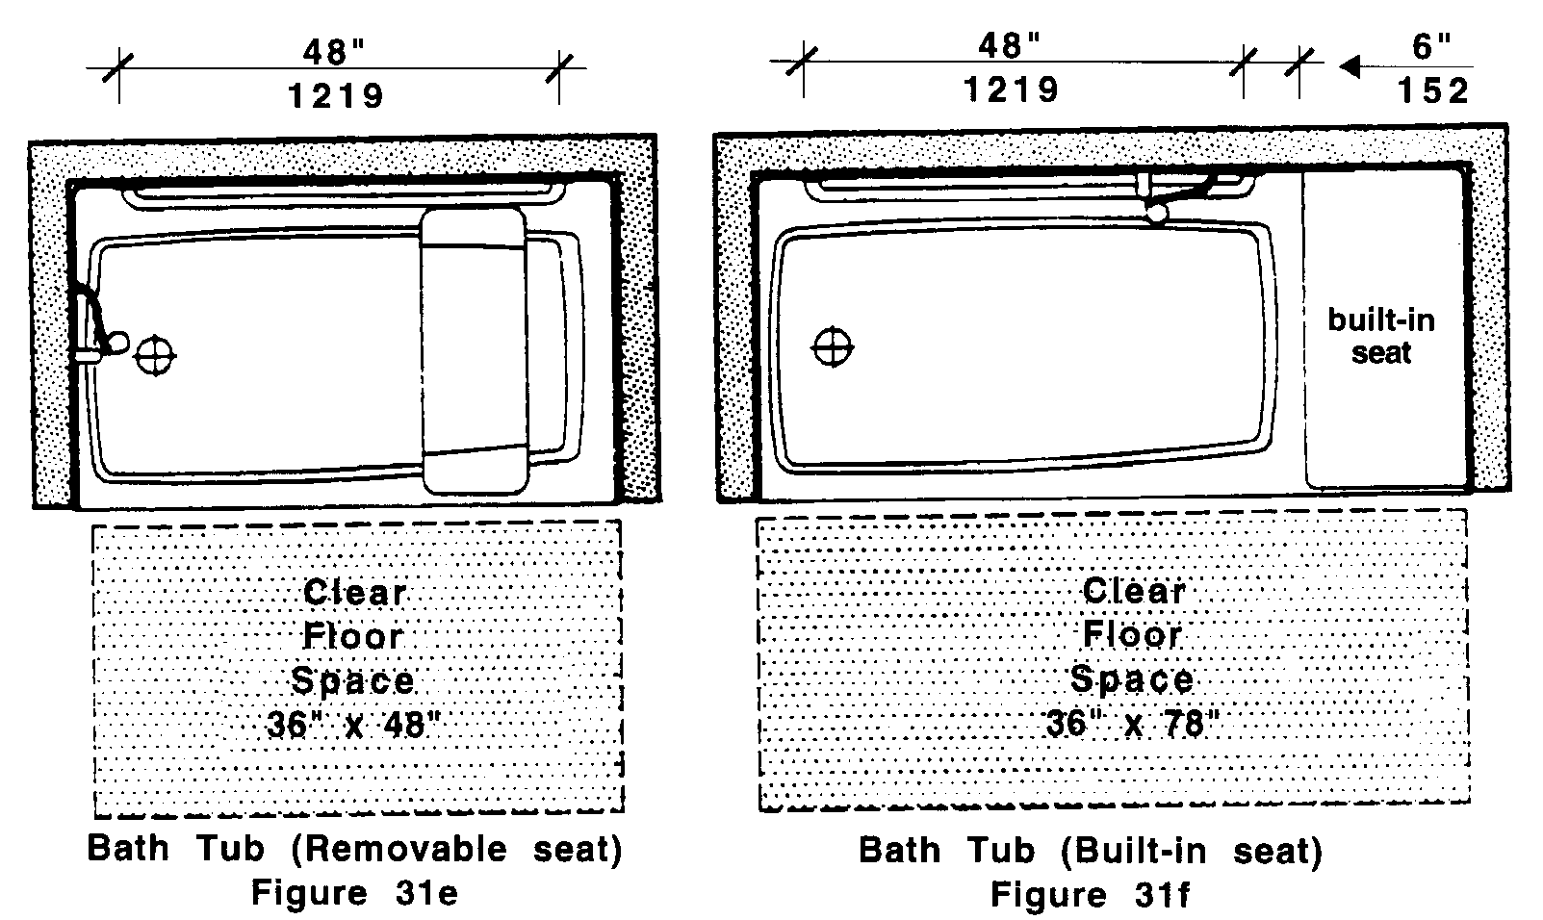

31.9.2 Seat: A removable in-tub seat or a built-in seat at the head end of the tub shall be provided as shown in Fig. 31g, and 31h. Seats shall be mounted securely and shall not slip during use. The structural strength of seats and their attachments shall comply with the definition of structural strength in 521 CMR 5, DEFINITIONS.
31.00: BATHING ROOMS

31.9.3 Grab Bars: Grab bars shall be provided as shown in Fig. 31g and h.

a. The top grab bar shall be placed horizontally between 33 and 36 inches (33" = 838mm and 36" = 914mm) above the floor line and the lower grab bar shall be placed approximately 15 inches (15" = 381mm) below the top grab bar.
b. The structural strength of grab bars and their attachments shall comply with the definition of structural strength in 521 CMR 5.00: DEFINITIONS.
c. Grab bars shall be between 1¼ inches to 1½ inches (1¼" to 1½" = 32mm to 38mm) in outside diameter, have a 1½ inch (1½" = 38mm) clearance between the bar and the wall. See Fig. 30f.
d. Grab bars shall also be non-rusting and acid-etched or roughened.

31.9.4 Controls: In bathtubs with built in seats, controls shall be mounted on the short wall opposite the built in seat.

31.9.5 Shower spray unit: A shower spray unit with a hose at least 60 inches (60" = 1524mm) long that can be used both as a fixed shower head and as a hand-held shower shall be provided.

31.9.6 Soap trays shall not incorporate hand hold features unless they can support 250 pounds for five minutes.

31.9.7 Bathtub Enclosures: If provided, enclosures for bathtubs shall not obstruct controls or transfer from wheelchairs onto bathtub seats or into tubs. Enclosures on bathtubs shall not have tracks mounted on the rim of the bathtub.
31.00: BATHING ROOMS

31.10 MIRRORS AND SHELVES
If mirrors and shelves are provided, then at least one of each shall be accessible. The top of any shelf and the bottom of any mirror which is provided above a sink shall be set with the bottom edge of the reflecting surface no higher than 40 inches (40" = 1016mm) above the floor. A full length mirror is also allowed.

31.11 CONTROLS AND DISPENSERS
If controls, dispensers, receptacles, or other equipment are provided, then at least one of each shall be on an accessible route and shall comply with 521 CMR 39.00: CONTROLS.

