521 CMR 32.00: KITCHENS

32.1 GENERAL
Non-commercial kitchens in public facilities such as classrooms and community rooms shall provide a clear space of 60 inches (60" = 1524mm) in diameter, measured 12 inches (12" = 305mm) above the floor. For requirements for kitchens in multiple dwellings, see 521 CMR 43.00: GROUP 1 KITCHENS and 521 CMR 45.00: GROUP 2 KITCHENS.

32.2 COUNTER TOPS
Counter tops that contain sinks and cooking units shall provide a minimum of 15 inches (15" = 381mm) of clear countertop on at least one side of the cooking unit and on at least one side of the sink and shall have a clear space underneath that complies with 521 CMR 32.6, Kneespace. Countertops shall be mounted no higher than 34 inches (34" = 864mm) above the finish floor. See Fig. 32a.

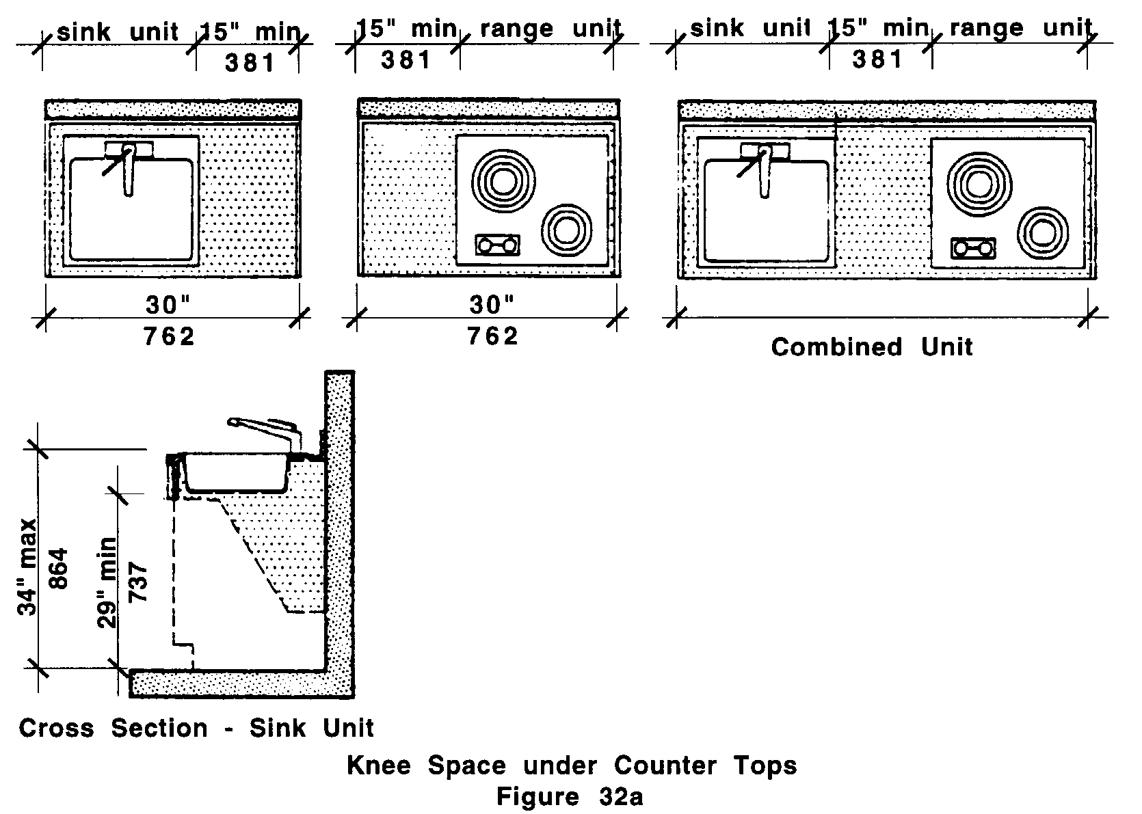

32.3 WALL CABINETS
The bottoms of the wall cabinets shall comply with 521 CMR 6.5 Forward Reach or 6.6 Side Reach

32.4 PANTRY UNIT
A tall cabinet at least 30 inches (30" = 762mm) wide and 72 inches (72" = 1829mm) in height may be installed in lieu of making overhead cabinets accessible. If walk-in pantry is provided, the door to the pantry shall fully comply with 521 CMR 26.00: DOORS AND DOORWAYS.

32.00: KITCHENS

32.5 HARDWARE
Cabinet hardware shall be operable with a closed fist. Cabinet opening devices shall be located at the top of base cabinets and at the bottom of wall cabinets.

32.6 KNEESPACE
Access space for the knees and feet of wheelchair users shall be provided under cooktops and sinks, and elsewhere as space and storage considerations permit.

32.6.1 All such spaces shall be at least 30 inches (30" = 762mm) wide, 27 inches (27" = 686mm) high, and 19 inches (19" = 483mm) deep.

32.6.2 Where sink and cooking units are within 15 inches (15" = 381mm) of each other, access space under the counter shall be continuous at a height of 27 inches (27" = 686mm) to the underside of the counter.

32.7 SINK
Sinks shall comply with the following:

32.7.1 Clear floor space: A clear floor space, complying with 521 CMR 6.3, Wheelchair Turning Space shall be provided in front of a sink to allow forward approach. The clear floor space shall be on an accessible route and shall extend a maximum of 19 inches (19" = 483mm) underneath the sink. See Fig. 30g.

32.7.2 Sinks shall be mounted with the rim no higher than 34 inches (34" = 864mm) above the finish floor.

32.7.3 Sink depth shall not exceed eight inches (8" = 203mm).

32.7.4 Sink traps and drains shall be located as close to rear walls as possible. Plumbing pipes shall be recessed, insulated, or guarded. There shall be no sharp or abrasive surfaces under sinks.

32.7.5 Faucets shall be operable with one hand and shall not require tight grasping, pinching, or twisting of the wrist. Lever-operated, push-type, touch-type, or electronically controlled mechanisms are acceptable designs.

32.7.6 Garbage disposals, when provided, shall be controlled by switches under the counter at the front.

32.8 COOKING UNITS
Shall comply with the following: See Fig. 32b.
32.00: KITCHENS
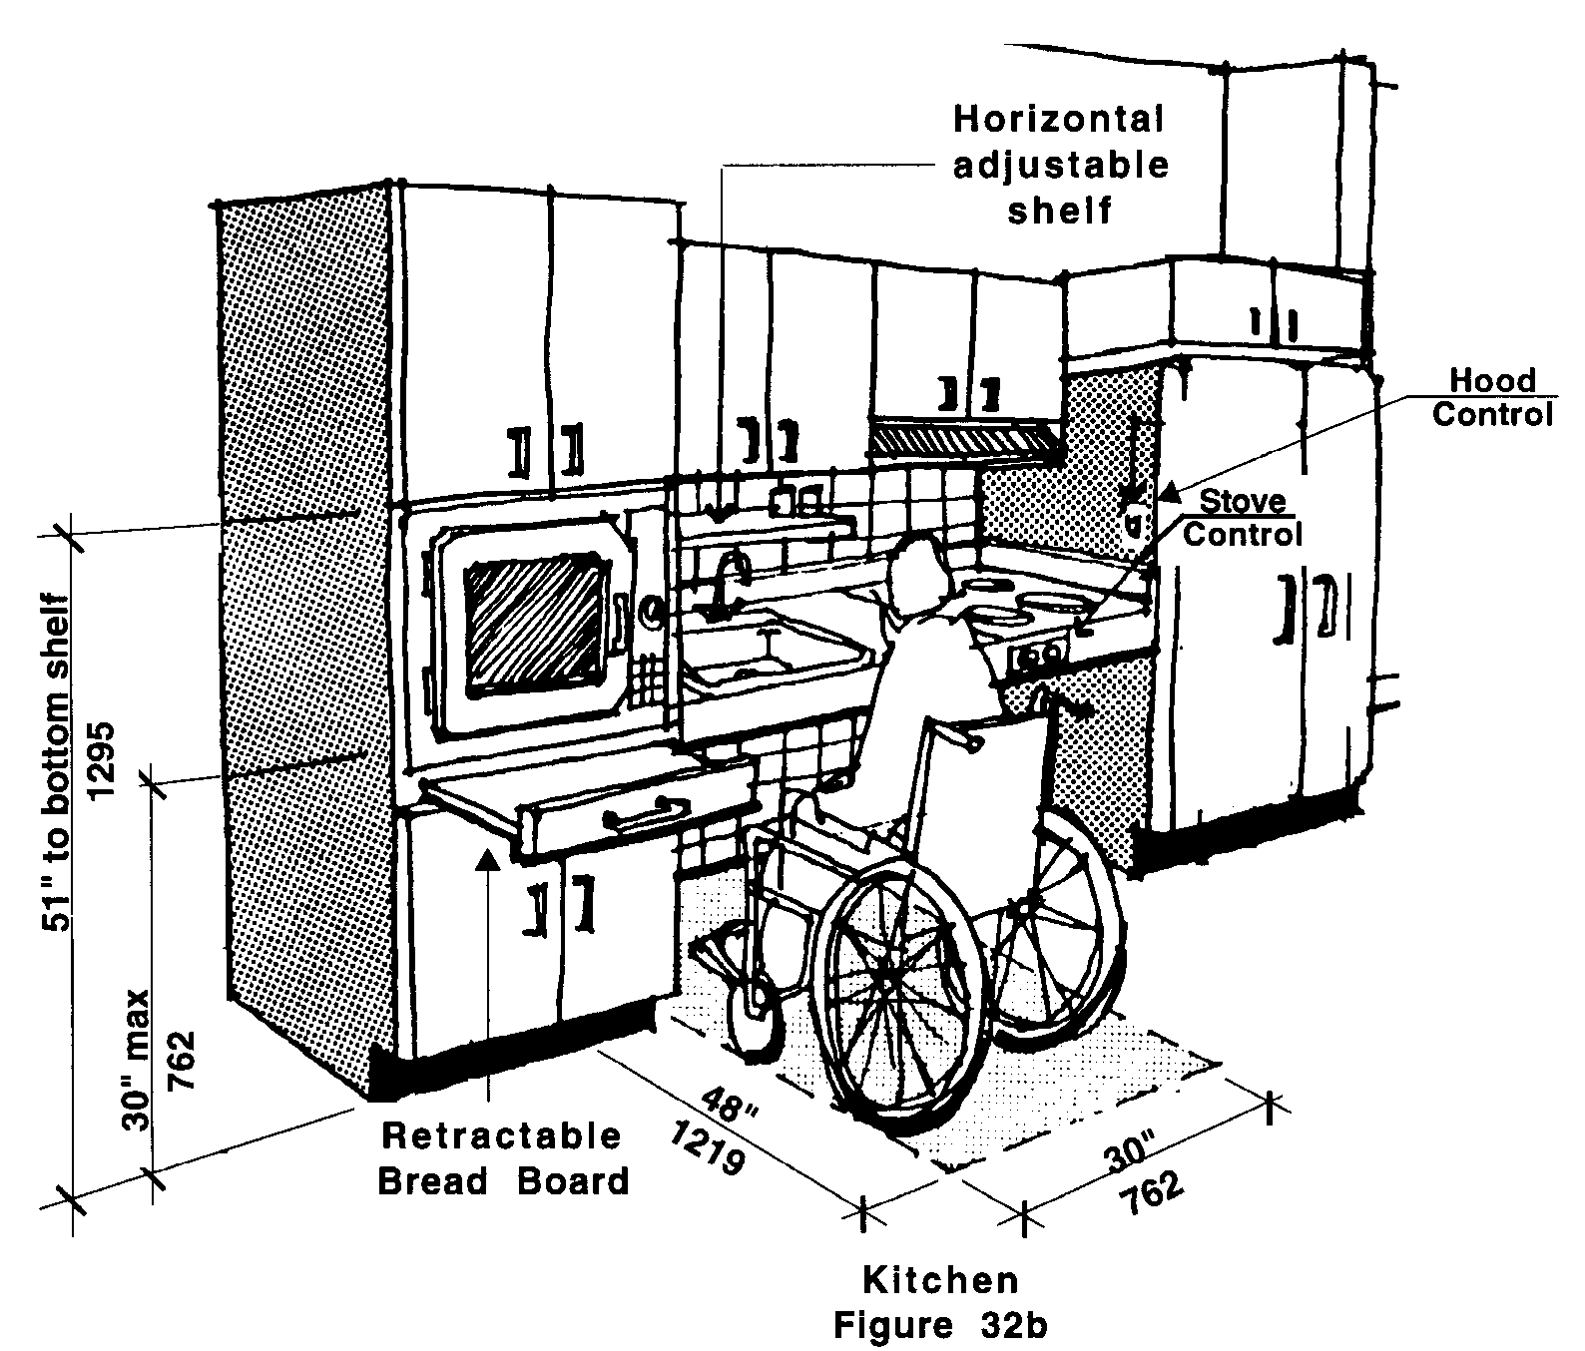

32.8.1 Cooking units shall be the in-counter type with controls at the front of counter or counter faces, and with open access space under the counter.

32.8.2 Where hoods are provided above cooking units, controls shall be located no higher than 54 inches (54" = 1372mm) above the floor, but shall not be located behind cooking units.

32.8.3 Ovens shall be the wall-oven type, set at a height such that bottoms of doors are 30 inches (30" = 762mm) above the floor.

32.8.4 Bottom-hinged ovens shall provide retractable "bread board" type shelf concealed in the counter, adjacent to the oven door. If side-hinged, the "bread board" type shelf shall be located under the oven.

32.8.5 Ovens shall also be self-cleaning, or continuous cleaning.

32.9 REFRIGERATORS
May be combination refrigerator-freezers with two doors side by side, or may be two door freezer-above-the-refrigerator units or refrigerator-above-the-freezer units, provided the bottom of such freezer or refrigerator is no higher than 44 inches (44" = 1118mm) above the floor. See Fig. 32c. Refrigerators shall be self-defrosting.

32.00: KITCHENS

Exception: In kitchenettes an undercounter type refrigerator is acceptable.

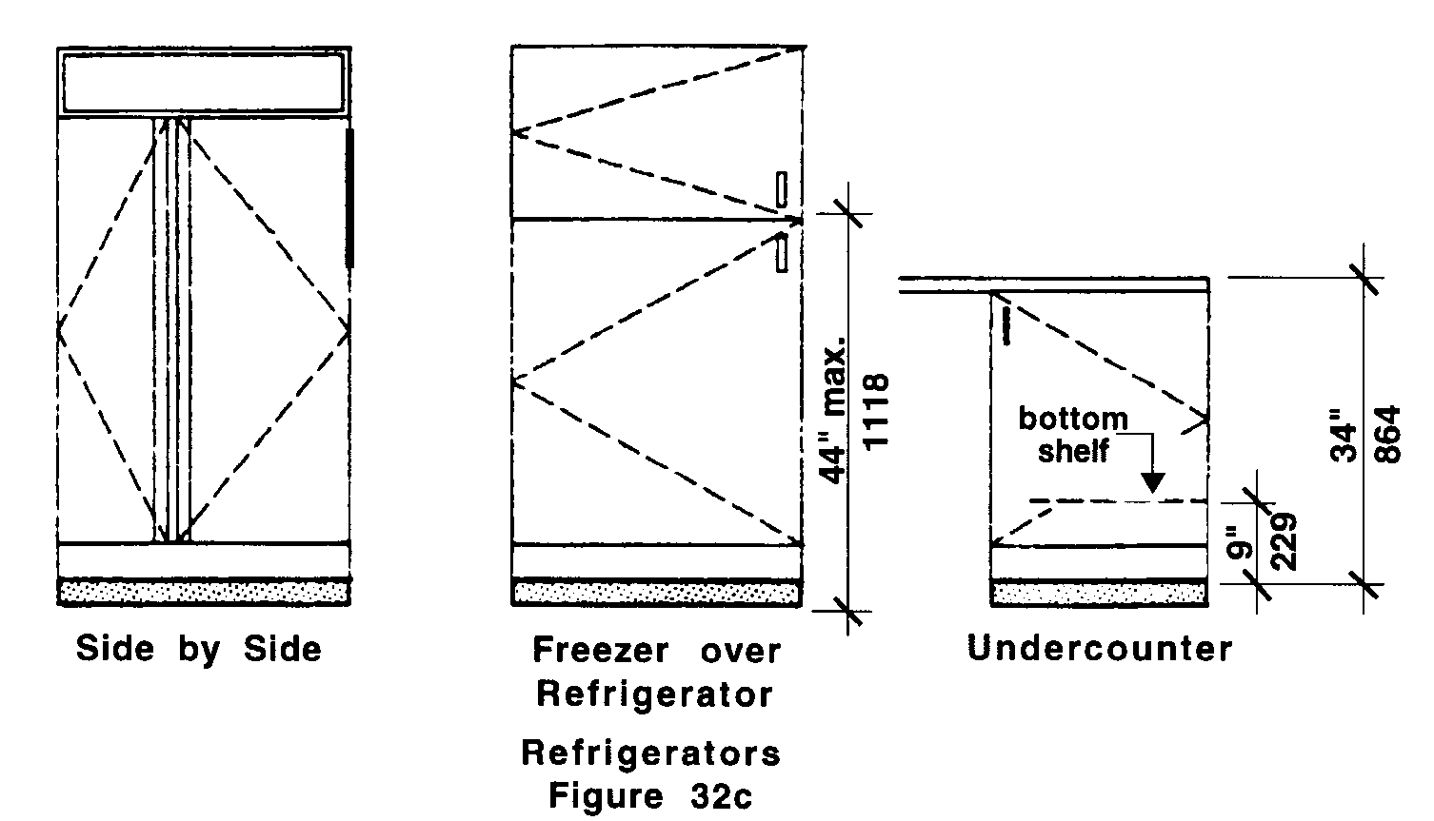

32.10 CONTROLS
All controls and switches shall comply with 521 CMR 39.00: CONTROLS.

