521 CMR 33.00: DRESSING, FITTING AND CHANGING ROOMS

33.1 DRESSING, FITTING AND CHANGING ROOMS
Where provided, dressing, fitting and changing rooms shall comply with the following:

33.2 DISTRIBUTION
5%, but never less than one, in each cluster of dressing, fitting and changing rooms shall be accessible. Where separate sex dressing, fitting or changing rooms are provided, at least one such room for each sex shall be provided.

33.3 LOCATION
Accessible dressing, fitting and changing rooms shall be on an accessible route complying with 521 CMR 20.00: ACCESSIBLE ROUTE. A wheelchair turning space complying with 521 CMR 6.3, Wheelchair Turning Space shall be provided in every accessible dressing, fitting and changing room entered through a swinging door, sliding door or curtain.

33.4 SIZE
The accessible dressing, fitting or changing room should be a minimum of five feet by six feet (5'-0" by 6'-0" = 1524mm by 1829mm). A clear floor area of 60 inches in diameter (60" = 1524mm), measured at 12 inches (12" = 305mm) above the floor, shall be provided in every accessible dressing, fitting or changing room. See Fig. 33a.

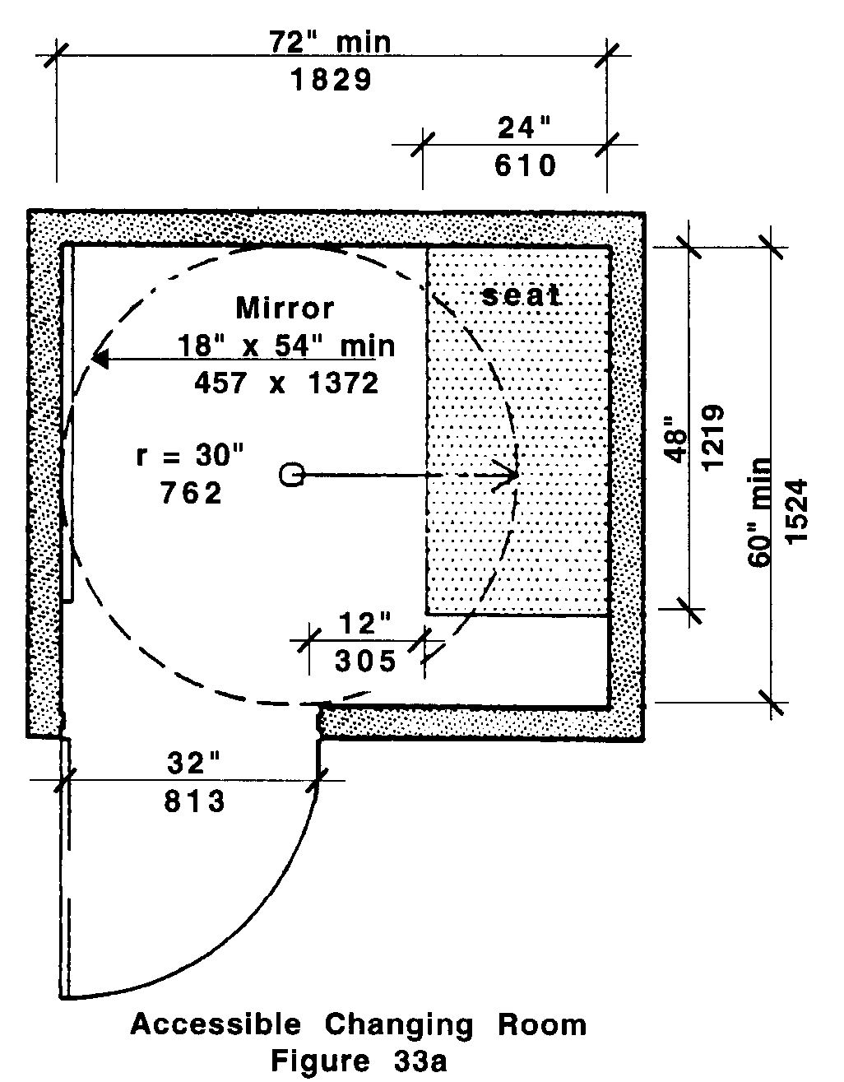

33.4.1 No door shall swing into any part of the turning space.

33.4.2 A coat hook shall be provided within the dressing, fitting or changing room and located no higher than 54 inches (54" = 1372mm) above the floor.

33.00: DRESSING, FITTING AND CHANGING ROOMS

33.5 DOORS
All doors to accessible dressing, fitting and changing rooms shall be in compliance with 521 CMR 26.00: DOORS AND DOORWAYS.
33.6 SEAT
Every accessible dressing, fitting and changing room shall have a seat/bench that complies with the following:

33.6.1 The seat/bench shall be 24 inches by 48 inches (24" x 48" = 610mm by 1219mm) and fixed to the wall along the shorter dimension.

33.6.2 The seat shall be mounted 17 inches to 19 inches (17" to 19" = 432mm to 483mm) above the finish floor and open below with a minimum of 12 inches (12" = 305mm) in height measured from the floor. See Fig. 33b.

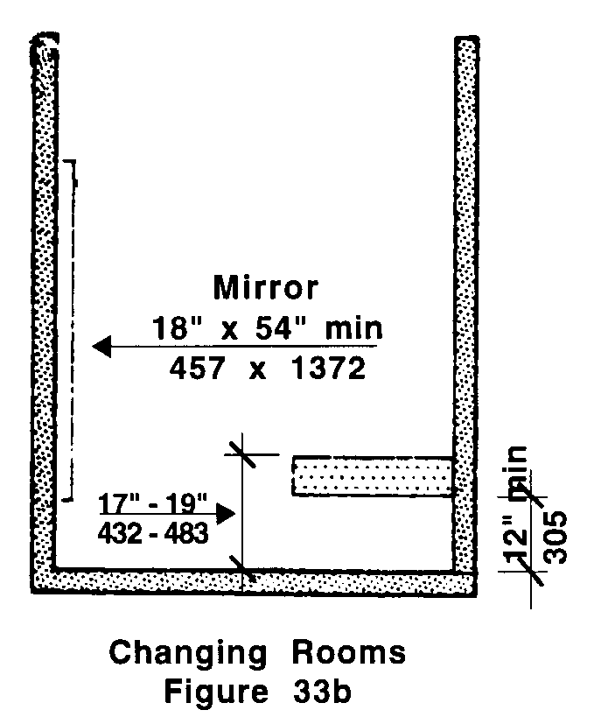

33.6.3 Clear floor space shall be provided alongside the bench to allow a person using a wheelchair to make a parallel transfer onto the seat.

33.6.4 The seat and attachments shall comply with the requirements for structural strength in 521 CMR 5.00: DEFINITIONS.

33.7 MIRROR
Where mirrors are provided in changing rooms a full-length mirror measuring at least 18 inches wide by 54 inches high (18" by 54" = 457mm by 1372mm), shall be mounted 18 inches (18" = 457mm) above the finish floor, in a position affording a view to a person on the bench as well as to a person in a standing position. See Fig. 33b.

