521 CMR 34.00: STORAGE

34.1 GENERAL
Fixed storage facilities such as cabinets, shelves, closets, and drawers that are required to be accessible shall comply with the following requirements.

34.2 CLEAR FLOOR SPACE
A clear floor space that allows either a forward or parallel approach by a person using a wheelchair shall be provided at accessible storage facilities.

34.3 HEIGHT
Accessible storage spaces shall be within at least one of the reach ranges specified in 521 CMR 6.5, Forward Reach and 521 CMR 6.6, Side Reach. See Figure 6k, 6l, 6m and 6n. Clothes rods or shelves shall be a maximum of 54 inches (54" = 1372mm) above the finish floor for a side approach. Where the distance from the wheelchair to the clothes rod or shelf exceeds ten inches (10" = 254mm) (as in closets without accessible doors), the height and depth to the rod or shelf shall comply with Fig. 34a and 34b.

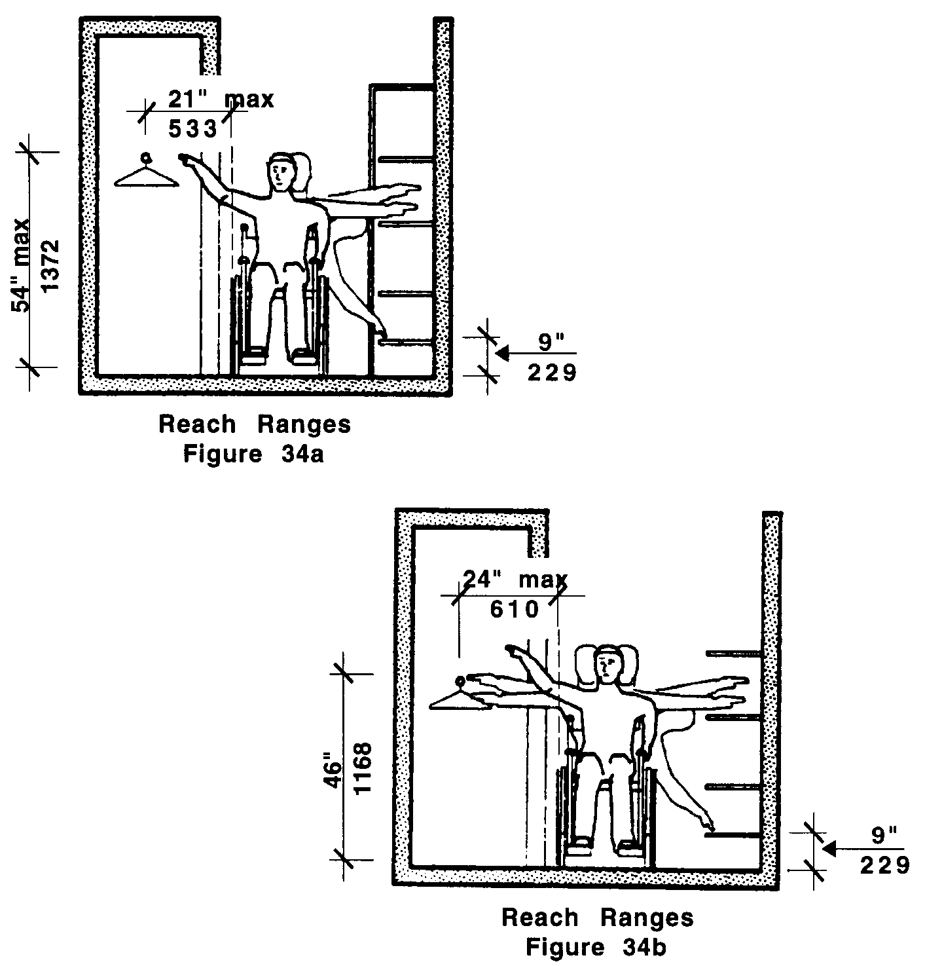
34.00: STORAGE

34.4 HARDWARE
Hardware for accessible storage facilities shall comply with 521 CMR 26.11, Door Hardware. Touch latches and U-shaped pulls are acceptable. See Fig. 34c.

