521 CMR 35.00: TABLES AND SEATING

35.1 FIXED TABLES AND BUILT-IN SEATING
Where fixed tables or built in seating are provided, at least 5%, but not less than one, of the fixed tables shall be accessible, be on an accessible route, and shall comply with the following. There shall be no fixed seats at accessible tables.

35.2 DISTRIBUTION
Accessible fixed tables shall be distributed by size and location throughout the space or facility. In establishments where separate areas are designated for smoking and non-smoking patrons, the required number of accessible fixed tables shall be proportionally distributed between the smoking and non-smoking areas.

35.3 CLEARANCES
Between fixed accessible tables there shall be at least a 36 inch (36" = 914mm) access aisle. No seating shall overlap the access aisle.

35.4 CLEAR FLOOR SPACE
Clear floor space shall be provided at each seating space. Such clear floor space shall not overlap knee space by more than 19 inches (19" = 483mm). See Fig. 35a.

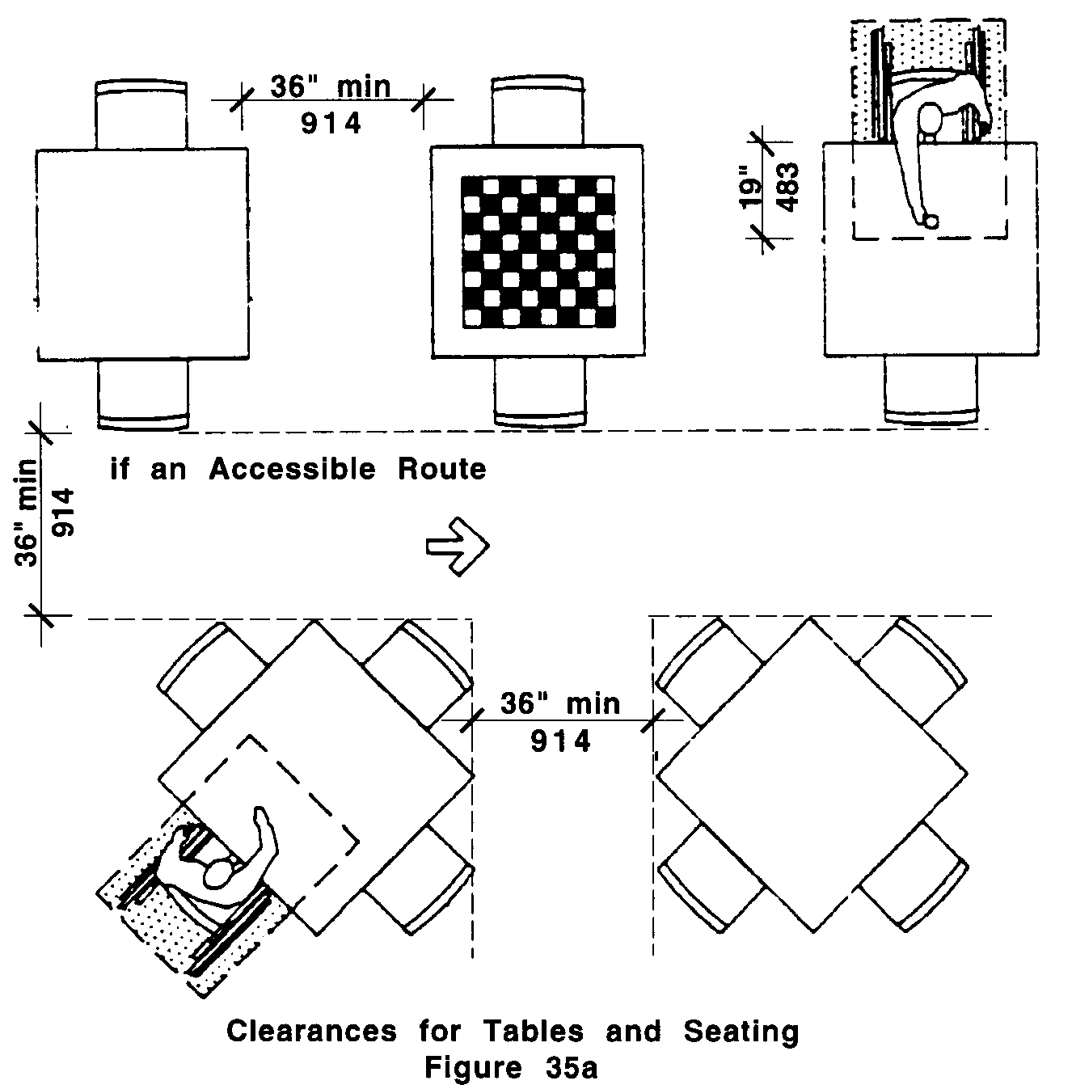
35.00: TABLES AND SEATING

35.5 KNEE CLEARANCES
If seating for people in wheelchairs is provided at tables or counters, knee spaces at least 27 inches (27" = 686mm) high, 30 inches (30" = 762mm) wide, and 19 inches (19" = 483mm) deep shall be provided. See Fig. 35b.

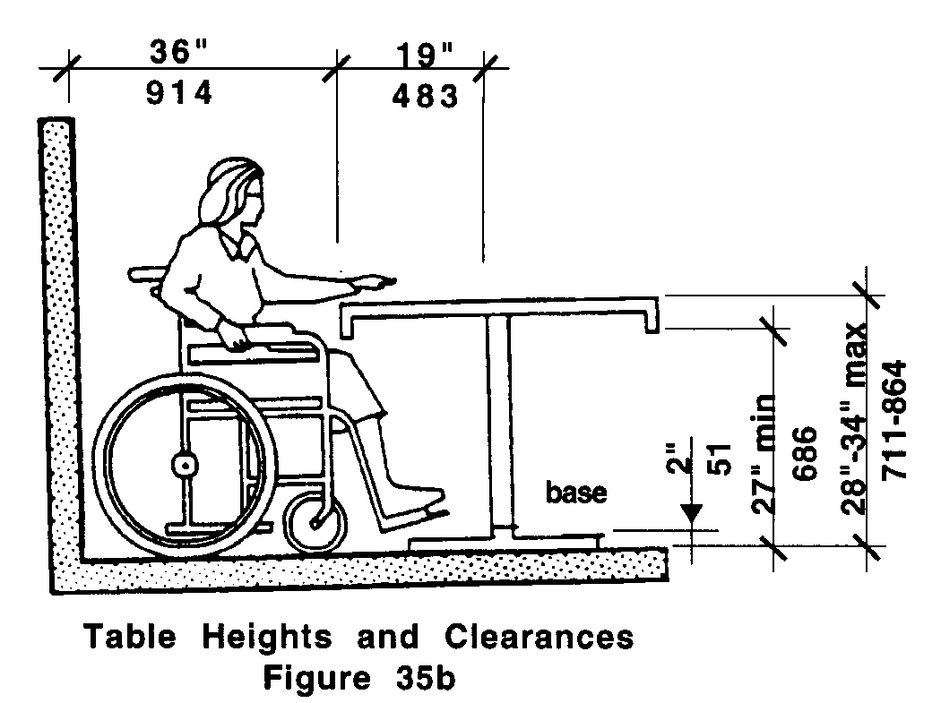

35.6 HEIGHT OF TABLES OR COUNTERS
The tops of accessible tables and counters shall be from 28 inches to 34 inches (28" to 34" = 711mm to 864mm) above the finish floor or ground.

