521 CMR 36.00: DRINKING FOUNTAINS

36.1 GENERAL
Drinking fountains shall include water coolers. Drinking fountains, when provided, shall comply with the following requirements.

36.1.1 Where only one drinking fountain is provided on a floor it shall be accessible. A single drinking fountain can be installed by the use of a "high-low" fountain; See Fig. 36a.

36.1.2 Where more than one drinking fountain is provided on a floor, one in each location shall be accessible and shall be on an accessible route.

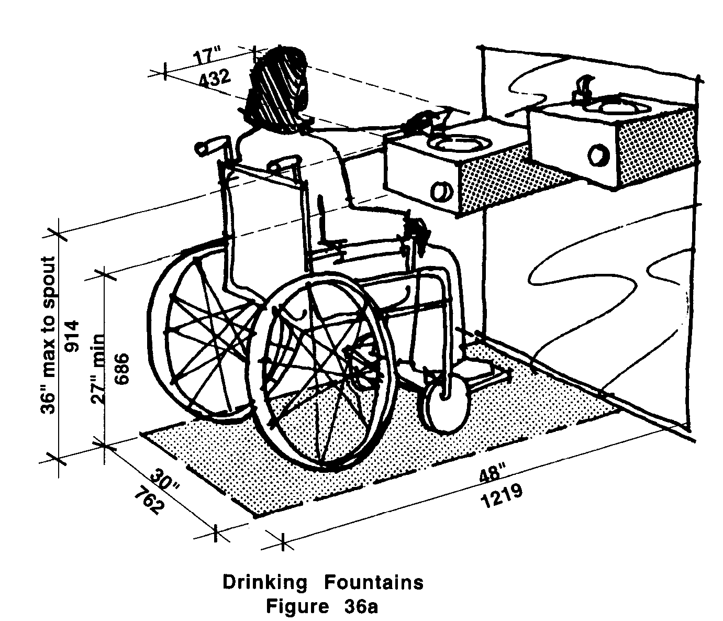

36.2 CLEARANCES
Shall comply with the following:

36.2.1 Wall and post-mounted cantilevered units allowing only a front approach shall have a clear knee space between the bottom of the apron and the floor or ground.

a. The knee space shall be at least 27 inches (27" = 686mm) high, 30 inches (30" = 762mm) wide, and 17 inches to 19 inches (17" to 19" = 432mm to 483mm) deep. See Fig. 36b and 36c.
b. These units shall also have a minimum clear floor space to allow a person in a wheelchair to approach the unit facing forward. See Fig. 36b and 36c.
36.00: DRINKING FOUNTAINS

6.2.2 Free-standing units not having a knee space under them shall have a clear floor space that allows a person in a wheelchair to make a parallel approach to the unit. See Fig. 36d. This clear floor space shall comply with 521 CMR 6.6, Side Reach.

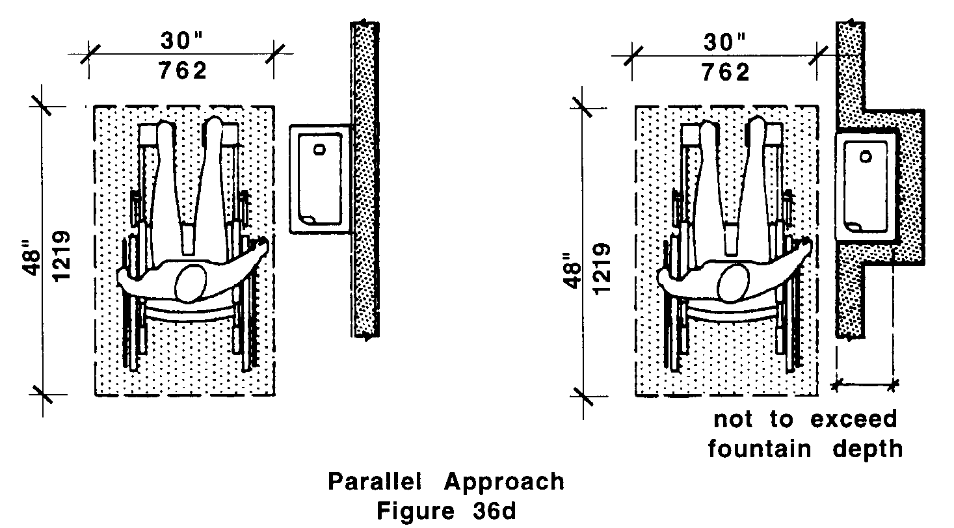

36.2.3 Built-in units shall comply with the following:

a. Where a drinking fountain is cantilevered or wall mounted along an accessible route it shall comply with the requirements of 521 CMR 20.6, Protruding Objects.
b. Where a drinking fountain is cantilevered in a recess, the recess shall be not less than 30 inches (30" = 762mm) wide, and the fountain shall comply with 521 CMR 36.2.1. See Fig. 36e.
36.00: DRINKING FOUNTAINS
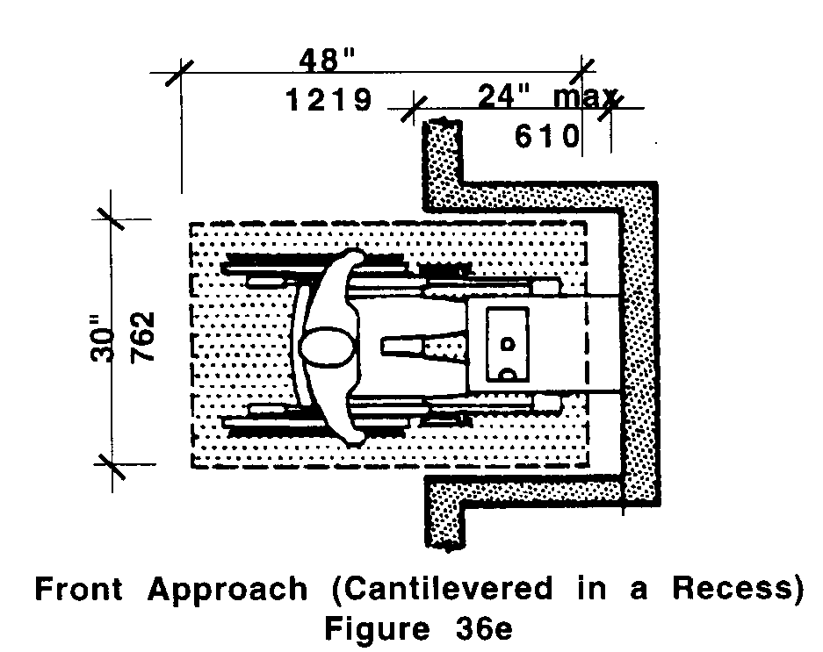

c. Where a drinking fountain is located in a recess and has no knee space below, the recess depth shall not exceed the fountain depth and the fountain shall have a clear floor space that allows a person in a wheelchair to make a parallel approach to the unit (See Fig. 36d). This clear floor space shall comply with 521 CMR 6.4, Clear Floor or Ground Space for Wheelchairs.

36.3 SPOUT LOCATION
The spouts of drinking fountains and water coolers shall comply with the following:

36.3.1 Spouts shall be located at the front of the unit and shall direct the water flow in a trajectory that is parallel or nearly parallel to the front of the unit.

36.3.2 The spout shall provide a flow of water at least four inches (4" = 102mm) high to allow the insertion of a cup or glass under the flow of water.

36.3.3 On an accessible drinking fountain with a round or oval bowl, the spout must be positioned so the flow of water is within three inches (3" = 76mm) of the front edge of the fountain.

36.4 SPOUT HEIGHT
Spouts shall be no higher than 36 inches (36" = 914mm), measured from the floor or ground surface to the spout outlet. See Fig. 36a.

36.5 CONTROLS
Controls shall comply with the following:

36.5.1 Controls shall be front-mounted or side-mounted near the front edge of the drinking fountain.

36.5.2 Controls shall be operable with one hand and shall not require tight grasping, pinching or twisting of the wrist. Knob-type faucets are not permitted. The force required to activate the controls shall be no greater than five lbs.

36.5.3 Other types of controls may be installed in addition to, but not instead of, hand operated controls.
36.00: DRINKING FOUNTAINS

NON-TEXT PAGE

